Teacher Preparation Notes for
A Scientific Investigation – What types of food contain starch and protein?

In the first part of this activity, students answer analysis and discussion questions as they learn about the structure, functions, and synthesis of starch and proteins. They use this information to explain why certain parts of plants or animals contain a substantial amount of starch or protein. Then, students carry out key components of a scientific investigation, including:
- generating hypotheses
- designing and carrying out experiments to test their hypotheses
- if needed, using experimental results to revise their hypotheses.
The Student Handout provides information and questions to guide students in designing the first experiment, which evaluates two indicator solutions to see whether they can be used to test for starch or for protein. Then, students formulate hypotheses concerning which types of food contain starch and which types of food contain protein (some or all foods derived from animals or plants or both). Next, students use their hypotheses to make predictions about the starch and protein content of several types of food, and they test their predictions in a second experiment. Students evaluate whether their results support their hypotheses and, if needed, they propose revised hypotheses.

Before beginning this activity, students should have a basic understanding of molecules.

The hands-on activity will probably require two 50-minute laboratory periods. You will probably want to complete your discussion of pages 1-3 of the Student Handout before the laboratory periods.

Learning Goals
In accord with the Next Generation Science Standards:
- Students learn the Disciplinary Core Ideas:
- LS1.C: Organization for Matter and Energy Flow in Organisms – "The sugar molecules thus formed contain carbon, hydrogen, and oxygen; their hydrocarbon backbones are used to make amino acids and other carbon-based molecules that can be assembled into larger molecules (such as proteins or DNA), used for example to form new cells."
- Students engage in the Science Practices of
- "Planning and carrying out investigations" – Students should be able to:
- "Decide what data are to be gathered … and how measurements will be recorded."
- "Decide how much data are needed to produce reliable measurements and consider any limitations on the precision of the data."
- "Plan experimental… procedures, identifying… the need for controls."
- "Analyzing and interpreting data" – Students should be able to:
- "Analyze data systematically, either to look for salient patterns or to test whether data are consistent with an initial hypothesis."
- "Evaluate the strength of the conclusion that can be inferred from any data set…"
- constructing explanations
- arguing from evidence.
- This activity helps to prepare students for the Performance Expectation:
- HS-LS1-6. "Construct and revise an explanation based on evidence for how carbon, hydrogen and oxygen from sugar molecules may combine with other elements to form amino acids and/or other large carbon-based molecules."
- This activity can help students to understand the Crosscutting Concept, Energy and Matter.
- This activity helps students to understand the Nature of Science, including:
- Scientific inquiry is characterized by a common set of values that include: logical thinking, precision, open-mindedness, objectivity, skepticism, replicability of results, and honest and ethical reporting of findings.
- Science knowledge is based on empirical evidence.
Additional Content Learning Goals
- Starch is a polymer of glucose. The function of starch is glucose storage.
- Proteins are polymers of 21 different types of amino acids. The many different types of proteins serve a variety of functions, e.g. enzymes, structure and movement.
- The molecules in food are useful for the plant or animal from which the food was derived.
- In plants, photosynthesis combines CO₂ and H₂O to make the sugar, glucose. Glucose provides precursor molecules to make other types of plant molecules. For example, molecules derived from glucose plus N atoms in ions from the soil are used to make amino acids. The monomers (amino acids or glucose) are joined together to make the polymers (proteins or starch).
- An indicator is a substance that changes color in the presence of a particular type of organic compound.
- To evaluate the specificity of an indicator, it is important to include negative controls.
- Accurate, consistent methods and replication of experiments are needed to produce reliable experimental results.
- Inductive reasoning can provide useful generalizations based on specific observations, but the results of inductive reasoning should be treated with caution, since additional observations may show exceptions to a generalization.
- To test a hypothesis, scientists use deductive reasoning to predict specific experimental results expected on the basis of the hypothesis.
- Experiments to test a hypothesis often produce results that stimulate scientists to modify their original hypothesis; then scientists perform additional experiments to test their modified hypothesis.
- Substantial amounts of starch are found in some foods derived from plants. Substantial amounts of protein are found in some foods derived from animals and some foods derived from plants.

Supplies
- Indicator Solution 1 = Iodine-Potassium Iodide Solution (~12 mL per class; available from http://www.carolina.com/; if not in an opaque container, should be stored in the dark)
- Indicator Solution 2 = Biuret reagent (~50 mL per class; available from http://www.carolina.com/; Biuret reagent should be fresh since old Biuret reagent is less sensitive as a protein indicator.)
- Dropper bottles for the indicator solutions (bare minimum of two, one for each indicator solution; ideally, as many as the number of student groups in your largest class, so each pair of student groups can share a pair of dropper bottles)
- Containers for testing such as small plastic or Styrofoam cups (28 if you have containers that will be washed and reused or, if you do not have a sink, 48 per class; white containers or transparent containers placed on a white background make it easier to see the color change in the indicator solutions; small paper cups should not be used because at least some brands test positive for starch even when the sample is pure water)
- Markers for labeling the containers
- Stirrers (e.g. plastic knives and/or spoons; 1 or 2 per student group in your largest class; more if you do not want students to have to wash stirrers during the experiment)
- Gloves (minimum of 1 per student group per day) (Goggles can also help student safety.)
- If you want your students to measure the amounts of each sample given on pages 5 and 7 of the Student Handout, you can use milliliter pipettes to measure the amounts of water and oil and a scale to measure the amounts of the solid samples and egg white. However, the tests for starch and protein work well with estimated amounts of samples, and your students can use measuring spoons to measure the amounts of samples. When you buy a set of measuring spoons, we recommend that you look for a set that includes 1/8 teaspoon measure. (In many sets ¼ teaspoon is the smallest measure.) If you have your students use measuring spoons, you should substitute the teaspoon amounts for the gram amounts in the Student Handout.
- Samples for pages 4-6 of the Student Handout – amount needed per class (It will be good to have a little extra of each of these.)
- Corn starch (~1.2 g or ~ ½ teaspoon; can be found in the baking needs aisle)
- Potato starch (~1.2 g or ~ ½ teaspoon; can be found in the baking needs aisle)
- Liquid egg whites (~3.2 g or ~1 teaspoon; an alternative is egg white from a whole egg or powdered egg whites (~1.2 g or ~ ½ teaspoon; a student group would dissolve ~0.3 g in ~2 mL of water)
- Unsweetened Gelatin (~0.4 g or < ~¼ teaspoon)
- Sucrose = "table sugar" (~1.2 g or ~ ½ teaspoon)
- Vegetable oil (~4 mL)
  - Samples for pages 7-8 of the Student Handout – amount needed per class (It will be good to have a little extra of each of these.)
- Beans (~8 canned beans; we have had good success with white cannellini beans which are easy to mash and have a light color, so the color change of Biuret solution is more visible)
- Almond paste (~2.5 g or ½ teaspoon; can be found in the baking needs aisle)
- Jelly (~6 g or ~1 teaspoon; since Part 2 of the activity analyzes the starch and protein content of foods derived from plants vs. animals, you will want to check the label to make sure your jelly does not contain gelatin)
- Butter (~4 g or ~1 teaspoon)
- Yogurt (~4 g or ~1 teaspoon; you should check the ingredients list to make sure you have a brand of yogurt (e.g. Stonyfield) that does not contain starch)
- Water (tap water should be fine; ~40 mL or ~9 teaspoons per class for pages 4-6 and ~10 mL or ~2 teaspoons per class for pages 7-8 + water for washing unless you have enough containers and stirrers so students do not need to wash them)

Suggestions for Implementation and Background Information
To maximize student participation and learning, I recommend that you have students work on groups of related questions individually or in pairs before having a class discussion of their answers.

In the Student Handout, numbers in bold indicate questions for the students to answer and letters in bold indicate steps in the experimental procedure for the students to do.
- indicates a safety precaution.

If you use the Word version of the Student Handout to make changes for your students, please check the PDF version to make sure that the figures and formatting in the Word version are displaying correctly on your computer.

A key is available upon request to Ingrid Waldron (iwaldron@upenn.edu). The following paragraphs provide additional instructional suggestions and background information – some for inclusion in your class discussions and some to provide you with relevant background that may be useful for your understanding and/or for responding to student questions.

Question 1 is designed to get students thinking about the driving question for this activity. As you discuss the student answers to this question, you may want to mention that we are only concerned with foods that have a substantial amount of starch or protein. I recommend that you not reveal which student answers are correct at this time, but rather return to this question at the end of the activity.

Page 1 of the Student Handout shows the more common form of starch. The figure below shows both forms of starch.
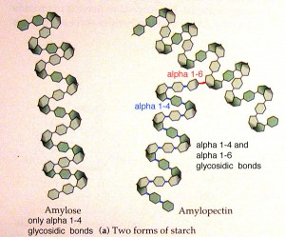
(http://www.precisionnutrition.com/wordpress/wp-content/uploads/2011/07/amylose-300x249.jpg)

The Student Handout does not discuss differences between different kinds of seeds. Grains (e.g., wheat or rice) and legumes (e.g., beans) tend to have more starch, whereas nuts tend to have more oil. Each of these foods has some protein (https://www.ars.usda.gov/arsuserfiles/80400525/data/hg72/hg72_2002.pdf).

This figure shows a more detailed version of the bottom figure on page 1 of the Student Handout. Some of the glucose molecules from the digestion of starch are used as input for cellular respiration to produce ATP, which provides energy for many cellular processes. Cellular respiration is not explained in this activity; for more information, see “Cellular Respiration and Photosynthesis – Important Concepts, Common Misconceptions, and Learning Activities” (http://serendipstudio.org/exchange/bioactivities/cellrespiration), which includes background information and suggested learning activities for your students. | 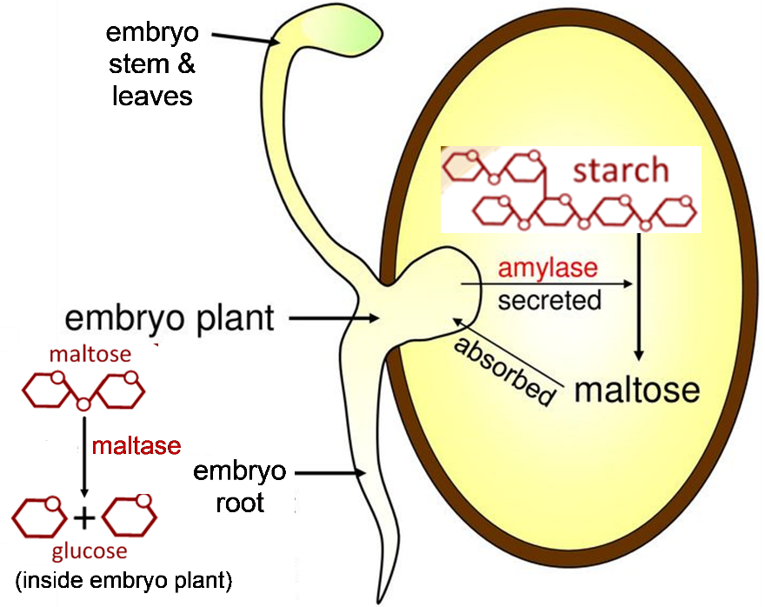

The classic understanding that human proteins contain only 20 different types of amino acids has been updated with the discovery that selenocysteine is incorporated in some human proteins. Question 4c is intended to elicit the answer that nitrogen is the type of atom that is present in amino acids, but not glucose. If appropriate for your students, you may want to add that some amino acids contain sulfur or selenium.

Scientists have estimated that there are roughly 100,000 different types of proteins in the human body. Protein functions include:
- transport within the cell, across cell membranes, and in the blood (e.g. hemoglobin)
- movement (including cilia, flagella and muscles)
- structure (e.g. cytoskeleton; see https://www.nature.com/scitable/ebooks/essentials-of-cell-biology-14749010/118240354/)
- enzymes
- chemical messengers (e.g. hormones)
- defense against infection (e.g. antibodies).
If your students are not familiar with the functions of proteins, you may want to use part or all of “Introduction to the Functions of Proteins and DNA” (https://serendipstudio.org/exchange/bioactivities/proteins). For more information about protein functions, see https://medlineplus.gov/genetics/understanding/howgeneswork/protein/ and https://www.ncbi.nlm.nih.gov/books/NBK26911/. For more information about the composition of meat, see https://amazingribs.com/technique-and-science/cooking-science/basic-meat-science/.

Page 3 of the Student Handout describes how some of the glucose molecules produced by photosynthesis are used to make starch and some are used to provide carbon backbones for the synthesis of other plant molecules. The figure below shows how molecules produced during the cellular respiration of glucose are used to synthesize amino acids. Since the carbon and oxygen atoms in the sugars produced by photosynthesis are derived from CO₂, the carbon skeletons used to make amino acids are also ultimately derived from CO₂ from the air.
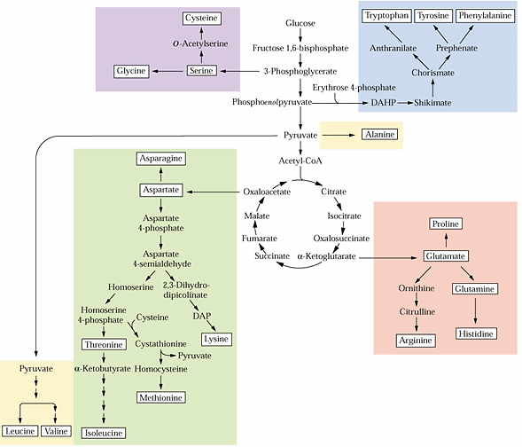
(http://www.uky.edu/~dhild/biochem/24/lect24.html)

The nitrogen needed for amino acid synthesis is taken up by the roots. NO₃- is converted to NH₄+ for incorporation in amino acids. This figure summarizes nitrogen metabolism in plants.  To highlight the need for uptake of water and nitrogen from the soil, you may want to add the following question after question 6.  6b. Explain how plant roots contribute to the production of proteins. | 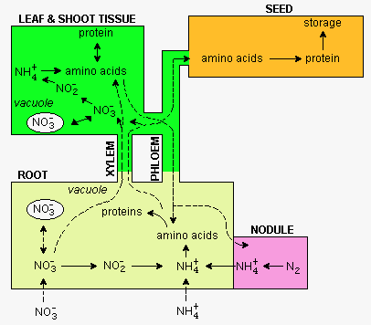  (http://www.uky.edu/~dhild/biochem/24/lect24.html)

Plants and bacteria can synthesize all of the amino acids they need. In contrast, humans must consume at least nine “essential” amino acids. (Sources disagree about the number of essential amino acids, because a person may need more types of amino acids in his/her diet, depending on his/her rate of growth and whether certain other amino acids are deficient in his/her diet.) Humans can produce the other needed amino acids from the essential amino acids by a process called transamination (illustrated in the figure below). Transamination also plays an important role in the synthesis of amino acids in plants and prokaryotes.
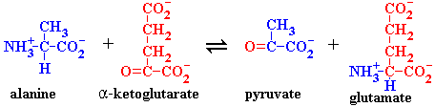
(http://www.chemistry.uoguelph.ca/educmat/chm452/gif/ala_kg.gif)

To synthesize a protein, a cell needs to use information from a gene in the DNA to specify the sequence of amino acids. To teach your students about the processes of transcription and translation, I recommend the hands-on, minds-on activity available at https://serendipstudio.org/sci_edu/waldron/#trans or the analysis and discussion activity available at https://serendipstudio.org/exchange/bioactivities/trans.

How can we test for starch and protein?
If your students ask how the starch in potatoes is useful for potato plants, you can explain that the starch in potatoes serves as glucose storage for the vegetative reproduction of potato plants. As shown in the figure below, potato plants can sprout from individual potatoes and then the potato plant produces multiple new potatoes. In the next growing season, each new potato can sprout one or more new potato plants. Compared to agricultural potato plants, wild potato plants make smaller new potatoes which are spread over a larger area; this facilitates vegetative reproduction.

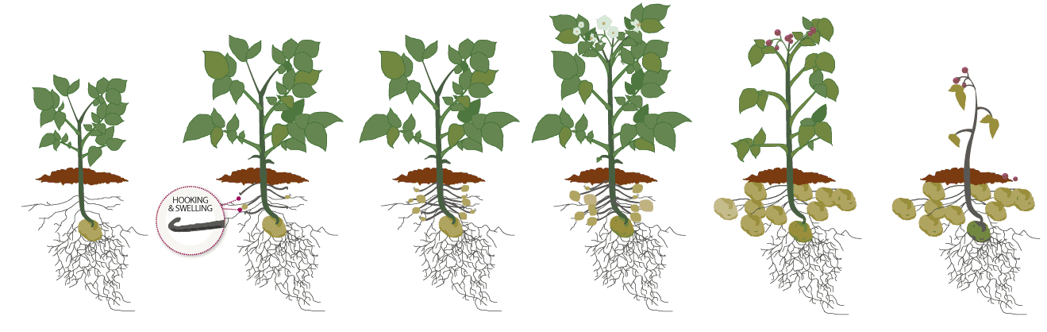
(https://i.pinimg.com/originals/dd/ea/79/ddea79c9088a253f27ce12c79edb94c0.gif)

To evaluate whether each indicator solution is a good indicator for starch or for protein, students should look for color changes when the indicator is added to:
- more than one type of starch or more than one type of protein
- negative controls, including water, sugar and oil.
The negative controls are important to establish that an indicator solution shows color change
only for starch or only for protein. The expected results are that, in the presence of starch, iodine will change color from yellow-brown to blue-black, and, in the presence of protein, Biuret reagent will turn from blue to purple. Biuret reagent is a little less reliable than the iodine indicator; it is important to use fresh Biuret reagent and it would be good to double check this test yourself ahead of time. You may want to show your students the color change for each of the indicator solutions before they begin their testing, so they will know what to look for. This will be helpful, for example, so students do not confuse the slight color change when egg whites are mixed with iodine with the reaction that occurs if starch is present.

You can either have your students measure the amount of each sample and water precisely or just estimate the approximate amount (see page 3 of these Teacher Preparation Notes for additional information).

To accomplish the goals of having negative controls and replicating results, the experimental design should have duplicate tests with each indicator for each sample for a total of 2 replicates x 2 indicator solutions x 7 samples = 28 tests. I suggest that you have your students work in groups of 2-4, and have each replicate test done by different groups (so whatever experimental error one group might make won't affect the replicate test). To maintain student engagement, you may want to have each student group test a starch sample, a protein sample, and one of the negative controls with each indicator. For example, if you have six student groups, you could use the following plan.
Group | Samples to Be Tested
1 | corn starch, egg whites, sucrose
2 | potato starch, gelatin, vegetable oil
3 | corn starch, gelatin, water
4 | potato starch, egg whites, water
5 | corn starch, egg whites, vegetable oil
6 | potato starch, gelatin, sucrose

This would result in three replicates of each starch and protein sample and two replicates of each negative control. To accommodate this plan, you will probably want to substitute the following table for the table currently shown in question 14. You may want to display this table on the board, so each student group can enter their data.

Sample | Did indicator solution 1  change color? |  |  | Did indicator solution 2  change color?
 | Replicate 1 | Replicate 2 | Replicate 3 | Replicate 1 | Replicate 2 | Replicate 3
Corn Starch
Potato starch
Egg whites
Gelatin
Sucrose
Vegetable oil
Water

Question 13 discusses the advantages of replication of each test. You may want to introduce the concept of false positives (which could occur if there were contamination) and false negatives (which could result from insufficient amounts of sample and/or indicator solution).

If there are any differences between replicate tests, the test should be repeated with optimum methodology to resolve the conflict. You can point out to your students that an important and necessary part of scientific research is to refine and standardize methods in order to get consistent and reliable results.

In discussing questions 17, you will want to include the limitations of inductive reasoning, especially when only a limited number of samples have been tested. To be more certain of conclusions concerning whether either of these indicator solutions can be used to test for starch or for protein, it would be desirable to test each indicator solution on a wider variety of samples, including additional types of starch and protein and additional types of negative controls, including glucose and amino acids (the monomers of starch and protein, respectively).

One important limitation of the indicator solution tests for starch or protein is that these tests are not sensitive enough to detect small amounts of starch or protein. The level of protein is high enough to be easily detected in concentrated sources of protein such as egg whites, beans, or milk (where the protein provides nutrition for the growing chick, plant seedling, or baby mammal, respectively). However, this indicator test will not detect the low levels of protein found in foods such as most fruits. You may want to mention that for intermediate levels of protein or starch, these indicators may give ambiguous results; you can discuss how scientific results are sometimes ambiguous, and scientists try to improve their methodology (e.g. develop quantitative methods) and repeat the experiment to clarify any ambiguity.

What types of food contain starch? What types of foods contain protein?
In this part, students:
- first use the data from the previous section to generate hypotheses about what types of food contain starch and protein,
- then carry out an experiment to test these hypotheses,
- interpret the results to see whether they support the hypotheses,
- and, if the initial hypotheses were not supported or only partially supported, formulate new revised hypotheses.
You will probably want to point out to your students that this is how real scientists work as they develop progressively better understanding of a research question.

Student hypotheses in response to question 20 will probably vary. This provides the opportunity to mention that this type of disagreement also happens in "real science" when different scientists have different interpretations of the same evidence; typically, these disagreements are resolved by obtaining additional evidence. At this point, all student hypotheses should be accepted as legitimate hypotheses to be tested by further experimentation, provided the hypotheses are compatible with the results summarized in question 19 which should show that:
- Some, but not all, foods derived from plants contain starch.
- At least some foods derived from animals do not contain starch.
- At least some foods derived from animals contain protein.
- At least some foods derived from plants do not contain protein.
Some of the student hypotheses may provide the opportunity to discuss how people formulate hypotheses based on both the results of the current experiment and also prior knowledge; this can be a useful part of the scientific process and contribute to cumulative improvements in our understanding of scientific questions.

To test their hypotheses, students will need to do replicate tests for each of the samples listed in question 21 with each of the indicator solutions. Thus, you will want a total of 2 replicates x 2 indicator solutions x 5 samples = 20 tests.

You may want to point out that generating the hypotheses to answer question 20 requires inductive reasoning (generalizing from specific examples to more general hypotheses, which has the risk of overgeneralizing, as demonstrated in this activity). In contrast, making the predictions in question 21 requires deductive reasoning (reasoning from general hypotheses to specific predictions, often used to test hypotheses).

Comparing the results for protein summarized in questions 19 versus 21 demonstrates the risk of generalizing from a limited set of observations. In the first set of samples, none of the foods derived from plants and all of the foods derived from animals have significant amounts of protein. In contrast, in the second set of samples, beans and almond paste have a significant amount of protein, whereas butter has almost no protein (so little that it is not detectable with our test).

Professional nutritional analysis provides the following values for starch and protein content for the food samples in this activity (% by weight; – indicates missing data).

Food | Starch | Protein
Corn starch | ~91% | 0%
Potato starch | – | –
Liquid egg whites | 0% | 11%
Powdered egg whites | – | 81%
Gelatin, unsweetened | 0% | 86%
Sucrose | 0% | 0%
Vegetable oil (corn oil) | 0% | 0%
White beans (canned) | – | 7%
Kidney beans (canned) | 9% | 5%
Almond paste | 0% | 10%
Jellies | – | 0%
Butter | 0% | 1%
Low-fat vanilla yogurt* | 0% | 5%
(Most data from www.nutritiondata.com, accessed in 2012)

*These figures apply to brands like Stonyfield which do not add starch; read the ingredients
list in the label to purchase a type of yogurt which does not have starch added.

The following information will be helpful in your discussion of the results of the investigation. Only plants produce starch, but starch is not present in significant amounts in some foods derived from plants, because the food is derived from a part of the plant that has little or no starch and/or because preparation of the food product has removed starch that was initially present. If a person consumes food with more calories than needed for cellular respiration, glucose molecules may be stored in glycogen (a polymer of glucose that can release glucose rapidly during intense exercise) or molecules absorbed from the digestive system may be converted to lipids. (More energy is available from a given weight of lipid stores than from the same weight of starch or glycogen stores; this is an advantage for mobile organisms like animals.)

Additional Resources for Teaching about the Scientific Method
A wealth of resources for teaching and understanding the scientific process are provided in
"Understanding Science – How science really works", available at http://undsci.berkeley.edu/

"The Strange Case of Beri beri" (available at https://www.biologycorner.com/worksheets/scientific_method_action.html.

"Battling Bad Science" is an entertaining talk about the errors and deceptions behind misleading nutritional or medical advice, available at
http://www.ted.com/talks/ben_goldacre_battling_bad_science.html (the first 7.5 minutes are the most relevant).

Additional Hands-on Activities in Which Students Design Experiments and Interpret the Results:
Activities that are explicitly aligned with the Next Generation Science Standards are indicated by (NGSS).

"Enzymes Help Us Digest Food", available at http://serendipstudio.org/sci_edu/waldron/#enzymes
In this hands-on, minds-on activity, students investigate the biological causes of Maria's symptoms and Jayden's symptoms. To explore the causes of these symptoms, students carry out two experiments and interpret the results, and they answer additional analysis and discussion questions. Students learn about enzyme function and enzyme specificity as they figure out that Maria's symptoms are due to lactase deficiency (resulting in lactose intolerance) and Jayden's symptoms are due to sucrase deficiency. In the final section, students are challenged to generalize their understanding of enzymes to interpret a video of an experiment with saliva, starch and iodine. This activity can be used in an introductory unit on biological molecules or later in the course during a discussion of enzymes. (NGSS)

“Homeostasis and Negative Feedback – Concepts and Breathing Experiments”, available at https://serendipstudio.org/exchange/waldron/breathing
This minds-on, hands-on activity begins with analysis and discussion questions that develop student understanding of homeostasis, negative feedback, and positive feedback. Then, students carry out a breathing experiment and develop a negative feedback interpretation of observed changes in breathing; questions about cellular respiration and the circulatory and respiratory systems help the students to develop their negative feedback model. In an optional final section, each student group formulates a question or hypothesis concerning homeostasis and changes in breathing; they design a relevant experimental investigation, carry it out, and interpret the results. Information provided in the Teacher Preparation Notes can be used to facilitate student investigations of exercise, breath-holding, changes in rate vs. depth of breathing, or the effects of CO2 vs. O2 levels. (NGSS)

Discussion Activities for Learning about the Process of Science
"Carbohydrate Consumption, Athletic Performance and Health – Using Science Process Skills to Understand the Evidence", available at https://serendipstudio.org/exchange/bioactivities/sciproc
This analysis and discussion activity is designed to develop students' understanding of the scientific process by having them design an experiment to test a hypothesis, compare their experimental design with the design of a research study that tested the same hypothesis, evaluate research evidence concerning two hypothesized effects of carbohydrate consumption, evaluate the pros and cons of experimental vs. observational research studies, and finally use what they have learned to revise a standard diagram of the scientific method to make it more accurate, complete and realistic.
"Vitamins and Health – Why Experts Disagree", available at https://serendipstudio.org/exchange/bioactivities/vitamins
In this analysis and discussion activity, research concerning the health effects of vitamin E is used as a case study to help students understand why different research studies may find seemingly opposite results. Students learn useful approaches for evaluating and synthesizing conflicting research results, with a major focus on understanding the strengths and weaknesses of different types of studies (laboratory experiments, observational studies, and clinical trials). Students also learn that the results of any single study should be interpreted with caution, since results of similar studies vary (due to random variation and differences in specific study characteristics).

Sources for Figures in Student Handout
- Starch from http://www.nutrientsreview.com/wp-content/uploads/2014/09/Starch.jpg
- Sprouting seed, modified from https://slideplayer.com/slide/13124647/79/images/7/Enzymes+are+used+in+seed+germination.jpg and https://i-biology.net/ahl/09-plant-science/
- Amino acids from http://www.carlagoldenwellness.com/wp-content/uploads/2015/07/a4657743.jpg and http://bio100.class.uic.edu/lectures/aminoacids01.jpg
- Protein from https://www.ebi.ac.uk/training/online/courses/protein-classification-intro-ebi-resources/wp-content/uploads/sites/96/2020/07/figure1.png
- Muscle and meat, modified from https://amazingribs.com/technique-and-science/cooking-science/basic-meat-science/
- Human protein processing, modified from https://www.nutritiontactics.com/measure-muscle-protein-synthesis/

By Dr. Ingrid Waldron, Department of Biology, University of Pennsylvania, 2021. These Teacher Preparation Notes and the related Student Handout are available at https://serendipstudio.org/sci_edu/waldron/#starch.
Quotations are from http://www.nextgenscience.org/sites/default/files/HS%20LS%20topics%20combined%206.13.13.pdf and http://www.nextgenscience.org/framework-k%E2%80%9312-science-education
To dispose of significant amounts of Biuret solution, do not pour into sink drains or sewers, but instead contact a permitted waste disposer. It appears that the tiny amounts of Biuret solution added to each sample can safely be disposed of by placing the tested samples in the regular trash. Additional safety information is available at http://www.carolina.com/pdf/msds/BIURETGHS.pdf and http://www.carolina.com/pdf/msds/iodinetincghs.pdf.
Substitute wording for first instruction on page 5 of the Student Handout: For either type of starch or sucrose, dissolve 1/8 teaspoon in ½ teaspoon of water. For gelatin, dissolve less than 1/16 teaspoon in ½ teaspoon of water. For liquid egg white or oil, use ¼ teaspoon as your sample. Amounts to substitute in the table in question 21 on page 7 of the Student Handout: - 1/8 teaspoon of almond paste, mixed with slightly less than 1/8 teaspoon of water - ¼ teaspoon of jelly, mixed with 1/8 teaspoon of water - ¼ teaspoon of butter and of yogurt.
During the daytime, much of the sugar produced by photosynthesis is converted to starch. At night, when photosynthesis is not occurring, starch is broken down and used for cellular respiration.

