How do we sense the flavors of food?

I. Introduction
In this activity we will make a distinction between taste and flavor.
- Taste is the sensation produced when molecules of food stimulate taste receptors in your mouth (especially your tongue).
- Flavor includes taste, but is also influenced by other senses.

1. You will investigate what taste contributes to the perception of flavor and what smell contributes. Complete this table to predict the results. Use words and phrases such as nothing, a little bit, a lot, detects lemon flavor, detects vanilla, detects sweet, detects sour or detects salty.

What Taste Contributes to  the Perception of Flavor | What Smell Contributes to  the Perception of Flavor

This figure shows two different ways that odor molecules from your food can get to the olfactory receptors in your nose. When odor molecules stimulate the olfactory receptors, these olfactory receptors send messages to the olfactory bulbs, which are part of the brain.
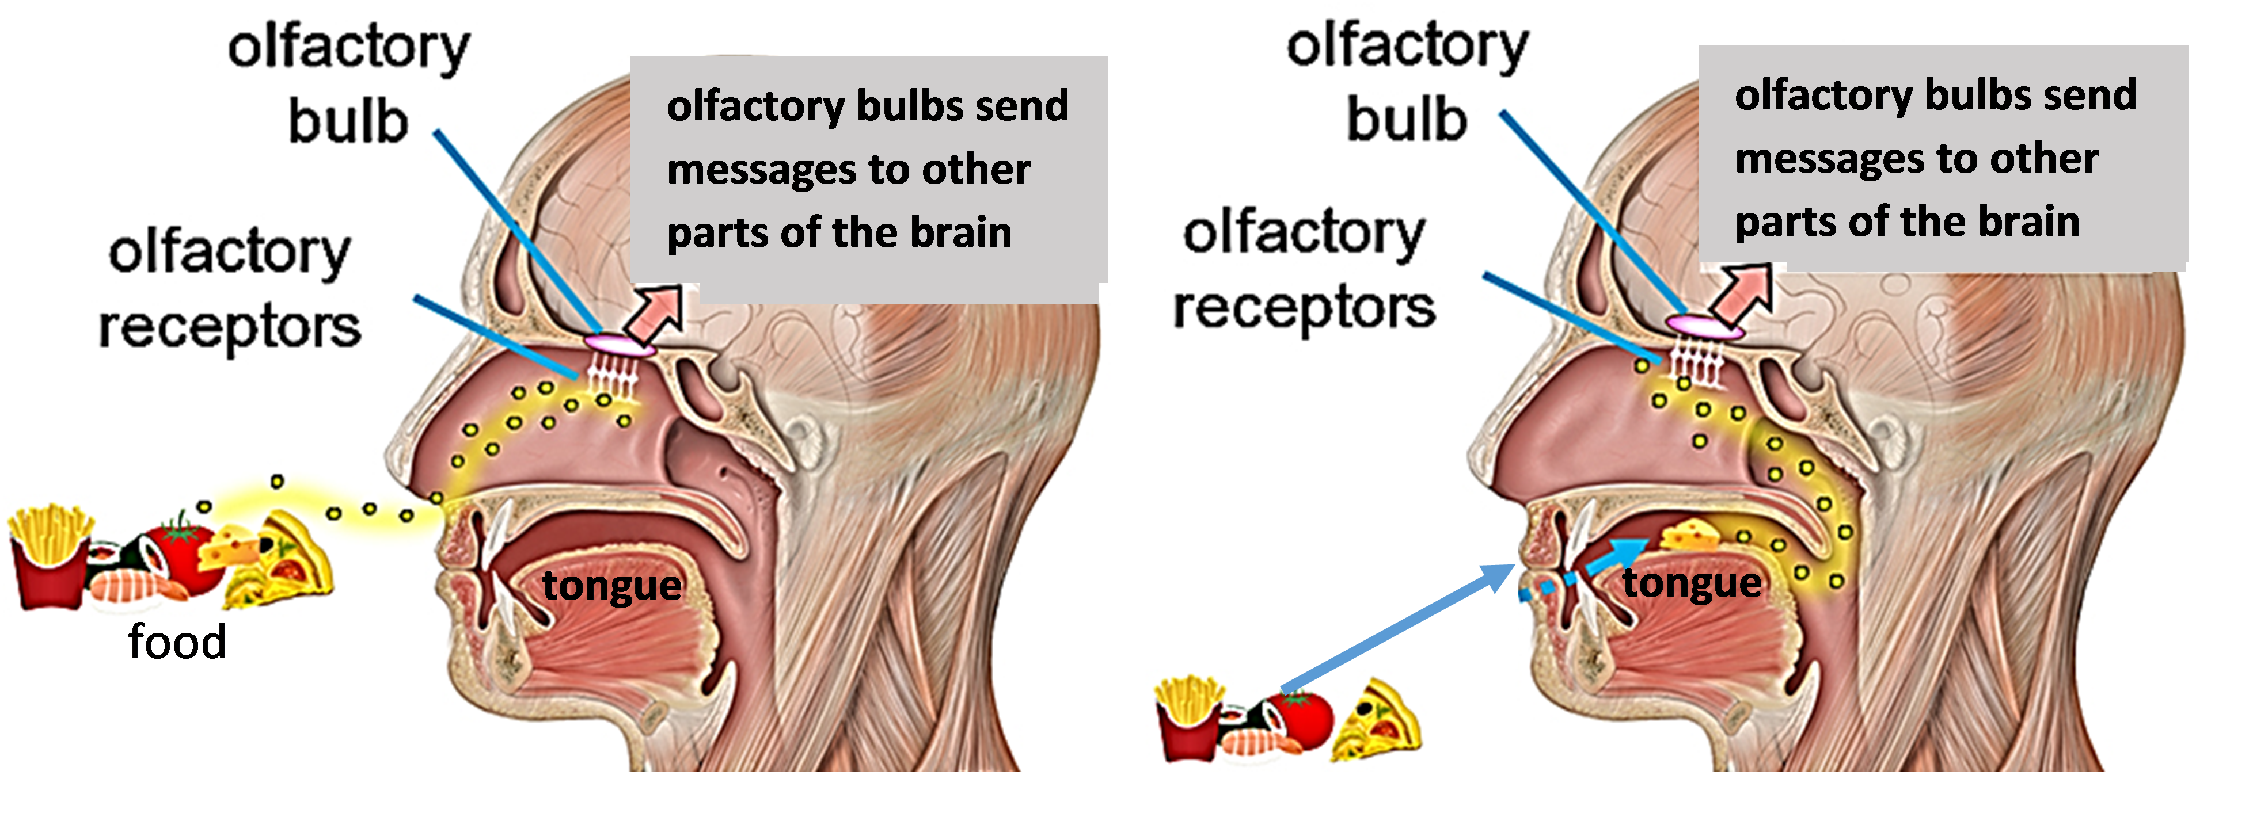
2. In the drawing on the right, draw arrows to show how odor molecules get from food in your mouth to the olfactory receptors in your nose.

3a. How could you test the contribution of taste without smell to the flavor of food? Why would you want the subject to avoid breathing out?

3b. How could you evaluate the contribution of smell to flavor (for food that you have in your mouth)?

4. Use your answers to questions 1-3 to predict the results for the samples listed in this table.

 | Expected taste  when you hold your nose | Expected change in flavor  when you let go of your nose
Lemon
candy
Sugar
water

In your investigation:
- Multiple subjects will evaluate the taste and flavor of each food sample.
- Each subject will evaluate the taste and flavor of multiple food samples.

5. Why is it useful to have multiple subjects evaluate the taste and flavor of each food sample?

6. The first column of this table shows some of the instructions in the procedure for your investigation. Complete the second column of the table to explain the reasons for each of these instructions.
Instructions for Subjects | How does this instruction contribute to more valid data concerning the contributions of taste and smell to flavor?
Put on a blindfold or goggles covered with paper, so you will not be able to see the sample.
When you report the taste or flavor of a sample, speak quietly so other subjects cannot hear you.
After you have finished with one sample and before tasting the next sample, rinse your mouth with water.

7. Explain why the following safety precautions are necessary.
- Before you begin, wash your hands thoroughly with soap and water or use a disinfectant cloth to clean your hands.
- Wear a glove when handling food samples. Once you put a glove on, be careful not to touch other surfaces that might contaminate your glove.
- To give a food sample to a subject, use a clean cup or spoon. Dispose of each cup or spoon once it has been used.

II. Investigation Procedure
For this investigation, you will work with a partner. For the first tray of samples, one of you will be the subject and one will be the experimenter. Then, you will get a new tray of samples and switch roles.

- If you are diabetic or have braces or food restrictions, let your teacher know, so you can decide together how you can safely participate.
- Clean your hands.
- Experimenter: Put your glove on the hand you will use for handling samples. To keep the glove sanitary, use your other hand to touch any surfaces that may be contaminated.
- Experimenter: Prepare a cup of water for the subject to use to rinse out his/her mouth.
- Subject: Words you can use to describe the taste or flavor of the samples include:
salty, sour, sweet, vanilla, fruity, cherry, lemon, lime.

- For each sample, you will follow the procedure below. (Your teacher will guide you through the procedure for the first sample.)

Experimenter: Give the cup of water to the subject. Prepare the sample. For a liquid sample, fill a small cup half full. For a solid sample, use a spoon to scoop up a small spoonful or a candy.
Subject: Put on your blindfold or goggles. Take a sip of water to rinse your mouth.

Subject: Hold your nose.
Experimenter: Hand the sample to your subject and tell them whether it is liquid or solid. Prepare to give the following timed instructions for your subject.

At 0 seconds:
For liquid samples: “Take a sip of your sample. Do not swallow.”
For solid samples: “Put your sample in your mouth and chew. Do not swallow.”

At 5 seconds: “Notice the taste. Remember this taste.”

At 10 seconds: “Let go of your nose and breathe out. Notice any change.”

At 15 seconds: “Notice the flavor.”

At 20 seconds: “Swallow your sample or spit it out in the bowl.”

Subject: Tell your experimenter the taste while holding your nose, the flavor after you let go of your nose, and any changes you noticed when you let go of your nose. Speak quietly so other subjects won’t hear your answers.
Experimenter: Record these results in the data table your teacher has given you. Write clearly! Dispose of any used cup or spoon.

- Repeat until you have finished all the samples on your first tray. Then, get a second tray with the other samples. Switch roles, so the experimenter becomes the subject and vice versa.

- Give your data table to your teacher.
III. Analysis and Interpretation of Results
Each student group will analyze the data for one liquid sample and one solid sample. Your teacher will give you the data sheets and tell you which samples your group should analyze.

8a. In this table, summarize the data for sample _____. Use tick marks to count the number of subjects who mentioned each flavor listed. Use the bottom row to record other responses.
Flavors | When nose held closed | With nose open
Nothing, water
Salty
Sour, acid
Sweet, sugar water
Vanilla
Fruity
Cherry
Lemon, lemony, lemonade
Lime
Other

8b. Summarize any comments about changes that subjects noticed when they let go of their nose.

8c. Summarize any comments about what the subjects thought the sample was. What do you think the sample was?

9. What did taste contribute to the perception of flavor for this sample? What evidence supports your conclusion? If you are unsure of your conclusion, explain why.

10. What were the main differences between the responses when subjects held their nose closed vs. with their nose open?

11. Did smell contribute to the perception of flavor for this sample? yes ___ no ___
If yes, what did smell contribute? What evidence supports your conclusion? If you are unsure of your conclusion, explain why.

12a. In this table, summarize the data for sample ____. Use tick marks to count the number of subjects who mentioned each flavor listed. Use the bottom row to record other responses.

Flavors | When nose held closed | With nose open
Nothing
Salty
Sour, acid
Sweet, sugar water
Vanilla
Fruity
Cherry
Lemon, lemony, lemonade
Lime
Other

12b. Summarize any comments about changes that subjects noticed when they let go of their nose.

12c. Summarize any comments about what the subjects thought the sample was. What do you think the sample was?

13. What did taste contribute to the perception of flavor for this sample? What evidence supports your conclusion? If you are unsure of your conclusion, explain why.

14. What were the main differences between the responses when subjects held their nose closed vs. with their nose open?

15. Did smell contribute to the perception of flavor for this sample? yes ___ no ___
If yes, what did smell contribute? What evidence supports your conclusion? If you are unsure of your conclusion, explain why.

16. Summarize your group’s results in the appropriate row of this table. If you are unsure about any of your results, indicate this with ? or ?? Your teacher will tell you how all the groups will share their results so you can complete this table. While you are waiting for this information, answer question 17.
Sample Code | Contribution of Taste  to Flavor Perception | Contribution of Smell  to Flavor Perception | Group’s Guess What Sample Was
A
B
C
D
E
F
G

17. What could be some potential sources of error and some reasons for variation in results for different subjects?

18. Based on the results for samples A-G, what did taste contribute to the perception of flavor for these samples? Summarize the evidence for your conclusion.

19. What did the sense of smell contribute to the perception of flavors of these samples? Summarize the evidence for your conclusion.

20. How do your results compare to your predictions in question 1? Describe the similarities and differences.
IV. Sensory Receptors, Brain and Behavior

The first step in smelling or tasting food occurs when different types of food molecules react with different types of receptor molecules in receptor cells. We have hundreds of different types of odor receptor molecules in our olfactory receptor cells. In contrast, our taste receptor cells have only a few types of taste receptor molecules, which respond to salt, sweet, sour, bitter, or savory (also called hearty or umami). The many different odors, combined with the much smaller number of tastes, allow us to distinguish the many different flavors of food.

This figure shows how smell and taste provide input to the brain, where flavor is perceived.
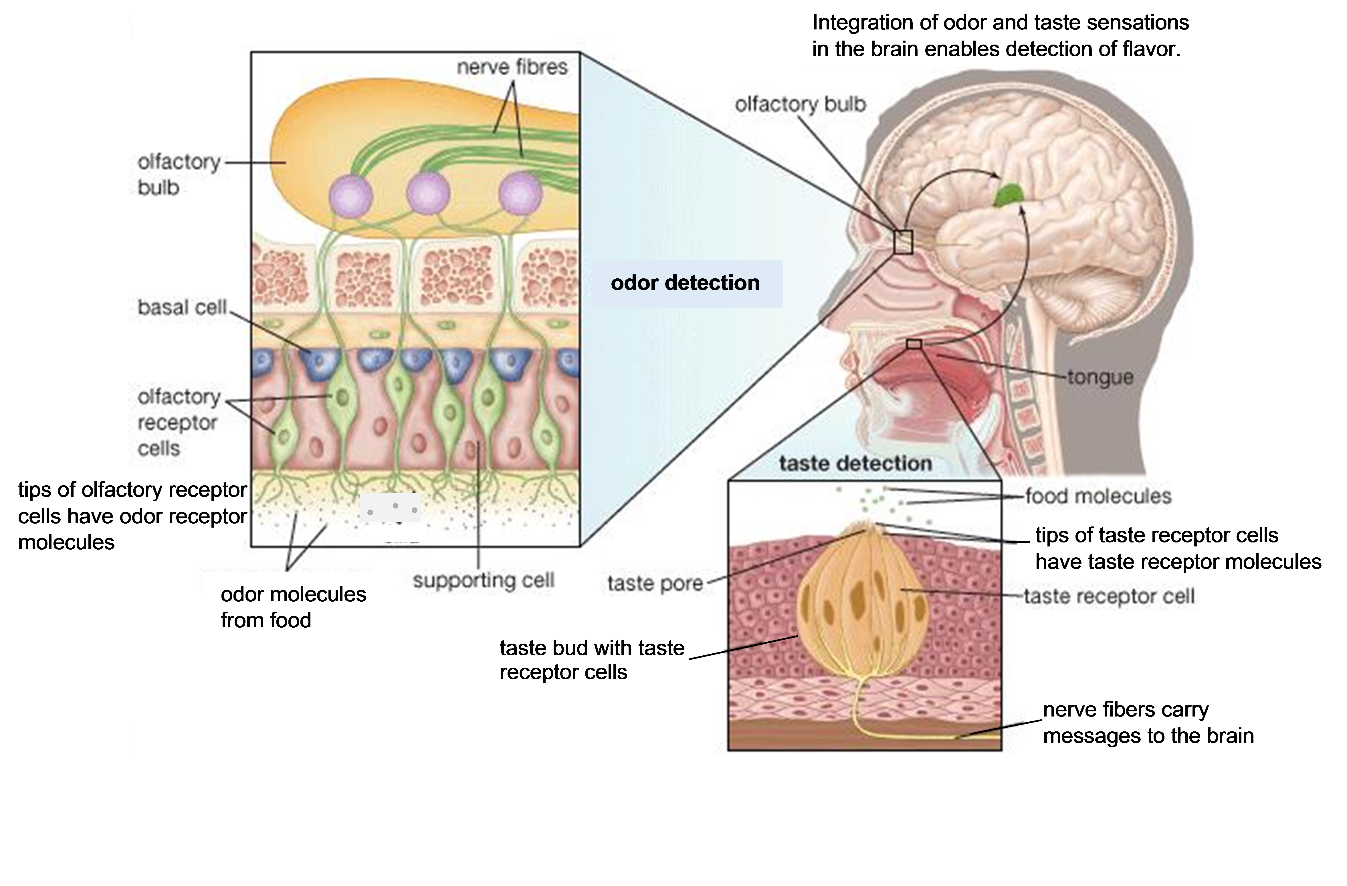

21. Draw a rectangle around the part of this figure that shows a magnified view of a small part of the nose and olfactory bulb.
- Circle the area where odor molecules bind to the odor receptor molecules in the olfactory receptor cells.
- Draw arrows to show how an olfactory receptor cell sends messages to an olfactory bulb cell which sends messages via nerve fibers to the rest of the brain.

Human infants respond to sweet taste by sucking in a sweet liquid. In contrast, infants respond to bitter taste by spitting out a bitter liquid. The brain plays a crucial role in these responses, as indicated by the following results from experiments with mice:
- Sweet taste in the mouth activates one set of nerve cells in the brain, and activity in these nerve cells stimulates drinking.
- Bitter taste in the mouth activates a different set of nerve cells in the brain, and activity in these nerve cells stimulates rejection of food.

22. In the above figure, draw a triangle around the parts that contribute to the behavioral responses to sweet and bitter.

23. Explain how infants’ behavioral response to sweet taste can be adaptive (increase survival).
V. Conclusions
24. Why is the number of tastes we can detect much smaller than the number of flavors we can detect? (Hint: See the first paragraphs on pages 1 and 7.)

25. Why does food often seem to have less flavor when you have a cold?

26. Use sentences or diagrams in each box to describe how we sense flavors. Include the following terms:
food molecules, nerve cells, nerve fibers, odor molecules, olfactory receptor cells,
olfactory receptor molecules, salty, sour, sweet, taste receptor cells, taste receptor molecules
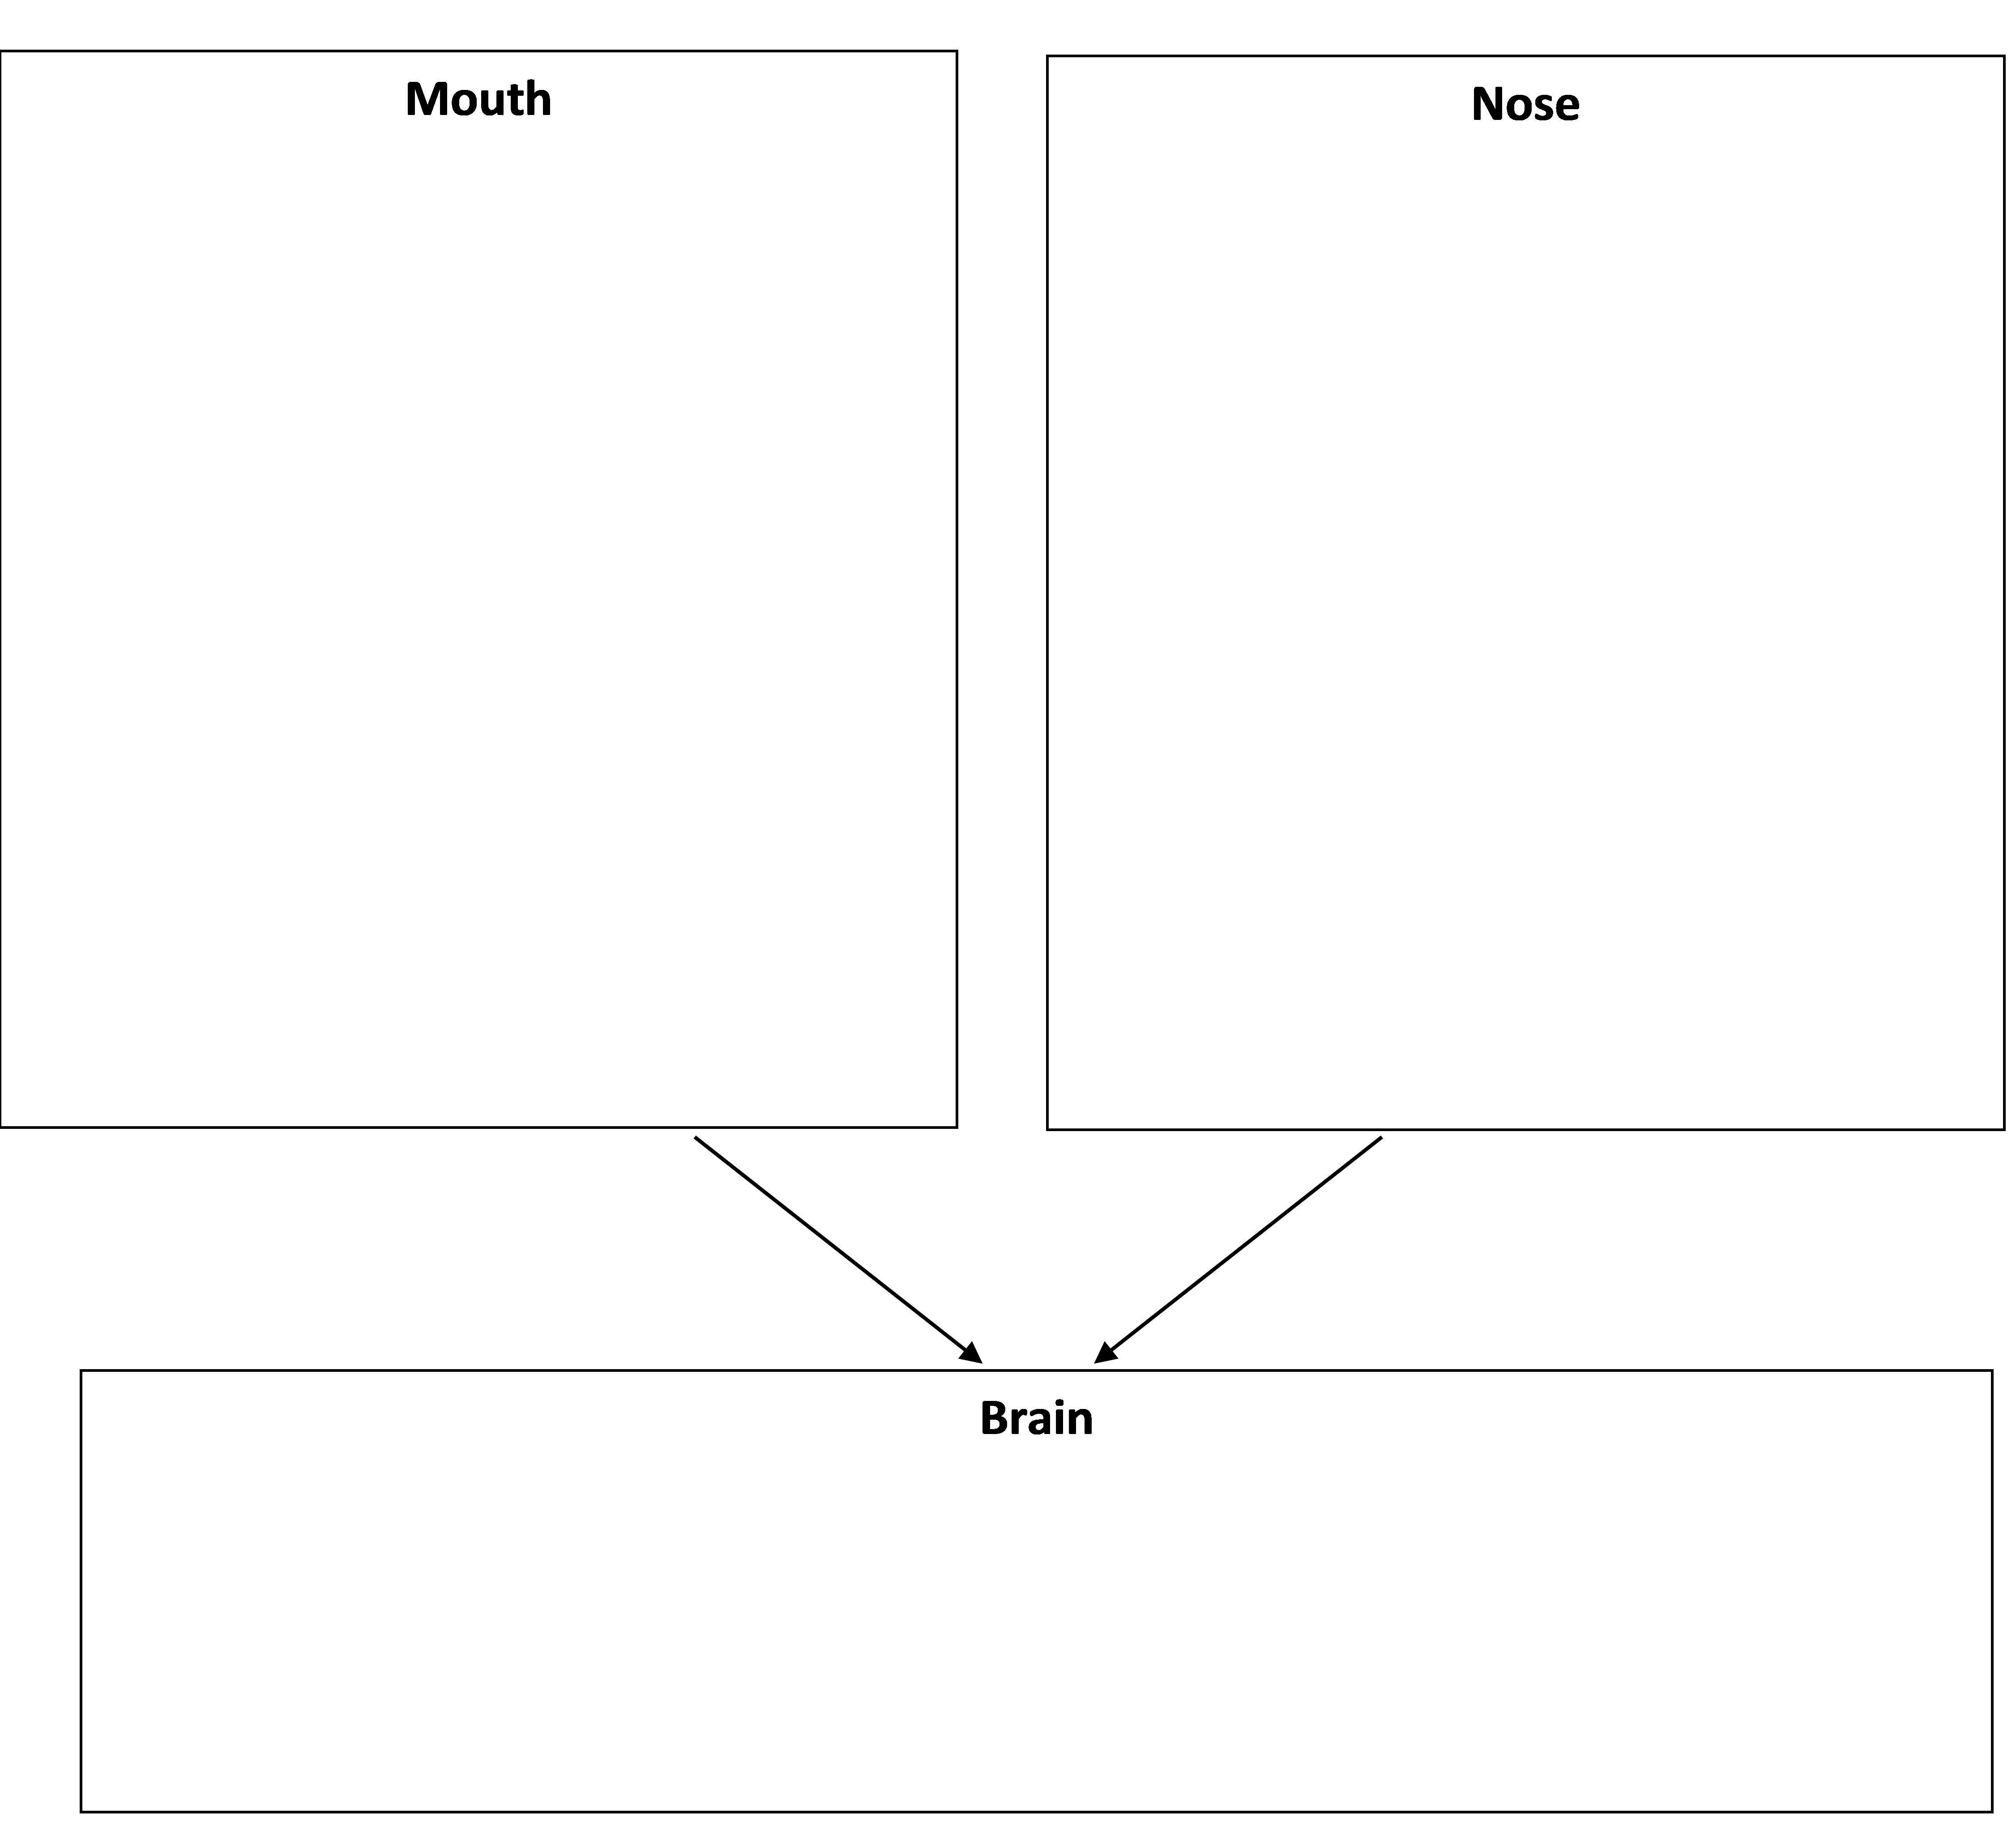

By Dr. Ingrid Waldron, Dept Biology, Univ Pennsylvania © 2017. Teachers may copy this Student Handout for classroom use. A Word file and Teacher Preparation Notes with instructional suggestions are available at http://serendipstudio.org/sci_edu/waldron/#senses.

