Teacher Preparation Notes for Photosynthesis Investigation

This Photosynthesis Investigation includes two parts.
- Part 1. Measuring the Rate of Photosynthesis
In this section, students learn how to use the floating leaf disk method to measure the rate of net photosynthesis (i.e. the rate of photosynthesis minus the rate of cellular respiration). They use this method to show that photosynthesis occurs in leaf disks in a solution of sodium bicarbonate, but not in water. The questions guide students in reviewing the relevant biology and interpreting their results.

This section will probably require one 45-50 minute lab period. To ensure completion within one lab period, you may want to use page 1 and the top of page 2 of the Student Handout as a pre-lab and/or you may want to use the bottom of page 3 with the top of page 4 as a post-lab.

- Part 2. Investigating a Factor that Influences the Rate of Net Photosynthesis
This student-designed investigation will probably require two-three 45-50 minute periods for the students to:
- design the investigation
- get feedback on the design of their investigation and make any needed improvements
- carry out the investigation
- analyze and interpret the results
- prepare a written or oral report
- participate in a follow-up discussion of findings, interpretations, and possible improvements in experimental design and/or follow-up investigations.

To reduce the class time required, you may want to have your students answer question 13 during the data collection for Part 1 and prepare the design of their investigation as a homework assignment. You may also want to have your students prepare the report of their results as a homework assignment. If you do not have enough class time and/or resources to carry out this investigation, your students can still benefit from carrying out Part 1 as a hands-on activity that enhances understanding of photosynthesis and cellular respiration, and also the introduction to Part 2 as practice in designing an investigation.

Before beginning this activity, students should have a basic understanding of photosynthesis and how photosynthesis and cellular respiration work together to produce ATP. For this purpose, we recommend the analysis and discussion activities:
- "Using Models to Understand Photosynthesis" (http://serendip.brynmawr.edu/exchange/bioactivities/modelphoto)
- “Photosynthesis and Cellular Respiration – Understanding the Basics of Bioenergetics and Biosynthesis” (http://serendip.brynmawr.edu/exchange/bioactivities/photocellrespir).

A possible alternative activity that covers much of the same material is “Photosynthesis, Cellular Respiration and Plant Growth” (https://serendipstudio.org/sci_edu/waldron/#photobiomass). This hands-on, minds-on activity begins with the question of how a tiny seed grows into a giant Sequoia tree. Students analyze data from research studies on plant mass and biomass, and they conduct a hands-on experiment to evaluate changes in CO₂ concentration in the air around plants in the light vs. dark. Students interpret the data to understand how photosynthesis makes an essential contribution to increases in plant biomass, and cellular respiration can result in decreases in biomass. This activity counteracts several common misconceptions about plant growth, photosynthesis, and cellular respiration.

Another possible alternative is “Photosynthesis and Cellular Respiration Kit”, which has a method of measuring the rate of photosynthesis that is more expensive, but more reliable than the method in this activity (http://www.bio-rad.com/en-us/product/photosynthesis-cellular-respiration-kit-for-ap-biology?ID=NR4XPVE8Z).

Learning Goals
In accord with the Next Generation Science Standards:
- Students learn the Disciplinary Core Idea LS1.C. "The process of photosynthesis converts light energy to stored chemical energy by converting carbon dioxide plus water into sugars plus released oxygen.… Cellular respiration is a chemical process whereby the bonds of food molecules and oxygen molecules are broken”, carbon dioxide and water are formed, and the energy released is used in the production of ATP from ADP and P. Then, the hydrolysis of ATP molecules provides the energy needed for many biological processes.
- Students engage in the Science Practices of asking questions, planning and carrying out an investigation, analyzing and interpreting data, and constructing explanations.
- This activity can help students to understand the Crosscutting Concept: Energy and Matter, including “Within a natural or designed system, the transfer of energy drives the motion and/or cycling of matter.”
- This activity helps to prepare students for Performance Expectation: HS-LS1-5. "Use a model to illustrate how photosynthesis transforms light energy into stored chemical energy."

Materials needed for Part 1 for each group of students:
- Five spinach leaves (Dark green, fresh spinach leaves produce better, faster results.)
- Two cups (Short clear plastic party cups work best.)
- ~300 mL of water with 0.2% sodium bicarbonate (0.2 g baking soda per 100 mL of water; you may prefer to use 0.3%-0.5% sodium bicarbonate which will result in a faster rate of photosynthesis and more rapid floating for the leaf disks)
- ~300 mL of water without sodium bicarbonate
- Two drops of dilute detergent (To prepare dilute detergent, add approximately 5 mL of dishwashing liquid soap to 250 mL of water.)
Reusable Equipment:
- Straw, hole punch, or scissors (If you use a hole punch, you will want to either purchase or modify your hole punch so that the leaf disks can be easily released.)
- Two 10 ml syringes without needles (syringes can be rinsed, dried and reused)
- Lamp with 23 W spiral compact fluorescent bulb (If you have a clamp lamp, obviously this could be attached to a ring stand or other vertical pole; if you don't have enough vertical poles, you could rig up a lamp support using a cardboard box.)
- Some way to keep track of minutes

Additional materials you may need for Part 2:
- bicarbonate, water, scale and graduated cylinder for students to make different concentrations of bicarbonate solutions
- ruler to measure distance from light source
- aluminum foil or box to prevent light from reaching the leaf disks
- green, blue and red colored light filters (e.g. https://www.carolina.com/physical-science-color/color-filter-set-5-piece/754628.pr; It may be helpful to have a light meter to evaluate the resulting decrease in light intensity. When using these filters, it may be helpful to have a more intense light source.)
- hot water, ice, larger container, thermometer

Instructional Suggestions and Background Information for Part 1 – Measuring the Rate of Photosynthesis
This activity is based on Investigation 5 Photosynthesis (http://media.collegeboard.com/digitalServices/pdf/ap/bio-manual/Bio_Lab5-Photosynthesis.pdf). Please consult this source for instructional suggestions and additional information. If you are teaching an AP biology class, you may prefer to use the Student Handout in this source.

Before your students begin the procedure described on page 2 of the Student Handout, it will probably be helpful to show them a video of key steps in the procedure (available at https://www.youtube.com/watch?v=vw8baZO89oc). If you are unable to show this video, you will probably want to view it yourself, demonstrate the procedure for your students, and perhaps circulate copies of the screenshot below showing how to pull back on the plunger to create a vacuum.

Some additional suggestions for success with this procedure are:
- If you don't have access to dark green, fresh spinach leaves, you could pilot test other greens such as collards. We have also had success with leaf disks from fast plants. If you have a nearby tree or bush with green leaves, you may have success with punching disks directly from the leaves on the tree or bush. One teacher has reported success with oak tree leaves.
- We have had success using a straw, hole punch, or scissors to prepare the leaf disks (or squares). The exact size of the leaf disks does not appear to significantly affect the results. If your students are using scissors, they should aim for a relatively uniform size, roughly the same size as a leaf disk produced by a straw or hole punch.
- Make sure the leaves are dry before the students begin punching the leaf disks; otherwise there is a tendency for the leaf disks to stick to the side of the syringe.
- When the students pour the leaf disks into the syringe, it is okay for them to pick up a stray leaf disk so long as they are gentle and make sure not to damage the leaf disk tissue.
- When squeezing the air out of the syringe, students should be sure not to get the disks stuck in the tip of the syringe; this would mean that they can't get all of the air out of the syringe.
- When students pull back on the plunger to create the vacuum, they should make sure that all the discs are submerged in the fluid. They can tap or swirl the syringe, but shouldn't shake it since you don't want the detergent to damage the cells in the leaf disks. After releasing the plunger, wait up to a minute to see if all the leaf disks will sink. Students can repeat this vacuum step up to two more times, but any more than that may damage the leaf disks. If the solution turns green, this indicates excessive leaf damage. If one or two of the leaf disks still don't sink, students can remove those leaf disks from the cup and make their observations with a smaller number of leaf disks.
- You will probably want two students in each group to prepare the leaf disks in bicarbonate solution and in water simultaneously, so the observation period for the disks in water and bicarbonate solution will coincide.
- For each student group, both cups should be at the same distance from the light source, since light intensity is proportional to the inverse of the distance squared.
- If you choose to prepare leaf disks ahead of time, they can be kept in the dark in the cups for half an hour before students begin their observations.

The bottom of page 3 of the Student Handout reviews the relationships between photosynthesis and cellular respiration and explains that the floating leaf disk method measures the rate of net photosynthesis. A helpful discussion of the effects of light intensity on the rate of net photosynthesis (relevant for question 11) is available in the "Effect of Light Intensity on Photosynthesis/Respiration Relations of Sun Versus Shade Plants" (see "page 54" of http://generalhorticulture.tamu.edu/lectsupl/light/light.html). These concepts (although not the term “net photosynthesis”) will be familiar to your students if they have completed the Plant Growth Puzzle in “Photosynthesis and Cellular Respiration – Understanding the Basics of Bioenergetics and Biosynthesis” (http://serendip.brynmawr.edu/exchange/bioactivities/photocellrespir).

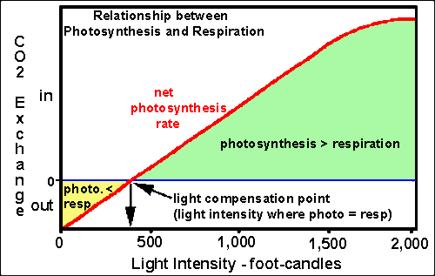

Questions 9-12 foster student understanding of:
- the relationships between photosynthesis and cellular respiration
- the need for cellular respiration to produce ATP, since ATP provides energy in the form that cells use to carry out many cellular processes (This basic concept is introduced in "How do biological organisms use energy?", available at http://serendip.brynmawr.edu/exchange/bioactivities/energy.)
- the importance of the sugar molecules produced by photosynthesis, not just for cellular respiration, but also as precursors for the synthesis of other molecules in the plant (as illustrated in the figure below; obviously nitrogen and phosphorus from soil water will also be needed to synthesize amino acids, nucleotides, and phospholipids).
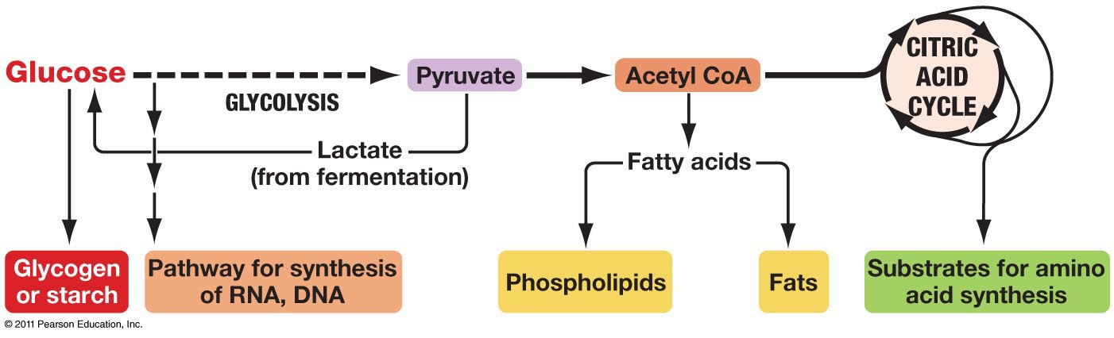
(http://www.uic.edu/classes/bios/bios100/lectures/09_28_anabolic_pathways-L.jpg )

Instructional Suggestions and Background Information for Part 2 – Investigating a Factor that Influences the Rate of Net Photosynthesis

Chapter 4 in the AP Biology Investigative Labs manual (https://apcentral.collegeboard.org/pdf/apbioteacherlabmanual2012-2ndprt-lkd.pdf?course=ap-biology) provides helpful guidance for teaching an inquiry activity. For example, this chapter suggests useful ways to discuss the meaning of terms such as hypothesis, procedure, variables, claims and evidence. This chapter also suggests probe questions to evaluate student understanding that can be useful for formative or summative assessment.

Encourage your students to design an investigation that tests a hypothesis that is based on their understanding of the biology of photosynthesis. For example, students can predict the effects of putting leaf disks in the dark. This figure shows results from an experiment in which the cup with floating discs was removed from the light and put under a cardboard box with no light after 14 minutes.

(Figure from Investigation 5, http://www.collegeboard.com/html/apcourseaudit/courses/pdfs/cb-biology-lab-manual-1-24-12.pdf).

The following paragraph provides predictions concerning the effects of temperature and light intensity on the rate of photosynthesis.
"Cold temperatures result in molecules moving more slowly, thus slowing down the rate of chemical reactions. Because photosynthesis is a series of chemical reactions, slowing down the individual reactions slows down the rate of the whole process. Although heat typically speeds up chemical reactions because it speeds up the movement of molecules involved in the reaction, it only works to a point. High temperatures will result in the breakdown of the enzymes involved in the reaction. Thus photosynthesis will cease at extremely high temperatures. The energy necessary for photosynthesis to take place is provided by light. As light intensity increases, so does the amount of available energy. More energy results in a greater rate of reaction. There is a point, however at which higher light intensity does not increase the rate of photosynthesis, because other factors involved in photosynthesis reaction will act as a limiting factor."

Predictions concerning the effects of temperature on the rate of net photosynthesis will be more complex, since these predictions will have to take into account the effects of temperature on the rate of cellular respiration, as well as the effects of temperature on the rate of photosynthesis. Students might want to include a control of leaf disks in water to compare effects of temperature on the rate of net photosynthesis vs. any physical effects of the change in temperature.

To help your students understand why light intensity is proportional to the inverse of the distance squared, you may want to use the following explanation.
(from http://www2.vernier.com/sample_labs/PWV-29-COMP-light_brightness_distance.pdf )

In order to interpret the effects of colored light filters, students will need to be familiar with the absorption spectrum of chlorophyll (and other plant pigments).
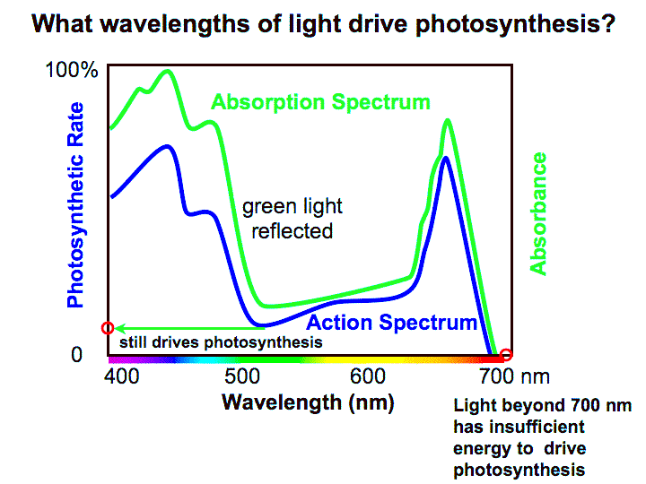
(http://plantphys.info/plant_physiology/images/actabs.gif )

Additional activities for learning about photosynthesis and cellular respiration are described in "Cellular Respiration and Photosynthesis – Important Concepts, Common Misconceptions, and Learning Activities" (http://serendip.brynmawr.edu/exchange/bioactivities/cellrespiration).

Figure in Student Handout modified from: http://www.mrothery.co.uk/images/Image88.gif (accessed in 2015)

Adapted from Investigation 5 Photosynthesis, http://media.collegeboard.com/digitalServices/pdf/ap/bio-manual/Bio_Lab5-Photosynthesis.pdf by Drs. Ingrid Waldron, Linda Robinson and Scott Poethig, Department of Biology, University of Pennsylvania, © 2018. We are grateful to Kieran Dilks for his very helpful advice. These Teacher Preparation Notes and the related Student Handout are available at http://serendip.brynmawr.edu/sci_edu/waldron/#photosynthesis. A key is available upon request to iwaldron@upenn.edu.
http://www.nextgenscience.org/sites/default/files/HS%20LS%20topics%20combined%206.13.13.pdf
Quotation from Argument-Driven Inquiry in Biology by Sampson et al. (NSTA Press, 2014). This source also presents a more sophisticated photosynthesis activity using CO₂ and O₂ sensors.

