Teacher Preparation Notes for
Photosynthesis, Cellular Respiration and Plant Growth

This minds-on, hands-on activity begins with the driving question of how a tiny seed grows into a giant sequoia tree. To address this question, students first consider what types of molecules and atoms are in plants. Next, they analyze data from an experiment on changes in plant biomass in the light vs. dark. Then, they conduct an experiment to evaluate changes in CO₂ concentration in the air around plants in the light vs. dark. Students interpret these data to develop an increasingly accurate and evidence-based model of the contributions of photosynthesis and cellular respiration to changes in plant biomass. This activity counteracts several common misconceptions about plant growth, photosynthesis, and cellular respiration.

This activity will probably require two 50-minute periods, with ~23 hours between these two periods. The first period will include pages 1-4 of the Student Handout and setting up the experiment. The next day, students will record the data from their experiment and complete pages 5-7 of the Student Handout. Teachers or their students will need to begin to grow the plants at least two weeks before the students will be doing the experiment.

Before beginning this activity, students should have a basic understanding of cellular respiration, ATP and photosynthesis. For this purpose, we recommend these analysis and discussion activities:
- “How do organisms use energy?” (https://serendipstudio.org/exchange/bioactivities/energy) (possibly with “Using Models to Understand Cellular Respiration” (https://serendipstudio.org/exchange/bioactivities/modelCR))
- "Using Models to Understand Photosynthesis" (https://serendipstudio.org/exchange/bioactivities/modelphoto)

If you are unable to do the hands-on experiment with your students (questions 7-9 and the Procedure and Results section on page 4 of Student Handout), you can substitute an ~8-minute video with questions (go to https://carbontime.create4stem.msu.edu/plants/activity-3.3 and scroll down).

Table of Contents
Learning Goals – pages 1-2
Supplies and Preparation – pages 2-5
Instructional Suggestions and Background Biology
General and pages 1-2 of the Student Handout – pages 6-8
Experiment 1 – Changes in Biomass for Seedlings Grown in Light vs. Dark – page 8-9
Experiment 2 – Changes in CO₂ in the Air around Plants in the Light vs. Dark – page 9
Interpretations and Conclusions – pages 9-14
Seeds and Seedlings – pages 14-15
Additional Resources – pages 16-17

Learning Goals
In accord with the Next Generation Science Standards:
- Students learn the Disciplinary Core Idea LS1.C. "The process of photosynthesis converts light energy to stored chemical energy by converting carbon dioxide plus water into sugars plus released oxygen. The sugar molecules thus formed contain carbon, hydrogen, and oxygen; their hydrocarbon backbones are used to make amino acids and other carbon-based molecules that can be assembled into larger molecules (such as proteins or DNA), used for example to form new cells. Cellular respiration is a chemical process whereby the bonds of food molecules and oxygen molecules are broken”, carbon dioxide and water are formed, and the energy released is used in the production of ATP from ADP and P. Then, the hydrolysis of ATP molecules provides the energy needed for many biological processes.
- Students engage in these Science Practices:
- “Developing and Using Models. Develop, revise, and/or use a model based on evidence to illustrate and/or predict the relationships between… components of a system.”
- “Analyzing and Interpreting Data. Evaluate the impact of new data on a working explanation and/or model of a proposed process or system.”
- “Constructing Explanations and Designing Solutions. Apply scientific ideas, principles, and/or evidence to provide an explanation of phenomena…”.
- This activity can help students to understand the Crosscutting Concepts:
- Patterns. “Empirical evidence is needed to identify patterns.”
- Energy and Matter, Flows, Cycles and Conservation. “Energy drives the cycling of matter within and between systems.”
- This activity helps to prepare students for Performance Expectation: HS-LS1-6. "Construct and revise an explanation based on evidence for how carbon, hydrogen, and oxygen from sugar molecules may combine with other elements to form amino acids and/or other large carbon-based molecules."

This learning activity will help to counteract several common misconceptions (Hard-to-Teach Biology Concepts, page 135, by Susan Koba with Ann Tweed).
– Many students think that plants get most of their biomass from the soil. To counteract this misconception, this activity introduces hydroponics.
– Many students don’t understand the importance of photosynthesis and find it hard to believe that the biomass of plants comes largely from a gas (CO₂). In this activity, students analyze why an increase in biomass for plants in the light is correlated with a decrease in CO₂ in the surrounding air.
– Many students believe that only animals carry out cellular respiration and plants only carry out photosynthesis. They do not understand that plants also need to carry out cellular respiration to provide ATP for cellular processes. In this activity, the importance of plant cellular respiration is highlighted as students interpret the results from plants in the dark (decrease in plant biomass and increase in CO₂ in the air around the plants).

Supplies and Preparation
Start growing the plants 14-20 days before you plan to do the activity with your students. You may want to start germinating the radish seeds on a Monday so students can observe the impressive changes during early development, including the sprouting of roots and the cotyledons. For maximum visibility of early plant development and to simplify the interpretation of experimental results, we recommend germinating the seeds on damp paper towels. Students can be enlisted to start the seeds, either in class if you have sufficient class time available or as an extracurricular project.

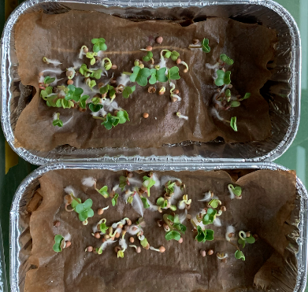 | This figure shows the root hairs and cotyledons of a radish seedling. (http://www.sliderbase.com/images/referats/1455b/(7).PNG)

To estimate how many groups you should prepare for, you should choose one of the instructional approaches described below.
- To carry out the complete experiment in all your classes, divide each class into an even number of groups of 3-4 students. Each pair of student groups will work as a team to investigate changes in CO₂ in the air around plants in the light and in the dark. You will need supplies for all the student groups in all of your classes.
- To reduce the amount of supplies needed, you can have your first class of the day carry out the complete experiment (steps A-E on page 4 of the Student Handout). Later classes can carry out steps C and E, using photographs of the plants and dishes of indicator solution, (1) before each sealed container is put in the light or dark for a day and (2) immediately after the day in the light or dark. You will only need supplies for each student group in your first class.

Supplies for growing the plants for each group
- 50 radish seeds (~0.50 g of seeds)
- disposable 1-pound loaf aluminum pan and plastic wrap to loosely cover it (in order to maintain a moist atmosphere around the sprouting seeds and growing seedlings)
- 15 cm length of cotton yarn
- brown paper towel (must be unbleached brown paper towel, 2-3 sheets per group or a roll, which should be enough for all of your groups)
- water for starting the seeds and maintaining the sprouts
- water with dilute nutrients (e.g. Miracle-Gro or Ionic Grow) for use after the seeds sprout (or at least after the cotyledons have turned green)

You will also need one or more large pans or trays (e.g. https://www.chewy.com/frisco-dog-crate-replacement-pan-22/dp/117380) to hold the loaf pans and the water to be wicked up into the loaf pans. (We recommend that you avoid large disposable aluminum pans, since we had major leakage due to corrosion as a result of interactions between the large and small disposable aluminum pans.)

Unless you have a very sunny place to grow the plants and long daylight, we recommend supplementing sunlight with artificial light. You can use grow lights or a cheaper alternative such as a compact fluorescent bulb in a clamp lamp with reflector. Seedling growth requires a fluorescent or LED bulb that is full spectrum, daylight or cool/blue (e.g https://www.amazon.com/GE-Lighting-93101230-Balanced-Spectrum/dp/B07NN6SVG6/ref=sr_1_7 or https://www.amazon.com/Lights-Spectrum-Indoor-Succulents-Seedling/dp/B07FKF6BT4/ref=sr_1_9). To provide sufficient intensity, the bulb should be 20-50 W, 6-10” from the growing plants. To provide adequate light for all the loaf pans of seedlings, you may need multiple bulbs/lamps.

Planting Instructions
- Poke a hole through the bottom of each loaf pan (with a pencil, nail or scissors).
- Run the yarn through the hole so that half the yarn falls outside the loaf pan and half is inside.
- Crumple 2-3 pieces of brown paper towel and place in the bottom of the loaf pan. Run the yarn wick up over the crumpled pieces of brown paper towel.
- Cut out a piece of brown paper towel big enough to cover the scrunched-up paper towels
and a bit up the sides of the loaf pan. You will put the seeds on this piece of paper, and upright edges will prevent the seeds from falling off.
- Put the loaf pans in the large pan(s), add water to the large pan(s), and moisten the paper towels in the loaf pans. You want the paper towels to be damp, but not wet. If the paper towels are too wet, mold may grow. If the paper towels are too dry, few seeds will germinate. In our experience, ~90% of the seeds will germinate if the top piece of paper towel is appropriately damp.
- Place the large pans where the seedlings will be grown.
- Count or weigh 50 radish seeds (~0.5 g) per loaf pan and carefully place these seeds on top of the damp paper towel in each loaf pan. Spread them out to give the seedlings room to grow.
- Loosely cover each loaf pan with a piece of plastic wrap to ensure that the top piece of paper towel stays damp.
- Set up the lights so each loaf pan is within 6-10 inches of a lamp. The lights should be on for 12-16 hours, alternating with approximately 8-12 hours of darkness; an electric timer is a convenient way to accomplish this. (During Experiment 2, you will want to keep each loaf pan of plants in continuous light for ~23 hours or in continuous dark for ~23 hours.)
- Add water to the larger pan(s) as needed to keep the paper towels damp. Switch to nutrient solution once the cotyledons turn green.

For each group for investigating the indicator solution (question 9)
- 2 small beakers or clear plastic cups
- 1 or more straws
- 1 syringe or 1 mL pipette
- indicator solution (You will need enough indicator solution per group to half fill the two beakers and the petri dishes for Experiment 2 (see below).) We recommend that you use phenol red or the following indicator solution (which we have found to give the clearest and most dramatic results). Prepare the indicator solution as a 10X stock in distilled water. For use, dilute the 10X stock solution to 1X with distilled water.
For 100 ml 10X stock solution:
Mix in beaker:
distilled or deionized water 97.99 ml
ethanol 1.72 ml (Carolina #861281)
2-propanol 0.10 ml (100 ul) (Carolina #884890)
Methanol 0.09 ml (90 ul) (Carolina #874950)
Add and stir into solution:
Sodium bicarbonate 0.08g (80 mg) (pure baking soda from grocery store)
Thymol blue 0.02 g (20 mg) (Sigma Aldrich # 114545-5G)
Cresol red 0.01g (10 mg) (Sigma Aldrich #114472-5G)
For 1X Solution: Dilute 10X stock solution 1:10 using distilled or deionized (not tap) water.

For each student group for Experiment 2
- 2 petri dishes + indicator solution to half fill the petri dishes + a straw
- loaf pan of plants (see pages 3-4)
- a clear plastic container, big enough to hold a loaf pan of plants and two petri dishes + a lid or plastic wrap to seal the container (e.g., 2-quart size clear plastic food storage container, https://www.katom.com/144-2SFSCW441.html)
- lamps for half the groups’ containers; for the other half of the groups’ containers, dark closet or large, dark plastic bags or boxes with no holes or cracks
- optional: color chart to interpret changes in indicator color (http://www.bio-rad.com/webroot/web/pdf/lsr/literature/10049348.pdf)
This photo illustrates the set-up at the beginning of the 24-hour exposure to light or dark.

Instructional Suggestions and Background Biology
To maximize student participation and learning, we recommend that you have pairs of students work together to answer each group of related questions. Student learning is increased when students discuss scientific concepts to develop answers to challenging questions; students who actively contribute to the development of conceptual understanding and question answers gain the most. As your students work in pairs to answer the questions, you may want to circulate around the room and ask open-ended, probe questions. After students have worked together to answer a group of related questions, we recommend that you have a whole-class discussion that probes student thinking and helps students to develop a sound understanding of the concepts and information covered.

In the Student Handout, numbers in bold indicate questions for the students to answer and letters in bold indicate steps in the experimental procedure for the students to do.

If you use the Word version of the Student Handout to make changes for your students, please check the PDF version to make sure that the formatting in the Word version is displaying correctly on your computer.

A key is available upon request to Ingrid Waldron (iwaldron@upenn.edu). The following pages provide instructional suggestions and additional background information – some for inclusion in your class discussions and some to provide you with relevant background that may be useful for your understanding and/or for responding to student questions.

Introduction (page 1 and the top half of page 2 of the Student Handout)
The figure on page 1 of the Student Handout and the recommended videos present the anchoring phenomenon, which is the very impressive growth of a tiny seed into a huge giant sequoia tree.
The figure below provides another way to convey how very large a giant sequoia tree can become. For additional information about giant sequoias, see https://en.wikipedia.org/wiki/Sequoiadendron_giganteum.

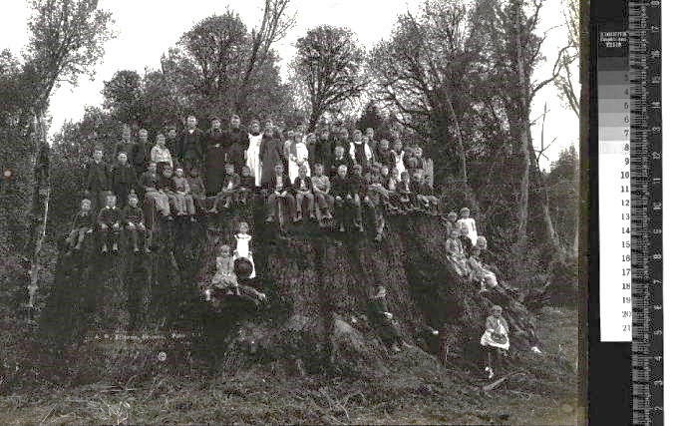
(This photo shows approximately 50 people standing or sitting on the stump of a giant sequoia tree.
https://qz.com/1519250/arborists-are-bringing-the-dinosaur-of-trees-back-to-life/)

Question 1 presents the driving question for this activity. Class discussion of student answers to question 1 should set up hypotheses to explore in subsequent sections of the activity. To preserve student interest in subsequent sections, please do not try to teach definitive answers during this introductory discussion.

The giant sequoia tree makes a dramatic anchor phenomenon. In contrast, smaller plants are more feasible to use for laboratory experiments, and students analyze data from smaller plants in subsequent sections of the Student Handout. Fortunately, as stated in the Student Handout, the same basic processes contribute to gain and loss of mass in giant sequoia trees and other plants.

In this activity, biomass refers to the mass of the organic molecules in a plant or plants. Since plants consist primarily of organic molecules and water, biomass is often estimated as the dry weight of a plant or plants. Another measure of biomass is the mass of carbon in a plant or plants; the mass of carbon is approximately half of the dry weight. (Unfortunately, biomass is sometimes used to refer to the total mass of an organism; this activity makes a crucial distinction between biomass and total mass.)

Actively growing tissues such as root tips and leaves are ~75-90% water, and woody parts such as a tree trunk are ~45-60% water. Roughly one-half to two-thirds of a tree’s mass is water. Almost all of the rest of a plant’s mass consists of organic molecules. (https://web.extension.illinois.edu/askextension/thisQuestion.cfm?ThreadID=19549&catID=192&AskSiteID=87).

The chemical formulas shown in question 3a illustrate that amino acids contain nitrogen in addition to the carbon, hydrogen and oxygen contained in carbohydrates. A few amino acids also contain sulfur (https://www.britannica.com/science/amino-acid/Standard-amino-acids). Plants need other minerals for other purposes. (https://www.dpi.nsw.gov.au/agriculture/soils/soil-testing-and-analysis/plant-nutrients). The Student Handout does not mention the need for sulfur and other minerals.

Question 3b introduces hydroponics, which provides a dramatic counter-example to the common misconception that most of a plant’s mass comes from the soil (https://extension.umn.edu/how/small-scale-hydroponics). This question assumes that your students understand that biological processes cannot create atoms or change an atom into a different kind of atom (although the chemical reactions in organisms can rearrange atoms into different molecules).

Experiment 1 – Changes in Biomass for Seedlings Grown in Light vs. Dark
This section introduces experimental results and analysis and discussion questions to help students understand that plants can gain biomass in the light, but plants lose biomass in the dark. Students may ask about the apparent discrepancy in the “no light, water” condition in the figure on the bottom of page 2 of the Student Handout; these plants had less biomass than the seeds they came from, but the volume of the plants was clearly larger than the volume of the seeds. The decreased biomass occurred because organic molecules were used for cellular respiration and the plant released CO₂ and H₂O to the atmosphere; the increased volume was due to the uptake of water.

Question 5b asks students to use what they have learned to make an improved model of how plants grow (improved relative to their answers to questions 1 and 2). It may be appropriate to remind students of question 3 and the need to have a source for each kind of atom.

Some students may remember that CO₂ is needed for photosynthesis, and they may notice that CO₂ enters the leaves but water and minerals (e.g., N) enter the roots. How do the CO₂, H₂O and N all converge in the same cell? This figure shows that water with dissolved minerals is transported up to the leaves and water with dissolved sugars is transported down to the roots.
(modified from
https://archive.is/cLD1/4990bf657935ecdd448ffb59502ad68499f04371.gif)

Question 5c reinforces the important concept that energy cannot be converted to matter and asks students to explain why light energy is needed to gain biomass. Question 6 asks students to propose a hypothesis about how seedlings lose biomass in the dark. If no students can offer answers to these questions, you may want to review photosynthesis (https://serendipstudio.org/exchange/bioactivities/modelphoto) and cellular respiration (https://serendipstudio.org/exchange/bioactivities/energy). Experiment 2 will provide evidence relevant to student hypotheses about photosynthesis or cellular respiration.

Experiment 2 – Changes in CO₂ in the Air around Plants in the Light vs. Dark
During discussion of student answers to question 7, you can encourage students to challenge each other’s ideas and defend their ideas, but please save the “correct” answers for your discussion of the Interpretations and Conclusions section of the Student Handout.

If students have difficulty with question 7a, you may want to remind them about their previous introductions to cellular respiration and photosynthesis. For question 7b, in the light condition
the last option is “could be decrease, increase, or no change”. The reason why is evident from this graph, which shows that a plant’s rate of photosynthesis increases as light intensity increases. At light intensity A, the plant will lose biomass and give off CO₂. At light intensity B, the plant will gain biomass and absorb CO₂. If you prefer to omit this complexity, you can substitute “no change” as the last alternative in question 7b. | (http://science.halleyhosting.com/sci/ibbio/cellenergy/photosynnotes/photosyn/intensity.htm)

Questions 8 and 9 will help students to interpret the color changes of the CO₂ indicator solution; it will also provide the opportunity for students to remember that human cells carry out cellular respiration, so our exhaled air is rich in CO₂. A good discussion of the indicator used in this experiment is available on page 10 of http://www.bio-rad.com/webroot/web/pdf/lse/literature/10000066050.pdf; this source also presents a possible alternative, more sophisticated hands-on activity suitable for AP or college students.

Interpretations and Conclusions
In your discussion of question 10, we recommend that you discuss the Patterns Crosscutting Concept, “empirical evidence is needed to identify patterns” and discuss how patterns provide evidence to test hypotheses. After question 10, you may want to show an ~8-minute video which engages students in understanding Experiments 1 and 2 (available at https://carbontime.create4stem.msu.edu/plants/activity-3.3 (scroll down for video)).

The figure on page 5 of the Student Handout shows glucose as the sugar produced by photosynthesis. Photosynthesis directly produces a three-carbon sugar, glyceraldehyde-3-phosphate, which is used to synthesize glucose and fructose. Some of the glucose and fructose is used to make sucrose, which is transported to other parts of the plant. As you discuss this figure, students should understand two important points:
- Cells can not directly use sunlight or glucose to provide the energy for most biological processes. Therefore, all organisms (including plants) need to make ATP which can provide energy in the form needed to carry out many cellular processes (e.g., pumping substances into and out of cells and synthesis of organic molecules).
- Most organisms carry out cellular respiration to produce ATP. The important point that plants need to carry out cellular respiration contrasts with some diagrams of the carbon cycle in ecology which show photosynthesis occurring in plants and erroneously show cellular respiration occurring only in animals.
If you want to reinforce these points, you could use this question:
11b. Cells in plant leaves have both chloroplasts and mitochondria. If plant cells can carry out photosynthesis to produce sugars, why do plant cells need mitochondria?

If your students are unclear about the structure of starch and cellulose, you may want to use the figure below.
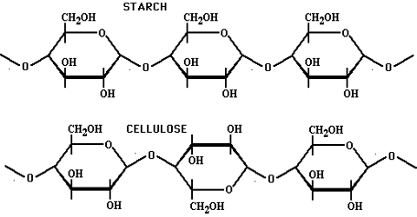
(https://qsstudy.com/wp-content/uploads/2017/02/Starch-and-Cellulose.jpg)

When you discuss how photosynthesis converts light energy to chemical energy, you should observe the following cautions. Chemical energy should not be thought of as stored in high-energy molecules such as glucose. Energy is not released when chemical bonds are broken. Energy can only be released when new chemical bonds are formed as molecules react to form other molecules. Therefore, it is more accurate to think of energy as stored in a system (e.g. the system of glucose and O₂ reactants), rather than in individual molecules or chemical bonds. (For a more complete discussion, see “Cellular Respiration and Photosynthesis – Important Concepts, Common Misconceptions and Learning Activities”; https://serendipstudio.org/exchange/bioactivities/cellrespiration)

As you know, hydrolysis refers to a chemical reaction in which a molecule is split into smaller molecules by reacting with water. Students may be less familiar with this term and may need help to recall this definition. The figure below shows the hydrolysis of ATP.
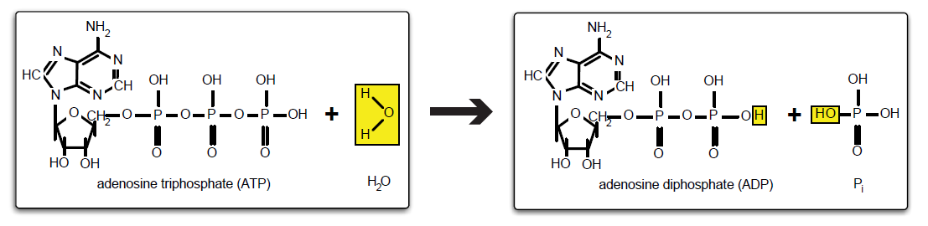
(http://umdberg.pbworks.com/w/page/79788248/ATP%20hydrolysis)

You may want to discuss any discrepancies between the observed results of Experiment 2 and student predictions in question 7b after question 12 or question 13.

The three-part figure near the top of page 6 of the Student Handout shows that a plant is made up of cells which contain chloroplasts which make sugars which are converted to other organic molecules in a plant’s cells. You may want to point out that the three parts of the Student Handout figure correspond to the organism, cell and organelle levels of organization. To help your students understand how water and CO₂ reach the chloroplasts, you may want to use the figure on page 8 of these Teacher Preparation Notes and the figure below.

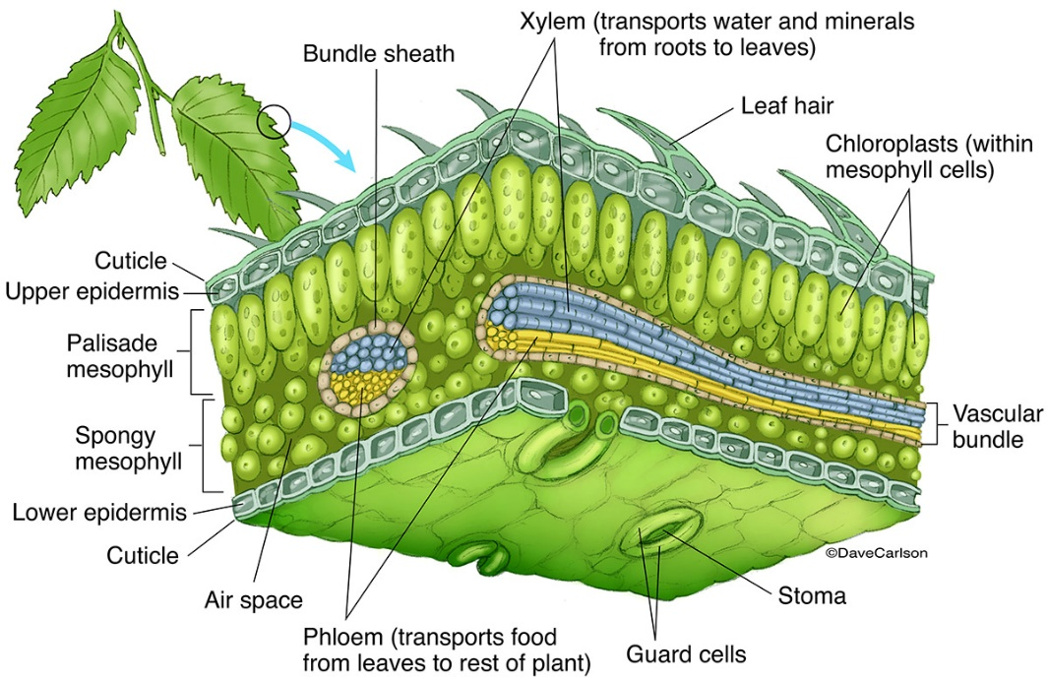
(https://www.carlsonstockart.com/images/xl/Leaf-Structure_labeled.jpg)

The Student Handout figure includes an edited mini-version of the figure below. If you want to introduce your students to the multiple reactions involved in photosynthesis, you can use the discussion and analysis activity “Using Models to Understand Photosynthesis” (https://serendipstudio.org/exchange/bioactivities/modelphoto). Similarly, if you want to introduce your students to the multiple reactions involved in cellular respiration, you can use the discussion and analysis activity “Using Models to Understand Cellular Respiration” (https://serendipstudio.org/exchange/bioactivities/modelCR).

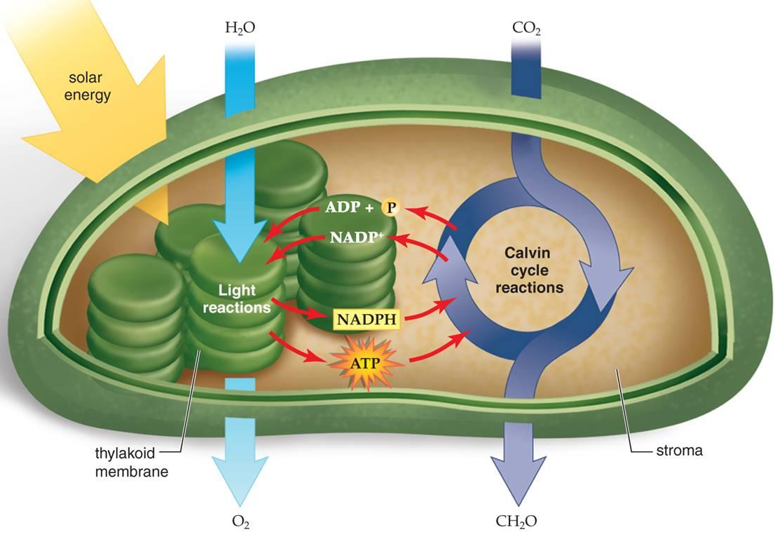
(https://www.accessscience.com/media/EST/media/511700FG0010.jpg)

The following evidence supports the conclusion that atoms from CO₂ are the primary source of the mass of the glucose molecules produced by photosynthesis. Since CO₂ and H₂O are the inputs for photosynthesis, the carbon atoms in glucose must come from CO₂. Experiments using isotopes of oxygen have shown that the oxygen atoms in the sugar molecules produced by photosynthesis come from CO₂, while the oxygen atoms in the O₂ produced by photosynthesis come from H₂O (https://www.howplantswork.com/2009/02/16/plants-dont-convert-co2-into-o2/). Note also that carbon and oxygen have much higher atomic weights than hydrogen, so most of the mass of glucose is due to the carbon and oxygen atoms. (See table below.)

Atom | Atomic weight | Percent of molecular weight of glucose
C | 12.0 | 40%
O | 16.0 | 53%
H | 1.0 | 7%

To help students understand that the gas, CO₂, actually has mass, you can use either or both of the following demonstrations.
- Have a student who is wearing a suitable protective glove hold some dry ice. He or she should notice the weight of the dry ice and also how it gives off CO₂ gas. Discuss how the same molecules/atoms are present in both the solid and gas, but are more spread out in the gas.
- Have the students measure the weight of a bottle or cup of carbonated soda immediately after removing the cap, and then several other times over a class period as more and more of the CO₂ bubbles off.

For students who initially said that plants get their mass from the soil, you may want to help them feel better about their mistake by showing the 3-minute video at https://www.youtube.com/watch?v=JhCHb6xtqeY, which shows that even MIT graduates make the same mistake.

In the light, photosynthesis produces sugar molecules which serve as precursors for the synthesis of other organic molecules in the plant. The figure below provides additional information.
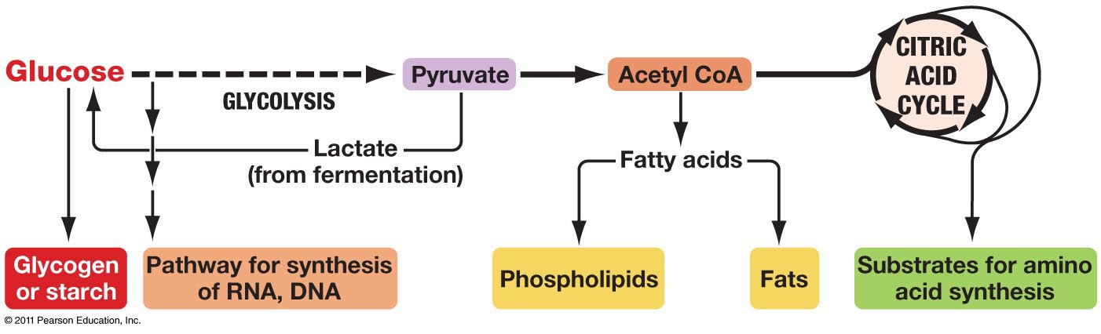
& cellulose
(http://www.uic.edu/classes/bios/bios100/lectures/09_28_anabolic_pathways-L.jpg )

In question 15, students use what they have learned to revise their models of where the giant sequoia tree’s mass came from. You may want to add the following question after question 15c.

15d. In addition to the biomass, where did the rest of the mass of the giant sequoia tree come from?

After question 15, you may want to add one or more of A-C (shown on the next page).

A.
For additional experimental evidence and a somewhat more complete and sophisticated analysis of where a plant’s mass comes from, you may want to add questions 8-12 from “Where does a tree’s mass come from?” (https://serendipstudio.org/exchange/bioactivities/plantmass).

B.
16a. Circle each of the five inputs to the tree shown in this figure.

16b. Explain why the tree needs each of these inputs.

16c. Explain how the carbon and oxygen atoms from a CO₂ molecule in the air can become part of a cellulose molecule in the cell wall of a root cell. Be specific about the multiple steps needed.
(https://images.slideplayer.com/24/6990883/slides/slide_3.jpg)
C.
After question 15, you may want to discuss the Crosscutting Concept, “Energy drives the cycling of matter within and between systems.” The figure below shows a carbon cycle (represented by
the solid arrows) and energy flows (represented by dashed arrows). This figure does not show the energy transformations and transfers inside the living organisms. For example, photosynthesis transforms light energy to chemical energy, and cellular respiration transfers chemical energy between molecules. These processes drive the carbon cycle. These processes also produce heat, which is radiated away from the ecosystem. If you
want to reinforce student understanding of carbon cycles, we recommend “Carbon Cycles and Energy Flow through Ecosystems and the Biosphere”.

You may also want to discuss how preventing forest destruction and growing new forests can reduce atmospheric CO₂ concentration, which can reduce global warming. However, you should be aware that these benefits are counteracted to varying degrees by other effects of trees (e.g. trees’ secretion of volatile organic compounds and the greater absorption of sunlight by leaves compared to more sunlight reflected by snow or light sand) (https://www.nature.com/articles/d41586-019-00122-z). For learning activities and more information about global warming, see “Food, the Carbon Cycle and Global Warming – How can we feed a growing world population without increasing global warming?” (https://serendipstudio.org/exchange/bioactivities/global-warming) and “Resources for Teaching about Climate Change” (https://serendipstudio.org/exchange/bioactivities/ClimateChange).

Seeds and Seedlings
You may want to supplement the figure on the top of page 7 of the Student Handout with either or both of the figures below. The figure on the left illustrates why whole grains have more nutrients than refined grains.

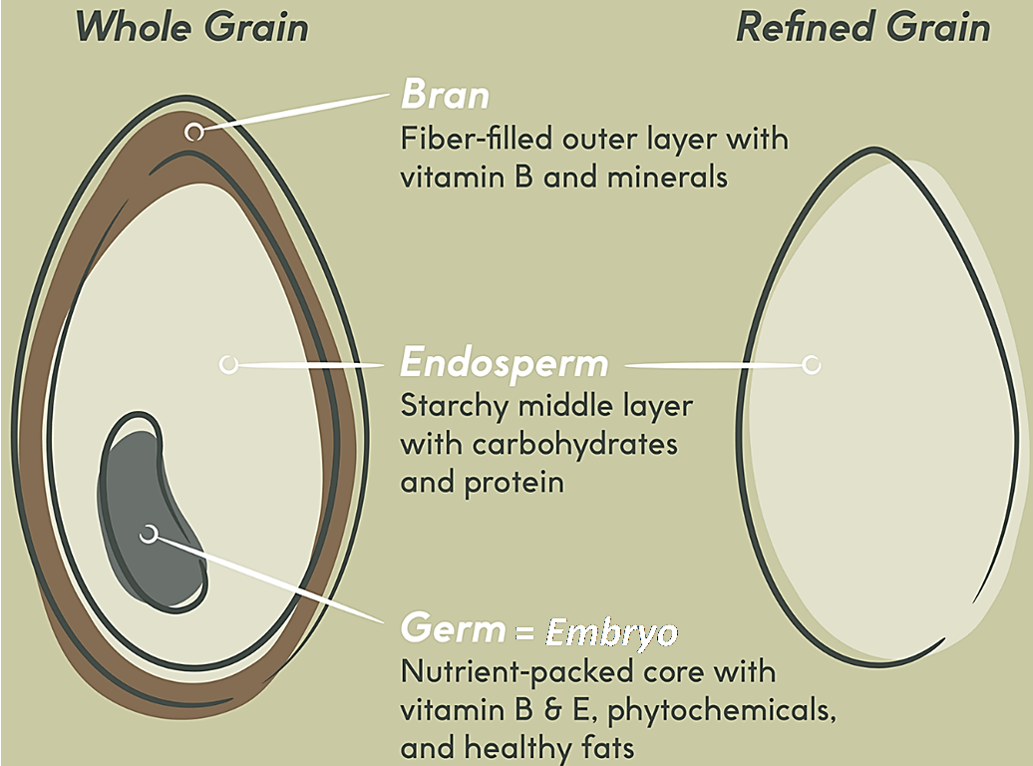
(https://chefiq.com/blogs/blog/the-whole-story-on-whole-grains; https://www.carlsonstockart.com/images/xl/Pine--Bean-Seeds.jpg)

The figure below shows some research evidence relevant to question 16. (Dry mass is very close to biomass.) The line that trends downward shows the decrease in biomass due to cellular respiration for peas sprouting in the dark. The line with the slight uptick at the end shows the trends for peas sprouting in the light. Biomass begins to increase once photosynthesis in the seedlings produces more sugars than the seedlings’ cells are consuming in cellular respiration.

In the Dark
In the Light
(“An Inquiry-based Approach to Teaching Photosynthesis and Cellular Respiration”, American Biology Teacher 70:352, 2008)

This figure may help students to understand how plants in the dark lose biomass (relevant for questions 16 and 17).

In response to question 18, students should explain that the starch in seeds is a source of glucose that can be used for cellular respiration and for synthesizing other organic molecules for the seedling while it is growing underground. Seeds also contain some oil, and many seeds also contain some sugar. The embryo in a seed also contains DNA, okay proteins, and phospholipids.

If your students would benefit from additional review and/or if you want to carry out formative assessment of their learning you could use the following question.

19. On whiteboards, poster boards, or on separate pieces of paper, draw:
- a diagram that shows how a plant cell can lose biomass; include the specific molecules and process
- another diagram that shows how plants gain biomass; include how the whole plant acquires the needed inputs and the processes inside the cells.
We recommend that you have students prepare a draft of their summary posters individually. Then, they should meet in small groups to discuss their individual summary posters and make a consensus summary poster that reflects the group’s thinking. As the groups work, you can circulate around the room, asking probing questions of each group. Each group summary poster can be prepared on a whiteboard. Then, a whole-class discussion of the different diagrams and charts can help to correct any remaining misconceptions and reinforce accurate understanding of the effects of photosynthesis and cellular respiration on changes in plant biomass.

Additional activities for learning about photosynthesis and cellular respiration are described in "Cellular Respiration and Photosynthesis – Important Concepts, Common Misconceptions, and Learning Activities" (https://serendipstudio.org/exchange/bioactivities/cellrespiration).

A good follow-up activity is “Food Webs, Energy Flow, Carbon Cycle and Trophic Pyramids” (https://serendipstudio.org/sci_edu/waldron/#ecolfoodweb).To begin, students view a video about the trophic cascade that resulted when wolves were reintroduced to Yellowstone. To better understand this trophic cascade, students learn about food webs and construct and analyze a food web for Yellowstone National Park. Next, students learn that the biosphere requires a continuous inflow of energy, but does not need an inflow of carbon atoms. To understand why, students analyze how the carbon cycle and energy flow through ecosystems result from photosynthesis, biosynthesis, cellular respiration and the trophic relationships in food webs. In the final section, students use the concepts they have learned to understand trophic pyramids and phenomena such as the relative population sizes for wolves vs. elk in Yellowstone. Thus, students are introduced to several ecological phenomena which they interpret as they learn about relevant processes at the cellular-molecular, organismal, and ecological levels.
The same material is covered in:
Food Webs – Understanding What Happened When Wolves Returned to Yellowstone
Carbon Cycles and Energy Flow through Ecosystems and the Biosphere
Trophic Pyramids
Each of these activities is aligned with NGSS.

Possible alternatives to this hands-on activity include:
– “Where does a tree's mass come from?” (https://serendipstudio.org/exchange/bioactivities/plantmass). In this analysis and discussion activity, students analyze evidence to evaluate four hypotheses about where a plant’s mass comes from. For example, students analyze Helmont’s classic experiment and evaluate whether his interpretation was supported by his evidence. Thus, students engage in scientific practices as they learn that trees consist mainly of water and organic molecules and most of the mass of organic molecules consists of carbon and oxygen atoms from carbon dioxide molecules in the air. (NGSS)
– “Photosynthesis Investigation” (https://serendipstudio.org/exchange/bioactivities/photocellrespir), which presents a semi-quantitative, but technically more difficult method for measuring the rate of photosynthesis. The last section gives instructions for student-designed investigations of factors that may influence the rate of photosynthesis (NGSS)
– “Photosynthesis and Cellular Respiration Kit”, which has a method of measuring the rate of photosynthesis that is more expensive, but more reliable than the method in “Photosynthesis Investigation” (http://www.bio-rad.com/en-us/product/photosynthesis-cellular-respiration-kit-for-ap-biology?ID=NR4XPVE8Z)

Sources of Student Handout Figures
- Figure of giant sequoia on page 1, modified from https://i0.wp.com/scng-dash.digitalfirstmedia.com/wp-content/uploads/2020/09/big-trees.jpg?fit=620%2C9999px&ssl=1
- Figures of chemical structures of organic molecules on the top of page 2 from http://www.nutrientsreview.com/wp-content/uploads/2014/09/Glucose-formula.jpg; https://classconnection.s3.amazonaws.com/954/flashcards/1172954/jpg/biopic1328807784092.jpg; https://www.britannica.com/science/amino-acid; https://labster-image-manager.s3.amazonaws.com/2bf1a236-a48f-4751-babf-77359c2b73b1/PSL_protein_structure.en.x512.png
- Figure of Experiment 1 on the bottom of page 2 – from Ebert-May et al., Disciplinary Research Strategies for Assessment of Learning, BioScience 53:1221-8, 2003
- Figure of giant sequoia on pages 3 and 6 – https://www.pngkey.com/png/detail/94-945686_are-giant-sequoia-trees-succumbing-to-drought-giant.png
- Figure of plant energy processes on page 5 – modified from https://sites.google.com/site/lmwhitebiology/_/rsrc/1443747840357/energy/photosynthesis-cellular-respiration/photosynthesis%20and%20cellular%20respiration%20image%202.gif?height=400&width=368
- Figure of plant, plant cell and chloroplast on page 6 – constructed using edited images from https://www2.estrellamountain.edu/faculty/farabee/biobk/leaf1.gif https://i.pinimg.com/originals/97/c8/07/97c8077bb24aaf8d9ee569c37e0cc57a.gif and https://www.accessscience.com/media/EST/media/511700FG0010.jpg
- Figure of a corn seed on page 7 – https://www.sciencefacts.net/wp-content/uploads/2019/12/Parts-of-a-Seed-Diagram.jpg
- Figure of growing seedling on page 7 – http://interpretapp.co/wp-content/uploads/2018/12/life-cycle-of-flowering-plants-lesson-plan-a-plant-worksheets-free-thunderbolt-kids-seed-dispersal-worksheet-grade-5-cycles-for-pdf-workshee.jpg

By Drs. Ingrid Waldron, Lori Spindler, Linda Robinson, and Bianca Pourmussa, Department of Biology, University of Pennsylvania, © 2022. These Teacher Preparation Notes and the Student Handout are available at https://serendipstudio.org/sci_edu/waldron/#photobiomass.
http://www.nextgenscience.org/sites/default/files/HS%20LS%20topics%20combined%206.13.13.pdf
This list of supplies and the planting instructions are modified from https://carbontime.create4stem.msu.edu/plants/pre-lesson-activity-0.2PT.
https://www.researchgate.net/profile/Muhsin-Menekse-2/publication/328772747_The_role_of_collaborative_interactions_versus_individual_construction_on_students'_learning_of_engineering_concepts/links/5be9ec54299bf1124fce1aab/The-role-of-collaborative-interactions-versus-individual-construction-on-students-learning-of-engineering-concepts.pdf
A 5-minute video that shows 14 years of growth is available at https://www.youtube.com/watch?v=j8M8aGuocco.
An organic molecule (also called an organic compound) is a complex carbon-containing molecule. Organic molecules are normally produced by and found in living organisms. For the purposes of this activity, weight is a good estimate of mass.
For this purpose, you would want one whiteboard per student group in your largest class. For information about how to make inexpensive whiteboards and use them in your teaching, see "The $2 interactive whiteboard" and "Resources for whiteboarding" in https://fnoschese.wordpress.com/2010/08/06/the-2-interactive-whiteboard/. To obtain whiteboards, you can go to Home Depot or Lowe's and ask them to cut a 8' x 4' whiteboard (e.g. EUCATILE Hardboard Thrifty White Tile Board) into six pieces with the dimension 32" x 24". They should have a power saw rig that allows their employees to cut the pieces very easily. They should not charge to cut them and the product cost is reasonable. Some important tips for using whiteboards: – Coat the white boards with Endust (or similar product) before using. Every once in a while, wipe them clean and reapply Endust. – Do not use markers that are old or almost empty. The ink from these are more difficult to erase. – Black markers are easiest to erase. To prevent stains, erase right away, especially red or green markers. Do not use markers that are old or almost empty, since the ink from these is more difficult to erase. Recommended brands are Expo markers and Pilot BeGreen markers. To clean up stains you can use Windex or Expo Whiteboard Cleaner. – Teacher and/or students can take a picture of the information on the board if they want to save it.

