Teacher Preparation Notes for “Introduction to Osmosis”

In this hands-on, minds-on activity, students investigate the effects of hypotonic and hypertonic solutions on eggs that have had their shells removed. As students interpret their results, they develop a basic understanding of the process of osmosis. As they answer additional analysis and discussion questions, students learn about the effects of osmosis on animal and plant cells and apply their understanding of osmosis to the interpretation of several “real-world” phenomena.

This activity will require roughly 20 minutes on day 1, 15 minutes on day 2, and a 50-75-minute period on day 3.

Before beginning this activity, students should have a basic understanding of molecules, cells and solutions.

Learning Goals
In accord with the Next Generation Science Standards:
- This activity helps students to prepare for the Performance Expectation, MS-LS1-2. "Develop and use a model to describe the function of a cell as a whole and ways parts of cells contribute to the function."
- Students learn one aspect of the Disciplinary Core Idea (LS1.A) "… the cell membrane forms the boundary that controls what enters and leaves the cell."
- Students engage in recommended Scientific Practices, including:
  - "… Carrying out Investigations: Collect data to serve as the basis for evidence to answer scientific questions…"
  - “Analyzing and Interpreting Data: Analyze and interpret data to determine similarities and differences in findings."
  - “Constructing Explanations… Construct an explanation using models or representations. … Apply scientific ideas, principles and/or evidence to construct, revise and/or use an explanation for real-world phenomena, examples, or events."
- Students learn the Crosscutting Concept, "Cause and Effect: Mechanism and Explanation: Cause and effect relationships may be used to predict phenomena in natural or designed systems."

Additional Content Learning Goals
- A membrane that is permeable to some substances, but not permeable to other substances is called a selectively permeable membrane. Each cell is surrounded by a selectively permeable cell membrane.
- Osmosis results in net movement of water across a selectively permeable membrane from a solution with a lower concentration of solute particles to a solution with a higher concentration of solute particles.
- If a cell is surrounded by a hypertonic solution (with a greater concentration of solute particles than the cytosol inside the cell), there will be net movement of water out of the cell. Conversely, if a cell is surrounded by a hypotonic solution (with a lower concentration of solute particles than the cytosol inside the cell), there will be net movement of water into the cell. This can cause animal cells to burst, but in plant cells the influx of water is limited by pressure from the surrounding cell wall.
- The effects of osmosis are responsible for phenomena such as water intoxication when a person drinks too much water too fast.

Supplies
- For each student group (or you can use one set of supplies to prepare a demonstration):
- 2 eggs
- 2 containers, with covers or plastic wrap
- white vinegar (enough to cover each egg in its container)
- corn syrup (enough to cover one egg in its container; after an egg has been in corn syrup for a day, the shrunken egg is easier to see if you use clear corn syrup, but the layer of water on top of the corn syrup is easier to see if you use dark corn syrup)
- at least 3 gloves
- paper towels
You will probably want to weigh some spare eggs and put each of them in vinegar, in case any of the eggs crack and the shell membrane is broken.
- Your students will also need access to:
- a scale with container for weighing eggs or a measuring tape
- a sink (or enough water to cover one egg in its container, plus water to wash the corn syrup off of one egg on day 3)
Obviously, the activity will proceed more rapidly if you have more than one sink and scale or measuring tape.
- If you would like your students to measure an exact volume of vinegar, water and corn syrup, you can test how much is needed to cover an egg in the containers you are using, provide measuring cups or graduated cylinders, and make appropriate modifications of the instructions on pages 1-2 of the Student Handout.

Instructional Suggestions and Background Information
To maximize student participation and learning, I recommend that you have student pairs work together to answer each group of related questions. Student learning is increased when students discuss scientific concepts to develop answers to challenging questions; students who actively contribute to the development of conceptual understanding and question answers gain the most. As your students work in pairs to answer the questions, you may want to circulate around the room and ask open-ended, probe questions. After students have worked together to answer a group of related questions, I recommend having a class discussion that probes student thinking and helps students to develop a sound understanding of the concepts and information covered.

In the Student Handout, numbers in bold indicate questions for the students to answer and
- indicates a step in the experimental procedure for the students to do.

If you use the Word document to make changes in the Student Handout, please consult the PDF file to see the correct format for the Student Handout.

A key is available upon request to Ingrid Waldron (iwaldron@upenn.edu). The following paragraphs provide additional instructional suggestions and background information – some for inclusion in your class discussions and some to provide you with relevant background that may be useful for your understanding and/or for responding to student questions.

Introduction
Questions 1 and 2 present anchoring phenomena to engage student interest in the sections that follow. During class discussion of these questions, you can probe student answers; for example, if students say that salt kills bacteria and molds, you can ask them how salt kills. These questions are revisited in the final section of the activity; please don’t reveal the correct answers until class discussion of student answers to questions 16 and 17.

What is happening to these eggs?
I recommend that you introduce this section by explaining that this experiment with eggs in different kinds of fluids will demonstrate phenomena that will suggest principles that provide the basis for understanding the phenomena presented in questions 1 and 2.

An unfertilized egg contains a single cell which includes:  - the germinal disc with the nucleus and organelles  - the yolk which contains lipids and proteins  (http://www.millerandlevine.com/ques/eggs.html). This cell is surrounded by the egg white (which contains proteins). In a fertilized egg, the lipids and proteins in the yolk and white are used as nutrients for the developing embryo. The shell membranes around the egg white consist primarily of protein fibers that give the shell membranes much greater strength than a cell membrane. The two shell membranes are closely joined and, for simplicity, the Student Handout refers to them as a shell membrane. The shell membrane is a selectively permeable membrane, which allows water, O₂. and CO₂ | 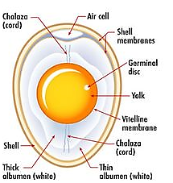
to cross. The large size and strong shell membranes of a chicken egg make it useful for demonstrating osmosis, a process which also takes place in more typical cells, but is not as easy to observe.

On day 1, students can see bubbles forming as the acetic acid of the vinegar reacts with the calcium carbonate of the shell to produce CO₂ bubbles:
2 CH₃COOH + CaCO₃ – > Ca(CH₃COO)₂ + H₂CO₃ – > Ca(CH₃COO)₂ + H₂O + CO₂.

On day 2, there will still be patches of shell on the surface of the eggs. It is possible to remove most of these patches of shell by washing while rubbing gently. However, this step is neither necessary nor advisable since there is a significant risk that students may break the shell membrane. The shell membrane is relatively tough, but you do need to be gentle!

White vinegar is about 95% water and 5% acetic acid (by weight). A chicken egg is ~74% water, which is similar to typical animal cells with ~70% water. Proteins are ~13% of the weight of a chicken egg (in the egg white and yolk) and lipids are ~11% (in the yolk). | 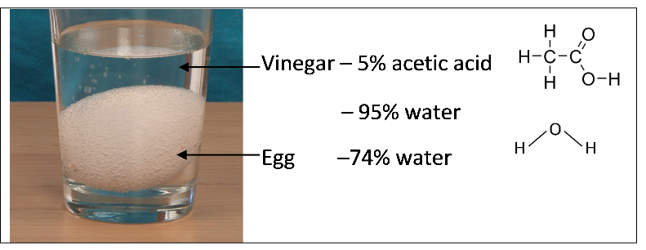

Students are likely to answer question 1b by saying that vinegar moved into the egg. Movement of acetic acid across the shell membrane may be slower than movement of water molecules, because acetic acid is a larger molecule which, as an acid, tends to ionize and attract a shell of polar water molecules.

On day 3, students will be able to see a dramatic difference in appearance between the enlarged egg that has been in water and the shrunken, shriveled egg that has been in corn syrup. The water that diffuses out of the egg in corn syrup typically forms a layer of water on top of the corn syrup; this layer of water will be particularly obvious if you use dark corn syrup, but it is easier to see the shrunken egg if you use clear corn syrup.

Corn syrup is about 20% water, and the rest consists of molecules of glucose and polymers of glucose of varying lengths (https://talcottlab.tamu.edu/wp-content/uploads/sites/108/2019/01/Corn-Syrup-Confusion.pdf). A chicken egg has 88% water in the white and 48% water in the yolk. The higher concentration of water in the white is the major reason why, in an egg that has been in corn syrup, the white is much more reduced and the yolk becomes more prominent.

If you present the experiment as a demonstration so your students are not making their own quantitative measurements, you may want to show the following sample data.
Day | Egg 1 |  |  | Egg 2
 | Weight (grams) | Circumference (cm) |  | Weight (grams) | Circumference
1 | 56.3 (with shell) | ~14.0 |  | 52.6 (with shell) | ~13.9 cm
 | Egg put into vinegar |  |  | Egg put into vinegar
2 | 72.7 (without shell) | ~15.1 |  | 65.2 (without shell) | ~15.0
 | Egg put into water |  |  | Egg put into corn syrup
3 | 83.5 | ~16.0 |  | 36.2 | ~9.9

To introduce or review diffusion, you may want to show your students the 18-second video at https://www.youtube.com/watch?v=qBig2wevHhw or the 1.5-minute video at https://www.youtube.com/watch?v=cs8ud7Eh7ko. During diffusion, molecules move in random directions. Therefore, water diffuses in both directions across a selectively permeable membrane.

Question 11 challenges students to review the results from the different parts of the egg experiment and derive an overall generalization concerning the direction of net water flow across the selectively permeable membrane surrounding the egg.

Question 12 challenges students to extrapolate their understanding to a case where the concentration of solutes is the same on both sides of a selectively permeable cell membrane. (The membrane surrounding the cell is also called the plasma membrane.) As you discuss the cell membrane, you may want to mention that the selectively permeable cell membrane allows some small molecules like oxygen, carbon dioxide and water to cross, but prevents large molecules like DNA and proteins from leaving the cell. In this context, you could ask the following question.

13a. Why is it important for cell membranes to prevent large molecules like DNA and proteins from leaving the cell?

13b. Explain why it is important for small molecules like oxygen and carbon dioxide to be able to cross the cell membrane.

Osmosis – Effects on Animal and Plant Cells
To introduce this section, you may want to show the animation at https://www.youtube.com/watch?v=sdiJtDRJQEc to help your students understand osmosis. The Appendix at the end of these Teacher Preparation Notes describes possible molecular mechanisms for osmosis.

The Student Handout uses the terms hypertonic, hypotonic and isotonic. If you prefer, you can replace these terms with hyperosmotic, hypo-osmotic and iso-osmotic.

A common student misconception is that isotonic solutions have equal numbers of solute and solvent particles, hypotonic solutions have fewer solute than solvent particles, and hypertonic solutions have more solute than solvent particles. The question below will help to counteract these misconceptions. In the class discussion you can celebrate any mistakes as an opportunity for correcting misconceptions and improving understanding.

13. Follow the instructions in each drawing. (The solution on the left represents the cytosol.)
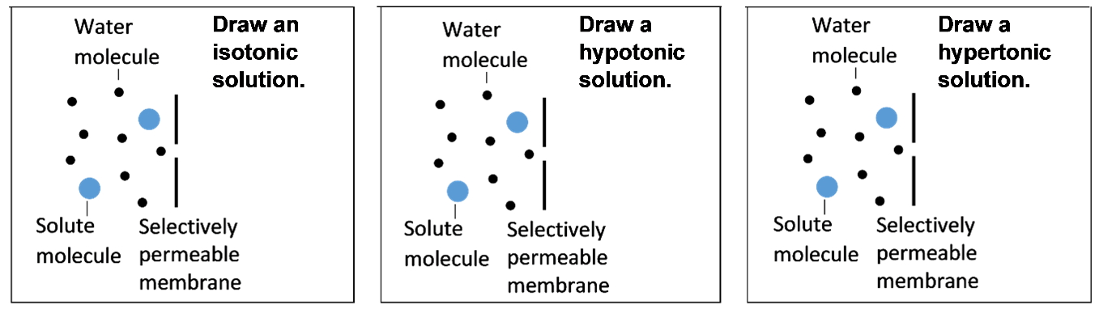

To be healthy, animal cells generally require isotonic surrounding extracellular fluid. For example, animal cells placed in hypotonic solution may burst. The eggs did not burst, even when placed in water, because of the strong surrounding shell membranes. Plant cells can flourish in hypotonic surrounding fluid because they have strong cell walls; water stops flowing into the cell when the turgor pressure matches the countervailing cell wall pressure. (See figure below. For additional explanation, see http://media.collegeboard.com/digitalServices/pdf/ap/bio-manual/Bio_Lab4-DiffusionandOsmosis.pdf).

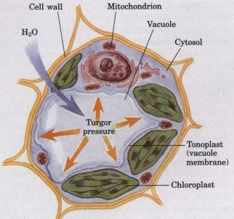 | 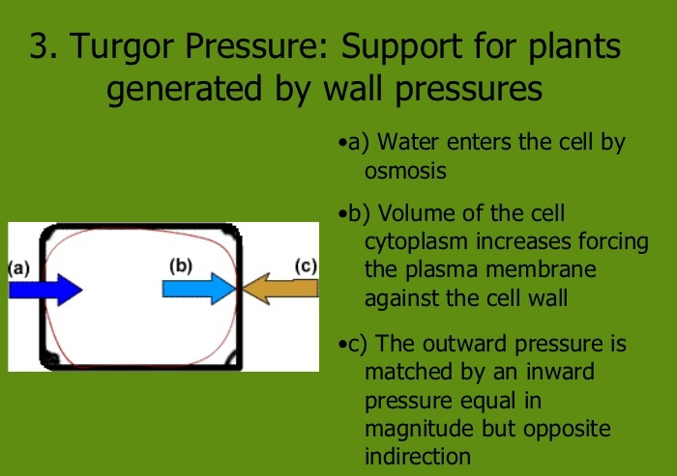  (http://image.slidesharecdn.com/1-unit9plantscomplete2-110306142821-phpapp02/95/ib-biology-unit-9-plants-61-728.jpg?cb=1375861208 )  (http://www.bioinfo.org.cn/book/biochemistry/chapt02/35-1.jpg )

When there is little water in the soil, plant roots are unable to take up water, so the extracellular fluid becomes hypertonic and cells lose turgor pressure which is needed to support the plant's structure. This explains why a plant wilts if you forget to water the plant or if it hasn’t rained.

You may want to ask your students this question.
15. Suppose that animal cells had stiff cell walls like those of plant cells. What problems would this cause for animals?
Since animals cannot make their own food, most types of animals need to move at least some part of their bodies to get food. Stiff cell walls would interfere with muscle contraction. Furthermore, for many types of animals, muscle cells also need to contract for the proper functioning of the circulatory, respiratory and/or digestive systems. This illustrates how adaptations are interrelated.

Applying Your Understanding of Osmosis
In your class discussion of student answers to questions 16-17, it will be helpful to reinforce the Crosscutting Concept, “Cause and Effect: Mechanism and Explanation. Cause and effect relationships may be used to predict phenomena in natural or designed systems."

Salting a food can prevent bacteria and molds from growing on the food by creating a hypertonic environment that deprives the cells of the water they need to survive. This was discovered empirically in many cultures long before people knew about cells or osmosis. Now, students can use their understanding of osmosis to predict that salting a food will prevent or reduce the growth of spoilage-causing bacteria and molds.

When a person rapidly consumes large quantities of water, this can result in hypotonic extracellular fluid, because the influx of water is too rapid to allow the normal osmotic regulation by the kidneys. The osmotic effects due to hypotonic extracellular fluid result in swollen cells, with the most harmful effects on the brain cells, which are especially prone to malfunction due to increased mechanical pressure as the swollen brain cells press against the skull (https://www.scientificamerican.com/article/strange-but-true-drinking-too-much-water-can-kill/).

Water intoxication and hyponatremia (low concentration of sodium) can be fatal. This has been observed in some participants in water-drinking contests and some marathon runners who have consumed excessive amounts of fluids. Harmful effects can result from excessive consumption of either water or sports drinks, both of which are hypotonic relative to our bodies' extracellular fluids and sweat. (Sports drinks do contain some salt, which can replace some of the salt lost in sweat.)

This example illustrates that dose makes the poison; in other words at high enough doses even a necessary and relatively innocuous molecule like water can become fatal. This example also illustrates that official advice can sometimes result in harmful outcomes if carried to extremes. The former official advice that athletes should drink "ahead of their thirst" is currently disputed as a result of recent evidence that optimum athletic performance and health is generally observed when athletes have free access to water and drink to thirst ("Dehydration and endurance performance in competitive athletes", Nutrition Reviews 70 (suppl. 2): S5132-6; https://serendipstudio.org/exchange/bioactivities/sportsdrinks). Of course, it is important to consume adequate amounts of water and salt to replace fluids that have been lost (e.g., to maintain adequate blood volume for effective heart function).

Challenge Question 18 asks about the effects of drinking hypertonic ocean water. Students are expected to answer that drinking ocean water will cause an increase in the salt concentration of the body's extracellular fluids, so the cells will lose water. Dehydration of nerve cells results in neurological symptoms. Sophisticated students may know that the kidneys generally excrete excess solutes by excreting hypertonic urine. To answer question 18, these students would need to know that ocean water is more hypertonic than the most concentrated urine that human kidneys can produce. Therefore, in order to excrete the excess salt consumed in the ocean water, the kidneys would have to excrete more water than had been consumed. This net loss of water would cause hypertonic body fluids.

You may also want to ask the following additional challenge question.
19. Archaea are single-cell organisms. Some types of archaea live in extremely salty water such as the Great Salt Lake or the Dead Sea. Use your imagination to describe how these archaea cells could prevent water loss while living in very salty water.

This question would challenge students to be creative in proposing how cells might adapt to highly saline environments. Many archaea that live in highly saline environments synthesize small organic molecules (e.g., sugars), and the high concentrations of these solutes inside the cell helps to balance the high concentration of salt in the surrounding environment, so the cell does not lose water by osmosis. This illustrates how osmosis depends on the total concentration of solute particles, even when the specific solutes differ. Some halophilic archaea (e.g., Haloferax) have a different adaptation to highly saline environments; they pump potassium into the cell in order to maintain osmotic equilibrium; in these archaea, enzymes and structural cell components have special characteristics that allow them to function at high potassium concentrations.

Students may propose other possible adaptations for living in extremely salty environments, and it will be enlightening to discuss their proposals. For example, students may propose that archaea might pump water across the cell membrane into the cell to counteract the osmotic effects of the hypertonic surrounding solution; thus far, biologists have not found any biological molecule that can directly pump water; instead, water is moved across cell membranes by osmotic gradients which cell membranes can set up by pumping ions.

Follow-Up Activities
Cell Membrane Structure and Function (https://serendipstudio.org/sci_edu/waldron/#diffusion)
This minds-on activity includes two hands-on experiments and numerous analysis and discussion questions to help students understand how the molecular composition and organization of a cell membrane result in its selective permeability. Students learn how the phospholipid bilayer and membrane proteins play key roles in the cell membrane function of regulating what gets into and out of the cell. Specific topics covered include ions, polar and nonpolar molecules; simple diffusion through the phospholipid bilayer; facilitated diffusion through ion channels or carrier proteins; active transport; exocytosis and endocytosis. (This activity is aligned with NGSS.)

You may want to have your students carry out a follow-up osmosis experiment, using one of the following options:
- Analyze osmosis in Elodea or moss cells and osmosis across dialysis tubing; see "Diffusion
and Osmosis" (available at http://media.collegeboard.com/digitalServices/pdf/ap/bio-manual/Bio_Lab4-DiffusionandOsmosis.pdf ).
- Analyze osmosis across dialysis tubing, in pieces of potato, and in onion skin; see "Osmosis and Diffusion" (available at http://www.biologyjunction.com/osmosis_lab_example_2.htm).
- Use microscopes, Elodea and various chemicals to study osmosis and rates of diffusion across the cell membrane of molecules of different size and hydrophobicity; see "Diffusion across Biological Membranes" (http://faculty.buffalostate.edu/wadswogj/courses/BIO211%20Page/lectures/lab%20pdf's/Diffusion%20lab%2006a.pdf ).

Should you drink sports drinks? When? Why? (https://serendipstudio.org/exchange/bioactivities/sportsdrinks). The questions in this activity help students to understand the effects of consuming sports drinks and when and how the consumption of sports drinks can be beneficial or harmful. This activity provides the opportunity to review some basic concepts related to osmosis, cellular respiration, mammalian temperature regulation, and how our different body systems cooperate to maintain homeostasis.

Sources for Figures in Student Handouts
- Figure on page 4 adapted from Biology – A Guide to the Natural World, 5th edition, by Krogh
The other figures were created by the author.
Appendix– Proposed Molecular Mechanisms for Osmosis

A Common Hypothesis about the Mechanism for Osmosis
Na+, Cl-, and the water molecules that are bound to these ions cannot cross the selectively permeable membrane. Only free water molecules (water molecules that are not bound to ions or other dissolved substances) can cross the selectively permeable membrane.  The concentration of free water molecules is lower in water with dissolved salt because some of the polar water molecules are attracted to the charged ions, so these water molecules are no longer free, but instead are bound water.  During osmosis, diffusion results in movement of free water molecules in both directions across the selectively permeable membrane. However, more free water molecules move from the region of higher concentration of free water molecules (pure water) to the region of lower concentration (water with dissolved substances).  This mechanism is frequently presented in college biology textbooks, but it should be noted that current evidence indicates that this is not the predominant mechanism responsible for osmosis. |  | selectively permeable membrane

A More Accurate Hypothesis about the Mechanism of Osmosis
Bulk flow is the movement of a fluid due to a pressure gradient, whereas diffusion is the movement of molecules from an area of higher concentration to an area of lower concentration. Osmosis appears to be the result of bulk flow due to a pressure gradient, as illustrated by the following example. If pure water is on one side of a selectively permeable membrane, and the other side has solute particles that cannot cross the selectively permeable membrane:
- solute particles bounce off the selectively permeable membrane and drag water molecules with them;
- this causes a lower pressure on the side of the membrane that has dissolved solute particles;
- this pressure differential results in bulk flow of water molecules through the selectively permeable membrane from the side with pure water to the side with dissolved solute particles.
(See “Challenging Misconceptions about Osmosis” (especially pages 68-70 and 80-83; http://www.ableweb.org/biologylabs/wp-content/uploads/volumes/vol-30/006.pdf) and “Osmosis and Solute-Solvent Drag: Fluid Transport and Fluid Exchange in Animals and Plants”, (https://www.ncbi.nlm.nih.gov/pubmed/15976460).)

This more accurate understanding of osmosis is important because it explains why the crucial variable for quantitative analyses of osmosis is the concentration of solute particles in the solutions on either side of the selectively permeable membrane. In our activity, the differential in the concentration of solute particles is in the same direction as the differential in percent solutes by weight, and the analysis is qualitative rather than quantitative, so explanations and questions are formulated in general terms (e.g., higher or lower concentrations), rather than quantitative measures of the concentration of solute particles.

By Dr. Ingrid Waldron, Department of Biology, University of Pennsylvania, 2022. These Teacher Preparation Notes and the related Student Handout are available at https://serendipstudio.org/sci_edu/waldron/#osmosis
Quotes from Next Generation Science Standards, available at http://www.nextgenscience.org/next-generation-science-standards
A selectively permeable membrane is sometimes called a semipermeable membrane. A follow-up activity about selectively permeable membranes is "Cell Membrane Structure and Function" (http://serendipstudio.org/sci_edu/waldron/#diffusion).
https://www.researchgate.net/profile/Muhsin-Menekse-2/publication/328772747_The_role_of_collaborative_interactions_versus_individual_construction_on_students'_learning_of_engineering_concepts/links/5be9ec54299bf1124fce1aab/The-role-of-collaborative-interactions-versus-individual-construction-on-students-learning-of-engineering-concepts.pdf
Regular corn syrup should be distinguished from high fructose corn syrup which contains roughly half fructose and half glucose (both of which are monosaccharides).
Athletes who are very active in a hot environment can become dehydrated as a result of copious sweating, although this is less likely if they have the opportunity to drink when they are thirsty. Dehydration can result in decreased volume of body fluids, including decreased blood volume. As a result, not enough blood returns to the heart and the heart can't pump enough blood to maintain adequate circulation, so blood pressure drops. This can result in decreased athletic performance and increased risk of heat cramps, heat exhaustion, and in extreme cases heat stroke. Thus, it is important to replace lost water and salt. Heat cramps are painful muscle spasms during heavy exercise in hot environments. Low fluid intake contributes to the risk of heat cramps. Heat exhaustion occurs when copious sweating without adequate fluid intake has reduced blood volume so the heart cannot pump enough blood; blood pressure falls which can result in fainting. Heat stroke occurs when the drop in blood pressure triggers decreased sweating and constriction of peripheral blood vessels; this helps to maintain adequate blood pressure and blood flow, but, unfortunately, these responses allow body temperature to escalate, which can result in denaturation of proteins and death.
Some animals can drink ocean water because their kidneys can excrete urine that has a higher concentration of dissolved solutes than ocean water or they have glands that secrete excess salt to the environment (https://theconversation.com/curious-kids-how-do-sea-creatures-drink-sea-water-and-not-get-sick-110979).
Molarity is the concentration of solute particles in moles/L. Molarity is also known as osmolarity.

