Introduction to Osmosis

Introduction
1. Food can spoil when bacteria or molds grow in it. For thousands of years, people have preserved foods by adding salt. How do you think that adding salt can keep a food from spoiling?

2. If a person drinks a very large amount of water in a short time without consuming salt, this can disrupt the functioning of nerve cells in the brain, which can cause confusion, seizures, coma, and even death. How do you think that drinking lots of water quickly causes these problems?

The following sections will help you to understand these phenomena.

What is happening to these eggs?
An unfertilized chicken egg contains a large cell surrounded by egg white, a shell membrane, and an egg shell. You will investigate how the size of an egg changes when the eggshell is removed and the egg is placed in different liquids.

Day 1
- Your group will be given two eggs. To begin, record the weight or circumference of each egg in the day 1 row in the table. (Measure the circumference around the widest part, not lengthwise.)

Caution: Because these are raw eggs, they may carry salmonella, so you should use gloves when handling the eggs.

Day | Egg 1 |  | Egg 2
 | Weight (grams) (or circumference (cm)) |  | Weight (grams) (or circumference (cm))
1 | (with shell) |  | (with shell)
2 | (after a day in vinegar;  most of shell removed) |  | (after a day in vinegar;  most of shell removed)
3 | (after a day in water) |  | (after a day in corn syrup)

- Put each egg in a container labeled Egg 1 or Egg 2. Pour in enough vinegar to cover the egg. Cover the container. Do you see bubbles forming around the egg? These are bubbles of CO₂ which result from the chemical reaction between the acetic acid in the vinegar and the calcium carbonate in the eggshell. This reaction will dissolve most of the eggshell by day 2.

Day 2
- Observe your eggs. Notice that most of the shell has been dissolved by the acetic acid in the vinegar. The shell membrane around the egg is fairly strong. However, the egg without its shell is fragile, so you will need to handle your eggs very gently and carefully!

- Rinse and dry each egg and measure the weight or circumference of each egg. Record your results for day 2 in the above table.
3a. Did the eggs become heavier/larger ___ or lighter/smaller ___?

3b. What do you think happened to cause the change in the eggs’ weight/size?

- Empty the vinegar from the container for egg 1 and rinse the container. Put egg 1 back in the container and add water to cover the egg.

- Empty the vinegar from the container for egg 2 and rinse the container. Put egg 2 back in the container and add corn syrup to cover the egg. As you pour the corn syrup, notice that it is viscous (thick, sticky).

4. What do you think causes the corn syrup to be so viscous?

Day 3
5. Compare and contrast the appearance of the egg that has been in water vs. the egg that has been in corn syrup.

6. You may be able to see a layer of water on top of the corn syrup. Where do you think this water came from?

- Rinse the corn syrup off of egg 2. Dry each egg, and measure and record the weight and/or circumference for day 3 in the table on page 1.

7. What do you think happened to cause the change in weight/size of the egg that was in corn syrup?

8. For the egg that was in water, where do you think the additional weight/volume came from?

9a. Recall that each egg is surrounded by a shell membrane. Based on your observations, which of the following do you think can cross this membrane?
- both water and the proteins in the egg white
- water, but not the proteins in the egg white
- the proteins in the egg white, but not water
- neither water nor the proteins in the egg white

9b. What evidence supports your conclusion?

10. The shell membrane that surrounds the egg is a selectively permeable membrane. Explain why “selectively permeable” is a good way to describe this membrane.

Each diagram shows a very magnified view of a tiny patch of the selectively permeable shell membrane between two solutions. Inside the egg is water with dissolved proteins, ions, etc. Outside the egg is water or vinegar (water with dissolved acetic acid) or corn syrup (water with dissolved glucose molecules and polymers of glucose).

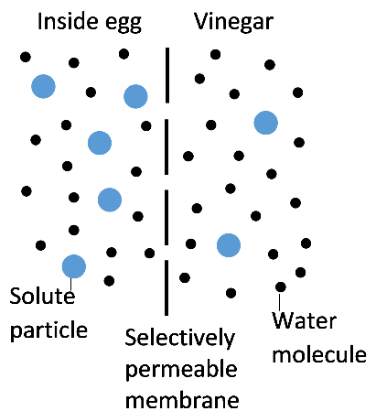

Molecules are constantly moving in random directions. As a result, water molecules cross the selectively permeable shell membrane in both directions. If more water molecules cross the membrane in one direction, this is called a net flow of water. Most solute particles cannot cross the selectively permeable shell membrane. Thus, the changes in weight/volume of each egg were mainly due to the net flow of water into or out of the egg.

11a. In each of the above diagrams, draw an arrow to show the direction of the net flow of water across the selectively permeable membrane. (Hint: Review your answers to questions 3, 7 and 8.)

11b. Your results show that, when the selectively permeable shell membrane separates two solutions, more water molecules cross

from the solution with  a __________ concentration of solute particles  (higher/lower)  and a __________ concentration of water  (higher/lower) | → | to the solution with  a __________ concentration of solute particles  (higher/lower)  and a __________ concentration of water.  (higher/lower)

The movement of water across the selectively permeable shell membrane is similar to the movement of water across the selectively permeable cell membrane that surrounds each tiny cell in your body. Inside the cell membrane is cytosol, which is water with dissolved proteins, ions, etc. (Cytoplasm is the cytosol, together with the organelles and cytoskeleton.) Outside the cell membrane is water with dissolved ions, etc.

12a. Suppose that a cell is surrounded by a solution that has the same concentration of solute particles as the cytosol inside the cell. Which of the following do you think would best describe the net flow of water across the cell membrane?
- There would be a net flow of water into the cell.
- There would be a net flow of water out of the cell.
- There would be no net flow of water into or out of the cell.

12b. Explain your reasoning.

Osmosis – Effects on Animal and Plant Cells

Osmosis is the diffusion of water across a selectively permeable membrane. Osmosis affects cells differently, depending on whether the surrounding solution is:
- hypertonic = has a higher concentration of solute particles than the cytosol
- hypotonic = has a lower concentration of solute particles than the cytosol
- isotonic = has the same concentration of solute particles as the cytosol

Figures A, B and C show the effects of osmosis on animal and plant cells that were put in three different types of surrounding fluid.
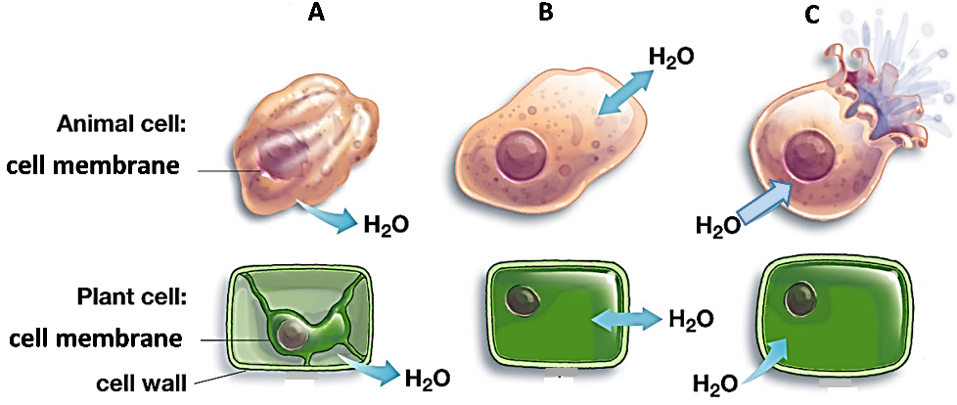

13a. Which of the animal cells looks like the egg in corn syrup? ____

13b. The fluid surrounding this cell was
- hypertonic b. hypotonic c. isotonic

13c. How do you know?

14a. The fluid surrounding the cells in figure C is
- hypertonic b. hypotonic c. isotonic

14b. In figure C, why does the animal cell burst, but the plant cell does not?

15. The cells in an animal are surrounded by a layer of water with dissolved substances. For animal cells to function normally, there should be equal amounts of water moving into and out of the cell, as shown in figure B. Which type of surrounding fluid would result in equal amounts of water moving into and out of an animal cell?
- hypertonic b. hypotonic c. isotonic

Applying Your Understanding of Osmosis

16. A food can spoil when bacteria and molds grow in it. Explain how salting a food can prevent it from spoiling.

If a person drinks a very large amount of water in a short time without consuming any salt, this can result in abnormal functioning of nerve cells in the brain. This can cause confusion, seizures, coma, or even death.

17a. When a person drinks too much water too quickly, the fluid surrounding the person’s cells changes from:
- hypotonic to hypertonic
- isotonic to hypertonic
- isotonic to hypotonic

17b. Explain your reasoning.

17c. How could this change in the fluid surrounding brain cells cause confusion, seizures and coma?

Challenge Question
18a. Suppose that you are stranded in a lifeboat in the middle of the ocean. You are very thirsty and you don’t have anything to drink except ocean water. The concentration of salt in ocean water is about four times as high as the concentration of salt in your blood and other body fluids. Should you drink some ocean water?
yes ___ no ___ need more information to make a good decision ___

18b. Explain your reasoning.

By Dr. Ingrid Waldron, Dept Biology, Univ Pennsylvania, © 2022. This Student Handout and Teacher Preparation Notes with instructional suggestions and background information, are available at https://serendipstudio.org/sci_edu/waldron/#osmosis.

