Cell Membrane Structure and Function

Each cell is surrounded by a cell membrane which regulates what gets into and out of the cell. The cell membrane is permeable to some types of molecules, but not others. This type of membrane is called a selectively permeable membrane.

1a. What does permeable mean?

1b. What does selectively permeable mean?

This figure shows four types of molecules that are found in cells. Each molecule is much smaller than shown here. In fact, protein molecules are so tiny that a billion protein molecules fit inside a human cell.  2. To show the relative sizes of these molecules, draw an oxygen molecule with atoms the same size as the atoms in the protein molecule.  3a. Fill in each blank below with one of the molecules shown.  For a cell to function properly: | 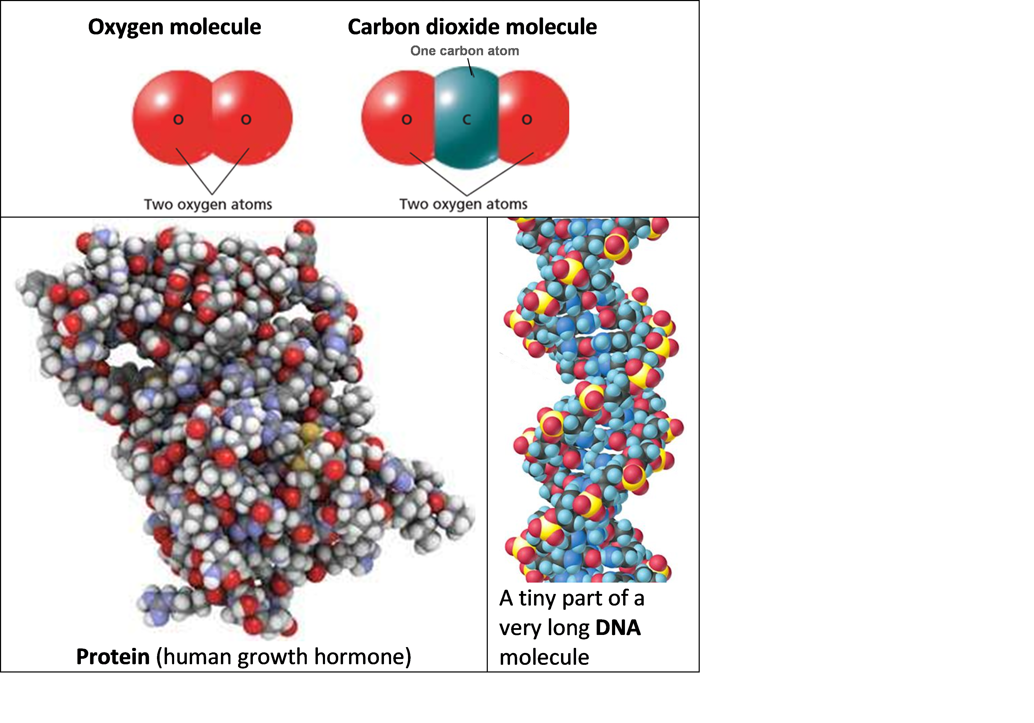

- ______________ and __________________ should be able to cross the cell membrane;

- ______________ and _______________ should stay inside the cell, so these molecules should not be able to cross the cell membrane.

3b. Explain your reasoning.

4. Write a hypothesis about the size of molecules and ions that can cross the cell membrane vs. the size of molecules and ions that can not cross the cell membrane. (Hint: Review your answers to questions 2 and 3a.)

Experiment 1 – Diffusion across a Synthetic Membrane

In Experiment 1, you will test this hypothesis.
Small ions and molecules can diffuse across a synthetic membrane, but large molecules and ions cannot cross the synthetic membrane.

To test this hypothesis, you will make a bag using dialysis tubing, a type of synthetic membrane. You will fill the bag with a starch solution and put the sealed bag in iodine solution. (See Beginning of Experiment figure.)

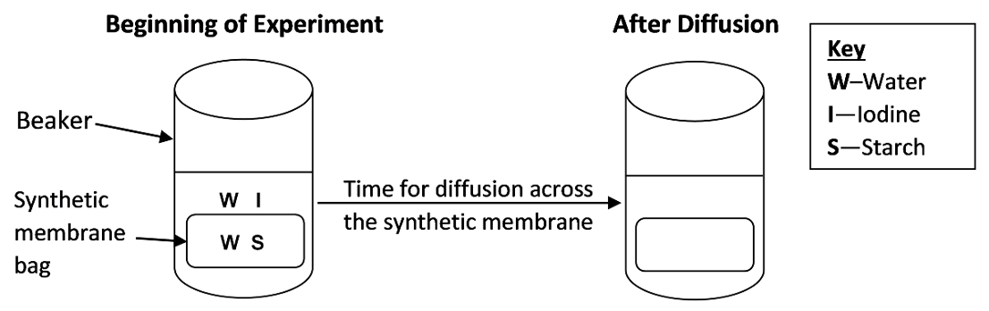
5a. What is diffusion?

5b. In the “After Diffusion” diagram, show where iodine and starch will be found if the hypothesis is correct.

5c. Explain your reasoning.

To evaluate whether iodine and/or starch have crossed the synthetic membrane, you will look for a change in color.
- A solution of iodine is tan.
- A solution of starch is milky white (or clear).
- When iodine and starch are together in the same solution, the solution is blue-black (or purple).

6a. Complete this table to show the expected colors after diffusion, depending on whether iodine and/or starch can cross the synthetic membrane.

If the synthetic membrane | Expected Color of Liquid After Diffusion
is permeable to: | In the Bag | In the Beaker
Neither iodine nor starch
Iodine only
Both iodine and starch

6b. Circle the colors that you will observe at the end of your experiment if the hypothesis is correct.

7. What change or addition to the experiment would provide a better test of the hypothesis? (Assume that you had a way to test for other substances in the solutions in the bag or beaker.)
Procedure (Complete and check off each step before you proceed to the next step.)

- Get a piece of pre-soaked dialysis tubing and two pieces of string. Fold the bottom of the piece of tubing 1 cm up and use a piece of string to tie the folded part tightly to create a bag.

- To open the other end of the tube, rub the end between your fingers until the edges separate. Use a pipette to add 8 mL of starch solution to the tube.

- Next, fold 1 cm of tubing at the top of the bag and tie it off tightly. Check to make sure there are no leaks. If scissors are available, trim the strings short.

- Rinse the bag and strings thoroughly in fresh water. Dry the bag and strings.

- Add 200 mL of distilled water to a 250 mL beaker. Add about 0.8 mL iodine to the water in the beaker. Caution: Be careful to avoid staining your clothes or fingers with the iodine.

- Put the bag in the beaker.

8. Record the colors of the liquid in the bag and the liquid in the beaker in the “Beginning of Experiment” row in this table.

 | Color of liquid
 | In the bag | In the beaker
Beginning of Experiment
After Diffusion

You will need to wait 15-20 minutes while substances have time to diffuse across the synthetic membrane.
While you're waiting, answer questions 12-16 on page 4.

9. After ~20 minutes, record your observations in the “After Diffusion” row in the above table.

10a. To interpret your observations, answer the questions in this table.

Ion or Molecule | Did this ion or molecule cross the membrane? | How do you know?
Iodine

Starch

10b. Do your results support the hypothesis that small ions like iodine can cross the synthetic membrane, but large molecules like starch cannot? yes ___ no ___

11a. Is the synthetic membrane selectively permeable? yes ___ no ___

11b. How do you know?

Experiment 2 – Ions, Polar Molecules, and Nonpolar Molecules

In this experiment, you will investigate a very different type of barrier to diffusion. This barrier depends on the properties of ions, polar molecules, and nonpolar molecules.

12. Match each item with the best match from the list below.

ion ___ nonpolar molecule ___ polar molecule ___

a. a molecule that has a small positive charge at one end and a small negative charge at the other end
b. a molecule that does not have a difference in charge between one end and the other
c. an atom or molecule that has a net charge because it has lost or gained one or more electrons

13. This figure shows that water is a  __________________ molecule.  (nonpolar / polar)  Opposite charges attract, so water molecules are attracted to each other (shown as hydrogen bonds in the figure to the right). Water molecules and ions are also attracted to each other (see figure below).  14. Which part of a water molecule is Na⁺ attracted to? | 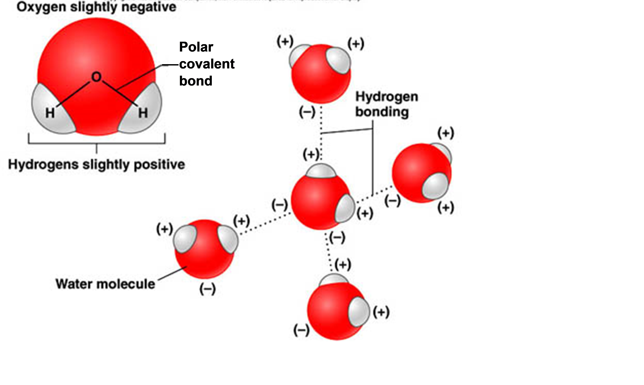

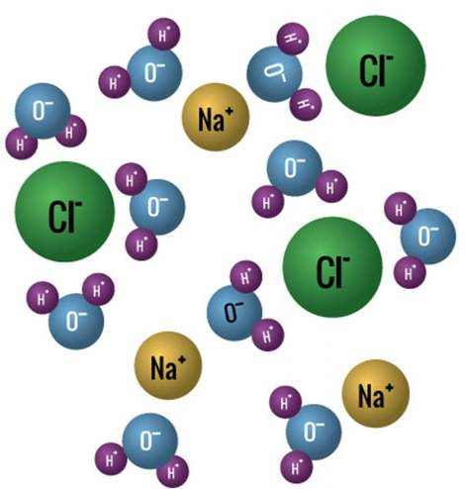 | Salt (NaCl) dissolves in water because the polar water molecules and the charged Na⁺ and Cl⁻ ions are attracted to each other. In general, a substance can only dissolve in water if there is a mutual attraction between water molecules and the ions or molecules of the substance.  15a. Would you expect polar molecules to dissolve in water?  15b. Explain your reasoning.

15c. Would you expect nonpolar molecules to dissolve in water?

15d. Explain your reasoning.

16. Choose the best matches for hydrophilic and hydrophobic.
hydrophilic = water loving, i.e. dissolves in water ___ ___ a. ions
hydrophobic = water fearing, i.e. does not dissolve in water ___ b. nonpolar molecules
c. polar molecules

Return to questions 9-11 on page 3 before you begin page 5.
Procedure – Part 1
- Get two clear plastic cups and label them 1 and 2.
- Pour a 2-4 cm layer of water in cup 1.
- Pour a 1-2 centimeter layer of water in cup 2. Carefully pour a 1-2 cm layer of oil on top of the water; pour the oil slowly down the side of the cup so it forms a layer on top of the water.

17. Food dye is water with dissolved dye molecules. The dye molecules are ions. Complete this table to predict what will happen when you put tiny drops of food dye on top of the liquid in each cup.

What do you think will happen to tiny drops of dye put on top of the water in cup 1? | What do you think will happen to tiny drops of dye put on top of the oil layer in cup 2?
Explain your reasoning. | Explain your reasoning.

Procedure – Part 2 (first for cup 1 and then again for cup 2)
- Suck up a small amount of food dye in a 1 mL pipette.
- Hold the pipette upright and slowly squeeze drops of dye back out into the dye container until the drops are replaced by a bubble on the tip of the pipette.
- Move the pipette with the bubble over the liquid in the cup. Slowly lower the pipette until the bubble just touches the surface of the liquid. Wait until the bubble pops or detaches from the pipette. Begin your observations immediately.

18a. Record your observations for each cup.

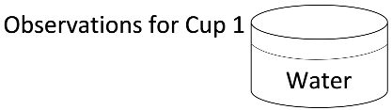 | 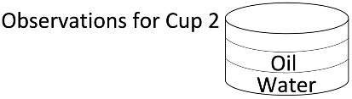

18b. If your observations do not match your predictions in question 17, provide a scientific explanation for your observations.

19. In this figure, the middle layer of nonpolar molecules is like the layer of oil in your experiment. Do you think that this middle layer of nonpolar molecules would prevent or slow diffusion of ions and polar molecules from one layer of aqueous solution to the other? | 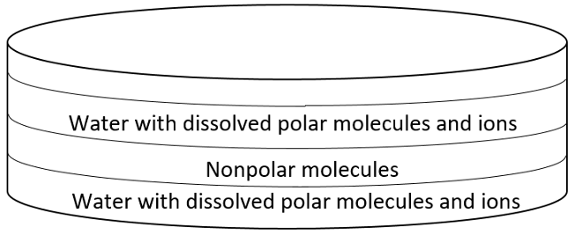
Explain your reasoning.
How Phospholipids and Proteins Combine to Form the Selectively Permeable Cell Membrane

The selectively permeable cell membrane separates the aqueous solution inside the cell from the aqueous solution that surrounds the cell.  - Inside the cell membrane is the cytosol which consists of water with dissolved ions and molecules, including large molecules like proteins. (The cytosol plus organelles and cytoskeleton is called the cytoplasm.) | 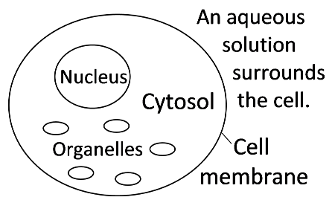
- Outside the cell membrane is water with dissolved ions and molecules.

20a. Much of the cell membrane consists of phospholipid molecules like this one. Explain why this type of molecule is called a phospholipid. | 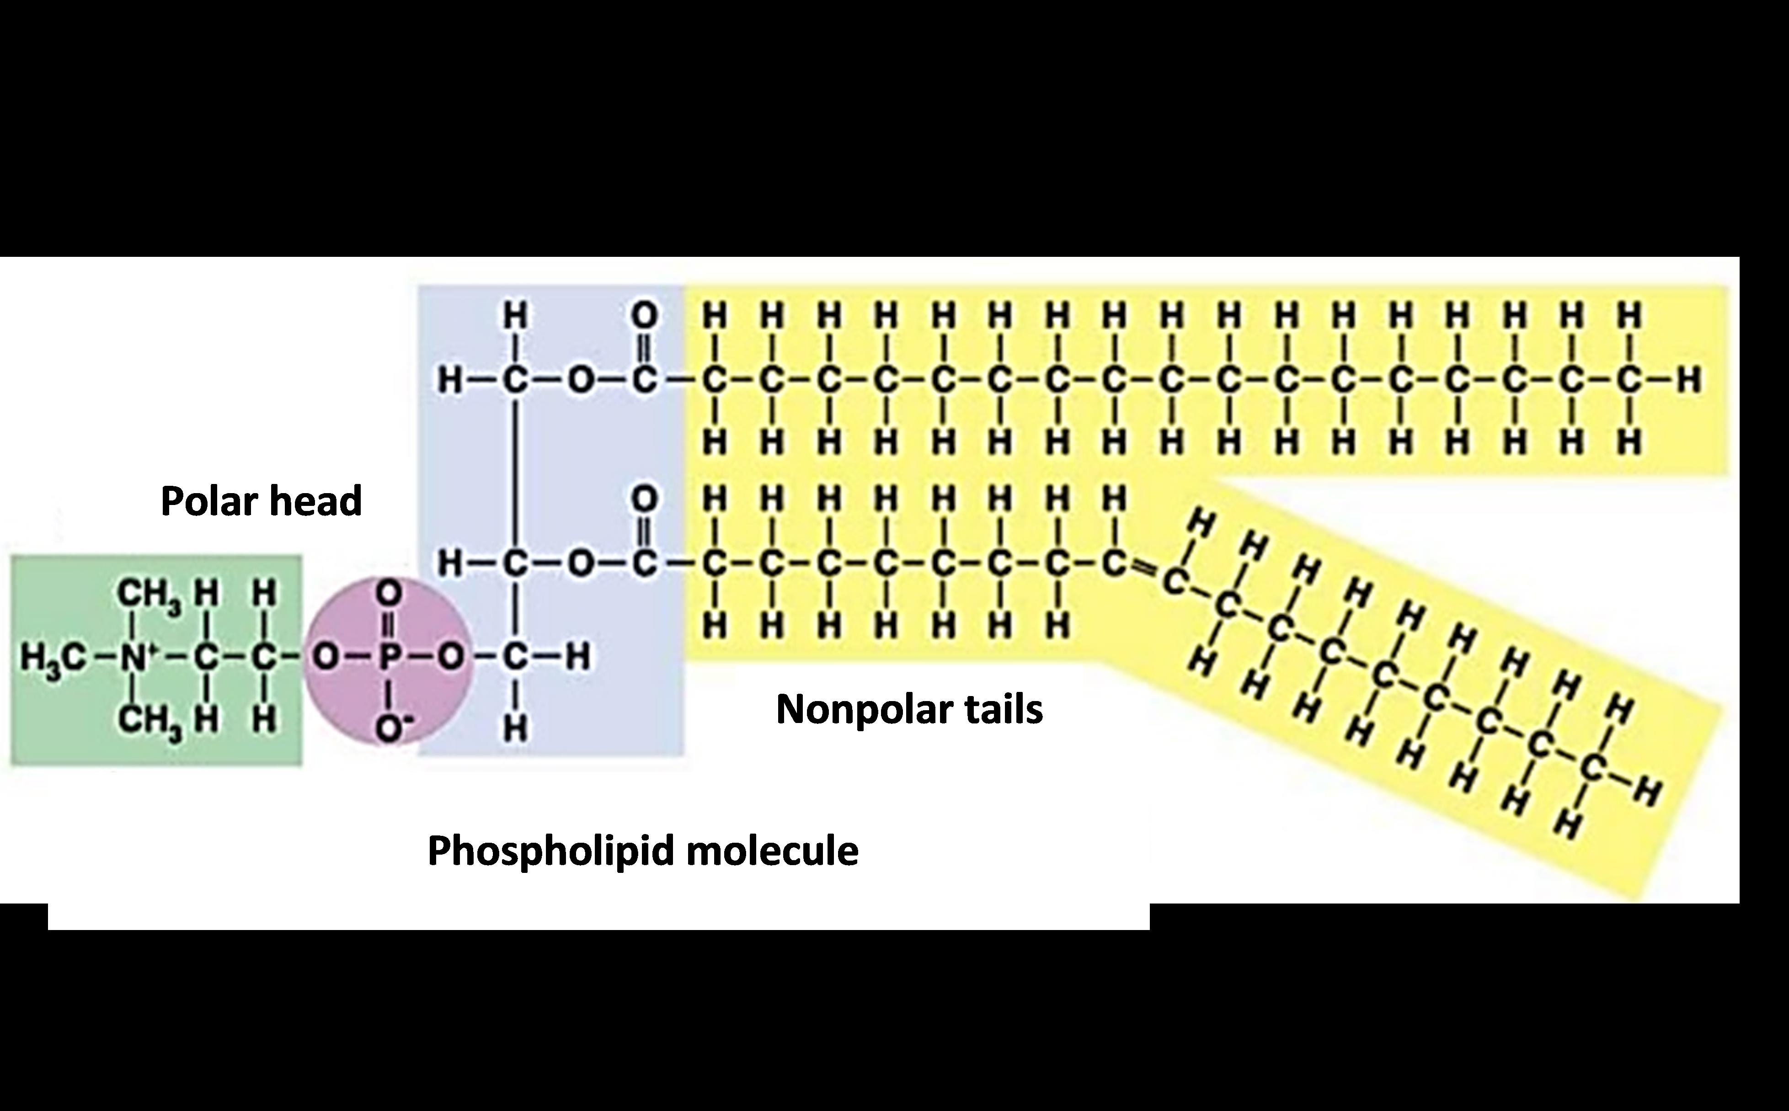

20b. Which part of a phospholipid molecule dissolves in water? nonpolar tails ___ polar head ___

Cell membranes have a double layer of phospholipids, called a phospholipid bilayer.  21. As new cell membrane is made, the phospholipid molecules spontaneously orient with their polar heads toward the outer surfaces of the cell membrane and their nonpolar tails in the interior of the | 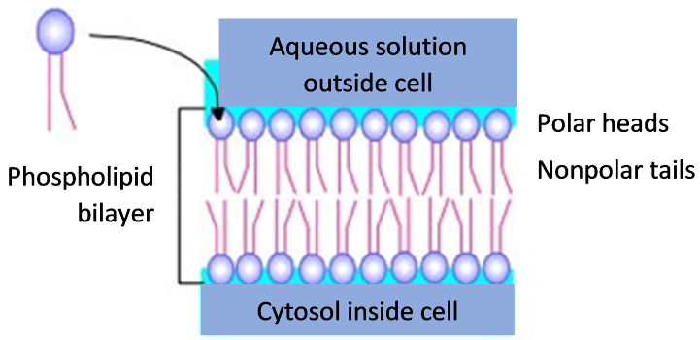
cell membrane. Why don’t the phospholipid molecules orient the other way around with their nonpolar tails on the outer surfaces of the cell membrane and their polar heads in the interior of the cell membrane?

The diagram in question 20a shows that the nonpolar tails of a phospholipid molecule are bigger than the polar head. For a substance to diffuse across the phospholipid bilayer, it must dissolve in the nonpolar tails. Nonpolar molecules dissolve in nonpolar solvents. (“Like dissolves like.”)

22a. Which would you expect to diffuse across the phospholipid bilayer?
small nonpolar molecules like O₂ and CO₂ ___ small ions ___

22b. Explain your reasoning.

Figure A shows that small nonpolar molecules like O₂ can diffuse across the phospholipid bilayer. Figure B shows how a carrier protein binds to a molecule like glucose and changes shape to release the glucose molecule on the other side of the membrane. Figure C shows a channel protein that allows specific ions like K⁺ or Cl⁻ to cross the cell membrane.

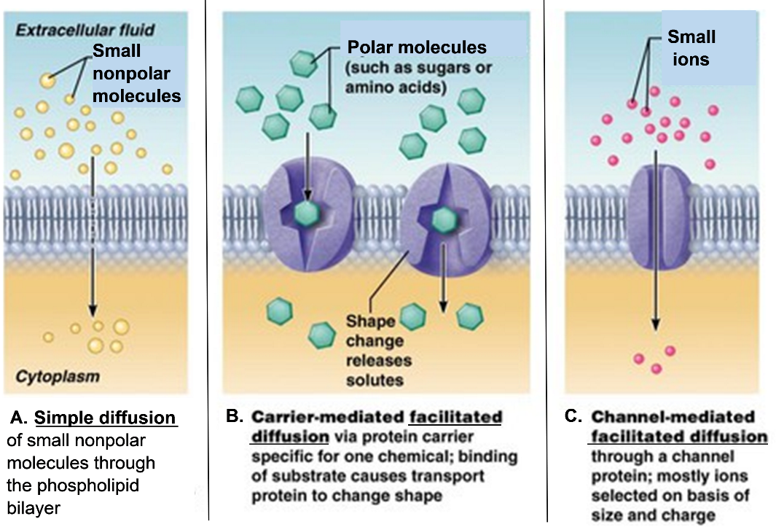

23. In the above figure, label a carrier protein, a channel protein, and a phospholipid bilayer.

24a. A cell uses glucose and O₂ for cellular respiration, the process that makes the ATP, which is needed to provide energy for many biological processes. How does glucose get into the cell?

24b. How does O₂ get into the cell?

25a. Figures A-C show how various types of molecules and ions can diffuse across the cell membrane. As a result of diffusion, there is a net flow of molecules or ions from a region of

____________ concentration to a region of ____________ concentration. Transport across the
(higher / lower) (higher / lower)
cell membrane that depends on diffusion is called passive transport.

25b. This figure shows an example of active transport. The protein in the cell membrane uses energy provided by ATP to pump molecules or ions  from a region of _____________ concentration  (higher / lower)  to a region of ________________ concentration.  (higher / lower)  25c. Describe two important differences between active transport and passive transport. | 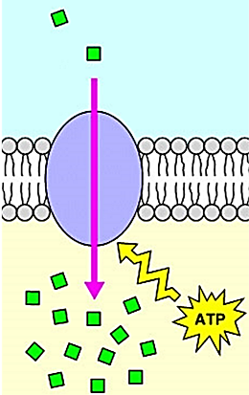
This figure summarizes much of the information that you’ve learned about the cell membrane.

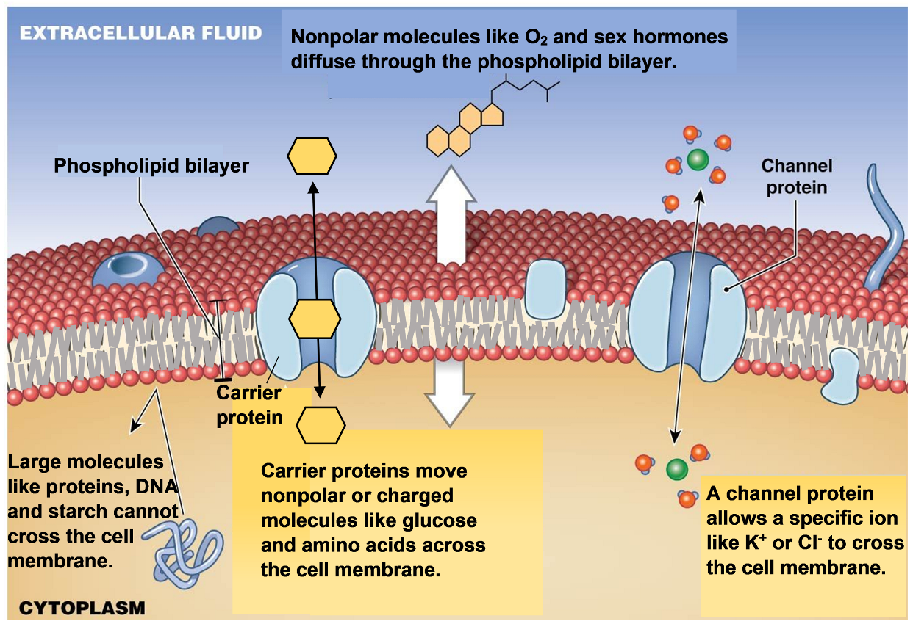

A model is a simplified representation of a real-world structure or phenomenon. A model can help us understand important points about the structure and function of a cell membrane. However, the simplifications of a model result in significant differences between the model and a real cell membrane.

26. The figure above presents a model of the cell membrane that shows some of the ways that substances can cross the cell membrane. However, this model is incomplete. What is the other major way that some substances are moved across the cell membrane?

27a. In Experiment 1, you used a synthetic membrane as a model of the cell membrane. Describe one way that the synthetic membrane is like a real cell membrane.

27b. Describe one way that the synthetic membrane is different from a real cell membrane.

28a. In Experiment 2, the model of the cell membrane was a layer of oil. Describe one way that the layer of oil was like a real cell membrane.

28b. Describe one way that a layer of oil is different from a real cell membrane.
You have seen how the phospholipid bilayer and membrane proteins cooperate to form a selectively permeable membrane that regulates what gets into and out of the cell.

29a. Suppose a cell had a cell membrane that consisted of a phospholipid bilayer only. Could this phospholipid bilayer prevent large molecules (e.g. proteins) from leaving the cell? yes ___ no ___  29b. Would this phospholipid bilayer allow ions (e.g. K⁺) or relatively small polar molecules (e.g. glucose) to enter and leave the cell?  yes ___ no ___  29c. Would this phospholipid bilayer allow relatively small nonpolar molecules (e.g. O₂) to enter and leave the cell? yes ___ no ___ | 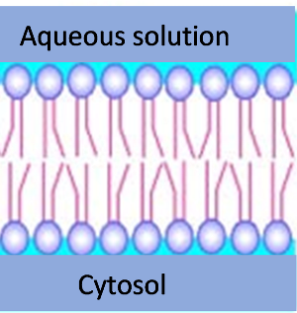

29d. Would this phospholipid bilayer pump ions or molecules across the membrane from a region of lower concentration to a region of higher concentration? yes ___ no ___

29e. On the end of the diagram of the phospholipid bilayer, draw and label an additional type of molecule that is found in a normal cell membrane. Explain how this type of molecule contributes to normal cell membrane function.

30. Complete this Venn diagram to describe the unique and shared characteristics of the different types of transport across the cell membrane.
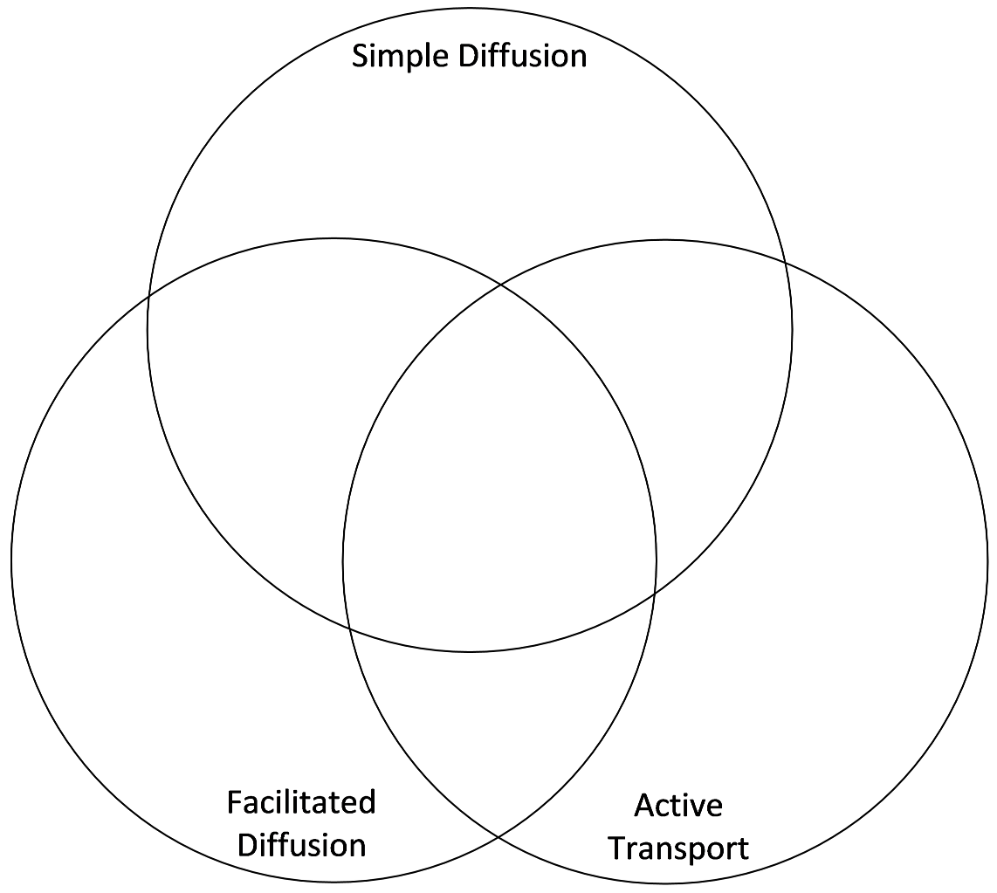

By Drs. Ingrid Waldron and Jennifer Doherty, Department of Biology, University of Pennsylvania, © 2020. Teachers are encouraged to copy this Student Handout for classroom use. This Student Handout and Teacher Preparation Notes with instructional suggestions and background information are available at http://serendipstudio.org/exchange/waldron/diffusion.

