Meiosis and Fertilization – Understanding How Genes Are Inherited

Introduction

1a. What is a gene?

1b. How does a child inherit one copy of each gene from each parent? Summarize what you already know.

2. Describe the processes that ensure that each cell in your body has a complete set of chromosomes with all the genes.

3. This flowchart summarizes how a child inherits one copy of each gene from each parent. During fertilization, a sperm unites with an egg to produce a zygote, which is a fertilized egg. Fill in the blanks in the flowchart.

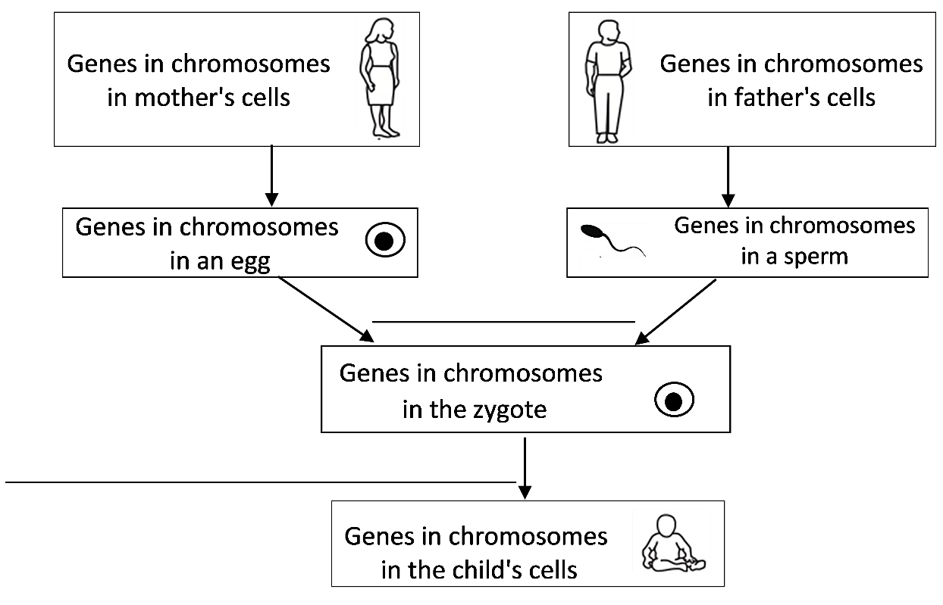

4. The zygote has all the chromosomes with all the genes that were in the egg and sperm. What problem would occur if eggs and sperm were produced by mitosis?

To understand the biological solution to the problem that would occur if eggs and sperm were made by mitosis, we need to think about pairs of homologous chromosomes.

5. What is a pair of homologous chromosomes?

- A diploid cell has pairs of homologous chromosomes. Almost all the cells in your body are diploid.  - A haploid cell has only one chromosome from each pair of homologous chromosomes. Eggs and sperm are haploid cells. | 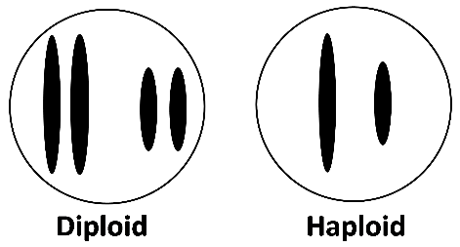
6a. Circle each pair of homologous chromosomes in the above figure.

6b. A haploid cell has ____________ as many chromosomes as a diploid cell.
(half / twice)

The type of cell division that produces haploid eggs and sperm from diploid cells is called meiosis. As a result of meiosis, each egg or sperm receives one chromosome from each pair of homologous chromosomes in the parent.

7a. Fill in each blank in this flowchart. The completed flowchart will summarize how a child inherits one copy of each gene from each parent.  7b. Write haploid next to any cell that is haploid.  7c. Circle a pair of homologous chromosomes in the zygote.  7d. Match each item in the first list with the best match from the second list.  Diploid cell → diploid cells ___  Diploid cell → haploid cells ___  Haploid cells → diploid cell ___  a. Fertilization b. Meiosis c. Mitosis | 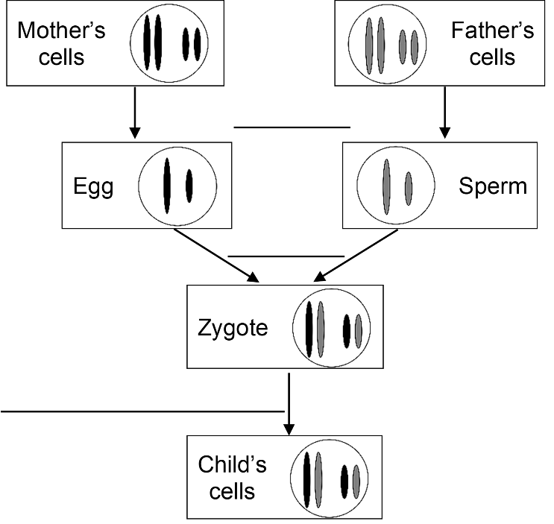

8. Use what you have learned to explain how each cell in a child gets one copy of each gene from his/her mother and another copy of each gene from his/her father. (Hints: You can use the flowchart in question 7 as an outline for your answer to this question. A complete answer will include these terms: meiosis, haploid, egg, sperm, pair of homologous chromosomes, gene, fertilizes or fertilization, diploid, zygote, DNA replication, mitosis.)

How Meiosis Makes Haploid Eggs and Sperm

Eggs and sperm are called gametes. The figure below shows how a diploid cell divides into haploid gametes. First, the DNA in the diploid cell is replicated and then two cell divisions produce four haploid gametes. The two cell divisions are called meiosis I and meiosis II.

9. Each paragraph below describes one step in meiosis. Draw an arrow from each paragraph to the matching part of the figure.  At the beginning of meiosis I, the two copies of the DNA in each chromosome are condensed into sister chromatids. The two homologous chromosomes are lined up next to each other.  During the meiosis I cell division, the homologous chromosomes are separated into two daughter cells. These daughter cells are haploid since each daughter cell has only one chromosome from the pair of homologous chromosomes.  During meiosis II, the sister chromatids of each chromosome are separated. Meiosis II produces four haploid daughter cells that become gametes.  10a. The A and a alleles are only labeled on some of the chromosomes or chromatids. Use your understanding of DNA replication and meiosis to label the A or a alleles on the other chromosomes and chromatids. | 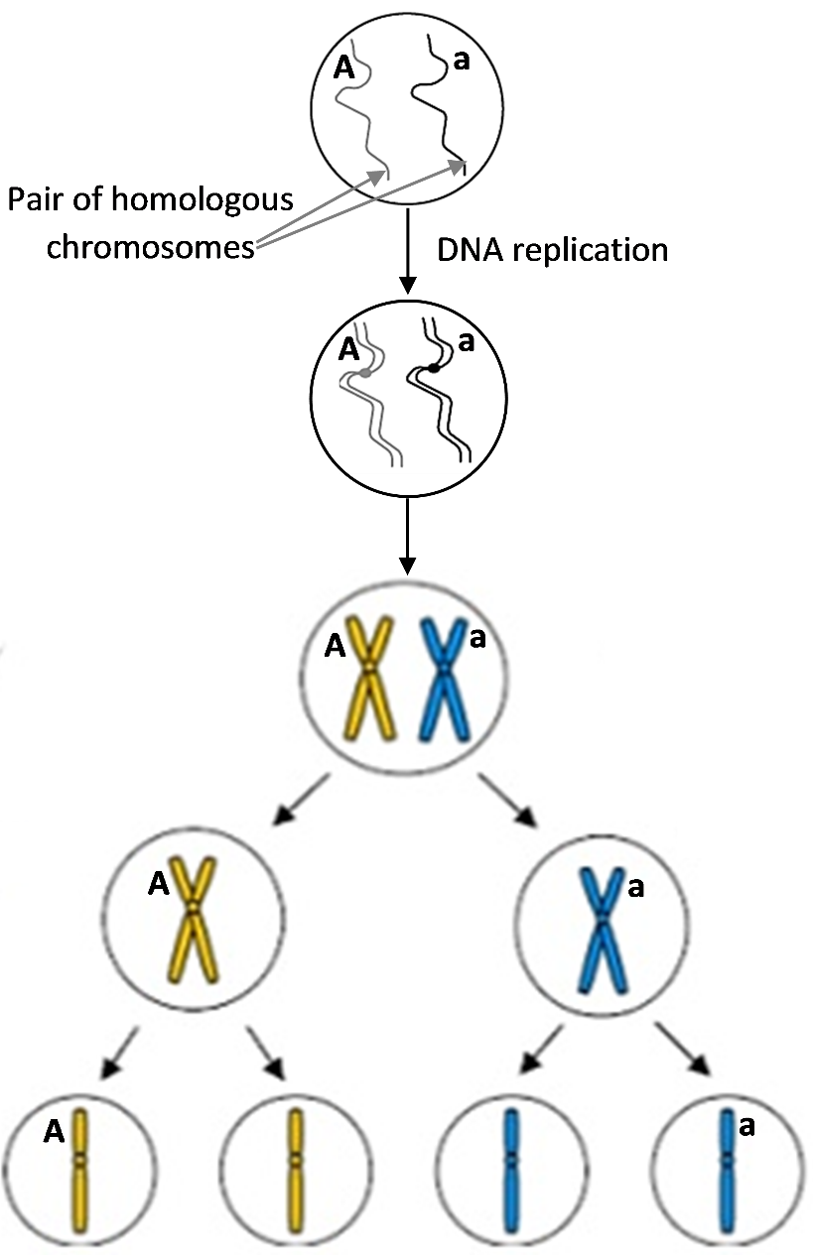

10b. For the labeled gene, there are ___ different types of haploid gametes.
(1/2/3)

11. To produce haploid gametes, DNA is replicated ___ time(s), followed by ___ cell division(s).
(0/1/2) (0/1/2)

12. To describe the characteristics of meiosis I, meiosis II, and mitosis, put a check for each characteristic that applies.

 | Meiosis I | Meiosis II | Mitosis
Separates pairs of homologous chromosomes
Separates sister chromatids
Produces genetically identical diploid cells
Produces genetically diverse haploid cells

Next, you will model meiosis using a pair of model chromosomes with the alleles shown here. Notice that the alleles for albinism (a) and sickle-cell hemoglobin (h) are on the same chromosome. There are more than 1000 additional genes on this chromosome. | 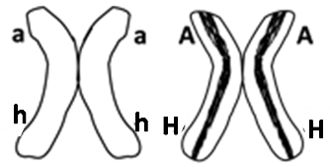

- Use your pair of model chromosomes to model each step of meiosis. Use your arms as spindle fibers to move the chromosomes, and use erasable marker, chalk or string to represent the cell membranes at each stage.
13a. Show the results of your modeling in this flowchart. Draw and label the chromosomes in each cell that is produced by meiosis I and by meiosis II.

13b. Which two combinations of alleles do you observe in the gametes?

__ah__ _____

Next, you will learn about two other processes during meiosis that contribute to the enormous genetic diversity of different gametes produced by the same person.

When a pair of homologous chromosomes is lined up next to each other at the beginning of meiosis I, the two homologous chromosomes can exchange parts of their chromatids. This is called crossing over. This figure shows crossing over for a pair of homologous chromosomes. At the beginning of meiosis, one chromosome has the A and H alleles and the other chromosome has the a and h alleles.

14. Label the alleles for these genes on each chromatid of the chromosomes in the bottom row.

Meiosis will separate the pair of homologous chromosomes and then the sister chromatids. This will produce gametes with four different combinations of the alleles for the two labeled genes.

15. The combinations of alleles in the different gametes will be:
_______ _______ _______ _______

Next, you will model meiosis using the two pairs of homologous chromosomes shown in the chart below. Notice that the two pairs of homologous chromosomes can line up in two different ways at the beginning of meiosis I. This is called independent assortment, since each pair of homologous chromosomes lines up independently of how the other pair of homologous chromosomes lined up.

- Use your two pairs of homologous chromosomes to model meiosis I and meiosis II for each possible way of lining up the model chromosomes at the beginning of meiosis I.

16. Complete this chart. Draw the missing chromosomes and label the alleles on each chromatid and chromosome.
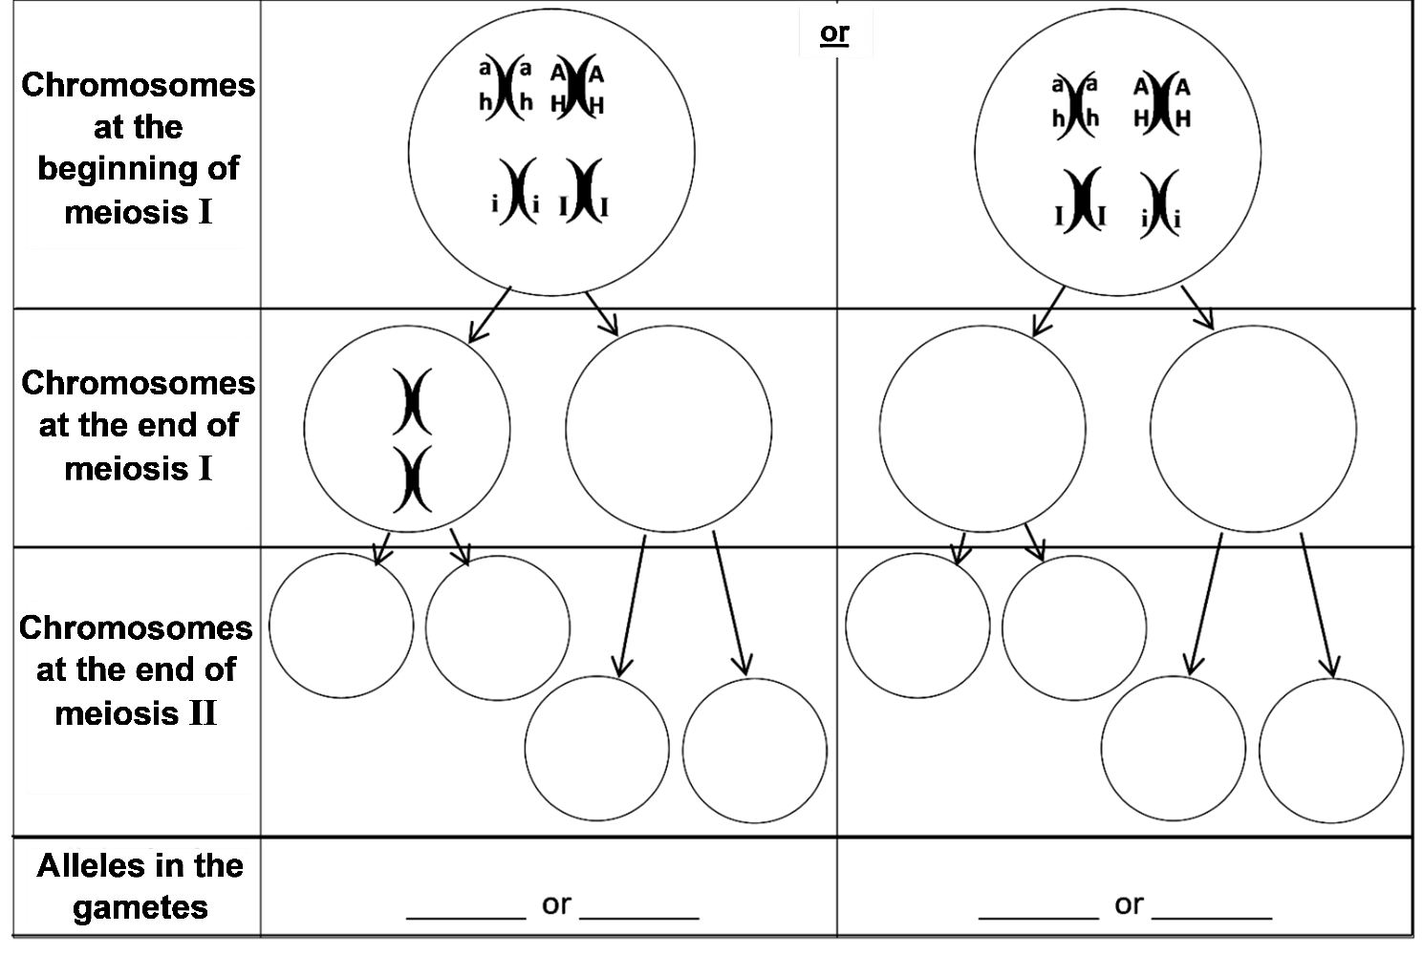

17. As a result of your modeling, you saw that independent assortment resulted in gametes with four different combinations of these alleles. What additional process could produce gametes with these four additional combinations of alleles – aHi, aHI, AhI and Ahi?

This analysis shows that meiosis can produce gametes with eight different combinations of the alleles for these three genes. Each human body cell has roughly 20,000 genes in 23 pairs of homologous chromosomes. Independent assortment of 23 pairs of homologous chromosomes can produce more than 8 million different combinations of chromosomes in different gametes produced by the same person! Crossing over results in an even greater number of different combinations of alleles in these gametes.

Genes are inherited via meiosis and fertilization.

To learn how meiosis and fertilization determine the genetic makeup of a child, you will analyze inheritance for two parents who both have the Aa genotype. This flowchart shows how these parents could have a child with the Aa genotype.

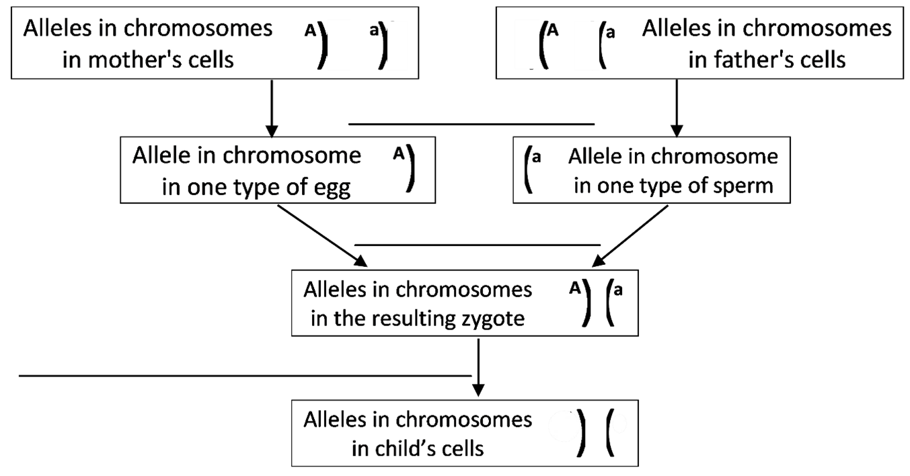
18a. Fill in the blanks in this flowchart.

18b. Label the alleles in the child’s cells. Explain how you know what these alleles are.

18c. Do you think that this is the only possible outcome of meiosis and fertilization for these two Aa parents? Explain why or why not.

- To investigate the possible outcomes of meiosis and fertilization for these Aa parents, you will model meiosis and fertilization with chromosomes that look like these. | 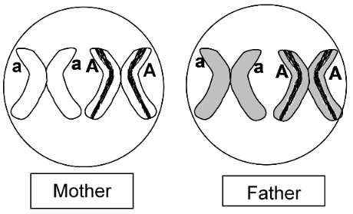
- To prepare the mother’s model chromosomes, use a pair of ah and AH model chromosomes. Tape blank strips of paper to cover the h and H alleles. | 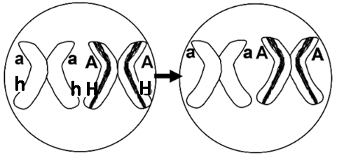
- To prepare the father’s model chromosomes, use a different color pair of the i and I model chromosomes. First, cover the i and I alleles with blank strips of paper. Then, use strips with the a allele or the A allele to finish preparing the father’s model chromosomes. | 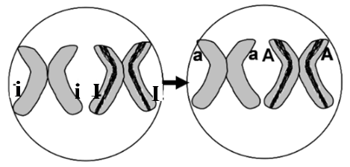
- This chart will guide you as you model meiosis and fertilization. Use chalk, dry erase marker or tape to outline the rectangles of this chart on your lab table. Each white rectangle should be big enough for a model chromosome, and each gray rectangle should be big enough for two.
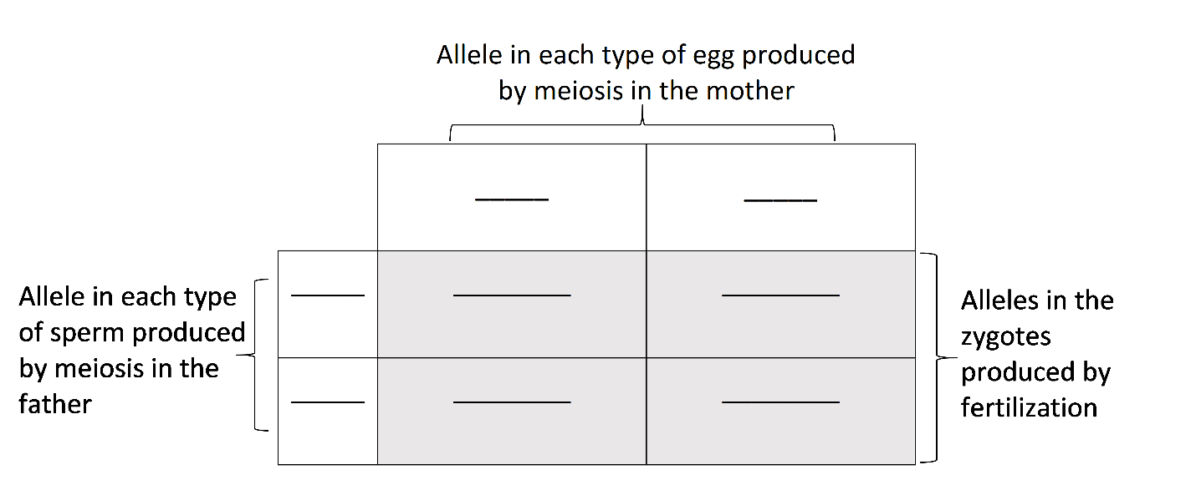
- Use one pair of model homologous chromosomes to demonstrate how meiosis produces eggs. Put a model chromosome for each type of egg in the top boxes in your chart on your lab table.
- Use the other color pair of model homologous chromosomes to demonstrate how meiosis produces sperm. Put a model chromosome for each type of sperm in the boxes on the left in your chart on your lab table.

19. Write the allele for each type of egg and sperm in the appropriate white boxes in the above chart.

- Model fertilization by moving the chromosome from one of the eggs and the chromosome from one of the sperm to produce a zygote which will have one chromosome from the egg and one from the sperm.
- Repeat, using each type of sperm to fertilize each type of egg.

20. Write the genetic makeup of each type of zygote in the appropriate gray box in the chart.

21a. Use the information in the table below to determine the phenotype (albinism or normal skin and hair color) of the mother, the father, and the child who would develop from each zygote. Write these phenotypes in the chart near the top of the page.

Genotype | → | Phenotype (characteristics)
AA or Aa | → | Normal skin and hair color
aa | → | Albinism (very pale skin and hair color)

21b. In the chart near the top of the page, circle the genotypes of each zygote that would develop into a person with the same phenotype as the parents. Use an * to mark the zygote that would develop into a person who would have a different phenotype that neither parent has.

22a. Explain why children often have the same phenotype as their parents.

22b. Explain how a child can have albinism when neither parent has albinism.

Each person has thousands of genes in 23 pairs of homologous chromosomes, so crossing over and independent assortment can produce millions of different combinations of alleles in his/her gametes. If each different type of egg from one mother could be fertilized by each different type of sperm from one father, this would produce zygotes with trillions of different combinations of alleles.

23. Explain why no two siblings inherit exactly the same combination of alleles from their parents (except for identical twins who both developed from the same zygote). A complete answer will include the following terms:
genes, homologous chromosomes, alleles, crossing over, independent assortment, meiosis,
gametes, millions, egg, sperm, fertilized or fertilization, zygote, trillions.

Sexual vs. Asexual Reproduction

Thus far, we have been discussing sexual reproduction in humans. Asexual reproduction involves only mitosis, without meiosis and fertilization. Asexual reproduction occurs in many
types of plants and some types of animals.  This figure shows one type of asexual reproduction. Repeated cycles of DNA replication, mitosis and cytokinesis produce the cells that form a bud. Then, the bud breaks off to form a daughter hydra. | 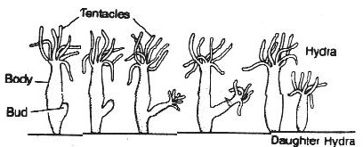  A hydra is an animal that lives in the water and uses its  tentacles to catch food.

24. Are there any genetic differences between the mother hydra and the daughter hydra? Explain your reasoning.

25a. What would be the advantage of asexual reproduction for an organism that lives in a stable environment that does not change?

25b. What would be the advantage of sexual reproduction for an organism that grows in a variable environment that often changes?

by Drs. Ingrid Waldron, Jennifer Doherty, R. Scott Poethig, and Lori Spindler, Department of Biology, University of Pennsylvania, © 2022; Word files for this Student Handout and Teacher Preparation Notes with background information and instructional suggestions are available at https://serendipstudio.org/sci_edu/waldron/#meiosis .

