Some Similarities between the Spread of Infectious Disease and Population Growth

I. The Spread of Infectious Disease
1. An infectious disease is any disease caused by germs such as viruses or bacteria. What are some examples of infectious diseases?

To investigate the spread of an infectious disease, we will assume that:
- At the beginning, only one person is infected. In the figure below, Time 0 shows one infected person. Everyone else is not infected. ☺
- The infectious disease spreads when an infected person interacts with a person who is not infected. During each round of interactions, each person interacts with one other person. Time 1 shows how the infection spread during the first round of interactions.
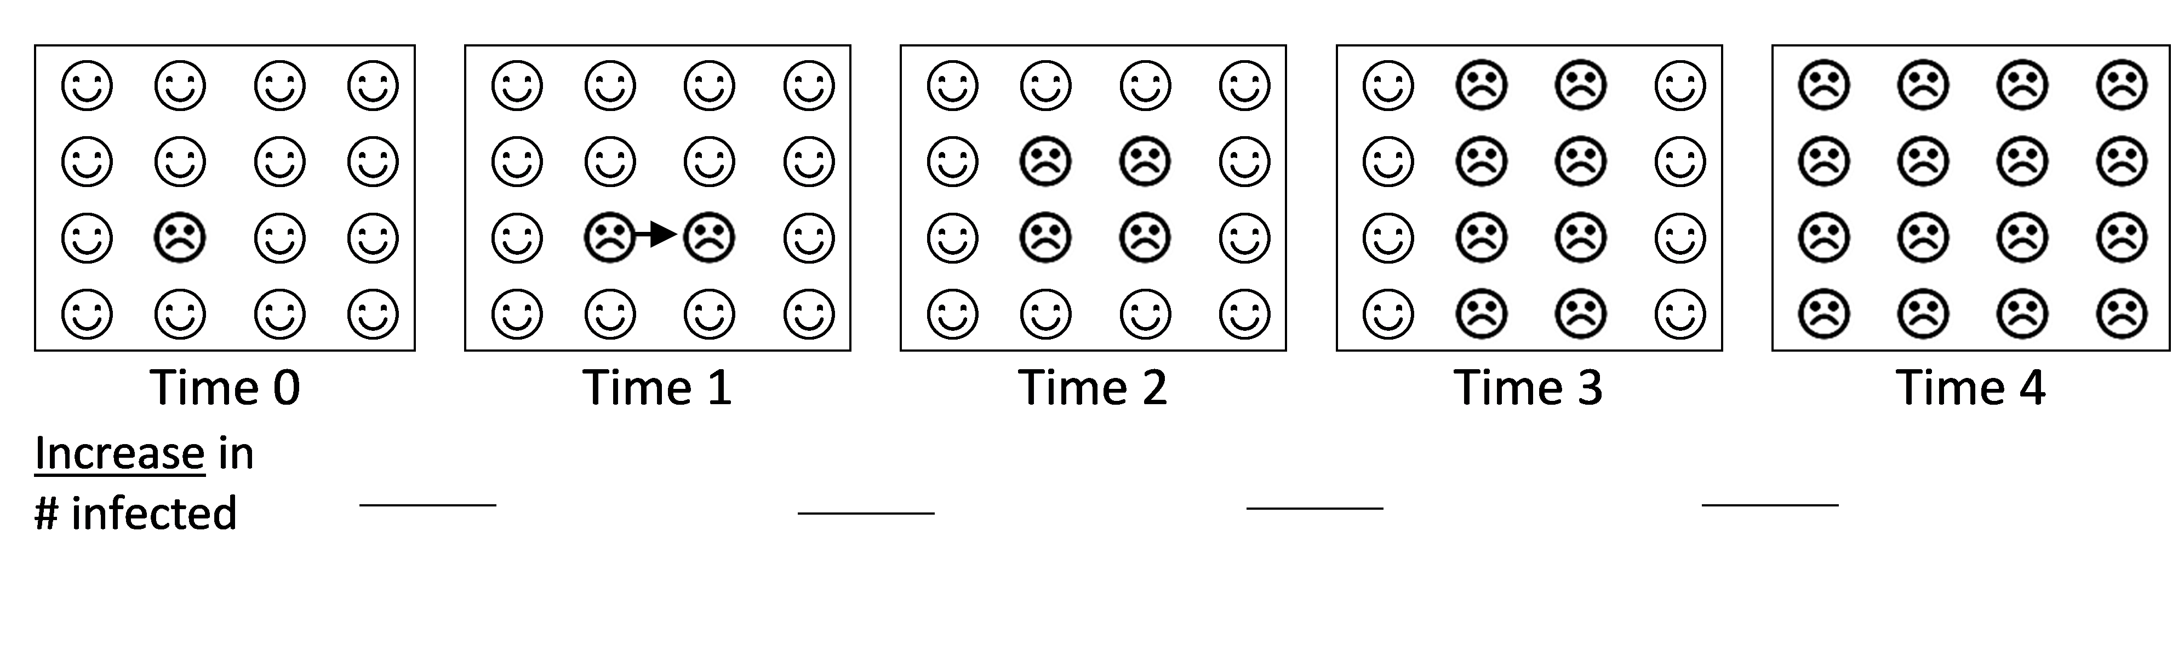

2a. Time 2 shows the results after the second round of interactions. Draw arrows to show how each person who was already infected spread the infection to a nearby newly infected person.

2b. For Times 3 and 4, draw arrows to show how the infection spread during the third and fourth rounds of interactions.

2c. Fill in the “Increase in # infected” blanks to show how many people became newly infected during each round of interactions.

3. Explain why the number of newly infected people was smallest in the first round of interactions and biggest in the fourth round of interactions.
During each round of interactions, each infected person passed the infection to one uninfected person. Therefore, the total number of infected people doubled after each round of interactions. This is an example of exponential growth.

4. Graph the total number of infected people at each time. Connect the points to create a line graph. This graph will show exponential growth.
Next, your class will carry out a simulation of the spread of infectious disease. A simulation is a simplified demonstration of a real life process. In this simulation, you will interact with a different partner during each round of interactions. If you interact with someone who is infected, will become infected and you will be infected for the rest of the simulation.

5a. In this table, predict how many people will be infected after each round of interactions.

Time | 0 | 1 | 2 | 3 | 4 | 5 | 6 | 7 | 8 | 9 | 10
Total # Infected people | 1

5b. Explain the reasons for your predictions.

Simulation Procedure
- Each participant will get a data strip with his/her secret number for time 0. Write your secret number on one of the sticky notes on the back of your data strip.
- When your teacher tells you to interact:
  - Find a partner and show your partner your sticky note with your secret number.
  - Multiply your secret number times your partner’s secret number.
  - Record the product on your data strip as your new secret number and record the name of the person you interacted with.
  - After you have interacted with one partner, go back to your seat. If your secret number has changed, use your second sticky note to write your new secret number and put it on top of the old one.
- Your teacher will tell you when to begin the next round of interactions. For each interaction, move to a different part of the room and interact with a different person.

After the simulation is complete, your teacher will explain the simulation and collect the data.

6. Enter the data from your simulation in this table.

Time | 0 | 1 | 2 | 3 | 4 | 5 | 6 | 7 | 8 | 9 | 10
Total # Infected people | 1

7a. The squares in this graph show exponential growth if the number of infected people doubled at each time. Use dots to graph the data from your simulation.

7b. Describe any differences between your simulation results and exponential growth.

7c. What caused these differences?

8. Where your predictions similar to the simulation results? If not, what was the main cause of the difference?
II. Exponential and Logistic Population Growth

In this section you will learn about some of the similarities between the spread of infectious disease and population growth.

Suppose that a single bacterium is placed in a container with plenty of food for bacteria. After 30 minutes the bacterium divides into two bacteria. Then, every 30 minutes, each bacterium in the container divides in two. Therefore, population size doubles every 30 minutes.

9a. Add to this figure to show how population size doubles from 60 minutes to 90 minutes.

9b. How many bacteria do you think there will be after five hours?

10a. Complete this table to show how many bacteria there will be at each time if the number of bacteria doubles every 30 minutes.
Time (minutes) | 0 | 30 | 60 | 90 | 120 | 150 | 180 | 210 | 240 | 270 | 300
# Bacteria | 1 | 2

Increase in # bacteria ___ ___ ___ ___ ___ ___ ___ ___ ____ _____

10b. Fill in the “Increase in # bacteria” blanks.

11. Why did population size increase slowly at the beginning and more rapidly at later times?

12. Graph the number of bacteria at each time. Connect the points to show the population growth curve.

13. In this example, population size doubled every 30 minutes. This type of population growth is called
___________________ growth.

14. A real population of bacteria cannot keep increasing exponentially forever. Why not?

15. Each individual in a population needs resources like food and water. As a population gets bigger,

competition for resources ________________. Increased competition results in increased mortality
(decreases / increases)
and/or decreased reproduction. Therefore, the rate of population growth ____________________.
(slows down / speeds up)
Eventually, the population will reach a maximum size which is called the carrying capacity of the environment. The carrying capacity depends on the amount of resources available in the environment. This type of population growth is called logistic population growth.

16a. One curve in this figure shows logistic population growth and the other curve shows exponential population growth. Label the curve that shows logistic population growth.

16b. Which population growth curve shows the effects of competition?
exponential ___ logistic ___ both ___ neither ___

16c. Notice that the difference between the exponential and logistic population growth curves is small at the beginning and
bigger at later times. Explain why.

The graph on the left below shows approximately logistic growth for a laboratory population of Paramecia. The graph on the right below shows approximately logistic growth in the total number of people infected during an Ebola epidemic in Guinea.

17. For each graph, match each letter to the correct item in the list below the graph.
Population Growth | Spread of an Infectious Disease
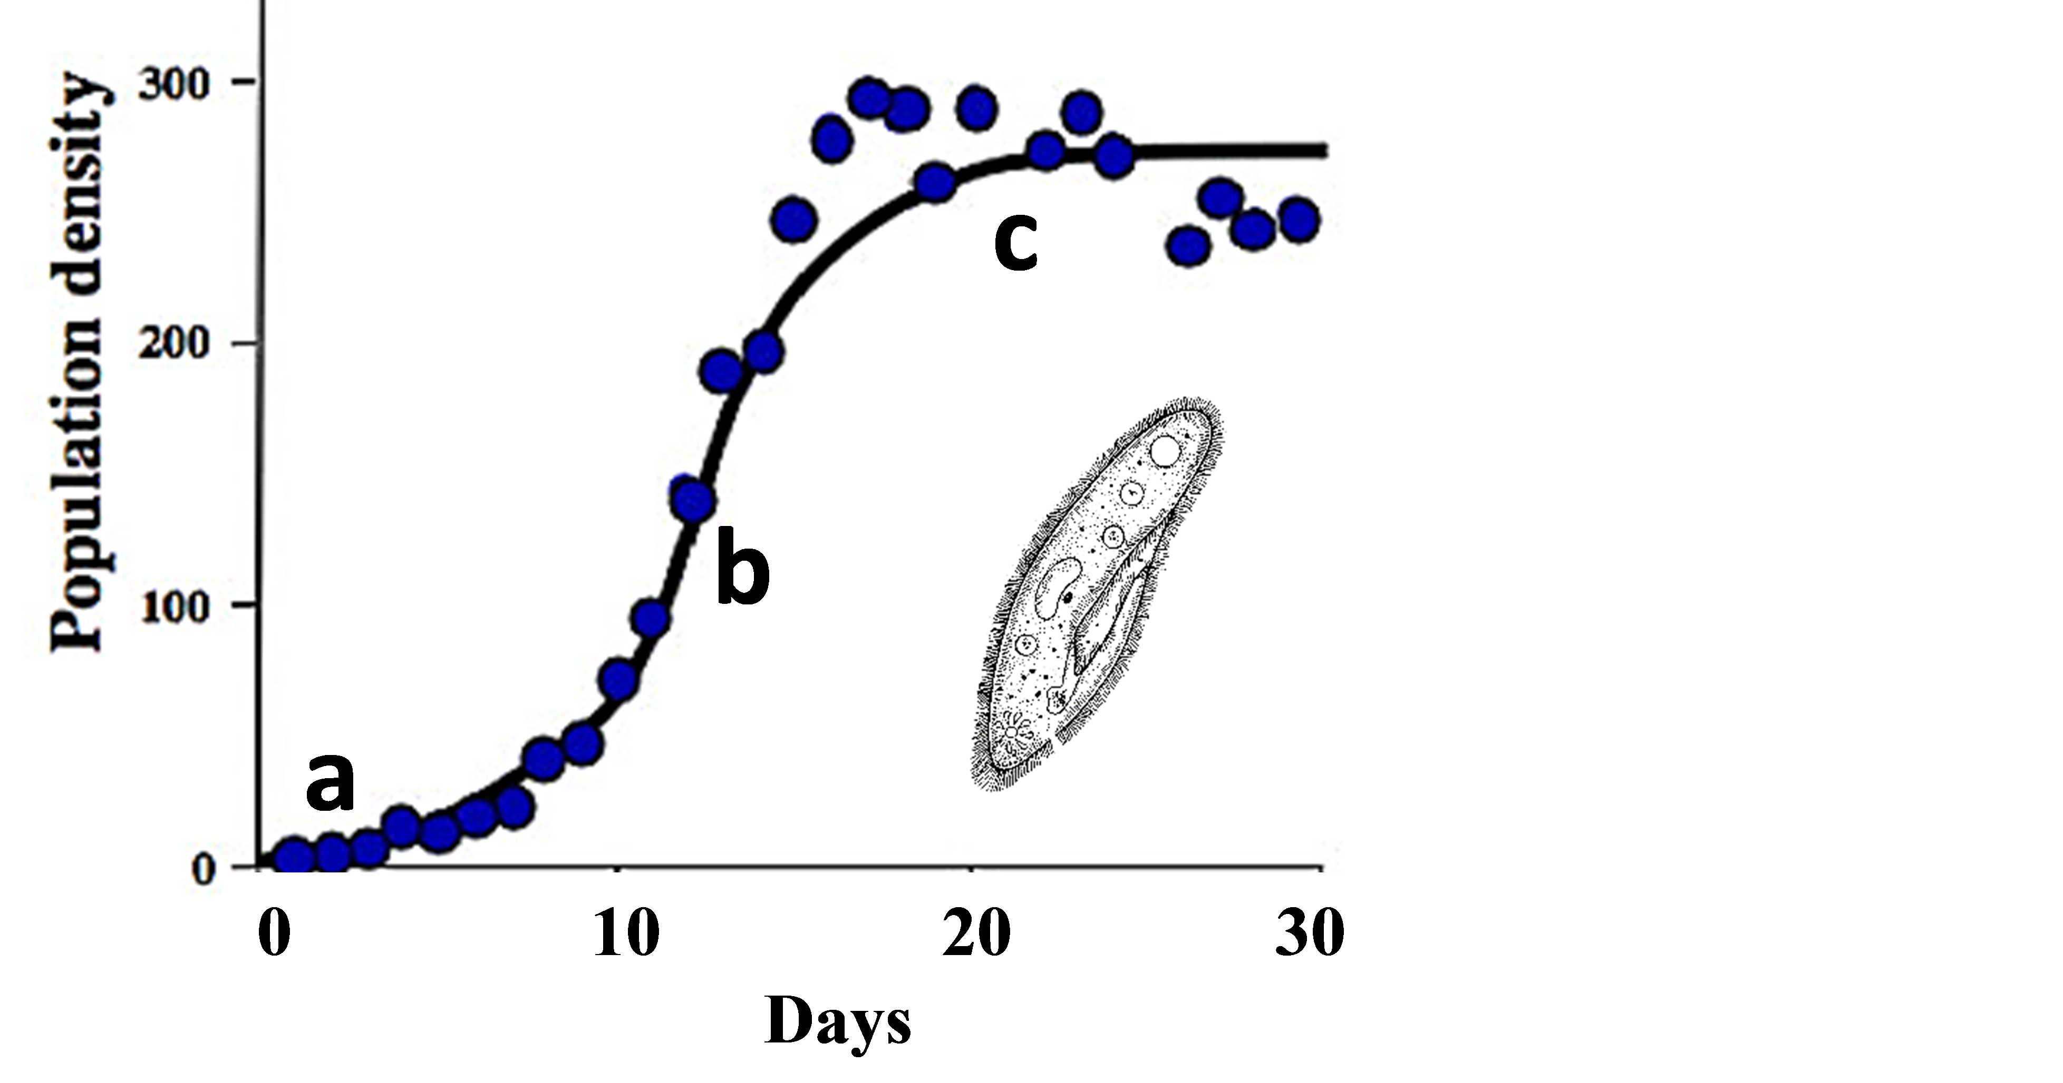 | 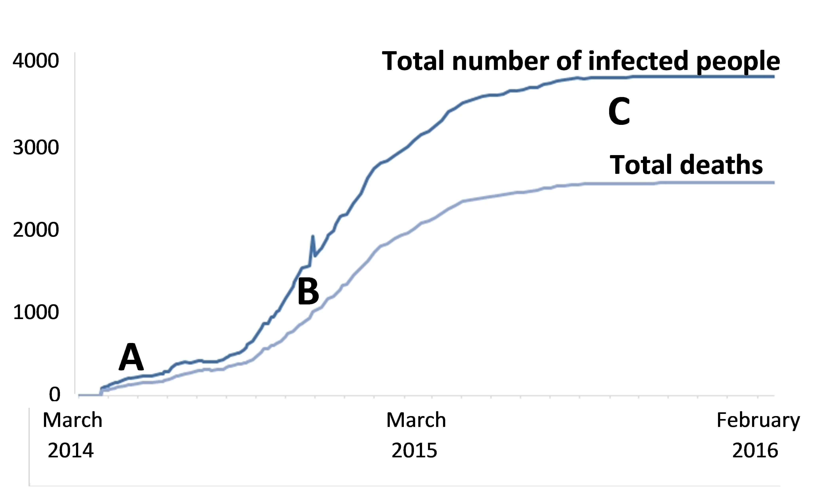
___Population growth was slow because there were only a few paramecia reproducing.  ___Population growth stopped because greater competition for food had increased mortality and/or reduced reproduction.  ___Population growth was faster because there were quite a few reproducing individuals and not too much competition for food. | ___Spread of infection was slow because few people had Ebola and could pass on the infection.  ___Spread of infection stopped because more effective sanitary precautions prevented new infections.  ___Spread of infection was faster because there were quite a few infected individuals and not enough sanitary precautions.

Notice the similarities in the processes responsible for both types of logistic growth.
III. Population Growth Models vs. Complex Reality
A model is a simplified representation of reality that can help us to understand a real-world phenomenon. However, a model may be too simple to accurately describe a complex real-world situation. For example, the exponential and logistic population growth models can help us understand some trends in population size, but not others.

18a. This graph shows seasonal changes in population size for a population of rabbits that lived in Ohio. How did population size change from October to January each year?

18b. Does population size ever decrease in the exponential or logistic population growth models?

18c. What caused the decrease in population size between October and January? Was carrying capacity constant?

A real world population is part of a complex ecosystem that includes the physical environment and communities of different types of organisms. In many marine ecosystems off the western coast of North America, sea otters are part of this food chain.
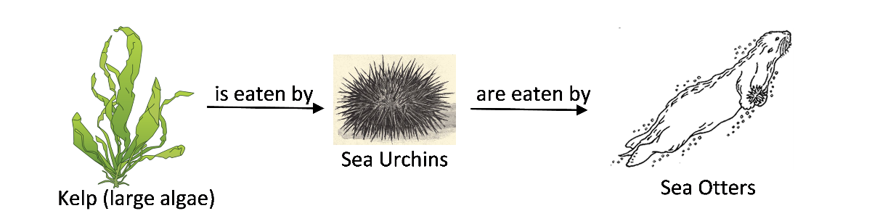

Do you think that changes in the number of sea otters would affect the abundance of kelp? To learn more, view the video at https://ww2.kqed.org/quest/2014/02/25/balancing-act-otters-urchins-and-kelp/.

19a. How does a decrease in sea otter population size affect sea urchin population size?

19b. How does a decrease in sea otter population size affect kelp population size?

20. To summarize what you have learned thus far, fill in one match per blank. (You may use each match more than once.)
The exponential population growth model includes ____
The logistic population growth model includes ____ ____
In the real world, population size can be affected by ____ ____ ____

- increases in population size as a result of reproduction
- the effects of changes in the environment
- the effects of competition for limited resources

By Drs. Ingrid Waldron and Jennifer Doherty, Dept Biology, Univ Pennsylvania, © 2018. This Student Handout (which may be copied for classroom use) and the Teacher Preparation Notes with instructional suggestions and biology background are available at http://serendipstudio.org/sci_edu/waldron/#infectious.

