**Teacher Preparation Notes for: “UV, Mutations, and DNA Repair”[1]**

Students learn about the effects of UV light, mutations and DNA repair on the survival of prokaryotes and the risk of skin cancer. In the first experiment, students evaluate the effects of different durations of UV exposure on survival and population growth of *Haloferax* *volcanii*. This experiment also tests for photorepair of DNA damage. Students design the second experiment, which evaluates the effectiveness of sunscreen. In addition, students answer analysis and discussion questions that promote their understanding of molecular biology, cancer, and the interpretation of experimental results.[2]

**Table of Contents**

**I. Learning Goals** – pages 1-2

**II. Supplies, Equipment and Instructions for Preparation** – pages 2-4

**III. Instructional Suggestions and Background Information**

1. General Information – page 5

2. Overall Sequence and Suggested Timeline for this Activity – pages 5-6

3. Introduction (Section I of the Student Handout) – pages 6-8

4. Testing for DNA Damage and Photorepair of DNA in *Haloferax volcanii* (Section II of the Student Handout) – pages 8-10

5. How well does sunscreen protect against UV light? (Section III of the Student Handout) – page 10

6. Mutations and Cancer (Section IV of the Student Handout) – pages 11-12

**IV. Possible Extension Activities and Follow-Up Activities** – pages 12-13

1. **Learning Goals**

1. General Learning Goals

In accord with the Next Generation Science Standards[3]

* Students learn the Disciplinary Core Ideas:
* LS1.A: Structure and Function – "All cells contain genetic information in the form of DNA molecules."
* LS3.B: Variation of Traits – "… Environmental factors can also cause mutations in genes."
* Students engage in the science practices of
* planning and carrying out investigations
* analyzing and interpreting data
* constructing explanations.
* This activity can help students to understand the Crosscutting Concepts:
* Cause and effect: Mechanism and explanation
* Stability and change.
* This activity helps to prepare students for the Performance Expectation:
* HS-LS3-2. "Make and defend a claim based on evidence that… genetic variations may result from… mutations caused by environmental factors"

2. Specific Content Learning Goals

* UV light can damage DNA. For example, when UVC strikes a DNA molecule, two nucleotides that are next to each other in a DNA strand can bond together and form a dimer. A dimer can prevent replication and transcription of DNA.
* Cells have molecular mechanisms for repairing DNA damage, including photorepair, which uses energy from visible light to repair DNA damage caused by UV light.
* If DNA damage is not repaired or is repaired inaccurately, this results in a mutation (a permanent change in the DNA). Mutations can result in cell death or in changed characteristics of cells. For example, mutations can result in the development of cancer cells, which multiply excessively and spread abnormally.
* Atmospheric ozone reduces UV exposure, especially UVC exposure; this explains why *Haloferax* (as well as humans and other terrestrial organisms) are able to survive and reproduce in very sunny environments.
* Sunscreen also reduces UV exposure, which can help to prevent sunburn and skin cancer.

**II. Supplies, Equipment and Instructions for Preparation**[4]

1. *Agar plates* (12 per class plus additional plates to grow the *Haloferax* (see 2 below); 8 for the first experiment; 4 for the sunscreen experiment)

The recommended amount of supplies is based on the assumption that you will purchase one UV bulb and make one exposure box. As a result:

* for the first experiment, you will have enough time in a 50-minute class period to expose

~8 plates to UV light.

* for the sunscreen experiment, you will have enough time to expose 3 or 4 plates to UV

light.

If you are able to purchase two bulbs and make two UV exposure boxes, this will expedite the experimental procedure and, if you obtain additional agar plates, you will be able to increase the number of plates and amount of data per class.

Obviously, you will need petri dishes. You can make suitable agar medium using either of the following recipes. You will be able to pour three plates per 100 milliliters of H2O.

Table 1. Recipe using mainly ingredients that can be obtained from a grocery store

|  |  |
| --- | --- |
| **Ingredient** | **g/100 ml of H2O** |
| BactoTM Tryptone, Pancreatic Digest of Casein by Becton, Dickinson and Company | 0.5 |
| DifcoTM Agar, Granulated, Solidifying Agent by Becton, Dickinson and Company | 1.5 |
| Morton Salt without Iodide | 15 |
| Relief MD Epsom Salt (Unscented) | 5 |
| Nu-Salt by Cumberland | 1.0 |
| Regular Strength Antacid- Peppermint Flavor Calcium Rich- Shoprite Brand: Active Ingredient: Calcium Carbonate 500 mg (TUMS) | Crush half of the  calcium pill with  mortar and pestle |

Table 2. Laboratory grade recipe (Tripepi et al. 2010[5])

|  |  |
| --- | --- |
| **Ingredient** | **g/100 ml of H2O** |
| BactoTM Tryptone, Pancreatic Digest of Casein by Becton, Dickinson and Company | 0.5 |
| BactoTM Yeast Extract, Dickinson and Company | 0.3 |
| DifcoTM Agar, Granulated, Solidifying Agent by Becton, Dickinson and Company | 1.5 |
| NaCl | 12.5 |
| MgCl2.6H2O | 4.5 |
| MgSO4.7H2O | 1.0 |
| KCl | 1.0 |
| CaCl2.2H2O | 0.134 |

While stirring, carefully bring the water, tryptone and agar (for Laboratory grade recipe, also yeast extract) to a boil in a flask that is at least twice the volume of the water. After boiling it twice, the agar should be completely dissolved, upon which you can add the salts and return to the hot plate. When this medium is boiling, quickly remove it from the hot plate to prevent the liquid from boiling over. Repeat this process at least 3 times until the mixture appears clear and the salts are completely dissolved. At this point any salt-loving microorganisms that were associated with the salts should have been killed. Stirring continuously at slow speed, let the media cool down to 50-60°C before pouring the plates. Use at least 30 ml per plate so the plates won’t dry out during the growth period for *H. volcanii*.

After you pour the plates, they should be stored upside down in plastic bags and kept in a refrigerator. Because of the high salt concentration of the agar, potentially infectious organisms cannot grow on these plates so they may be disposed of without special precautions.

2. *Haloferax volcanii*: To obtain *Haloferax* *volcanii,* please write Dr. Mecky Pohlschroder ([pohlschr@sas.upenn.edu](mailto:pohlschr@sas.upenn.edu)) with your request. She will send you a culture-soaked filter disk that can last for a couple of weeks. Use forceps to hold the filter disk and spread it across an agar plate. The culture on the agar plate can last up to three months, but it is probably best to use a Q-tip or a spreader to streak the *Haloferax* onto a fresh agar plate every 6-8 weeks if you are not going to do the activity within that time. Rub your spreader gently on the plate with *Haloferax* and then spread the *Haloferax* onto the new plate. Make sure to cover the whole plate. The plate should be stored in a plastic bag (to prevent drying out) upside down with the lid on the bottom (to prevent moisture from accumulating on the agar). At room temperature you should see colonies within a couple of weeks and they will survive for at least 6-8 weeks after which they should be restreaked onto fresh plates if you are not going to do the activity within that time.

Each culture plate will provide enough *Haloferax* for students to prepare at least 20 experimental plates. To have optimal *Haloferax* for the experiment, prepare the culture plates so that the *Haloferax* can grow for ~2-3 weeks at room temperature (or 3-5 days at 40-45°C if you have an incubator, see below). Use these plates for the student activity within 4 weeks.

We have chosen the halophile, *Haloferax volcanii*, for this experiment because it is harmless and no pathogens can grow on the very salty agar that *Haloferax* grows on. Therefore, growing *Haloferax* and the experiments in this activity are safe even without the use of sterile procedures. However, if you are teaching microbiology, you will probably want to have your students follow ASM Biosafety Guidelines for this BSL1 microorganism (<http://www.asm.org/images/asm_biosafety_guidelines-FINAL.pdf>).

3. 45oC incubator (optional) – *Haloferax* will grow best at 45°C (~3-5 days growth required at 45°C versus ~2-3 weeks at room temperature).You can make a suitable incubator from a Styrofoam cooler (~30 cm high and 30 x 45 cm area at the top) with the bottom part lined with a large heating pad (~30 x 59 cm) and something like a tissue box on top of the heating pad to serve as a support for the plates. While the *Haloferax* will grow well at temperatures in the 40°-45°C range, you should avoid exposing *Haloferax* to temperatures above 45°C.

4. UVC compact germicidal bulb (1) (UVC Germicidal CFL Lamp bulb Voltage 120V Wattage: 15W Base: E26 Medium screw base Compact Germicidal Bulb).

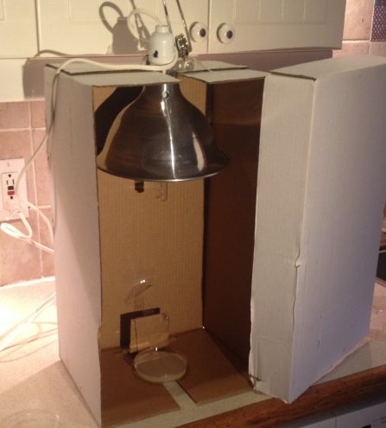5. UV exposure box (1) You can make a UV exposure box from a photocopy paper box and a clamp lamp as shown in the figure on the right. A cutout at the top of the box will hold the UV lamp in place. It is important for the UV lamp to be set inside the box to minimize the risk of UV exposure for students. Set the light straight in the cutout so it will irradiate every part of the petri dish (plate) with the same intensity. After the box is assembled, put on protective glasses, turn on the light, and position an empty petri dish to be at the center of the light; mark this location to indicate where the plate should be put each time. Cut the bottom edge off the box lid to make it easy to slide the lid on and off for each UV exposure.

6. Goggles

7. Q-tips (4-8 per class) or spreaders (4-8)

8. Plastic wrap (enough to cover 12 plates in each class)

9. Aluminum foil (enough to wrap around four plates in each class)

10. Permanent markers (4-8)

11. Pieces of thick paper or quarters of a petri dish lids (3)

To shield quadrant sectors of each plate from the UV light (see instructions on pages 4-5 of the Student Handout), you can use pieces of thick paper (e.g. index cards) or quarters of a plate lid.

If you use pieces of thick paper, you can use the pattern on the last page of these Teacher Preparation Notes to cut three paper pieces that each cover one quarter of the plate. To prevent these pieces from slipping on the saran wrap, provide tape for your students to put a loop of tape under each piece to secure the pieces to the plastic wrap before the UV exposures.

If you use lid quarters, you can cut them using a hot razor blade held in forceps. Use tape to secure the first quarter lid piece before the UV exposure.

12. SPF 15 spray sunscreen

**III. Instructional Suggestions and Background Information**

1. General Information

Before beginning this activity, your students should have a basic understanding of DNA structure and function. For this purpose we recommend the version of our "DNA" activity, which includes extraction of DNA from Haloferax (<http://serendipstudio.org/sci_edu/waldron/#dna>). In addition, students should understand the role of RNA polymerase in transcription and the role of transcription in protein synthesis.

In the Student Handout, numbers in bold indicate questions for the students to answer and

* indicates a step in the experimental procedure for the students to do.

If you use the Word version of the Student Handout to make changes for your students, please check the PDF version to make sure that the figures and formatting in the Word version are displaying correctly on your computer.

A key is available upon request to Ingrid Waldron ([iwaldron@sas.upenn.edu](mailto:iwaldron@sas.upenn.edu)). The following paragraphs provide additional instructional suggestions and background information – some for inclusion in your class discussions and some to provide you with relevant background that may be useful for your understanding and/or for responding to student questions.

2. Overall Sequence and Suggested Timeline for This Activity

We recommend that you pilot test the experiment described on pages 4-7 of the Student Handout to make sure that the specified exposure intervals work satisfactorily for your particular UVC bulb and exposure box. You may want to adjust the time intervals given in the Student Handout to optimize the demonstration of photorepair. Before you begin your pilot test, we suggest that you view our video, which describes and demonstrates the experimental procedure (available at <https://youtu.be/-g0OpR3NQKU>).

Timeline for Student Activity:

Day 1: Introduce the activity with section I – Introduction (pages 1-3 of the Student Handout). You may want to show your students the video at <https://youtu.be/-g0OpR3NQKU> at the end of Day 1, or you may prefer to show it at the beginning of Day 2. If you have been storing your plates in the cold, take them out so they will be at room temperature by day 2.

Day 2: Carry out the experiment described on pages 4-5 of the Student Handout and have students answer questions 6-9. (You may need to postpone discussion of questions 8-9 to day 3 in order to have enough time to complete the UV exposures on day 2).

After the *Haloferax* have grown (~3-5 days if you have an incubator or otherwise ~3 weeks),

analyze and interpret the results of the experiment using questions 10-16 on pages 6-8 of the Student Handout. If there is sufficient time, end with a discussion of question 17; otherwise, you may want to assign question 17 as homework.

Next Class: Develop a plan for the sunscreen experiment, using the top of page 9 of the Student Handout together with a class discussion. Introduce section IV using the information on the top of page 10.

Next Class: Carry out the experiment and have students work on questions 20-21. (You may need to discuss these questions on an additional class day to ensure that you will have enough time to complete the UV exposures.)

After *Haloferax* have grown (~3-5 days if you have an incubator or otherwise ~3 weeks)

analyze and interpret the results of the sunscreen experiment using question 19 on page 9 of the Student Handout.

3. Introduction (Section I in the Student Handout)

|  |  |
| --- | --- |
| UVC and UVB light can be absorbed by DNA molecules; this often results in the production of pyrimidine dimers. These dimers distort the shape of the DNA double helix which stalls RNA or DNA polymerase and thus can disrupt transcription and replication of DNA.  UVA light may also cause formation of dimers. Also, UVA light is absorbed by certain molecules in the cell and this results in the production of oxidative free radicals which are highly reactive and damage DNA and other cellular molecules. | cid:D74CE09A-8084-4327-B14F-ED9816BA2E1B |

High and/or prolonged doses of UVC result in extensive formation of dimers; this increases the likelihood that some of these dimers will be repaired incorrectly or not at all. Unrepaired damage to DNA results in mutations (permanent change in the DNA).[6] Mutations (including dimers) can disrupt cell function sufficiently that the cell cannot carry out its normal functions so it dies or is unable to divide to produce daughter cells. (This effect is demonstrated in the experiment in section II of the Student Handout.) This is why UVC light is sometimes used to disinfect water, laboratory equipment, or medical equipment.

In addition to UV light, ionizing radiation (e.g. x-rays) and some types of environmental chemicals (e.g. some of the chemicals in cigarette smoke) can result in DNA damage and cause mutations. Also, spontaneous mutations (not due to environmental factors) result from errors in DNA replication or naturally occurring damage to DNA caused by molecules produced by cell metabolism.

Damage to DNA is quite frequent, so cells have evolved multiple molecular mechanisms for repairing DNA damage. The Student Handout discusses photorepair of UV-induced damage to DNA; this is of special interest because students can test for photorepair using the low-tech methods of the experiment in Section II. In addition to photolyase, the other molecule that plays a key role in photorepair is a chromophore, which converts light energy to the chemical energy needed for photorepair.

|  |  |
| --- | --- |
| This figure presents data from the research mentioned in question 5[7] in the Student Handout. The top part of this figure shows the quantitative relationship between larger doses of UVC and decreased survival due to more DNA damage. (Note the log scale extending from 100% survival down to 0.001% survival. This graph shows survival for *Halobacterium*, with photorepair after the UV exposure.)  The bottom part of the figure shows differences in survival after UV exposure with recovery in visible light (gray bars) vs. recovery in the dark (black bars). The first two histograms show survival for wild type *Halobacterium* at two different UV doses. *Halobacterium* that recover in the | Figure 1  (<http://genome.cshlp.org/content/14/6/1025/F1.medium.gif>) |

light have higher survival, which provides evidence for photorepair. The last three histograms show results for three mutant strains of *Halobacterium*, two of which have decreased effectiveness of photorepair.

|  |  |
| --- | --- |
| Another very important mechanism for repairing damage to DNA is nucleotide excision repair (see figure).  Notice the importance of the double helix structure of DNA in providing the information for correctly repairing damage. The double helix structure of DNA is also important for accuracy in several other types of DNA repair. | http://www.nature.com/scitable/content/18125/10.1039_b201230h-f3_full.jpg  <http://www.nature.com/scitable/content/18125/10.1039_b201230h-f3_full.jpg> |

Some other types of DNA repair are less accurate and can result in a permanent change to the DNA, i.e. a mutation. DNA damage caused by UV exposure can be repaired by photolyase or nucleotide excision repair (both of which are virtually error-free) or by an error-prone repair system, which uses inaccurate bypass or translesion DNA polymerases.

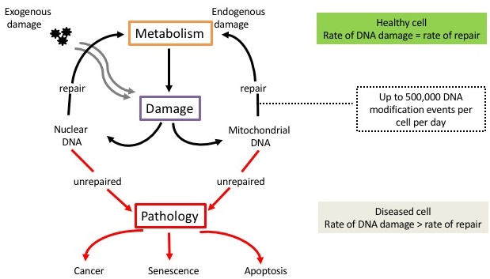If there is limited unrepaired damage to specific genes, the cell may survive but with mutations which may result in altered characteristics (e.g. the excessive cell division observed in cancer cells). (Section IV of the Student Handout describes how mutations can contribute to the development of cancer.)

Useful resources on the topics in this section include:

* "The Molecular Perspective: Ultraviolet Light and Pyrimidine Dimers", available at <http://theoncologist.alphamedpress.org/content/6/3/298.full.pdf+html>
* "DNA Damage and Repair: Mechanisms for Maintaining DNA Integrity", available at <http://www.nature.com/scitable/topicpage/dna-damage-repair-mechanisms-for-maintaining-dna-344>
* "Thymine Dimers: Formation and Repair", a useful animation of photorepair and nucleotide excision repair, available at <http://highered.mheducation.com/sites/0072995246/student_view0/chapter20/thymine_dimers_formation_and_repair.html>

4. Testing for DNA Damage and Photorepair of DNA in *Haloferax volcanii* (Section II in the Student Handout)

For accurate assessment of the effects of UV light:

* Students need to **spread** the *Haloferax* **evenly** over the entire plate using a Q-tip or a spreader.
* To ensure consistent intensity of the UV light, the **UV lamp** should be **on for 5 minutes to warm up before** the UV exposures begin. Then, the lamp should be turned off before removing the box lid to put in the first plate.

After the plates have been exposed to UV light and the "no visible light exposure" plates have been wrapped in aluminum foil, all the plates should be left near a window for 1-3 hours. (There is no need for direct sunlight.) Note that this will provide similar conditions for both the wrapped and unwrapped plates during this time, as discussed in the answer to question 8 in the Student Handout. After the visible light exposure, remove the aluminum foil from the wrapped plates and put all of the plates, bottom-side-up, in the incubator for ~3-5 days or put in the dark at room temperature for ~2-3 weeks.

In your discussion of question 9, you may want to show a helpful video about what happens when you get a sunburn, available at <http://www.cancerresearchuk.org/about-cancer/causes-of-cancer/sun-uv-and-cancer/how-the-sun-and-uv-cause-cancer>.

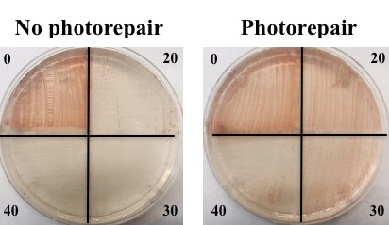The photographs on the right show an example of photorepair. When there was no photorepair, a lawn was only observed after 0 seconds of UV exposure. In contrast, when UV exposure was followed by photorepair, a lawn was observed after 0, 20 and 30 seconds UV exposure. (We used different times during the development of this activity, but this figure nicely illustrates the general pattern of response.)

You may want to post the table below on the board for your students to record their results. Have students use L if there was a lawn on the sector and – if there was no lawn. Then, you can use the data in this table to calculate the percentages needed for the table in question 12a in the Student Handout.

|  |  |  |  |  |  |  |  |  |  |  |
| --- | --- | --- | --- | --- | --- | --- | --- | --- | --- | --- |
| Visible Light Exposure | | | | |  | No Visible Light Exposure | | | | |
| Group ID | 0 secs. UV | 15 secs. UV | 30 secs. UV | 45 secs. UV | Group ID | 0 secs. UV | 15 secs. UV | 30 secs. UV | 45 secs. UV |
|  |  |  |  |  |  |  |  |  |  |
|  |  |  |  |  |  |  |  |  |  |
|  |  |  |  |  |  |  |  |  |  |
|  |  |  |  |  |  |  |  |  |  |

If the results of the experiment were entirely consistent for each combination of UVC exposure duration and whether or not there was follow-up exposure to visible light, then all the numbers in the table in question 12a would be either 0% or 100%. If any of the numbers in that table are between 0% and 100%, this means that *Haloferax* growth differed on some of the sectors that were supposed to have the exact same exposures. You may want to ask your students what factors might account for any differences in results for sectors that should have had the exact same exposures (e.g. differences in the amount of *Haloferax* spread on the plate, differences in UV exposure due to experimental error, differences in speed and thoroughness of wrapping in aluminum foil).

As shown in the figure in question 17, ozone in the atmosphere absorbs virtually all UVC, so little or no UVC reaches the earth's surface. We have nevertheless chosen a UVC bulb for the experiment because only relatively brief UVC exposures are needed to produce observable effects on *Haloferax*; this is necessary to meet the time constraints of a classroom experiment. An informative article, "Ozone and UV: Where are we now?", is available at <http://www.skincancer.org/prevention/uva-and-uvb/ozone-and-uv-where-are-we-now> . An informative video, "The Antarctic Ozone Hole", is available at <http://vimeo.com/104321114>.

*Haloferax* are able to survive in very sunny environments because of the protective effects of ozone; because the *Haloferax* have very effective repair of the DNA damage caused by UVB and UVA; and because the carotenoids that give *Haloferax* their pink color help to protect *Haloferax* by absorbing UV light.

5. How well does sunscreen protect cells against UV light? (Section III in the Student Handout)

Your class discussion of student proposals for experimental design in response to question 18 will provide the basis for designing a class experiment to test whether sunscreen with an SPF of 15 increases the lethal exposure time by a factor of 15. Given the long exposure times required to test this hypothesis, you will probably only be able to expose 3 or 4 plates in a 50 minute class period. In order to expedite the experiment, we recommend:

* In this sunscreen experiment, only test *Haloferax* survival and growth after exposures with sunscreen; compare these new results with the no-sunscreen results from the first experiment (on page 7 of the Student Handout).
* Plan for an experiment with no photorepair.

For this experiment, it is important for students to gently pull the plastic wrap tight to get rid of all wrinkles; the plastic wrap should be stretched evenly over the agar plate. A student should spray the plastic wrap from a distance of about 1 foot and spray on as even a layer as possible of the sunscreen. You may want to hold the plate while each student sprays; this can help to make the replicate spray plates somewhat more consistent.

Since there will probably only be 3 or 4 plates to observe, we recommend that you take color photographs of the plates. Students can use these photographs to score the results, using the same methods as for the first experiment. Comparison of these results with the results on page 7 of the Student Handout will provide the data for students to test whether SPF 15 sunscreen increased the lethal exposure time by a factor of 15 (question 19b).

One major clinical trial in a semitropical region of Australia supports the expectation that sunscreen lotions or creams that block UV light reduce the risk of melanoma and other types of skin cancer. However, many people do not apply sufficient quantities of sunscreen as often as needed to provide adequate protection. For advice on appropriate use of sunscreen see <http://www.mayoclinic.org/healthy-lifestyle/adult-health/in-depth/best-sunscreen/art-20045110>, especially the last section. Other methods of protecting your skin and eyes from UV damage include staying indoors during the middle of the day, staying in the shade, and wearing protective clothing.

One concern is that many people are vitamin D deficient and a primary source of vitamin D is production in sun-exposed skin. Alternative sources of vitamin D are diet and/or supplements. Adequate levels of vitamin D have multiple health benefits, including strong bones and possible reduction in risk of some types of cancer (<http://www.medicalnewstoday.com/articles/161618.php>).

6. Mutations and Cancer (Section IV in the Student Handout)

This section introduces students to the accumulation of somatic mutations as a basic biological process responsible for the development of cancer. (Somatic mutations are mutations that occur in somatic cells such as skin cells and not in the reproductive cells such as sperm and eggs.) This illustrates the general principle that mutations influence the characteristics of cells.

The top half of page 10 of the Student Handout provides a very brief introduction to the biology of cancer. For additional background on the biology of cancer, you may want to read "Understanding Cancer" (available at <https://science.education.nih.gov/supplements/nih1/cancer/guide/understanding1.html>).

Page 10 in the Student Handout focuses on melanoma, the most deadly form of skin cancer. The risk of melanoma is particularly increased by intermittent exposure to intense sunlight, especially during childhood and adolescence; increased number of sunburn episodes during childhood and adolescence is associated with increased risk of melanoma. Frequent use of indoor tanning facilities before age 35 is also associated with a substantial increase in risk of melanoma. (A useful overview of melanoma is available at <http://cdn.intechopen.com/pdfs-wm/42734.pdf>.)

|  |  |
| --- | --- |
| Melanoma cells are derived from melanocytes. Melanocytes produce the protective skin-darkening pigment, melanin, and provide melanin to nearby keratinocytes. The keratinocytes migrate toward the surface of the skin (which would be upwards in this figure) and mature into the flattened cells of the outer skin layers. | http://www.lephysique.com/wp-content/uploads/2014/07/Screen-Shot-2014-07-10-at-9.10.50-AM.png  (<http://www.lephysique.com/wp-content/uploads/2014/07/Screen-Shot-2014-07-10-at-9.10.50-AM.png> ) |

Two other important types of skin cancer are basal cell carcinoma and squamous cell carcinoma. Risk of basal cell carcinoma seems to be associated with both chronic and intermittent sun exposure. Risk of squamous cell carcinoma is associated more with chronic sun exposure. Scientists don’t understand why the different types of skin cancer are associated with different patterns of sun exposure.

As discussed in question 21, mutations in genes that code for proteins involved in DNA repair contribute to the development of cancer. DNA repair is important in preventing temporary changes in DNA from becoming mutations, i.e. permanent changes in DNA. We should note that we are not aware of any evidence that defects in photolyase contribute to cancer. However, defects in other proteins involved in DNA repair (not specifically mentioned in the Student Handout) are associated with increased risk of cancer. ([http://www.nature.com/scitable/topicpage/dna-damage-repair-mechanisms-for-maintaining-dna-344#](http://www.nature.com/scitable/topicpage/dna-damage-repair-mechanisms-for-maintaining-dna-344)).

If would like your students to learn more about cancer, you may want to use the optional questions shown on the next-to-the-last page of these Teacher Preparation Notes. The slow process of accumulating cancer-causing mutations in a single cell line helps to explain the long lag time typically observed between carcinogenic exposures and diagnosis of cancer. Another important contributor to this long lag time is the time required for cancer cells to multiply sufficiently for a cancer to be detected. These factors also explain why cancers are much more common in older people.[8] In discussing the long lag time between exposure to a carcinogen and the development of cancer, you may want to mention cigarette smoking as another behavior that contributes to risk of cancer decades later. Mutagenic chemicals (carcinogens) in cigarette smoke increase smokers' risk of lung cancer (approximately tenfold), and also increase the risk of many other types of cancer. Passive exposure to cigarette smoke also increases cancer risk. For additional information see <http://www.cancer.gov/about-cancer/causes-prevention/risk/tobacco/cessation-fact-sheet> .

Programmed cell death (e.g. apoptosis) plays an important role in preventing cells with damaged DNA from surviving to contribute to the development of cancers. Mutations that result in the failure of programmed cell death contribute to the development of cancer. Apoptosis also plays an important role in embryonic development (<https://en.wikipedia.org/wiki/Programmed_cell_death>).

**IV. Possible Extension Activities**

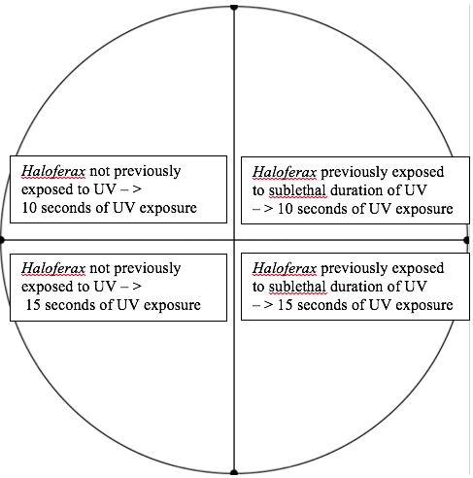After the sunscreen experiment (page 9 of the Student Handout) some students may have additional questions about the effects of different strengths and amounts of sunscreen. This could provide the impetus for interesting individual research projects. Students could also test the effectiveness of sunscreen before and after leaving it in the heat for a couple of days. Exposure to heat (e.g. on the beach or in a hot car in the summer) reduces the effectiveness of most types of sunscreen. Hence, even if a sunscreen has not reached its expiration date it may be much less effective than the labeled value.

You may also want to have your students test whether *Haloferax* that have been exposed to sublethal doses of UVC have accumulated some potentially damaging (but not lethal) mutations. To test this, students can evaluate the effects of a second sublethal UV exposure. Use a spreader to take similar amounts of cells from the unexposed quarter of a plate and from the quarter exposed to a sublethal dose of UVC, and spread each of these samples on half of a new plate. Then, make UVC exposures as shown in this figure and evaluate survival and growth (without photorepair).

**Possible Follow-Up Activities**

The Molecular Biology of Mutations and Muscular Dystrophy (<http://serendipstudio.org/exchange/bioactivities/mutation> )

This analysis and discussion activity will introduce students to other types of mutations. Specifically, students explore the effects of different types of point mutations and deletion mutations and analyze the reasons why deletion mutations generally have more severe effects than point mutations. Students use their understanding of the molecular biology of mutations to analyze the genetic basis for the differences in severity of two types of muscular dystrophy.

A Mutation Story

(<http://www.pbslearningmedia.org/resource/tdc02.sci.life.gen.mutationstory/a-mutation-story/> )

Our *Haloferax* activity focuses on potential harmful effects of mutations. This video shows the potential beneficial effects of some mutations as the raw material for natural selection. Specifically, this video tells the story of the mutation for sickle cell hemoglobin. In an individual who is heterozygous for this allele, the sickle cell hemoglobin has the beneficial effect of reducing the severity of malaria infections. Therefore, the sickle cell allele has become common in many regions where malaria is prevalent.

Understanding the Biology of Cancer (<http://serendipstudio.org/exchange/bioactivities/cancer>)

This analysis and discussion activity introduces students to the molecular and cellular biology of cancer, including the important contributions of mutations in genes that code for proteins involved in regulating the rate of cell division. The questions in this activity challenge students to interpret the information presented in prose, tables and diagrams and apply their knowledge of basic molecular and cellular biology in order to understand multiple aspects of the biology of cancer, including the contributions of a variety of environmental exposures to increased risk for different types of cancer and the long lag between exposure to carcinogens and the diagnosis of cancer.

**Related Learning activity**

Does Sunscreen Protect My DNA? (<http://teach.genetics.utah.edu/content/dna/sunscreenteacher.pdf>) (includes experiment with yeast and suggestions for student investigations)

Optional Additional Page on Cancer for Student Handout

This figure shows how, over a lifetime, mutations can accumulate in a cell line (a cell and its descendants). The development of a cancer requires the accumulation of multiple mutations in a single cell line. Mutations that contribute to the development of cancer are relatively rare, so it typically takes decades for a cell line to accumulate the multiple mutations that cause cancer.

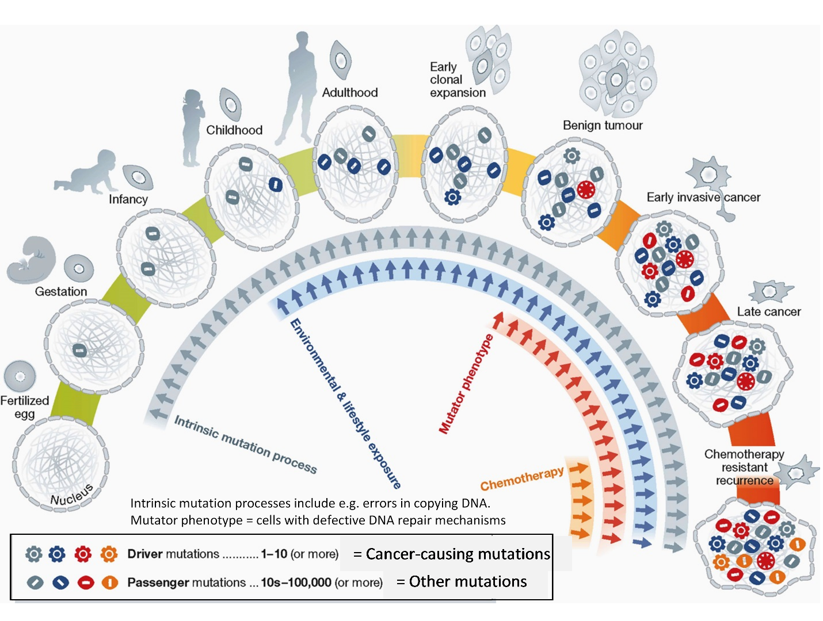

*1 (From: Stratton, M. R. (2013), Journeys into the genome of cancer cells. EMBO Mol Med, 5: 169–172. doi:10.1002/emmm.201202388).*

**22.** Give two examples of environmental and lifestyle exposures that can increase a person’s risk of cancer.

**23.** Explain how your behavior as a teenager (e.g. high exposure to the UV in sunlight or tanning beds) can affect your risk of developing cancer decades later as an older adult.

**24.** If a cell is unable to repair DNA damage, molecular processes within the cell may result in cell suicide (programmed cell death). When a cell in your body has DNA damage that the cell cannot repair, how could cell suicide be helpful?

Template for cutting cardboard pieces for student experiments.



1. By Dr. Ingrid Waldron, Joshua Kouassi, Dr. Manuela Tripepi and Dr. Mecky Pohlschroder, Department of Biology, University of Pennsylvania, 2020. These Teacher Preparation Notes and the related Student Handout are available at <https://serendipstudio.org/sci_edu/waldron/#uvmutations>
2. If you prefer to omit the section on cancer, you can use pages 1-9 of the Student Handout.
3. Quotations from <http://www.nextgenscience.org/sites/default/files/HS%20LS%20topics%20combined%206.13.13.pdf>
4. A Kit (UV-Mutagenesis and Photorepair) containing all required materials to conduct this experiment will be available from Nasco in the near future (<https://www.enasco.com/science/>).
5. 2Tripepi, M. S. Imam and M. Pohlschroder. ***Haloferax volcanii* Flagella Are Required for Motility but Are Not Involved in PibD-Dependent Surface Adhesion▿**
6. The definition of mutations varies in different textbooks, but we prefer this more inclusive definition of mutation as a permanent change in a cell's DNA, including changes in nucleotide sequence, alteration of gene position, gene loss or duplication, or insertion of foreign sequences. It should be noted that the formation of a dimer may not strictly be a mutation since it may be repaired accurately and thus may not result in a permanent change in the DNA; strictly speaking, it would be more accurate to refer to the dimer as DNA damage or a DNA lesion, but we have chosen not to include this additional terminology.

   Most mutations are either neutral or harmful because random changes in the DNA generally do not cause improvements in the alleles that have resulted from evolution by natural selection. However, it should be remembered that some mutations can be beneficial and provide the raw material for natural selection.
7. If your students are not familiar with archaea, you will want to briefly introduce archaea before question 5. Archaea are single-cell prokaryotic organisms like bacteria, but there are many biochemical and molecular biology differences between archaea and bacteria (<http://www.zo.utexas.edu/faculty/sjasper/images/27T.2.gif>). Many archaea are adapted to extreme environments such as very high salt concentrations. Other archaea live in a variety of environments such as the ocean, soil, and the human colon.

   *Haloferax* cells accumulate high concentrations of K+ to balance the high osmotic concentration of the extremely salty environments where *Haloferax* grows. (Many other halophiles accumulate high concentrations of relatively small organic molecules.) *Haloferax volcanii* is not photosynthetic, but instead absorbs nutrients from the environment. Sugars are a preferred carbon source. A brief summary of the biology of Archaea and *Haloferax volcanii* is available at <https://sites.google.com/site/molecularbiologyiw/home/haloferax-molecular-biology>.
8. The tendency for lymphomas and leukemias to occur in younger people can be understood since white blood cells already have many of the characteristics of cancer cells (e.g. the ability to move into other tissues) so fewer mutations are needed for the development of these types of cancers.