**UV, Mutations, and DNA Repair**[1]

**I. Introduction**

Sunlight contains all the colors of the rainbow, as we can see when a prism or water droplets in the air separate light into different colors. These different colors correspond to light of different wavelengths. Sunlight also contains ultraviolet (UV) light, including UVA, UVB and UVC, which have progressively shorter wavelengths.

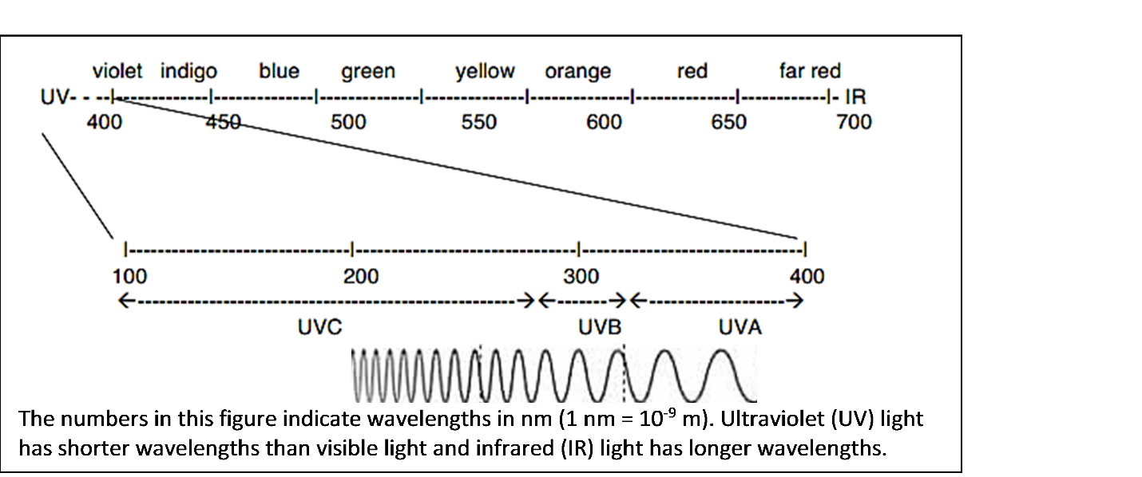

|  |  |
| --- | --- |
| UV light can damage DNA. For example, when UVC light strikes a DNA molecule, two nucleotides that are next to each other in a DNA strand can bond together and form a dimer. The dimer distorts the shape of the DNA double helix.  **1.** Circle and label the dimer in the figure. | C:\Users\Ingrid\AppData\Local\Microsoft\Windows\Temporary Internet Files\Content.Word\figure UV 1.5.png |

|  |  |
| --- | --- |
| This figure shows DNA replication. Two copies of the DNA molecule are made by producing a new matching strand for each old DNA strand.  **2**. In the figure, circle the name of the enzyme that forms the matching DNA strand.  This enzyme moves along the original DNA strand and adds matching nucleotides |  |

one-at-a-time. If the original DNA strand has a dimer, the enzyme is blocked, so DNA replication cannot be completed and the cell cannot divide into two daughter cells.

|  |  |
| --- | --- |
| **3.** The first step in protein production is transcription of a gene in the DNA to make mRNA. Explain how a dimer would interfere with transcription. (Include RNA polymerase in your answer.) |  |

**4a.** Germicidal lights, which produce mainly UVC, are used to kill bacteria. How could exposure to UVC kill a bacterium? (Include dimer, protein and transcription in your answer.)

**4b.** Even if a bacterium is not killed by UVC, the effects of UVC can prevent the bacterium from dividing into two daughter cells. Explain how this could happen. (Include DNA polymerase in your answer.)

|  |  |
| --- | --- |
| **4c.** After a very brief UVC exposure, many of the bacteria may have little or no DNA damage. A longer UVC exposure can cause more DNA damage and thus have a bigger effect on a population of bacteria. Explain why a small population of bacteria can grow to become a much larger population of bacteria after a very brief UVC exposure, but not after a longer UVC exposure. |  |

The DNA in cells is constantly being damaged by:

* UV light and ionizing radiation (e.g. x-rays)
* some types of environmental chemicals
* some of the molecules produced by the cells’ own metabolism

One scientist has estimated that the DNA in a single cell can experience half a million DNA changes per day! If the DNA damage is not repaired or the repair is inaccurate, this introduces a mutation (a permanent change in the DNA). Many mutations have harmful effects.

Clearly, cells need to be able to repair DNA damage in order to maintain the accuracy of the genes that code for needed proteins. In fact, evolution has produced multiple molecular mechanisms for DNA repair.

One type of DNA repair is called photorepair. In photorepair the enzyme, photolyase, uses energy from visible light to break the abnormal bond in a dimer and restore the DNA to its original, normal structure.

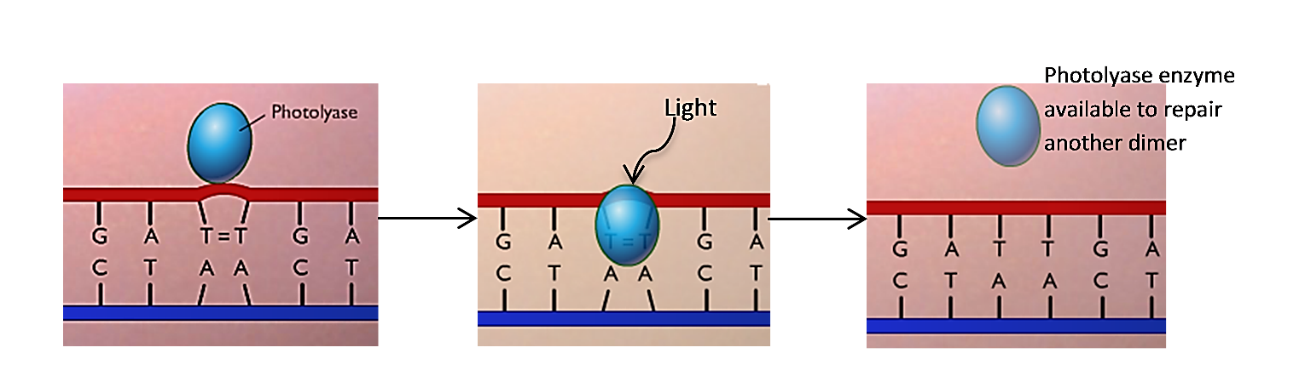

|  |  |
| --- | --- |
| **5.** In one experiment, scientists exposed two populations of archaea to the same intermediate-duration of UVC. (Like bacteria, archaea are single-cell prokaryotic organisms.)  After this UVC exposure, one population of archaea was immediately put in the dark and the other population of archaea had a chance to recover in the light. The population of archaea that recovered in the light had much higher survival and more cell division, resulting in more population growth.  Give a molecular explanation for why the archaea that recovered in the light were more likely to survive and produce daughter cells. |  |

**II. Testing for DNA Damage and Photorepair of DNA in *Haloferax volcanii***

*Haloferax volcanii* is a type of archaea that lives in very salty water such as the Dead Sea, Great Salt Lake, or the very salty brine that results when seawater is evaporated to produce salt. In these very sunny environments *Haloferax* is exposed to intense UV light. Your experiment will test two research questions:

1. What are the effects of different amounts of UVC light on *Haloferax* survival and growth?
2. Does *Haloferax* have a photorepair mechanism that can reverse the DNA damage caused by UVC light?

|  |  |
| --- | --- |
| Each student group will spread *Haloferax* on a plate of agar that contains the nutrients needed by *Haloferax*. For each plate, four sectors will each have a different duration of UVC exposure.  After the UVC exposures, half the plates will be wrapped so the *Haloferax* are not exposed to visible light, and the other plates will not be wrapped so the *Haloferax* can recover in visible light. After a recovery period, the plates will be incubated so any healthy *Haloferax* cells can produce daughter cells. | Duration of UVC exposure |

**6a.** Which research question can be investigated by comparing the wrapped plates vs. the unwrapped plates? ___A ___B

**6b.** Explain your reasoning.

For each sector of the plate:

* If many *Haloferax* cells survive and produce daughter cells, then *Haloferax* will cover the whole sector and you will see a pink coating of *Haloferax* on the agar; this is called a lawn.
* If only a few *Haloferax* cells survive and produce daughter cells, you will see a few colonies; each colony includes the many, many descendants of a single cell that survived UVC exposure.
* If the UVC exposure kills all the *Haloferax* cells in a sector, you will see no growth in that sector.

**7.** In the above figure, use an L to mark the sector that will be most likely to have a lawn.

Use an N to mark the sector that will be most likely to have no lawn and no colonies.

Experimental Procedure

* Each group should get and label a plate.
* On the bottom draw four sectors and label each sector with the appropriate duration of UVC exposure, as shown in the above figure.
* If your group has been assigned a plate that will be wrapped and have no Visible Light Exposure after the UVC exposures, write "no VLE". If your plate will not be wrapped, write "VLE".
* Add your group initials.

|  |  |
| --- | --- |
| * Rub your swab (Q-tip) gently on the plate with *Haloferax*. Streak the *Haloferax* onto your plate. Make sure to cover the whole plate by first spreading the *Haloferax* cells from one side to the other in one direction and then rotating the plate 90° and spreading the *Haloferax* cells from one side to another in the perpendicular direction. | Macintosh HD:Users:pohlschr:Desktop:Screen Shot 2016-02-02 at 3.53.14 PM.png |

* To prepare the plate for UVC light exposure, you will take the lid off the plate and cover the plate with plastic wrap. (UVC can penetrate the plastic wrap to reach the *Haloferax*. UVC cannot penetrate the lid of the plate.) Spread your piece of plastic wrap flat (no wrinkles) on your lab table, place the plate upside down onto the plastic wrap, and pull the plastic wrap tightly around the plate. (You will probably need to tug the plastic wrap tight at four or five points around the plate to get rid of all the wrinkles. Cut off any excess plastic wrap on the bottom.)
* As shown in the table below, you will make three 15 second UV exposures for each plate; for each 15 second exposure, pieces of heavy paper or plastic lid on the plastic wrap will cover specific sectors of the plate to prevent the UV light from reaching the *Haloferax* on those sectors.

|  |  |  |  |  |
| --- | --- | --- | --- | --- |
|  | Sectors which will be covered by cardboard pieces | | | |
| 0 sec. | 15 sec. | 30 sec. | 45 sec. |
| During the first 15 sec. exposure | ✓ | ✓ | ✓ |  |
| During the second 15 sec. exposure | ✓ | ✓ |  |  |
| During the third 15 sec. exposure | ✓ |  |  |  |

* Since ***UV rays can be harmful***, the UV light will be inside a protective cardboard box. To prepare for each UV exposure, put your plate on the circle marking the center of the UV light and place the paper or lid pieces to cover the appropriate sectors.
* Put the cover on the front of the box before you turn on the UV light. Also, the student who is making the exposure will wear goggles. Do *not* look at the lamp or expose your skin to UV. Turn on the UV light switch which is outside the box for 15 seconds for each exposure.
* As soon as the UV exposures have been completed, take off the plastic wrap and put the lid back on your plate. If you have been assigned a plate with no visible light exposure, immediately wrap your plate in aluminum foil.
* Give your plate to your teacher.

*While you're waiting for all the groups to finish the UV exposures, answer questions 8 and 9.*

**8.** The unwrapped plates will be put near a window for exposure to the visible light that is needed for photorepair. Should the wrapped plates also be put near the window or should they be put in a dark drawer? Explain your reasoning.

**9.** UVB and UVA are contained in sunlight and in the light from tanning lamps. UVB and UVA can induce mutations in the DNA of your skin cells. After intense exposure to sunlight or tanning lamps, the DNA of some skin cells is so severely damaged that the cells die. If the amount of UV exposure is sufficient to cause sunburn, dead cells will be removed as part of the peeling skin.

With shorter or less intense exposures to the UV in sunlight or the light from tanning lamps, skin cells with less severely damaged DNA can survive. Will the mutations in the DNA of these cells be inherited by your future children? Explain why or why not.

Results (*to be completed after the Haloferax on the plates have grown for several days*)

**10.** Draw the growth on your plate. Label each sector with:

* L if it had a lawn
* C if it had colonies
* N for no colonies or lawn.

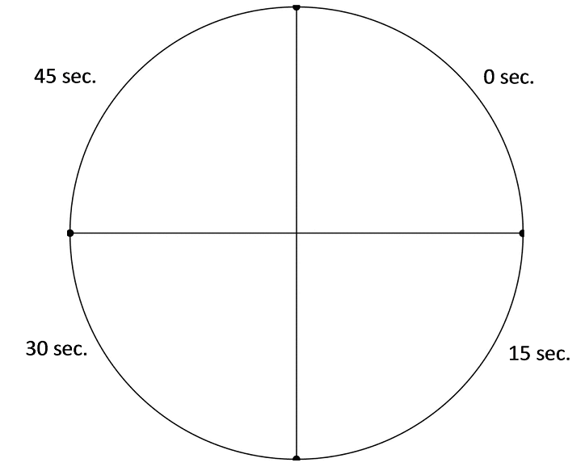

Was your plate ___ no VLE or ___ VLE?

Report your results to your teacher.

*While you're waiting for your teacher to compile the results from all the groups, answer question 11.*

**11.** Explain how a few *Haloferax* cells could survive to produce colonies even on a sector of the plate that received a generally lethal dose of UVC. Use your imagination to come up with possible reasons!

**12a.** Once the results from all of the student groups have been compiled, your teacher will provide the information you need to complete this table.

|  |  |  |  |
| --- | --- | --- | --- |
| For sectors with this UVC exposure: | followed by visible light exposure | or | followed by *no* visible light exposure |
| % with lawn | % with lawn |
| 0 seconds |  |  |
| 15 seconds |  |  |
| 30 seconds |  |  |
| 45 seconds |  |  |

|  |  |
| --- | --- |
| **12b.** Graph the values from the above table. Use:  • for results with visible light exposure after the UVC  ○ for results with *no* visible light exposure after the  UVC | C:\Users\Ingrid\AppData\Local\Microsoft\Windows\Temporary Internet Files\Content.Word\figure UV 5.png |

Interpretation

**13.** Do these results support the prediction that longer duration UVC exposures kill more of the *Haloferax*? Explain how your conclusion is supported by the results of the experiment.

**14a.** For the plates with visible light exposure, estimate the lethal exposure time (the minimum duration of UVC exposure that results in no lawn of *Haloferax*). Based on your class data, what is the range of possible values for the lethal exposure time?

**14b.** For the plates with *no* visible light exposure, estimate the lethal exposure time. What is the range of possible values for this lethal exposure time?

**15.** Based on the evidence from your class experiment, did photorepair occur in the *Haloferax*? Explain your reasoning.

**16.** What procedures could you use to get a more precise estimate of the lethal exposure times?

Your results suggest a paradox. In your experiment, a brief exposure to UVC light killed *Haloferax*, even when the *Haloferax* had a chance for photorepair. But we know that *Haloferax* survive in very sunny environments, even though sunlight contains a lot of UV light.

|  |  |  |
| --- | --- | --- |
|  | **17a.** What happens to the UVC in sunlight that reaches the earth’s outer atmosphere? Does this UVC light reach the earth’s surface?  **17b.** Explain how *Haloferax* can survive in very sunny environments. | cid:11738352-C715-48AA-B87A-5BA4ED1E0FAC  The Ozone Layer |

**III. How well does sunscreen protect cells against UV light?**

Sunscreen helps to prevent sunburn and reduce the risk of skin cancer by reducing the amount of UV light that reaches skin cells. In theory, a sunscreen with an SPF (skin protection factor) of 15 increases the amount of time a person can stay in the sun without getting sunburned by a factor

of 15. However, to actually achieve adequate protection, sunscreen should be reapplied every two hours and after swimming or heavy sweating.

**18.** Describe an experiment to answer this question:

Does SPF 15 sunscreen applied to the plastic wrap over a plate with *Haloferax* increase the lethal exposure time by a factor of 15?

Use your results in question 14 to plan the specific durations of UVC exposure in your experiment.

Your teacher will lead a discussion to develop a class plan for an experiment to test whether SPF 15 sunscreen increases the lethal exposure time by a factor of 15. Your class will carry out this experiment.

*While you're waiting for your classmates to finish the UV exposures for the sunscreen experiment, read "IV. Mutations and Cancer" and answer questions 20 and 21 (on the next page).*

Results (*to be completed after the Haloferax on the plates have grown for several days*)

**19a.** Summarize the results of your class sunscreen experiment.

**19b.** Do these results support the conclusion that SPF 15 sunscreen increased the lethal exposure time by a factor of 15? If yes, explain your reasoning. If no, explain what conclusion is supported by the results.

**19c.** Compare the different plates to see if there was any variation in results for sectors that had the same UV exposure. If yes, describe the variation and suggest what could have caused this variation.

**IV. Mutations and Cancer**

You have seen how UVC exposure can cause cell death due to lethal mutations in *Haloferax*. The UVB and UVA in sunshine and tanning lamps can also cause mutations.

Often, mutations do not result in cell death, but instead change the characteristics of a cell. For example, an accumulation of mutations can result in the development of cancer cells which multiply excessively and can invade nearby tissues.

Melanocytes are skin cells that produce the pigment melanin. This figure shows how mutations can change melanocytes into increasingly abnormal cells that eventually become melanoma, the most dangerous type of skin cancer. First, mutations in genes that code for proteins that regulate cell division can result in excessive cell division. Then, additional mutations can result in cancer cells that can enter blood vessels so the cancer can spread to other parts of the body.

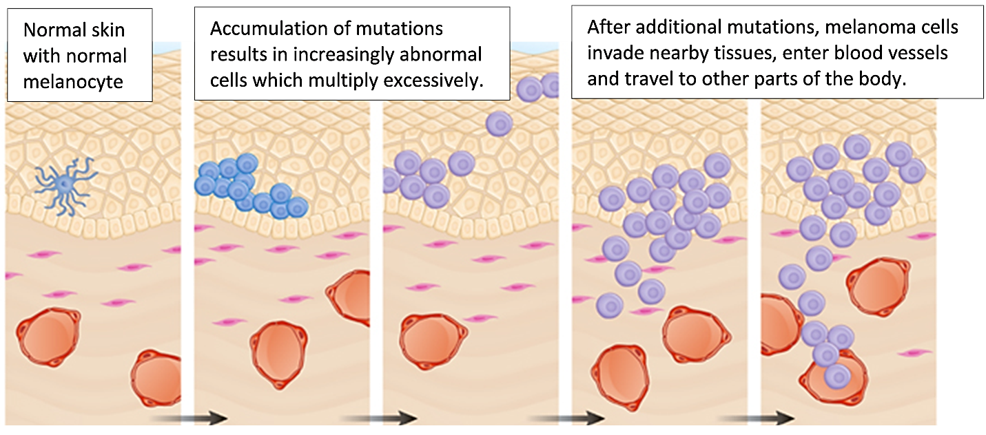

**20.** Explain how exposure to intense sunshine or tanning lamps can increase a person's risk of developing melanoma.

**21.** Some people inherit a mutation that causes their cells to have defective DNA repair mechanisms. Explain why these people have an increased risk of cancer.

1. By Dr. Ingrid Waldron, Joshua Kouassi, Dr. Manuela Tripepi and Dr. Mecky Pohlschroder, Department of Biology, University of Pennsylvania, 2016. This Student Handout and Teacher Preparation Notes with instructional suggestions and background information are available at <http://serendipstudio.org/exchange/waldron/HaloferaxUV>.