Genetics

Why do parents and their children generally have similar characteristics? If siblings have the same biological mother and father, what explains any differences in the siblings’ characteristics? To answer these questions, you will learn how genes influence our characteristics and how a child inherits genes from his or her mother and father.

How do genes influence our characteristics?
A gene is a segment of DNA that gives the instructions for making a protein. This chart illustrates how different alleles of a gene give the instructions for making different versions of a protein, which can result in different characteristics.

Genotype | → | Protein | → | Phenotype (characteristics)
AA | → | Normal enzyme that makes melanin, the pigment that gives color to skin and hair | → | Normal skin and hair color | 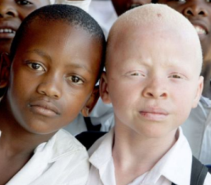
Aa | → | Normal enzyme that makes melanin and defective enzyme that does not make melanin | → | Normal skin and hair color
aa | → | Defective enzyme that does not make melanin | → | Very pale skin and hair color (albino)

1. Why does each genotype have two letters? What do these two letters represent?

2. Use the information in the chart to explain why a person with the aa genotype has very pale skin and hair color.

- A person is homozygous for a gene if both alleles for that gene are the same.
- A person is heterozygous for a gene if the two alleles are different.

3. Explain why a person who is heterozygous (Aa) has normal skin and hair color.

4. This example illustrates how a dominant allele (A) can determine the phenotype of a heterozygous person. Explain why the recessive allele (a) does not influence the phenotype of a heterozygous person.

5. A heterozygous person has the same phenotype as a person who is homozygous for the
_______________________ allele.
(dominant/recessive)
How does a child inherit genes from his or her mother and father?

To review how meiosis and fertilization result in inheritance of genes, you will use model chromosomes for two parents who are both heterozygous, Aa.

- Your group will need two pairs of model chromosomes that look like these.  - One person should use the first pair of model chromosomes to demonstrate how meiosis produces different types of eggs.  - Another person should demonstrate how meiosis produces different types of sperm. | 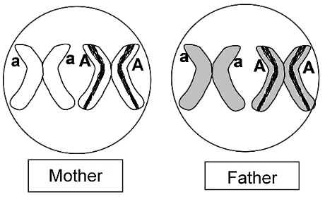

6. In this chart, record the allele in each type of egg produced by meiosis, and record the allele in each type of sperm produced by meiosis.  - On your lab table, outline the rectangles shown in this chart.  - Put a model chromosome for each type of sperm and each type of egg in the appropriate positions on your lab table.  - Use these chromosomes to model how each type of sperm fertilizes each type of egg.  7. Record the genetic makeup (the pair of alleles) for each type of zygote you produced as you modeled fertilization. | 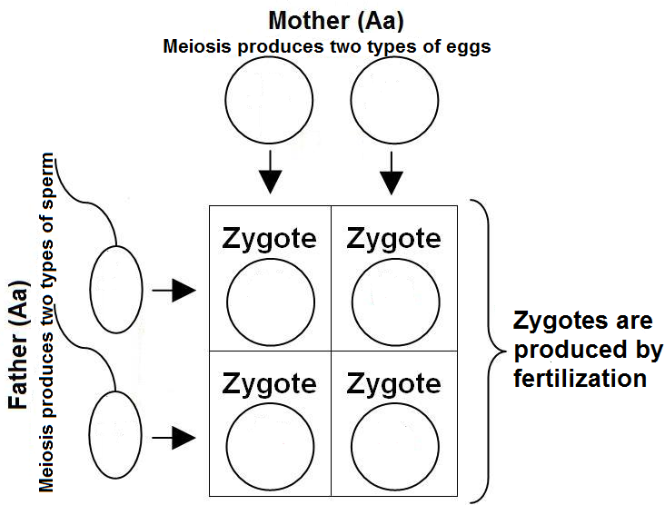

Biologists use a similar chart to analyze inheritance However, biologists omit much of the detail and use a simplified  version called a Punnett Square. | A  a | A | a
 |  | AA | Aa
 |  | Aa | aa
8. In this Punnett square:
- Label each letter that represents the genetic makeup of a gamete with a G.
- Label each pair of letters that represents the genetic makeup of a zygote with a Z.

9. Explain why the genetic makeup of each zygote in this Punnett square is the same as the genotype of the child that would develop from this zygote. (Hint: Think about how the cells in a child’s body are produced.)

10a. Draw a Punnett square for two albino parents.

10b. Explain why two albino parents will not have any children with normal skin and hair color.
11a. The genotype of a parent with normal skin and hair color is ______ or ______. Draw three Punnett squares, one for each possible combination of these parental genotypes.

11b. Circle the genetic makeup of the only zygote that would develop into an albino child.

11c. Explain how two parents with normal skin and hair color could have an albino child.

12. Explain how genes contribute to similarities between parents and their children.

13a. You have analyzed the effects on skin color of the A and a alleles of one gene. Do you think that other alleles and/or other genes also influence skin color? Explain why or why not.

13b. What environmental exposure also influences skin color?

Coin Flip Genetics

14a. If two Aa parents have a family of 4 children, how many of the children do you think will have the Aa genotype?  0 ___ 1 ___ 2 ___ 3 ___ 4 ___ could be any of these ___ | A  a | A | a
 |  | AA | Aa
 |  | Aa | aa

14b. Explain your reasoning.

We will return to this question after you have analyzed the coin flip model of how genes behave during meiosis and fertilization. You and a partner will be heterozygous Aa parents. After each coin flip, heads will represent the A allele and tails will represent the a allele. This table explains how you will model meiosis and fertilization.

Biological Process | How You Will Model This
Meiosis in an Aa parent produces gametes. Each gamete has an equal probability of having an A allele or an a allele. | Flip your coin and check for heads up (A) vs. tails up (a). This represents the equal probability that a gamete will have an A allele or an a allele.
Fertilization of an egg by a sperm produces a zygote. Each gamete contributes one allele to the genotype of the child that develops from the zygote. | You and your partner each flip a coin to determine the alleles that the egg and sperm contribute to the zygote that develops into a child.
When you flip a coin, half the time you will get heads and half the time you will get tails. If you and your partner each flip a coin, the probability of getting two tails is ½ x ½ = ¼.

15a. Explain why, for a zygote produced by two Aa parents, the probability that the zygote will have two a alleles is ¼. | A  a | A | a
 |  | AA | Aa
 |  | Aa | aa

15b. Explain why, for these parents, the probability of an Aa zygote is ½.

16. If two Aa parents have four children, then, on average, the predicted number of children with each genotype is ____ AA, ____ Aa, and ____ aa.

- Work with a partner to make a family of four coin-flip children. Each of you should flip your coin to determine the genotype of the first child (heads = A and tails = a). Record this genotype in the box for the first child in the first family in the table below. Make three more pairs of coin flips and record the genotypes for the second, third and fourth coin-flip children in this family.

Genotypes of coin-flip children produced by two heterozygous (Aa) parents
 | Genotype for each child |  |  |  |  | # with each genotype |  |  |  | % with each genotype
 | 1st | 2nd | 3rd | 4th |  | AA | Aa | aa |  | AA | Aa | aa
First family of 4 children

Next family of 4 children

Next family of 4 children

Next family of 4 children

Totals

- Repeat this procedure three times to determine the genotypes for three more families of four coin-flip children each. Record your results in the table.
- For each family of coin-flip children, fill in the number with each genotype and the percent with each genotype. Calculate the total number for each genotype and give these totals to your teacher.

17a. How many of your coin-flip families had exactly the predicted numbers of AA, Aa and aa coin-flip children? 0 ___ 1 ___ 2 ___ 3 ___ 4 ___

17b. Why didn’t all of your coin-flip families have exactly the predicted number of children with each genotype?

18. In your coin-flip families, did the genotype produced by the first pair of coin flips have any effect on the genotype produced by the second pair of coin flips? yes ___ no ___

In real families the genotype of each child depends on which specific sperm fertilized which specific egg. This is not influenced by what happened during the fertilizations that resulted in any previous children. Therefore, the genotype of each child is independent of the genotype of any previous children.

19a. Think about real families where both parents are heterozygous Aa. If the first child is albino, what is the probability that the second child will be albino?
0% ___ 25% ___ 50% ___ 75% ___
19b. Explain your reasoning.

20a. For a family of four children born to two Aa parents, how many of the children will have the Aa genotype? 0 ___ 1 ___ 2 ___ 3 ___ 4 ___ could be any of these ___

20b. Explain your reasoning.

21. Complete this table. Your  teacher will provide the data  for the top two rows. |  | # of coin-flip children in class data: ____ | % AA | % Aa | % aa
 |  | Class data for coin-flip children
 |  | Predictions based on Punnett square

22. Random variation is common in small samples, but random variation usually averages out in large samples. Therefore, Punnett Square predictions are more accurate for larger samples and are often less accurate for smaller samples. Evaluate this claim, using the data from the above table and the table on the previous page.

23a. Fill in each blank in these sentences with the best match from the list below.

A Punnett square can accurately predict _____ and _____.
A Punnett square can not accurately predict _____ or _____.

a. the average percent albino in a large sample of the children of two heterozygous parents
b. the percent albino in a specific family of children of two heterozygous parents
c. the probability that the next child in a family will be albino
d. whether the next child in a family will be albino

23b. Explain your reasoning.

24. The Punnett square for two heterozygous Aa parents predicts that, on average, one quarter of the children will be albino. Why aren’t one quarter of the children in your school albino?

IV. Review

25. How does each cell in a baby’s body get one copy of each gene from each parent? Give your answer in sentences or a labeled flowchart.

The flowchart below summarizes how genes contribute to similar characteristics within a family.

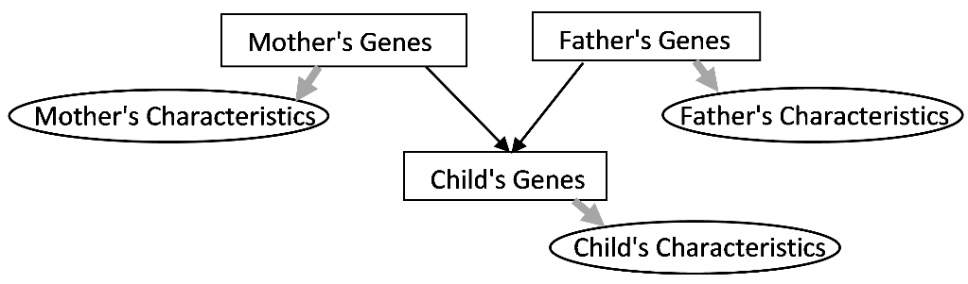

26a. Explain how genes influence a person’s characteristics (represented by the fatter gray arrows). A complete answer will include the words alleles and protein.

26b. What biological processes transmit genes from parent to child (represented by the thin black arrows)?

27a. Draw a Punnett square for a mother who is heterozygous for the albinism allele (Aa) and a father who is homozygous for the albinism allele (aa).

27b. On average, what fraction of the children of couples like this will be albino?

27c. Explain your reasoning. (A complete answer will include dominant or recessive.)

27d. If these parents have four children, the minimum number that will be albino is ____ and the maximum number that will be albino is ___.

27e. Explain your reasoning.

By Drs. Ingrid Waldron, Scott Poethig and Jennifer Doherty, Dept. Biology, Univ. Pennsylvania, © 2020. This Student Handout (which assumes prior completion of "Meiosis and Fertilization – Understanding How Genes Are Inherited") and Teacher Preparation Notes (with instructional suggestions and background information) are available at https://serendipstudio.org/sci_edu/waldron/#genetics.

