Food Webs, Energy Flow, Carbon Cycle, and Trophic Pyramids

Wolves in Yellowstone National Park

In the early twentieth century, humans eliminated wolves from Yellowstone. In the late twentieth century, humans brought wolves back to Yellowstone. How did these changes in the wolf population affect the other animals and plants in Yellowstone?

To begin to answer this question, watch the “Ecosystems Video” (https://www.learner.org/series/the-habitable-planet-a-systems-approach-to-environmental-science/ecosystems/ecosystems-video/), beginning at 13 minutes and 40 seconds and ending at 22 minutes and 37 seconds. An ecosystem includes the animals, plants and other organisms in an area and their physical environment.

These graphs summarize recent trends in the numbers of wolves and elk in the Northern Range in Yellowstone.
1. Why did the number of elk decrease after 1995?  2a. Approximately how many wolves were there in 2010-2015?  2b. Approximately how many elk were there in 2010-2015? | 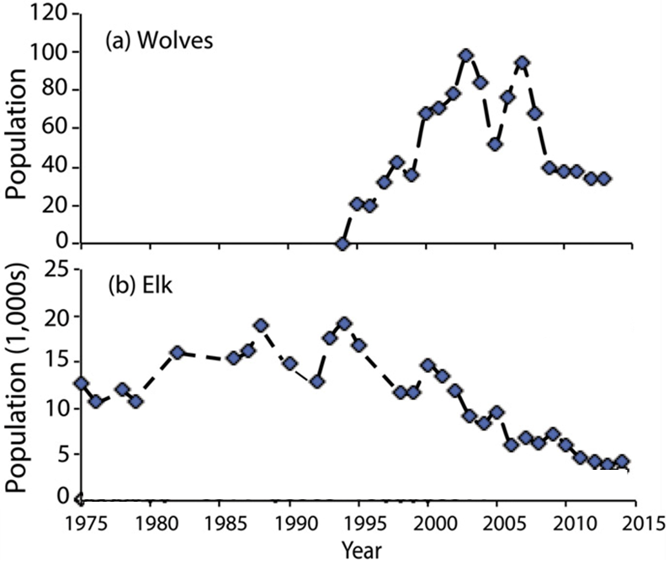

2c. Notice that the number of wolves is much lower than the number of elk. What is one possible explanation for this difference?

3. After 1995, the growth of willows increased in some parts of Yellowstone. What is one possible explanation for this trend?

4a. Beavers use tall willows for food and building dams. Predict the change in the number of beavers when wolves returned to Yellowstone Park. decreased ___ increased ___

4b. Explain your reasoning.

We will return to each of these questions as you learn more during this activity.

Food Chains and Food Webs

This figure shows a food chain. Secondary consumers eat primary consumers which eat producers (plants).

Notice that producers are shown at the bottom of the food chain. Each level above that eats organisms from the level below.

A food chain summarizes a sequence of trophic relationships, where trophic means eating or nutrition.

5. Write mountain lion, grass, and rabbit in the appropriate blank boxes to show a food chain.

There is another type of food chain that doesn’t begin with living plants.

6. Think about a 100-year-old forest where the leaves have dropped from the trees each fall, dead branches have fallen, and animals have died each year. You won’t see 100 years of dead stuff piled up on the ground in the forest. What has happened to all the dead stuff?

Decomposers get their nutrition from dead organic matter. Decomposers include bacteria and fungi (e.g. mushrooms) which secrete digestive enzymes and absorb digested molecules from the dead organic matter.

The first flowchart on the right shows a food chain with decomposers, and the second flowchart shows an example from Yellowstone.  7. If you visited Yellowstone, you would not notice this food chain. Why not? | 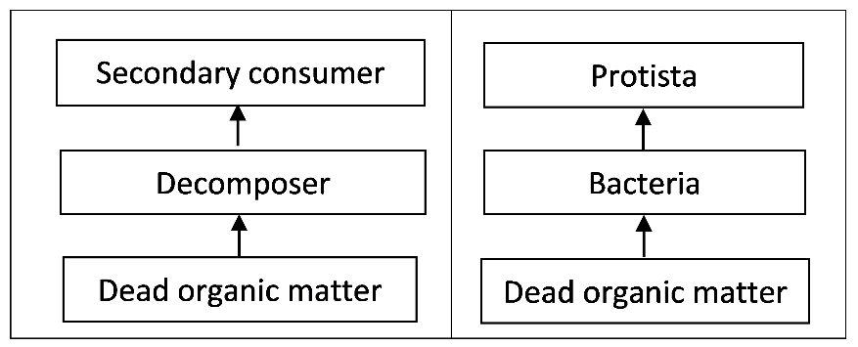

8. Match each item in the top list with the best match or matches from the bottom list.

Producer ___
Primary consumer ___ ___
Secondary consumer ___ ___

- an animal that eats plants
- an organism that consumes primary consumers
- an organism that consumes producers
- an organism that makes its own organic molecules from small inorganic molecules (e.g. uses photosynthesis to make sugars from CO₂ and H₂O)
- includes some predators and Protista
In real biological communities, the trophic relationships are much more complex than a simple food chain. These more complex trophic relationships are summarized in a food web.

This figure shows a small part of a food web. Notice that the food web contains multiple food chains.

9. Use asterisks (*) to mark the organisms in one food chain in this food web.

Most of the organisms in this food web can be classified in one of these trophic levels:
- producers
- primary consumers
- secondary consumers.
However, not all organisms fit in a single trophic level. You may have heard of omnivores which eat both plants and animals. A more general category is a trophic omnivore which is any animal that eats organisms from more than one trophic level.

10. In the above figure, use one of the following symbols to label each type of organism.
P = Producer (There are 2 of them.)
PC = Primary Consumer (3)
SC = Secondary Consumer (2)
TO = Trophic Omnivore (3; any animal that eats trophic omnivores is a trophic omnivore.)

Trophic Relationships in Yellowstone

Your teacher will give you a deck of cards that you will use to make a Yellowstone food web. In the procedure below, complete each step and check the box before beginning the next step.

- To begin, draw the rectangles in this chart on your lab table or on the large paper provided by your teacher. Each rectangle should be big enough for the number of cards shown. Be sure to leave space for trophic omnivores between and above the two sets of rectangles.

- Find the cards for the producers and dead organic matter in your Yellowstone deck. Put these cards in the appropriate rectangles.

- Find the cards for the primary consumers (which eat only producers) and the decomposers (which consume only dead organic matter). Put these cards in their rectangles. Draw an arrow to show each trophic relationship listed on the cards.
- Use the remaining cards to put the secondary consumers in their rectangle and the trophic omnivores in appropriate places outside the rectangles. (Any animal that eats trophic omnivores is also a trophic omnivore. Yellowstone wolves are trophic omnivores, since they eat coyotes as well as primary consumers.) Draw an arrow to show each trophic relationship.

Your Yellowstone food web may look complex, but a complete Yellowstone food web would be much more complex.
- Many more types of organisms live in Yellowstone, including more than 1000 different kinds of plants and more than 1000 different kinds of insects.
- The trophic relationships are more complex than is shown in your food web. For example, when an elk is killed by a pack of wolves, the wolves eat much of the meat, but other animals such as bears, coyotes and ravens eat some of the rest, and parts of the elk become dead organic matter which is consumed by decomposers.
- Some of the trophic relationships shown are much more important than others. For example, Yellowstone wolves eat many elk and few beavers.
11a. Make the arrow from elk to wolves fatter to represent the importance of this trophic relationship.

11b. Draw arrows from the primary consumers and producers to dead organic matter. These arrows will represent the general point that all or parts of many plants and animals become dead organic matter which is consumed by decomposers.

12. Use teacher comments to improve your food web, and then take a picture of it to submit.

Even though your food web is incomplete, it can help you to predict and understand important ecological phenomena.

A trophic cascade occurs when a change in the population of a predator not only affects its prey population, but also has indirect effects on another population in the ecosystem. In this flowchart, each arrow represents a negative effect of one population on the size of another population.

13. Add a curved arrow with a (+) to show the indirect effect of wolves on the willow population in this trophic cascade.

14. Explain how changes in the wolf population could produce the following trends in the number of beaver colonies.
- After wolves were eliminated from Yellowstone, the number of beaver colonies decreased.
- After wolves were reintroduced to Yellowstone, the number of beaver colonies increased.
(Hint: Beavers use tall willows for food and building dams.)

Carbon Cycles and Energy Flow through Ecosystems and the Biosphere

The biosphere includes all of the Earth’s organisms. Life in the biosphere depends on a continuous inflow of energy from the sun.  15a. Suggest a hypothesis to explain why life in the biosphere needs a continuous inflow of energy.  15b. Life in the biosphere requires carbon atoms. However, the | 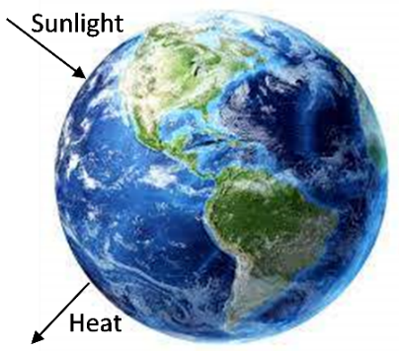
biosphere does not receive an inflow of carbon atoms. Suggest a hypothesis to explain how life in the biosphere continues without an inflow of carbon atoms.

To better understand why the biosphere needs an inflow of energy, but not carbon atoms, we need to review three biological processes that transform energy and carbon-containing molecules.

Photosynthesis  Plant cells use the energy from sunlight to make sugar molecules from CO₂ and H₂O. | 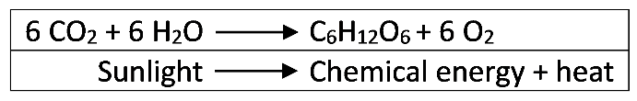  The upper box shows changes in how the atoms are organized in molecules. The lower box shows the associated energy changes.

16a. Circle the glucose molecule in the chemical equation for photosynthesis.

16b. Explain how photosynthesis illustrates this general principle.
Atoms are neither created nor destroyed in biological processes.

16c. Explain how photosynthesis illustrates these general principles.
Energy is neither created nor destroyed in biological processes, but energy can be transformed from one type to another. During energy transfers and transformations, some of the input energy is transformed to heat energy.

Cellular Respiration  These equations summarize how cellular respiration produces ATP.  17a. Why do cells need ATP? | The curved arrows represent coupled chemical reactions; the  top reaction provides the energy needed for the second reaction.

17b. Why is glucose needed for cellular respiration to produce ATP?

17c. What process produces the glucose that plant cells use for cellular respiration?

Biosynthesis
Some of the sugar molecules produced by photosynthesis are used for biosynthesis, which produces all the different organic molecules that make up an organism. For example, multiple
glucose molecules are combined to make the polymer cellulose, which is used to make plant cell walls. Animals and decomposers use food molecules | 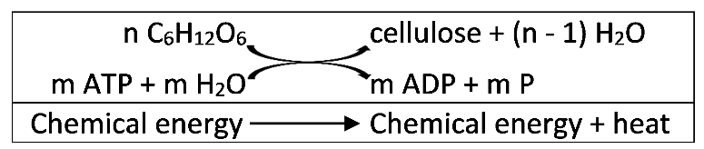
as input for biosynthesis.

These biological processes result in the carbon cycle, where carbon atoms cycle between CO₂ in the air and organic molecules in living organisms or dead organic matter. The figure below shows a carbon cycle that includes a simple food web.

18a. The B arrow shows CO₂ entering a plant. How do the carbon atoms in CO₂ become carbon atoms in organic molecules in the plant? | 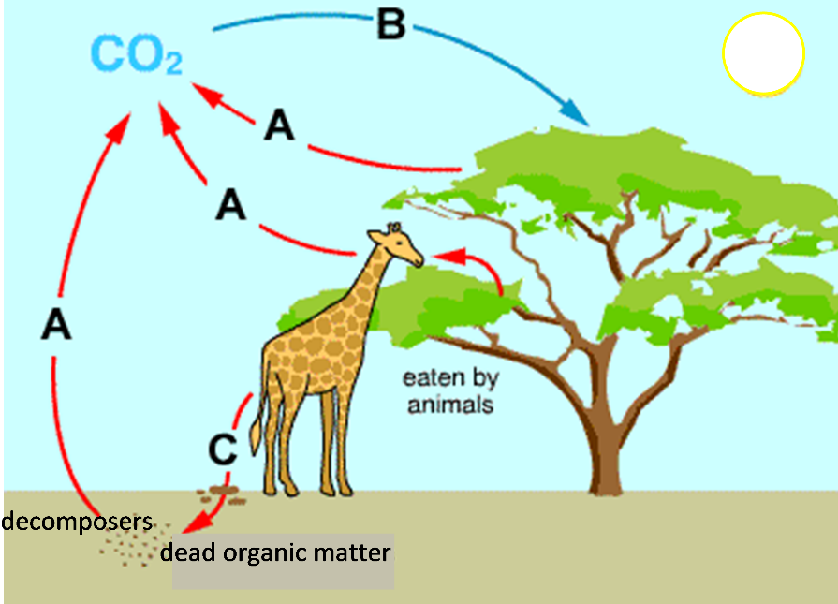

18b. The A arrows show CO₂ leaving plants, animals and decomposers. How do the carbon atoms in the organic molecules of plants, animals and decomposers become carbon atoms in CO₂?

18c. The C arrow shows defecation and/or death. Add another C arrow to show part or all of the tree dying and becoming available to decomposers.

19a. Carbon atoms in organic molecules in a tree can become carbon atoms in organic molecules in a giraffe. Fill in the blanks to describe how this can happen.

The giraffe __________________________________________________________ .
The giraffe’s digestive and circulatory systems _______________________________________.
The giraffe’s cells _______________________________________________________________.
19b. Explain how a carbon atom in an organic molecule in a giraffe could become a carbon atom in an organic molecule in a tree. (Hint: A complete answer will include cellular respiration, photosynthesis, and biosynthesis.)

In this figure, energy flows (represented by dashed arrows) have been added to the carbon
cycle.  20a. This figure does not show the energy transformations and transfers inside the living organisms. For example, photosynthesis  transforms light energy to chemical energy, and cellular respiration transfers chemical energy between molecules. All of these processes  produce _________, which is radiated away from the ecosystem. | 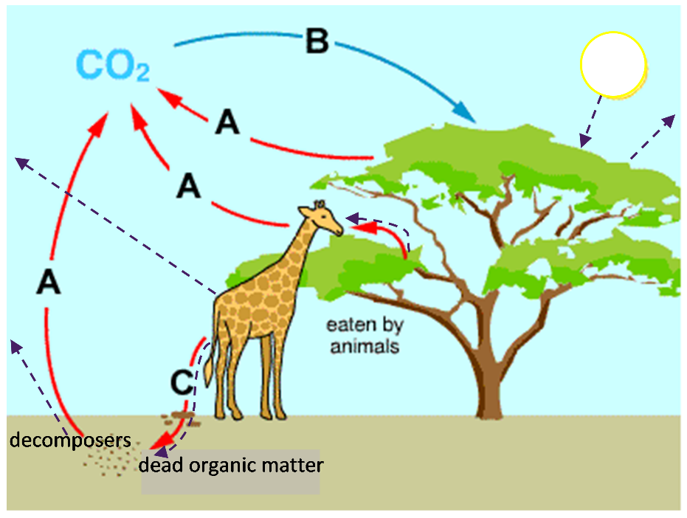

20b. Label each dashed arrow in the above figure with one of these abbreviations:
S = the inflow of energy in the form of sunlight.
CE = chemical energy moving from one trophic level to the next in the food web or moving from a living organism to dead organic matter.
H = for arrows that show that biological processes produce heat, which leaves the organisms and ultimately is radiated out to space.

21. How can the sun’s energy be transformed to provide the energy that a giraffe uses to move? Be specific about the multiple steps that are required.

22a. Explain why life in the earth’s biosphere needs a continuous inflow of energy.  22b. How can life continue in the earth’s biosphere without an inflow of additional carbon atoms? | 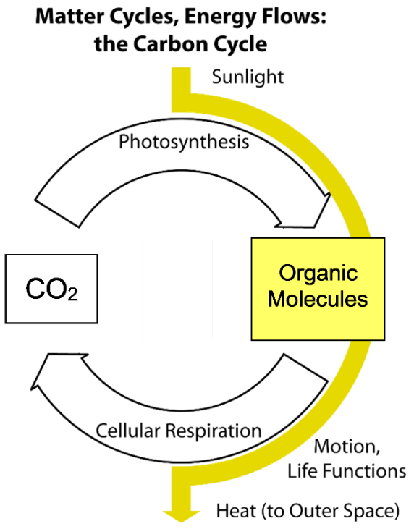

Trophic Pyramids
The average American consumes almost 2000 pounds of food each year. Obviously, we do not gain
2000 pounds of weight each year!  23. What happens to all the weight of the food we eat? Where do the atoms in the food molecules go? | 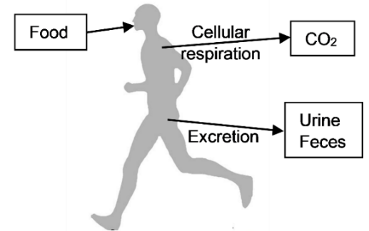
The biomass of an organism is the mass of all the organic molecules in the organism. For each trophic level, the net rate of biomass production is the total mass of the organic molecules produced in a year minus the mass of the organic molecules used for cellular respiration. You can think of this as the amount of growth during the year; this includes any new individuals or growth of individuals in a trophic level, even if some things died.

Researchers assessed the net rate of biomass production at different trophic levels in a forest in New Hampshire. The relative size of the boxes in this flow chart indicates the relative magnitude of the net rate of biomass production for the producers vs. the primary consumers plus decomposers.
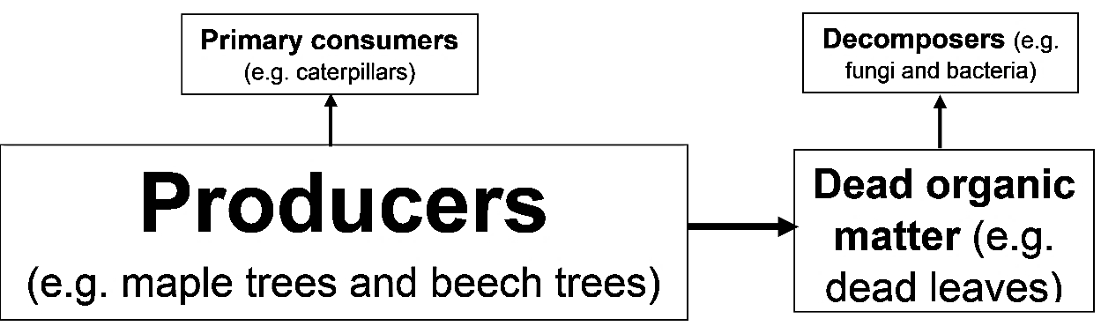

24. Add to this flowchart to show the reasons why the net rate of biomass production for the primary consumers plus decomposers is lower than the net rate of biomass production for the producers. (Hint: Think about question 23.)

25a. The left column of this table shows a summary food web, and the right column gives the rates of biomass production at different trophic levels in the forest. Circle the only rate of biomass production that would be possible for the secondary consumers.
 | Net Rate of Biomass Production (g/m²/year)
Secondary consumers (e.g. birds) | 30? 200? 1000?
↑
Primary consumers + Decomposers | 200
↑
Producers | 1000
25b. Explain your reasoning.

25c. The width of each bar in this graph shows the net rate of biomass production for the producers and for the primary consumers plus decomposers in the forest. Add to the graph to show the net rate of biomass production for the secondary consumers.
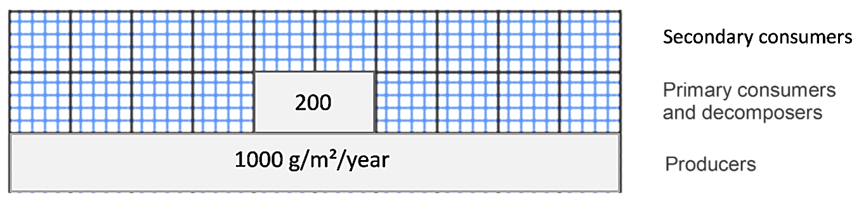

Information about the relative rates of biomass production at different trophic levels is often displayed in a trophic pyramid like this one.
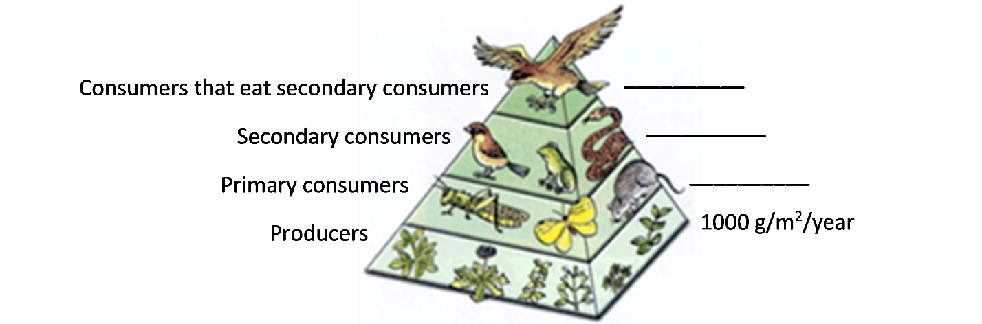
Scientists sometimes use the general estimate that the rate of biomass production at each trophic level is about 10% of the rate at the trophic level just below it.

26a. Use the 10% estimate to calculate the rate of biomass production at each consumer trophic level in the above trophic pyramid.

26b. This 10% estimate is sometimes described as the 10% rule. What evidence from the forest ecosystem indicates that this 10% rule is not accurate in some cases?

27a. Some trophic pyramids show the relative numbers of organisms at each trophic level. Based on the trophic relationship between wolves and elk in Yellowstone, which would you expect?
- about 10 times more elk than wolves
- about the same number of elk and wolves
- about 10 times more wolves than elk

27b. In Yellowstone during the 21st century, there have been roughly 100 times as many elk as wolves. What is one possible reason why there is only one wolf for every 100 elk, instead of one wolf for every 10 elk? (Hint: See page 4.)

28a. For lunch, Pat had a baked potato and Erin had a hamburger with no bun. They each consumed the same amount of biomass, but from different trophic levels. In comparison to the amount of land needed to produce Pat’s potato, how much land was needed to produce enough cattle feed to produce Erin’s hamburger?
- about 10% as much land to produce the hamburger
- about the same amount of land to produce the hamburger and the potato
- about 10 times as much land to produce the hamburger

28b. Explain your reasoning.

By Drs. Ingrid Waldron and Lori Spindler, Dept Biology, University of Pennsylvania. © 2021. This Student Handout and the Teacher Preparation Notes with instructional suggestions and background information are available at http://serendipstudio.org/sci_edu/waldron/#ecolfoodweb

