Food Webs – How did the elimination and return of wolves
affect other populations in Yellowstone?

Wolves in Yellowstone National Park
By 1927, humans had eliminated wolves from Yellowstone National Park. Almost 70 years later, humans brought wolves back to Yellowstone. These changes in the wolf population affected the populations of other animals and plants in the Yellowstone ecosystem. An ecosystem includes the animals, plants and other organisms in the area and their physical environment.

To learn about the effects of these changes in the wolf population, watch part of the “Ecosystems Video” (https://www.learner.org/series/the-habitable-planet-a-systems-approach-to-environmental-science/ecosystems/ecosystems-video/); begin at 13 minutes and 40 seconds (right when the video switches from a tropical ecosystem to Yellowstone) and end at 22 minutes (right after the researcher shows that tall willows escape browsing).

These graphs summarize recent trends in the numbers of wolves and elk in the Northern Range in Yellowstone National Park.  1. Why did the number of elk decrease, beginning in the late 1990s? | 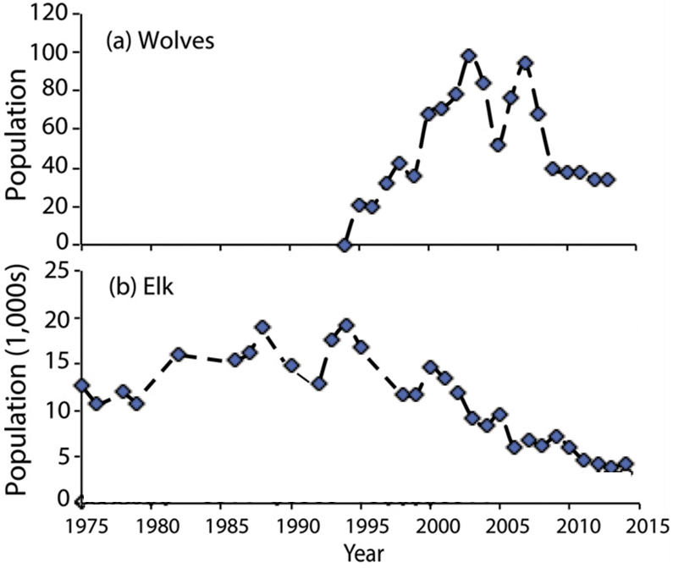
2a. What happened to the number of elk in Yellowstone after wolves were eliminated from Yellowstone in the early 1900s?

2b. After wolves were eliminated from Yellowstone, willow growth decreased. What is a likely explanation for this trend in willow growth?

3a. Beavers use tall willows for food and building dams. Predict the change in the number of beavers when wolves were eliminated from Yellowstone. decreased ___ increased ___

3b. Explain your reasoning.

We will return to these questions after you have learned more during this activity.
Food Chains and Food Webs

A food chain summarizes a sequence of trophic relationships. Trophic means eating or nutrition. As shown in this figure, producers (e.g. plants) are eaten by primary consumers (herbivores). Primary consumers are eaten by secondary consumers (predators).  Notice that the arrows in a food chain | 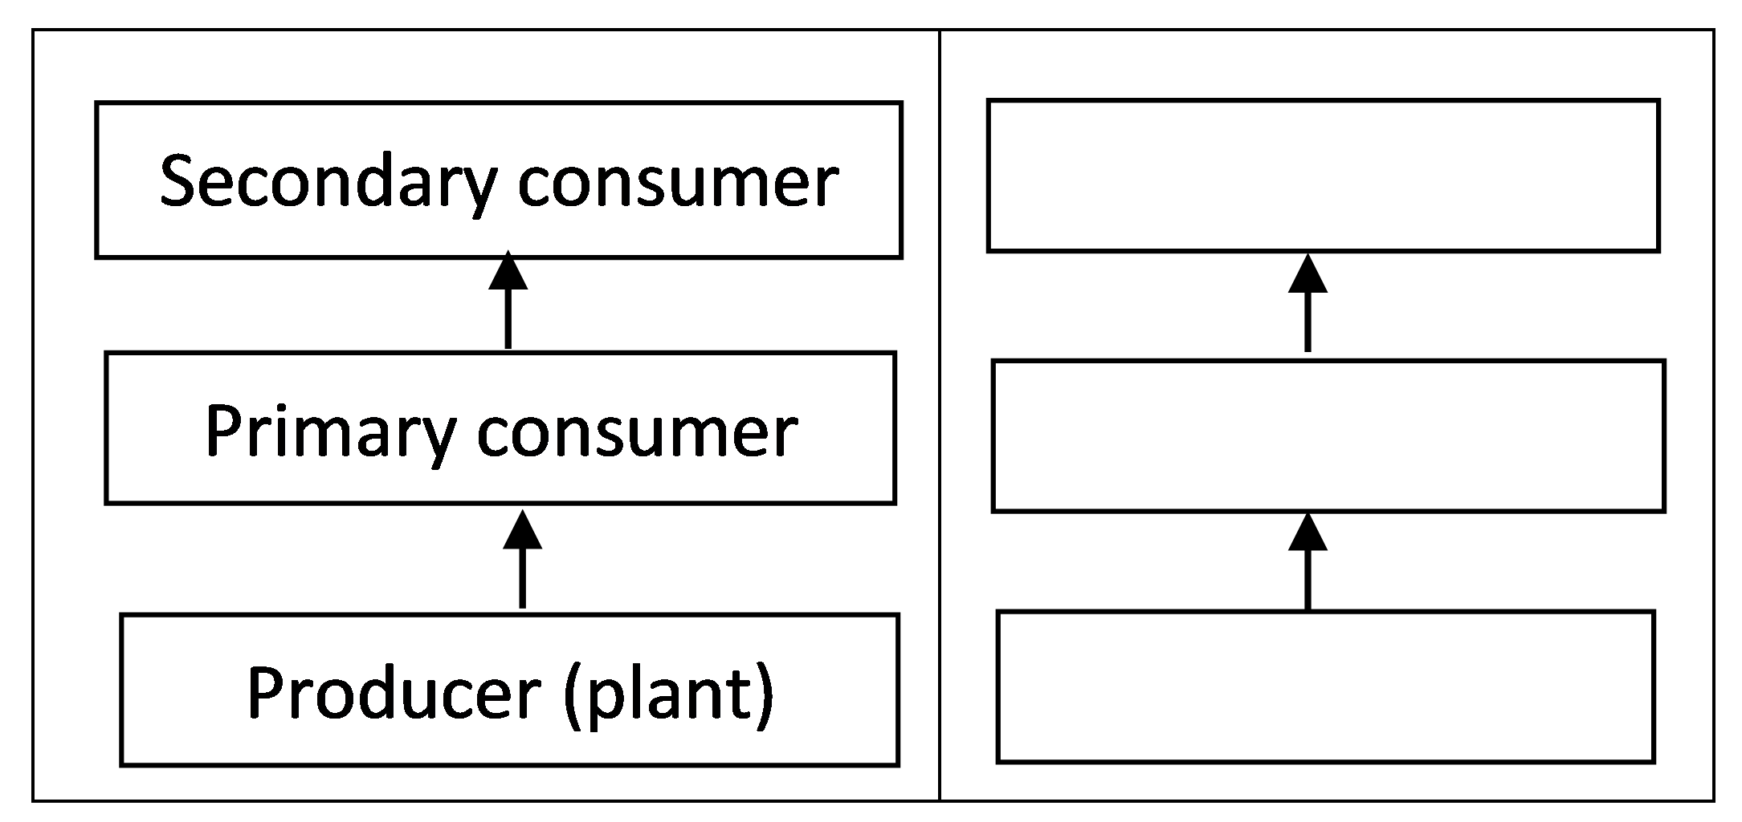
indicate the direction that nutrition flows.

4a. Primary consumer and herbivore are different names for an animal that eats ___________.

4b. To show a specific food chain, write grass, mountain lion, and rabbit in the appropriate blank boxes.

There is another type of food chain that doesn’t begin with living plants. Think about a 100-year-old forest where the leaves have dropped from the trees each fall, dead branches have fallen, and animals have died each year. But, you won’t see 100 years of dead stuff piled up on the ground in the forest.

5. What do you think has happened to all the dead stuff?

Decomposers get their nutrition from dead organic matter. Two major types of decomposers are bacteria and fungi (e.g. mushrooms). These bacteria and fungi secrete digestive enzymes into dead organic matter and absorb digested molecules. The bacteria and fungi are eaten by secondary consumers, which are eaten by animals higher in the food chain.

The first flowchart on the right shows a food chain that begins with dead organic matter. The second flowchart shows an example of this type of food chain in Yellowstone.  6. If you visited Yellowstone, you probably wouldn’t notice this food chain. Why not? | 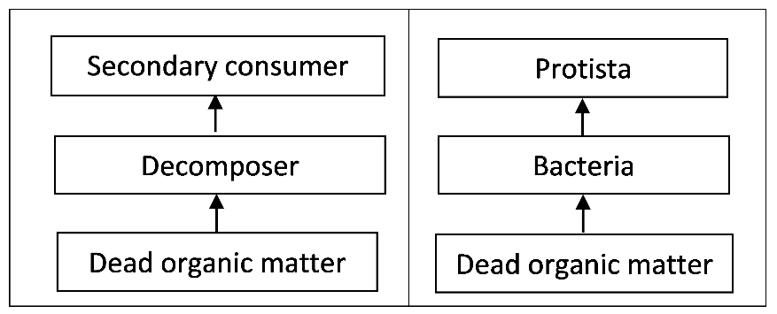

7. Match each item in the left list with the best match or matches from the right list.

Decomposer ___ a. an animal that eats plants
Producer ___ b. an organism that consumes dead organic matter
Primary consumer ___ ___ c. an organism that eats primary consumers or
Secondary consumer ___ ___ decomposers
d. an organism that eats producers
e. an organism that makes its own organic molecules from
small inorganic molecules (e.g. uses photosynthesis to
make sugars from CO₂ and H₂O)
f. includes some Protista and predators
In real ecosystems, the trophic relationships are much more complex than a simple food chain. These more complex trophic relationships are summarized in a food web.

This figure shows a small part of a food web. Notice that the food web contains multiple food chains.  8. Use asterisks (*) to mark the organisms in one food chain in this food web.  Most of the organisms in this food web can be classified in one of these trophic levels:  - producers  - primary consumers  - secondary consumers. | 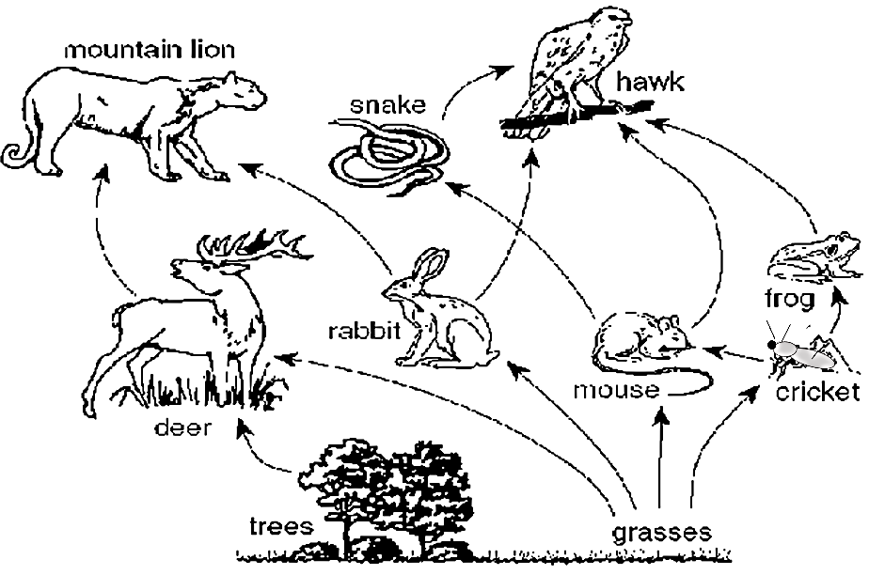
However, some organisms do not fit in a single trophic level. You may have heard of omnivores which eat both plants and animals. A more general category is a trophic omnivore, which is any animal that eats organisms from more than one trophic level.

9. In the above figure, use one of the following symbols to label each type of organism.
P = Producer (There are 2 of them.)
PC = Primary Consumer (3; Primary consumers eat only producers.)
SC = Secondary Consumer (2; Secondary consumers eat only primary consumers or decomposers.)
TO = Trophic Omnivore (3; Any animal that eats trophic omnivores is a trophic omnivore.)

A Yellowstone Food Web
Pages 5-7 show the trophic relationships for each organism that will be included in your Yellowstone food web. To make your food web, complete each step in the procedure below and check the box before you begin the next step.

- Your teacher will explain how to get a set of cards. You will need a surface that is approximately 45 cm (1.5 feet) wide and 60 cm (2 feet) tall for your food web. Draw and label the rectangles shown below on your lab table or on a large piece of paper. Leave space for trophic omnivores between and above the two sets of rectangles.
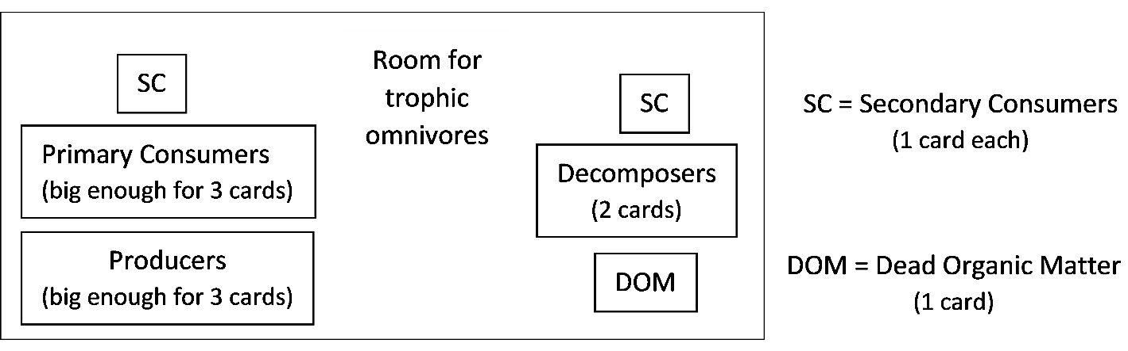

- Find the cards for the producers and dead organic matter in your Yellowstone deck. Put these cards in the appropriate rectangles.
- Find the cards for the primary consumers (which eat only producers) and the decomposers (which consume only dead organic matter). Put these cards in their rectangles. Draw arrows to show the trophic relationships listed on the cards.
- Use the remaining cards to put the secondary consumers in their rectangles and the trophic omnivores in appropriate places outside the rectangles. (Remember that any animal that eats trophic omnivores is also a trophic omnivore.) Draw an arrow to show each trophic relationship.

Your Yellowstone food web may look complex, but a complete Yellowstone food web would be much more complex. Here are some examples of this additional complexity.
- Many additional types of organisms live in Yellowstone. For example, there are more than 1000 different kinds of plants and more than 1000 different kinds of insects in Yellowstone.
- The cards only show the trophic relationships between the organisms in the card deck, but not other important trophic relationships. For example, many Yellowstone elk are killed by human hunters when the elk migrate out of the park during the winter.
- Some of the trophic relationships shown are much more important than others. For example, Yellowstone wolves eat many elk and few beavers.

10. To add a little of this complexity to your food web:
- Make the arrow from elk to wolves fatter to represent the importance of this trophic relationship.
- Add humans as predators on elk.
- Draw arrows from the producers and primary consumers to dead organic matter. These arrows will represent the general point that, every year, many plants and animals become dead organic matter.

11. Your teacher may suggest improvements for your Yellowstone food web. After you have made any suggested improvements, your teacher will tell you what to do next.

Even though your food web is highly simplified, it can help you to predict and understand important ecological phenomena. Examples are discussed in question 12.

12a. A trophic cascade occurs when a change in the size of a predator population has indirect effects on the size of another population in the ecosystem. For example:
- An increase in the number of wolves reduces the number of elk.
- An increase in the number of elk reduces willow growth.
- Therefore, a change in the number of wolves would be expected to change willow

growth in the ______________ direction.
(opposite / same)
12b. Explain your reasoning.

12c. After wolves were eliminated from Yellowstone, the number of beaver colonies decreased. What is a likely explanation? (Hint: Remember that beavers use tall willows for building dams and for food.)

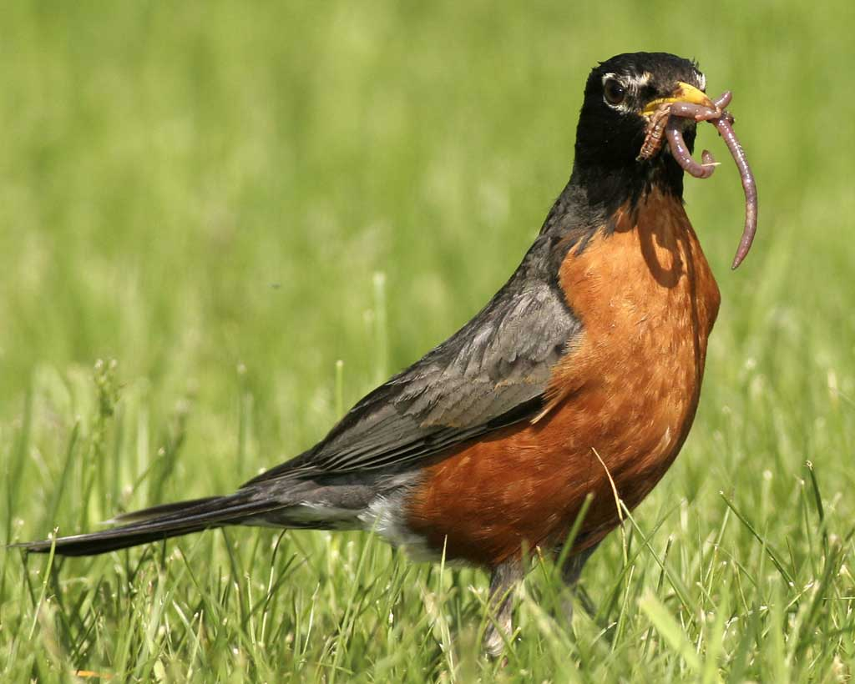  23-28 cm  American Robins  Eat: Earthworms, beetles,  other flowering plants  Eaten by: Snakes and  birds of prey (not  included in this food web) | 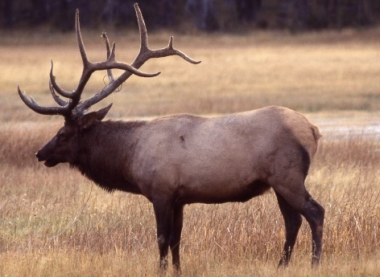  2.1-2.4 m  Elk  Eat: Grasses, willows,  other flowering  plants  Eaten by: Gray wolves,  grizzly bears, coyotes | 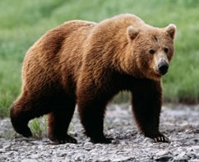  1.8-3.3 m  Grizzly Bears  Eat: Other flowering  plants (including  berries), elk
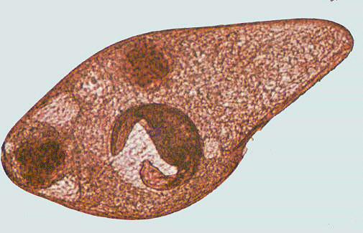  <1 mm  Protista  Eat: Bacteria  Eaten by: Nematodes | 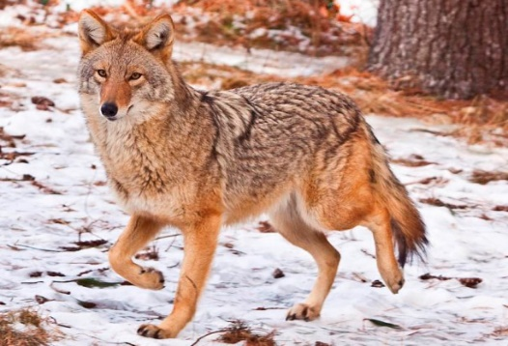  1-1.4 m  Coyotes  Eat: deer mice, elk  Eaten by: Gray wolves | 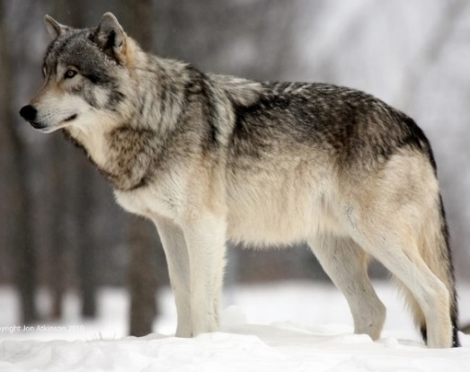  1.4-2 m  Gray Wolves  Eat: Elk, coyotes, beavers

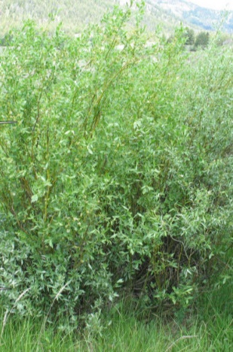  <80-400 cm  Willows  Eaten by: Elk, beavers | 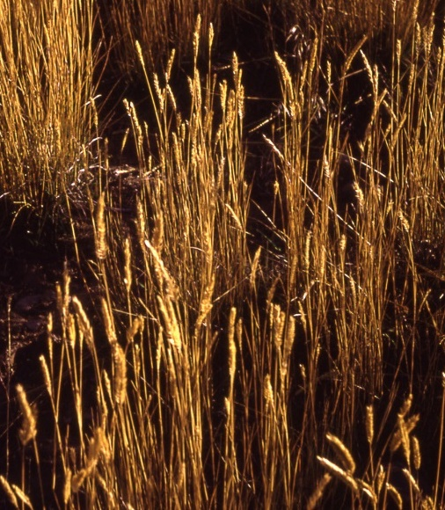  Grasses (including seeds)  Eaten by: Elk, deer mice | 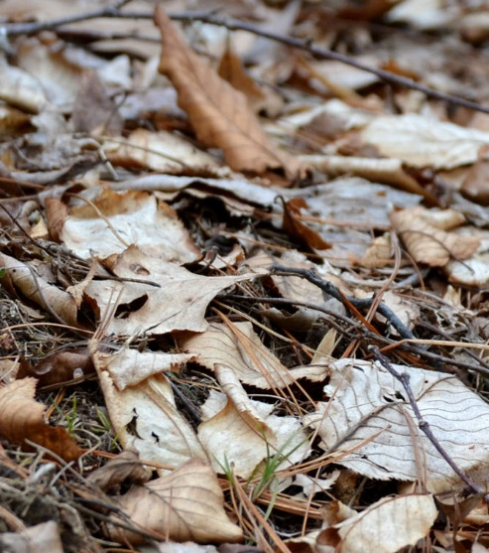  Dead Organic Matter  Consumed by: Bacteria,  fungi, earthworms
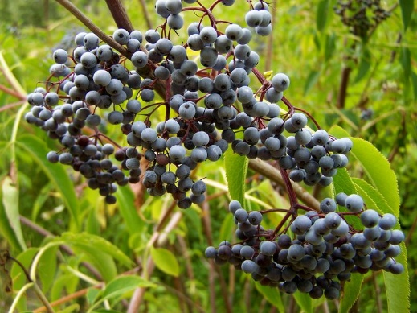  Other flowering plants  (including berries)  Eaten by: American  robins, deer mice,  elk, grizzly bears | 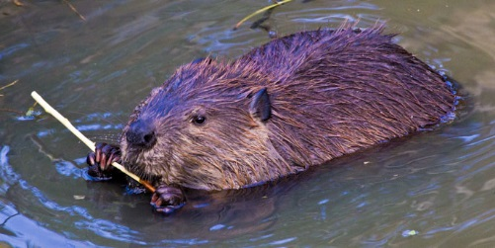58-99 cm (length, excluding tail)  Beavers  Eat: Willows  Eaten by: Gray wolves | 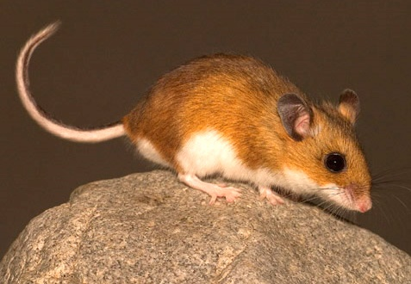  8-10 cm (length, excluding tail)  Deer Mice  Eat: Grasses; other  flowering plants  Eaten by: Coyotes

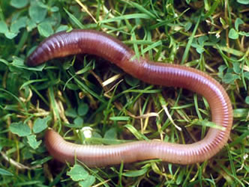  7-35 cm  Earthworms  Eat: Dead organic matter,  fungi, bacteria  Eaten by: American robins | 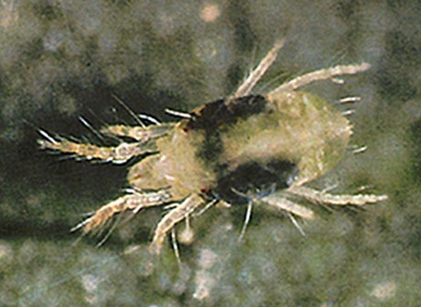  0.5-1 mm  Mites  Eat: Nematodes, fungi  Eaten by: Beetles | 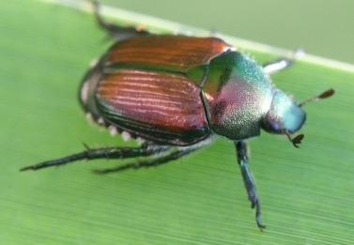  1-30 mm  Beetles  Eat: Mites  Eaten by: American  robins
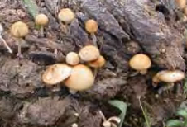  Fungi  Consume: Dead organic  matter  Eaten by: Earthworms,  mites, nematodes | 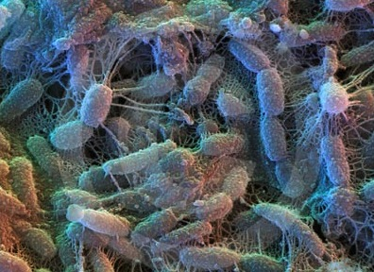  2-6 µm  Bacteria  Consume: Dead organic  matter  Eaten by: Protista,  nematodes,  earthworms | 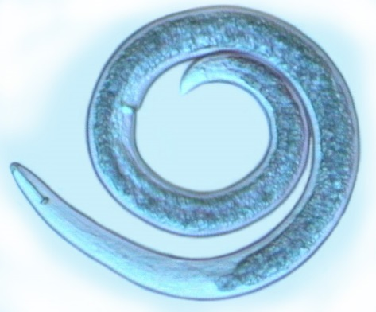  0.1-2.5 mm  Nematodes  Eat: Protista, fungi,  bacteria  Eaten by: Mites

By Drs. Ingrid Waldron and Lori Spindler, Dept Biology, University of Pennsylvania. © 2025. This Student Handout, an alternative version for students who are learning at home and do not have a printer, and the Teacher Preparation Notes with instructional suggestions and background information are available at https://serendipstudio.org/exchange/bioactivities/foodwebRR.

