Enzymes Help Us Digest Food

Maria’s Problem
After Maria drinks a couple of glasses of milk, her abdomen feels uncomfortable, and she has diarrhea and flatulence. Maria has noticed three things about her problem.  - She has the same symptoms after she drinks milk that has had the fat removed.  - She does not have these symptoms if she drinks milk that has had the sugar lactose removed. | 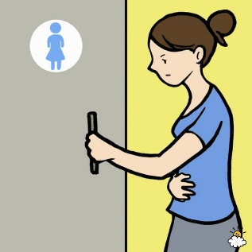
- She does not have these symptoms if she takes a pill that contains the enzyme lactase when she drinks whole milk.
1a. Based on these observations, which molecule in milk causes Maria’s symptoms?  1b. How do you think the enzyme lactase prevents Maria’s symptoms? (Hint: An enzyme speeds up a chemical reaction.) | 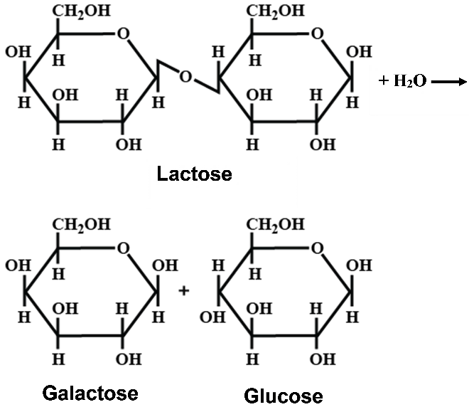  Lactose can be broken down to galactose plus glucose.

1c. Peter does not experience symptoms after he drinks a lot of milk. What do you think is the difference between Peter’s digestive system and Maria’s digestive system? Explain your reasoning.

What does the enzyme lactase do?
An enzyme speeds up a chemical reaction which converts a substrate molecule or molecules to a product molecule or molecules. Without an enzyme, many of the reactions in our bodies would occur at extremely slow rates – too slow to sustain life. The effects of enzymes like lactase can be written as follows.
Enzyme
Substrate molecule + H₂O Product molecules

2. Show the chemical reaction that you think is speeded up by lactase.

3a. You will do an experiment to test your hypothesis in question 2. You will have available a lactose solution, a lactase solution, water, and a test for glucose. Complete this table to describe a test of your hypothesis, a control, and the expected outcomes if your hypothesis is correct.
Test of Hypothesis – What will you do? – Explain your reasoning. | Expected Outcome if Your Hypothesis is Correct
Control – What will you do? – Explain your reasoning. | Expected Outcome if Your Hypothesis is Correct

3b. You will also have milk available. Complete this table to describe an experiment you could do to test the hypothesis that milk contains lactose.

Test of Hypothesis – What will you do? – Explain your reasoning. | Expected Outcome if the Hypothesis is Correct
Control – What will you do? – Explain your reasoning. | Expected Outcome if the Hypothesis is Correct

Procedure
- Each member of your group should prepare one of these test tubes.

Label Test Tube | Put in the Test Tube
1 | 10 mL lactose solution + 1 mL lactase solution
2 | 10 mL lactose solution + 1 mL water
3 | 10 mL milk + 1 mL lactase solution
4 | 10 mL milk + 1 mL water

- Each person should put on a glove, put his/her gloved thumb on the top of the tube and turn the tube upside down several times to mix the two liquids.

- Wait at least 3 minutes to allow time for lactose to break down to glucose and galactose.

- While you are waiting:
- Each of you should get a test strip. In the next step, if glucose has been produced in your test tube, you will observe a color change in the test strip. Record the original color of your test strip. ____________
- Prepare a piece of paper with a labeled place to put each test strip.

- After there has been enough time for lactose to break down, each of you should use your glucose test strip to test for glucose in the solution in your test tube. To get clear results, you should evaluate change in color at 3 minutes after you dipped the test strip in the solution in your test tube.

- Record your results in the table in question 4 below.

- Clean your test tubes.

Results
4. For each test tube, record your test strip color approximately 3 minutes after you dipped the test strip in the solution. Then, complete the last two columns.

Test tube | Test strip color | Was there any  change in the color  of the test strip? | Conclusion
1. 10 mL lactose solution +1 mL lactase solution |  |  | ___ no glucose produced  ___ some glucose produced
2. 10 mL lactose solution + 1 mL water |  |  | ___ no glucose produced  ___ some glucose produced
3. 10 mL milk  +1 mL lactase solution |  |  | ___ no glucose produced  ___ some glucose produced
4. 10 mL milk  +1 mL water |  |  | ___ no glucose produced  ___ some glucose produced

Interpretation
5a. Based on the results from test tubes 1-2, was lactose broken down to glucose plus galactose
– when the enzyme lactase was present? yes ___ no ___
– when there was no lactase? yes ___ no ___

5b. Based on these results, what is the function of the enzyme lactase?

6a. Did the milk in test tube 4 contain glucose?

6b. Based on the results from test tubes 3-4, does milk contain lactose?

6c. Explain your reasoning.

7. The names of most enzymes combine the suffix -ase with part of the name of the substrate. Explain why the enzyme you have investigated is called lactase.

8a. Each enzyme has an active site where a substrate molecule can bind. Label the substrate and the active site of the enzyme in this diagram.  8b. When a substrate molecule binds to the active | 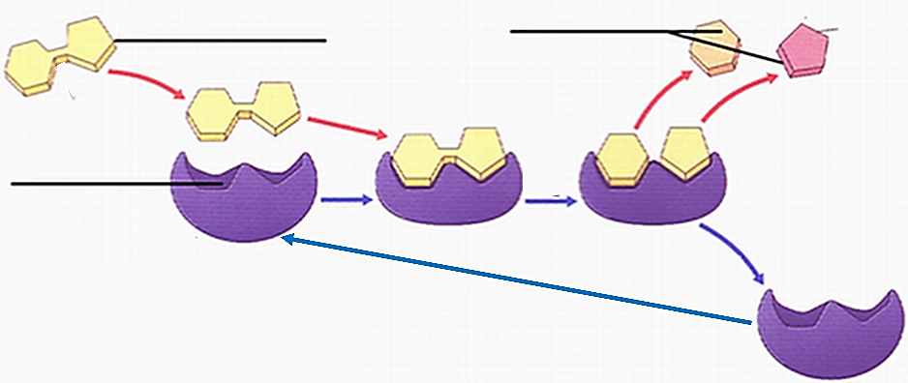
site, the enzyme acts to produce the product molecules. Label the products in this diagram.

After the products leave the active site, the enzyme returns to its original state and is ready to act on another substrate molecule. Thus, an enzyme molecule can be reused over and over again. For example, a single molecule of the enzyme lactase can speed up the digestion of many, many molecules of lactose to many, many molecules of glucose and galactose.

9. To describe what happened in your experiment, match each item in the top list with one of the items from the bottom list.

Lactose (substrate) ___ Lactase (enzyme) ___ Glucose and galactose (products) ___

a. Amount decreased from the beginning to the end of your experiment.
b. Amount increased from the beginning to the end of your experiment.
c. Amount stayed the same from the beginning to the end of your experiment.

10a. A catalyst is a substance that speeds up a chemical reaction without undergoing any permanent change. Is the enzyme lactase a catalyst? yes ___ no ___

10b. Explain why or why not.

11. Explain why the first version of the chemical equation is a better way to represent the process of lactose digestion. What is wrong with the incorrect version?

Correct: | Incorrect:
Lactase  Lactose + H₂O Glucose + Galactose | Lactose + H₂O + Lactase Glucose + Galactose

12. In Test Tube 1, there were over 10,000 lactose molecules for each lactase molecule. How can a single lactase molecule break down many, many lactose molecules?

How Too Little Lactase Can Cause Symptoms When a Person Drinks Milk

13. Maria has symptoms after she drinks a lot of milk, but Peter does not. In Peter’s small intestine, some of the cells make lactase which breaks down _______________ to glucose and galactose.  In the small intestine, small molecules like glucose and galactose are absorbed into the blood. The larger lactose molecule is not absorbed into the blood.  14a. In this diagram, write GG to show where:  - an enzyme in Peter’s digestive system breaks down lactose to glucose and galactose, and  - glucose and galactose are absorbed into the blood. | 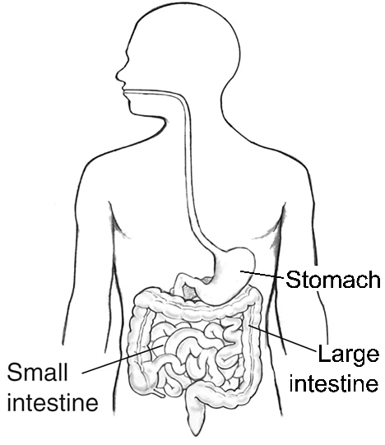

14b. As food is being digested, it moves from the stomach to the small intestine to the large intestine. When Peter drinks a glass of milk, lots of lactose enters his stomach, but very little lactose reaches his large intestine. Explain why very little lactose reaches Peter’s large intestine. Where did the lactose go?

14c. The cells in Maria’s small intestine make very little lactase – only enough to digest the lactose in a small glass of milk. If Maria drinks two large glasses of milk in a short time, what do you think happens to most of the lactose molecules in the milk? Explain your reasoning.

15. When lactose molecules reach Maria’s large intestine, the lactose is digested by bacteria. These bacteria produce gases, which result in flatulence and discomfort. In addition, osmotic effects reduce reabsorption of water from the contents of the large intestine; this results in diarrhea, which adds to her discomfort. This combination of symptoms after drinking milk is called lactose intolerance. Use this information to complete the flow chart below.
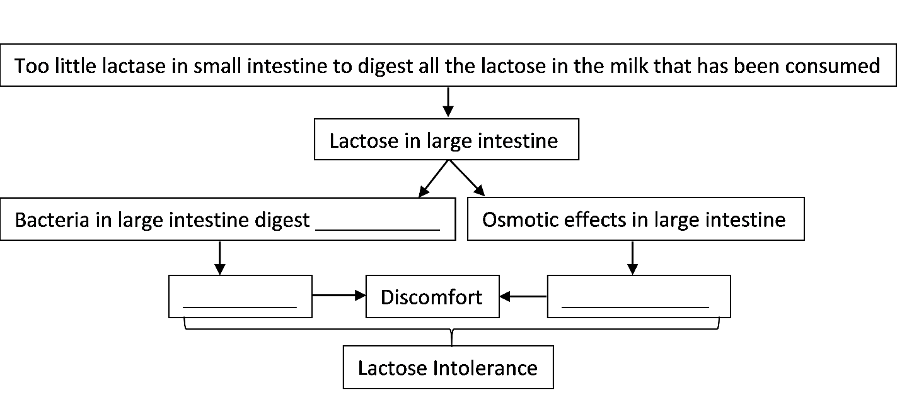
Jayden’s problem is different from Maria’s problem.

Jayden does not have any symptoms after he drinks milk. Instead, after he eats fruit, he has abdominal discomfort, diarrhea, and flatulence. In contrast, Maria has these symptoms after she drinks milk, but not after she eats fruit.
Many fruits contain significant amounts of the sugar, sucrose. Maria’s small intestine makes sucrase, an enzyme that breaks down sucrose to glucose and fructose, which are absorbed into the blood. Sucraid contains sucrase; if Jayden takes Sucraid when he eats fruit, he doesn’t have symptoms afterwards.  16. What chemical reaction do you think is speeded up by the enzyme sucrase? Write your answer in this format.  Enzyme  Substrate + H₂O Products | 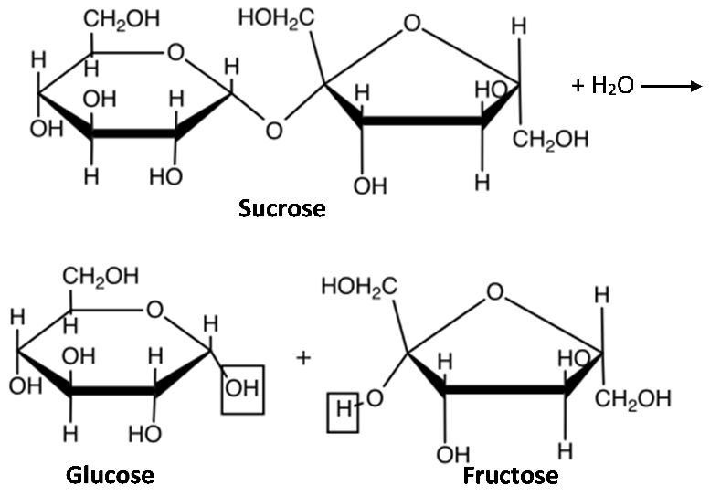  The boxed atoms in the glucose and fructose molecules show where the atoms from water are added when sucrose is broken down to glucose and fructose.

17. What do you think happens in Jayden’s digestive system to cause his symptoms?

18a. Complete this table to predict the effects of lactase and sucrase.

Enzyme | Do you think that the enzyme breaks down:
 | lactose? | sucrose?
Lactase | yes ___ no ___ | yes ___ no ___
Sucrase | yes ___ no ___ | yes ___ no ___

18b. Describe an experiment you could do to test each prediction in question 18a. Number your predictions in question 18a. Then, complete each row of the table below to describe an experiment that could test the prediction with the same number.

Test Tube | Contents of Test Tube |  |  | Do you predict these contents will produce glucose?
 | Substrate |  | Enzyme
1
2
3
4
Procedure
- Each member of your group should prepare one of the test tubes listed in the table in question 19.
- Each person should put on a glove, put his/her gloved thumb on the top of the tube and turn the tube upside down several times to mix the two liquids.
- Wait at least 3 minutes to allow time for the lactose or sucrose to break down to glucose plus galactose or fructose.
- While you are waiting:
- Each of you should get a test strip. In the next step, if glucose has been produced in your test tube, you will observe a color change in the test strip. Record the original color of your test strip. ____________
- Prepare a piece of paper with a labeled place to put each test strip.
- After there has been enough time for the lactose or sucrose to break down, each of you should use a glucose test strip to test for glucose in the solution in your test tube. To get clear results, you should evaluate change in color at 3 minutes after you dipped the test strip in the solution in your test tube.
- Record your results in the table in question 19.
- Clean your test tubes.

Results
19. Record your results in this table.

Test tube # | Amounts of  substrate + enzyme | Test strip color | Was there any  change in the color  of the test strip? | Conclusion
1 | 5 mL lactose solution + 2 mL lactase solution |  |  | ___ no glucose produced  ___ some glucose produced
2 | 5 mL lactose solution + 2 mL sucrase solution |  |  | ___ no glucose produced  ___ some glucose produced
3 | 5 mL sucrose solution + 2 mL lactase solution |  |  | ___ no glucose produced  ___ some glucose produced
4 | 5 mL sucrose solution + 2 mL sucrase solution |  |  | ___ no glucose produced  ___ some glucose produced

Interpretation
20a. Which sugar or sugars are broken down by lactase? How do you know? (Which test tube results support your answer?)

20b. Which sugar or sugars are broken down by sucrase? How do you know?

20c. Does the same enzyme digest lactose and sucrose? yes ___ no ___
Your results illustrate a general principle called enzyme specificity. Enzyme specificity means that each enzyme acts on only a single substrate or several chemically similar substrates which fit into the active site of the enzyme.

21a. Compare the shapes of sucrose and lactose to explain why they are not digested by the same enzyme.  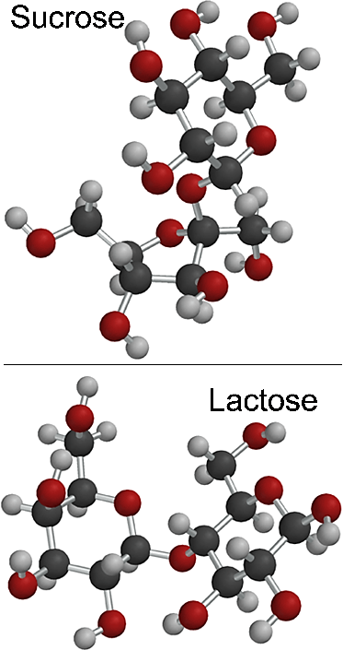 | 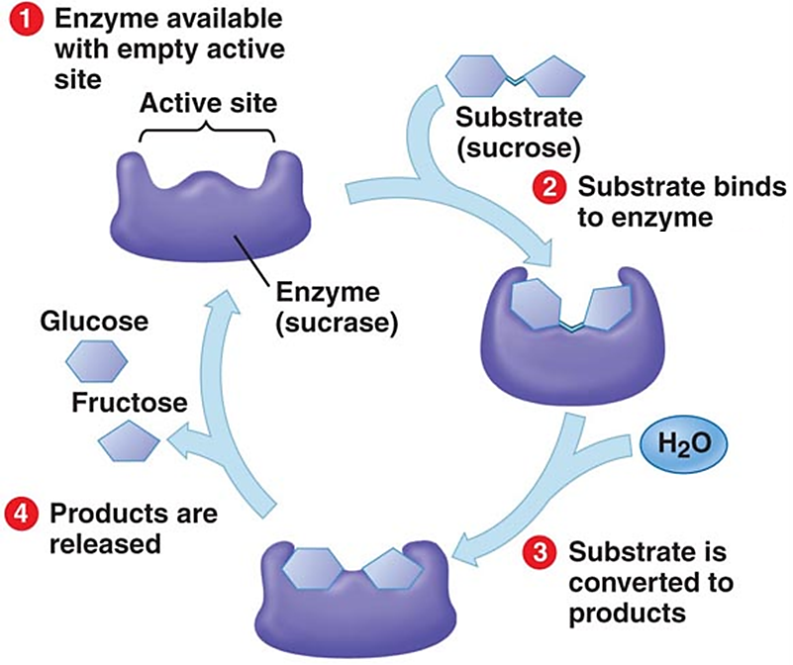  21b. After _____________ binds to the active site, the enzyme, sucrase, changes shape. To learn more, watch the video, "Enzyme Action and the Hydrolysis of Sucrose” (https://www.youtube.com/watch?v=XAw6DH1SMAc&t=26s). After the products leave the active site, the enzyme returns to its initial shape. Therefore, each molecule of sucrase can be reused over and over to break down thousands of molecules of _____________.

Because of enzyme specificity, your body needs lots of different types of enzymes to digest different types of food molecules. To conclude, you’ll learn about one more digestive enzyme.

Interpreting an Experiment with Starch and Saliva
Watch the video, “Experiment with Salivary Amylase Enzyme”, available at https://www.youtube.com/watch?v=YiW9PcUwL4g. Right near the beginning of the video the teacher made a mistake; he meant to say that “Iodine in the presence of a polysaccharide (starch) produces that dark purple color.” In contrast, iodine interacts with short fragments of starch molecules to produce a pink color.

22a. Propose an explanation for why the contents of the beaker with saliva turned pink, but the contents of the other beaker stayed purple.

22b. How does saliva contribute to the digestion of starch-containing foods like bread or pretzels?

By Drs. Ingrid Waldron, Lori Spindler and Jennifer Doherty, Department of Biology, University of Pennsylvania, © 2024. Teachers are encouraged to copy this Student Handout for classroom use. This Student Handout and Teacher Preparation Notes with instructional suggestions and background information are available at https://serendipstudio.org/sci_edu/waldron/#enzymes.

