DNA

Introduction
1. Everyone has heard of DNA, but what is it and what does it do? Briefly summarize what you already know about DNA and how DNA influences a person’s characteristics.

A key fact about DNA is that each DNA molecule contains many genes. A gene is a segment of DNA that provides the instructions for making a protein.

A cell needs many different types of proteins to function. For example, a cell needs:
- protein enzymes to carry out the chemical reactions that sustain life
- transport proteins to move ions and molecules into and out of the cell.

2. All organisms, including humans, other animals, plants, bacteria and other prokaryotes, have DNA inside their cells. Why does each type of cell need to have DNA?

Genes influence an organism's characteristics by determining what types of proteins the organism makes. The table below shows the effects of two different versions of a human gene.

Gene in DNA | → | Protein | → | Characteristic
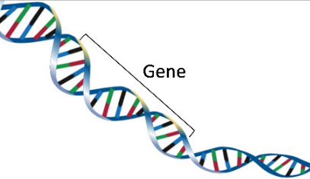 | → | 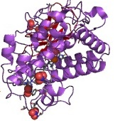 | → | 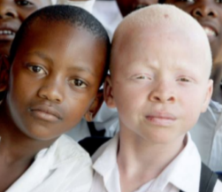
One version of the gene gives the instructions for making a functional protein enzyme. | → | The functional enzyme makes melanin, the pigment molecule in skin and hair. | → | Normal skin and hair color
Another version of this gene gives the instructions for making a nonfunctional version of this protein. | → | The nonfunctional protein does not make melanin. | → | Very pale skin and hair = albinism

3. Explain how a difference in their DNA can result in one boy being albino and another boy having normal skin and hair color. (A complete answer will include the words: gene, protein, enzyme, and melanin.)

DNA Extraction
Today, you will extract DNA from a prokaryote: the archaeon, Haloferax volcanii. Your teacher will give your group an agar plate with many tiny Haloferax growing on the agar. You will be able to see the Haloferax colony as a red growth on the agar plate.

In nature, Haloferax grow in extremely salty environments such as the Great Salt Lake, Dead Sea, or the very salty brine that results when seawater is evaporated to produce salt. To balance the high salt concentration in their environment, each Haloferax has a high concentration of salt inside the cell.

4. The first step in extracting the DNA from the Haloferax cells will be to add water to the Haloferax on the agar plate. Based on your understanding of cells and osmosis, what do you think will happen when the Haloferax cells are put in water with no salt? | 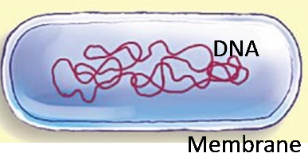

- Use a pipette to add 5 mL of water to your group’s plate of Haloferax. Use a Q-tip or spreader to gently move the burst cells off the agar. Mix thoroughly so the cells’ contents dissolve in the water.  - Each student in your group should use a pipette to suck up 1 mL of the water with dissolved cell contents. You should be able to see the strands of DNA swirling as you suck up this solution. Notice that these long DNA strands make the solution viscous or goopy. Put the 1 mL of solution in your test tube. Before the fourth student in your group gets his/her solution, you may need to add 1 mL more of water to the plate and stir.  - To extract the DNA from the solution in your test tube, you will add a layer of chilled alcohol on top of the solution. Get a pipette with 1 mL of chilled alcohol.  - Tilt your test tube at a 45° angle, hold the pipette against the side of the test tube, and gently squeeze the pipette so the alcohol flows down the side and forms a layer on top of the water with dissolved | 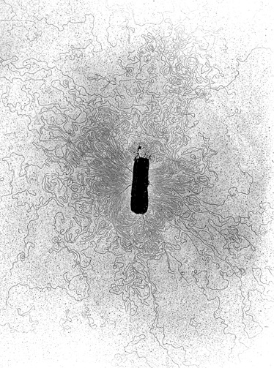  This figure shows how the DNA spreads out in many long strands when it is released from a cell. The total length of the DNA molecule is 500-1000 times longer than the cell!
Haloferax DNA and other molecules. Do not shake the test tube. Gently place it where it will
be undisturbed for 20 minutes while the DNA precipitates out of solution.

While you’re waiting for the DNA to precipitate, read the next page and answer the questions.

DNA Structure and Function
A DNA molecule has two strands of nucleotides twisted together in a long spiral called a double helix. This figure shows a small part of a double helix and the chemical structure of a short segment of this double helix.
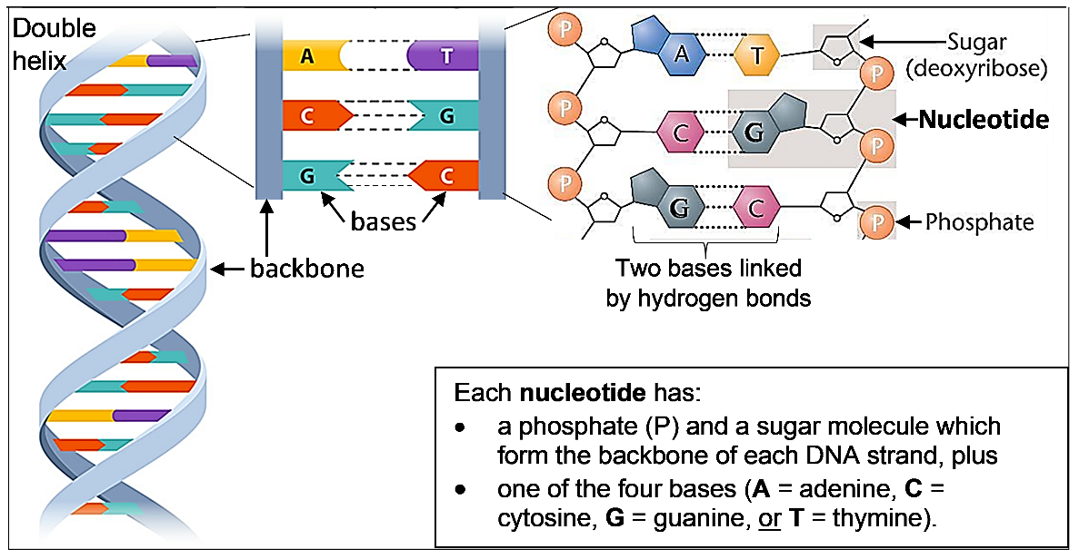
5. The sugar of each nucleotide is bound to the phosphate of the next nucleotide to make the backbone of each DNA strand. Draw a rectangle around the backbone of the right-most strand of DNA in the above figure.

6a. Each base in one strand of the DNA double helix is paired with a base in the other strand. The base-pairing rules describe which bases pair together in a DNA double helix.
A in one strand pairs with _____ in the other strand.
C in one strand pairs with _____ in the other strand.
6b. The only difference between DNA nucleotides is the base each nucleotide contains. Therefore, a nucleotide is given the same symbol as the base it contains (A, C, G, or T) and the base-pairing rules apply to the nucleotides. The nucleotides that pair together are called complementary nucleotides. Which nucleotide is complementary to G?

Different versions of a gene have a different sequence of nucleotides. As shown in the figure below:
the sequence of nucleotides in the DNA of a gene
determines the sequence of nucleotides in RNA which
determines the sequence of amino acids in a protein which
determines the structure and function of the protein which
influences the characteristics of the organism.
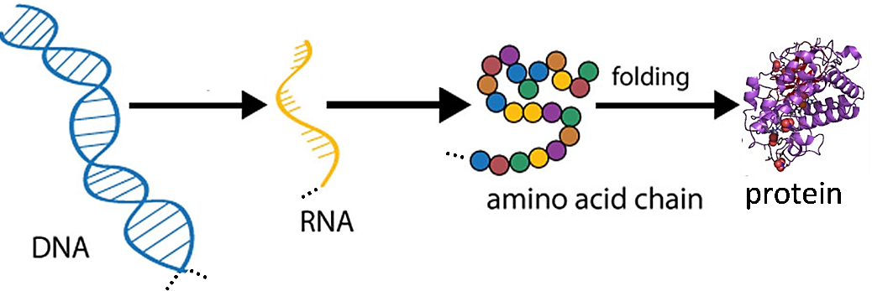

7. How can a different sequence of nucleotides in a gene result in one boy being albino and another boy having normal skin and hair color?

DNA Extraction (continued)
E.  F.  G. | 20 minutes or more after you added the alcohol to your test tube, carefully examine the tube without bumping it. You should be able to see a translucent layer with DNA between the alcohol and the solution of water with dissolved cell contents. Often there will be strands of DNA stretching up into the alcohol, sometimes with bubbles on the strands.  Gently tilt the test tube at a 45° angle, put your stick ½ inch into the solution, and stir gently in one direction only to wind the DNA onto the stick. Then slowly draw the stick up along the inside of the test tube. You should see trailing goopy strands – this is the DNA.  Gently rub the stick on the edge of the test tube and stretch the stick outward slowly. You should see the DNA stretching out between the stick and the test tube.

DNA Replication
Our bodies need to make new cells to grow and to replace damaged cells. This figure shows how new cells are formed by cell division. Before a cell divides into two daughter cells, the cell makes a copy of all of its DNA (DNA replication).

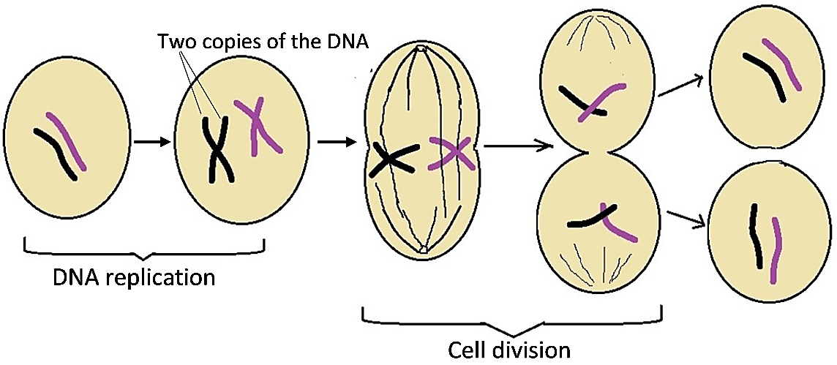

8. Explain why a cell needs to replicate its DNA before the cell divides into two daughter cells.

This figure shows how DNA replication produces two new DNA molecules that are identical to the original DNA molecule.
- First, the two strands of the DNA double helix are separated.
- Then, each nucleotide in the old strand is matched by the base-pairing rules with a complementary nucleotide in the new strand.
An enzyme, DNA polymerase, joins each new nucleotide to the previous nucleotide in the new DNA strand.

9a. This figure shows two free nucleotides, A and G. Which of these will be the next nucleotide to be added at the top of the growing new DNA strand on the left? ___

9b. How do you know?

The top half of this figure shows a short segment of DNA. In the bottom half of the figure, the two DNA strands have been separated in preparation for replication.  - Your job is to play the role of DNA polymerase and create new strands of complementary nucleotides to produce two segments of double-stranded DNA. Use the base-pairing rules to add complementary nucleotides one-at-a-time. (Your teacher will give you additional instructions.)  10. Compare the two new double-stranded segments of DNA with the original double-stranded segment of DNA. Do they all have the same sequence of | 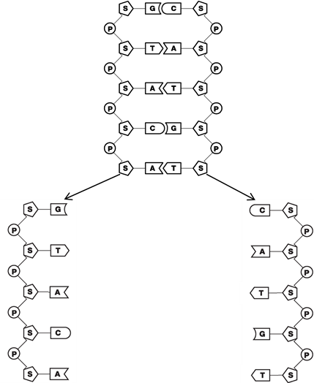
nucleotides in both strands? yes ___ no ___

11. Why is it important for both copies of the DNA produced by DNA replication to have the exact same sequence of nucleotides as the original DNA?

12. Based on the function of DNA polymerase, explain why each part of the name DNA polymerase (DNA, polymer, -ase) makes sense.

13. Explain how DNA polymerase, the double helix structure of DNA, and the base-pairing rules work together to produce two identical copies of the original DNA molecule.

By Drs. Ingrid Waldron, Lori Spindler, Jennifer Doherty and Mecky Pohlschroder, Department of Biology, University of Pennsylvania, © 2023. This Student Handout and Teacher Preparation Notes (with instructional suggestions and biology background) are available at https://serendipstudio.org/sci_edu/waldron/#dna.

