Were the babies switched? – The Genetics of Blood Types and Skin Color¹

Two couples had babies on the same day in the same hospital.
- Emily and Earnest had a girl, Tonya.
- Danielle and Michael had twins, a boy, Michael, Jr., and a girl, Michelle.

Danielle was convinced that there had been a mix-up and she had the wrong baby girl. Tonya and Michael Jr. looked more like twins since they both had darker skin, while Michelle had lighter skin. To check | Tonya Michael Jr. Michelle
whether there had been a mix-up, Danielle asked the hospital to test the blood type of each baby and parent.

How could blood types help to identify the true parents of each baby girl?
Each person has one of the blood types shown in this chart. Your blood type is determined by whether your red blood cells have type A and/or type B carbohydrate molecules on the surface.

A person with: | has:
type A blood | type A carbohydrate molecules  on the surface of his or her red blood cells
type B blood | type B carbohydrate molecules  on the surface of his or her red blood cells
type AB blood | both type A and type B carbohydrate molecules  on the surface of his or her red blood cells | 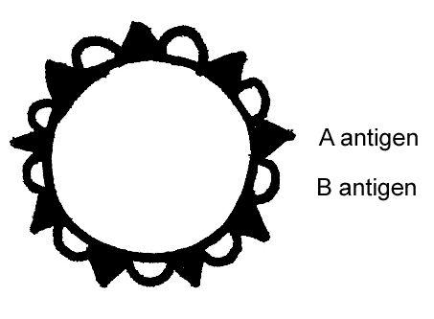
type O blood | neither type A nor type B carbohydrate molecules  on the surface of his or her red blood cells

1. What do you already know about inheritance of these blood types? Can a child have a different blood type than either of his/her parents?

The blood types listed above result from three different alleles of a single gene. Each allele of this gene gives the instructions for making a different version of a protein enzyme that can put carbohydrate molecules on the surface of red blood cells.

Allele* | gives the instructions for making a version of the enzyme that:
E^{A} | puts type A carbohydrate molecules on the surface of red blood cells
E^{B} | puts type B carbohydrate molecules on the surface of red blood cells
e | is inactive; doesn't put either type of carbohydrate molecule on the  surface of red blood cells
*The E in each allele name stands for enzyme.

2. Genes only give the instructions for making proteins. So, how do different alleles of the blood type gene result in different carbohydrates on the surface of red blood cells?

______________
¹ By Drs. Jennifer Doherty and Ingrid Waldron, Dept Biology, Univ Pennsylvania, © 2024. This Student Handout and Teacher Preparation Notes with background information and instructional suggestions are available at https://serendipstudio.org/exchange/waldron/bloodtests.

Each person has two copies of the blood type gene in each cell. One copy was inherited from his/her mother and the other copy was inherited from his/her father. This table shows some of the possible genotypes and the blood type that results from each genotype.

Genotype | Cells of a person with this genotype make: | Blood Type
E^{A}E^{A} | the version of the enzyme that puts type A carbohydrate molecules on the surface of red blood cells. | A
ee | the inactive protein that does not put either type A or type B carbohydrate molecules on the surface of red blood cells. | O
E^{A}e | both the version of the enzyme that puts type A carbohydrate molecules on the surface of red blood cells and the inactive protein | A

3a. In a person with the E^{A}e genotype, which allele is dominant? E^{A} ___ or e ___
3b. Explain your reasoning. Include a definition of a dominant allele in your answer.

4. For each genotype in the table below, indicate whether the person’s cells would make each type of enzyme and which blood type would result.

Genotype | Will this person's cells make the version of the enzyme that puts this carbohydrate on the surface of his/her red blood cells? | Blood Type
E^{B}E^{B} | type A yes ___ no ___; type B yes ___ no ___;
E^{B}e | type A yes ___ no ___; type B yes ___ no ___;
E^{A}E^{B} | type A yes ___ no ___; type B yes ___ no ___; | AB

Codominance occurs when two alleles of a gene each have a different observable effect on the phenotype of a heterozygous individual. Thus, in codominance, both alleles are dominant.

5a. In the above table, circle the blood type that shows evidence of codominance.
5b. Explain your reasoning.

6a. A mother with the E^{A}e genotype makes eggs with either the ____ or the ____ allele.
6b. A father with the E^{A}E^{B} genotype makes sperm with either the ____ or the ____ allele.
6c. Draw a Punnett square for this mother and father.
6d. Show the blood type for each parent and each possible child.
6e. Circle the possible child or children who would have a blood type that neither parent has.

Why do blood types matter?

The type A and type B carbohydrate molecules on the surface of red blood cells are called antigens because they can stimulate the body to produce (generate) antibodies. Antibodies help the immune system to identify and destroy invaders, such as bacteria or viruses that have infected your body.
Each specific type of antibody binds to a specific antigen. For example, anti-B antibodies in the blood bind to type B antigens, but not to type A antigens. When an antibody binds with an antigen on the surface of a cell, this typically results in damage to the cell. Fortunately, your body usually does not make antibodies against any antigens that are part of your body.

7. Use this information to fill in the blanks in this chart.
People with type A blood have:  - type A antigens on the surface of their red blood cells and  - ________ antibodies in their blood. | People with type B blood have:  - type B antigens on the surface of their red blood cells and  - ________ antibodies in their blood. | People with type AB blood have:  - both type ___ and type ___ antigens on the surface of their red blood cells and  - neither anti-A nor anti-B antibodies in their blood. | People with type O blood have:  - neither type of antigen on the surface of their red blood cells and  - both ________ and ________ antibodies in their blood.
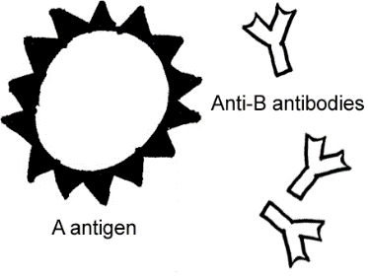

8a. If a person with type A blood were given a transfusion of type B red blood cells, what do you think would happen? What could cause the type B red blood cells to clump together and block small blood vessels? (Hint: See top figure on this page.)

8b. A person with type _____ blood is called a universal donor because his/her red blood cells have no antigens and thus can be safely given to people with any blood type.

8c. A person with type _____ blood is called a universal recipient because he/she can safely receive any type of red blood cells. Explain your reasoning.

Testing Blood Types
9a. If a sample of blood is mixed with antibodies that match the antigens on the red blood cells, the result will be clumping. To test the blood type of each parent and each baby, you will:
- mix one sample of their blood with anti-A antibodies to test whether their red blood cells have the type ____ antigen
- mix a second sample of their blood with anti-B antibodies to test whether their red blood cells have the type ____ antigen.
9b. To prepare to interpret the blood type tests, fill in this chart. | Blood type | Will this blood type clump if mixed with
 |  | anti-A antibody? | anti-B antibody?
 | A
 | B
 | AB
 | O
Procedure
- Your group should get a blood-typing tray or other testing surface, and label two spots (A and B) for each person in the table below.
- Go to the station for each person and put three drops of the person’s blood on his/her A spot. Do the same for his/her B spot.
- For each person, put three drops of anti-A antibody solution on the blood in the A spot and put three drops of anti-B antibody solution on the blood in the B spot.
- Return to your seat and mix each blood sample and antibody solution with a clean toothpick. Discard each toothpick after you have used it.
- If your testing surface is transparent, put it on a white background so you can more easily see whether there is a clumping reaction.
- Wait a minute before looking for clumping; look especially carefully at the edges of each sample. Record the results of each test in the second or third column of the table below.

Results
10. Use the information on this page to write the blood type of each person in the table below. Use the information on page 2 to add the possible genotypes of each person.

Blood from | Reacts with anti-A antibody (Yes or No) | Reacts with anti-B antibody (Yes or No) | Blood type  (A, B, AB, O) | Possible genotype or genotypes
Danielle
(mother of twins)
Michael
(father of twins)
Emily
(mother of daughter)
Earnest
(father of daughter)
Michael Jr.
(boy twin)
Baby girl 1
(girl twin, according to hospital)
Baby girl 2
(daughter of Emily and Earnest, according to hospital)

Interpretation
Next, you will use the results of the blood tests to evaluate whether the hospital made a mistake and accidentally switched the baby girls.

11a. Draw a Punnett square for each possible combination of genotypes for Danielle and Michael. Label the blood type for each possible child of this couple.

11b. Could Danielle and Michael be the parents of Baby girl 1? yes ___ no ___

11c. Could Danielle and Michael be the parents of Baby girl 2? yes ___ no ___

12a. Draw a Punnett square for each possible combination of genotypes for Emily and Earnest. Label the blood type for each possible child of this couple.

12b. Could Emily and Earnest be the parents of Baby girl 1? yes ___ no ___

12c. Could Emily and Earnest be the parents of Baby girl 2? yes ___ no ___

13a. The hospital said that:
- Danielle and Michael were the parents of Baby girl 1, and
- Emily and Earnest were the parents of Baby girl 2.
Did the hospital make a mistake? yes ___ no ___

13b. How do you know?

Why do the twins look so different?
Now, Danielle wants to know how her twins could look so different, with Michael Jr. having dark skin and Michelle having light skin. First, Danielle needs to understand that there are two types of twins. Identical twins have exactly the same genes, since identical twins originate when a developing embryo splits into two embryos.

14. How do you know that Michelle and Michael Jr. are not identical twins?

Michelle and Michael Jr. are fraternal twins, the result of two different eggs, each fertilized by a different sperm. These different eggs and sperm had different alleles of the genes that influence skin color. So, Michelle and Michael Jr. inherited different alleles of these genes.

To begin to understand how Michelle could have light skin and her twin brother, Michael Jr., could have dark skin, consider the effects of the T and t alleles of one of the genes that
influence skin color. Notice that a heterozygous Tt individual has an intermediate phenotype, halfway between the two homozygous individuals (TT and tt). This is an example of incomplete dominance. | Genotype | Phenotype (skin color)
 | TT | dark brown
 | Tt | light brown
 | tt | tan

Incomplete dominance occurs when the phenotype of a heterozygous individual is intermediate between the phenotypes of the two different types of homozygous individual.

15. Match each item in the list on the left with the best match from the list on the right.

If the phenotype of a heterozygous individual: | then the type of dominance is:
∙ is intermediate between the phenotypes of the two different types of homozygous individuals, ___ | a. a dominant-recessive pair of alleles
∙ is the same as the phenotype of an individual who is homozygous for the dominant allele, ___ | b. codominance
∙ shows distinct observable effects of both alleles, ___ | c. incomplete dominance

16. The parents, Danielle and Michael, both have the Tt genotype and light brown skin. Draw a Punnett square for this couple, and explain how these parents could have two babies with different color skin – one dark brown and the other tan.

Obviously, people have many different skin colors, not just dark brown, light brown, or tan. These varied skin colors result from the effects of multiple alleles of multiple genes, plus environmental factors such as amount of exposure to sunlight. This flowchart summarizes how multiple genetic and environmental factors influence skin color.
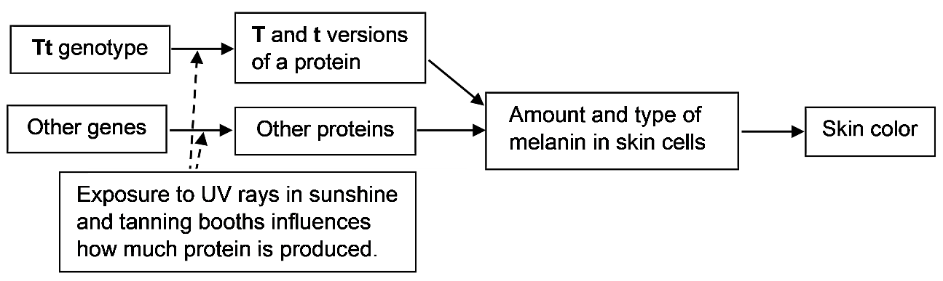

17. This information indicates that the table on the top of this page is oversimplified. Since multiple genetic and environmental factors influence skin color, two people who both have the Tt genotype can have different skin colors. Give two possible reasons why one person with the Tt genotype could have darker skin than another person with the same genotype.

