Preparing to go into Riverside Correctional Facility, Fall 2017
Orientation Packet, first prepared by Sasha de la Cruz,
Sara Gladwin & Hayley Burke, updated by Anne Dalke and Jody Cohen

How i t all started!
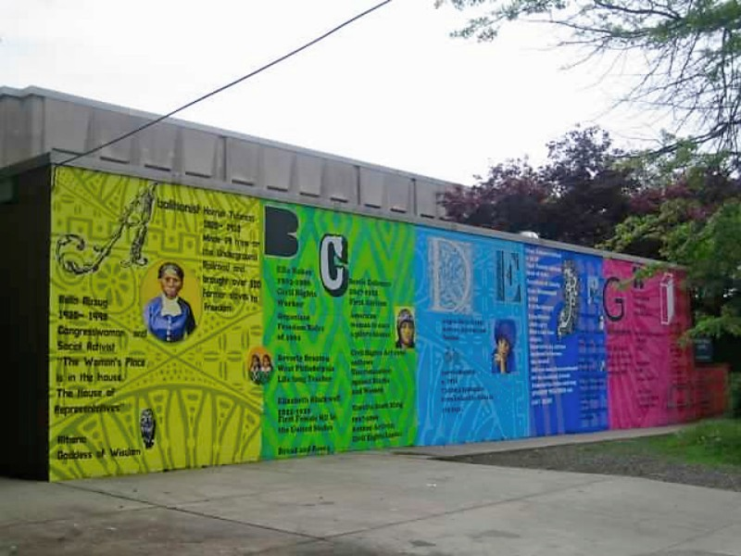
In Fall 2012, the “Women in Walled Communities” 360 “focused on the constraints and agency of individual actors in the institutional settings of women's colleges and prisons.” During that 360, we made art with people incarcerated in the Cannery; now we have a reading and writing class that goes into Riverside Correctional Facility (RCF).

We are NOT a Community Service Project!

As college students, we already have some sort of privilege, not just inside the prison, but in society in general – it’s how our society is structured. It is imperative that we always, ALWAYS keep in mind that we are creating partnership with the people at RCF. We are not attempting to save, help, inspire or empower them. We are not researching, or observing those at RCF. We try our best to equalize the playing field and work past the fact that we are in a position of power and privilege. We make no assumption about the literacy levels of those inside, and do not question their competency/abilities for discussions.

Purpose of the group

We are not here to teach those who are incarcerated.
Our purpose is to provide a safe space for participants (BMC/HC students and RCF folk) to come together
and have meaningful conversations and do some writing about a certain topic or idea that will stem from the books we read – just like any other classroom, just a
bit more informal.

What Can’t I Wear?

For students of all genders….
- NO transparent clothing
- NO shorts
- NO mini skirts [preferably knee length or longer]
- NO tank tops, spaghetti straps
- NO cleavage
- NO crop-tops
- NO open back
- NO hoodies/anything with a hood
- NO halter tops
- NO bare legs
- NO open toe shoes or sandals of any kind

--lots of NO’s, we know--

Bring ID!

Please be sure to bring a valid government-issued photo ID. These include:
- Drivers’ or Non-drivers’ License
- Passport
- Foreign Counselor ID card.

YOU WILL NOT GET IN WITHOUT THIS KIND OF ID.
It’s very important to take the time, on the morning you will be coming to prison, to review these guidelines; if you violate the prison rules you may end up spending your time in the van rather in class; you may also put our program at risk.

What kind of materials can I bring in?

We are allowed to bring in pens, pencils, notepads and your book –all we’ll really need anyways. If for any reason we have to bring other materials, Anne or Jody will request permission in advance.

We are not allowed to go in with unbuttoned sweaters or jackets, or with our bags, phones, keys, etc. Van drivers can give the van keys to the CO to leave with their ID. There are lockers at the entrance in case we forget to leave something in the car.
Check your pockets before leaving the car to make sure you do not unintentionally bring anything else in with you. “Contraband” confiscated from Bi-Co folks in the past includes sunglasses and a pocket knife.

How do we get there/How do we get in?

Van departs from Pem Arch
at 11:45 am on Friday morning. The driver will
need a guide, someone with a smart
phone and GPS capacities, who can
direct her to 8151 State Rd,
Philadelphia, PA. NOTE: your GPS
is likely to recommend your taking
I-76 into the city, then I-95 out
to North Philly. Select instead the better,
shorter route, via
City Ave
I-76E
Route 1 (Roosevelt Blvd)
Cottman Ave
State Road.
Once we enter the building, we give our ID’s in exchange for a visitors pass to the CO who is at the front desk. We place our materials through a scanner and we walk through metal detectors. We are then patted down and the CO stamps our hand with black light ink.

We pass through two sets of locked sliding doors, are patted down a second time, and then proceed to the elevators, which take us up to our classroom (also a locked space; the guards will let us in, and then they will call the students who are incarcerated to join us).
Schedule and Expectations for Attendance:
We will be going into Riverside 13 times this spring (excepting only the week of Spring Break). Be sure to let us know ahead of time if you need to skip one week’s visit; we expect you to attend @ least 10 of these sessions.

