Preparing to go into Riverside Correctional Facility,
Arts of Resistance 360°, Fall 2015
“With 5% of the world's population, the U.S. incarcerates 25% of the world's prisoners.”
“The U.S. leads the world in incarceration, imprisoning one in 100 people. This translates into more than two million men and women being incarcerated in U.S. prison and jails. The incarceration rate for women in particular is growing at record rates, approximately 400% in the past 25 years. With more than 200,000 women confined in the nation’s federal, state and county facilities, approximately 10% of all incarcerated people are women and this number is expected to rise. Given this reality, it is imperative for social scientists and practitioners, and citizens nationwide, to understand the forces that drive mass incarceration, the meaning and experience of incarceration, especially for women, and its implications for the social world.”

How i t all started!
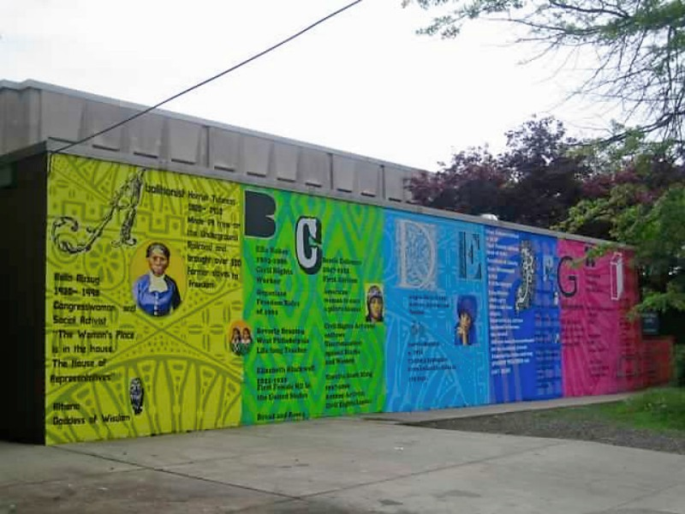
The idea of doing something in a prison stemmed from the Women in Walled Communities 360 during Fall Semester in 2012. This 360 “focused on the constraints and agency of individual actors in the institutional settings of women's colleges and prisons.” During the 360 we focused on art at the Cannery, now we have a reading/writing group and a literacy group and go twice weekly into Riverside Correctional Facility (RCF).

We are NOT a Community Service Project!

As college students, we already have some sort of privilege, not just inside the prison, but in society in general – it’s how our society is structured. It is imperative that we always, ALWAYS keep in mind that we are creating partnership with the women at RCF. We are not attempting to save, help, inspire or empower the women at RCF. We are not researching, or observing the women at RCF. We try our best to equalize the playing field and work past the fact that we are in a position of power and privilege. We make no assumption of the women’s literacy levels and do not question their competency/abilities for discussions.

Purpose of the group

We are not here to teach the women. Our purpose is to provide a safe space for participants (BMC/HC students and RCF women) to come together and have meaningful conversations and do some writing about a certain topic or idea that will stem from the books we read – just like any other classroom, just a bit more informal.

What Can’t I Wear?

For students of all genders….
- NO transparent clothing
- NO shorts
- NO mini skirts [preferably knee length or longer]
- NO tank tops, spaghetti straps
- NO cleavage
- NO crop-tops
- NO open back
- NO hoodies/anything with a hood
- NO halter tops
- NO bare legs
- NO open toe shoes or sandals of any kind

--lots of NO’s, we know--

Bring ID!

Please be sure to bring a valid government-issued photo ID. These include:
- Drivers’ or Non-drivers’ License
- Passport
- Foreign Counselor ID card.

YOU WILL NOT GET IN WITHOUT THIS KIND OF ID.
It’s very important to take the time, on the morning you will be coming to prison, to review these guidelines; if you violate the prison rules you may end up spending your time in the van rather in class; you may also put our program at risk.

What kind of materials can I bring in?

We are allowed to bring in pens, pencils, notepads and your book – it’s all you’ll really need anyways. If for any reason we have to bring other materials, Romi, Anne, Jody or Joel will request permission in advance.

We are not allowed to go in with unbuttoned sweaters or jackets, or with our bags, phones, keys, etc. Van drivers can give the van keys to the CO to leave with their ID. There are lockers at the entrance in case we forget to leave something in the car.
Check your pockets before leaving the car to make sure you do not unintentionally bring anything else in with you. “Contraband” that has been confiscated from Bi-Co folks in the past includes sunglasses and a pocket knife.

How do we get there/How do we get in?

Van leaves English House immediately after class at 3:45 pm on Thursdays, and departs from Pem Arch
at 11:45 am on Fridays. The driver will
need a guide, someone with a smart
phone and GPS capacities, who can
direct her to 8151 State Rd,
Philadelphia, PA. NOTE: your GPS
is likely to recommend your taking
I-76 into the city, then I-95 out
to North Philly. Select instead the better,
shorter route, via
City Ave
I-76E
Route 1 (Roosevelt Blvd)
Cottman Ave
State Road.
Once we enter the building, we give our ID’s in exchange for a visitors pass to the CO who is at the front desk. We place our materials through a scanner and we walk through metal detectors. We are then patted down and the CO stamps our hand with black light ink.

We pass through two sets of locked sliding doors, are patted down a second time, and then proceed to the elevators, which take us up to our classroom (also a locked space; the guards will let us in, and then they will call the women to join us).
Schedule and Expectations for Attendance:
We will be going into Riverside 11 times this fall, including Oct. 8-9 (the Thursday and Friday before Fall Break) and Dec. 10-11 (the last day of classes, and the day after). We will NOT be going in during the weeks of the Pope’s visit to Philadelphia (Sept. 24-25), fall break (Oct. 15-16) and Thanksgiving week (Nov. 26-27). Be sure to let us know ahead of time if you need to skip one week’s visit; we expect you to attend @ least 10 of the sessions.

