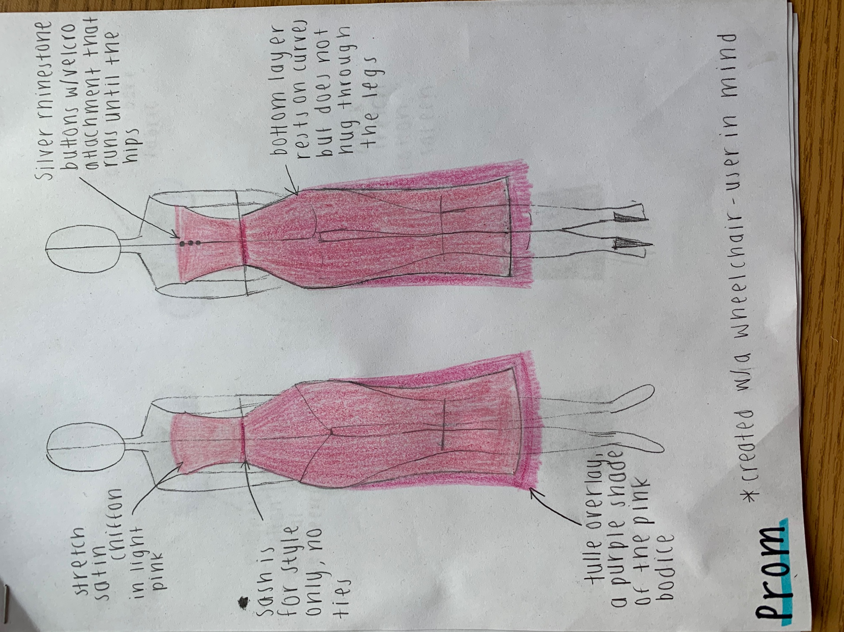

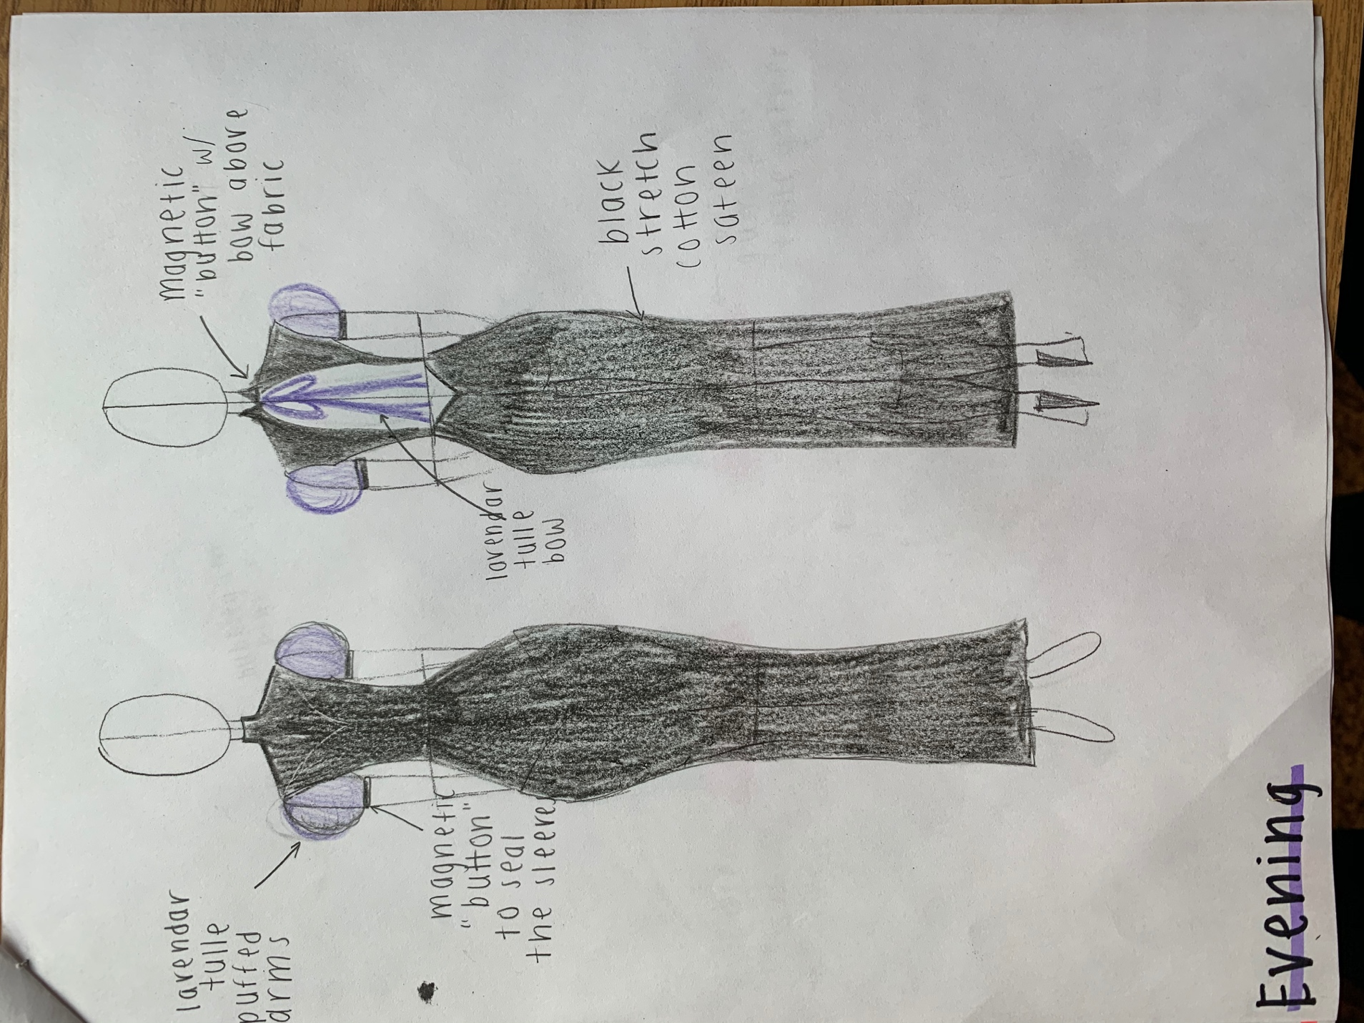

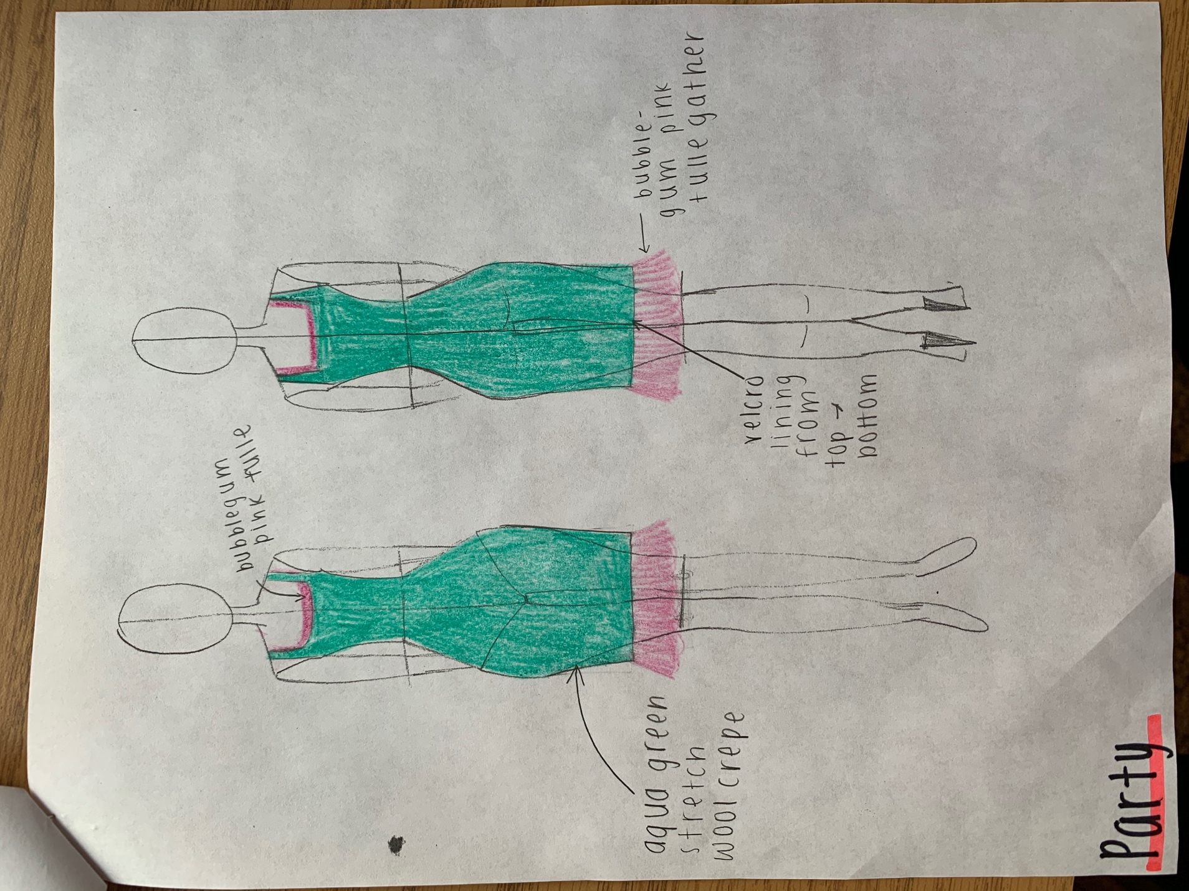

Fit.

Designer’s Note:
Fashion is a daunting topic for those who the industry rejects. Until the early 21st century, people with physically disabilities had minimal clothing options that revolved around black yoga pants and oversized t-shirts. Mainstream fashion companies such as Nike and Tommy Hilfiger launched adaptive fashion lines to fill this gap in the market while simultaneously alienating and restricting the disabled community to conservative, boring, and casual styles. Fashion is a form of individual expression, and as adaptive fashion gains momentum, its boring designs hide disabled people. Forced into muted sweater sets and high waisted jeggings, adaptive fashion houses preached about their successful efforts that allow the disabled community to assimilate to mainstream styles but not position themselves as trendsetters.
In high school I had the opportunity to make good and bad fashion decisions by the very nature of being able bodied. I had more designs available to me because I could zip up a dress on my own and shimmy into high-waisted jeans that were too tight for me. Through my fashion flops, came the victories as I curated pieces that improved my body image and put a smile on my face. In taking Critical Disability Theory, we learn about the culturally conditioned marginalization of different disabled communities and I believe that the global fashion industry is among the worst perpetrators. I designed “Fit.” because I want to create a fashion house for disabled and non-disabled bodies, not one or the other. No body ought to “adapt” or “integrate” into society by means of clothing because standing out is okay. Fit. creates dresses for one’s individual expression, particularly women between the ages of 15-30 who shouldn’t wear cashmere to a party out of desperation, but choice. Enjoy these three sample pieces with some information about the design and how it helps convey a vision of inclusion, not assimilation.

Prom Design:
I love glitz and glamour as much any five-year-old princess wannabe, but prom dress designers tend to overdo it. They sew sequins or splatter glitter across simple dresses and mark the price absurdly high. Teenagers are pressured to buy these ridiculous, uncomfortably poufy fits because there are few simple alternatives. I designed a dress for girls who are drawn to sophisticated styles, yet still desire an element of fun. I chose a longer dress design for high schoolers who use a wheelchair and/or have insecurities about their lower body. I also chose a waistline that flatters all body shapes and allows for easy tailoring adjustments, should they be necessary. The pink and purple shades complement one another, especially with the purple tulle overlaying the pink foundation of the skirt to create a darker shade of the pink corset. The strapless style is an inclusive design because it eliminates shoulder discomfort, specifically with the stretchy fabric I chose for this dress, which accommodates busts of all sizes. The bedazzled buttons, while not functional, add an element of glamour to this otherwise matte design. I use Velcro to close the dress because for people who unable to close buttons on their own, Velcro is an equally stylish alternative. The dress will flatter bodies of all shapes and sizes; including abled and non-abled bodied consumers.

Evening Design:
In researching adaptive fashion, I noticed the hegemonic emphasis on casual clothing. While jeans, t-shirts, and yoga pants are among the most important articles of clothing for general consumers, able-bodied people are easily able to locate and purchase evening dresses and other formal ware that physically disabled people cannot. This dress is designed for a mature client anywhere along the able-bodied spectrum who is attending a formal event. I chose a full-length style because it ensures that wheelchair users do not worry about exposing themselves in their seated position; another benefit of a longer dress is that it can be easily adjusted for shorter consumers. Black is a popular color for formal ware, however, I wanted to add some excitement by mixing up standard color preferences and adding subtle lavender purple touches. The black dress base is made of a stretchy for various body shapes and maximum comfortability. I chose a high neck for dramatic purposes, which the open back advances. I recognize that standard high neckline designs are not comfortable for all populations, but I try to overcome this issue with my soft fabric choice and magnetic “buttons”– both of which allow the client to put on with minimal difficult. The lavender tulle bow is a style choice that contributes to the striking nature of this design, when contrasted against matte black. The tulle puffed sleeves seal with the same magnetic button fastener as the neck and adds more dramatic flare to the front of the design.

Party Design:
Black halters and jean shorts are out; what about an aqua green dress with pink tulle fringe for major mermaid vibes? Adaptive fashion lines lack any night out/party attire that one could wear without being mistaken for a 1990s librarian. This dress is quick to put on, as I use stretchy wool crepe to maintain a shape to the dress while not restricting the individual’s mobility. For those who go all out on the dancefloor, I added straps to keep the dress in place but allow for maximum arm movement. The dress fastens with a Velcro lining that runs across the entire backside of the dress, thereby, making it easy to slip in or out for whatever reason. I added the pink tulle as a fun detail for dancing, but it does not serve a functional purpose.
Final Note:
I would like to note my commitment to affordable fashion. There is immense wealth inequality between disabled and nondisabled people, which worsens when one’s disabled status intersects with other marginalized identities. Although these designs may never be sold, I wanted to point out the importance of fashion that is not only accessible in style and comfort, but also cost.

