Maggie Heffernan
Midterm Project
Disability Seminar
My Brother is Not Cute—He’s a Badass

Recently at a track meet, my assistant coach approached me to share how excited he was to meet my brother.

“Your younger brother—he is just so cute,” he gushed, gesturing towards the bleachers where my brother was sitting.

Mid-way through my warm-up for the 5k, I feigned a smile and nodded at him, pretending to match his enthusiasm as he proceeded to talk about the “benefits of people with disabilities” and how profoundly his son had been affected by meeting someone with autism the other day.
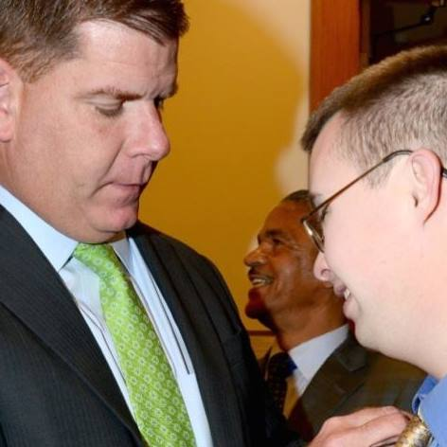
Besides the fact that my brother is three years older than I am, there is something else wrong with my coach’s statement: my brother is not “cute”—he’s a badass.

Brian, now 25, was my parents’ first of three children. As she did with all of us, my mom opted out of prenatal testing while pregnant with Brian, telling the doctor that no result was going to change her decision about having her child.

Because of this choice, my parents were thoroughly surprised when Brian was born with Down syndrome. Realizing after not too
Brian meeting Boston Mayor Marty Walsh

much research that the public schools in Boston were not going to cut it for their son with special needs, they decided to move to Newton, a nearby suburb renown for its special education programs.

And, since moving to Newton, Brian has taken and enjoyed mainstreamed classes, graduated with a high school diploma, and passed all Massachusetts standardized testing, a feat not common for individuals with Down syndrome due to the cognitive and fine motor skills needed to complete the tests within the given time constraints.

Oh, and he works at the State House now, a platform he frequently utilizes to advocate for disability rights.

“I’m smart, popular, a geek, and a diva,” he stated recently during a speech at a local elementary school when asked what four words he would use to describe himself.
Needless to say, “cute” is not the first word that jumps to mind when I think of my older brother. Yet my coach’s comment is not unique: individuals with Down syndrome have long been portrayed and discussed in popular culture as embodiments of cuteness.

As disability studies scholar Rosemarie Garland-Thomson writes, there exist four visual rhetorics of disability: the wondrous, the sentimental, the exotic, and the realistic. Each of these ways of viewing people with disabilities invokes a different response in the viewer, as well as influences the behavior and actions of the viewer. And, according to Garland-Thompson, all representations of disability “either inadvertently or deliberately summon these visual rhetorics and their accompanying cultural narratives.”

For people with Down syndrome, the go-to visual rhetoric is “the sentimental.” People with Down syndrome are often described and depicted as being incredibly loving, perpetually gleeful, and “angelic.” Though these descriptions fit some people with Down syndrome, they by no means encompass them all. And deducing the persona of any individual to an object of sentimental cuteness is not just infantilizing—it is dehumanizing.

The “cuteness” characterization is also too often employed when it is not relevant. Just the other day I was reading a Huffington Post article about how an increasing number of colleges and universities are developing programs for individuals with intellectual disabilities. The piece features Zach Neff, a young man with Down syndrome who participated in one of these programs. Yet, instead of initially highlighting Neff’s coursework or academic achievements, the article opens with an anecdote about how his teachers had to put him on a “hug diet.”

The Down syndrome community often plays a role in this perception as well. Awareness campaigns and organizations targeted towards families and friends of individuals with Down syndrome are often effusively positive, coated with exclamatory phrases such as “Believe!” or “Never give up!” On World Down syndrome Day in 2014, a video montage of individuals with Down syndrome dancing to Pharrell’s upbeat “Happy” was released, producing myriad smiles and reactions of awe in its viewers.

These messages are important because there are people who believe Down syndrome is a condition to be lamented. And these messages are, to an extent, necessary, because there are also anxious parents who do not know how to adapt to having a child with special needs. Indeed, not too long ago, individuals who were born with Down syndrome were routinely institutionalized. Society therefore neither saw nor interacted with this demographic much at all, and were left to make up their own, fragmented and ignorant conclusions about what these types of people must be like. After all, projecting inspirational, hopeful depictions of people with Down syndrome is much better than shutting them off from society entirely.

Yet we can do better. As David Perry, whose son has Down syndrome, wrote in an article last year, “Happy lives are good, but is happy enough? What about inclusion, support, jobs, education, accessibility? How do we get past the low-hanging fruit of happy to do the hard work that our community needs?”

Many of the issues Perry references plague individuals with Down syndrome when they are older and, as is true with most people when they age, arguably less “cute.” According to a 2015 survey of individuals with Down syndrome from 37 states, only 57% of respondents were employed. Of those who were employed, their jobs were largely in the fields known as “the five Fs”: Food (fast food and kitchen services), Filth (cleaning and janitor work), Flowers (florists and landscaping), Factories (light assembly line work), and Filing (office mail delivery).

Since the skillset for every person with Down syndrome varies greatly, job training that is individualized instead of generalized should be implemented in programs and schools. Additionally, more places of employment should broaden their applicant pools to include—rather than automatically discount and exclude—individuals with Down syndrome. Indeed, categorizing a subset of people by their “cuteness” is dehumanizing, yet it also does not aide someone who is trying to find a job. (As a senior who is currently job searching, I cannot emphasize how many times I have been advised to “act professional.”)

In order to begin to change the rhetoric and popular conception of individuals with Down syndrome to include more than just “cuteness” or perpetual happiness, we must ensure that individuals with Down syndrome of all abilities, personalities, and ages are represented in the media. Actor Chris Burke, who is most known for his role on the sitcom Life Goes On, is a great example of an individual with Down syndrome whose media presence revolves around his talent rather than the sentimentality he invokes. Now 50 years old and past his acting prime, Burke continues to perform in smaller roles as well as appear as a guest on television talk shows. As he said during a 2014 interview with Oprah, his acting is not about “performing disabilities—its about performing abilities.”

Brian with actor Chris Burke

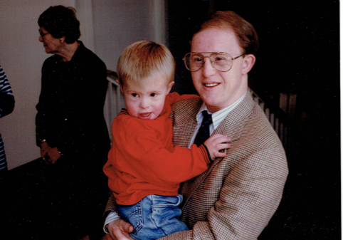
In Brian’s speeches about self-advocacy and political reform for individuals with special needs, he is unfailingly witty, incredibly articulate, and enthusiastic to share his own story. His knowledge of current events, American history, and literary works shines through during conversations with him, in which he is never shy about sharing his opinion.

“Well, 18 is the age when debutantes usually come out to society,” Brian recently remarked to my mom, calling upon his Downton Abbey expertise in thinking about a young female character in Charles Dickens’ Our Mutual Friend.

The demand for his presentations at both local elementary schools and renowned universities is high, and it is his individual accomplishments and distinct persona that generate awe. And it is my hope that when Brian becomes an old man—perhaps with less charm, perhaps with the beginnings of Alzhemier’s, perhaps with less youthful appeal—that he will continue to speak, because it is what he loves.

Of course he will. Because he is a badass and because it is what he loves.

