Kristen Fiore
Critical Disability Studies

The Media Enforcing Normalcy

In the Disability Studies Reader, author Lennard Davis opens up his discussion of disability by addressing the creation of normalcy in our modern society. According to Davis, the concept of normal did not even enter the English language until 1840 (Davis 1). With the industrial revolution came the notion of certain actions and people being deemed worthy because they contributed more to industrial progression. Although I continue to use progression in reference to this time period, it honestly cannot be the correct word. Progression refers to the technology and creation of urban centers during this time, but does not account for the increased discrimination and further implementation of normalcy that became ingrained into the foundation of our current society. We change our clothing, how we talk, how we act, and how we behave all in order to mimic the ideal of our surrounding culture. However Davis argues that in Ancient Greece, “The notional of an ideal implies that, in this case, the human body as visualized in art or imagination must be composed from the ideal parts of living models. These models can never embody the ideal since an ideal, by definition, can never be found in this world” (Davis 2). He continues to introduce a Greek artist, Zeuxis who took inspiration from various women to create his painting of Aphrodite. Since in this instance the Goddess of beauty was not modeled after a single woman, Davis believes that in Ancient Greece, the ideal was divine and unattainable. However, upon further investigation, the Greek were incredibly preoccupied with the athletic and fit male body. This is clearly evident in any sculpture or portrayal of men in art from Ancient Greece, for example consider the statue of Discobolos, the discus thrower. Although Davis might argue that these ideal body depictions were unattainable, I cannot help but connect this trend with modern media. Our society idealizes a certain body type that is reflected in the media. These bodies are photoshopped or uniquely tall and thin. Although we recognize the media to be photoshopped, this does not stop the issues of body image that are so prevalent. If the ancient Greeks were surrounded by these divine portrayals of male bodies, I would imagine that they implied these standards upon themselves. Which according to Simon Goldhill, they absolutely did and this is reflected in the abundant presence of gymnasiums, as well as health and athleticism guides (Goldhill). As societies separated by time, we both seem to be very influenced by the representations placed upon us. Since these representations hold much social power, this is evidence of how much power the media holds for the generation and continuation of stereotypes. One could argue that certain attitudes have to be present before they are reflected in the media, and therefore the media is not the cause of these issues, but instead reflective of it. However I believe that the media continues to perpetuate various stereotypes or attitudes by constantly displaying and focusing on what is considered “normal”, therefore continuing the history of normalcy in our society.
This idea of the media reflecting stereotypes as a result of being blinded by normalcy can be seen when simply turning on the television or reading a magazine. Time is changing and the main characters and features are turning away from the stereotypical white, male lifestyle to paint a more detailed picture of our society. Although certain features are changing, the prevalence of ableism continues to persist. With regards to variety in physical ability, the spectrum ranges from Artie in Glee to the son with cerebral palsy in Breaking Bad. The spread of neurodiversity is a bit more limited, as these characters will display more savant qualities and therefore are on the higher-functioning level. Examples include the autistic son in Touch, who is proclaimed to have God-like abilities, as well as Sherlock Holmes in both the movie and current BBC TV series and Dr. Temperance Brennan in Bones. All of these characters turn away from social relationships and this is marked as a fault on their character. But their disability is accepted due to their immense knowledge and intelligence. These examples only begin to touch the surface of disability representation in television shows, but these still paint an overall trend of the negative view disability is given. Considering that an advertisment’s purpose is to elicit a specific response in an observer, the motivation of representation is very clear and unfortunately in the case of disability it can be rather upsetting.
The largest disparity and conflict for disability in the creation of identity and pride has to be the medical model. Beginning with the freak shows and unethical physical examinations, medicine has historically assumed a right over disability, a right to cure or examine what was deemed abnormal or odd. The acknowledgement of the abnormal due to deviations from normalcy is what has generated the modern understanding of disability as a social construct. This push for the acceptance of disability as an aspect of identity rather than an ailment to be cured is on the rise, but unfortunately not yet widespread. Evidence for the continuation of the medical model of disability can be encountered daily on a private patient-doctor level, but also in the public sphere. In 2007, the New York University Child Study Center began a campaign to raise awareness for various childhood psychiatric disorders such as Asperger syndrome, autism, obsessive compulsive disorder, and bulimia. The campaign could have proposed advertisements that helped to inform about the general public about these different conditions or raise funds for therapeutic research. But instead each advertisement was a ransom note written by a specific disorder regarding the abduction of a child. The note addressed from autism stated, “We have your son. We will make sure he will not be able to care for himself or interact socially as long as he lives. This is only the beginning.” (Kaas). To provide another example the Asberger note stated, “We have your son. We are destroying his ability for social interaction and driving him into a life of complete isolation. It’s up to you now”. Personally, I found it extremely hard to read both of these notes and I can only imagine what it would feel like to read that text if I had autism. Both of the advertisements are based off of the metaphor that autism and Asberger syndrome are child abductors who remove children from society and alienate them from their parents. Not only will the child be removed from society, but apparently they will be unable to care for themselves and forced into isolation. The purpose of the advertisement was to create that pit in your stomach that drives the population to donate or support research. By presenting both conditions as an abduction from society, NYU certainly managed to attract attention, but not the attention they hoped. The Autistic Self Advocacy Network reached out to NYU, as well as created an online petition that received 1,300 signatures (Kaas). Their complaints included that the ads stigmatized people with these disabilities, conveyed false information about the strengths and weaknesses of the conditions, and finally that the ads discouraged parents from helping their “doomed” children (Kaas). As a result of this united effort, the ads were pulled 12 days later. By presenting autistic individuals as social outcasts, whose isolation causes severe suffering and turmoil, NYU (for the time that the ads were up) perpetuated the negative medical stereotype of disability.
Another institute like NYU that continues to make similar advertisements, but has not received the same reprisal is the Mind Institute at UC Davis. This institute shares that its purpose is to “further understand causes, development and best treatments” (UC Davis MIND Institute). I am not arguing against the work of the Mind Institute because they have made some great advancements. However, I find their advertisements to be reflective of a negative attitude towards disability. Yes the purpose of an advertisement is to inform the public about an event, organization or to share propaganda, but disability research does not need to be funded solely on the fear that one day someone you know will develop a disability. This just perpetuates negative stereotypes that focus on the suffering and pity. One of these advertisements shows a child hiding scared behind a tree, “At age five he still spoke to NO ONE. After four weeks of treatment his family was speechless”. There is a play on words almost demonstrating a transfer of speechlessness from the child to the parent, but it is roped into this continued idea that the isolation is filled with suffering. Hiding behind a tree, the child appears timid and lost, even the cloud in the sky is crying and as the advertisement makes it clear, this is all due to the child’s selective mutism. Considering that this advertisement portrays the child’s disability as something that causes suffering, this demonstrates how the Mind Institute continues negative stereotypes of disability.
Physical disabilities are commonly portrayed in public service announcements regarding drunk driving or smoking. Unfortunately these advertisements do not use disabled participants as subjects, but rather disability is the focus for the purpose of scare-tactics. In the series called “A Tip from a Former Smoker” from the Center of Disease Control and Prevention, each advertisement highlights a difficulty someone faces because of their history smoking cigarettes. However, most often these difficulties are actual disabilities that the former smoker developed. For example Figure 3 shows an individual having to put on his prostheses. I can understand the intention behind the advertisement, but the wording implies that having to use prostheses is a source of suffering and hardship, but it also creates a tense relationship between the man who had a choice to smoke that resulted in him losing his legs and the man who was born without legs. This is not the only series that describes disability to be a punishment for not abiding by well known health concerns or safety laws. Figure 4 is an advertisement that presents disability as the suffering that occurs for someone after they are in a drunk driving accident. In another advertisement about driving safety, BMW offers the advice that “Spare parts for humans are not as original as those for cars” (Figure 5). If taken out of the context of a drinking and driving ad, this quote first of all does not make sense, but also diminishes the value of prostheses. Original implies that a car spare part is more authentic than human spare parts; however by adding the negative, as in “not as original”, the quote generates an antipathetic attitude towards prostheses and various physical disabilities. This suggests that artificial body parts or disability is something not native or authentic to the human experience or body. By representing disability as not authentic, but rather abnormal, this demonstrates another instance where normalcy is embedded deep into the portrayal of disability. Between the “A Tip from a Former Smoker” series and these other drunk driving public announcements, disability is used as a punishment or scare tactic to prevent instances of smoking and drunk driving. By using disability as a punishment, these advertisements present disability as a cause of suffering instead of as an identity. Interestingly the insistence to focus on suffering is quite comparable to the medical model, but instead of asking for a cure, disability is warned as the worse case scenario result.
For autism, the most controversial representations have to be perpetuated and created by the well-known organization, “Autism Speaks”. Founded by Bob and Suzanne Wright, this foundation is “dedicated to funding research into the causes, prevention, treatments and a cure for autism” (Autism Speaks). Although their attitude is not as apparent in this mission statement, it is more apparent in their documentary “Sounding the Alarm: the battle against the autism epidemic”. By presenting autism as an epidemic or a disease, Autism Speaks perpetuates the cure based medical model of disability. In the following advertisements by Autism Speaks, as shown in Figure 6, autism is presented as something inhibiting parents from connecting with their child. In the first advertisement, they directly state how something is apparently wrong with infants who have autism. Here the diction is extremely important, why would they decide to use wrong instead of different, distinct or unique? In the second advertisement, autism is described to obstruct the relationship between child and parent. By focusing on the lack of smiles by autistic children, the advertisement interestingly focuses on a societal norm of smiling to portray happiness. A lack of smiling does not mean that the child is suffering or not happy, but rather is not conforming or abiding by this specific societal norm. In both of these instances, Autism Speaks could have changed the wording or presented information helping parents to accept or learn to live with the different nature of their child. But rather both of these advertisements imply that something is wrong and highlights the suffering relationship between parents and autistic children. Upon focusing on the separation between autism and society, Autism Speaks implies that the autistic way is wrong, whereas the societal way is right. Since they proclaim that autism inhibits an individual from operating in society, autism is represented to cause suffering and alienation. Autism Speaks also presents autism for the medical, cure based model of disability and therefore does not emphasize the acceptance of disability as an identity.
Outside of the world of advertisements, negative representations of disability continue to persist outside of the medical model. In all of the advertisements described above, disability is presented as embodied suffering, but disability is also used as a point of inspiration. In her TED Talk, disability activist Stella Young introduces a concept, which she calls inspiration porn. According to Young, inspiration porn “objectif[ies] one group of people for the benefit of another group of people. So in this case, we’re objectifying disabled people for the benefit of nondisabled people. The purpose of these images is to inspire you, to motivate you, so that we can look at them and think, ‘Well, however bad my life is, it could be worse. I could be that person.’” (Young). Instances of inspiration porn are the social media stories that show disabled individuals doing what are considered average tasks or activities, such as going to prom, creating an art piece, or running in a race. On face value these stories could seem positive because they are highlighting disabled individuals for their abilities. But by applauding the disabled for performing average tasks, this places the disabled at a lower level and demonstrates the belief that disability prevents people from functioning in society. Examples include Figure 7, which features a boy with prostheses running a race with the caption, “Your excuse is invalid”. The media argues that if this boy can race despite his disability than someone who is not disabled has no excuse. By using his disability as a source of inspiration, this halts the progress of trying to accept disability as a minority in society. Another example of inspiration porn that Young uses in her video is the quote by Scott Hamilton, “the only disability in life is a bad attitude”. According to Young, “the reason that that’s bullshit is because it’s just not true. No amount of smiling at a flight of stairs has ever made it turn into a ramp. Never.” In this case, disability is downplayed as something to be overcome. By comparing disability with a bad attitude, this quote does not help to accept disability as an identity.
The relationship between inspiration, athletics and disability is an extremely complex one. For example, consider Oscar Pistorius, the double amputee olympic sprinter. Having qualified to run at the London Olympics, there was a lot of controversy over whether he was allowed to compete with his proteases because many considered them to be an unfair advantage. But in the end, he was able to overcome the original ruling in 2007 by the International Association of Athletics Federation that prohibited him from competing in able-body competitions. Regarding his participation, many people had the sentiment that “it does not matter what Pistorius does or does not in the London Olympics, that he’s “already a winner” just for getting there “at all” and that isn’t it something that he has “even” made it to the semifinals (that’s from NPR).”(Kristina C). Before his current murder conviction, articles were published such as one by the Independent titled “Oscar Pistorius: The boy who fought the odds to inspire millions”. Now based upon the idea of inspiration porn, should we, as informed students of disability theory be uncomfortable with this representation? Pistorius stated "On the blocks, I didn't know if I should cry or be happy" (Chappell), therefore should we not celebrate his achievement with him? There is value in recognizing achievement on the basis that he was able to overcome the original ruling by the International Association of Athletics Federation. But should he be labeled as an inspiration? No articles exist with Pistorius commenting on others labeling him as an inspiration; however he does add in an interview with New York Times writer, Michael Sokolove that “he gets no special thrill from defeating men with two biological legs. To do so would be to dwell on his own disability. ‘You have to move past it,’ he said. ‘Everyone has setbacks. I’m no different. I happen to have no legs. That’s pretty much the fact.’ (Sokolove). This demonstrates Pistorius’s focus on racing and competing rather than having his forefront goals be driven by disability. Pistorius is also an interesting case study because he has even stated, “‘I’m not disabled,’ he said on another occasion. ‘I just don’t have any legs.’ That’s perhaps his most famous quote. He wasn’t ‘overcoming’ a disability. He was defying it.” (Barbash). Maybe this was his attempt to stop people from labeling him for his disability or by denying such he is trying to separate himself from disability all together; however it is hard to know for sure.
If he focuses on athletics rather than being an advocate for disability, would it not be best to highlight his achievements as such, his ability to be an incredible athlete versus being able to “overcome disability”? This sentiment is extremely prevalent in the media, by highlighting Pistorius as “The athlete who overcame disability to become a global star”. The issue with these representations is that as a global star, his portrayal of disability becomes a standard for the ableist population. According to writer Rob Crossan, “There seems to be a sense among non-disabled people that, if you’re disabled, then the chances are you’re also a Paralympian or you’re constantly engaging in ‘challenging’ and ‘inspirational’ activities that ‘push beyond the physical boundaries’. It makes the vast majority of disabled people feel pretty guilty. My hobbies revolve around drinking white wine in bars and dancing badly to any Motown I can find in various South London nightclubs. Fun, yes, but inspirational? Hardly.” (Crossan). Therefore not only can cases of inspiration porn in athletics be demeaning to the disabled athlete, but also harmful to the disabled population as a whole because a standard is created for others with disabilities when the praise is given to those who were able to exceed extraordinarily.
Representations of disability in the media can take many forms, but even if it is inspiration porn or advertisements based off of the medical model, both forms perpetuate stereotypes. For inspiration porn, the stereotype is that disability makes normal functioning in society a feat or achievement that is rewarding of inspiration. Advertisements are often based in the medical model that propose that disability is equated with suffering. Considering that the disabled are a minority in our society, when people do not grow up having met or lived with someone who is disabled, their understanding of disability is built by media representations. Based off of the proposal of disability theory to accept disability as an identity rather than as an affliction or deviation from the human norm, these representations do nothing to assist this movement. For example, consider the Dove series that helped girls to love their bodies through the Self Esteem project. By recognizing that these stereotypes about a perfect body type originate from fashion and the media, Dove instead used the media to reverse original representations to form one that is more accepting and inclusive. If the media recognized their power in perpetuating these stereotypes or negative images, I think they could help to spread the recognition of disability as an identity. For example imagine if the advertisements by Autism Speaks, such as the video “I am Autism” highlight the active autistic community or helped to demonstrate to parents that the social differences with autism are identity based rather than deficit based. The integration of disability theory has ways to go, but help from society to change social media practices could largely help.

Works Cited

Autism Speaks. Web. 05 Mar. 2016.

Barbash, Fred. "The Audacity of Oscar Pistorius: The Athlete Who Said ‘I’m Not Disabled’ Used Disability as a Defense." The Washington Post, 12 Sept. 2014. Web. 06 Mar. 2016.

Sounding the Alarm: Battling the Autism Epidemic. Dir. John Block. Autism Speaks, 2014.

C, Kristina. "The Dangers of Inspiration Porn: The Case of Oscar Pistorius, a Great Athlete." The Care. 04 Aug. 2012. Web. 06 Mar. 2016.

Chappell, Bill. “Oscar Pistorius Makes Olympic History in 400 Meters, and Moves on to Semifinals.” NPR The Torch. 04 Aug. 2012. 06 Mar. 2016.

Crossan, Rob. "Please Don't Call Me 'inspiring' Just Because I Have a Disability." The Telegraph. Telegraph Media Group, 05 Dec. 2014. Web. 06 Mar. 2016.

Davis, Lennard J. The Disability Studies Reader. Routledge, 2013. Print.

Gibson, Owen. "Oscar Pistorius: Athlete Who Overcame Disability to Become a Global Star." The Guardian. Guardian News and Media, 14 Feb. 2013. Web. 06 Mar. 2016.

"The Perfect Body." : An Excerpt from Love, Sex and Tragedy: How the Ancient World Shapes Our Lives by Simon Goldhill. Web. 04 Mar. 2016.

Howden, Daniel, and Simon Turnbull. "Oscar Pistorius: The Boy Who Fought the Odds to Inspire Millions." The Independent. Independent Digital News and Media, 15 Feb. 2013. Web. 05 Mar. 2016.

Kras, Joseph F. "The "Ransom Notes" Affair: When the Neurodiversity Movement Came of Age." Disability Studies Quarterly. Medical College of Wisconsin and Washington University School of Medicine. Web. 04 Mar. 2016.

Sokolove, Michael. "The Fast Life of Oscar Pistorius." New York Times Magazine, 18 Jan. 2012. Web. 05 Mar. 2016.

UC Davis MIND Institute. Web. 05 Mar. 2016.

Young, Stella. "I'm Not Your Inspiration, Thank You Very Much." TED. Apr. 2014. Web. 03 Mar. 2016.

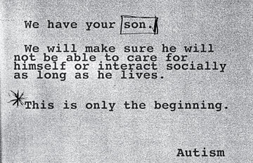
Figure 1. NYU Randsom Note
http://online.wsj.com/media/OB-AV563_health-autismSM.jpg
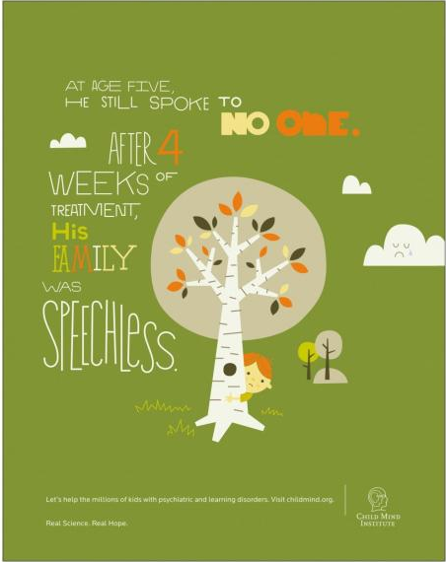
Figure 2. UC Davis Mind Institute
http://files2.coloribus.com/files/adsarchive/part_1581/15819255/file/child-mind-institute-selective-mutism-600-70478.jpg

Figure 3. A Tip from a Former Smoker
https://s-media-cache-ak0.pinimg.com/736x/25/54/db/2554db114afa1f807aa1147f9596bf8e.jpg

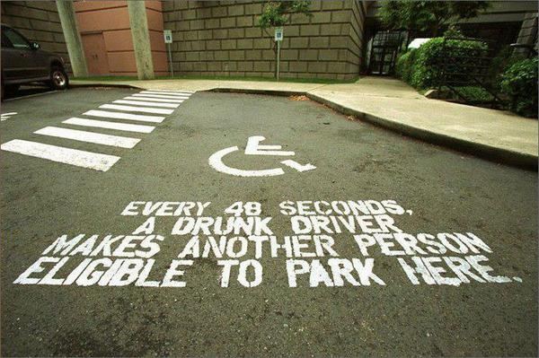
Figure 4. Drunk driving causes disabilities
http://www.newyorkduilawyer.net/top-10-ads/images/wheelchair.jpg

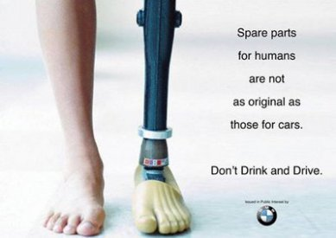
Figure 5. BMW Drunk Driving
https://s-media-cache-ak0.pinimg.com/736x/59/a3/87/59a387f5d2b616aaef9398e231af8d83.jpg

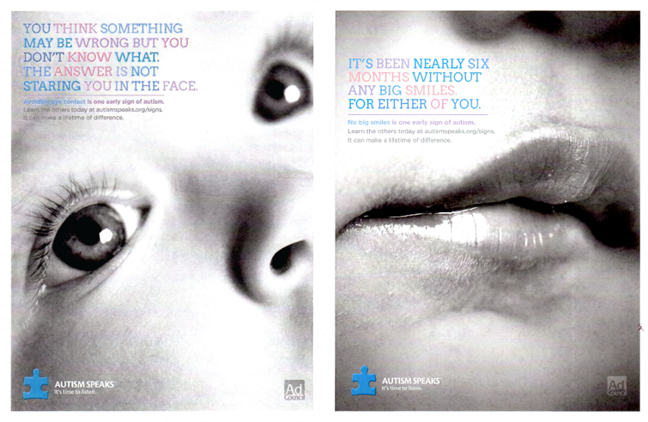
Figure 6. Autism Speaks
http://bsheacreative.com/wp-content/uploads/2013/07/autism1.png
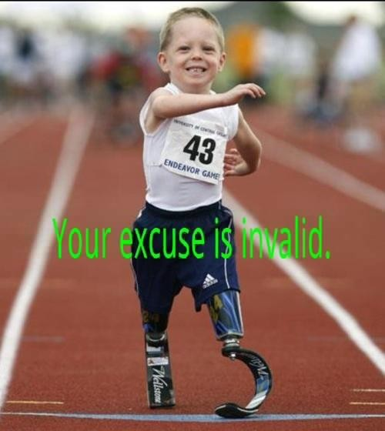
Figure 7. “Your excuse is invalid”
http://www.youthareawesome.com/wp-content/uploads/2012/01/Excuse.jpg

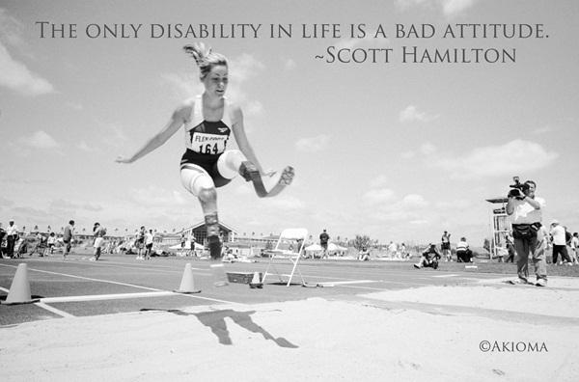
Figure 8. “The only disability in life is a bad attitude”
http://www.everydaykiss.com/wp-content/uploads/2014/05/1622.jpg

