Margaret Gorman
Critical Disability Studies
Prof. Kristin Lindgren
Final Project
May 10, 2017

Disability Aesthetics: Un-Intact People Making Un-Intact Art
CW: injury, ableism, institutionalization, gore, nudity, death, ableist slurs

When disabled people, who have been silenced for so long, are given the opportunity to make art, their art typically stands in opposition to the conventions and traditions of art and society that have silenced them. The artwork, like the bodies and minds of the artists, comes out “strange and twisted,” defying expectations of what finished pieces of art can and should be (Kuppers 1). Disabled playwright Charles Mee discusses his personal experience with this phenomenon in his introduction to A Summer Evening in Des Moines:

I find, when I write, I don’t want to write well-made scenes, narratives that flow, structures that give a sense of wholeness and balance, plays that feel intact. Intact people should write intact plays…I like a play that feels as if a crystal goblet has been thrown on the floor and shattered, so that its pieces...still describe a whole glass, but the glass itself is in shards.
(Kuppers 6)
This quality of “un-intactness” pervades the art of people with disabilities. It is what many people describe as “disability aesthetics.” The philosophical concept of “aesthetics” refers to the judgements humans place on the value and beauty of a different stimuli (Siebers 542; “Aesthetics”). To Petra Kuppers, author of Disability Culture and Community Performance, disability aesthetics is “the shapes, senses, and emotions of bodyminds labeled as ‘different’” -- the aesthetics of people with disabilities (Kuppers 5). Tobin Siebers believes that disability aesthetics is “an approach that values the atypical and asymmetrical” and rejects the idea of perfect, whole bodies as the height of aesthetic virtue (Lindgren; Siebers 542-3). Kuppers’ definition would suggest that disability aesthetics are unique to people with disabilities; Siebers argues that all “good art” contains disability aesthetics in some way, and that it can be found in most examples of modern art.

However, Kuppers specifically tries in her book to avoid harsh lines and distinctions that separate the “disabled” from the “nondisabled” and therefore create exclusivity within the disability community -- a community already so divided and varied because of the diverse ways in which disability exists in the world. Of Mee’s earlier quote, for example, she specifies that she sees “‘intact’...as a rhetorical puppet, not an essentializing dividing line,” and asks, “Who is ‘intact,’ anyway?” (Kuppers 7). Upon this further inspection, it is clear that Kuppers’ definition is not in conflict with Siebers’. Siebers believes that disability aesthetics “broadens the inclusion of disability,” taking it from a socially applied label to an artistic framework (Siebers 546). Kuppers clearly sees disability aesthetics in this way as well, understanding that disability is not just an identity, but a lens through which artists can view and create art.

Under this definition, disability aesthetics arises from the experiences and sensibilities of disabled people, but can be accessed and utilized by anyone, regardless of their ability. This is not to say that any person making disability aesthetic art is actively engaging with the concept, label, or identity of disability, but that in order to engage in disability aesthetics, one must be aesthetically aware of differences in body and mind -- an aesthetic awareness that seems to come naturally to people with disabilities. It is difficult to say that anything is innate to any group of people, especially a group so tangentially tied as disabled people, but disability aesthetics are extremely prevalent in the works of disabled artists.

Where does this aesthetic sense come from? Why do people with disabilities so often create works that embody disability aesthetics? Does this aesthetic sense appear because of “impairment” or because of the experiences of disabled people in society? Or is it a conscious choice based on an understanding of society’s treatment of people with disabilities? Before delving deeply into these questions, it is beneficial to look at some examples of disabled artists whose work contains characteristics of disability aesthetics.

The work of portraitist Riva Lehrer is one example of disability aesthetics. In her recent exhibit at Haverford College, Consent to Be Seen, Lehrer subverts traditions in portraiture through her deliberate artistic choices. Though portraits typically depict immobile subjects sitting in immobile scenes, all of the portraits in this exhibit either have subjects who are in motion or incorporate moving objects. Lehrer’s self-portrait Edgewater Beach, for example, depicts her by the sea, her hands and face blurry as they move with the waves and pigeons in the background. Even Lehrer’s hair seems to blow in the wind. Mirror Shards: SHERI/DRAGON depicts painter Sheri Rush clearly in motion, crawling forward with one hand still in the air; in The Risk Pictures: Alice Sheppard, the subject floats in midair, arms and legs going every which way; Finn Enke fidgets, Deborah Brod pulls wires from an icy lake; a bullet soars over Lynn Manning’s head like a comet, and water pours down around Gordon Sasaki (“Mirror Shards”). Every single portrait in this exhibit contains some form of motion.

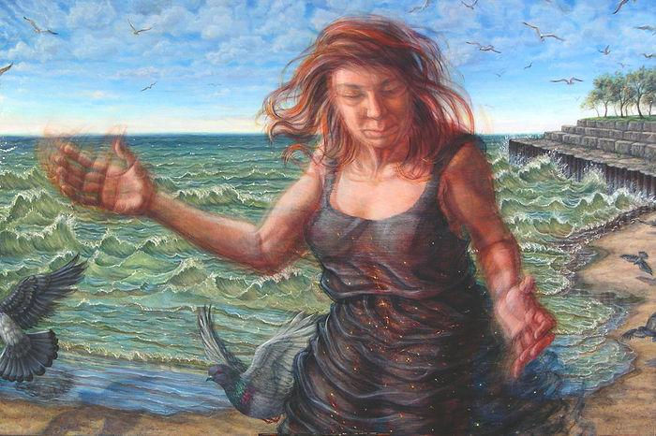Edgewater Beach by Riva Lehrer (source).

Lehrer’s work can be compared to that of another disabled artist, Henri de Toulouse-Lautrec. His pieces also depict people in motion, typically engaging in some sort of work. Toulouse-Lautrec is notable for his depictions of working-class Parisians, rather than usual subjects of portraiture, the wealthy and privileged (Cushman; “Henri”). Here, another similarity can be observed between Toulouse-Lautrec and Lehrer: both contradict normative ideas of the “who” of portraiture. Lehrer set out, in Consent to Be Seen, to depict “subjects who are socially stigmatized” -- particularly those with “socially devalued bodies” (Lindgren).

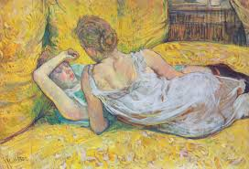
Abandonment (The Pair) by Henri de Toulouse-Lautrec (source).

In all of her portraits, Lehrer intends to subvert the imbalance of power between artist and subject. She engages her subjects in conversations about how they would like to be depicted, and in The Risk Pictures, she allows the subjects physical agency over their depiction by having them add to and change the portrait mid-creation (Lindgren). The result is portraits with mixed styles and elements that are not completely cohesive.

Another disabled artist whose work contains this “un-intact” quality of disability aesthetics is Dav Pilkey, author of the Captain Underpants series. Pilkey’s reliance on scatalogical humor and his encouragement of pranks and other misbehavior push against ideas of what is and is not “appropriate” to say to children or to say at all. Pilkey’s books switch between the genres of comic and prose, refusing to commit to one solid form. Pilkey peppers his comics with “imperfections” that are in sharp contrast to the clean, “finished” style of most modern graphic novels. Shaky lines, misspellings, irregularly formed letters, and crossed-out mistakes are all integral parts of the design of Pilkey’s books. Even though these stylistic choices are most apparent in the sections of Pilkey’s books meant to be in the voice of his two young characters George and Harold, some carry over to comics that are in Pilkey’s own voice. The comic “George and Harold’s College O’ Art” below is noticeably cleaner, but the borders of the panels are still shaky, and the lettering contains a mixture of capital and lowercase letters.
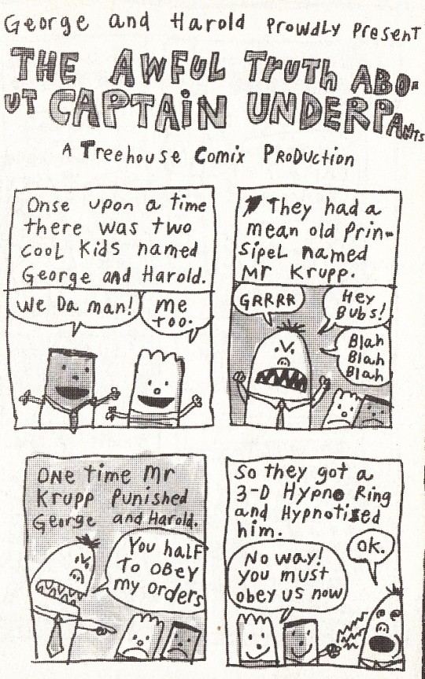
(source)
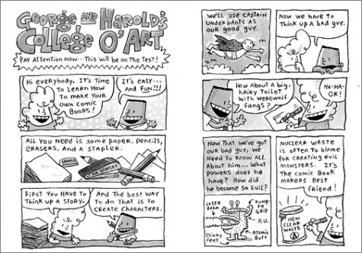
(source)
Another example of work that embodies this quality of “un-intactness” is a self-portrait that I created during my junior year of high school. The piece is called “The Poster Child for ADHD.” Even as I was drawing this piece, I recognized that all the different elements in it did not make sense together. The phrase “poster child” means someone who exemplifies a trait -- often a disease or disorder -- so well that they could be on a poster for it (“Poster Child”). However, the poster depicted here is a mix between a wanted poster, a missing child poster, and the kind of “awareness poster” from which a “poster child” smiles. The mugshot placard that I hold in the poster is blank. The poster is also drawn as if it were on a crumpled piece of paper, although the drawing itself is not literally crumpled. There are a multitude of incomplete elements, themes, and ideas in this drawing, none of them fitting together entirely. However, they all relate to my identity as a person with ADHD: as Charles Mee describes, my work is a shattered glass on the floor, but it “describe[s] a whole glass” (Kuppers 6). Additionally, as in Pilkey’s work, the lines are not straight, and the lettering is not neat or regular.
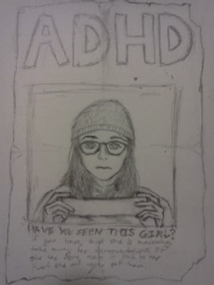
The Poster Child for ADHD by Margaret Gorman

Disability aesthetics can also be observed in the work of Judith Scott. Scott was an intellectually disabled and deaf artist who spent much of her life in a restrictive and abusive asylum. During these years, although Scott expressed interest in art, she was prevented from creating any by asylum staff who believed she was “too r*tarded” to draw (Hassaneldibi). Once released and enrolled in a program for intellectually disabled adults called Creative Growth, Scott eventually began to create intricate fiber sculptures like the ones pictured below. Scott chose found objects -- such as chairs, beads, brooms, and tissue boxes -- to serve as the core of her sculptures (Rich; Hassaneldibi). Scott’s entire body of work consists of these abstract pieces. Many people have theories about what each piece represents -- like the work below commonly interpreted as a reflection of Scott’s experience as a twin -- but as with most abstract art, the meaning of each piece, if it exists, is not clear.

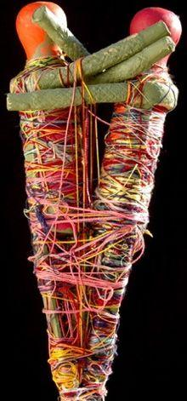
Many people believe that this piece reflects Judith Scott’s experience as a twin (source).

Scott worked tirelessly on each sculpture, entranced by it, sometimes working so intensely that her fingers began to bleed (Hassaneldibi). Intense concentration of this kind was also exhibited by Jackson Pollock, the well-known abstract expressionist artist (“Jackson”). There are many similarities between the work of Pollock and Scott: the varied use of color, the way strands -- either of paint or of fiber -- overlap and overtake one another to build a whole, and the motion suggested by this overlapping structure even on a still canvas or in a still sculpture.
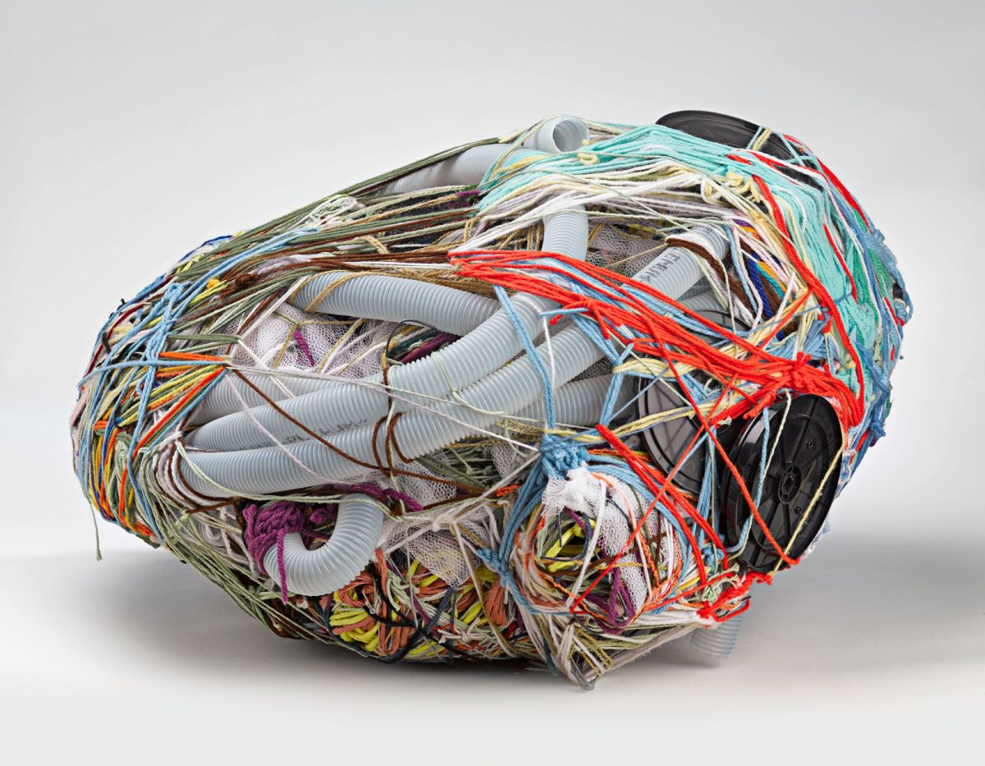
Untitled (2004) by Judith Scott (source).
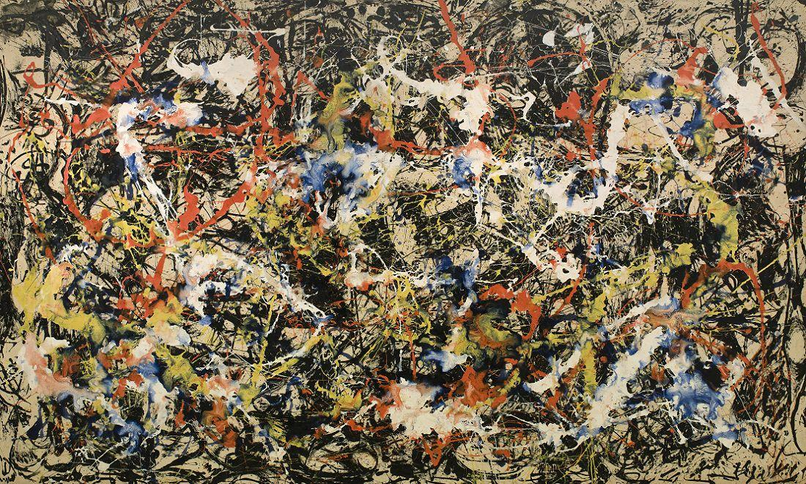
Convergence by Jackson Pollock (source)

In addition to similarities to Pollock and other abstract artists, Scott’s work is similar to the work of other disabled artists. Kelly Brown is an artist at the Center for Creative Works, a Pennsylvania program similar to Creative Growth. Brown is intellectually disabled and deaf, like Scott, and she also intricately weaves fiber around everyday objects in order to make sculptures (“Kelly”). Additionally, the director of Creative Growth has remarked more broadly that he sees “similarities in style or form” between the work of the artists at Creative Growth and the work of disabled artists elsewhere (Rich).
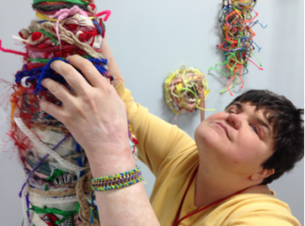
Kelly Brown at an exhibit of her artwork (source)

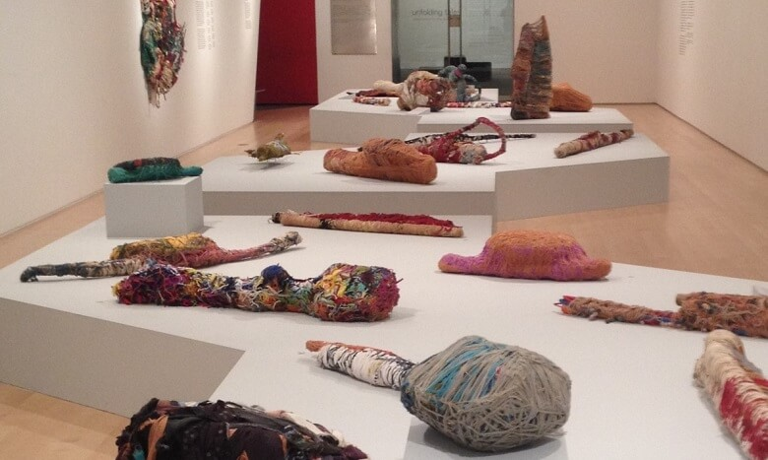Judith Scott’s work at the Brooklyn Museum (source)

Scott’s work has been considered disability aesthetics not just because of its form, but because of the unique questions that Scott’s authorship evokes. According to Siebers, Scott’s work is disability aesthetics because it “challenges the absolute rupture between mental disability and art” (Siebers 545). Her existence as a disabled person creating something that can immediately, naturally be labeled as “art” by a viewer calls into question normed ideas of intelligence’s relation to art. Additionally, Siebers argues that because we cannot know whether Scott views her work as art, it forces audiences to question what art is and who an artist is (Siebers 545-6).

The last example of disability aesthetics examined here is the artwork of Frida Kahlo. Kahlo’s physical disability had several causes, including polio, a trolley accident, and possibly spina bifida (Daunton). Her works contain many surrealist elements, often depicting grotesque bodily impossibilities that poignantly symbolize her reality. Kahlo does not shy away from depicting “strange and twisted” bodies, usually her own. In What the Water Gave Me, bodies cover the water, all in different states of life, death, sexuality, and ability. Kahlo’s foot in this picture is bleeding, prominently alluding to her her disability and chronic pain. In Self Portrait with the portrait of Doctor Farill, Kahlo depicts herself in a wheelchair with a bloody organ on her lap. In The Broken Column, Kahlo powerfully depicts her disability, both through surrealist imagery -- the ionic column inside her, representing her spine, and the nails imbedded in her body, representing her pain -- and through realistic imagery -- the steel corset she had to wear for much of her life (“Frida Kahlo: Room”). These self-portraits all contradict traditional notions of portraiture that expect the subject to appear idealized, and overall reject ideas of coherence and perfection by incorporating a multitude of literal and symbolic elements.
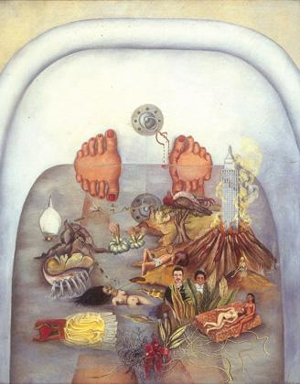
What the Water Gave Me by Frida Kahlo (source).
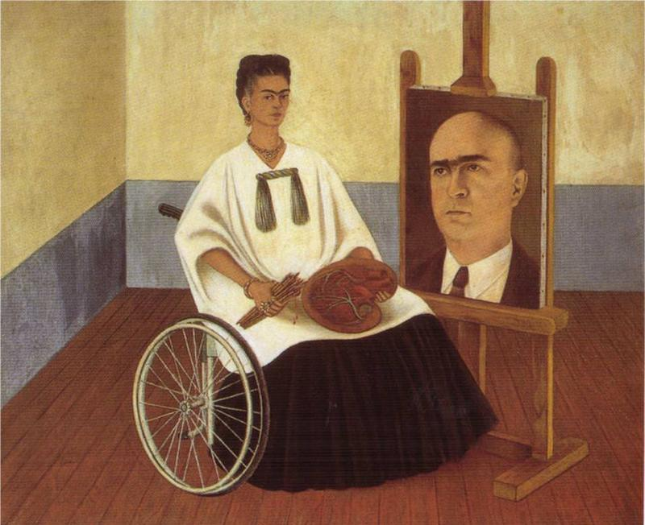
Self Portrait with the portrait of Doctor Farill by Frida Kahlo (source)
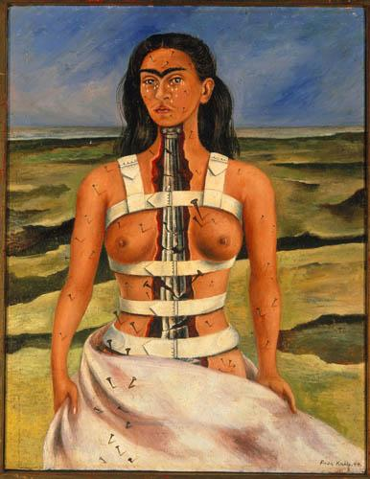
The Broken Column by Frida Kahlo (source).

Returning to the question of where this aesthetic sense comes from, one theory is that it arises out of impairment. Disability -- or, rather, impairment -- exists as a physical reality. Disability studies draws an important distinction between impairment and disability. Impairment is “an injury, illness, or congenital condition that causes or is likely to cause a loss or difference of physiological or psychological function” (“Defining”). Disability is the societal consequence of such an injury, illness, or condition.

The distinction between impairment and disability typically fits into a larger discussion of social model of disability, which argues that society is the “problem” of disability, not impairment. However, both impairment and disability can impact the life of a person with a disability, a fact which the social model ignores in order to promote disability pride and simplify issues of discrimination and access. As Eli Clare discusses in his book Exile and Pride, there are many things that Clare experiences because of society, but his inability to do or difficulty doing some things, like physically climbing a difficult mountain trail, are not the result of social barriers for people with cerebral palsy, but the result of his cerebral palsy itself (Clare).

Impairment exists outside of labels placed on people with disabilities, and outside of a deliberate disability identity. There is evidence supporting the idea that disability aesthetics comes from impairment shaping the artistic bodyminds of disabled people. This framework certainly seems to be the case for Charles Mee, who asserts that the “fragmented” nature of his work “feels like life” to him (Kuppers 6). Judith Scott’s work’s resemblance to the work of others with similar impairments also supports this hypothesis. Shades of this hypothesis can be seen in the creation of Dav Pilkey’s work: as a child, he had little interest in sitting down and reading long-form books, and longed for books with “lots of pictures, not too many words, and lots of short chapters” (Carpenter). This relationship with reading influenced the way that he wrote. Additionally, when asked in an interview whether he “make[s] spelling mistakes on purpose or [is...] just really bad at spelling,” Pilkey replied simply, “Both” (Mancini).

The case for this origin of disability aesthetics is further supported by Kahlo’s work. Kahlo is quoted as saying, “I don't paint dreams or nightmares, I paint my own reality” (“Frida Kahlo Quotes”). That her reality consisted of the reworkings of the body visible in her artwork is telling. Additionally, Kahlo does not comment often, if at all, about how society sees her disability. Her work is entirely centered around her own pain and suffering, be it emotional, physical, or both (Daunton).

However, this explanation of disability aesthetics’ origin is not perfect. It almost reduces disabled people to a “hive mind,” neglecting the incredible diversity of the minds and bodies of even people with the same impairment. It ignores the possibility that a person with an impairment could sit down to make whatever art comes most naturally to them and draw a completely traditional portrait. It closes “regular” and “traditional” art off to disabled people because of an inborn trait, which ultimately limits the potential of disabled people in the same way that discrimination does. This explanation also has a tendency to “other” disabled people by imbuing them with magical insight and hypercreativity. The stereotype that disabled people are somehow “magically gifted” has existed at least since Classical times, and this vision of disability aesthetics could unintentionally contribute to that stereotype. However, the frequency with which disabled people themselves connect impairment to disability aesthetic form is striking. Many disabled people seem to find the idea that impairment shapes art compelling and valid.

The physical reality of disability -- impairment -- creates disability as a social category, and regardless of whether or not they identify as disabled, most people with impairments cannot go through their lives without being labeled as such or experiencing discrimination based on their impairment. These people experience “disability” as the social model defines it: as significant social “othering” and discrimination. They experience the effects of disability regardless of whether or not they identify as disabled or are conscious of the impairment that makes others label them as such. Dav Pilkey, for example, does not identify as disabled. He believes that ADHD is not a “disorder” or “disability,” but rather a normal mode of being that comes with unique gifts (“Captain”). He even rebrands it as “Attention Deficit Hyperactivity Delightfulness” (“Captain”).

However, this outright rejection of a disabled identity has not stopped people from discriminating against him. Pilkey’s Captain Underpants books are a product and reflection of the experiences he had navigating a school system created for nondisabled people. In elementary school, Pilkey was considered so disruptive that one of his teachers forced him to sit in a special desk outside of the classroom. It was at this desk, the physical site of his “othering,” that he created the character of Captain Underpants. Additionally, Pilkey was constantly berated by his teachers for his hyperactivity and distractibility; he received the message that the would “never amount to anything” and could not “do anything right” (Pilkey). Pilkey recalls that he would often “come home crying” because of the way he was treated by teachers at school (McClintock). The experiences Pilkey discusses are common to many individuals with ADHD.

It is entirely possible that the prevalence of disability aesthetics in the work of disabled artists is caused by the conscious or unconscious desire of many people with disabilities to challenge this social “othering.” It seems, in many works by disabled people that incorporate disability aesthetics, the artists are saying to society, “you told me that it had to be done this way, and that expectation hurt me, so I’m going to do it a different way.” It is possible that this response to “othering” through disability aesthetics can be unconscious. For example, some have theorized that Judith Scott’s practice of stealing and wrapping objects is a result of the abuse and isolation that she experienced in an institution: this behavior represents an attempt to create the sense of “secur[ity] and safe[ty]” that she was so long denied (Hassaneldibi).

Additionally, the volume of art which Scott produced and the wholehearted devotion with which she worked on each piece could be an unconscious response to the institution’s practice of preventing her from doing art. It is also possible, however, that these qualities in Scott’s art are completely intentional and conscious disavowals of the abuse and mistreatment that she endured. Since Scott could not normatively communicate her intentions, we cannot know for certain why she subverted norms in her art or whether she was consciously or unconsciously doing so.

Riva Lehrer and Dav Pilkey, on the other hand, have been able to communicate their intentional disavowal of the treatment they received as disabled people. The discrimination that Dav Pilkey experienced is an extremely relevant motivating factor in the “un-intact” form of his art. As mentioned above, some of Pilkey’s subversions of traditional form come from his impairment itself. However, he stresses that may of the “mistakes” in Captain Underpants are intentional. He has said in multiple interviews that he makes mistakes in order to inspire kids to create their own comics for fun without worrying about making them polished and perfect (Carpenter; Mancini; “Captain”).

He also has discussed a desire to share his negative experiences with school in the hopes that kids like him will relate (McClintock), and to create a resource that he never had -- in the form of a book that is actually fun to read -- for other kids with ADHD, Dyslexia, or trouble reading for any reason (Carpenter). As a child who was unable to live up to the neurotypical, abled standards placed upon him by society and particularly by school, Pilkey as an adult sets his book in the location where he experienced a significant amount of “othering” and attempts to normalize and celebrate the traits and actions that made people “other” him there.

There is compelling evidence that both impairment and disability shape bodyminds in such a way that increases the prevalence of the existence of this aesthetic sense in disabled people. The physical reality of disability affects bodyminds; disabled people internalize the social impacts of disability; the social impacts of disability motivate disabled people to resist ingrained structures. For each of the artists examined here, and for every disabled artist who engages with disability aesthetics, the reasons for such an engagement are different and varied. This variance of reasons reflects how experiences of disability -- and disability as a category -- are themselves different and varied. Petra Kuppers’ definition of disability aesthetics seems to support this reading. She specifies not bodies and minds that are different, but bodies and minds that are labeled as different, not specifying whether it is the difference or the labeling that gives rise to disability aesthetics.

These discussions of disability aesthetics raise many more unanswered and potentially unanswerable questions. Is there a difference between art that is intended to incorporate disability aesthetics as a form of social commentary -- such as the work Pilkey and Lehrer -- and art where a disabled artist naturally utilizes this aesthetic sense? Petra Kuppers’ introductory chapter suggests that art that deliberately challenges normed ideas of bodies and beauty engages with a wide and nebulous concept called “disability culture.”
Taking this further, is art different when the artist has a fully realized disability identity? Outside of societal labels and physical impairments, there exists another meaning “disability”: disability identity. For many disability studies scholars, identity is what transforms someone from “impaired” to “disabled.” Rosemarie Garland-Thomson, Simi Linton, and Georgina Kleege have all written about the importance of claiming a disabled identity; Garland-Thomson specifically compares it to coming out of the closet, saying that it “demands learning how to live effectively as a person with disabilities, not just...as a disabled person trying to become nondisabled” (Garland-Thomson).

Disability identity is vitally important in discussions of disability culture and art. To many, disability art is something that can only be produced by those knowingly identifying as disabled (Solveng; Kuppers 5). This category would exclude the works of Dav Pilkey, and likely those of Frida Kahlo and Judith Scott. Many definitions of disability culture also require a dialogue with identification (Solveng; Kuppers 4). However, disability aesthetics places no such burden on participants. It does not require impairment, social labeling, or identity -- although it is often motivated by these things when disabled people utilize it. Nondisabled people can engage in disability aesthetic work alongside disabled people, and distinctions only arise in the motivations behind it.

WORKS CITED
1. Kuppers, Petra. Disability Culture and Community Performance. Palgrave Macmillan, 2011. Web. May 10, 2017. EBL Reader.
2. Siebers, Tobin. “Disability Aesthetics,” PMLA Vol. 120 No. 2. Modern Language Association, 2005. Web. May 8, 2017. JStor.
3. “Aesthetic.” Merriam-Webster.com. Merriam Webster, Inc., 2017. Web. May 10, 2017. https://www.merriam-webster.com/dictionary/aesthetic.
4. Lindgren, Kristin. “Consent to Be Seen,” Consent to Be Seen: Riva Lehrer. Haverford Libraries, 2016. Print.
5. “Mirror Shards: Sheri / Dragon,” Rivalehrerart.com. Emma Dei. Web. May 10, 2017. https://www.rivalehrerart.com/sheridragon.
6. Cushman, Emily. “Henri de Toulouse-Lautrec.” Museum of Modern Art, 2016. Web. May 10, 2017. https://www.moma.org/artists/5910.
7. “Henri De Toulouse-Lautrec Biography.” Toulouse-Lautrec-Foundation.org, 2002. Web. May 10, 2017. http://www.toulouse-lautrec-foundation.org/biography.html.
8. “Poster Child,” Merriam-Webster.com. Merriam Webster, Inc., 2017. Web. May 10, 2017. https://www.merriam-webster.com/dictionary/poster%20child.
9. Hassaneldibi. “Judith Scott at the Museum of Everything.” Youtube, 2011. Web. May 10, 2017. https://www.youtube.com/watch?v=46LdVzWoNhI.
10. Rich, Nathaniel. “Art House,” The New York Times Magazine Dec. 2015. The New York Times Company, 2015. Web. May 10, 2017. https://www.nytimes.com/2015/12/20/magazine/a-training-ground-for-untrained-artists.html.
11. “Jackson Pollock,” Wikipedia: The Free Encyclopedia. Wikimedia Foundation, Inc., 2017. Web. May 10, 2017. https://en.wikipedia.org/wiki/Jackson_Pollock.
12. “Kelly Brown,” Center for Creative Works. Center for Creative Works, 2017. Web. May 10, 2017. http://www.centerforcreativeworks.org/kelly-brown.
13. Daunton, Nichola. “Disabled icons: painter Frida Kahlo and pushing boundaries,” Disability Horizons. DH Media Group, 2015. Web. May 10, 2017. http://disabilityhorizons.com/2015/12/disabled-icons-painter-frida-kahlo-and-pushing-boundaries/.
14. “Frida Kahlo: Room Guide: Room 11.” Tate.org.uk. Web. May 10, 2017. http://www.tate.org.uk/whats-on/tate-modern/exhibition/frida-kahlo/frida-kahlo-room-guide/frida-kahlo-room-guide-room-11.
15. “Defining Impairment and Disability,” Center for Disability Studies. University of Leeds. Web. May 10, 2017. http://disability-studies.leeds.ac.uk/files/library/Northern-Officers-Group-defining-impairment-and-disability.pdf.
16. Clare, Eli. Exile and Pride. Duke University Press, 2015. Kindle Edition.
17. Carpenter, Susan. “Dav Pilkey stretches 'Captain Underpants' series,” Los Angeles Times. Los Angeles Times, 2010. Web. May 10, 2017. http://articles.latimes.com/2010/aug/17/entertainment/la-et-dav-pilkey-20100817.
18. Mancini, Madison. “Questions about Dav Pilkey.” Scholastic. Scholastic Canada Ltd, 1996-2013. Web. May 10, 2017. http://www.scholastic.ca/captainunderpants/books/interview2.htm.
19. “Frida Kahlo Quotes,” Frida Kahlo Paintings, Biography, Quotes. www.FridaKahlo.org, 2011. Web. May 10, 2017. http://www.fridakahlo.org/frida-kahlo-quotes.jsp.
20. “Captain Underpants,” Dav Pilkey’s Extra Crunchy Website O’ Fun. Dav Pilkey, 1997-2017. Web. May 10, 2017. http://www.pilkey.com/book-series/captain_underpants.
21. Pilkey, Dav. “The Almost Completely True Adventures of Dav Pilkey,” Dav Pilkey’s Extra Crunchy Website O’ Fun. Dav Pilkey, 1997-2017. Web. May 10, 2017. http://www.pilkey.com/pdf/dav-pilkey-bio.pdf.
22. McClintock, Alex. “Bestselling children's author Dav Pilkey talks Captain Underpants,” Radionational. ABC, 2014. Web. May 10, 2017. http://www.abc.net.au/radionational/programs/lifematters/the-top-secret-truth-about-captain-underpants/5512020.
23. Garland-Thomson, Rosemarie. “Becoming Disabled,” The New York Times. The New York Times Company, 2016. Web. May 10, 2017. https://www.nytimes.com/2016/08/21/opinion/sunday/becoming-disabled.html.
24. Solveng, Per Koren. “From identity politics to dismodernism? Changes in the social meaning of disability art,” ALTER European Journal of Disability Research, Vol. 6 Iss. 3. Association ALTER, 2012. Web. May 10, 2017. http://www.sciencedirect.com/science/article/pii/S1875067212000478.

This is not just true for physical disability -- the “physical reality” of something like depression or autism exists in the marked difference in brain functioning.

