Digital Exhibit : Autistic Filmmakers on YouTube
Autistic Self Advocacy and Self Expression

– Alison Love – May 12, 2018 – HLTH Critical Disability Studies – Professor Kristin Lindgren –

Table of Contents
Welcome 3
Audience 3
Background 3
Themes 4
Neurodiversity 4
Online Communication 5
Non-Verbal Methods of Communication and Self-Advocacy 5
Curatorial Perspective 6
Featured Filmmakers 7
Amythest Schaber 7
“Ask an Autistic #1 - What is Stimming?” 7
Highlighted Comments that Exemplify the Connective Power for Online Autistic Self Advocacy 7
silentmiaow 8
“In My Language” 8
Quotes from nonverbal Autistic self advocates 8
silentmiaow’s inspirations from and for other videos 10
“Exuberance” 10
“Happy Dance” 10
“Happy Dance Meme (post your own!)” 10
kuiamalynne 11
“I stim, therefore I am [Loud Hands Blogaround]” 11
Comments Section 12
Reflection 13
Sources 14

Welcome
Welcome to this exhibit! This collection of videos features YouTube videos by Autistic film creators whose works are a mode of self-advocacy, self-expression, and communication about Autism. This exhibit centers on three film creators in particular, Amythest Schaber, silentmiaow, and kuiamalynne. This project also references connected videos, comments, blogs, and organizations that are linked to the central videos. In addition to YouTube film creators, this exhibit also includes references to nonverbal Autistic self advocates.

Audience
This exhibit is designed for a wide audience of autistic and non-autistic people. It is a resource for Autistic people who are interested to learn about Autistic activists, filmmakers, and authors, as well as a resource for parents and other allies of Autistic people. This exhibit also aims to welcome in people who do not know much or anything about autism so that they can be an informed ally.

Background
To set a groundwork so that the visitors of this gallery share a common understanding of what autism is, this section presents a barebones definition of autism. The following quotes are from Amythest’s video “Ask an Autistic #23 - What is Autism.”

Autism: “Autism is a pervasive neurological developmental condition that affects about 1% of human beings. To unpack that a little bit - pervasive means that autism affects pretty much every part of a person - their personality, their experiences, their memories, how they grow up, how they communicate, and how they can move” (Ask an Autistic #23 - What is Autism”, 2015). “Autism is a naturally occurring variation in the human brain and there have always been autistic people, it’s just that we didn’t recognize them as autistic. Autism isn’t a disease; It’s not something you can catch or transmit. And it’s not an illness; Autism is not something you can fix or cure” (“Ask an Autistic #23 - What is Autism”, 2015).

These quotes from Amythest’s definition are useful to establish some of the basics of understanding the themes and films in this exhibit. For a more complete definition, please watch Amythest’s full video. Even in her video, Amythest states that she dreaded trying to define autism in a 10 minute video because it is difficult to fully define this “massive” topic (“Ask an Autistic #23 - What is Autism”, 2015). This exhibit is a window into a deep and wide body of work and activism by Autistic authors and creators defining and describing autism. I encourage visitors to this exhibit to follow up on connections beyond this selection of films.

Themes
It is probable that most people have heard some information about autism; this gallery aims to make it so that most people have heard directly from an Autistic person about Autism. This exhibit focuses on the ways that people can connect with other videos, concepts, self-advocacy, and self-expression over YouTube and linked online platforms.

Neurodiversity
This exhibition fits into larger concepts of the neurodiversity paradigm and the neurodiversity movement. The following quotes define these terms. The quotes are by Nick Walker, an “Autistic author, educator, speaker, transdisciplinary scholar, and aikido teacher” (Walker, 2014). Nick is an editor, author, and featured speaker in many publications including books, documentaries, and a webcomic. He is also a faculty member at California Institute of Integral Studies and Sofia University. These following quotes are from his blog, “NEUROCOSMOPOLITANISM: Nick Walker’s Notes on Neurodiversitym Autism, and Cognitive Liberty” (Walker, 2014).

Neurodiversity: “Neurodiversity is the diversity of human brains and minds – the infinite variation in neurocognitive functioning within our species” (Walker, 2014).

The Neurodiversity Paradigm: “The neurodiversity paradigm is a specific perspective on neurodiversity – a perspective or approach that boils down to these fundamental principles:
1.) Neurodiversity is a natural and valuable form of human diversity.
2.) The idea that there is one ‘normal’ or ‘healthy’ type of brain or mind, or one ‘right style of neurocognitive functioning, is a culturally constructed fiction, no more valid (and no more conducive to a healthy society or to the overall well-being of humanity) than the idea that there is one ‘normal’ or ‘right’ ethnicity, gender, or culture.
3.) The social dynamics that manifest in regard to neurodiversity are similar to the social dynamics that manifest in regard to other forms of human diversity (e.g., diversity of ethnicity, gender, or culture). These dynamics include the dynamics of social power inequalities, and also the dynamics by which diversity, when embraced, acts as a source of creative potential” (Walker, 2014).
The Neurodiversity Movement” “The Neurodiversity Movement is a social justice movement that seeks civil rights, equality, respect, and full societal inclusion for the neurodivergent” (Walker, 2014).

This exhibit supports the neurodiversity paradigm and the neurodiversity movement because the featured filmmakers are Autistic self-advocates who create informative and artistic works as self expression and communication of their conditions in the world. An aim of this exhibition is to open more people to information directly from Autistic perspectives on autism. With more understanding, hopefully there can be more alyship and accommodations for Autistic people.

Online Communication
Posting videos on YouTube and writing on blogs enables people to connect even if they are geographically far apart. Online platforms have the potential to connect Autistic people, allies of Autistic people, and non autistic people wanting to learn more information directly to Autistic self advocates and experts, even if they do not have access to these perspectives and this information in their local areas.
Communicating online also has the prospect of relieving some challenges that Autistic people might face when communicating in person. Creating videos and writing on blogs have the potential to share information with many people without going to a large conference or visiting many schools and other organizations to share your perspective. Autistic people all have some sensory differences, such as being over or under sensitive to input such as lights, tastes, and sounds (Ask an Autistic #9 - What is Sensory Processing Disorder?”, 2014). Autistic people can have other traits that make it difficult to communicate in person, such as difficulty with staying on task and difficulty responding to open-ended questions and more subtle social cues (“Ask an Autistic #25 - What is Executive Functioning?”, 2015). There are many other traits common in Autistic people that can make it difficult to be in new or large settings. However these traits are not inherent in all Autistic people and effect different Autistic people in some different ways. This section points out the potential positives of communicating online but does not argue that this is the only way that Autistic people can and should communicate.

Non-Verbal Methods of Communication and Self-Advocacy
Communicating online has some advantages for all Autistic people, as described in the previous section, as well as specific advantages for nonverbal Autistic people. Some Autistic people can not communicate with their mouths in current standard conventions of language. Methods of Alternative and Augmentative Communication (AAC) include American Sign Language, signed English, letter board, praid prompting method, and text-to-speech (“Ask an Autistic #11 - What is AAC?”, 2014).
YouTube videos, blogs, and books can include these modes of communication and self expression to reach a wide audience. Usually, methods of AAC take a long time compared to the pace that non autistic people are accustomed to (“Ido in Autismland”, n.d.). Creating videos, book, or other forms of writing can convey information at a more controllable pace for both Autistic people and non autistic people.
A central theme of this exhibit is that Autistic people who do not communicate in standard conventional spoken language are people who are completely equal to those who communicate in perceived standard forms of language. This should go without saying, but, as expressed in silentmiaow’s featured film, “In my Language,” and many of the works of the authors quoted below, nonverbal autistic people are commonly treated as lesser. Amythest describes this as the “lie that if you can’t speak with your mouth then you have nothing to say” (“Ask an Autistic #10 - How to Be An Ally”, 2014).
To be a good ally, Amythest suggests “presuming competence” in all Autistic people:
“If you are presuming competence when you are interacting with an Autistic person or reading the writings of an autistic person who may be classified as “low function” or non-verbal, you can open yourself up to another world - the voices and experiences and stories of autistic people who most people have never heard because of this very negative rhetoric of fear, and tragedy, and that Autistic people are burdens” (“Ask an Autistic #10 - How to Be An Ally”, 2014).

Curatorial Perspective
As Amythest states in her film, “Ask an Autistic #10 - How to be an Ally,” non autistic people, also known as allistic people, need to stand with and behind Autistic self-advocates. Too often, conversations, organizations, and lessons focused on autism do not include or listen to Autistic people (“Ask an Autistic #10 - How to be an Ally”, 2014). As a non autistic person, I do not aim to enter in the conversation on autism, rather I draw connections between and highlight conversations that are already happening that come from Autistic self advocates and experts.

Featured Filmmakers
These three filmmakers are all Autistic self advocates who publish works on YouTube to communicate about autism. Please watch the linked videos, read the creators’ descriptions, and browse the comments if you wish.

Amythest Schaber
Amythest blogs about disability and autism on her blog, Neurowonderful and on her YouTube channel, Ask an Autistic. Amythest responds to questions that she receives on her blog and in the comments on her YouTube videos (“Ask an Autistic #1 - What is Stimming?”, 2014). She commonly provides links to more resources in her video descriptions, references other Autistic advocates in some of her videos, and sometimes references her own experiences.

“Ask an Autistic #1 - What is Stimming?”
https://www.youtube.com/watch?v=WexCWZPJE6A&t=186s
By Amythest Schaber
Published on Jan 25, 2014
(“Ask an Autistic #1 - What is Stimming?”, 2014).
YouTube Channel: https://www.youtube.com/user/neurowonderful/featured
Tumblr Blog: http://neurowonderful.tumblr.com

Highlighted Comments that Exemplify the Connective Power for Online Autistic Self Advocacy
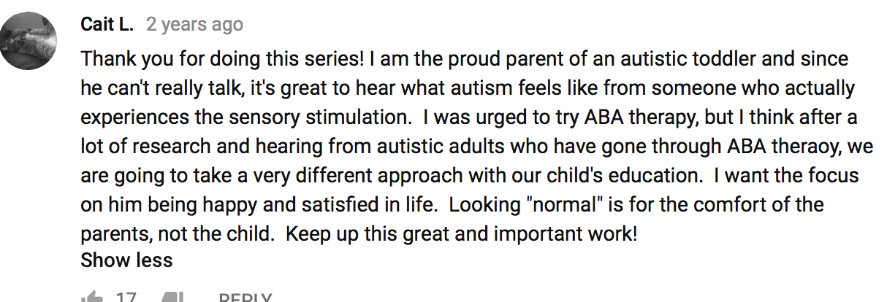
(“Ask an Autistic #1 - What is Stimming?”, 2014).
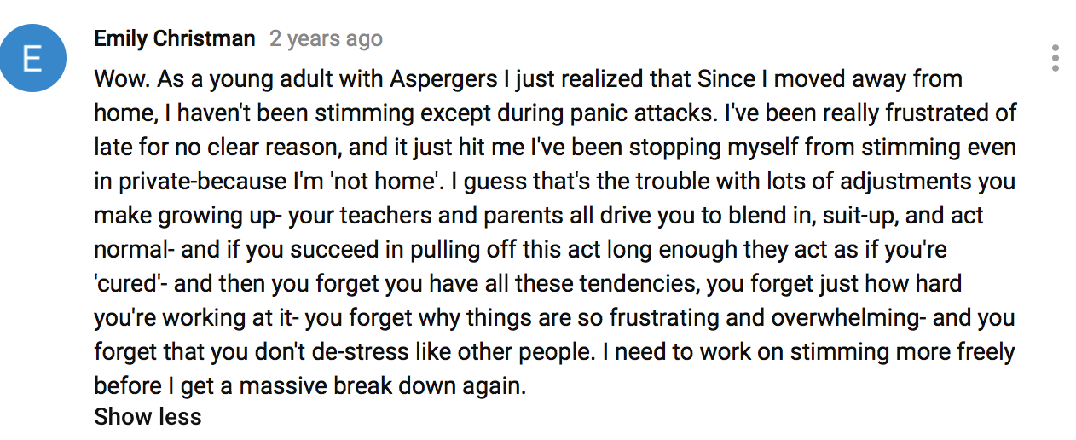
(“Ask an Autistic #1 - What is Stimming?”, 2014).

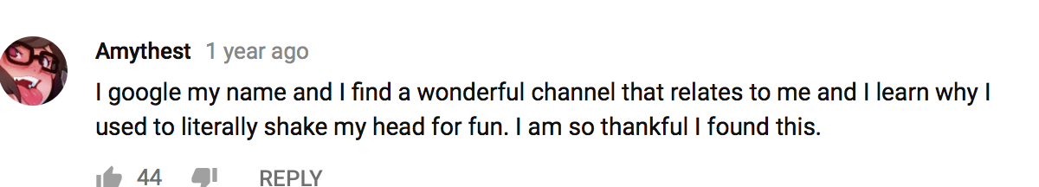
(“Ask an Autistic #1 - What is Stimming?”, 2014).

silentmiaow
Silentmiaow creates YouTube videos, some of which center on the topic of autism.

“In My Language”
https://www.youtube.com/watch?v=JnylM1hI2jc&t=1s
By silentmiaow
Published on Jan 14, 2007
(silentmiaow, 2007)

Quotes from nonverbal Autistic self advocates
These quotes provide another layer for the context of slientmiaow’s film; They are only snipits of the authors’ perspectives and conditions. If you are interested in learning more, please follow the links to further material on the authors. Many of them have books, blogs, and other extensive platforms. I chose these authors based on the list of nonverbal Austistic advocates that Amythest provides in her video, “Ask an Autistic #10 - How To Be An Ally.” (“Ask an Autistic #10 - How to Be An Ally”, 2014).

Naoki Higashida
“I can also type on a computer keyboard, but I get stuck on or obsessed about certain letters. Or sometimes I’ll type a word over and over. I can’t converse well, but this doesn’t mean I don’t think. It’s just that when I try to speak, the words that come to mind disappear. I wonder if this isn’t similar to the sensation we all have of forgetting something? Even if a person with severe autism learns to use a computer, it doesn’t mean he or she will be able to express in writing all the emotions they have been unable to verbalize. Expressing what’s inside the heart and mind of my autistic self will always be problematic, I think.” (Hopper, 2017).
Link to more Time Magazine article about Naoki: :http://time.com/4856602/autism-nonverbal-book-naoki-higashida/

Mike Weinstein
“People assume that if you cannot speak, then you must be retarded. Most people who are trained in special education know nothing about autism, although they think they are the autism experts. If you cannot speak, you have to fight for everything you want to do academically. Sometimes you win that fight, but sometimes you lose” (Weinstein, n.d.).
Link to blog post by Mike: http://www.goldenhatfoundation.org/about-us/blog/125-golden-hat-foundation-blog-70211

Ido Kedar
“‘Communicating has enabled me to break free, to not be as trapped by my disability, to help others and to correct scientific understandings of non-speaking autism.’ he says. ‘Communication is a basic human right’” (“Ido in Autismland”, n.d.).
Link to website by Ido and his family: http://idoinautismland.com

Sharisa Joy Kochmeister
“A mystery - a dilemma - a puzzle - an enigma - a conundrum - a curse
- a gift - a "disease" in need of a "cure" - CURE HAM, TREAT PEOPLE!
I do NOT have a DISEASE - I have DIS-abilities as well as ABILITIES
that cause UNEASE - generally to others! Please feel free to discuss,
challenge, comment, prognosticate, pontificate, define, etc.” (Joy Kochmeister, 2007).
Link to blog by Sharisa: http://sharisa-kochmeister.blogspot.com

Amy Sequenzia
“We are people, neurodivergent, neurominority.
We tell our stories because only we can be truthful.
We tell our stories because too many non-autistics are talking about us, without us.
We tell our stories because the stories being told about us are really about how the neurotypical majority sees us, filtered by the thick lens of ableism.
Or we don’t tell our stories, because we are people, and we must have our choices respected.
If you are not an Autistic person, and you are telling our stories, you are likely telling lies, assumptions and wrong perceptions.
If you are listening to a non-autistic person telling our stories without citations, crediting Autistic voices, forget what you heard.
Our stories are only true stories of autism, and of what being Autistic is, if we tell them ourselves” (Sequenzia, n.d.).
Link to article by Amy: https://ollibean.com/mystoryismine/

silentmiaow’s inspirations from and for other videos
The following three videos exemplify the connections that people can form over YouTube. Please follow the links and read the creators’ captions to follow the progression of inspiration from one video to the next. These videos are listed in chronological order of which they were created.

“Exuberance”
By shinymetalbrain
Published on Dec 12, 2006
https://www.youtube.com/watch?v=OTpV4giH5Cw
(shinymetalbrain, 2006).

“Happy Dance”
By silentmiaow
Published on Sep 16, 2007
https://www.youtube.com/watch?v=kfHxoUDBQ4w&t=39s
(“Happy Dance”, 2007)

“Happy Dance Meme (post your own!)”
By silentmiaow
Published on Sep 27, 2007
https://www.youtube.com/watch?v=KdTQSAmkBp0
(“Happy Dance Meme (post your own!)”, 2007)

kuiamalynne

“I stim, therefore I am [Loud Hands Blogaround]”
By kuiamalynne
Published on Jan 26, 2012
https://www.youtube.com/watch?v=s2QSvPIDXwA
(kuiamalynne, 2012).

Link to the Loud Hands Project: http://loudhandsproject.org

Comments Section
In keeping with the idea that online platforms are powerful in that they allow people from all over with diverse perspective to communicate, this section encourages people to leave comments and ideas. Please feel free to writing in this comments section, reach out to me, or link this gallery in other places around the world. Thank you in advance for the thoughtful reactions and contributions.

Reflection
This section is a reflection on the process of creating this digital gallery and some of the reasoning behind the presentation of the films and filmmakers. This writing is not intended as a part of the gallery.
I do not analyze the films very much because they convey their own messages and I do not want to detract from the statements by the authors. I designed the gallery to have a lot of information early on to provide a common footing for visitors. By defining autism, the neurodiversity paradigm, the neurodiversity movement, and outlining the theme of self advocacy online, I hope to provide visitors with an understanding of the context of the films. I use many quotes from Autistic authors because I aim to foreground these perspectives. These authors and experts have already defined the central terms far better than I could.
This gallery provides a tiny view into the massive online discussion by Autistic authors and advocates. I provides many links to other sites and hope that people will follow some of the connections, as well as discover connections on their own with this gallery as a starting point. I chose to focus on Autistic filmmakers on YouTube because this specificity is helpful when there are so many authors and platforms on these central topics. To not exclude these other platforms, I provide references and links to blogs, such as the blog Neurowonderful.
I wanted to embed the videos in the document, but could not get this operation to work on Serendip or in google documents. If the videos were embedded in the document, this exhibition would visually read more like an art exhibition. It is also a bit of a hassle to click away from the browser window. A positive of the links instead of embedded videos is that the visitors can read the film creators’ captions and scroll through comments.
During the process of creating this document, I considered the lessons from our class about accessible designs. I think that is it helpful that this gallery centers on works with audio. I wish that Amythest’s videos included subtitles. If I had more time to work on this project, I would have liked to make transcriptions for her featured video about stimming. Because this exhibit is online, it does not necessarily need a social story or some other physical access considerations. Because it is online, people can zoom in closer to the text or change the brightness on their screen. This exhibition is not very accessible if you do not have access to a computer.
I chose to make an exhibition instead of an essay because this platform allowed me to highlight and foreground the Autistic authors. As a curator, my narrative strings together conversations instead of entering in the conversation in a substantial way myself.
I learned a huge amount while creating this work, as well as learned how much more there is out there to watch and read by Autistic authors.

Sources
Kuiamalynne, “I stim, therefore I am [Loud Hands Blogaround],” Online video clip. YouTube. 2012. https://www.youtube.com/watch?v=s2QSvPIDXwA

silentmiaow, “Happy Dance Meme (post your own!)” Online video clip. YouTube. 2007. https://www.youtube.com/watch?v=KdTQSAmkBp0

silentmiaow, “Happy Dance,” Online video clip. YouTube. 2007, https://www.youtube.com/watch?v=kfHxoUDBQ4w&t=39s

shinymetalbrain, “Exuberance,” Online video clip. YouTube. 2006, https://www.youtube.com/watch?v=OTpV4giH5Cw

Sequenzia, Amy, “My Story is Mine to Tell,” Ollibean, No Date. https://ollibean.com/mystoryismine/

silentmiaow, “In My Language,” Online video clip. YouTube. 2007. https://www.youtube.com/watch?v=JnylM1hI2jc

Sharisa Joy Kochmeister, “My Surreal Life.” 2007. http://sharisa-kochmeister.blogspot.com

Amythest Schaber, “Ask an Autistic #1 - What is Stimming?”, Online video clip. YouTube. 2014.
https://www.youtube.com/watch?v=WexCWZPJE6A&t=186s

Amythest Schaber, “Ask an Autistic #10 - How to Be An Ally”, Online video clip. YouTube. 2014. https://www.youtube.com/watch?v=JsllOQeWqNg&t=66s

“Ido in Autismland,” Author Unknown, No Date. http://idoinautismland.com

Amythest Schaber, “Ask an Autistic #11 - What is AAC?”, Online video clip. YouTube. 2014. https://www.youtube.com/watch?v=Mcr56leaVWA&t=5s

Amythest Schaber, “Ask an Autistic #25 - What is Executive Functioning?”, Online video clip. YouTube. 2015. https://www.youtube.com/watch?v=229Xb50_o8M&t=201s

Amythest Schaber, “Ask an Autistic #9 - What is Sensory Processing Disorder?” Online video clip. YouTube. 2014. https://www.youtube.com/watch?v=upU-dc19Taw&t=54s

Amythest Schaber, “Ask an Autistic #23 - What is Autism,” Online video clip. YouTube . 2015. https://www.youtube.com/watch?v=Vju1EbVVgP8&t=24s

Walker, Nick. “Neurodiversity: Some Basic Terms & Definitions,” NEUROCOSMOPOLITANISM, (2014). http://neurocosmopolitanism.com/neurodiversity-some-basic-terms-definitions/

Hopper, Nate, “My Autism Allows Me to See the World in a Different Way,” Time Magazine. 2017. http://time.com/4856602/autism-nonverbal-book-naoki-higashida/
Weinstein, Michael, “Life With Autism,” Golden Hat Foundation. Date Unknown. http://www.goldenhatfoundation.org/about-us/blog/125-golden-hat-foundation-blog-70211

