Is Being Reactive Enough? An In-Depth Look at the Accessibility of Haverford College

By Maggie Heffernan

Daniel Gillen ’17 has lived in the same dorm complex for the past four years of college. And, although this was his choice, his reasoning is not what you might expect.

“It took me a few months to familiarize myself with the campus and navigate my way from the New Dorms,” said Gillen, who has lived in the same room in Kim Hall for the past three years. “My Customs team was very helpful in guiding me.”

Gillen, a physics and music double major, has been legally blind “approximately his entire life.” After both of his retinas detached when he was less than one year old, the now 21-year-old lost his sight completely.

When he turned six, his family enrolled him in the Filomen M. D’Agostino Greenberg Music School, the only community music school in the United States for individuals who are blind or visually impaired. Given the school’s history of providing for individuals with a variety of visual impairments, Gillen experienced little difficulty receiving the accommodations he needed. When he came to Haverford, however, he had to be an educator.

“In high school, people congregated around me,” said Gillen, who walks with a cane and often asks students to guide him places on campus. “The support network was built from the outside, top down. Now, I have to build support networks from me—out and around."

Receiving full accommodations at Haverford is sometimes difficult due to the small amount of staff and money available in the Office of Access and Disability Services (ADS), the low number of students with significant disabilities who have attended Haverford, and the inaccessibility of many of the College’s older buildings.

Former ADS Coordinator Rick Webb, who was replaced by Sherrie Borowsky in July of 2015, only devoted five hours a week to his role since he had another full-time job.

Given the multifaceted nature of this position, however, five hours was simply not enough.

“A lot of the time, students who apply for accommodations have multiple issues,” explained Borowsky, who will spend much of the summer setting up accommodations for the approximately 60-70 students who will need them during the 2016-2017 school year. “A student who needs a housing accommodation, for example, may also need other services for something like anxiety or depression.”

According to the Americans with Disabilities Act (ADA), a school is required to provide “reasonable accommodations” for its students with disabilities. The “typical accommodations” as listed on the ADS website, all of which are adapted from the guidelines of other colleges including Swarthmore, Bryn Mawr, and the University of Washington, are only examples of potential services. As such, Borowsky interacts regularly with Counseling and Psychological Services (CAPS), Residential Life, Instructional & Information Technology Services (IITS), and Facilities in addition to students’ deans and professors to provide accommodations on a case-by-case basis.

Administrative Assistant Sharon O’Neill, who, like Borowsky, is part-time, is the only other staff member who works exclusively in ADS. According to Gillen, recent staffing changes in the office have added another layer of difficulty for students who receive accommodations.

“A Swarthmore graduate named Gabriela Moats used to work in ADS, and I knew her well,” said Gillen, who helped hire Moats. “When Borowsky picked everything up, it was like taking nine steps forward and three steps forward because she was still so new to a lot of things and not as well-acquainted with students’ particular needs.”

Since Gillen is only the second legally blind student to attend Haverford—the first was a student who graduated in the 1940s—he has needed to be proactive in ensuring he receives appropriate accommodations. Some of his particular needs include finding a note taker for some of his classes, acquiring versions of his textbooks in braille, and making sure that all his online course material has the necessary screen reading equipment.

Though Gillen has ultimately received most of these services, their stability is what most often gives him trouble.

“There have been instances when my tutors cancel or when a quiz on Moodle doesn’t have the correct text to speech formatting, which means that I am unable to do what is expected of me as a student,” said Gillen. “Last year, ADS was trying to save money so they ordered the third version of my Calculus book in instead of the fourth version, which the rest of the class had.”

“There were a lot of problems that weren’t in my edition.”

Though Linguistics Professor Danielle Lillehaugen created a tactile magnet board a few years ago to help Gillen better engage in some of his classes, Gillen says that his most useful technology is his braille computer.

“I have used [my computer] for taking notes, reading accessible electronic books and handouts, performing calculations, writing most e-mails and much more,” said Gillen, who has used this device since he lived in New York.

“Aside from all its great advantages for this day and age, though, the biggest drawback is that it—and no other braille display available on the market—can show more than one line of braille simultaneously or display any tactile graphic,” Gillen added. “But products of this kind have been evolving over the past twenty years or so from a number of companies.”

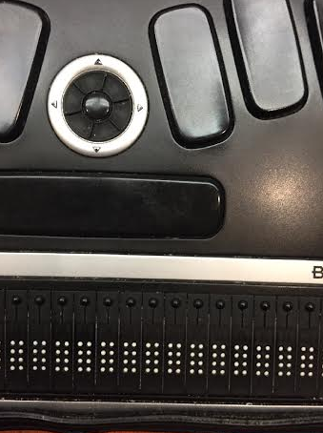

A picture of Gillen’s braille computer

According to Associate Computer Science Professor John Dougherty, who became interested in accessible technology through having multiple children with disabilities, the College has improved greatly in terms of accessibility in recent years.

“Haverford is very good at being reactive,” said Dougherty, whose daughter Eva has used a wheelchair for almost her entire life. “I worked frequently with Facilities when my family lived on campus to make it more physically accessible, and I have seen a lot of progress since I came here in 1997. But there are definitely areas in which it could improve.”

Dougherty cites the 1985 renovation of the now iron truss bridge that runs over Railroad Avenue as a great improvement to campus. The preceding bridge, which was constructed in 1903, was not enclosed and not nearly as wide, both of which made it more dangerous and less accessible to people in wheelchairs.

Carl Sigmond ’13, one of the College’s first full-time wheelchair-users, had to embrace a similar role as Gillen in being a self-advocate when he came to Haverford.

“Carl was very comfortable asking for the services that he needed,” said Kristin Lindgren, assistant professor and director of Haverford’s Writing Program who also teaches courses on disability studies. “However, for someone shier than Carl, the thought of needing to do so much self-advocating while at college might have been daunting.”

When Sigmond, who has cerebral palsy and communicates using assistive technology, arrived on campus, a ramp was built leading into his apartment since none of the entrances into the apartments—as well as the entrances into many of the dorms—are accessible. Even though Barclay Hall has an accessible bedroom and bathroom on its ground floor, there was no way for individuals with physical impairments to actually enter the building and see this set-up for many years.

In response to a student petition to make the entrance accessible, Facilities installed a ramp in 2006.

“The lack of an accessible entrance was a turn-off for many students and parents with physical impairments who came to tour the campus,” said Lindgren. “Even though the tour guides routinely stated that accommodations would be made should a student with an impairment be placed in this building, the fact that there wasn’t a ramp still alienated and excluded certain individuals.”

Haverford’s tradition of being reactive fails to consider not only certain prospective students and parents who tour the campus, but also visitors of different abilities in general. Given the various talks and events Haverford hosts that are open to the public, being reactive presents obstacles from time to time.

Lindgren encountered difficulty in 2006 when she and English Professor Deborah Sherman organized a symposium on campus called “Representing Disability: Theory, Policy, Practice.” Various disability scholars were invited to the event, many of whom had some sort of physical impairment. When Lindgren and Sherman began brainstorming physically accessible spaces on campus where they could hold such a large-scale gathering, they were at a loss.

“Stokes Hall was our best option because of the ramps that lead into the building,” said Lindgren. “However, the only way to get to the auditorium without going back outside was by using the few steps that led down to it, which many of our visitors could not use.”

“We ended up getting a wheelchair lift to make the entrance into the auditorium accessible from the inside,” said Lindgren, who noted that this lift is now transported to different areas of campus when needed.

In addition to requiring “reasonable accommodations” for students that need them, the ADA states that all buildings constructed after 1990 must be handicap accessible. And, when major renovations are made to buildings, they, too, must be made handicap accessible.

Since most of the buildings on Haverford’s campus were built years before 1990, however, some individuals are loath to renovate them given their historical value. Woodside Cottage, for example, was constructed in 1811 and is the only existing building on campus that predates the College. The three-story edifice houses the majority of English classes as well as many professor offices, yet there is no elevator between floors and no way to enter the building that does not involve stairs.

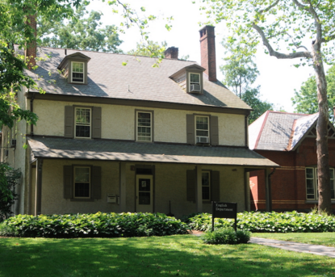

A front view of the historic but not wheelchair-friendly Woodside Cottage

Given its historical significance and the fact that there has yet to be a physically-impaired English major on campus, there have been no serious conversations about making Woodside accessible.

“Haverford does seem to be doing more than the minimum required by the ADA,” noted Dougherty, who currently has four students working on theses related to accessibility in the technological world. “Universal design is something that should definitely be promoted more, though.”

For many people, however, accessibility is not an issue they think about until they or someone close to them needs accommodations. At Haverford, where roughly 40% of the student body plays a varsity sport, accessibility often becomes relevant when a student is temporarily injured.

“[Being on crutches] turned out to be a lot less frustrating than I expected,” said Sam Fujimori ’16, a track and field athlete who was on crutches due to a hip injury for much of first semester last year. “People would help me grab food in the Dining Center and hold doors, which made everything really easy and showed how much we support each other here.”

Indeed, perhaps the most accessible feature of Haverford’s campus is its students.

“15 years ago, people might not have let certain things go in class,” said Dougherty, who added that there have been multiple students in his classes who are on the spectrum. “Now, if I bring my daughter to class and she makes a noise when everyone else is quiet, or if someone with Asperger’s goes off topic for a bit when participating in class, students just roll with it.”

