Entering the Global Village: Is World Wide Web for People with Disabilities?
By ChuHui Fu

Introduction.

Of course! And this is a bad question. If you are an engineer or a web designer, that would probably have been your first response to the question. Indeed, according to Jacob Nelson, a web production specialist at University of Washington, while people with disabilities might have a hard time enjoying certain computer applications, it’s the engineer’s job to make them enjoyable, as an engineer’s duty is “to make the impossible possible, to solve big problems.”¹

Clearly, the problem in this case is the web being inaccessible, yet for years, many might implicitly view people with disabilities as the problem and exclude their presence from this global village without a second thought. While they certainly don’t identify themselves as ableists, they might think that the web is just not for people with disabilities, particularly those who have disabilities that might directly make the internet experience challenging. I recall hearing a comment from one of my school teachers in 2011 when Voice Over on the computer was accidentally enabled. Annoyed by the sound and temporarily unable to disable the software, the teacher said, “Why do we even have this function? I mean, how do blind people use the computer or internet anyway?” Well, they do use the web, and yes, it’s more difficult for them for many reasons.

According to the Pew Internet & American Life Project in 2011, in which Princeton Survey Research Associates International conducted a phone survey to 2260 adults from July 25 to August 26 in English and Spanish, 27% of adults who self-identified as living with disabilities are significantly less likely than those without to go online. (That is, 54% of adults with disabilities versus 81% of adults without disabilities said they go online.) After accounting for demographic factors, such as old age, less education, and poverty, there is still a negative correlation between internet usage and disability.² Surely, a person with a severe cognitive disabilities might not be able to understand the concept of internet at all, and there are other severe disabilities that stop a person from communicating in most forms. But can it also be that the websites themselves are inaccessible?

From these data, more questions arise. First of all, why is it important that the web is accessible to people with disabilities? In short, why should we care? Then we can ask, in what ways is the internet inaccessible? What are some currently available technology to make computer and internet usage easier? What does accessibility even mean? Also, when we say people with disabilities, who do we include? Are there regulations around web accessibility? How clear and effective are they?

In the following sections, I will briefly address these questions through data and articles gathered from different websites. By doing this, I hope to enhance my own and others’ understanding of this significant problem and motivate everyone, particularly those in related fields, to continue tackling it for the benefits of those with disabilities and those without.

Web Accessibility for People with Disabilities is Important for Everyone.

According to Tim Berners-Lee, who is considered to be the father of the web, “The original idea of the web was that it should be a collaborative space where you can communicate through sharing information.”³ The key words for me are “collaborative”, “communicate” and “sharing” because they indicate that the power of the web come from the people who use it. In other words, if the web is inaccessible to people with disabilities, then we are losing both information receivers and information contributors.

Clearly, there are many ways that accessible web can benefit people with disabilities; here, I will talk about online support groups. When a person is first diagnosed with some type of disability, the person might feel alone and might want to reach out to others with similar disabilities for medical information, companionship, or understanding. Online Facebook groups such as Teaching Disability Studies, The Pillow Fort, ⁶ and Disability Visibility Project are a great platform for support. While the person might not find very specific information on the group posts, they can contact group members either individually or through group postings to ask for suggestions on how to obtain the information wanted and listen to experiences of others. In addition, most group posts are on the topic of disability and health. The content ranges from recent disability theatre and modern drama, great speech given by a speaker with disabilities to problematic policies or media coverage on people with disabilities. Being constantly bombarded with such information about disability might help the person transition into accepting themselves, thinking of disability as a common human experience instead of a personal tragedy.

At the same time, having the voice of people with disabilities on the web is just as important. Though the idea of disability gain might be foreign to some because we tend to think about disabilities through diagnoses and see them as health problems in need of cures, both gains and losses are present in the experience of living with disabilities. Because people with disabilities have living experiences that are different from non-disabled people, they gain uncommon knowledge and offer new perspectives on problems.

For writing this paper, I decided to consult a physics and music double major student who is legally blind. During the meeting, the emphasis on web inaccessibility was somehow shifted onto an amazing collection of maps he made. Because enlarged, detailed braille maps (Fig. 1) of small countries like Iran are hard to find, the student made his own through his braille printer, and as he was showing me different regions, he effortlessly pointed out the location of each one, knowing exactly where it should be. Later, we started talking about the recent renovations, which blocks a large area of the roads connecting the north and south sides of campus. As a sighted person, I usually walk on the grass around the fences to get across. However, for the student, walking on grass can be disorienting, so he gets across by going through the connected second floor in the science buildings. He also pointed out that the importance of timely removal of snow from the roads during winter. In addition to being slippery, when covered by snow, the road and grass seem the same, which is a problem I have never considered.
Figure 1. A picture of a braille map found online

While what the fellow student knows and points out might seem inapplicable to larger population at the moment, communities of people with disabilities definitely have offered lessons on different areas, one of which is crowdsourcing. Since disability communities emphasize interdependence, they have lots of experiences on crowdsourcing, a term that means “using the collective human intelligence of often anonymous workers toward some coordinated aim.” ⁴ An example is TTY Relay Services used starting 1970’s, which provided assistants for translating between text and speech so that deaf people could call their hearing friends.⁵ According to Jeffrey Bigham, professor at University of Rochester, and Richard Ladner, professor at University of Washington, mainstream crowdsourcing mostly focus on goals like achieving high quality service with low cost when privacy and anonymity protection are in need of attention. Because people with disabilities have long started this before the rest of the general public, they have already addressed issues such as confidentiality and anonymity, worker competence, latency and accuracy. ⁴ They are pioneers who provide guidelines for future system engineering.

In summary, people with disabilities can offer valuable inputs on the web, and at the same time they can benefit greatly from access to information and online communities.

Getting on the Web can be Difficult Partially Due to Factors Other than Web Design.

Since web accessibility is important, I start brainstorming reasons of inaccessibility. While user-unfriendly web interface is the first idea that comes to mind, by conducting online searches, I investigate other potential factors leading to inaccessibility.

Ability Limits. Many people, like the school teacher mentioned in the beginning of this paper, believe that people with disabilities are just incapable of using the computer and the web in general. While the Pew Internet & American Life Project in 2011 showed that it might indeed be challenging or completely impossible for 2% of adults with disabilities to use the web ², (though I am uncertain how they determined this number), this leaves the rest 25% of adults with disabilities unaccounted for. Furthermore, according to Oxford Internet Surveys 2013, which were conducted through face-to-face interviews with 2000 participants at their homes, whose selections are based on a process that first randomly selected areas within stratified regions and then randomly selected 10 participants within each area ⁷, there is no difference between the percentages of users versus non-users for people who claim that their disabilities hinder them from using computer or internet (Fig. 2). ⁸ Although this is conducted in Britain, the similarity of Britain and United States suggests high probability of obtaining similar results in U.S.. Clearly, the methodology of this survey makes the result biased, given that the survey is conducted with people who could actually talk to and understand the interviewers. So I expect that there is some percentage of people whose disabilities make it impossible for them to use the web. However, data from both surveys suggest that the disability itself is definitely not the only reason why the web is inaccessible, which means there are other changeable factors that we should focus on to enhance accessibility.

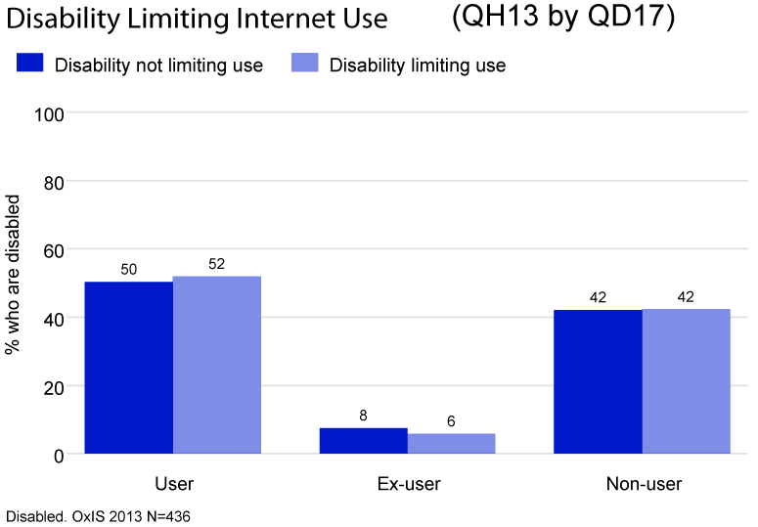

Figure 2. Comparing Internet usages of people with disabilities (limiting versus non-limiting) ⁸

Old Age. Another common reason of lower usage that people tend to think about is old age. Indeed personal computers were popularized around three decades ago, which means that many older people with or without disabilities, might not know how to use computers, much less how to get on the web. While this assumption can be true to some extent, through examination of the 2014 Disability Statistics Annual Report, I noticed that 40.3% of disabled US citizens are age 65 (Fig. 3) and older, which means 59.7% of people are unaccounted for due to this reason alone.⁹

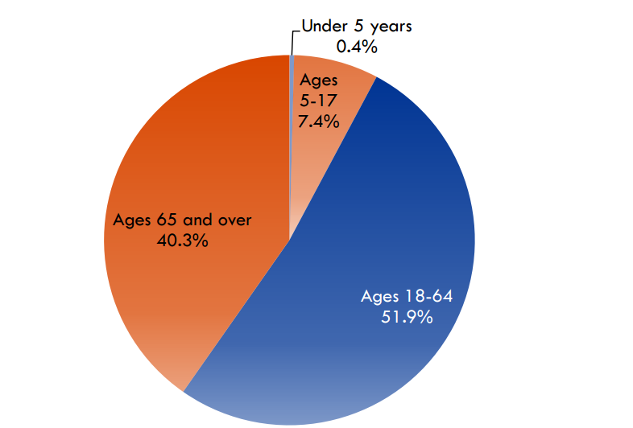
Figure 3. Age Distribution in the U.S. Population of Citizens with Disabilities, 2013 ⁹

Financial Limits. It is common knowledge that people with disabilities have a harder time finding jobs than those without even though the law prohibits discrimination based on disability. According to Pew Internet & American Life Survey, 46% of adults with disabilities have household income being $30,000 or less, compared to only 26% of non-disabled adults with the same level of income, a finding that agrees with U.S. census.² Hence, it’s definitely plausible that in order to save money, those low-income adults with disabilities choose not to use internet. However, through online searches, I found that eligible low-income families can have internet for $10/month or $120/year, and laptops are available at around $300 (taxes included). While this amount of money might still be a lot, financial considerations cannot be the only reason why the web is inaccessible.

Certainly, there are other factors not including web design and the ones listed above that might lead to web inaccessibility, for example, some people with disabilities might not find using the web necessary because their work doesn’t require it. Nonetheless, it should be clear by now that none of these factors alone can explain the significantly lower internet usage among people with disabilities, much less to conclude that people with disabilities just cannot use the web. Therefore, it’s worthwhile to consider how we might enhance web designs that makes the user experience for people with disabilities more convenient and enjoyable.

Accessible Web Design Should Consider Users with Different Numbers, Types and Degrees of Disabilities.

In order to make the web more accessible, we must first understand what an accessible web means, which leads to the question: For whom should it be accessible? To clarify why the first question leads to the second one, let’s consider the case of a visually impaired person versus a legally blind person. While both people have visual impairment, the severity of the impairment is very different. Whereas a magnifying tool might be enough to make a webpage usable for the visually impaired person, it will do nothing to help the legally blind person. Therefore, it’s important to brainstorm who the users are.

Current approaches to enhance accessibility mostly consider people with visual and auditory impairments. Having screen readers like JAWS12 (Windows) and Voice Over (Mac) enables blind people to use computer and the web to some extent, while having closed captions on videos enables deaf people to assess their content. However, are the measures taken so far enough for everyone who is blind or deaf or both? What about everyone else who has disabilities other than those two?

These questions arise as I attempted to use Voice Over on mac myself and when I watched the blind student mentioned earlier using JAWS12 on his computer. It’s very easy to see why I quickly started questioning if this is enough once you try it yourself. Remember how annoyed my school teacher was when Voice Over was accidentally turned on? Well, there is a reason: for everything a person clicks on or touches on the web, the screen readers reads out loud what’s being presented. (The student was perfectly patient with that; I was not so much.) Presenting information this way seems like a fine thing until I start considering: what if the person who is blind also happens to have Hyperacusis, a health condition that increases sensitivity to certain frequencies and volumes of sounds, whose severe form makes the person pain from just everyday sounds? In this case, there’s already a solution: use the technological devices designed for a person who is deaf-blind. But what about other cases where the accommodation for a particular disability interferes with another disability or disabilities that the person has? Software developers should seriously consider this issue if the goal is truly to make the web accessible to everyone.

Meanwhile, people with mental and cognitive disabilities also use the web, and the types of problems they encounter might be more challenging than others. According to Heather Mariger from National Center on Disability and Access to Education, the diversity of conditions within cognitive and mental disabilities makes a single solution unlikely to be created.¹⁰ To understand what that means, let’s examine some of the problems that Mariger has mentioned. “Persons with learning disabilities often have trouble processing language and numbers, deciphering auditory input, and with spatial orientation”; “a person with a brain injury…often takes longer to think and respond to online stimuli”; “sequential operations can be … distractions to those with memory deficit problems ¹⁰.” The straightforward answer here might be to simplify the web interface; by that, I mean taking the time to reduce number of unnecessary words, graphs, and links, increase the size of items on screen, and avoid distracting items that are flowing, blinking and disappearing, etc. By making everything obvious—i.e. “buttons should look like buttons” ¹⁰—web designers have enhance the web experience for both people with cognitive and mental disabilities and others without such disabilities. While these sound like easy things to watch out for, there are just so many of them that it’s often easy to neglect some. Ironically, the website for Mariger’s article, which advocates for all these guidelines, fails to do some of what it suggests (Fig. 4). While suggesting “the use of appropriate and clear graphics”¹⁰, the whole page (not including header) was without any picture or graphs that might enhance understanding; while it’s important to have easy to read text, when shrunk to a smaller window, the links cover part of the text, making it difficult for a user to read. Things like these might seem like more of a usability issue, but it’s these small inconveniences adding together that strongly discourages a person with disabilities from using the web.

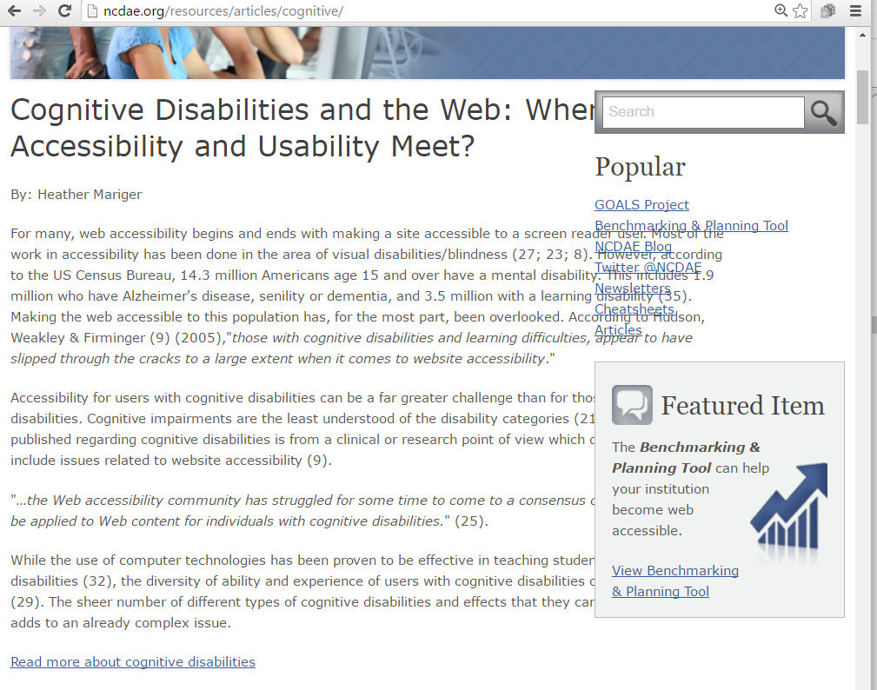
Figure 4. Example of Problematic Web Design.

Matter of fact, for a lot of people, these inconveniences become a big issue. Let’s look at the case of bad animation. For experiment purpose, you can do the following (Warning: dizziness, headache or migraine might be induced):
Try scrolling down this website.
https://vimeo.com/cameo
Try continuously watching the front page of this website.
http://www.wix.com/
Take a break, now watch this apple app.
https://www.youtube.com/watch?v=OON2bZdqVzs
If you consider this experience to be terrible, I completely agree with you. As someone who experiences motion sickness, I feel slightly dizzy after viewing the links. However, for someone with vestibular disorders, that is, someone with any disease or damage to “the system around the inner ear and brain that processes sensory information involved in controlling balance and eye movements,” such animations can cause “dizziness, nausea, headaches or worse.” ¹¹ Indeed, this problem affects approximately 10.6 million American adults, which includes those who have chronic problem with dizziness as well.¹¹ While the first two websites above are technically accessible for these 10.6 million American adults, in the sense that they can get there and see what are on the sites, they will probably be too distracted to retain any information they see. As it’s unlikely that those adults greatly enjoy visiting the websites, they probably feel discouraged to visit the sites frequently. Moreover, being a part of those 10.6 million American adults means that one has to constantly watch out for such exaggerated animations. So every time they click on a link, they have to worry about the possibility of getting one of the dreaded symptoms. Luckily, this issue has been analyzed and multiple solutions are being or have been produced.

From the cases described, we can see the importance of considering for people with disabilities other than or in addition to visual and auditory impairments. Such considerations allude to overlooked details that drastically impacts web accessibility.

Unclear Legal Definition of Accessibility Invokes Confusion and Violations.

As you might remember, I begin the prior section trying to define what web accessibility means, but even at this point, I haven’t explicitly made or cited any statements. So now, let’s look at our government’s definition. Wait a second, it doesn’t exist. That’s right, there is no clear and definite legal requirements for web accessibility, despite the fact that the American Disability Act (ADA) Title II & III imply that websites should be accessible.¹² This might seem shocking at first, until you start considering that the ADA was enacted in 1990, a time when internet didn’t really exist for the general population. And actually, the Department of Justice (DOJ) has made effort on web accessibility for people with disabilities: it published an Advanced Notice of Rulemaking in 2010, which states that regulations around web accessibility and ADA Title III will be released, but not until 2018 ¹³. On the other hand, about two weeks ago, the Department of Justice also announced a postponement on its Notice of Proposed Rulemaking (NPRM) under Title II of ADA¹². So yes, currently, we do not have a set of official, clear and definite legal requirements on what small businesses should do in order for their web to be accessible.

Understandably, due to this ambiguity in the definition and lack of clear regulations, there are rising numbers of web accessibility lawsuits filed against American businesses. More specifically, in 2015 alone, there have been more than 40 cases. ¹³ Most of these cases are like test cases for the DOJ. For example, in a complaint filed November 20, 2015, a visually impaired individual sued Home Depot’s website for exclusive visual interface despite the fact that available technologies can enable him to access the hardware and building materials on the website. However, the extent of access is clearly not the same as someone who is non-disabled. Therefore, if the website is considered to be a place of public accommodation, then Home Depot is indeed violating the ADA Title III given that it doesn’t provide “full and equal enjoyment of public accommodations ¹⁴.” Clearly, in such a case, there is the question of to what extent is the accommodation considered sufficient. Since it might be hard based on current available technologies to enable the visually impaired person to have the same experience as those without such disabilities, to what extent should the business itself be responsible for such inequity? In other words, what is considered to be reasonable accommodation for people with disabilities and what is asking too much? If the rules are there, then the business are more likely to conform and the time for such cases can be saved for the plaintiffs with disabilities. Also, right now, if a business knows that its website is currently inaccessible, what should it be doing to make it accessible? Obviously, there are unofficial guidelines such as those on World Wide Web Consortium ¹³, but they might be asking more than it’s required by law. Since most for profit businesses would like to reduce cost, this might increase business owners’ anxiety and lower their profits. In short without clear guidelines, (even though at times they seem arbitrary), these cases can negatively impact businesses and people with disabilities.

While having increased input from the general public before creating a rule for web accessibility is an understandable reason for postponement, the trouble and confusion caused by this postponement might have considerable consequences. Perhaps in the long run, the benefit of a clearer guideline outweighs the current troubles, but it’s important to realize that the clarity is possible at the expense of both businesses and people with disabilities today.

Conclusion.

In the sections above, I’ve argued that it’s beneficial for everyone if websites are accessible for people with disabilities since that enables us to an increased number of minds receiving and contributing information in the sharing center. However, at the same time, in addition to inaccessible web designs, factors such as ability limits, old age, and financial limits reduces web accessibility to some extent, though they certainly don’t nullify the capacity of a person with disability to surf the web. And I’ve also suggested that considering people with different number, type, and degree of disabilities can help identify omitted details that are crucial. Finally, I’ve mentioned the problematic fact that we still don’t have a clear federal regulation for web accessibilities.

I hope that after reading this paper, you have found interesting points that you will further investigate on your own, or that you might keep in your mind as you go about your everyday life. I know that for me, writing this paper has certainly opened my eyes to many questions that I have never considered before and has surprised me with possibilities that I once thought were extremely unlikely to exist. From my perspective, the many issues raised about web accessibility here is only the peak of the iceberg of the social challenges people with disabilities face. But I am hopeful that they will be solved gradually. In fact, one of the lines that I have heard from all the people I met with is that it’s really the people, not so much the technology, that enable accessible experiences. I believe that if we truly care about web accessibility, we will eventually reach designs that level the playing ground for everyone in the global village.

Works Cited.

- University of Washington. "Developing Accessible Websites." Accessible Technology. Web. 13 May 2016. http://www.washington.edu/accessibility/web/

- Fox, Susannah. "Americans Living with Disability and Their Technology Profile." Pew Research Center Internet Science Tech RSS. 21 Jan. 2011. Web. 13 May 2016. http://www.pewinternet.org/2011/01/21/americans-living-with-disability-and-their-technology-profile/

- "BBC NEWS | Technology | Web's Inventor Gets a Knighthood." BBC News. BBC, 2003. Web. 13 May 2016. http://news.bbc.co.uk/2/hi/technology/3357073.stm

- Bigham, and Ladner. "What Disability Community Can Teach Us About Interactive Crowdsourcing." University of Rochester, Aug. 2011. Web. 13 May 2016. https://cs.rochester.edu/hci/pubs/pdfs/interactions-2011.pdf

- "National Association of the Deaf." TTY and TTY Relay Services. Web. 13 May 2016. https://nad.org/issues/telephone-and-relay-services/relay-services/tty

- Conversation with Niki Barker

- "Methodology." Oxford Internet Surveys OxIS. 2014. Web. 13 May 2016. http://oxis.oii.ox.ac.uk/research/methodology/

- "Almost Half of People with Disabilities Don't Use the Internet: But Why?" Oxford Internet Surveys OxIS. 2013. Web. 13 May 2016. http://oxis.oii.ox.ac.uk/blog/almost-half-people-disabilities-dont-use-internet-why/

- "2014 Disability Statistics Annual Report." Web. 13 May 2016. http://www.disabilitycompendium.org/docs/default-source/2014-compendium/annual-report.pdf

- "Cognitive Disabilities and the Web: Where Accessibility and Usability Meet?" Cognitive Disabilities and the Web: Where Accessibility and Usability Meet. Web. 13 May 2016. http://ncdae.org/resources/articles/cognitive/

- "Designing Safer Web Animation For Motion Sensitivity." A List Apart The Full. 2015. Web. 13 May 2016. http://alistapart.com/article/designing-safer-web-animation-for-motion-sensitivity

- "DOJ Restarts ADA Title II Web Accessibility Rulemaking." The National Law Review. Web. 13 May 2016. http://www.natlawreview.com/article/doj-restarts-ada-title-ii-web-accessibility-rulemaking

- "Absence of U.S. Regulation Leads to Web Accessibility Lawsuits." Practical Ecommerce. Web. 13 May 2016. http://www.practicalecommerce.com/articles/95179-Absence-of-U-S-Regulation-Leads-to-Web-Accessibility-Lawsuits

- Kramer, Alexis. "Lawsuits Mount Over Website Accessibility." 27 Nov. 2015. Web. 13 May 2016. http://www.ebglaw.com/content/uploads/2015/12/Stein-Joshua-ADA-Web-Accessibility-BNA.pdf

