Table of Contents

- Introduction
- Paper #3: “Working Towards a Productive Methodology of Empowerment”
In this paper, I work towards a productive definition of empowerment that avoids the damage centered and deficit orientations that arise when many individuals attempt to help others. Instead, I advocate for the making of space for an individual to realize their own desires upon the way towards empowerment.
- A Compilation of My Field Notes
My field notes consist of the many thoughts I had throughout my placement in a
kindergarten classroom. I tackle themes such as teacher authority, lesson planning, and played based learning.
- My Top 5 Postcards
My postcards consist of the happenings of my daily life as they relate to my own
development. I have had many educational and social experiences this semester that have helped me realize various things about myself.
- Book Project Reflection
I evaluate how I was able to supplement my desire to pursue the role of social justice in empowerment through the reading of Between the World and Me.
- Paper #1: “The Importance of a Holistic Approach to Education in Play Based Learning”
I focus upon the need to approach the roles that both the academic and the social have in a play based learning model.
- Paper #2: “A Refocusing of Our Empowering Learners Class”
I advocate for a redirection in how our own class discusses issues of empowerment that arise in the field of education and beyond.

Introduction

Dear Reader,
In this portfolio, I have included all of the work that I created along my struggles to comprehend, and move towards a productive definition of empowerment. The first section of my portfolio is my final paper. I begin this paper by explaining the influence that the work of Grace Boda, who attempts to explain a theory on adult development, had upon the rest of my semester. Through investigating the writing of Jonathan Shay upon the veteran experience, I conclude that all individuals have the capacity to be categorized as learners and, consequently, have the capacity for development. Under the assumption that everyone can be categorized as a learner, I am interested in investigating how an individual generates the capacity to help another on the way towards their own empowerment. I will conclude that, in order to help someone along the way towards empowerment in a productive way, one must become an effective enabler. It is not the job of any individual to dictate what another wants, but to give space for that individual to discover their own desires which, in their realization, will empower them.
Aside from my final paper, this portfolio also includes a compilation of my weekly thoughts and investigations that take their form in both my field notes, and my top five postcards. Throughout the entire semester, I had, on a weekly basis, various difficulties completing my postcards. Most of those difficulties were spurred through a combination of both my dislike of the artistic portion of the assignment, and my consequent prioritization of many of my other assignments over their creation. Upon their completion, however, I have concluded that, although I found their completion tedious, these postcards aided me in my discovery of what methods of expression were productive for myself, whilst also holding me to a constant process of reevaluation. As I contend in my final paper, a large portion of what comprises adult development is prompted by how much space an individual makes for the reevaluation of the self. In having to constantly press the boundaries of my own skill and interest, I was able reaffirm my academic identity upon a near weekly basis.
The other main portions of my portfolio consist of both a review of the book group project we undertook as a class, and my previous two papers. In my papers, I investigate, respectively, the effectiveness of a kindergarten curriculum and the curriculum of our own course. Writing these papers allowed for me to, through a more comfortable method, explore themes of empowerment in two contrasting stages of education. The book group, as I explain, was a valuable experience for me as an individual who was very interested in the place for social justice in empowerment. Through being given the opportunity to choose my own path, (to a certain extent) I was able to put into conversation topics that our class had covered such as development with a book, Between the World and Me, that I had already wanted to read for some time. I hope this portfolio allows you insights into my continued pursuance of a definition of development with regards to social justice, and making space for the empowerment of others.

Working Towards a Productive Methodology of Empowerment
Grace Boda’s writing on Adult Development was the first reading that I latched onto within this course. Within the beginnings of the course, this reading served to inform me that I needed to broaden my definition of a learner considerably moving throughout the rest of the semester. Boda’s writing justifies that learning does not necessarily have to stop once we reach adulthood. She writes, “in the most global sense, development can be described as the gradual unfolding of people’s capacity to embrace ever vaster mental horizons and to plumb ever-greater depths of the heart.” (Boda, 1) The lack of limitation that Boda puts upon learning and the ability for an individual to learn makes perfect sense in correlation to the name of our course, Empowering Learners. There is a distinctive reason why the course is not called, Empowering Students. In order to proceed through the realm of education, and for that matter the world, it is critical to acknowledge that everyone has the capacity to be a learner at any time. It is up to the individual and those that surround them to enable that learning to take place through the process of empowerment.
Boda continues on in her writing to explain a stage sequential model that can be described as the vertical development theory. According to Boda, there is a sequential growth pattern that everyone follows as learners. This model characterizes eight stages, “opportunists, diplomats, experts, achievers, pluralists, strategists, alchemists, and unitives.” (Boda, 4-5) However, in our conversation with Grace during class, it struck me that this vertical development model was problematic for a few reasons. A person, according to what Grace said, is restricted in their vertical development by their intellect. In his book, Achilles in Vietnam, Shay approaches a veteran with the intent of speaking to him about a topic he knows is both sensitive and personal. Acknowledging this, he qualifies what he is about to say, saying he knows, “this is a very sensitive subject and that it made many vets feel angry.” (Shay, 8) Shay’s qualification here was met by the veteran with just as much remorse for the topic as there would have been without the qualification. Yet, his actions indicate something profound that anyone who wishes to empower others must acknowledge. Shay clearly cares about the people that he works with in a profound way. However, relating Shay’s place to adult development, it becomes apparent that he does not have the correct rhetoric or mental framework to be having these conversations on the vertical development level that he wants to express. It can be concluded, therefore, that development can not be looked at as only an internal progression, but that one’s actions and ability to express themselves matter a lot as well.
The way Shay approached this veteran indicated that he already had a presumed framework in his head for understanding the veteran’s experience. Instead of coming in with preconceived notions about an individual or a certain situation, James E. Miller and Susan C. Cutshall in their book, The Art of Being a Healing Presence, advocate for a space that promotes both, “listening,” (Miller and Cutshall, 39) and, “being open to your prejudices.” (Miller and Cutshall, 24) The presence of a predetermined framework limits an individual’s capacity to listen drastically. In the case of Shay, the presumption he makes in assuming that he knows what this individual will feel because of past experiences he has had with other individuals is demeaning in nature. It is also clear that Shay believes that it is within his rights to ask a question involving sensitive material. James E. Miller and Cutshall also explain that, “Healing is not something you can make happen in someone else, no matter who you are, no matter what kind of training you have.” (Miller and Cutshall, 19) Shay, being in a position where he was capable of helping others, assumed that within that position came an inherent trust of him, which in turn prompted a false sentiment of authority within him. Shay, here, falls victim to an assumption of trust that he believed existed between him and those he wanted to help simply because he was there to help them. He then utilizes this assumed trust to justify a behavior that, without trust, can only be categorized as invasive. Shay does not know these veterans outside of the position he occupies and must therefore earn their trust before he feels justified in initiating these potentially sensitive and personal conversations. Without trust, these interactions are in danger of promoting a damage-based narrative.
Any definition of empowerment must acknowledge that, in attempting to enable another to reach their own sense of empowerment and autonomy, there is the potential to fall victim to a deficit orientation that focus’ upon the obstacles and damage in the way of someone achieving that empowerment. In their article, Helping Prison, Ram Dass and Paul Gorman explain the inherent danger present within the subscription to the “helper” and “helped” dichotomy. They contend that,

Helper and helped become states of mind and ways to behave that go way beyond function. Entrapment in these alienates us from one another: a social worker and a juvenile offender just miss; a nurse and a patient seem worlds apart; a priest and a parishioner, so distant, so formal. What otherwise could be a profound and intimate relationship becomes ships passing in the night. In the effort to express compassion, we end up feeling estranged. (Dass and Gorman, 1)

In an effort to enable empowerment, it is important to not limit the individual seeking empowerment to the subordinate role of seeker. It is not the role of any individual to assume the role of savior with regards to another’s circumstances. Instead, as Eve Tuck advocates, for a desire based approach to empowerment. Tuck categorizes desire, “as an antonym to damage, as if they are opposites.” (Tuck, 419). Tuck claims that, “when communities are broken and conquered, they are so much more than that - so much more that this incomplete story is an act of aggression.” (Tuck, 418). Without making space for an individual to come to a realization about their own desires, Tuck believes that we are perpetuating the damage centered orientation and perspective. This perpetuation is restricting to the learner and must be actively acknowledged in order to be eliminated.
Tuck’s desire based model begs the question as to whether those who share similar backgrounds or experiences are inherently better equipped to assist someone in pursuance of their desires through a shared base of knowledge. In one particular example, having not experienced any of the traumas that the veterans he works with have, I was left questioning whether Shay was at a disadvantage in his ability to empower them as individuals. It is difficult to assume that Shay necessarily has the authority to initiate any conversations regarding these traumas. Yet, it appears even more difficult to conceive that Shay, having not experienced any of traumas associated with the veteran experience, can hope to know what a veteran needs and aspires towards. A solution to this lack of knowledge can be found in our conversation with Qui Alexander.
As Qui discussed with our class, it is much more productive to focus on the art of enabling rather than knowing. This process of enabling focuses on making space for an individual to realize and move towards their own desires. Qui explained, "I do not know what is best for women just because I am in a space that promotes discussion about women.” (Alexander, Class Discussion) The question we need to ask, therefore, is "How do I lift a person up to be put in a position to discover their wants and needs?” Asking this question does not require the person who is trying to enable to know the answer and, in fact, the point is that they do not know what the answer may be for anyone in their search for empowerment. The privilege of not having shared some of the experiences or obstacles that a person who is struggling through their own empowerment does not have to be looked at as an inherent and irreparable divide. Rather, those seeking to empower others, “must use the leverage that can be found within that privilege to offer spaces for those who may be disempowered to say what they want and need.” (Alexander, Class Discussion)
At times this semester, it has been very difficult for me to see practices of empowerment within my placement. One of the main focuses that I had in my placement each week was an evaluation of the forms of adult development present within the classroom. However, as the semester unfolded, it became clear that there was a profound absence of adult development occurring within the classroom. Everytime disagreements arose or a general issue was taken up between a teacher and a student, the teacher was never considered to be at fault. This is not to say that the teacher, in my experience, was ever wrong in what they were telling a student or in how they responded to certain situations. Rather, it is to simply say that, in classrooms occupied by younger students, it is difficult for teachers to receive feedback or be made aware of any of their potential mistakes It is consequently difficult to find signs of continued adult development amongst the teachers who are present. This issue is only exacerbated if the teachers present in the classroom have been teaching for an extended period of time. In these cases, it is not difficult to imagine a teacher’s practice being routinized and thus curbing their continued development due to them becoming comfortable within their routines and habits.
In an article titled, The New Preschool is Crushing Kids, given to me by the teacher who manages my placement, Erika Christakas writes that, “The same policies that are pushing academic goals down to ever earlier levels seem to be contributing to - while at the same time obscuring - the fact that young children are gaining fewer skills, not more.” (Christakas, 3). Many teachers, because of the value placed upon policies that advocate for teaching to tests and getting their students ahead of the curve, have been shrouded from the issues that arise in following this model. The process of reevaluation of the self is critical to Boda’s concept of adult development. She writes, “As people develop, the content of their ideas may not change... but the way they understand these ideas is likely to change.” (Boda, 1). The denial of teachers the opportunity to reevaluate themselves in young learner classrooms is dangerous in that it has the potential to cultivate habitual practices that never allow for a teacher to see their shortcomings and work to change them.
Many of the issues that arise with regards to empowerment arise from deficit orientations or damage centered models of interaction. Throughout this semester however, I have been reaffirmed constantly of the inextricable link between these obstacles and issues of social justice. In, A Glossary of Haunting, Eve Tuck and C. Ree criticize the terminology of social justice. They write, “Social justice is a term that gets thrown around like some destination, a resolution, a fixing… The promise of social justice sometimes rings false, smells consumptive, like another manifest destiny.” (Tuck and Ree, 647). I would argue, however, that even if something is not perceived presently as attainable, that is not adequate grounds to halt its pursuance. It is worth noting that I do not believe that anyone is ever going to be capable of reaching the highest level of Boda’s vertical development model for any considerable amount of time. This does not mean that there is not value in the pursuit of development. In the same way, although we may never reach the ideals that some believe social justice stands for, this does not mean that our current definition and devotion to social justice should be torn down in favor of something more realistic. I am of the opinion that it is in the pursuit of the unattainable that we reach the edge of the realistic.
One question that I will continue to explore throughout the rest of my pursuit of a minor in education, and every other part of my life, is whether there is a way to detach the inherent victimization social justice carries with it from the facilitation of social awareness which enables an individual to have the capacity to empower others that are different from them. In concluding that there is a place for, at the very least social awareness and, hopefully, practices of social justice within the art of empowerment, I hope to continue to pursue ways in which to create space for others in ways that enable them to have a profound role in reaching for their desires.

Compilation of Field Notes
Week #1
What: I arrived in the classroom for the first time, heard everyone's names, and was almost immediately thrust into a game of freeze tag on the playground. The seven students that were there that day all participated and universally declared me as the first freezer. Ms. Dolly, who was on the playground with us, also participated in the game. Once she assumed I was too tired to continue chasing everyone around, she assigned two students to be the new freezers. This went well for a while but was then complicated when one of the freezers grabbed another student, began jokingly wrestling with that student, only to end with both of them toppling over into the nearby sunken sandpit. Ms. Dolly came over to scold the two students and tell them that they were most certainly not playing by the rules of the playground and that we should not be grabbing each other. Later, once we had returned inside and begun our free play time, Ms. Linda pulled me aside and explained that, within a young student setting such as this, violence of any kind is to be discouraged, This extended even into how the students played with the various lego toys that they devoted almost the entirety of their free play time to.
So What: It was clear that the students loved to play both freeze tag and legos. I understand the hesitancy to allow for the perpetuation of violence or physical altercation within a classroom environment and beyond, but it bothered me that so many forms of expression were met with a similar type of scolding by the teachers in charge of upholding the class's values. I do think that setting limits on a student's opportunities to integrate ideas and concepts of violence into their play is a productive practice, but it appeared as if, at least on the playground, the students were scolded without making room for any kind of student to student dialogue or at least apologies to be issued.
Now What: I was left with many questions regarding the place of physicality in early childhood education. Is there a point where this type of behavior should be permissible? Should a teacher's role in situations like that encountered on the playground be to first stress the wrongdoing of the students, or serve as an instigator of student dialogue. I understand that wrestling on the playground is probably a recipe for disaster, but the act of grabbing someone, in itself, appears less harmful than that. Should all levels and forms of physical violence, whether actively participated in or acted out with legos, be subject to punishment and scolding by a teacher in an early childhood classroom?
Week #2
What: On Wednesday night before my Friday morning placement, an absolutely massive tree fell down near the cricket house. This tree was in absolute plain sight of the classroom window of the Thorne Kindergarten. Upon arriving on Friday, Ms. Linda explained to me how they had been watching the tree and the way that the arboretum staff at Haverford were dealing with it very closely. On Thursday, the class headed out to look at the tree during recess and watched from the classroom window in the afternoon as people began to cut the tree apart. Once I arrived, the class went back to the window to watch as parts of the tree were went into the wood chipper and Ms. Dolly asked the students to describe both what they were seeing and what they thought was going to happen to the woodchips. We then proceeded to read a book about to boys who, after a hurricane, find a fallen tree that they use to play.
So What: The incorporation of the surrounding campus into the Thorne curriculum is both heavily advertised, and, as I came to know, undoubtedly true as well. Not only did Ms. Dolly and Ms. Linda take a special recess trip to go explore the area around the tree, they incorporated time during what would normally be classified at the Thorne school as, "Teacher Choice Time" to look at the tree through the window at various times throughout the week. This, coupled with an incorporation of a consequently much more relevant book during the class's normal storytime prove that the Thorne curriculum is not rigid, but capable of adapting to the abundant opportunities present on campus.
Now What: I plan on asking Ms. Dolly and Ms. Linda how far ahead they plan certain lessons and activities to get a better understanding of how they make room for unforeseen events and where they believe it is best to weave those events into the classroom.

Week #3
Race in a Kindergarten Classroom
Three weeks ago, I was placed in the upstairs classroom of the Rose Kindergarten instead of my usual class downstairs. The only difference between the classes is that the students who are taught upstairs are, I was told, “in need of a little extra help with their reading.” We spent the two hours almost solely focused on reading and writing. The main difference between the two classrooms is that the class downstairs has a counting jar that they fill every week and make estimations for the big reveal every Friday. In this event’s place was a more phonics/word based activity where a student is chosen to go and pick an object from a list of cards, puts it in the, “word box” and gives the other students three clues from which they must guess the word. It is usually a word that has to do with the current unit of study so, when I arrived during healthy eating week, the three words we used were lettuce, grapes, and burger.
After completing this activity, we went into snack and kid’s choice time. This being my first time interacting with this group of students, I used this downtime to talk to some of the kids. One of the students, Dylan, was telling me the street addresses of each of his classmates based entirely from memory when his classmate, Bryan, a student of color, asked me where I lived. I told Bryan that I was from New Jersey to which he responded, “That’s where my grandma lives! But whenever I go to visit her I never see any white people there.” I smiled and tried to ask where in New Jersey she lived but the teacher who was listening in to our conversation quickly changed the subject. Although I was not made very uncomfortable by Bryan’s comment and wanted to continue the conversation, it was clear that the other two adults in the room had the air sucked out of them for a moment. After this week, I was left wondering whether there was a place for my conversation with Bryan in a kindergarten classroom or whether, at such a young age, conversations about race should not be taken up by the student’s teachers, but instead be left for parents.

Week #4
The Importance and Misuse of Sight Words
Two weeks ago, I focused my attention on the usage of cite words in the Rose Kindergarten classroom. Sight words are a list of words that the teachers have written and posted on the wall of the classroom and that have extra time and emphasis devoted to student’s learning about them. During this placement, I have seen both the obvious benefits of this increased emphasis, but also the pressure, and subsequent dangers and impatience that has sometimes been spurred by this focus. Every Friday, there is special time made in the morning to read a poem of part of a song that students then search for sight words in and circle on their own individual papers. However, when I say that time is devoted, I mean that this activity has almost always been thrust in the middle of two projects that the teachers devote much more time to and are regarded as much more important. This would certainly be fine if all the students could finish within the time allotted for this exercise. However, these sight word searches have consistently ended in one or two students not having found all the words by themselves, being told how many words they should’ve had, and then having the teacher point them out before the student him or herself can go back and correct their own mistakes.
There are, of course, other activities that the teachers devote more time to involving sight words. However, these activities involve a student being called on in front of the rest of their classmates and asked to read a certain word or sentence out loud. Being thrust into a more high pressure situation such as this after not being given enough time to evaluate sight words on their own appears problematic to me. What is even more problematic is that, if a student is called on and is struggling to identify a sight word, the only assistance the teacher gives is, “it’s a sight word” or, “come on, you know this one.” Although this assistance could help narrow down the list of words a student is thinking about, I have, on multiple occasions, seen this process only add to the pressure a student is feeling and, this week, one student simply shut down upon realizing she did not remember a sight word. Although a beneficial tool, the way in which a teacher utilizes a tool such as sight words can lead to both positive and negative responses from their students.

Week #5
Voice Down
One week ago, while at my placement, I became very focused on one student in particular. Cody always gets in trouble for speaking too loudly. He is told time and time again that he has to keep his voice down while inside. Sometimes, this has to do with him speaking loudly in small groups, or out of turn, or sometimes feeling the need to scream out in excitement in frustration. However, what first drew my attention to Cody was that, even when he is making productive points or raising his hand, he is sometimes still told to lower the sound of his voice. During this placement, the sound of his voice was actually used as a focus of the whole class when Teacher Linda explained to the class, after already explaining to Cody, that sometimes people’s voices are too high or too low and we have to be able to speak at just the right height when we are inside. Although there are obvious consequences of calling someone out in front of the whole class and repeating the same message to someone multiple times, this instance got me thinking about other times that I had seen Cody’s voice come up as a problem. Cody, in previous weeks, has been asked to, if he feels the need to scream for whatever reason, to go to the cubbie area and gather himself. Having gone to an all boy’s elementary school from kindergarten until eighth grade, it feels strange to me to have two female teachers telling a young student who is a boy how to deal and contain his emotions while also constantly trying to tell him that how he speaks is too loud. Obviously these skills are important, but I believe that the kindergarten class at Rose could do a better job.

Week #6
Earth Week
This past week, I went to my placement at Rose only to be reminded that I was visiting class on Earth day. All week, the class had been participating in activities that included building fort out of recycled boxes and talking about the different environments that exist all around the world. When I arrived, the class began an activity involving the earth, a large painted circle with a frowny face and thermometer in its mouth, being sick and having a high temperature. The students all took turns putting bandaids on the earth with potential, “solutions” to getting the earth better written on them. The activity was framed as in a way so that the students kept their solutions very practical and remained on a more individual level. Once we had run out of band aids, we replaced the frown and thermometer that was in the earth’s mouth with a smiling face and hung it up on the wall. The activity was followed up with kid choice time, during which I was designated to lead the charge in constructing a race car out of recycled cardboard to go along with the fort that was already made. The hands on activities with cardboard, in my opinion, fit in very well in the kindergarten environment. However, I believe that the band-aid activity, although productive in its ability to get the students thinking about solutions, is not a wholly productive exercise in that it appears to be designed with a fear of leaving the issues facing our planet unresolved. The activity consequently ends in a way that may lead the students to believe that the issue is much less serious and ongoing than it is in reality.

5. Top 5 postcards

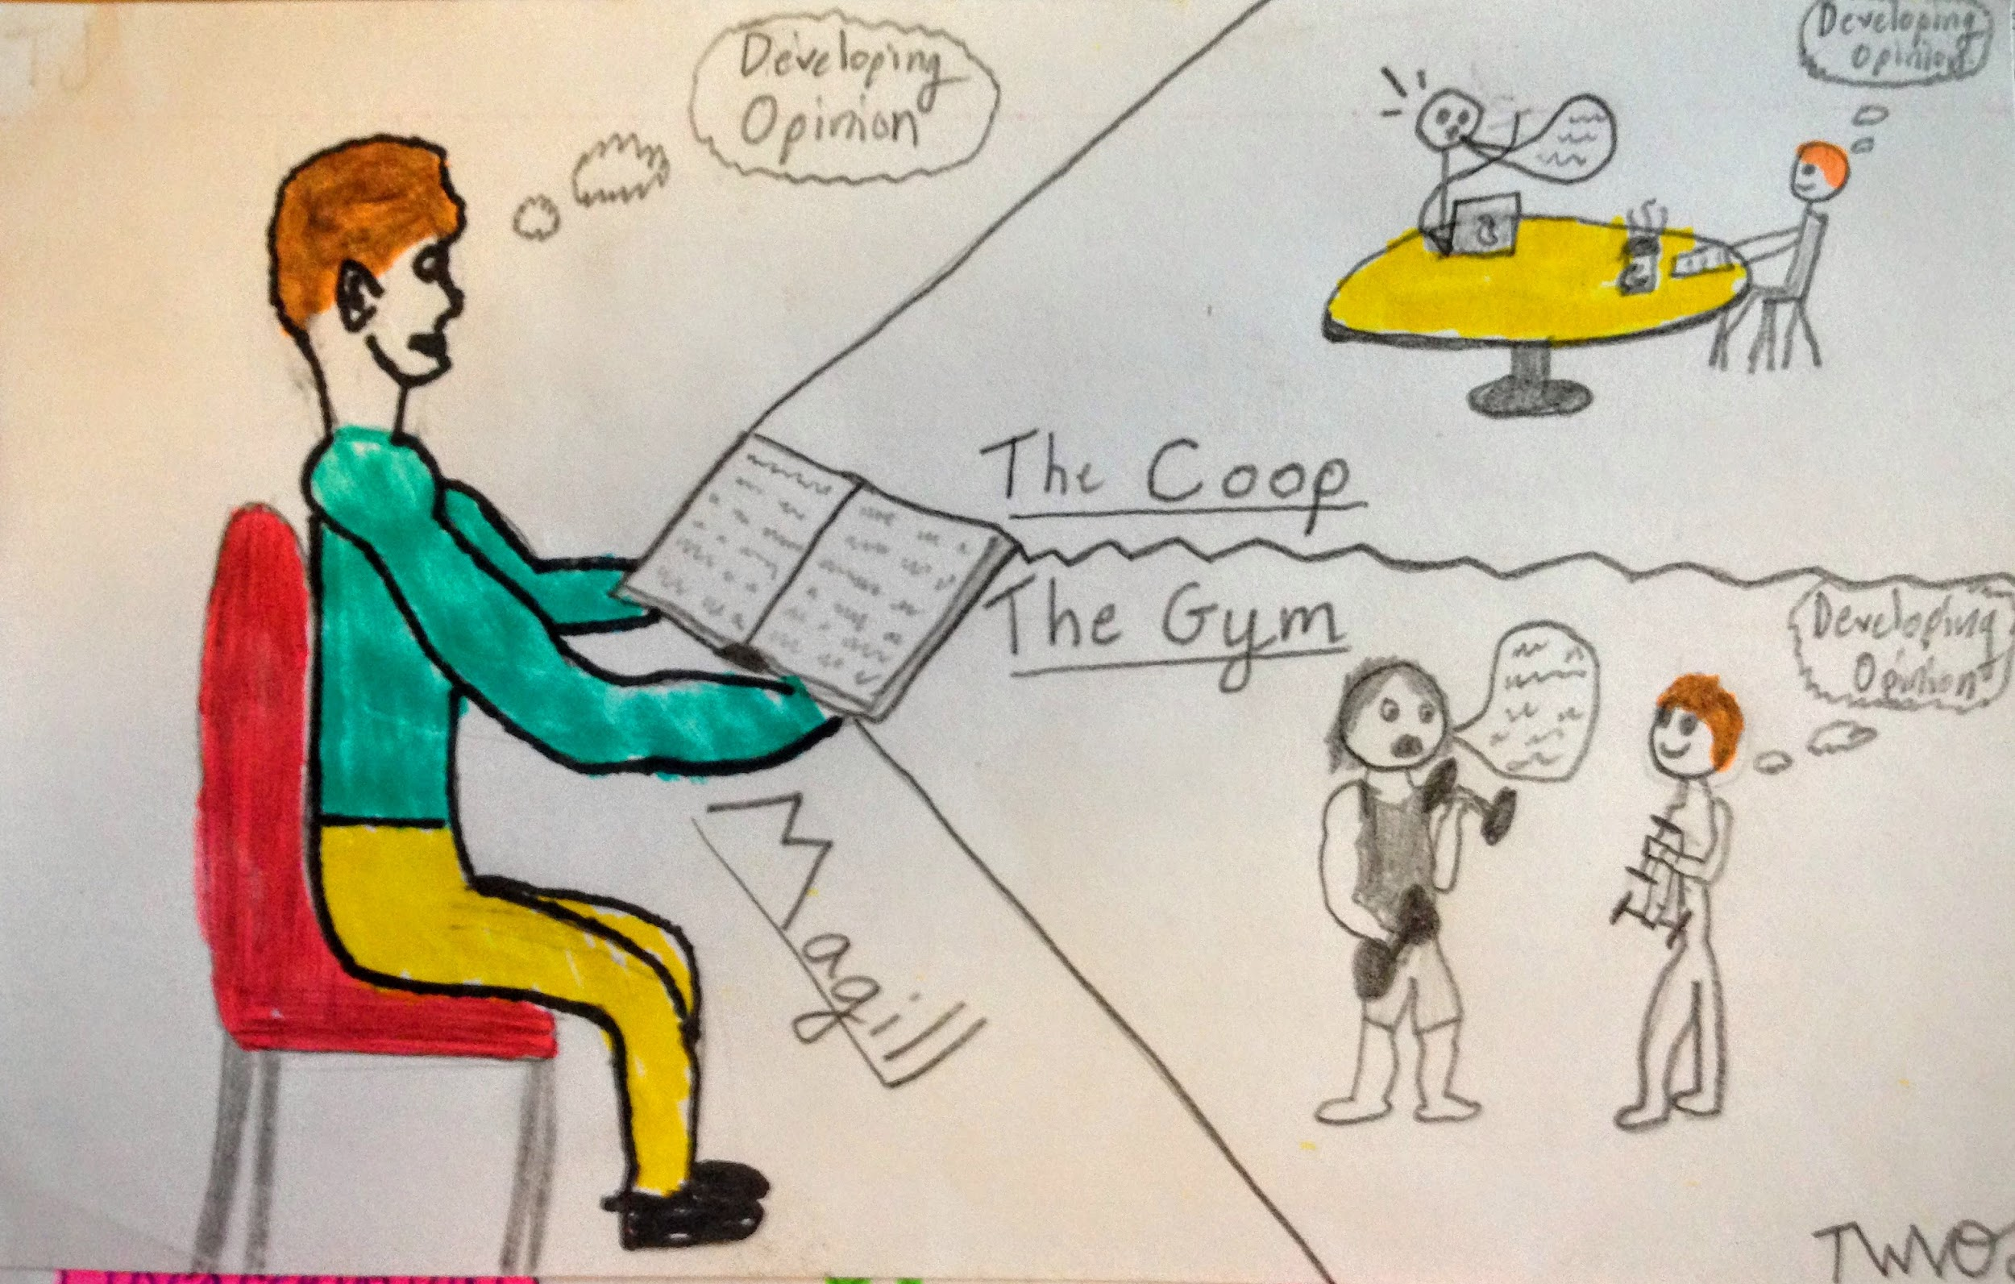
Postcard #1 Postcard #2
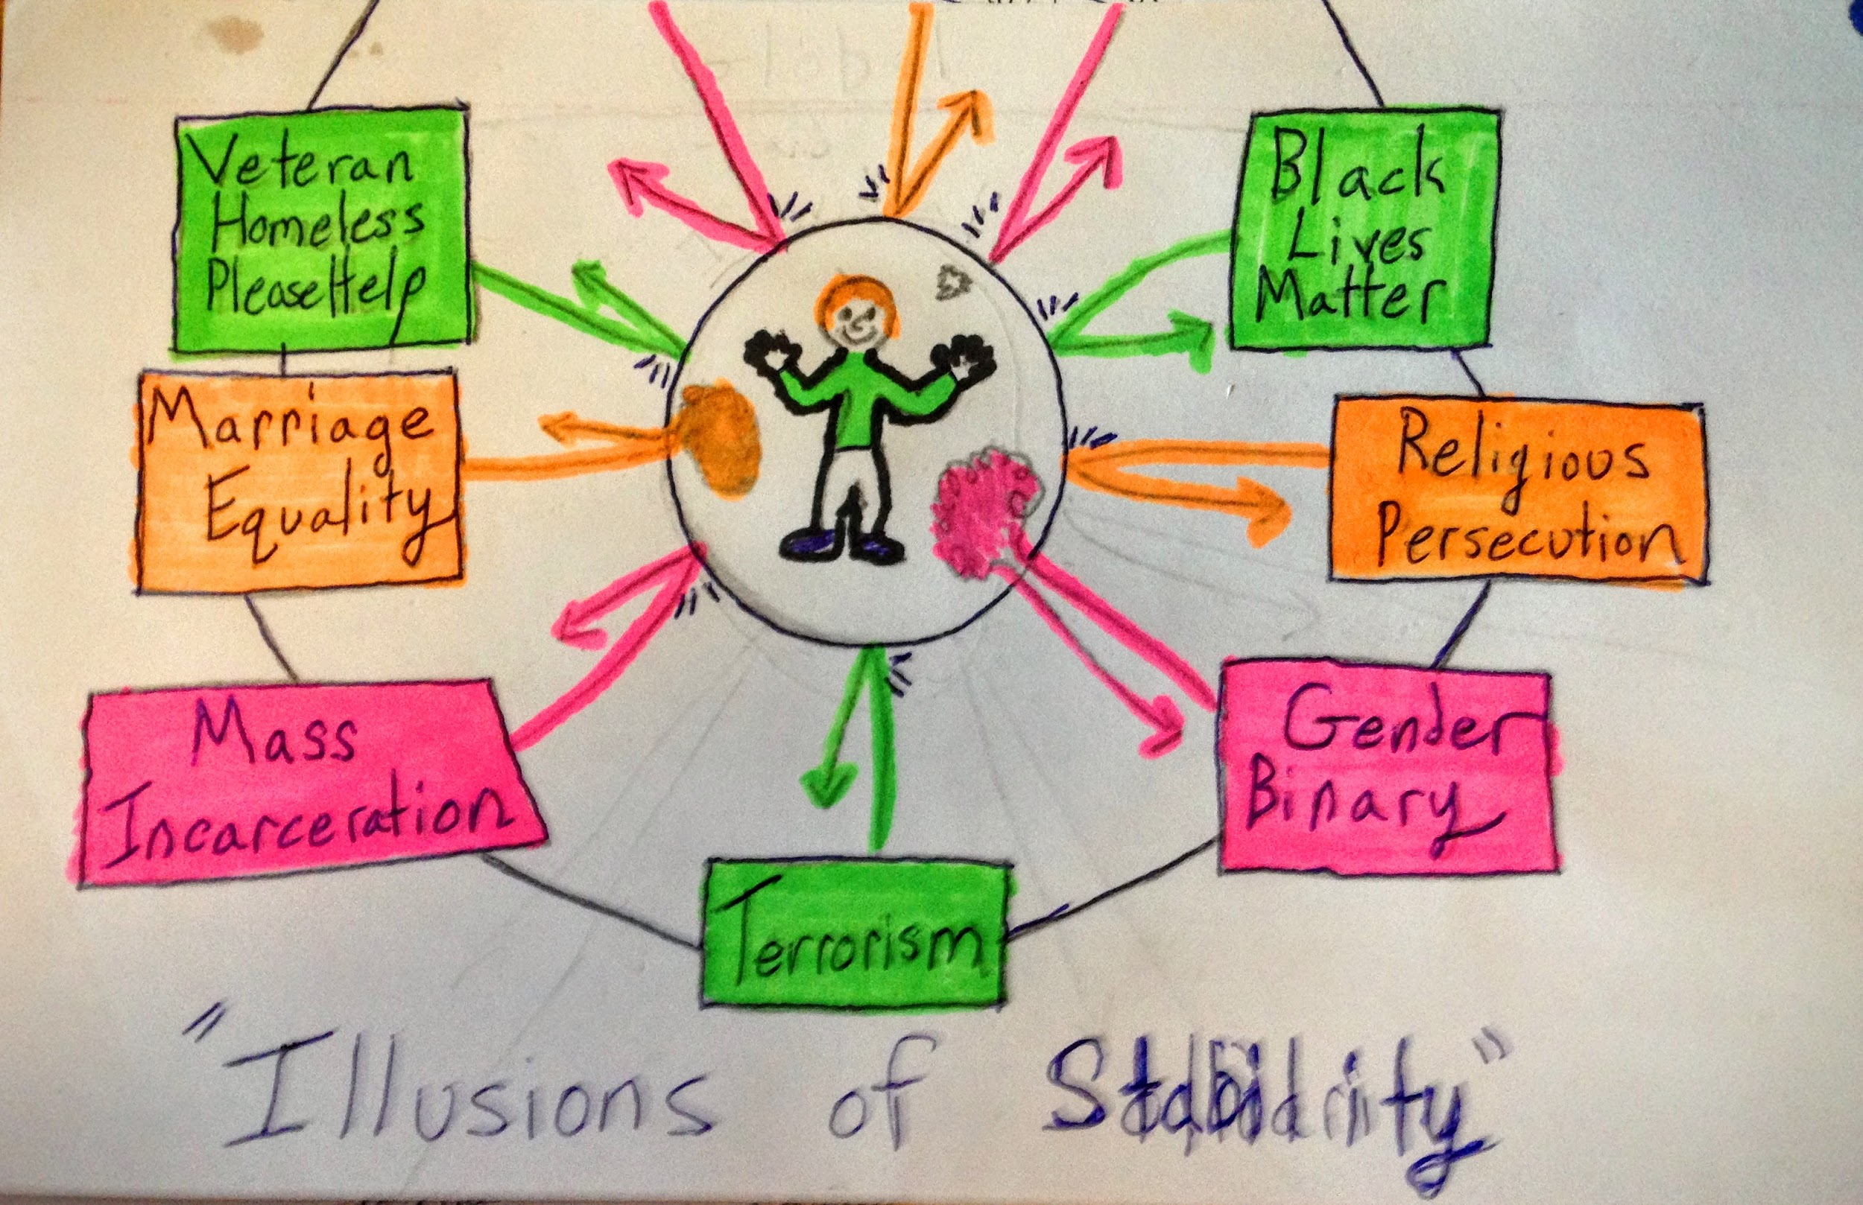

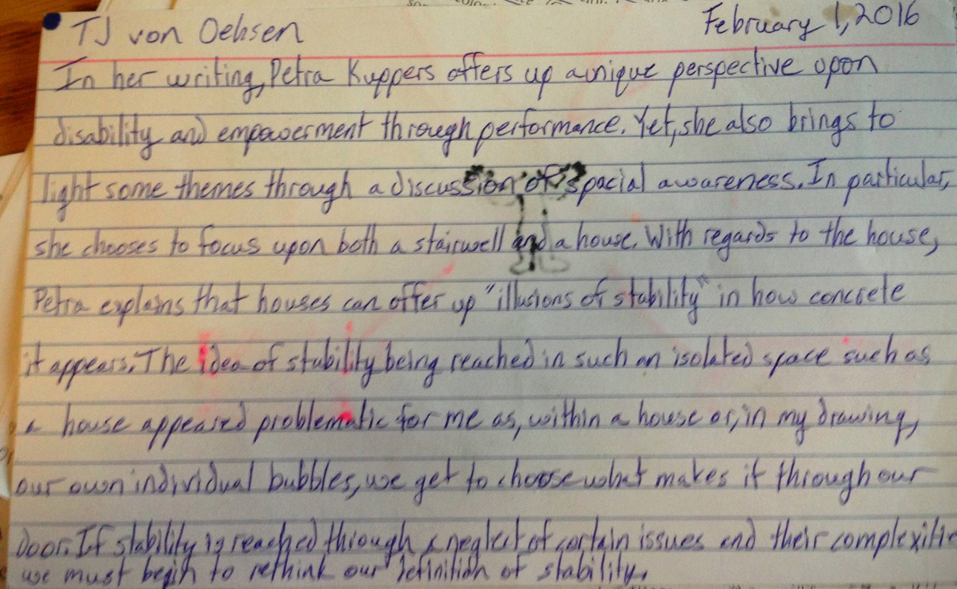
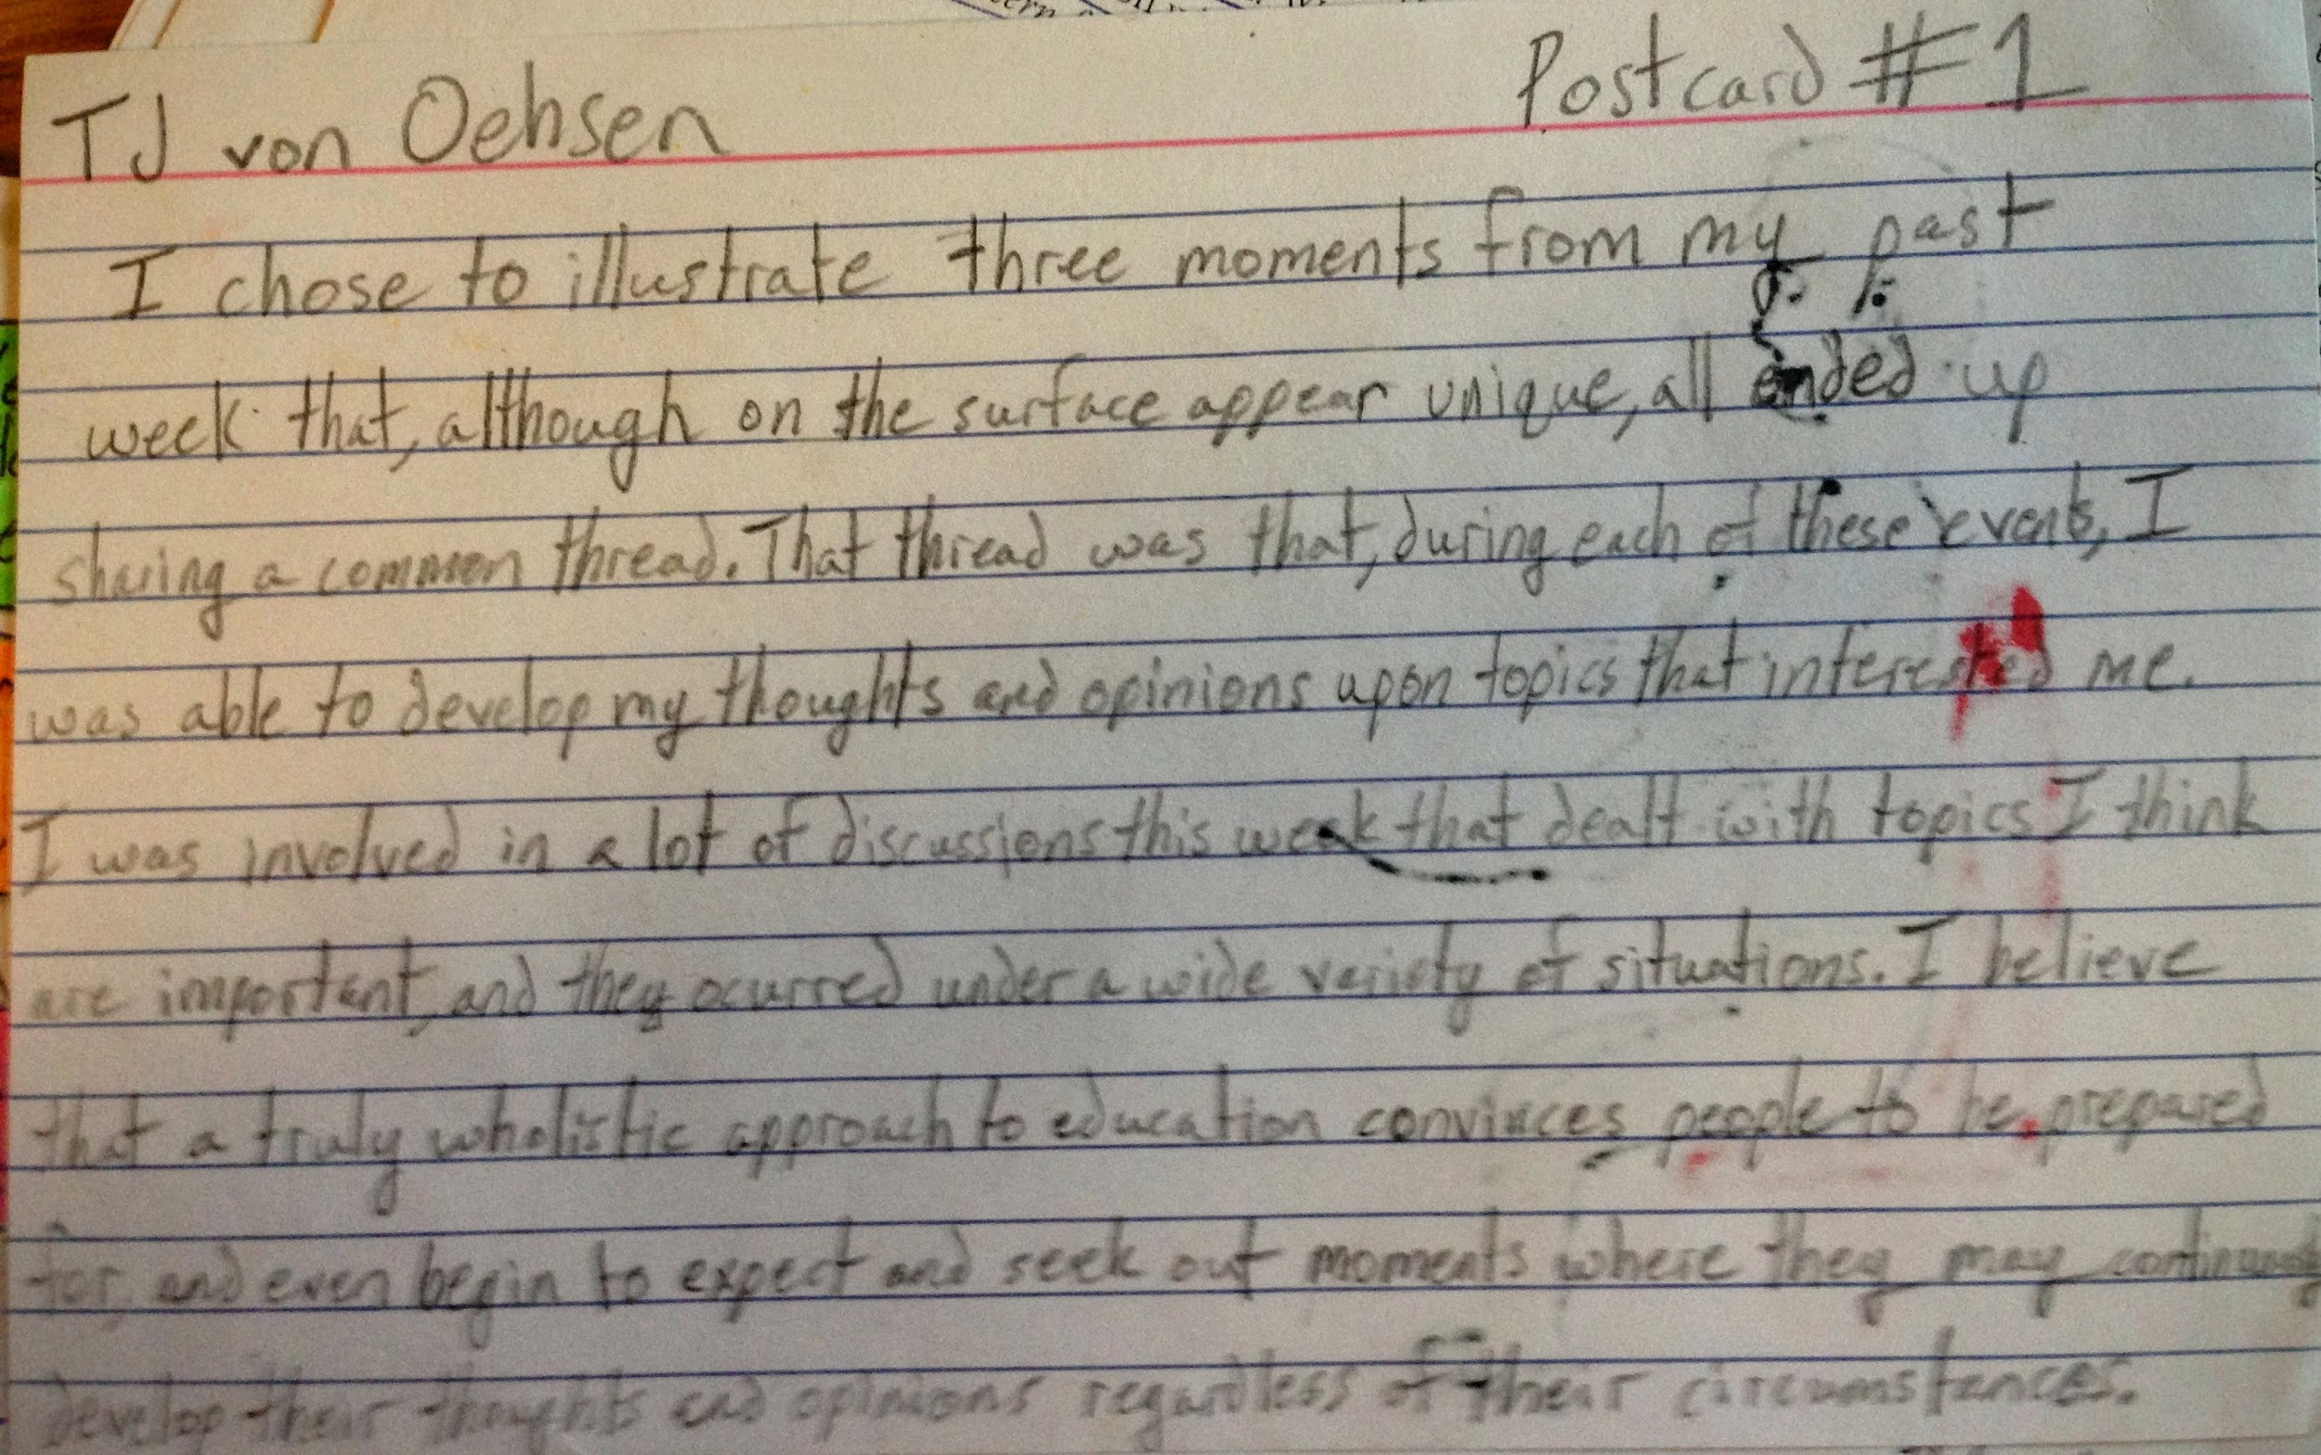

Postcard #3

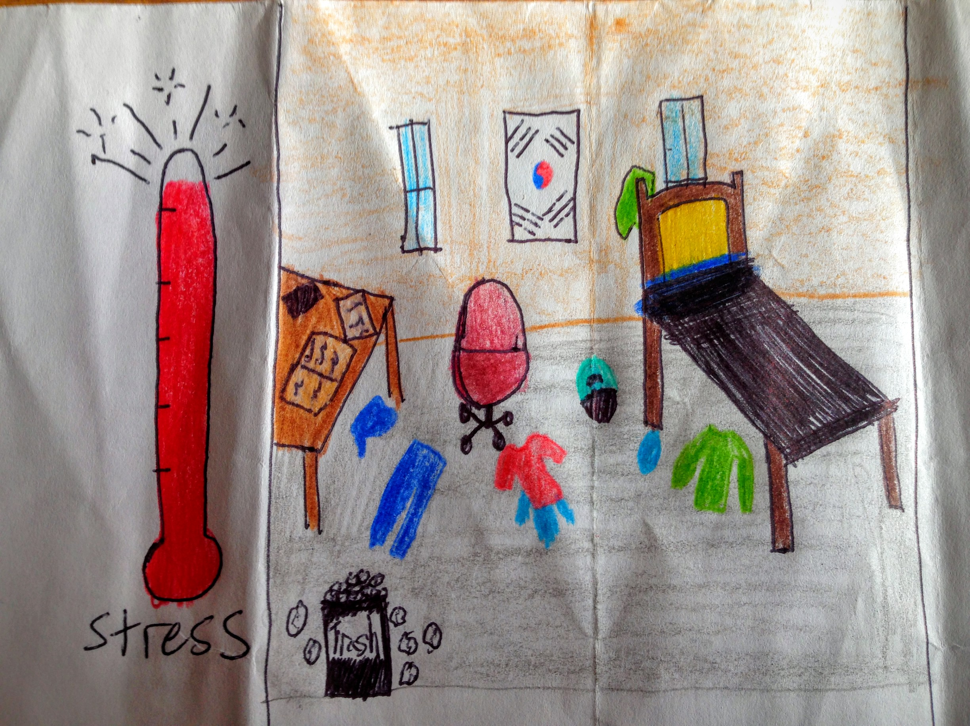
Having grown up with two younger brothers, gone to boarding school all four years of high school, and living in a double in the apartments last year, I have never had a room all to myself. This year, living in Lunt dorm, I have been faced with both the luxury and challenge of life in a single. Mostly, the extra space and time to myself has been appreciated in ways that I was not even aware I found valuable. I had no idea that I derived great benefits from being able to close my door and recharge with some alone time. I also had no idea how easy it would be for a simple recharge to extend and become a center for procrastination and general time wasting. Having a room to myself has come with its obvious benefits, but I have also realized, as a result, that I have relied on others to keep me responsible in a number of different ways. Most physically apparent, having a roommate fuels me to be much more aware of the state I keep my space. This year, I have undoubtedly kept my room much more disheveled than ever before. Over the course of the year, my room has constantly fluctuated from being sneakily clean on a very surface level, to looking as if it had been utterly abandoned after some sort of natural disaster. Sadly, no such natural disaster ever hit my room. Rather, it was a very human-centric disaster, revolving around my deprioritization of cleanliness.
As I have reflected on my disappointing room tidiness performance this year, I can not help but also acknowledge that this year has, without a doubt, been the busiest, and generally most chaotic year of my life. Many moments of chaos have actually been, in my eyes, very positive experiences that I certainly would label as some of the highlights of my year. However, in the face of such a crammed schedule, it has occurred to me that the first thing that I de-prioritize is the state of my room. (Followed closely behind by sleep) Coming to this realization has benefitted me in a number of ways. Knowing now how important time to myself in my room is, I realize that the space that I spend the least amount of time in and the least amount of time caring for is my room. Seeing my room in a dishevelled state only adds to my list of things to do and consequent pressures, so, I am coming to terms with the fact that I may have to spend a little more time on the space that takes care of me if I want to be able to better take care of myself. Identifying the things that benefit me the most has been critical to my enjoyment and feelings of fulfillment this year, and I believe all students and learners must identify these types of things on their way towards fulfillment.

Postcard #4

Over the course of this year, the two captains of my frisbee team have done a tremendous job of attempting to remain in a state of constant self reflection and evaluation. In doing this, they have always tried to align what they were doing and planning for the team with what the other players wanted out of the team. Over a large portion of the fall, we spent a lot of time learning the basics and trying to keep the team accessible and open to everyone who wanted to come out, regardless of how highly they prioritize the team or how often they chose to come to practices. As the Fall season began to wind down, the team had individual meetings with the captains and a discussion as a full team in which a large portion of the team expressed the sentiment that they wanted to become a more competitive team in the spring season.
As a result of these meetings, the captains did everything they could to try and adapt to what the players wanted. We played in competitive tournaments, we upped the intensity of practices, and all the while the captains tried to make room for fun and inclusiveness, but with a much more competitive underlying vibe. As the spring season progressed, it became clear that our team, in expressing a desire to be more competitive, never fully understood or clarified whether being more competitive would prioritize skill or effort in the pursuit of competition. Many people began to get upset about not getting a lot of playing time or feeling that they were not having fun at practice. These feelings, however, were never brought to the attention of the captains and, if they were, people expected immediate change that catered to their concerns. Many people, in voicing their concerns, failed to recognize that their feelings may not have been shared by the team as a whole and that change is hard when people change their minds during the middle of a season about what they want.
As a result of these failures to communicate, and people’s failure to understand what they themselves want, or what that entails, the team has been in flux for the past week and a half. All of this underlies the importance of communication in any kind of team or group dynamic. This communication must come from a place of knowledge about oneself, but also make room for people to figure out how they feel as they talk through things. Our team is ultimately going to be fine, but things will improve only through a shift in communication.

Postcard #5

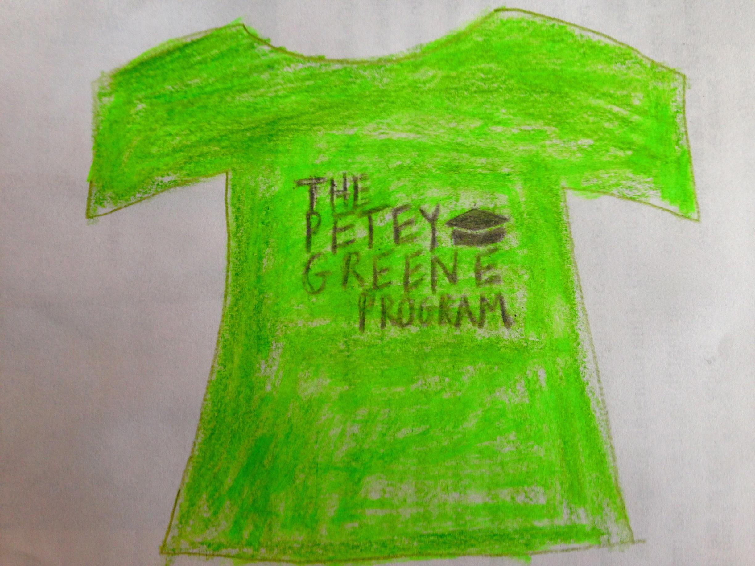
As I come towards the end of my semester, the pressures and time constraints of my daily life have only amplified in their intensity. One aspect of my schedule that has remained a very consistent, high intensity endeavor every week has been tutoring at the Curran-Fromhold Correctional Facility. As I described earlier this semester, there is a heavy amount of turnover within the class that I help out in. This turnover has made it difficult to form relationships with, or tailor any tutoring styles I might be able to utilize to the individuals I am working with. However, another difficulty I have come into contact with a lot each week is a heavy amount of negative assumptions that are made about me and my volunteering in the class.
Almost every week, I am helping with a new student in a one on one setting. The question always comes up about whether or not I am doing this for credit in a class. Yet, it is not usually phrased as a question about whether or not I am getting credit, it is usually assumed and they want to know what course it is, or simply jump right into whether I feel any sense of while guilt or burden in coming into the CFCF. What is shocking is that , upon hearing that I have chosen to be there of my own accord, I have seen many of the students that I perceived as irritated by my presence shift their attitudes completely. Once they learn this simple fact, all of their hostile feelings and actions dissipate for the rest of the time I am there with them. The stark contrast in the way I am treated at the beginning of my visit each week to when I leave is both astounding and draining. It is clear that I am capable of making progress, but with so many students fighting court cases that end while they are enrolled in the class, people testing out and into the program on a two week basis, and the fact that I am assigned to a different student every week makes any change I may be making absolutely invisible. As a person who has the privilege of assuming the role of one who can empower others, I have found that it is important to recognize and find a way to be comfortable in this lack of fulfillment. Results, in attempting to help someone on their way towards self-empowerment, may never appear. Being able to find a way to motivate and work within this reality is critical to supporting others as they progress towards fulfillment.

Book Project Reflection

This semester, I came in with a strong inclination to investigate the place of components of an individual's identity, such as race, class, and gender. In turn, I was very excited to begin discussing social justice themes in our class and read various literature on the topic. As the semester got underway, however, it became clear that moving towards the art of empowerment is much more than just the undertaking of social justice initiatives. Assisting someone on the way towards their own empowerment is, in fact, an art form that one can develop through being self-reflective and conscientious of the world around them. Although I ended up latching onto concepts of development, both in adults and youth, and engaging with developmental perspectives in each of our readings, I was a little disappointed that I was not able to undertake as direct an investigation of the role of social justice within our regular class discussion. The book project, however, allowed me to do just that.
Through being given the autonomy to choose my own pursuit in the form of a book, I was able to supplement my desire to pursue the role of social justice in empowerment through the reading of Between the World and Me. Aside from enjoying the very powerful commentary that Coates writes for his son, the project as a whole was incredibly productive for me. Being able to discuss at length issues that we had self selected as ones that interested us put the conversations on a much deeper level from the beginning. The presentation of our project to the rest of the class came effortlessly from this shared passion, and allowed us the unique opportunity to practice our abilities as educators and leaders on issues that we found important.
Paper #1

The Importance of a Holistic Approach to Education in Play Based Learning

During the first part of our semester, our class has approached the idea of holistic education as a means to combat the hindrance of empowerment in some students. Yet, in my initial exploration into the Thorne Kindergarten, I am wondering how ideas of empowerment will end up coming across within this environment. With a curriculum revolving around, “opportunities for active play and social interaction,” I anticipate that the goal of developing confidence with regards to academic growth is not going to be on full display in this class. Yet, the more I think about the ideas of holistic education, the more I realize that my initial assumption to say that issues of empowerment were not going to be as present within this space is potentially damaging in itself. The issues of empowerment can revolve around more than just an academic stratosphere and, in fact, there are many circumstances where social interaction plays the largest role in inhibiting empowerment of students. A reactionary dismissal of empowerment in contexts that do not appear to need as much help is something that a holistic approach to education should focus on if it is to promote empowerment across a variety of environments.
A great many of the fifteen qualities that Judi Chamberlin’s introduces in, A Working Definition of Empowerment, have direct implications in a play based learning environment. In particular, Chamberlin stresses the importance of communication and belonging in empowering a learner. She writes, “it is necessary to recognize that empowerment does not occur to the individual alone, but has to do with experiencing a sense of connectedness with other people.” This sentiment of connectedness relates directly to her subsequent and compelling idea of coming out of the closet where she emphasizes that, “individuals who reach the point where they can reveal their identity are displaying self-confidence.” What Chamberlin does not explicitly say here but that is undoubtedly implied is that this displaying of confidence after coming to a point of self-discovery, can only happen in the presence of, and interaction with, others. The presence of others in a space that has been designated as one of play based learning is without a doubt a hot-spot for empowerment. It is therefore incredibly important for those who facilitate spaces such as these to be mindful of the role that they and a student’s classmates have on their development of confidence.
Another relevant set of experiences that I am bringing with me to my placement this semester is my work as a Petey Greene tutor. The Petey Greene program works with the Philadelphia Prison System through the education programs that they have implemented in the various jail facilities located in the city. As a tutor, I go into Philadelphia to help at the Curran-Fromhold Correctional Facility where I assist a teacher with her pre-GED course that she offers to the people that have been placed here awaiting their trials. The coincidence is that I will be working with the Thorne Kindergarten on Fridays from 10-12 and then, after a quick lunch, be hopping in a van to head to tutor at the CFCF from 1-3:30. The physical spaces in which I will be working are about as contrasting as one could imagine. Thorne is located on a small liberal arts campus just off the Main Line, and the classroom in the CFCF, located on the north east side of Philadelphia, can easily be likened to a cement box with an alarmed door. However, the material that I am assisting the people I work with on is addition, subtraction, multiplication, and division. These four areas are very reminiscent of the kind of learning one does during elementary school, the next step for every child in the Thorne Kindergarten. So, although at first glance these two places appear insurmountably in contradiction, it is without a doubt that many of the same principles of empowerment that I hope to see focused on at the Thorne Kindergarten are present in the CFCF.
Looking more thoroughly at my education class placements in the past, I have come to realize how critical the role of a teacher is in what, how, and why the students learn in a classroom. Yet, what I have found to be most critical is what Susanne Cook-Greuter addresses; writing about how it does not necessarily matter how one chooses to be a human being. She builds upon this point saying, “what does matter is how well an individual’s styles fits the context and the task, and how well he or she can read and interact with people who have different preferences.” The teacher, in with regards to Cook-Greuter’s theory, is responsible for constructing contexts and tasks that students are capable of fitting into, or finding ways to make these contexts more inclusive to all types of students. Within the context of a play based learning model, this involves a constant self awareness regarding the methods that a teacher is incorporating into a space. Making sure students are not becoming isolated from their peers, identifying possible conflicts, and acknowledging an individual’s background, experiences, and issues on a daily basis are crucial roles that a teacher is capable of filling. Yet, filling these various roles requires both a belief in the concept of adult development, and a willingness to actively reevaluate and think critically about one’s practices.
The role of adult development and reevaluation of the self has a role in both Thorne and the CFCF. A teacher for the Thorne kindergarten has the benefit of a very low, if non-existent, turnover rate within the classroom throughout the course of an academic year. The teacher, therefore, has the luxury of being able to get to know each of their students, their needs, and how to meet their individual personalities. In contrast, there was not a single time I went to the CFCF where we were working with the same class for two weeks in a row. The high turnover rate of the jail makes it nearly impossible to meet an individual’s needs and learning style as there is simply not enough time to get to know someone. This, coupled with the irregularity of some people’s attendance disrupts any opportunity for the teacher to find any kind of flow in a curriculum. The CFCF might have the advantage of not being able to fall into any kind of habitual rut in teaching, but there is no doubt that the people who participate in the program would benefit from the many qualities of empowerment that Chamberlin lists that are only attainable through the development of a fuller relationship with the other members of the community.
Where the Thorne kindergarten and the CFCF truly differ is in the fact that one prioritizes a battling of existing stigma, and the other, not being obligated do the same, advances a more holistic approach to learning. Methodology aside, access to resources immediately divides these two educational environments. The Thorne kindergarten’s access to Haverford’s arboretum and farm are two incredibly unique circumstances that the people in the pre-GED class of the CFCF will never have paired with their educational experiences. Instead, what the CFCF is forced to focus on is a constant need to motivate students past the weight of their stigmatization as, “felons” by the rest of our society. Every student in the class knows the stories of how difficult it is to get a job with a criminal record. These realities are present in the minds of each person in every lesson of the class. Motivating people past these stigmas in the CFCF classroom could involve a few different processes involving empowerment. The first is accomplished simply by treating the people involved in the criminal justice system as people. Even the very words: felon, ex-convict, and criminal carry with them dehumanizing sentiments that chip away at the humanity behind each of these people that have recently had their lives transformed in almost every aspect. The self-fulfilling prophesy of these words is real and it is dangerous. Second, the teacher I work with understands that, “Most learning, training and development is geared towards expanding, deepening, and enriching a person’s way of meaning making.” She tells the students she teaches that education is a doorway to becoming a better person, someone you can be proud of, and ultimately does make it much more likely to find success after their sentence. Through figuring out how to overcome the fear to engage in conversations that directly address the issues that people have on their minds, the teacher at the CFCF both underwent a process of adult development, and allowed others to have access to the same.
I am consequently very excited to work in a classroom where none of these stigmatizations is as ferociously present. Empowerment can be found in more holistic methodology, but it is difficult for classrooms to implement holistic approaches if they are limited in the resources available to them. Adult development will definitely play a key role in how the dynamic of the Thorne classroom is built, and I am excited to have these two experiences in conversation with each other. A classroom such as Thorne’s is able to focus much more heavily on aspects of holism in education due to their access to resources. The implementation of resources such as the Haverford Farm is going to be a very interesting and new approach to education than those that I have had thus far in my Bi-Co placement experience so far.
Comments
Dear T.J.,
I really appreciate the way you put your two field settings together here. This move itself raises possibilities of holistic engagement: the move to see these two drastically different places as parts of one whole -- whether a whole story about adult development, or how humans learn basic math, or how stigma is built, or how resources flow with such ferocious (your term) unevenness in our world.
To me, the most compelling part of your cross-consideration is the insight about relationships over time and how hard they are to come by in CFCF, compared with the way in which uninterrupted continuity is a given, even an entitlement, in Thorne. This theme will recur when we read Achilles in Vietnam and the author, Shay, discusses the key role of relationships among soldiers in a fighting unit.
Not yet so clear to me is the question you are carrying into these experiences; as written, this essay seems to push for answering rather than clarifying a question. What's your sense here? Is it the case that the work on integrating the placements pulled you first to trace cross-cutting issues on the way to developing an inquiry about this?
Good start -- and I note that your work in class discussions has been crucial in getting the class launched in a deep and relevant way. Thank you.

Paper #2
A Refocusing of Our Empowering Learners Class

In this paper, I hope to successfully advocate for a sort of recentering of the Empowering Learners course. I hope to initiate, in particular, a reevaluation of how our discussions operate, and what we end up focusing on. Throughout our time as a class so far, we have had discussions about different tools that a student, teacher, or parent could potentially utilize to enhance the educational experience. This conversation, however, has not veered significantly in the direction of the unequal accessibility of these tools. Instead, we have chosen to focus on the sharing of personal experiences. At the beginning of the semester, we agreed as a class that making room for the sharing of personal experiences would be beneficial to our discussions. However, many of these personal stories that our discussions end up focusing upon involve incidents of active disempowerment. For these reasons, I argue strongly that this class should not operate as a credit/no credit course. I believe that, even under the current grading system, people fail to keep up consistently with our readings and assignments. If we are to adopt any of the practices I wish to introduce a conversation around, a strong grounding within readings will be important; and if people are already choosing not to do them, I fear what would become of class discussions under any other framework.
The role of personal experience in an education class is both necessary and problematic. Inherently in the fact that we are taking courses at two prestigious liberal arts institutions, each student in the course brings with them a wide range of both positive and negative educational experiences. When asked to think critically on these previous experiences however, the first experiences that we draw upon are, logically, those that would be considered the most memorable. In being the most memorable experiences, moments of active disempowerment dominate our recollections. Moments of active disempowerment involve a teacher or student’s actions directly resulting in the oppression of another student. These moments stick out in our heads because of the extreme and obvious manner they are embodied. I do not believe it to be a secret or a heavy assumption that, within our classroom, we all feel very comfortable denouncing practices such as telling a student they will not be able to get into a college or actively discriminating against someone based upon race.
Due to the fact that we all belong to the Bi-College consortium, which is very cognizant of both social justice issues and incidents of disempowerment, it is easy for us to discuss moments such as these as we already have opinions formed upon them. However, as I will argue in this paper, centering our class around topics that are commonplace within the bico is not the most productive way to utilize our space, and most of our opinions upon these topics are shared by a large portion of the BiCo. In order to be able to discuss things that are more nuanced and that we have less strongly ingrained opinions and solutions upon, it would be important for our course to rely heavily on readings and theory to supplement our discussions. This would dramatically shift how our discussions are presently.
If we were to eliminate these incidents of active disempowerment from the educational system, we would still find that the system as it currently stands to be more accessible to some than others. Therefore, disempowerment must not only be being perpetuated through active and intentional means, but also located within the framework of the educational system as it is currently constructed. In our class, the question arose as to whether an, “expert” was needed to teach any subject matter effectively. Many came to the conclusion during this discussion that an expert was not needed at that exploration, critical thinking and discussion among peers were the most central processes to the educational experience. At first glance, this conclusion appears agreeable. Even in subjects such as mathematics, struggling to find formulas and learning how to approach and solve problems are skills that can be achieved and perfected amongst a group of peers. However, in this conclusion, there exist a set of assumed skills and abilities that no student possess when they begin their educational experience. In order to be able to have discussions with peers, a student must learn how to communicate with others in productive and respectful ways. Communication also requires students to be able to think critically. Even before that, however, communication and critical thinking require a certain base level of proficiency and understanding of language. It is clear that, in order to achieve the ideal classroom setting that we discussed, a variety of precursory steps must be taken. These steps can be rooted back to concepts, such as learning the alphabet, that can only be taught in very specific ways. The limitations in how it is possible to teach the alphabet imply that there are structural limitations inherently built into the base layers of knowledge that we expect all students to build their entire educational experience upon. Spending time discussing ways in which to address the existence of structural means of disempowerment should be one of our class’s main focuses.
In a course that cannot separate itself from social justice initiatives, we should embrace or place in the BiCo and, from this shared place of knowledge, use our classroom space to explore issues we do not already agree upon or have preconceived opinions and extensive experience with. At the beginning of a semester, it is difficult to gauge what experiences a group of students brings with them into the shared identity of a classroom. As our classroom identity has unfolded, the level of interest our class has with social justice initiatives, and experience we collectively hold with engaging with these issues, has become increasingly apparent. As we have discussed issues of empowerment are, at their core, centered around limitations of the autonomy of learners. In our discussions of empathy, adult development, mindfulness, and trauma, our discussions were at full strength when we incorporated questions of equality across race, gender and class along with a discussion of these topics on a broader scale.
In one of our most recent units, we explored the experience of veterans as they struggle through PTSD and reintegration into the United States and the role of mindfulness within an educational experience. Here, our discussions moved quickly towards a discussion of both the positives and negatives of the manner in which Shay chooses to engage with people dealing with trauma. One of the conclusions which we drew from these discussions was how much it mattered that Shay had not gone through the Vietnam war himself. His rhetoric and ability to speak with the veterans he interacted with in ways that were not problematic or offensive were consequently limited. In this instance, our class agreed that there is considerable value, when attempting to empower others, in the existence of shared experience. Everyone’s experiences and struggles are unique, and no one should ever assume they know what is best for someone else. Yet, it appears as if a certain amount of shared background, or commonality of experience or identity makes a person better equipped to form deep relationships with someone else. This conclusion, however, was one that became universally agreed upon very quickly. Within discussions of ongoing issues such as trauma and inequality concluding with an assertion that stirs up no controversy appears to be a misutilization of space. If there were any certainties within issues of disempowerment such as these, it would be unnecessary to have discussions in the first place.
Another sizeable portion of our class’ thinking has centered around the incorporation of mindfulness and mindfulness practices into education. Our discussion of mindfulness was at its best when we embraced the social justice component of the topic with Qui Alexander and devoted time to discussing unequal access to tools such as mindfulness due to certain parts of a person’s identity such as race and class. What Qui concluded with us is that we have to, “empower someone to have their own experience around something. Don’t be afraid of letting people struggle, struggling is a means of empowerment.” According to Qui, a productive utilization of privilege is not to assume an active role in leading another towards empowerment. Instead, “we must use our leverage within privilege to offer spaces for those who may be disempowered to say what they want and need with a community of shared experience.” It is in making space, and creating leverage for others that we have the best chance of assisting them in reaching their own goals.
In the same way that Qui advocated for the creation of empowerment through the active process of making space for others, our class must attempt to make space for ourselves to struggle and work towards difficult solutions. During our discussion with Qui, we struggled and talked back and forth regarding various issues we see in how access to empowerment changes across identities and individuals. In a classroom such as our, we have the unique ability to think critically, make assertions about how we would potentially go about mitigating inequality in a wide range of circumstances, and then evaluate these assertions amongst our peers. Solutions to instances of active and systematic disempowerment will always be fluid and based on the one of a kind circumstances to which each instance is subjected. However, proposing potentially disputable solutions to a variety of hypothetical circumstances in a brave space such as our classroom will better prepare us to face disempowerment in as many ways as possible.
Comments
Dear TJ,
I appreciate your conscientiousness in bringing thoughtful critique about the quality and impact of our class discussion. I think your essay would be stronger if grounded in specific examples, especially when you get to the call for a debate-oriented pedagogical approach.
Your focus on the importance of exploring ways to mitigate systemic injustice is important. My thinking is that our key texts address this at the level of work with individuals, as individuals, but also as part or suggestive of broader efforts, or in Qui's terms movements. Here, too, a specific example could be useful in supporting your working out this possibility.
I wonder whether the argument of this paper was relevant to you in our "pop-up" panel on prison education last week. The (at least) two models of empowerment in the two focal programs discussed offer a generative contrast due much discussion -- but I am not sure whether to debate which one is better is that useful. It might be interesting to consider these two models of empowerment next to that which you've seen at Thorne and use the look across to gain a deeper sense of system and individual work within/across.
I appreciate (and regret!) your frustration in the course, and respect your working with and from it. Of course I also appreciate the amazing contribution you have made to class discourse.

http://www.brynmawr.edu/thorne/programs/kindergarten.html
Chamberlin, Judi. A Working Definition of Empowerment.
Chamberlin, Judi. A Working Definition of Empowerment.
Cook-Greuter, Susanne. Making a Case for a Developmental Perspective. (1)
Cook-Greuter, Susanne. Making a Case for a Developmental Perspective. (3)

