Claire Cywes
Professor Kristin Lindgren
Critical Disability Theory
5 May 2023
Accessible Play: How Can Haverford Improve Its Campus Playgrounds?
An Overview of Adaptations to Playground Equipment and Surfaces that Increase Accessibility For Children with Disabilities
Play in a non-academic environment pushes children to develop physically, cognitively, socially, and emotionally; it is an essential part of socialization for children in which they learn to role play, share, and tackle challenging obstacles (Ginsburg et al., 2007). While there are numerous forms of play, the playground constitutes one of the most well known environments in which the majority of these activities take place for young children. Playgrounds are designed to support children interacting with each other, yet children with disabilities are often at a disadvantage due to the lack of accessible structures and terrains typically seen in playgrounds, which may deprive disabled children of the socialization opportunities other children are afforded (Fernelius & Christensen, 2017). A lack of awareness and education resources about the wide variety of disabilities children experience as well as the lack of resources available to make play accessible may lead to ostracism from the social scene of school. While a standard for the minimum level of accessibility exists for all playground designs, even when the standards are followed, issues of inclusivity arise (Fernelius & Christensen, 2017). Children with disabilities are often unable to engage in the same level of social play as other children in addition to a lack of accessibility of the physical components of the playground. As such solutions for making playgrounds not only more accessible but also more inclusive are a necessity. Here, the components of accessible playgrounds are outlined and the playgrounds on Haverford College’s campus are critically examined for elements of accessibility (or lack thereof).
There are a wide variety of options for playgrounds that should be made accessible, ranging from the surface of the ground, to ramp access to higher structures on the playground. The first, and possibly most important playground component that should be made accessible is the ground surface, which should be firm, soft enough to absorb falls, and uniform in elevation and texture to provide the highest level of access (Brown et al., 2021). Many playgrounds have mulch, tire chips, or other loose, soft substances lining the ground. While softer substances may appear to be safer as it can cushion falls from playground structures, having loose material prevents wheelchair access and also serves as a choking hazard for small children (Bird-Curcio, n.d.). A safer alternative that is soft, but still firm enough for wheelchair access due to its uniform surface is poured in place rubber. In addition to absorbing the impact of falls, this surface is environmentally friendly, can be customized with different shapes and colors to offer sensory benefits, and can help distinguish different areas of the playground using changes to the design (allinclusivedevadmin, 2021). However, the surface does have a disadvantage in that wearing of the rubber may occur to high-traffic areas. Another alternative option to mulch or tire chips is safety tile. This surface is more durable than the pour in place rubber and shares the features of fall absorption and a firm uniform surface that is accessible for wheelchair users (allinclusivedevadmin, 2021). Overall, the poured in rubber or safety tile offers the most protection from falls while also being accessible to wheelchair users and offering added benefits of color design and the ability to create sensory pathways from the surface.
In addition to the surface of playgrounds, the play structures should also be made accessible by adding ramps, textural components, or other aids. On many playgrounds, the main structure is only accessible by taking at least one step up, as the structures are frequently elevated. In order to circumvent getting up onto the elevated surface without taking a step, playgrounds should install a ramp into the structure in addition to the steps. Furthermore, slides attached to these play structures should be made static free so children with cochlear implants can play with the most comfort (Brown et al., 2021). Swings are also not typically made in an accessible fashion, as they are not wheelchair accessible and do not have safety restraints for children that have mobility impairments, although they are known as a particular favorite structure for children with disabilities (Brown et al., 2021). Figure 1 shows the layout of accessible swings, which still may require the assistance of a caregiver but can be accessed by children of most sizes and with a variety of disabilities. Finally, merry-go-rounds are common components of playgrounds, though they are often inaccessible due to a step up onto the structure or the bars being too close together/too close to the edge of the circle. Adaptable solutions for merry-go-rounds include the structure seen in Figure 2, which adds space for children in wheelchairs as well as a seat for children that cannot stand while spinning. While the merry-go-round as a whole is somewhat inaccessible as many children cannot undergo that level of rotation and speed, providing spaces for children to sit or place their wheelchairs does increase the accessibility of the structure.
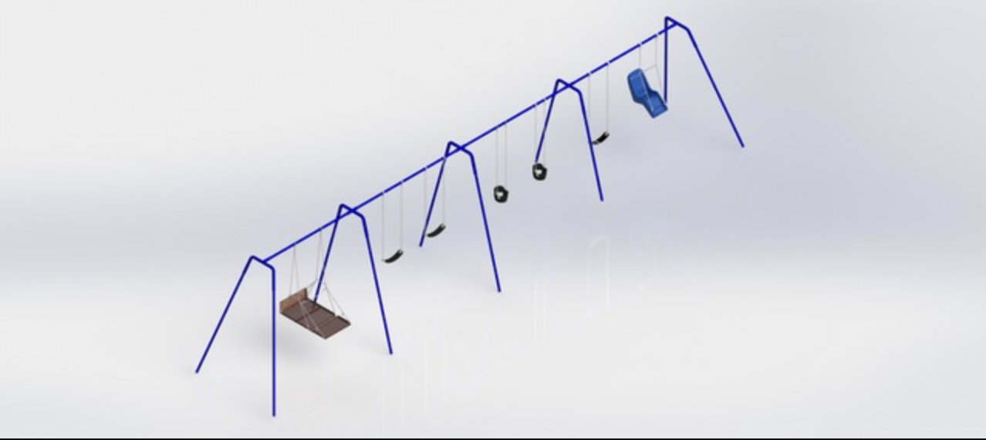
Figure 1. Inclusive Swing Set from Bluegrass Playgrounds, Inc. The swings depicted above show the variety that should be offered at all playgrounds for swing options. On the left, there is a wheelchair accessible swing containing a ramp that can be raised and lowered to keep a wheelchair in place. Next, the traditional swings are depicted with a pliable scoop seat. To the right of the traditional swings are swings made out of the same pliable material but with a support underneath and around the sides of the swing, fitting smaller children and toddlers. Finally, on the far right is a swing with a full seat including a back and leg rest that also has safety restraints to ensure children stay safely in the seat.
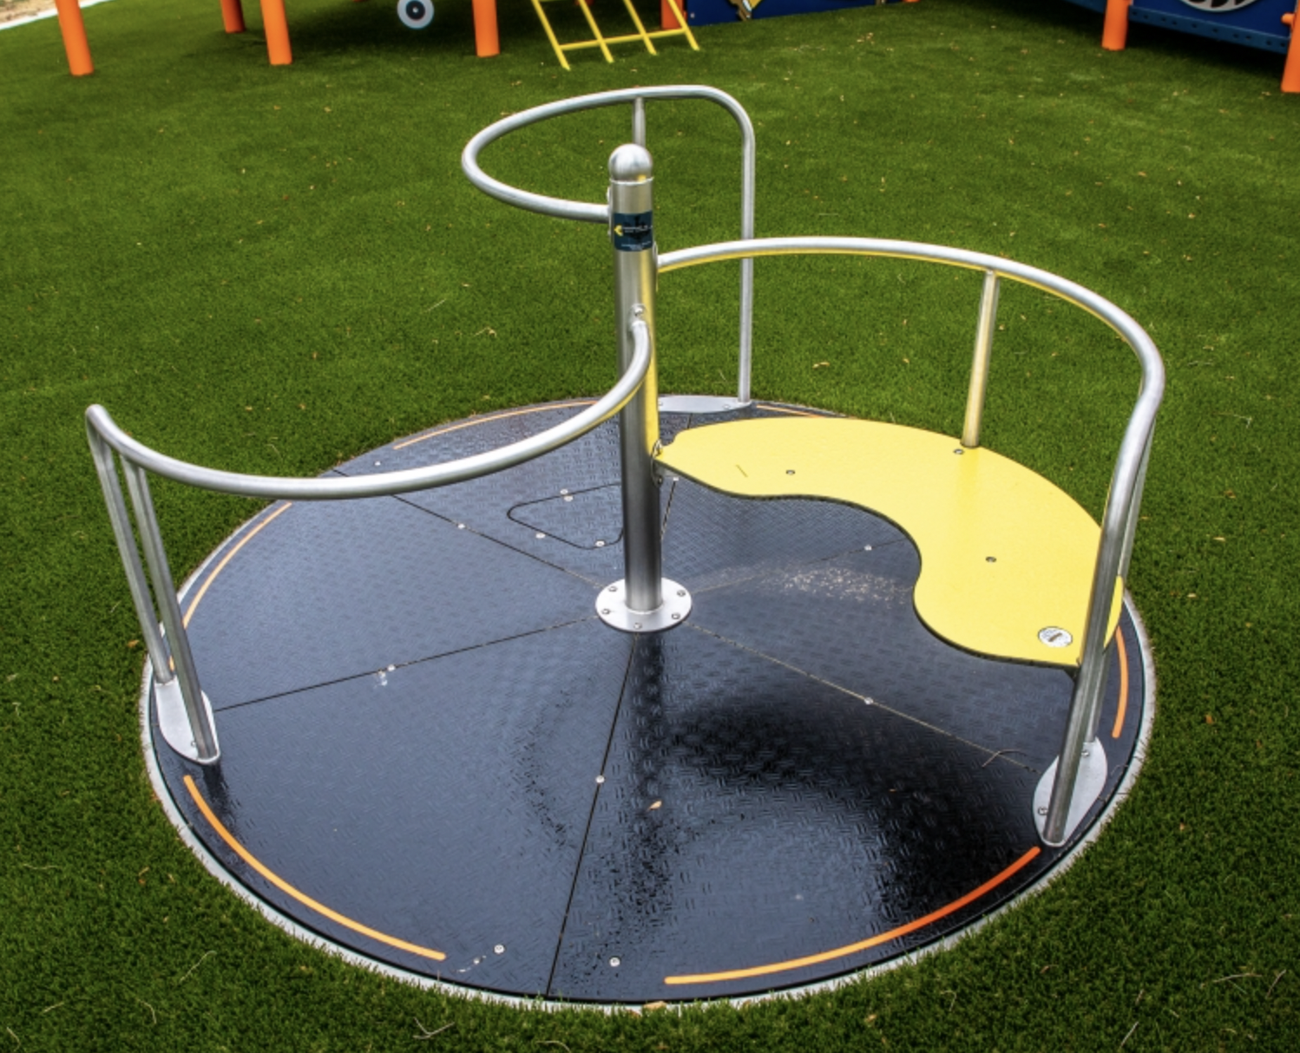
Figure 2. Inclusive Merry-go-round from SpecialNeedsPlaygroundEquipment. The merry-go-round shown above allows for access to children, regardless of their disability. The top section of the structure shows an area in which a child could stand and hold on to the bar and provides space for a child to propel the merry-go-round. On the left, there is a more open area of the structure in which a wheelchair can fit. There is no additional step to walk over, as the structure is embedded into the ground. The last open segment contains a seat which could fit one or two children as well as another open space with a bar for holding on. The only element to this structure that appears to be missing is a form of safety restraint that could be used for children with dexterity issues that would not be able to hold onto the railing, though this could likely be added.

While ensuring the physical structures of playgrounds are accessible is paramount, another essential element that should be considered when designing a playground is adding elements of challenge appropriate for all ages of children, as this allows children to select the level of play at which they would like to engage (Brown et al., 2021). For example, sensory elements to playgrounds such as music elements or visual and tactile stimuli. Sensory pathways can be used inside and outside and can include elements built into the ground for easy access to wheelchair users as well as auditory elements for deaf children and textural elements for children with vision impairment. In addition to sensory pathways, it is also beneficial to leave sections of the playground without structure to allow for imaginative play that encourages children to engage with other children, observe other children playing, or provides a place for children to retreat to when they become overstimulated (James et al., 2022). Thus, sensory elements and open space are as important to making an inclusive playground as ensuring that all physical structures are accessible.

How Do the Playgrounds on Haverford College’s Campus Measure in Accessibility?
The Haverford College campus has three main playgrounds/outdoor exercise facilities that are used frequently by children and students on campus (see below for images of the playgrounds). While there are several inaccessible elements to the outdoor exercise facility (Figure 3A-B), it has many accessible components. Accompanying the poured-in rubber surface that provides a high level of accessibility, one of the exercise options is a set of rings free hanging from the structure. They can be used for swinging, pull ups, and other upper body exercises and are set to a height of either about six feet from the ground or about four feet from the ground. Having multiple height options promotes accessibility to people in wheelchairs that may want to use the equipment. However, the rings require grip strength and finger dexterity in order to grasp the structure and there is no additional support such as straps to assist people with lower grip strength. Similarly, there are several other grip oriented exercises on the guide such as the “Swedish Ladder”, and “Variable Monkey Bars” and the “Chain Ladder”. The outdoor exercise facility also has several elements with ropes across the bottom of the structure, making it difficult to navigate for wheelchair users. In addition, this rope element is inaccessible to most people with disabilities, as any vision or mobility impairment makes the balance task difficult. Although some exercise tasks are made more difficult due to disability, exercise facilities should make their equipment as accessible as possible. Finally, there is no shaded area for people to rest if they become overheated nor access to water and seating is limited. The facility at Haverford is accessible in that it has a firm, even surface, offers some elements that are accessible to people in wheelchairs, and has a QR code linked to instructional videos for visual learners or people with visual impairments, though there are several glaring access issues in that the area is difficult to traverse in a wheelchair due to the layout and number of structures high off the ground.
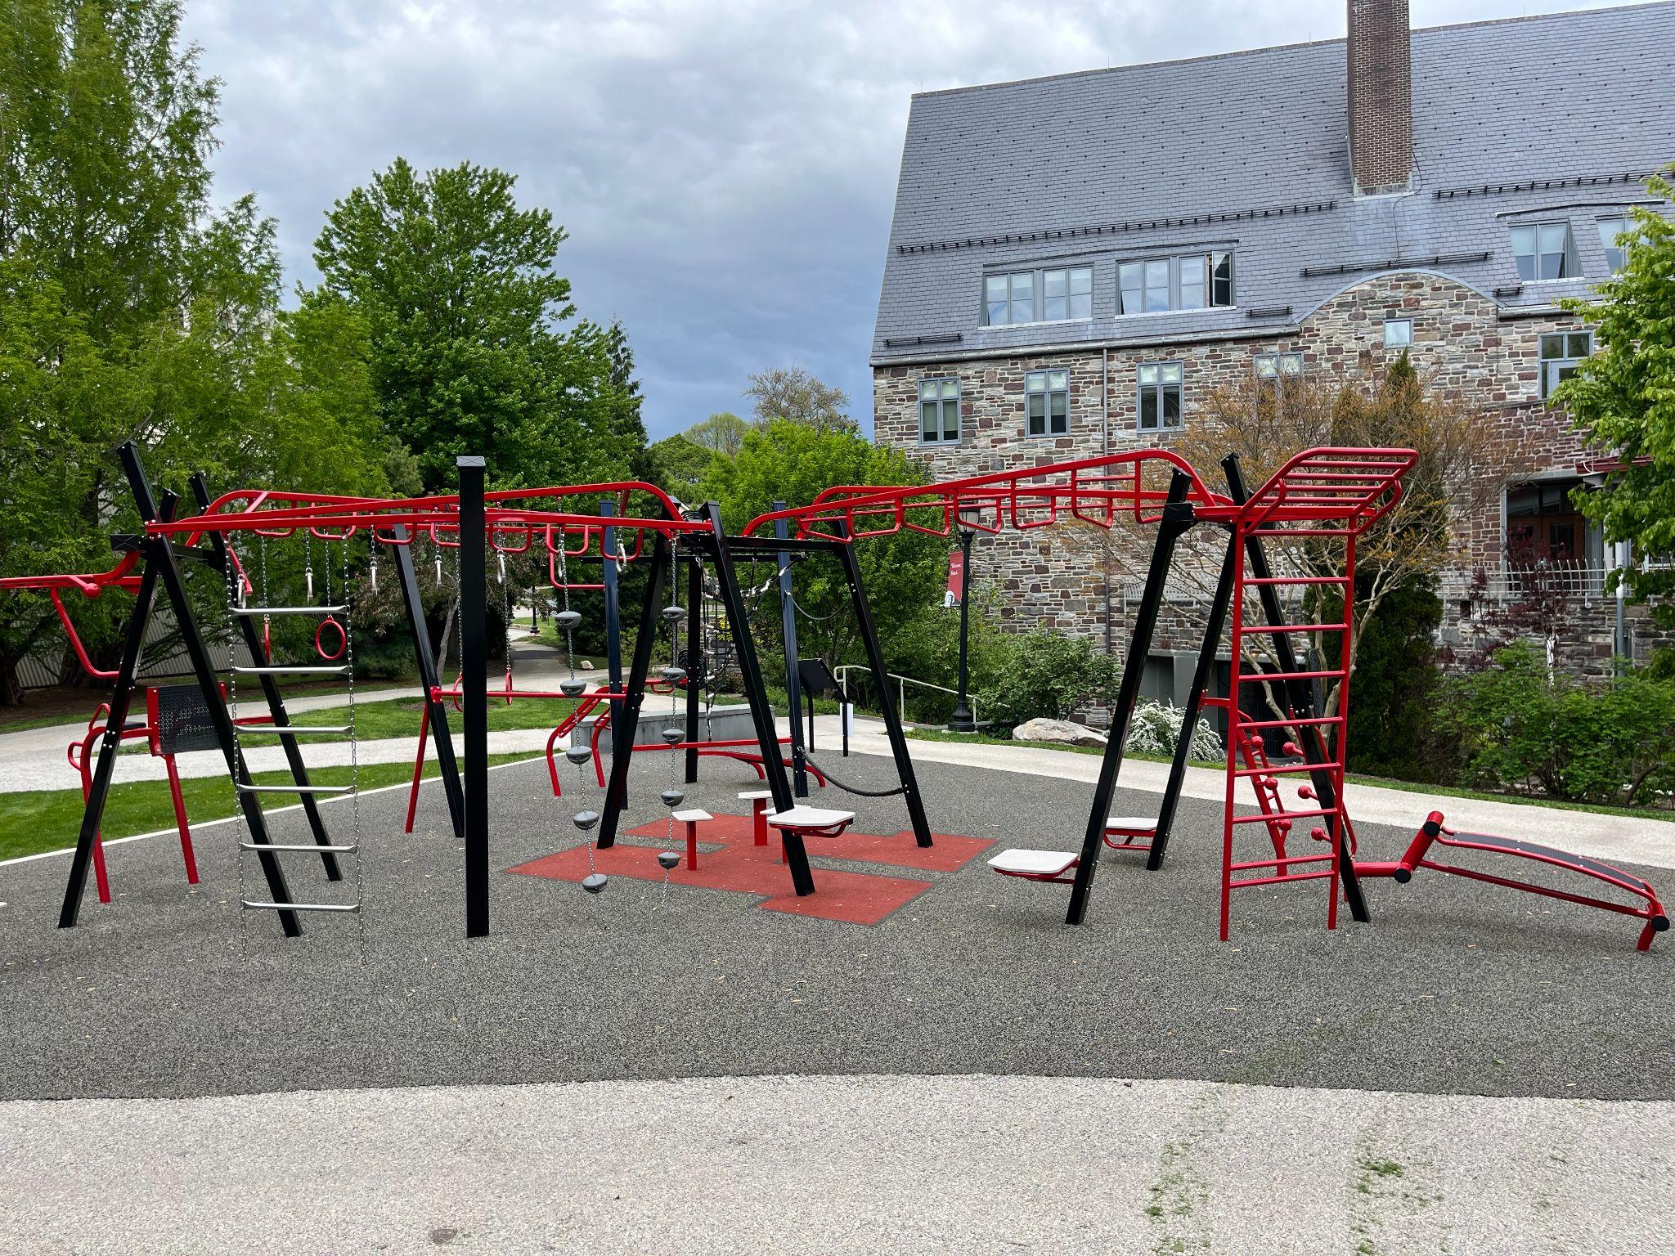A
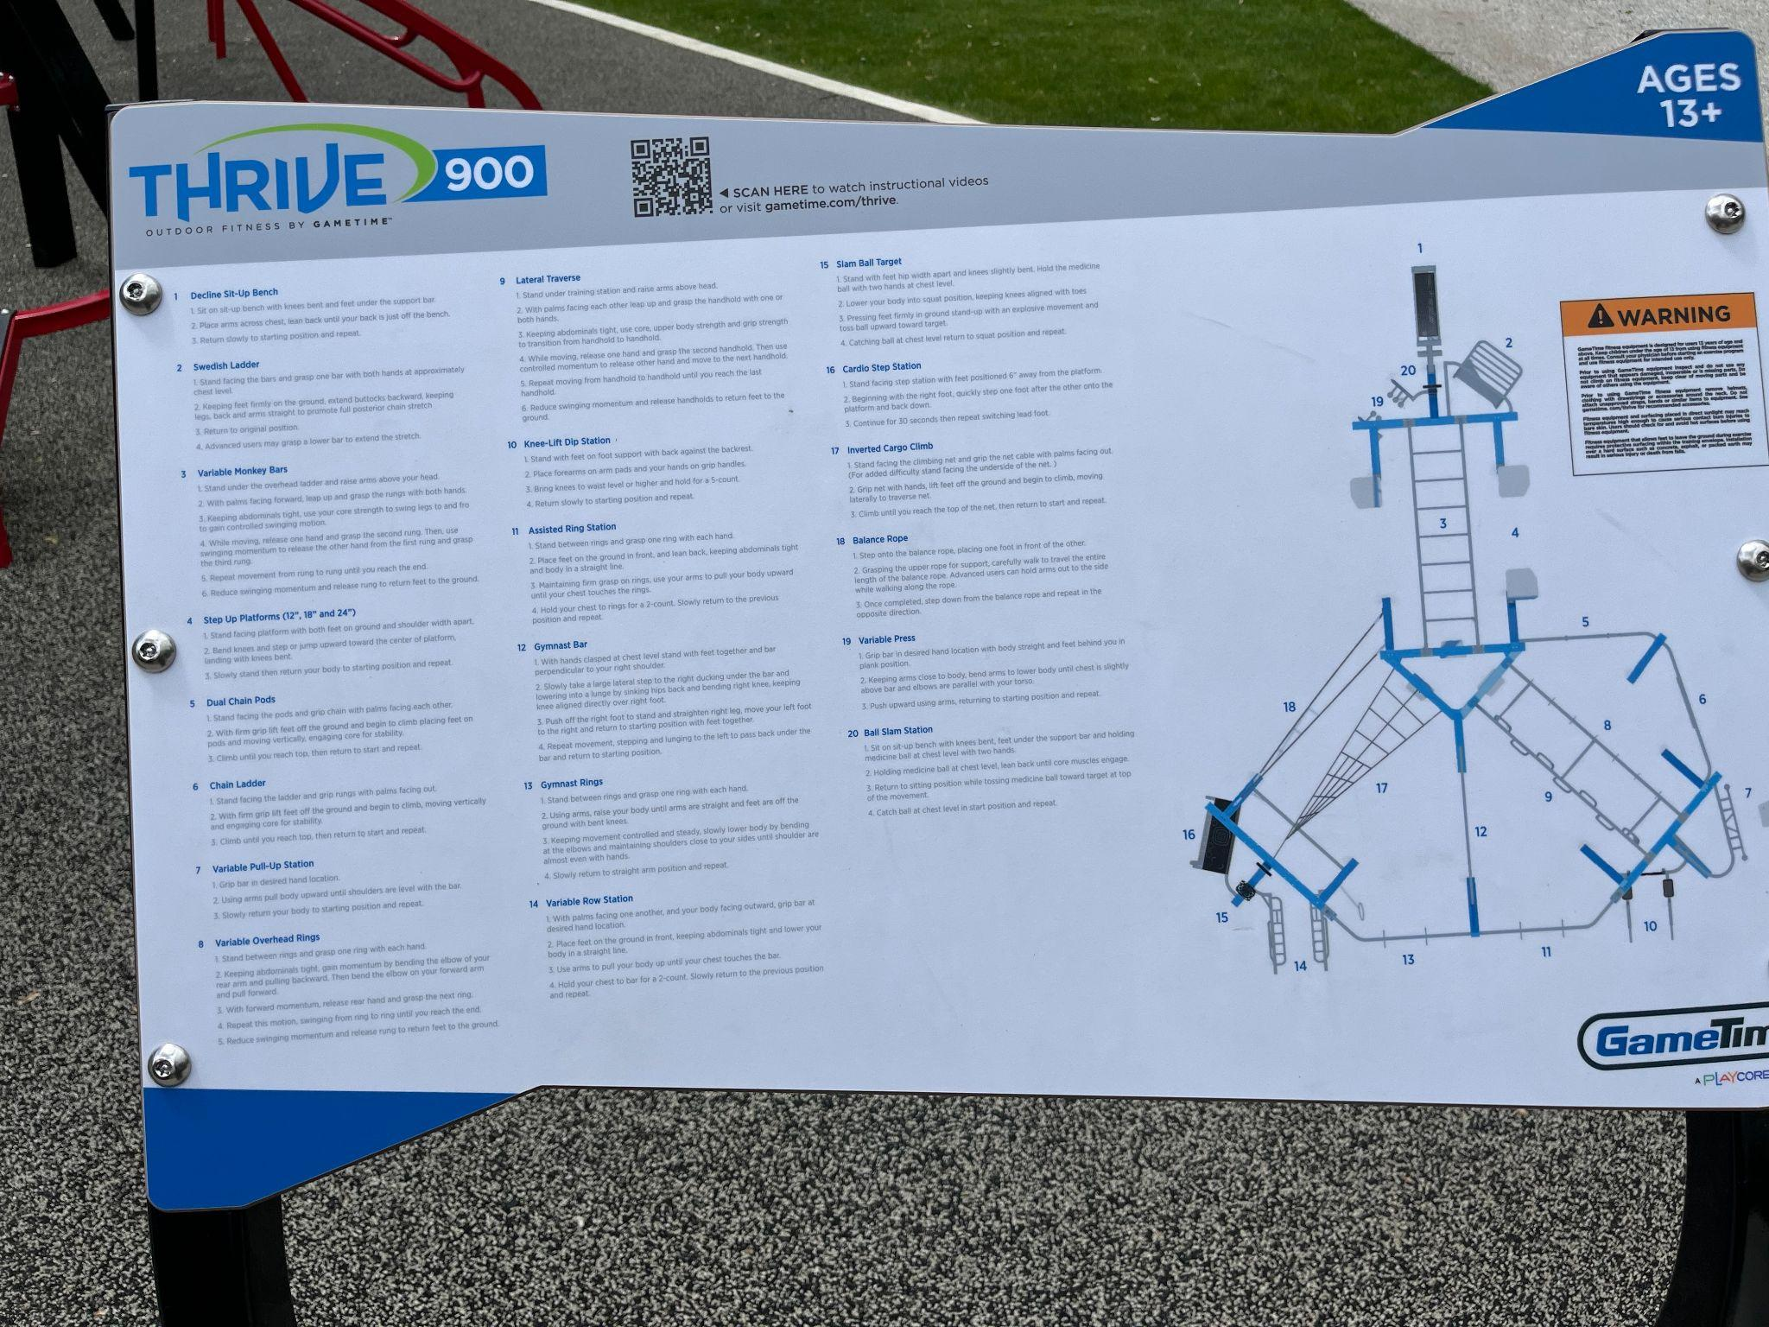B
Figure 3A-B. Outdoor Exercise Area by Gardner Integrated Athletic Center. (A) The outdoor exercise structure by the Gardner Integrated Athletic Center is set up on a pour-in rubber surface and contains 20 options for exercise. (B) A placard on the opposite side of the area lists the exercise options and a QR code at the top of the placard offers video instructions on how to use the area. Several of the elements of the facility require climbing or at least one step up onto a platform, though a set of rings are offered at a lower height around four feet off the ground.

The playground at the Phebe Anna Thorne preschool on Haverford’s campus has several accessible components (Figure 4). Similar to the outdoor exercise facility, the surface is made from poured-in rubber. The area is completely surrounded by fencing that is about five feet tall, with bars that prevent children from running into the nearby road. In addition to the typical play structure of slides, steps, and climbing elements, there is an added sensory component in the form of a sand pit, though there is a lip around the sand pit that is about six inches to a foot off the ground. The main play area itself is largely inaccessible to children that use wheelchairs or have mobility issues, as at least one stair or climbing up a plastic climbing wall is required to enter the play structure. Once on the play structure, there is another sensory component of gears that are colorful and can be turned using knobs of different sizes. Thus, while there is a barrier to getting onto the structure, once on the structure, there are several play options. The last component of the playground is a set of two teacup spinners that children can sit in, with a similar play type to a merry-go-round. The teacup spinners in this playground are not accessible, as children with mobility issues would likely not be able to support themselves, nor get into the teacup. This, while the sensory components of the playground are strong, children with disabilities can only access a few of the components, not the entire playground.
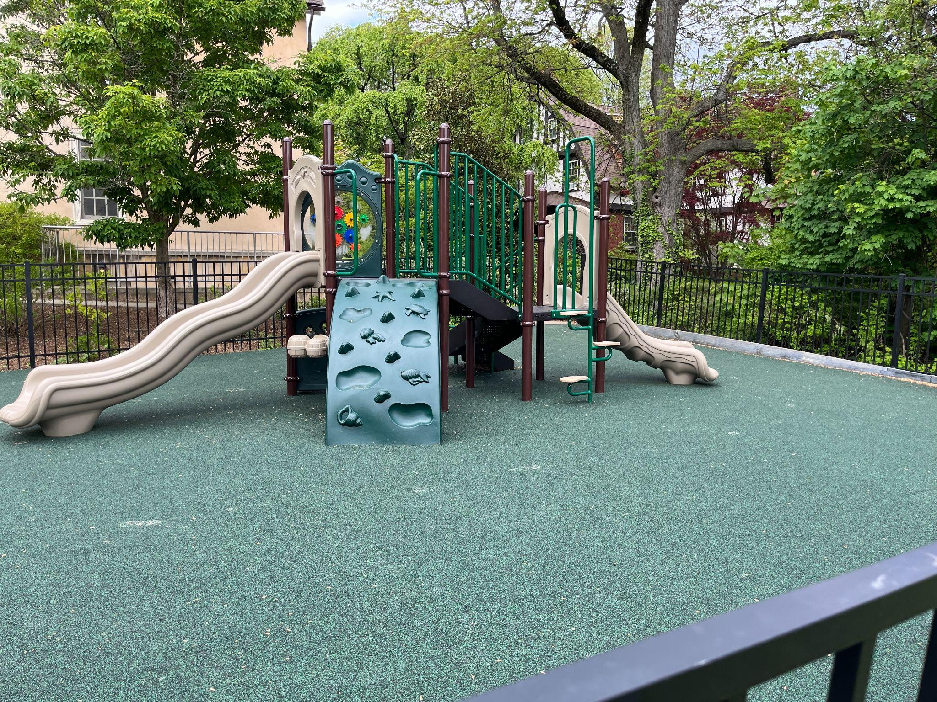
Figure 4. Phebe Anna Thorne Preschool Playground. The playground at the Phebe Anna Thorne Preschool has a pour in rubber surface and contains two teacup spinners as well as a main play structure containing two slides and a sensory component accessible only by stairs/steps or a plastic climbing wall. In addition, in the corner of the playground is a sand pit with toys including plastic trucks. The playground is completely fenced in by a black metal fence.

Finally, the playground in front of the lower level of Lutnick Library contains a typical set of swings, a sand pit, and a set of stairs leading up to a slide (Figure 5). A tree with branches close to the ground serves as an additional play element, although it was likely not initially intended to be such. The woodchip surface of this playground is the least accessible of the three playgrounds on campus, as it poses a choking hazard, does not absorb shock from falls well, and is difficult to traverse for people with mobility aids. Furthermore, the swings are inaccessible as they are the traditional pliable seats with no back support or safety restraints. The stairs leading up to the slide are also inaccessible, as there is no alternative ramp leading up to the slide and the slide is not static proof. Despite each of these inaccessible components, the sandpit does provide a positive, as it is a sensory component that most children can use. In addition, there is a large amount of open space for children to engage in imaginative play as well as several benches under shade providing trees.
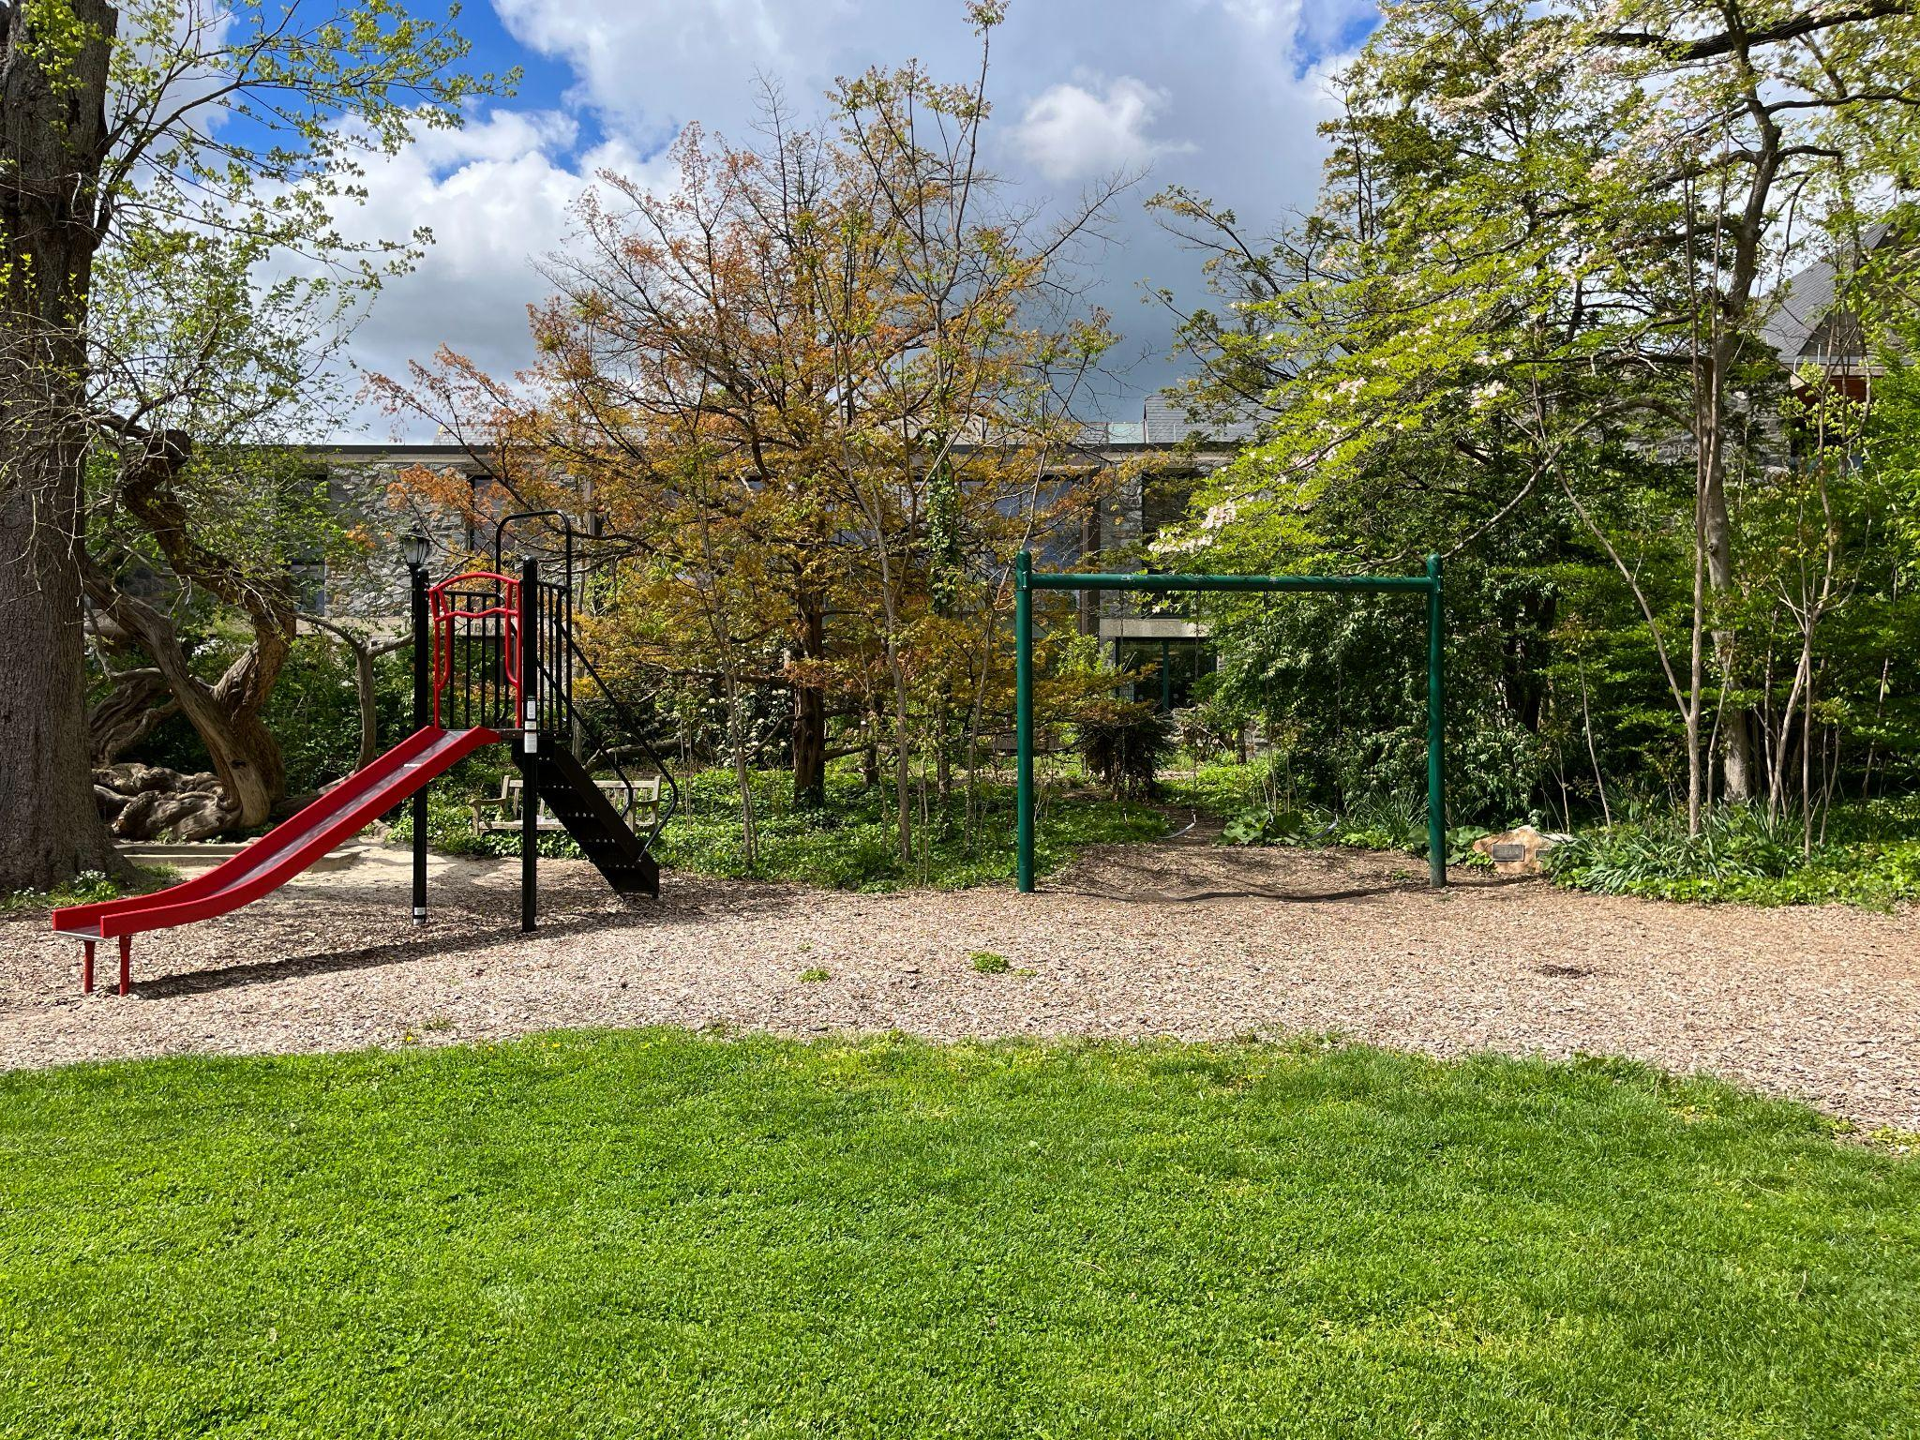
Figure 5. Playground by Haverford College Lutnick Library. The playground by Haverford College Lutnick Library consists of a woodchip base and has a swing set with two non adapted swings, a stairway leading up to a slide, and a sand pit. In addition, a large tree behind the sand pit is often utilized as a climbing structure for children.

Each of the areas on Haverford’s campus mentioned above are highly trafficked by both children from the preschool as well as Haverford students and visitors (with the exception of the preschool’s playground which is only visited by the children at the preschool). While the school may not have encountered complaints about the lack of accessibility in the majority of these structures, there are several measures that should be taken to make the spaces proactively more accessible. First, the surface of the playground by Lutnick Library should be changed to either turf, poured-in rubber, or safety tiles to minimize hazards. Second, ramps should be added to all elevated play structures and those that can be lowered to ground level should be. Finally, the purpose of the outdoor exercise facility is said to be ensuring that all students have a comfortable space to exercise. The facility must be adapted to allow students with disabilities access. This could be in the form of adding bars at lower levels, braille to each of the components so visually impaired students can navigate the area, and widening the spaces to accommodate wheelchair users for each component instead of limiting wheelchair users to the outskirts of the facility. Considering the diverse population of Haverford and the consortium schools, more efforts should be made to increase the accessibility of these spaces to students and the children that seek space to play or exercise.

References:
allinclusivedevadmin. (2021, September 24). The 3 Best Safety Surfaces for an Inclusive Playground. All Inclusive Rec. https://allinclusiverec.com/the-3-best-safety-surfaces-for-an-inclusive-playground/
Bird-Curcio, E. (n.d.). Playground Surfacing Safety Standards and Regulations. Https://Sof-Fall.Com/. Retrieved May 5, 2023, from https://sof-fall.com/playground-surface-safety-standards/
Brown, D. M. Y., Ross, T., Leo, J., Buliung, R. N., Shirazipour, C. H., Latimer-Cheung, A. E., & Arbour-Nicitopoulos, K. P. (2021). A Scoping Review of Evidence-Informed Recommendations for Designing Inclusive Playgrounds. Frontiers in Rehabilitation Sciences, 2, 664595. https://doi.org/10.3389/fresc.2021.664595
Fernelius, C. L., & Christensen, K. M. (2017). Systematic Review of Evidence-Based Practices for Inclusive Playground Design. Children, Youth and Environments, 27(3), 78–102. https://doi.org/10.7721/chilyoutenvi.27.3.0078
Ginsburg, K. R., and the Committee on Communications, & and the Committee on Psychosocial Aspects of Child and Family Health. (2007). The Importance of Play in Promoting Healthy Child Development and Maintaining Strong Parent-Child Bonds. Pediatrics, 119(1), 182–191. https://doi.org/10.1542/peds.2006-2697
James, M. E., Jianopoulos, E., Ross, T., Buliung, R., & Arbour-Nicitopoulos, K. P. (2022). Children’s Usage of Inclusive Playgrounds: A Naturalistic Observation Study of Play. International Journal of Environmental Research and Public Health, 19(20), 13648. https://doi.org/10.3390/ijerph192013648

