Mind in Revolt…
On Disability Studies & Radical Mental Health

A zine by Emily Kingsley
May 13, 2016
Introduction-

In this zine, I open up the possibility of a Disability Studies take on mental illness. Ultimately, I arrive at radical mental health as an existing discourse at the intersection of Disability Studies and the world of the mind. I elucidate the core components of radical mental health in relation to the tenants of Disability Studies. I then turn to Social Anxiety Disorder as case study, analyzing this mental illness through a radical mental health lens. My choice of project format was inspired by the Mindful Occupation zine—a valuable resource for anyone interested in radical mental health and its connection to activism. The questions I engage with here are much larger and more complicated than anything I could address in one project. There are many areas that I did not touch on in this work, invariably limiting the perspective I can provide. More specifically, I have left race and gender relatively unexplored in this analysis. These are crucial intersections of identity that should be accounted for in future research. Thank you for engaging with my project and contributing your thoughts and perspectives to the ongoing quest for more communal, more supportive, more loving and liberated minds.
-Emily

Mindful Occupation zine:
http://mindfuloccupation.org/files/booklet/mindful_occupation_singles_latest.pdf

The disability studies framework is powerful. It is an orientation grounded in the belief that disability is a social construction—a “social, cultural, and political phenomenon” (“Why Disability Studies?”). Disability is defined not by an “individual deficit,” but instead by a constrained environment limiting accessibility for those acting within it (“What is Disability Studies?”). In using the Disability Studies model to enter conversations about difference and ability, we equip ourselves with a conceptual understanding that pushes past individualized narratives to focus on the larger social forces shaping the rules of normativity and deviance. Disability Studies asks us to critically reexamine the assumptions we make about many ‘disabled’ ways of being, from blindness and intellectual disability to deafness and chronic illness. Despite the broad scope of this perspective, though, one subject is often conspicuously absent: mental illness. All semester, I have wondered how Disability Studies could be used to interpret mental illness and other ‘disordered’ states of mind. Can mental illness, like disability, be effectively understood as a social construction? What are the implications of such an approach?
Some scholars and thinkers have already begun to unpack these questions by introducing mental illness into the realm of Disability Studies. For instance, Margaret Price in Mad at School explores “mental disability” as it is lived and experienced within academia (Price 1). E.J. (Ibby) Grace takes up similar queries in the piece, “Are You Neuroqueer.” “Bipolar? Anxious? Schizophrenic? Epileptic?,” Grace writes, “Autistic? Borderline? Perhaps... a little too... creative? All the ways our brains work, they use these against us” (Grace). Here, Grace embraces mental illness as a form of neurodivergence—a space of mental difference. Such projects represent crucial steps towards a bridging of Disability Studies and mental illness.

Part 1-
Expanding the Paradigm: A Disability Studies Approach to Mental Illness?

“They call depression a 'mental illness' label, but I call it a way to be Neuroqueer, and I warmly invite you into our culture.” -E.J. (Ibby) Grace

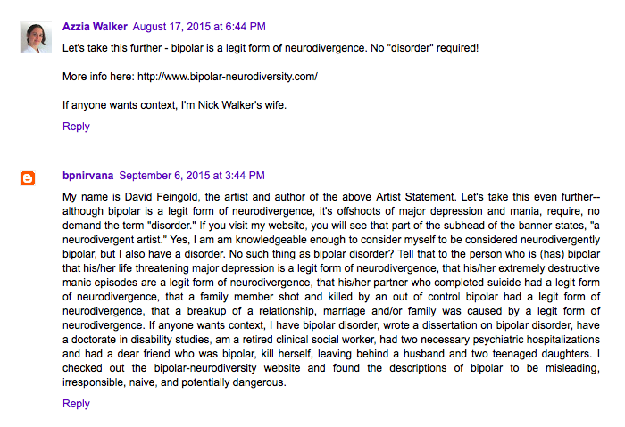
Yet, this exploration is not necessarily an easy or a comfortable one. Any attempts to interpret mental illness beyond the “biomedical model of psychiatry,” with its insistence that “mental health issues are the result of chemical imbalances in the brain,” are forays into dangerous territory (Mindful Occupation 16). Mental illness, as a largely intangible and subjective phenomenon, has long fought for legitimacy in a world that seeks to downplay and disparage perceived deviations from ‘normal.’ For people whose minds have led them into crisis, any efforts to jostle psychiatry’s story of mental illness as a real and curable “brain disease” may understandably be regarded with fear and mistrust; no one wants the reality of their struggle called into question (Corrigan and Watson 477). Such misgiving are in many cases quite needed, as this conversation has often veered in dangerous directions that focus not on contextualizing the experiences of the mind but simply writing them off as imaginary or made up. This trend is encapsulated by the article, “High Anxiety: the Social Construction of Anxiety Disorders,” which presents anxious states as evidence of a society obsessed with “conspiracism” and “victimization” (Dowbiggin 433, 431). “The overall environment of modern-day life,” the essay states, “bestows a kind of legitimacy on the pool of anxiety-related symptoms” (Dowbiggin 435). Such framings are belittling and trivializing. They make light of the very real ways in which people experience the mind as a scary and unpredictable place.
A conversation thread on the website NeuroQueer makes evident the visceral, charged reactions that can emerge when claiming mental illness as a variation of interior experience that is valid and perhaps even desirable. In these comments, artist and disability rights activist David Feingold highlights the pitfalls of a Disability Studies take on mental illness even as he situates himself within this movement:

Here, Feingold writes with urgency and conviction that some mind states, “require, no demand the term ‘disorder’” while still remaining a “legit form of neurodivergence” (“My Bipolar Pain(t)”). Speaking about existing scholarship on alternative notions of mental illness, Feingold derides such resources as “misleading, irresponsible, naïve, and potentially dangerous” (“My Bipolar Pain(t)”). I can’t help but agree; many of the anti-psychiatry texts that I came across while researching for this project struck me as reactionary and alarmist, which titles like “Smash the Biological Anxiety Myth: Say ‘No’ to Benzodiazepines” (Berezin) and “ADHD: The Hoax Unravels” (Hickey). While there is value in these attempts to question phenomena that we usually accept out of hand, these authors all-or-nothing approaches leave little room for nuance. What’s more, a common theme in these materials is to posit mental illnesses as natural aspects of the human experience that have been unnecessarily pathologized by psychologists and reified by the pharmaceutical industry. But as Feingold recognizes, such arguments rest on shaky ground: Do we really want to embrace schizophrenia, eating disorders, and other potentially destructive conditions as recognizable extensions of neurodivergence?
While it is hard to fathom mental health on a Disability Studies trajectory, it is possible to move forward with this liberatory, non-normative assessment of mental illness. Doing so will not be easy. It requires that we challenge fundamental beliefs about psychology, mental illness, and normalcy and that we confront complex questions about which states of being we deem ‘acceptable’ and which we do not. It invites us to subvert power structures and reimagine sanity.
As it turns out, there is already a robust movement underway doing exactly this work. Situated at the intersection of Disability Studies and mental illness, the radical mental health movement is fighting oppression through a revolutionary approach to the mind. Using this perspective as our guide, we can explore what it means to ‘crip’ mental illness. To engage in this work of radical mental health is to be a mind in revolt.

Part 2-
Disability Studies and Radical Mental Health

“Radical mental health means conceiving of, and engaging with, ‘mental health’ and ‘mental illness’ from a new perspective.” -Mindful Occupation, pg. 14

We can understand radical mental health as an extension of and interjection into Disability Studies scholarship. The foundational principles of radical mental health are strikingly similar to those embraced by the Disability Studies community. While the two movements should not be conflated, it is important to recognize their shared beliefs and similar positionalities. Radical mental health can be viewed as an offshoot of the larger Disability Studies world that applies its social constructionist and communitarian foundations of this perspective in service of activism and a radical reclaiming of the mind.
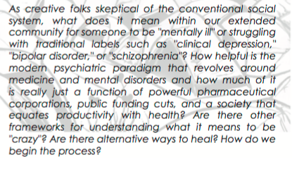
A passage on radical mental health from the zine, Mindful Occupation:

To better address the intersecting nature of these perspectives, I have elaborated below a few key points on which Disability Studies and radical mental health are closely aligned:
- Disability and mental illness are located within society, not the individual.
This approach to disability and mental illness flips the conventional wisdom by situating the ‘flaw’ of a disordered state outside of the individual. As Simi Linton explains in her essay, “What is Disability Studies?,” it is a stance that forces us to reconcile with the limitations of a society not built to include and support all people. This is a perspective in which “the lens is turned toward the representational and institutional structures” that shape our lived experiences (Linton 518). For a society that excels at individualizing its problems, this conception is a vital shake up. Radical mental health mirrors this philosophy by calling to our attention American culture’s persistent tendency to view mental illnesses on an individual label—as manifestations of internal and personal mental afflictions and brain defects. As is explained in the radical mental health zine, Mindful Occupation: “More and more, the belief that our dis/ease is in our brains has desensitized us to the idea that our feelings and experiences often have their roots in social and political issues” (Mindful Occupation 16). We must carefully reassess the factors we consult when reconciling with the realities of mental illness and disability. Instead of buying into the tunnel vision of individualization, we can push for a context-drive approach that accounts for the “broader conditions that enable a disorder to exist” (Hickinbottom-Brawn 733). Here, Disability Studies and radical mental health collide in their emphasis on structural, patterned, and historical interpretations of oppression.
- Our minds and our experiences are more than our labels.
Both perspectives reflect a complicated and uncertain relationship to labels and labeling. Disability Studies has sparked in some cases a reclaiming of labels. In their new iterations, these descriptors are redefined and reinvented as self-proclaimed badges of identity and disruptive difference. A similar trend is underway in the radical mental health movement. As Marageret Price does in her work, some have harkened back to ‘mad’ and ‘madness’ as descriptors of identity and mental experience. Others claim their illnesses as explicit components of their personhood. David Feingold, for instance, describes himself on his website as a “bipolar anti-stigma artist,” thereby welcoming the bipolar label as crucial part of who he is. Alternately, many people involved in Disability Studies and radical metal health work have expressed serious reservations about the labeling of disability and illness. They emphasize the ways in which labels have been against as a way to define and essentialize, and they are mindful of the inextricably link between labeling and power. Those with the capacity to define and label, they acknowledge, hold a fundamental form of control that shapes how we view ourselves and how we are understood by others. What matters, then, is who gets to make these labeling decisions. And as it stands now, the current model of psychological diagnosis is one that “privileges ‘specialists’ and ‘professionals,’ and ‘scientists’” in the assessment of mental illness “in such a way that can undermine the expertise of personal experiences, local communities, and alternative models of well-being” (Mindful Occupation 17). While a self-made label can be a beacon of agency and autonomy, it is all too often the case in the diagnosis of disability and mental illness that labels are thrust upon us without our consent.
- Stories and personal experience are vital; nothing about us without us.
Disability studies and radical mental health draw their strength from personal storytelling and experience sharing. They destabilize norms of authority and knowledge production by offering a platform for marginalized voices and pushing back on accepted notions about who has the ‘credentials’ needed to speak on a given topic. These disciplines find great insight in the realm of the personal and experiential, and they hold space for those lived realities. As is acknowledged in the Mindful Occupation zine, “mainstream conceptions of mental health and illness reduce people’s experiences into brain chemicals or personal histories” (Mindful Occupation 14-15). In contrast, “we challenge the exclusive voice of formal expertise, and demand that our stories and experiences be considered alongside the voices of professional mental health service providers, profiteers, and institutions” (Mindful Occupation 19). These sentiments are often summarized by the slogan “nothing about us without us,” which has been adopted by both movements. This phrse reflects a potent demand for self-representation and self-advocacy and reminds us that each individual holds unique knowledge about their lived experience of oppression.

Revisiting sites of uncertainty-
By orienting our approach to mental illness through the discourse of radical mental health, we can reconcile with many of the initial fears provoked by the thought of understanding mental illness through a Disability Studies framing. Much pushback on the social construction of mental illness comes from those who fear that recognizing mental illness in this way will result in an erasure of the biological and experiential realities of such mind states. They worry that it will force them to abandon treatment and medication— after all, why would we respond to a condition that does not exist? This, though, is not the case. It is entirely possible to view something as a socially constructed reality bounded by and shaped within a particular context—by history, politics, economics, social norms, and other potent forces— even as its effects and implications are recognized as legitimate. Along the same lines, the radical mental health movement is careful to distance itself from anti-psychiatry’s uncompromising stance on psychology/psychiatry. As Mindful Occupation reads: “Some may assume that radical mental health is simply ‘anti-psychiatry.’ However, most of us take far more complicated, diverse, and nuanced viewpoints. Radical mental health may mean accepting some of the things that mainstream, medicalized models suggest for our well-being, while discarding some of the things we may not find useful, helpful, or positive” (Mindful Occupation 17). By honoring radical mental health’s invitation for multiple perspectives and multiple approaches to treatment, we see how a reevaluation of mental illness can fit within a Disability Studies approach without asking us to abandon labels or halt therapies.
Radical Mental Health, Psychology, and Oppression-
In addition to those characteristics discussed above, one other central tenants of both Disability Studies and radical mental health is their aim of justice seeking—of uprooting systems of oppression. Disability Justice focuses on countering ableism, striving to build a world in which all bodies, minds, and ways of being are invited into community with others.
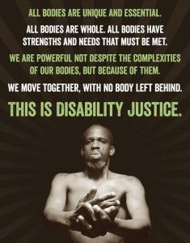

For radical mental health, a connection to social justice runs to the core of the movement. By locating their critiques within the psychological/psychiatric institution and drawing strength from their rebuttal of traditional mental illness diagnoses and treatments, the cause of radical mental health is fundamentally rooted in a call for change. Through their deconstruction of the psychological and pharmaceutical industries, radical mental health activists find themselves at a crucial junction of oppressions. Indeed, the mind is a vulnerable and often-targeted site of contestation for unjust ideologies. Since “the psych-disciplines are inextricably linked to power and governance,” they exist in co-dependent relationships with existing power structures like capitalism, patriarchy, and white supremacy (Hickinbottom-Brawn 735). Additionally, it should be recognized that oppression (along with the work to fight it) greatly impacts mental health and wellbeing. As such, the mind is a place where inequalities coalesce and intersect.
Psychology, fostering oppression-
“The psychiatric establishment has a history of diagnosing entire groups of people who were queer, black, women, poor, gender-variant and/or trans, sick and abnormal, therefore justifying forms of violence and exclusion that maintained the dominance of whiteness, patriarchy, and heteronormativity” (Mindfu Occupation 18)
By supporting and validating the structures and mentalities of the powerful, psychology can ‘treat’ us into alignment with social norms.
“What kind of self does psychology promote?” Does psychology merely classify and manage people in ways that conform with dominant ideologies? (Hickinbottom-Brawn 745)
The act of psychological treatment—whether through conventional or alternative methods—is an inherently political act that seeks to maintain or counteract normative forces in our minds and our actions.
“The seemingly private issue of appropriating scientific strategies to secure self-selected ends is undeniably political because the practices themselves are intertwined with the vocabulary of liberal individualism” (Hickinbottom-Brawn 736).
Through radical mental health, the mind becomes a site of struggle.

Part 3-
Theorizing Social Anxiety Disorder from a Radical Mental Health Perspective

We move now beyond an overarching analysis of radical mental health and its relationship to Disability Studies to consider a specific case in which these perspectives can be applied. Here, I consider meanings of Social Anxiety Disorder (SAD), a condition with which I personally identify. First, I offer a psychological explanation of the disorder. Then, I delve into alternative models influenced by social constructionist and radical mental heath thinking. Personal experience is also include as I reflect on what it means when the questioning of mental illness hit close to hope.

The standard psychological framing of Social Anxiety Disorder-
Social Anxiety Disorder, also termed Social Phobia, is associated with intense feelings of discomfort and judgment during interpersonal interactions. According to the Anxiety and Depression Association of America (“Social Anxiety Disorder”), whose medicalized mission is “to promote the prevention, treatment and cure of anxiety and mood disorders, OCD, and PTSD,” social anxiety is “the extreme fear of being scrutinized and judged by others in social or performance situations” (“Social Anxiety Disorder”). Quite similarly, the DSM-V describes the condition as “a persistent fear of one or more social or performance situations in which the person is exposed to unfamiliar people or to possible scrutiny by others” (“DSM-5 Definitions”). In estimating the prevalence of Social Anxiety Disorder, scholar Sarah Hickinbotton-Brawn reports that “as much as 12% of the population suffers from social anxiety disorder (SAD), making it the third most common form of psychological dysfunction” (Hickinbottom-Brawn 732). The span of SAD’s reach has seen a rapid increase in recent years, as it has “gone from being virtually nonexistent to a ‘public health danger that appears to be heading toward epidemic proportions’” (Henderson & Zimbardo qtd. in Hickinbottom-Brawn 732). This massive uptick in diagnosis makes Social Anxiety Disorder a particularly significant site of study. By bringing disability studies and radical mental health into the picture, we can begin a serious questioning of this disorder and its widespread occurrence. We can ask what social conditions might be facilitating its large-scale spread and what factors might be playing into its emergence as a diagnosable, experientially-confirmed condition. In the following discussion, I draw specifically on Sarah Hickinbottom-Brawn’s 2013 essay, “Brand ‘You’: The emergence of social anxiety disorder in the age of enterprise,” which traces the appearance and legitimization of SAD as a historical and political process. The article also links defining aspects of the disorder to neoliberal culture and capitalist values.
It is important to recognize that in doing this work, Hickinbottom-Brawn does not seek to discredit the existence of SAD, nor does she offer any definitive statements about a biological basis (or lack thereof) for the disorder. As she makes clear, her goal in writing the essay is “to examine the conditions that enable social anxiety to exist as a disorder” (Hickinbottom-Braw 733). She is working to identify the broader forces implicated in the existence of SAD not as a way to fundamentally disavow the existence of the disorder, but instead to complicate our understanding of why it exists and what it means. Connecting Hickinbottom-Brawn’s contribution back to the larger discourse of radical mental health, then, her work represents an attempt to shift the conversation outside the bounds of the psychological imagination. She is taking an intersectional approach that pulls from history, philosophy, and sociology to challenge normative assumptions about SAD and to evaluate the implications of how we construct the disordered mind.
Disrupting the discourse with new lenses-
Social Anxiety Disorder and “enterprise”/neoliberal culture-
One of the threads that Hickinbottom-Brawn traces throughout her essay is the extent to which Social Anxiety Disorder is bound up in America’s neoliberal, capitalist culture. She describes various attributes prized by this “enterprising culture,” which include “’energy, initiative, ambition, calculation, and personal responsibility’” (Rose qtd. in Hickinbottom-Brawn 735). Once she has established this checklist of capitalist virtues, Hickinbottom-Brawn proceeds to analyze the ways in which the expectations of this cut-throat system lead to the very experiences that characterize Social Anxiety Disorder. “If networking and social prowess are vital for personal and economic viability,” she says, “the rise of SAD seems hardly a mystery” (Hickinbottom-Brawn 739). While she is not asserting that this profiteering, individualistic, and competitive environment is the cause of the disorder, the essay makes evident the various ways in which these attitudes may be contributing to and reinforcing socially-anxious encounters. Hickinbottom-Brawn goes a step further by linking these neoliberal norms to the anxiety treatment paradigm, observing a telling interplay between “the language of enterprise and the language of the therapeutic,” both of which “imply that self-knowledge and self-mastery are key to autonomy” (Hickinbottom-Brawn 736). In this way, not only is a capitalist framework embedded in the components of SAD, but it is recognizable in our treatments for the disorder as well. Developing an awareness of the extent to which psychology is circumscribed by the “enterprising culture” within which it exists demonstrates the necessity of radical mental health; we need avenues through which to think beyond the limitations and biases of psychology (Hickinbottom-Brawn 735).
Social Anxiety Disorder and institutional expectations-
In “Brand ‘You’,” Hickinbottom-Brawn delves into the process by which institutional structures make and remake the realities of Social Anxiety Disorder. Like Foucault, she understands social institutions to be “’surfaces of emergence’” for SAD—spaces that invite the occurrence of the disorder through the values they promote and the norms they enforce (Foucault qtd. in Hickinbottom-Brawn 740). School is one institution that her essay hones in on as a constructor of Social Anxiety Disorder. Elaborating the ideologies that define today’s education system, Hickinbottom-Brawn speaks to the “heavily psychologized, ‘student-centered’ vision of education” in which a student “confidently expresses opinions, takes initiative in utilizing strategies of enterprising self-management and promotion, and feels entitled to demand rights and authority in determining his/her learning” (Hickinbottom-Brawn 740). Within this world of demanding academic standards, she says, it is no surprise this Social Anxiety Disorder as flourished. “In this view of education, where confidence and initiative are considered markers of adjustment and future success,” Hickinbottom-Brawn writes, “the once ideal student who sits quietly in the classroom is now construed as a problem” (Hickinbottom-Brawn 740-41). This is not to say that schools create social anxiety, or that the qualities schools now expect from their students are inappropriate or harmful ones. It is simply to assert that we must acknowledge the clear juxtaposition between the characteristics of SAD and the core attributes schools demand of their students. It is easy to see how students who do not live up the standards of interaction and self-presentation insisted upon by the education system could become pathologized by the institution, labeled as deviant and low-achieving for their inability to ‘perform academics’ in accepted ways. It is here that schools become “surfaces of emergence” for SAD by establishing the qualifications of success and ‘disordering’ those who do not meet them (Foucault qtd. in Hickinbottom-Brawn 740)
The power of a label-
A third channel through which Hickinbottom-Brawn explores the meaning-making of Social Anxiety Disorder is the process of labeling. When a disorder becomes diagnosable, it gains unprecedented legitimacy. This ‘realness’ is furthered still by the development of pharmaceutical drugs to treat the condition. Speaking about the makers of Paxil, a drug commonly prescribed for SAD, Hickinbottom-Brawn notes how the company “reframed social dis-ease as disease,” and in doing so, deemed credible the existence of the disorder and the need for medication to treat it (Hickinbottom-Brawn 739). With both label and accompanying medication firmly in place, a given mental state is elevated from the realm of personal experience to that of recognized illness. While labeling is always powerful, its potency in the case of mental illness is especially great. The intangibility and subjectivity of our interior states means that we can never fully ‘prove’ what someone else is experiencing. Thus, a label is one of the only available ways to standardize the language of mental health, to provide a common vocabulary for understanding what it feels like to inhabit our minds. At the same time, we must also acknowledge that the process of labeling is not a linear one; once a condition has been named and defined, the nature of the phenomenon— as well as the way we experience it in ourselves— is fundamentally altered. Hickinbottom-Brawn captures this reality by observing that “psy-disciplines do not simply perform the academic task of revealing knowledge,” but instead “play a role in inventing selves by elaborating descriptions of the kinds of persons we are and reshaping subjectivities accordingly” (Hickinbottom-Brawn 735). This approach may prove counterintuitive, as we usually think of labels as the way to pinpoint a reality, rendering it definable and static. In actuality, though, the act of labeling is itself a destabilizing force that transforms any entity it is applied to.
The liberation and danger of diagnosis-
The transformative power of labeling is especially notable in the way that a diagnosis can rearrange our conceptions of self. To make sense of one’s complex and confusing inner experiences through the neatness of a mental illness label can be a liberating prospect. Indeed, a diagnosis function as “a singular, authoritative explanation for past and present difficulties that frees the diagnosed from self- and others’ scrutiny” (Hickinbottom-Brawn 744). The following quote from an individual diagnosed with SAD illustrates the impact that a label can have:
“One might not think a high score on a mental disorders test would be something to celebrate, but I couldn’t have been happier. I wasn’t making it up!...When Dr. A. asked if I had allergies to any medications, I felt further vindicated. I was going to be prescribed something. It was real. It was real” (Ford qtd. in Hickinbottom-Brawn 744).
As this account indicates, there is often great comfort in the act of labeling. Even so, we must keep in mind that danger of a diagnosis, which can lull us into a false sense of security, making us believe that a phenomenon— once labeled— is unquestionably real and stable. We must, as the principles of radical mental health remind us, remain wary of labels and the messages they convey. For, just because something has a name does not make it real. I do not mean to imply that Social Anxiety Disorder is an inappropriate diagnostic category. Instead, I wish to issue a necessary caution about the danger of becoming too comfortable in the categories with which we define ourselves.
Labeling Social Anxiety Disorder: Personal Experience-
I was not aware of Social Anxiety Disorder until the end of my first year at Haverford. When I first began looking it up online, I was shocked by how well the descriptions and characteristics matched my own experiences. I felt empowered, comforted by the knowledge that I now had an explanation for some of my most troubling experiences and tendencies. After learning about the disorder, I now had a sure-fire way to calm myself when things went south in a social situation: “Oh, that was because of social anxiety, that’s why I felt that way.” After a while, I got used to labeling myself as someone with Social Anxiety Disorder. I didn’t like how it sounded, didn’t like to say it out loud, but the description fit, so I went with it. More recently, though, I have begun to lose faith in my self-selected label. On one hand, I question the relevance of the diagnosis to my situation: Am I ‘bad enough’ to claim that descriptor? What if it is just an excuse not to do the things I’m afraid of, like talk in class? On the other hand, sometimes I question the concept of SAD in its entirety: What if this is just the way I respond to social situations, and that’s okay? At this point, I don’t know where I stand on the label or what it represents. One thing I have come to realize is that accepting a psychological diagnosis is not the end of the story, but only the beginning of a much larger process of critical thinking and self exploration.
Social anxiety disorder, a relational condition-
One final component of theorizing social anxiety reflects on its nature as an inherently relational condition. Indeed, we must question what it means when a disorder with social in its name is understood as existing solely within the individual. SAD manifests itself in relationships and in the interpretation of interactions, yet it is typically framed as a flaw within one actor who misinterprets social cues and builds false narratives about their self-presentation. As a disorder rooted in communication and interpersonal exchange, there is no better candidate for an exploration of mental illness as a social construction than SAD.
Directions for future study-
There are crucial aspects of identity whose relationship to Social Anxiety Disorder I have not addressed here. Future research on radical approaches SAD should explore intersections of race, gender, sexuality, and class as they relate to experiences of social anxiety. Additionally, another valuable project would be to explore Social Anxiety Disorder from an international vantage point—studying whether or not the disorder is recognized in different cultures and how it manifests in those varying contexts.
Conclusion-
What lies beyond the scope of psychology and psychiatry? In what ways do these disciplines constrain our understanding of the mind and its ‘proper’ functioning? These are questions I have been asking myself all semester. Through my work with Disability Studies and radical mental health this semester, I have begun to recognize the limitation of the normative and to open up my thinking to new possibilities, new ways of conceiving the ‘mentally healthy’ mind. This is research I will continue doing in the months and years to come as I seek to understand my own relationship to mental illness. Beyond the scope of my own mind, I hope to engage with radical mental health and Disability Studies as an ally—striving for a more inclusive, more radical world that welcomes, celebrates, and is strengthen by our diverse bodies and minds. Only when we come together to fight the interlocking oppressions that hold us captive do we become true minds in revolt.

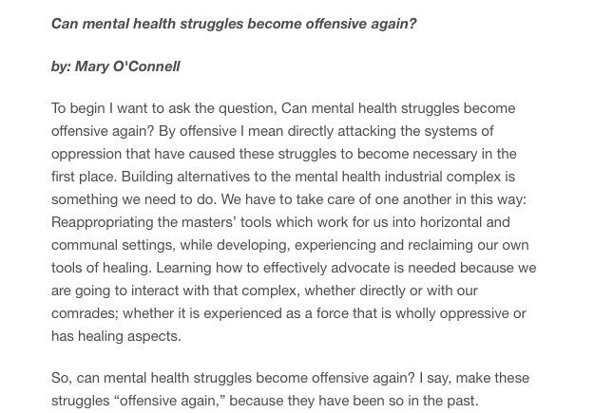
Image from the Rad Brains tumblr page.

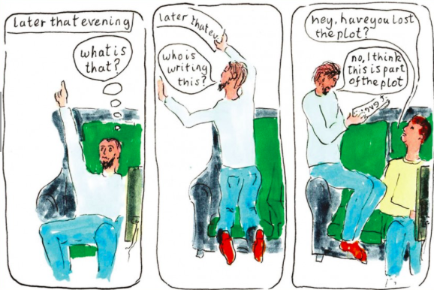
Image from the Asylum Magazine For Democratic Psychiatry.

Works Cited
Asylumonline.net. Asylum Magazine, 2016. Web. 13 May 2016.

Berezin, Robert. “Smash the Biological Anxiety Myth: Say ‘No’ to Benzodizepines.” Mad in America. Mad in America Foundation, 1 March 2016. Web. 12 May 2016.

Corrigan, Patrick W. and Amy C. Watson. “At Issue: Stop the Stigma: Call Mental Illness a Brain Disease.” Schizophrenia Bulletin 30.3 (2004): 477-479. Pdf.

Dowbiggin, Ian R. “High Anxieties: The Social Construction of Anxiety Disorders.” Canadian Journal of Psychiatry 54.7 (2009): 429-436. Pdf.

“DSM-5 Definitions of Social Anxiety Disorder.” Social Anxiety Institute. Social Anxiety Institute, n.d. Web. 12 May 2016.

Grace, E.J. (Ibby). “Are You Neuroqueer?” NeuroQueer. N.p., 18 September 2013. Web. 12 May 2016.

Hickey, Philip. “ADHD: The Hoax Unravels.” Mad in America. Mad in America Foundation, 10 March 2016. Web. 12 May 2016.

Hickinbottom-Brawn, Sarah. “Brand ‘You’: The emergence of social anxiety disorder in the age of enterprise.” Theory & Psychology 23.6 (2013): 732-751. Pdf.

Linton, Simi. “What is Disability Studies?” Modern Language Association 120.2 (2005): 518-522. Pdf.

Mindful Occupation: Rising Up Without Burning Out. Richmond: Mindful Occupation, 2012. Pdf.

“My Bipolar Pain(t) by David A. Feingold.” NeuroQueer. N.p., n.d. Web. 10 August 2015.
O’Connell, Mary. “Can mental health struggles become offensive again?”

Price, Margaret. Mad at School: Rhetorics of Mental Disability and Academic Life. Ann Arbor: The University of Michigan Press, 2010. Pdf.

Rad Brains. Rad Brains, n.d. Web. 13 May 2016.

“Social Anxiety Disorder.” Anxiety and Depression Association of America. ADAA, n.d. Web. 13 May 2016.

“What is Disability Studies?” Society for Disability Studies. N.p., n.d. Web. 12 May 2016.

“Why Disability Studies?” disabilitystudies.utah.edu. The University of Utah, n.d. Web. 12 May 2016.

