Natalie DiFrank

Critical Disability Theory

Spring 2016

An Exploration of Communication Within Silence
Through a Disability Studies Framework

First encounters with Silence
What exactly is silence? The easiest answer that may come to you is a lack of noise but, what does one mean when they say noise? Does silence automatically mean an absence of something? In many ways we relay heavily on noise as a main form of communication. If noise is not present than we are not talking and if we are not talking than we are not communicating. If noise is being made directed from one person to another and words are not understood are these two people still communicating? Is the room silent without words? This are all questions I plan explore through a disability framework. Utilizing personal experience, I plan to prove that communication can be made without noise and without normative language. All of my examples will be based on my year long work at Center for Creative Works working with artists with intellectual disabilities.

In order to understand how silence can be used as communication we must first explore what it means to communicate. Communication is basically understood as the ability for two or people to understand the needs, wants, feelings, or thoughts of another. Speaking takes the most basic and usually the first mode of communication learned by young children beginning with our first cry. If child doesn’t cry or begins talking at a later pace medical professionals are involved. Silence in our very first moments of life induce panic in our parents. This can be our first conditioning that causes a fear in silence. A conditioning necessary for survival yet, powerfully in our psyche. This begins our first moments of communication. Crying is also utilized by young children as a way of gaining basic needs like food, nutrients, and care as a whole. Without this cry parents are unable to know when their child is in need. This is how we ask for help, through noise, loud abrasive noise.

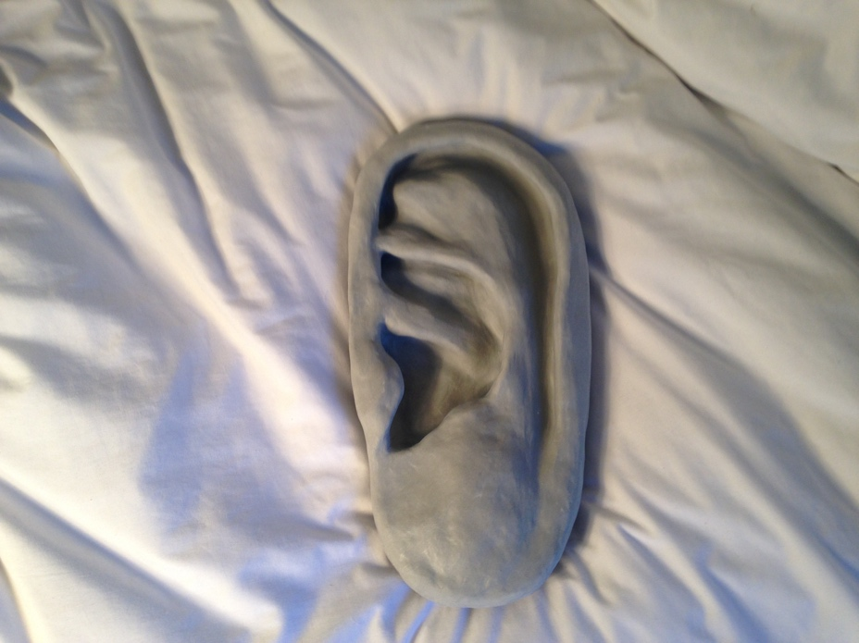
Untitled by Natalie DiFrank

What is Communication
The most normative and basic forms of communication are reading, writing, and speaking. This is how teachers and professor’s grades students on knowledge, the basis of most clinical therapy, as well as a skill that begins to form at a very young age. As we age cries are expected to become words. For many with intellectual disabilities this may not happen or happen at a slower rate than non disabled children. In some cases, this is one of the first signs of an intellectual disability and causes doctors or caregivers concern.

As children grow older and begin going to school the learn to writing. Writing and reading tend to be taught hand in hand. While learning the alphabet we sound out each letter. As we right them we are expected to annunciate each letter and then groups of letters. From there we are taught how to words, phrases, and sentences. During the process of learning how to read we are told to read aloud in order to hear ourselves. We are read to by teachers in order to hear each word and perfect our pronunciation. As we get older reading and writing become a solitary and silent activity. Conversations with ourselves begin to happen within our own heads. To the others around us we are silent yet, to ourselves we can hear sound. This of course varies from person to person as some people thinking more in images then sound. Yet, none the less we are told that we should be filling space.

In classroom teachers expect students to fill the classroom with questions, discussion points, or responses. Students’ participation grades tend to be largely waited on how often the student talks no matter what the student is saying. Both students and teachers find discomfort in silence, whether it be a question left floating unanswered or a discussion halted. The fear comes with the sense of performance that is asked of both student and teacher during a lesson. It is as if a comedian is on stage and hears no laughter or a play ends with no applause. We find affirmation as well as reassurance in the noise, the talking. Another aspect of this is the grading for students who are non verbal. Many teachers believe that if a student remains silent they are unable to know whether they are truly understanding the content. This is where pop quizzes as well as other written assignments can be utilized to fill the space of the participation. For many with anxiety or other disabilities this act of performance is impossible to complete in both spoken and written forms. Teachers are left struggling to figure out how to assess students who struggle to communicate in these forms.

A willingness to communicate takes a certain level of vulnerability. One must make an effort to express them selves either through words, signs, or actions and hope that another person will be able to understand exactly what you are feeling or thinking. There is a lot of trust that is needed in order to communicate with others. Trust in their attention and trust in their ability to listen. This leads me to question if communication as a whole is exclusive with its unspoken cultural norms and inferred reciprocation. Although various forms of communication exist they can only be utilized if the listener is willing to both receive and focus. If person tries to communicate with another and it is not received or noticed is it still considered communication?

Communication is largely used a tool to empower people. It comes in various forms that may appear unexpected or may be overlooked. Whether through the use of hands, looks, interactions, decisions, or words, humans seem to constantly yearn to communicate. This communication is in many ways ignored because of the very constraining framework that has been culturally created causing people to view it a limited sense. I still wonder what is considered communication and what considered just actions? Does it need to have the intent of being reciprocated or understood?

A Dependence on language and Fear of the Unknown

There is a strong sense of fear when it comes to silence within a space. This fear can be stemmed from a lack of clarity and the unknown that silence can bring. When we have been raised to believe that noise or speech is how we mainly communicate a lack of such means that we may not be able to know exactly what another wants or needs. In quiet we scramble for words or push for conversation. When I first began working at Center for Creative Works, I was confronted with this fear when I paired with an artist who was non verbal. I found myself constantly trying to ask him questions and listening to form any word for a mumble or creek in his chair. I began to feel deeply uncomfortable working with him. The silence made feel vulnerable. After reflection I realized this feeling of vulnerability was originating from anxiety around the idea of failing to understand him.

These feelings were not limited to just artists who were non verbal but also artists who had trouble annunciating words or spoke more in muffled sounds such as grunts and laughs. I felt as without words I was exposed. I was in volunteering to aide these artists in their work and if I didn’t know the exact words that they meant than I would be unable to provide ample support. In some ways it made me feel helpless. I had to relearn what I thought I knew about communication and found that communication and time has a strong, inseparable relationship. As time progressed I would begin to build relationships with out the words I was so familiar and reliant on. Body language, facial expressions, and art work began to be the basis of bonds made.

Time began to be one of the largest impacts to these relationships. Conversations took more than a couple hours but days, weeks and months. This was because within the space we are not able to return sentences that exactly summed up our thoughts or feelings. The element of time is common topic within disability, Crip time. In order to have a conversation in silence one must be able to be fully present with the other. The knowing process of another is not limited or quick compared to conversation that begin with how are you and continue with questions that reveal information about the person. Instead you must be fully aware and open to communication in any form whether that be through a picture on paper, a smile, a shift in shoulders, or a look away. The tiniest movements act as words.

After moving past my initial feelings of both vulnerability and uneasiness I began to be more watchful of the artist’s movements. I found that he tended to move his hands in a rhythmic fashion when he wasn’t drawing. He found comfort in movement. His body swaying back and forth in a rocking motion. It was explained to me that these movements may be his way of self soothing. I decided to try to find ways to incorporate similar forms of stimulation for him while art making.

I worked with woodshop teacher on helping use different tools that had vibration or lots of movement. I hoped that finding him another outlet for the motion to create art I would aide him in his art process. We tried giving him drills as well as sanders and found that his interest in woodworking was much greater. The time he spent in the woodshop was longer and he continued working a pieces for 5-10 minutes rather than his typical 3-5. I would have never understood this about him if I wasn’t able to spend hours next to him.

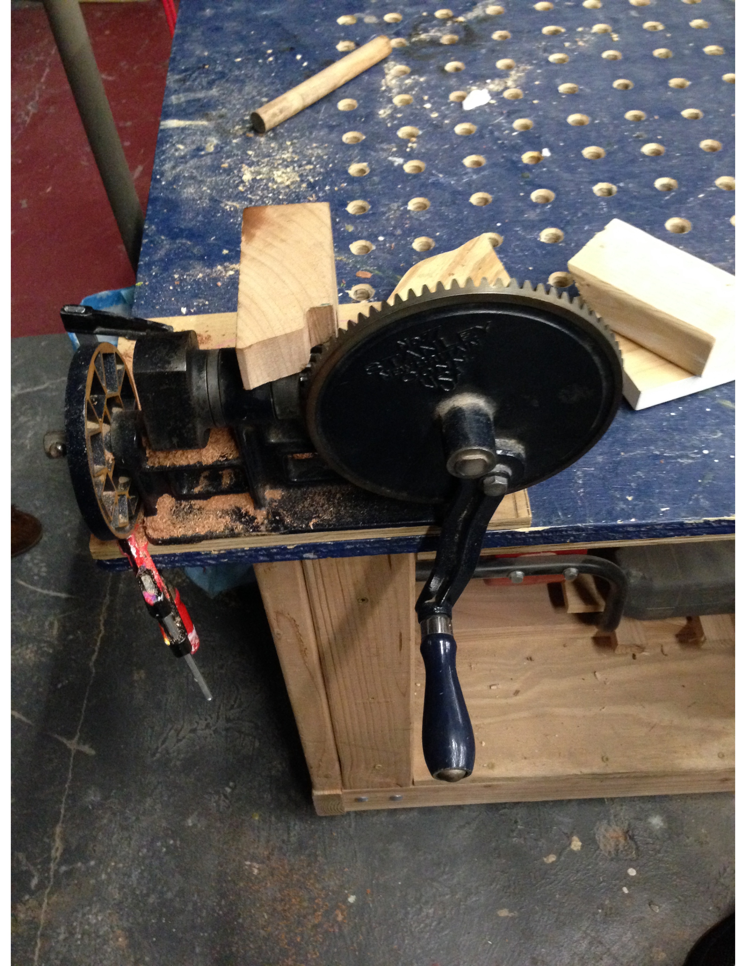 Picture of accessible tool used with artist

Other facts or aspects of this story is that I, a neuro typical volunteer, wanted to understand him in a normative manner. There is no exact solid proof that he enjoyed himself or even wanted to be in the woodshop to begin with. My own need to hold some sort of normative relationship with him may have pushed to assume his wants and what made him feel good or bad. Although his time in the woodshop increased, after a couple weeks he began refusing to go into the shop. This hard stance left me to reflect on my own thoughts on what I thought was communication between us.
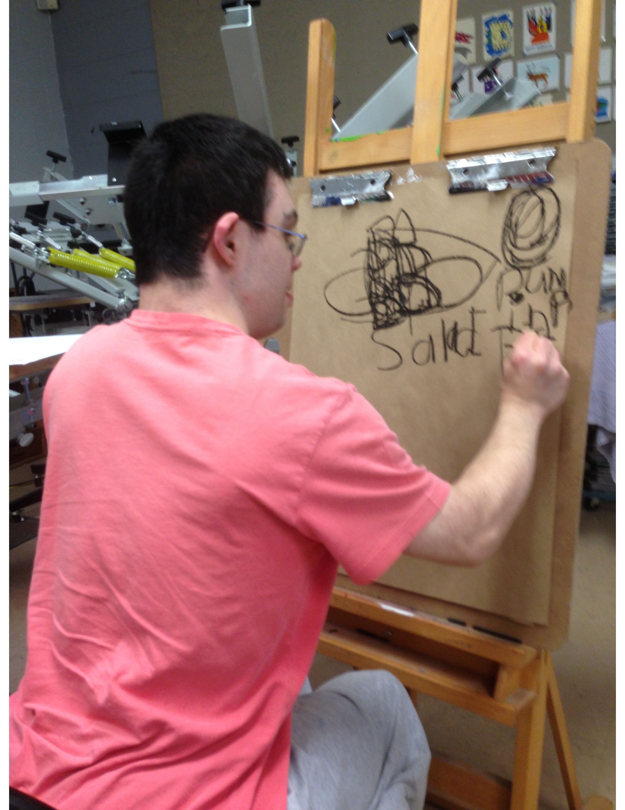 said artist working on drawing

This example brings to the light the most feared aspect of silence, a lack of assurance. In silence there is no confirmation about whether my presence was even wanted. I had to base most of thoughts and perceptions on my own intuition and the decisions he made to work or not work. This lack of clarity is what began my feelings of of uneasiness to begin with. We fear the unpredictable or failing. Failing can mean not fulfilling what one had expected from the relationship they believe they were fostering. Once one can start to accept that they are not in complete control of relationships they seek out to make then failing becomes impossible.

Communication Through Art
Art can be understood as communication in itself. A way of speaking without words but movement and materials. In spaces such as conferences speeches and written work is necessary in order to communicate to others one’s ideas. This makes these spaces inaccessible to people who are non verbal and speak using their body or art. How can art be made as an equal voice the written and spoken words someone? Must we always communicate in these normative and limiting modes?
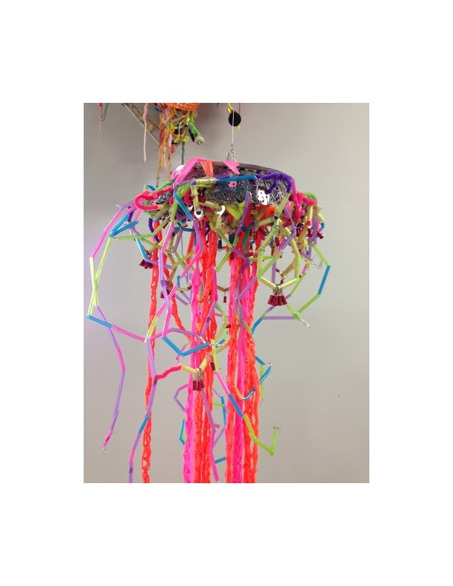
Jelly Fish by Kelly Brown
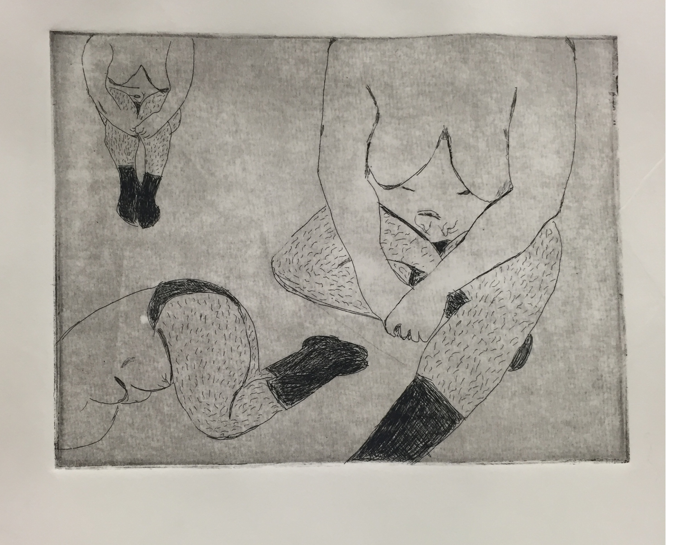
untitled by Natalie DiFrank

Both of these pieces like post pieces are made with intention. The materials are found or given and utilized in a fashion to express more than a simple emotion but a story a stance. When looking at pieces of artwork we feel the need to use words and normative expressions in order to share what we understand. Doing this in some way limits the power of the work. A piece must be imbibed as a whole without the need to depict what it means. When I make a piece of work I do not set out with an immediate intention just like when I speak. It flows and moves out of me and is done with intention but not with words.
Can art be used to change the meaning of silence from an absence to a fulfilled space? Art can be utilized to give voice to many without the need for language or with a redefining of our definitions. I can learn about another or their views by looking and staring at the work and not translating it into another form. If can accept this form of communication within conferences and events that require discourse than we create a platform for people who are non verbal to have space to express themselves and complex personhoods.

