Alliyah Allen
Prof Jody Cohen
Race-ing Education
October 7, 2016

Calling the Theoretical to Practice: Owning My Story and Finally Dancing at the Party
“Representations are flimsy because they always require upkeep, updating, and upping the ante. While not easy to destroy, representations are contested even after they have been established. While they aspire to the status of incontrovertible truth, more often images manipulate our ability to reason, going around, rather than through it.” (Leonardo 117)

Preface

I am choosing to tell my own story. While leaning on the quote about representation from Leonardo, I am recognizing the risk in creating an image or representation of a race/single group of people. Therefore, I am valuing the power of the individual and ownership of one’s own story. While drawing on themes of haunting, ownership, and storytelling, I do not feel power or strength in telling any other story but my own. Also, in the process of both understanding and critiquing academia, the institution, and theory through story, I am discarding the traditional means of writing. Therefore, I ask that you read my words as if you were to look at a painting or piece of artwork. I ask that you appreciate the form, structure, and organization. But I am also calling you to connect to light, energy, emotion, and truth within the story, which I am affirming is the true source of learning and education.

“I’ll never forget this day. Tuesdays were the worst. I had a full day of classes, meetings, and no free periods. Then, after all of that, I had to go to therapy for an hour and a half. Good thing I’m not playing basketball anymore. I might have just crashed… again. I can’t believe I got myself in this situation in the first place—me of all people. I typically have everything together in my life. But for some reason, everything felt as if it were falling apart.
I wasn’t Alliyah that night. I wasn’t a person anymore. I felt like a malfunctioning machine. I was exerting an immense amount of effort but I was producing very little results. I felt worn out and exhausted, like something else was sucking up my energy and I couldn’t figure out why.” (Allen 3)
This part of the story was written two years ago during my freshman year of college. I was reflecting on my senior year of high school, when I first crashed. I found myself unable to think and unable to work. I was pushed to my limit. And while I had so much access, opportunity, and privilege from attending a boarding school, I still felt as if I was exerting an immense amount of energy and effort and not getting anywhere.

However, the main issue was that I could not place this lack of energy. As a young black woman, from both Newark and Trenton, New Jersey, I had no context. Through my “academic” spaces, I was able to learn about concepts such as the Achievement Gap and racial inequity. I performed a TEDx Talk, Closing the Gap: Inspiring Kids to Work Hard and Achieve Greatness. I just knew with all the will and determination that I had that my ideas would end these injustices. In my work as a young academic, I was so dedicated to finding a solution.

I knew that in these structures that exist, I was on the bottom of them. However, in my eyes I wasn’t allowed to feel that oppression. I put an unnecessary pressure on myself. I created a formula in my head that proved to me that perfection of my body would cancel out any form of oppression and doubt in myself and family. I thought that if I redirected my energy into being the change that Gandhi speaks of it and my middle school coined as a slogan and working hard that I would solve this mystery called life.

Three years later, in a 360 cluster about Politics and Race, responding to writing prompt about story/theory, I find myself in the same situation and even more wrong.

In Race Frameworks, Zeus Leonardo writes, “These material conditions prevent students from the self-objectification that forms part of the dialectic of knowledge (Apple 1979/2000). Certainly, one could have an incomplete education even with access to appropriate materials if classroom relations were problematic or toxic. But without the prerequisite educational materials, students of color are unable to externalize their inner experience, short-circuiting the epistemological circle that is a hallmark education.” (Leonardo 58)

This portion of Leonardo’s writing relies on Marxism to make commentary about race, labor, and education and is crucial to understanding how my story unfolds. Economically, I was in one of the best positions possible. I had “worked” hard enough to earn a seat. And it was in the name of scholarship. My parents worked hard enough to get me a Macbook. I had more than enough clothes. I permed my hair to make in manageable to play sports and then go to class the next morning. I found my identity in the cliché of what was known to be a student. I went to class and excelled. Studied hard and was the top of my class. However, every action was in service of the institution, not in service to myself.

Now, I question what true learning could mean. The power of the classroom is helpful, however, there is much more work to be done with the self in order to find that meaning and to truly give students opportunities. To be stuck in a capitalistic mode of thinking means to be perpetuating this idea that learning only happens under a mask. I was so cushioned by the path of boarding school, that I committed myself to performing for four years. I smiled and posed for pictures, mentored younger students, lead multicultural groups and affinity groups in the name of diversity and individualism, took the hard classes, and essentially became a part of the elite. However, somewhere in the midst of that, I still was not able to tap into the pure, raw energy that is Alliyah. I was not able to fully redeem the benefits of being a student, because I was pushing myself to act like a student.

As a junior in college, I’m ready to say, I’m done with acting. I love academia. There is no other place where I can truly be myself. Having the space to read, to think, to talk, to write, and to see, to learn, and to feel truth is both important to me and the basic foundation to learning. Nevertheless, I am choosing to do so on my terms. I understand the presence of the institution, and I am committed to debunking its power structures—not for the ones of already benefit from it, but for those of us who have been chained by it.
“Storytelling is not valued so much for its truth content as its truth effects, its ability to affect our actions and orientation to the Other.” (Leonardo 20)
I understand that while looking for truth, the methodology and means to such conclusion are typically misconstrued, misunderstood, and/or buried under layers of haunting and trauma. This road blockage is the main reason why I choose to create my truth effect through the act of seeing. I was able to proclaim this purpose with both the help of Leonardo and an image I took this past summer. I had just gotten my new camera for my birthday and was automatically ready to shoot. I was working for the Village of Arts & Humanities in North Philadelphia. One day, my manager asked that I accompany one of artists into the neighborhood so that I can take pictures of them while they spoke of trauma and community healing. I then met Ms. Diane, and with my camera I was finally able to push past just was she saying. She was clearly an activist and community rock. She helped so many people. However, as a black woman from the same environment, I ran into so many women like Ms. Diane in my lifetime, as she is the epitome of their magic, strength, and capabilities.

However, what made he stuck on time was the fact that I was able to see her.

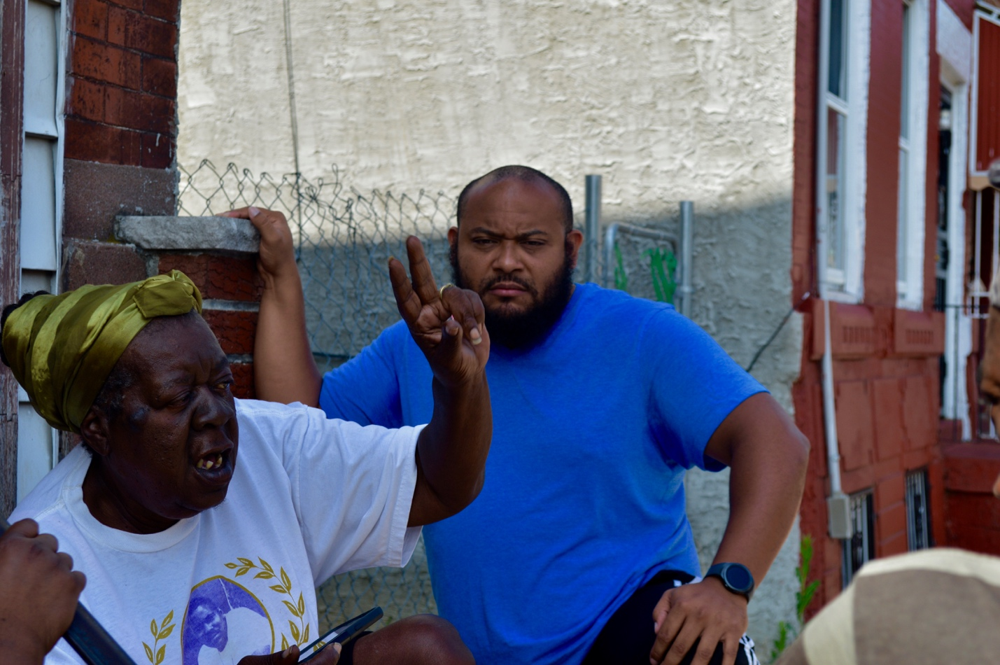

From the lines of the peace sign she’s throwing up to the beautiful blackness deep in her skin. Ms. Diane is magic. She wears t-shirts and memorabilia of lost ones like jewelry. She sat on her stoop that morning and taught me a lesson. We didn’t need books or pencils or a projector with a screen. All we needed was our fully bodies, mind, spirit, and hearts. That’s the root of learning. That’s the root of education.
“I am invited to speak, but only when I speak my pain.” –bell hooks 1990
To close, I invite us all to sit with this quote. This quote is my life’s theme; the title of the paper any students who studies me will write about. Better yet, it has been all that I have ever written about. The simplicity of it is the root to every theory that I’ve ever read and resonates with every change I have tried to make, in the light of my reading. Our perceptions of education are only in the mindset and character of oppression. My way of thinking, speaking, way of processing, writing, way of seeing, listening has been endlessly compromised by the forces that be white supremacy, in the disguise of education. However, now by recognizing such, I am focusing on this pain bell hooks speaks of. And I would just push my hero a little further and say that, while I have been invited because of my pain, that does not account for how I show up dressed, who I come with it, and how I party.

They might just want my pain, and I will give it. But through my triumphs, my happiness, my sadness, my body, my smile, my hair, my words, my brokenness, my completeness, and most importantly, my story.

Works Cited
Allen, Alliyah. Tall Brown Girl From Jersey. 2015.
Leonardo, Zeus. Race Frameworks: A Multidimensional Theory of Racism and Education. New York: Teachers College, 2013. Print.

