Clara Abbott
Kristin Lindgren
Critical Disability Studies
11 May 2018

Critical Disability Studies Final Project: “Mindful Conversations on Disability” Workshop

Learning Objectives, Context and Audience: This lesson plan is geared towards college students who have not yet explored Disability Studies as a framework or Disability activism in depth, but who are perhaps interested in learning more. This workshop format aims to honor and engage a wide breadth of perspectives, learning styles and strengths, acknowledging power dynamics that may exist within groups with regard to ability as well as other identities such as race, class, and gender identity. This workshop is open to students of all identities, but is geared towards students who do not identify as disabled and who wish to enter conversation about disability in a mindful and effective way.

This workshop primarily engages with the intersection of disability and language. How do we speak about disability? What language is affirming, and to whom? And what language can be limiting, to whom, and why? As with many identity groups, fear of learning how exactly to speak in the first place about disability can be a huge roadblock for interrogating one’s privileges or perhaps exploring issues of disability in a deeper or more nuanced way. Thus, this workshop aims to help participants reflect on and explore the way they use and relate to language, specifically surrounding disability.

Identifying Positionality: Crucial to the framing of this workshop about how we speak about disability is identifying my own privileges and perspectives that inform the way I have crafted this lesson and the way I might lead it if it is ever implemented. I identify as non-disabled, white, European-American, upper-middle class, queer, college-educated, atheist and politically left. The understandings I hold about the way language works and the ways we might wish to explore it are deeply rooted in this positionality.

I want to name the fact that my identity as non-disabled limits the conversations I can hold about disability. There are stakes to these conversations that I am still learning about and insights I do not have because I have learned about disability by research rather than by living it. And at the same time, part of the way ableism works is by erasing non-disabled identities, marking them as the “default.” Though I have not had experience with disability by being disabled, I have had experiences informed by non-disabled privilege that are worth critically interrogating and reflecting on.

For this reason, this workshop is geared towards non-disabled participants. This space aims to be one in which we in spaces of privilege hold each other accountable and challenge each other to create a more accessible world. This workshop will be informed by the work of Jay Dolmage, Melanie Yergeau, Margaret Price, Harriet McBryde Johnson, and other disability activists and theorists, as well as narratives surrounding disability and language. This workshop aims to equip non-disabled students to be more mindful and self-reflexive when speaking about disability.

Context and Before the Workshop: The workshop would be framed through an explicit naming of the above information. Participants would ideally be aware of the above information via email or conversation before the workshop even begins, so that intentions can be set before the session. Participants would also have access to this document or some type of plan for the workshop (an informal “Know Before You Go”) so that they might be prepared for the activities implemented. In terms of space, a room with easy access to water and food, wheelchair accessible, and with plenty of space to move around, as well as within an accessible building is essential. We would establish a “tap-out” space and person in case members of the workshop need to process activities on their own or take some time to themselves. In addition, iPads would be available for people who do not feel comfortable or cannot write with pen and paper. Conversations or exchanges with each person entering the workshop would occur ahead of time so that participants could name accommodations they need or concerns they have.

Opening Up the Space: I want to budget 10-20 minutes for “setting up” once the group (ideally about 10-15) have arrived, mainly to make sure everyone’s needs are met. This could take the form of moving around and checking in, or perhaps asking another facilitator or “tap out” person to do so. This ensures that at the start of the workshop and throughout, people feel comfortable and accommodated in the space. Even if the space is geared towards challenging and starting conversation with non-disabled folks, I wish to model accessibility practices in the space. So that everyone would be able to sit on the floor, there might be a table and chairs in a formation similar to our CDS class, but with perhaps more open space in the room, plenty of light, and comfortable chairs. Large-print handouts of this plan/variation of this and handouts for each activity, as well as pencils, paper, and iPads (as needed) would be supplied. When people have eaten and everyone has had some sort of check-in, we can begin.

We would start with a moment for people to take a mindful quiet moment and record, whether mentally, on a notecard, or digitally 1) what they need the room to know about them in order for this workshop to be an affirming space 2) what an affirming space must include for them and not include 3) what they need from the other folks in the room for the space to be affirming. If there is an activity in this plan that, after this discussion, would not be affirming to someone for some reason, that activity would be altered as needed.

Having considered and recorded these reflections, we would make space for participants to share their #1, including names and pronouns if people would like to share. Then, as a group, participants would share their #2 and #3 to the group and we would make a list we could refer to later. This activity would not work well for someone with trouble speaking or speaking to large groups, and we could modify it with an app like Padlet, which might allow students to project their thoughts on the board via iPad without speaking to the group.

Activity 1: Reflecting on Past Experiences What have your experiences been like with language? What language makes you feel known and affirmed? What language makes you feel misunderstood or invisible? To give participants with relatively little background on conversations surrounding disability a framework to process and name their own perspectives entering this work, it is important to speak about language. These reflections and means of processing will be used in future activities, and participants will know this.
- Participants will decide whether they choose to join a large group (4-5) people, a pair, or work alone. They will identify a time in which someone described, named, or spoke about them in a certain way that had some kind of emotional effect on them. What emotions arose in that moment? Afterwards? Did this description feel true? Why or why not? This aspect of the activity would work both for people who feel comfortable speaking and not, but does not carry a visual or sensory component.
- There will be a box of objects somewhere in the room, as well as foods, pictures to be found on ipads, and pen and paper. The task now is to find or make something: a sound, a taste, a feeling, a picture, a smell, that in some way portrays the feeling from the chosen moment. So for example, if someone described me as a “girl” even though I feel that I am a woman, I might choose a prickly object. Or if someone described me as an English scholar, which is flattering but perhaps overly so, I might draw a picture of an expensive object or diamond ring. These are just two examples, but the activity aims to allow another way to process and convey the reflection from part A. This may be an activity in which people need assistance because it requires moving around the room.
- There will be a moment for people to interact with their objects or expressions in some way, reflecting on them. What does this expression convey or not convey about this chosen experience? What does it embody?
- There will then be a gallery walk in which objects, expressions and artwork will be placed on the circular table, as well as any written or typed framing next to the object the participants wish. Participants will have time to walk around the room and interact with other people’s objects, touching them, looking at them, hearing them, smelling them if they wish. This would be difficult for participants with mobility issues but easier for participants who do not wish to converse or wish to absorb information in more sensory ways.

Activity 2: Identifying Affirming Language to Describe Disability How do we talk about disability? What words do we use and avoid and why? This activity will outline and compare words and expressions that are affirming to the disability community, versus language that many in the disability community find incorrect or degrading. As we conduct this activity, we will be aware that we cannot treat the disability community as a monolith, and that each individual person has their own relationship to language.

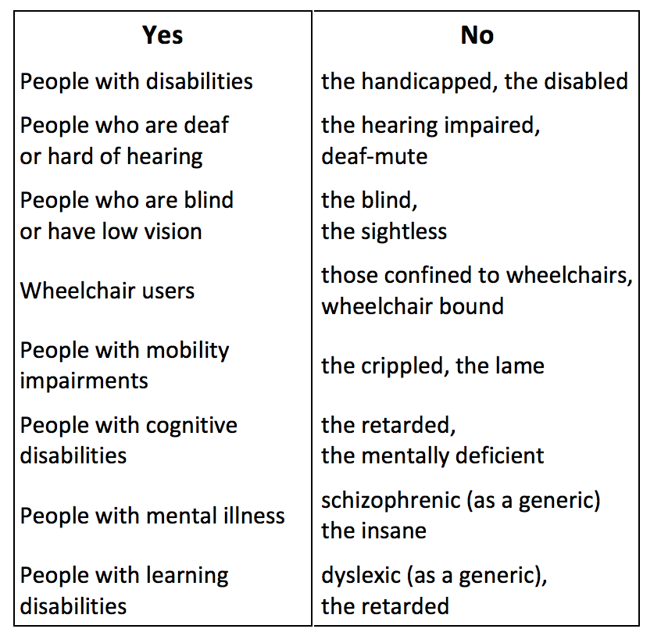

- The group will analyze and reflect on the above graph, sourced from the Smithsonian Guidelines for Accessible Design (http://accessible.si.edu/pdf/Smithsonian%20Guidelines%20for%20accessible%20design.pdf ) . What questions do people have? First, the group will take a moment to look at the graph and privately generate a few questions or observations each. This exercise will be beneficial to students who benefit from processing information independently or without talking to people, as well as students who benefit from visuals. A handout with large-print of this chart will be handed out.
- The questions and observations (anonymous) will be collected and put in a box, and then researched in groups. Each group will attempt to answer the set of questions they receive and respond to the set of observations they receive. After discussing and forming a mini presentation for the rest of the group, each group will attempt to present answers and follow-up questions for the larger group. This exercise works well for students who prefer discussing in small groups, students with visual impairments, and does not require movement. Participants who struggle socializing in some way might struggle with this activity, however, a participant’s level of involvement in the “presentation” is up to their discretion.
- Can we expand on this list? If so, how and why? What might we add to this chart in each column? An anonymous chat will be projected on the board and each student will use an iPad if they wish to post suggestions. This way, students will not have to speak to make suggestions, but the discussion will be open to the entire group. This requires a great deal of involvement from the facilitator, who should keep in mind the intentions set by the group at the beginning of the semester surrounding the creation of an affirming space.

Activity 3: Narrative Sharing and Analysis How can we put together our own narratives surrounding language, labels, and naming with the knowledge we have gained? How have people felt in the disability community felt when affirming language was used and not used? What are the stakes of these conversations and this work for the disability community? Where do we place ourselves within the following narratives? How might the narratives we have shared be interconnected with those we read about the disability community? This activity aims to draw connections between the previous two activities and underscore the importance of Activity 2.
- Narratives of many different types, videos, artwork and text will be shared with the group for about 20-30 minutes. The variations in types of narrative/medium will ensure that participants have some entry point into the conversation. For participants who benefit from visuals, artwork and handouts of narrative text will be helpful. For participants with visual impairments or who for some other reason prefer auditory experience, talks and videos with auditory components will be included.
- Each participant will pick some narrative or story that resonated with them or called to mind emotions they experienced or described in their narratives earlier in the session, or another narrative from their experience. There will be a quiet moment (1-2 minutes) to silently reflect on why that particular narrative resonated and what it calls to mind.
- Art materials, for sculptures, paintings, drawings will be available. iPads will also be available for making movies, and pen and pencil will be available. Participants will be challenged, over the next 10-20 minutes, to generate some kind of artistic response that incorporates emotions and aspects of their experiences with aspects of the narratives they heard. The goal here is not to equate experiences but generate and foster solidarity between the participants and those who have shared they have just heard. Ideally, each student would be able to find some means of executing this process that makes them feel comfortable and empowered. Students will also have the option of pairing up or working in a project on the group if they find thematic overlaps in their interests.
- This activity will end with a short (1-2) minute optional presentation from each group and then a gallery walk in which participants can examine and study what their peers have worked on. Again, mobility concerns must be honored here to make sure that all participants can see all pieces of art. This might mean moving out to the hallway or rearranging tables.
BREAK: At this time, participants will have 20-30 minutes for individual check-ins, to eat food, walk around, or independently process content.

Activity 4: Synthesizing and Planning What will we do with this information moving forward? How can we commit to speaking more mindfully, intentionally, and effectively about disability? What will we do when we hear another non-disabled person use harmful language to describe a disabled person or a disability? This activity aims to tie together what we have learned, felt, and described to think about how we can speak and act differently moving forward.
- For this portion, participants will separate into groups and set intentions for how to proceed. The groups will be small, 3-4 person “pods” and each group will figure out some system of accountability or strategy to check-in with each other after the session. Intentions might be something like, “I want to better educate myself about Deaf culture” or “I want to intervene or start a conversation when I hear someone use the word ‘special’ to describe someone with a disability.” The purpose of the groups is to make the practice of intention setting mean something, so that participants do not come away with empty or abstract goals. This exercise works well for participants who have visual impairments or prefer to process things verbally, but not as well for participants who wish to work more independently or have trouble hearing or speaking. This portion of the workshop is inspired my Mia Mingus’s idea of Accountability Pods (https://batjc.wordpress.com/pods-and-pod-mapping-worksheet/, groups that continually check in to hold themselves and each other accountable for their choices).
- Using a variety of materials in the room, such as iPads, paper, art materials, sculpture materials, participants will create, with others or independently, some type of object or letter to which they will return at a later date. Like a time capsule, the object will remind the participant to check in with themselves about the intentions they have set, and perhaps to set new ones. The object might reflect some aspect of the workshop that stuck with the participant, or that they found meaningful. This is also a chance to think about how we check in with ourselves, thinking self-reflexively and self-critically at all points in our process of engaging in conversation. What personal stake do we have in this? Why did we come to this workshop in the first place? And what will participation in this workshop mean in the long term?
- If participants wish, they are invited to share with their groups or pods their object, letter, picture, etc. If participants would rather keep their creations private, that is also encouraged. This portion of the activity is meant for groups to share what “checking in” individually might look like, have more space to reflect on the workshop as a whole, and verbally reflect on their thought processes having had some independent time to mull things over. This overall synthesizing activity is meant to engage learners who wish to work independently as well as learners who feel they benefit from engaging with groups. The goal here is to discuss and establish systems of accountability moving forward.
Wrapping Up We have thought as groups about what accountability could look like for us, processed experiences we ourselves have had around language and the way we understand ourselves, gained new frameworks for thinking and speaking about disability and expressed how those new frameworks might integrate into our lives. Was this useful? What went well and did not go well? Was this space both affirming and challenging? How so? Part of thinking intentionally and reflexively is also thinking about the process of the workshop itself, and how it made us feel.
- Participants will record on post-it notes “moments” from the workshop, whether it be joyful moments, frustrating moments, moments that were challenging, moments that left something meaningful. This exercise works for participants who benefit from writing and processing privately, but might be difficult for participants who have trouble writing. Facilitators could be available to talk with or write on post-its for participants who cannot do this. Each participant is invited to record several moments and experiences on several post-its. Participants are also encouraged to note on their post-its whether or not they would prefer for them to be read aloud.
- Next, the group will together generate 4-5 categories that will go on big sheets of paper around the room (so these categories could be “frustrating” “exciting” “room for growth” etc.), and there will be a giant piece of paper on each wall with each of these categories. This will be one of the few times the group decides something as a collective, and facilitators will need to be mindful of power dynamics in the room as this decision is being made. Ideally, categories brainstormed by the group can be combined in some way.
- Once the big pieces of paper are up on the wall, participants are invited to stick their sticky notes where they feel like they belong. If sticky notes belong in more than one place, participants are also encouraged to stick the same experience or moment in multiple places (writing on another post it note, etc.) This is a way for experiences to be anonymized and fully processed, and for experiences to somehow be marked as related to one another. This will be adapted for participants who have issues with mobility and cannot so easily get around the room. If the space is fully accessible, this will not be as much of a problem, but post-its can also be hand-labeled and given to facilitators to post on the paper.
- These pieces of paper will be used by facilitators to figure out what worked and didn’t work about the workshop, and facilitators will read aloud to the group post-it notes on each board so that the group has an idea of the feelings and experiences in the room and feels that the group has heard and respected their experiences.
- The floor will be opened for 10-15 minutes if participants have final thoughts, concerns, or closing reflections. If participants want to jot down a note to a facilitator or another participant, they are invited to do so. Facilitators will also be available to check in with participants after the workshop.

Narratives for Activity 3 These narratives intentionally take a wide variety of different formats – though verbal narrative can be useful for some participants, others may wish to hear narratives verbally or see a narrative as a piece of art. With that in mind, participants will interact with all of these narratives and choose ones they feel resonate with them most deeply.

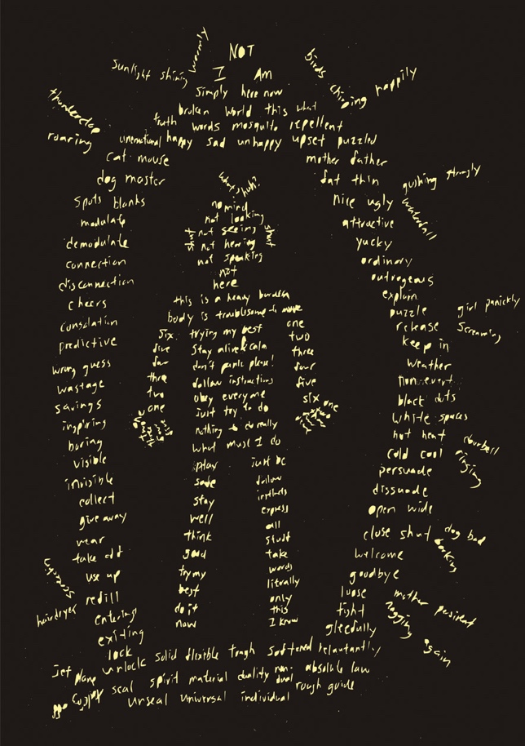 Eric Chen, Mirror Mind poster 3, 2005

This narrative incorporates both image and words to convey a felt relationship between disability and language. Eric Chen writes, “I created these posters to commemorate and promote the launch of my self-published autism book, Mirror Mind. The book aims to convey the inner feelings I feel as a person with autism, and the pictures represent a poem from each book.”

(Sourced from http://50watts.com/Drawing-Autism)

- https://www.youtube.com/watch?v=0UbI_Rl2i2w “Voice/Over” by Shelley Barry engages with issues of speaking, silencing, and the effect of language. It has both visual and auditory components, and also thinks about the role of silence as we consider language. It is also part of Barry’s series of three films, so if participants want to learn more, they can keep researching her work. The film intertwines a political narrative with its political implications.
- https://www.youtube.com/watch?v=NyXa2_zDQnI This poem by Leroy Moore thinks about the stakes of labels in the context of police brutality and violence. Themes in this spoken word poem include labeling and profiling. The visual component of this video is not necessary for appreciating it, but it can be considered. This may be appropriate for a participant who prefers auditory means of expression, enjoys or resonates more with poetry or music over prose, or wishes to further explore the intersections of disability with other factors, such as race.
- https://leavingevidence.wordpress.com/2011/08/22/moving-toward-the-ugly-a-politic-beyond-desirability/ This written blog post, entitled “Moving Toward the Ugly: A Politic Beyond Desirability” by Mia Mingus explores the intersections of disability with particularly race, gender and sexuality. Mingus explores her reckoning with labels such as “femme,” and her exploration of whether or not she feels these labels embody her experience. This blog post, rooted in personal narrative, may be helpful for participants who prefer to read rather than hearing or seeing.
- https://www.rivalehrerart.com/self-portraits-ghost-parade Participants are invited to explore a digital gallery of Riva Lehrer’s work, particularly her portraits entitled, “Ghost Parade.” Lehrer writes (quoted from website above), “Self portraits have been a way for me to explore my evolving relationship with my own body. These works also allow aspects of formal experimentation that do not have an impact on anyone else’s self-image. When I work with a portrait subject I am acutely aware of the extent to which I hold their ego in my hands. In working with my own body, I can go in directions that would be difficult to ask of another person.” This gallery does not contain a written component, so it would be accessible for participants who prefer visual and nonverbal forms of information. Importantly, a non-verbal component also allows for us to expand what we mean by “language” exactly to a larger discussion of empowering representation and expression.

Sources Cited

Barry, Shelley, director. Voice/Over. 5 Dec. 2007, www.youtube.com/watch?v=0UbI_Rl2i2w.

Chen, Eric. “Mirror Mind.” Drawing Autism: 50 Watts, 2005, 50watts.com/Drawing-Autism.

Dolmage, Jay. “Universal Design: Places to Start.” Disability Studies Quarterly, vol. 35, no. 2, 2015, doi:10.18061/dsq.v35i2.4632.

Lehrer, Riva. “Self Portraits: Ghost Parade.” Riva Lehrer, www.rivalehrerart.com/.

Linton, Simi. Claiming Disability: Knowledge and Identity. New York University Press, 2010.
Mingus, Mia. “Moving Toward the Ugly: A Politic Beyond Desirability.” Leaving Evidence, 21 Sept. 2011, leavingevidence.wordpress.com/2011/08/22/moving-toward-the-ugly-a-politic-beyond-desirability/.

Mingus, Mia. “Pods and Pod Mapping Worksheet.” Bay Area Transformative Justice Collective, 4 Sept. 2016, batjc.wordpress.com/pods-and-pod-mapping-worksheet/.

Moore, Leroy. “Leroy Moore in Seattle.” 4 July 2013, www.youtube.com/watch?v=NyXa2_zDQnI.

Smithsonian Accessibility Program. “Smithsonian Guidelines for Accessible Design.” Smithsonian Institution, www.si.edu/Accessibility/SGAD.

