Madeline Svengsouk
Bryn Mawr College| Critical Disability Studies
addiction as a disability, Eugenics, & the black female body as a site of control
“Crack babies”:

Media Epidemiology: Social Criminalization of Drug Use
Journal Article Titles and Content
Crack’s Toll Among Babies: A Joyless View, Even of Toys- New York Times 1989
      - “Prenatal exposure to…crack seems to be ‘interfering with the central core of what it means to be human.’”
  - “Many of these babies today show symptoms similar to those in children with mild autism or those with personality disorders, conditions characterized by withdrawal and lack of emotion.”
A Time Bomb in Cocaine Babies- Washington Post 1989
  - “Already, a few of them are turning up in first- and second-grade classrooms around the country, wreaking havoc on themselves and others. Severe emotional damage and even physical deformities not so readily apparent today may mushroom in the near future.”
The Cost of Not Preventing Crack Babies - New York Times 1991
  - “Researchers estimate that cocaine-exposed babies cost the country more than $500 million a year. And that doesn't include the subsequent cost of health and social services required to help such children cope with the damage sustained before birth.”
Time Magazine 10/1/90 (Washington 2006)
  - “Maternity wards around the country ring with the high-pitched ‘cat cries’ of crack babies.”
Children of Crack: Are the Schools Ready? - A Special Report: Crack Babies Turn 5, and Schools Brace- New York Times 1990
  - “What can you expect, given the limitations of public schools dealing with this population of poor and minority children?... If you add special needs on top of that, the likelihood of failure increases. These children enter school with an absolute prescription for failure.” – Dr. Xylina Bean
  - “The most severely affected children suffer from seizures, cerebral palsy, or mental retardation. Most children have an array of symptoms that include hyperactivity, sudden mood swings, extreme passivity, apparent lack of emotion, slow language acquisition or mild speech impairment. Many are overwhelmed by stimuli like noise or piles of toys, have trouble interpreting nonverbal signals, are easily frustrated, find it hard to concentrate, and learn something one day only to forget it the next.”
Children of Cocaine- Washington Post 1989
  - “The inner-city crack epidemic is now giving birth to the newest horror: a bio-underclass, a generation of physically damaged cocaine babies whose biological inferiority is stamped at birth… theirs will be a life of certain suffering, of probable deviance, of permanent inferiority. At best, a menial life of severe deprivation… the dead babies may be the lucky ones.”

A Brief History of the War on Drugs
In the early 90s, concerns about cocaine use became racialized. There are two types of cocaine: powder cocaine and crack cocaine, which are chemically identical and have identical effects on the mind and body. Despite their similarity, they are associated with use by different groups of people. Because crack cocaine was developed as a cheaper alternative to powder cocaine, it is associated with lower income communities of color. Alternatively, powder cocaine came to be seen as a luxury afforded to white elites due to being higher in cost. As a result, much more severe sentences were issued for crack cocaine than powder cocaine. The Anti-Drug Abuse Act passed in 1989 “set penalties that were 100 times harsher for crack than for powder cocaine convictions. We now know that an astonishing 85 percent of those sentenced for crack cocaine offenses were black, even though the majority of users of the drug were, and are, white” (Hart 2014).

What is a “Crack Baby”?
Fetuses exposed to crack cocaine in utero, dubbed “crack babies”, were falsely found to be born with physical, neurological, behavioral, and learning disabilities (Singer, Farkas, & Kliegman 1992). These early research findings were then promoted by the media and society at large out of fear. By centering on the use of a drug associated with black people, the media perpetuated the idea that the “monstrous crack-smoking mother” was typical of black women in particular (Slandering the unborn 2018). These infants and their mothers were sensationalized by the press during the early 90s and were a catalyst for moral panic, leading to disproportionate incarceration of black and brown folks, and separation of families. In fact, women who use substances while pregnant and have lost their babies during birth or who have miscarried have been convicted of child endangerment and even fetal homicide (Slandering the Unborn 2018). Furthermore, legal substances such as alcohol and tobacco have in fact been shown to be far more damaging to a developing fetus than other illicit substances such as cocaine (Okie 2009). These babies were simultaneously seen as victims of their mother’s decision to use substances, as well as a threat to the system due to the imagined inevitability of being intellectually or physically disabled.

“Crack Babies”: Victims or a Threat to the System?
Interestingly, the purported identity of a crack baby is contradictory to itself. These babies are seen as innocent victims of their mother’s cocaine use, while also being a financial threat to services the country is morally obligated to provde its citizens such as adequate education, medical care, and financial support for people experiencing poverty. In an effort to divest the government from its obligation to provide for individuals needing additional support, the accepted solution is to demonize these babies and their mothers, such that they are to blame for their own suffering. Positioning them as a moral, medical, and financial threat to society effectively holds these individuals culpable for their own illness as well as how they might affect others. These dual fallacies were and continue to be utilized by people and institutions who benefit from the opression of black mothers.
Constructing the identity of “the crack baby” as one of subhuman and animalistic character made these children a product of their mother’s supposed inability to control her own body and her addiction. It also portrays mothers and children as less than human, devaluing their lives and further justifying stigma. This effectively put the onus for change on individuals struggling with substance use, rather than recognizing the role of institutional failure in failing to provide adequate care for people who use drugs. The impact can be seen in how mothers charged with illegal drug use are treated by the welfare state. For instance, in 1996 “congress denied food stamps and welfare payments for life to people convicted of drug felonies — many of whom happened to be women with children in desperate need of medical or mental health care.” (slandering the unborn) Evidently, they thought that taking away people’s basic needs would be an appropriate motivator to create a change in behavior.
It goes without saying that the conversation around the notion of substance use resulting in disability is alarming to say the least. The language used by media outlets is strikingly similar to that used during the forced sterilization era rooted in eugenicist beliefs. There exists seemingly endless fear around certain individuals being a burden on the system because of their “extra” needs and because of the imagined negative influence they might have on society at large. The idea of morally and mentally inadequate women giving birth to a new generation of physically and morally depraved children is something we’ve seen in the past as in the Buck v. Bell case that continues to live on today, albeit in a different context. This kind of contradicting roles is not uncommon in paternalistic systems of social control where certain actors are positioned as inherently in need of salvation by the privileged outsider, or who embody threats that necessitate discipline, which in this case is criminalization.

Addiction: Lacking Willpower or a Disability?
While significant long-term neurological and physiological impacts of crack on fetuses during pregnancy have been disproven since their inception in the 90’s (Okie 2009), the fear of physical, mental, and moral deviance lives on in ways that stimatize the individual. In fact, labeling children as “crack babies” puts them “at substantial risk of stigma and discrimination in edcational contexts. They may be subject to medical misdiagnosis and unnecessary, detrimental separation from loving and supportive families as a result of ill-informed and inappropriate child welfare interventions” (National Advocates for Women 2013). Furthermore, individuals who struggle with drug use are deemed as simply not trying hard enough to quit, or worse, are labeled as uncaring about themselves or their families. In reality, “drug addiction is not a “bad habit” or willful indulgence in hedonism, but a chronic medical condition. Demonizing pregnant women creates an environment where punishment rather than support is the predominant response, and will inevitably serve to discourage women from seeking care” for their illness (National Advocates for Women 2013).
Personally, I believe that addiction should be thought of as a disability. The definition of disability remains ellusive, especially in situations where a disability might be aquired rather than congenital. The concept becomes even harder to flesh out when the disability is caused by something an individual is partaking in of their own volition. In this case it is essential to understand that substance use is a diagnosable medical condition in the DSM, defined as “a maladaptive pattern of substance use leading to clinically significant impairment or distress” which is manifested by “failure to fulfill major role obligations at work, school, or home”, “substance use in situations in which it is physically hazardous”, use resulting in “substance-related legal problems”, or “continued substance use despite persistent or recurrent social or interpersonal problems caused or exacerbated by the effects of the substance” (APA 1994). While substance use might initially involve personal choice, the addictive neurological response to the drug quickly takes personal choice out of the equation. Interestingly, prior to 1996, an individual “could be eligible for Social Security disability benefits if they were an alcoholic, but Congress changed that, and [now] you can’t receive these benefits if alcoholism is the only impairment you have (Recovery Village 2017). This shift also occurred around the time moral panic escalated in regard to crack cocaine useage.
According to the U.S. Department of Health and Human Services, “drug addiction, including an addiction to opioids, is a disability under Section 504 of the Rehabilitation Act, the Americans with Disabilities Act, and Section 1557 of the Affordable Care Act, when the drug addiction substantially limits a major life activity.” However, “individuals who currently engage in the “illegal use of drugs” are specifically excluded from the definition of an individual with a disability when a covered entity takes an adverse action on the basis of that current use” (DHHS 2018). I interpret this to mean that under the law, drug addiction is considered a disability unless that individual is currently using substances illegally. In other words, someone is eligible for disability benefits if they are in recovery from using illegal drugs such as crack cocaine; however, 40-60% of people with substance use disorder relapse. Disability benefits should not be revoked if this occurs; how is someone expected to focus on recovery if they are potentially concerned about not having their basic needs met? This discrepancy might arise out of a false government perception that validating addiction to illegal drugs as a disability is to enable illegal drug use itself. That being said, this policy excludes thousands of people from receiving the support they need to take steps towards recovery.
Many people struggling with addiction describe it as incredibly debilitating, and it should be understood as such. Drug dependence severely impairs an individual’s ability to work; according to American Addiction Centers, “almost twice as many people who are unemployed struggle with addiction than those who are fulltime workers”. Furthermore, “Of the 2.3 million people in American prisons and jails, more than 65% meet the criteria for addiction, [and] around 75% of individuals in state prison or local jail who suffer from mental illness also struggle with substance abuse” (Scot 2020). It is well known that prisons act as a stand in for social services that the government fails to provide. The comorbidity of drug addiction, mental illness, and disability is something that needs to be addressed as a disability rather than as a product of poor choice. Furthermore, it becomes even more difficult to find stable employment and adjust back to everyday life post incarceration. It is also well known that individuals who are greatly stigmatized are less likely to seek out care, especially in institutional settings such as hospitals or government-funded programs.

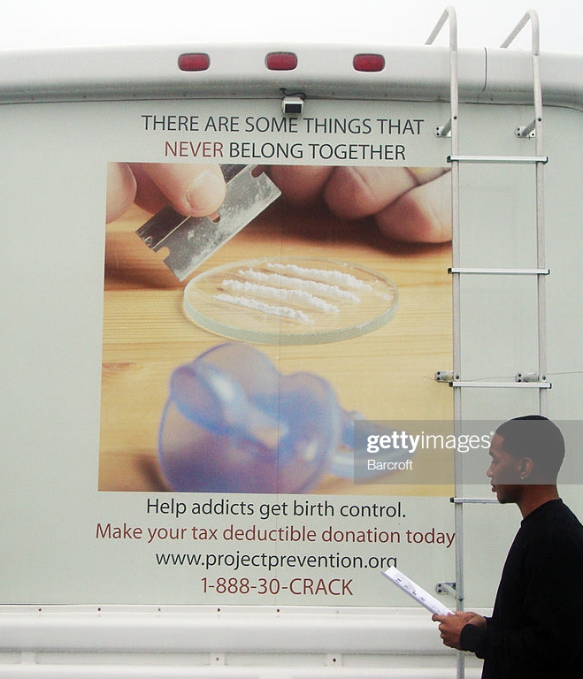
Eugenics Today: C.R.A.C.K
Unfortunately yet unsurprisingly, eugenicist beliefs towards marginalized individuals continue to exist today in an effort to save the social body from impurity. For instance, a nonprofit organization founded in 1994 that continues to operate today, Children Requiring a Caring Kommunity or C.R.A.C.K. for short, offers $300 cash for women who use drugs to “volunteer” for long-term birth control or sterilization. When the nonprofit first started in 1994, it offered more payment for tubal ligations and vasectomies than for IUDs and other implanted birth control methods, but after facing criticism, now pays a flat rate for either procedure. Despite this shift, the discrepancy in financial reward illuminates the reality that the organization values sterilization over a temporary inability to reproduce. This also communicates the message that women who use drugs should not and cannot be trusted with their own bodies. C.R.A.C.K. has paid approximately 7,412 people to go on birth control or become sterilized since its inception (Project Prevention 2019). Demographically they report over half of their "clients" are white, about 20% are Black, and 10% are Hispanic, but it should not be forgotten that black people only make up 12-13% of the population and are therefore disproportionately overrepresented in these numbers.
Barcroft Media
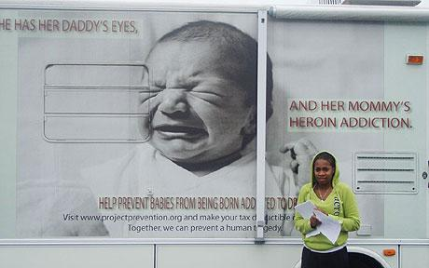
The beliefs upon which this organization is founded upon become clear when listening to founder Barbara Harris discuss the problem their organization is attempting to address. She has been quoted as saying “we don’t allow dogs to breed. We spay them. We neuter them. We try to keep them from having unwanted puppies, and yet these women are literally having litter of
children” (Vega 2003). When asked about this statement, she admitted these methods amount to bribery, but said it was the only way ot stop babies being physically and mentally damaged by drugs during pregnancy. Clearly, this organization is acting on paternalist and eugenicist principles of societal purity. C.R.A.C.K.'s solution to undesirables, which are in this case drug users, "unfit" mothers, and (the potential occurrence of) disabled children, is to prevent them from ever being born in the first place. What does "voluntary" really mean for someone who might have no or inconsistent income? In biomedical research, it is well known that monetary compensation can be coercive for participants with low socioeconomic status. Financially coercing someone to willingly subject themselves to sterilization is still a form of forced sterilization- especially if they are poor, disabled minority women.
Clifford M.

Concluding Thoughts
False findings around “crack baby” disability has the same effects on the social body that pseudoscience has had in justifying black inferiority. It is easy to view people struggling with substance use as responsible for the impairment in their lives, to condemn them as immoral for enabling intellectual and physical disability in their own children. Blaming and stigmatizing people who use drugs engenders hostility in institutional settings, which can be a barrier to seeking care, and doing so effectively justifies a lack of support and criminalization. Furthermore, addiction needs to be regarded through the lens of disability studies. If it were to be thought of as such, I belive people would be more compassionate towards individuals who struggle with substance use disorder, which would incentivize recovery through the creation of a more understanding and supportive system. Children who are coloquially called “crack babies” should not be thought of as disabled solely based on exposure to cocaine; however, mothers struggling with addiction should be thought of as disabled and should qualify for disability benefits. Doing so would allow for much needed health insurance coverage and supplementary income for recovering mothers who are struggling with unemployment.

References
American Psychiatric Association. Diagnostic and Statistical Manual of Mental Disorders - Fourth Edition (DSM-IV). American Psychiatric Association, Washington D.C., 1994.

Barcroft Media. (2010, February 26). Barbara Harris’ campaign motorhome with a volunteer handing out flyers. Retrieved from https://www.gettyimages.com/detail/news-photo/barbara-harris-campaign-motorhome-with-a-volunteer-handing-news-photo/97509226

Blakeslee, S. (1989, September 17). Crack's Toll Among Babies: A Joyless View, Even of Toys. The New York Times. Retrieved from https://www.nytimes.com/1989/09/17 /us/crack-s-toll-among-babies-a-joyless-view-even-of-toys.html?pagewanted=all

Chira, S. (1990, May 25). Children of Crack: Are the Schools Ready? A Special Report: Crack Babies Turn 5, and Schools Brace. The New York Times. Retrieved from https://www.nytimes.com/1990/05/25/us/children-crack-are-schools-ready-special-report-crack-babies-turn-5-schools.html

Clifford, M. (2010, October 19). Project Prevention, a Us based charity, has given a British drug addict €200 in return for being sterilized. Retrieved from https://www.telegraph.co.uk/news/health/8071664/Drug-addict-sterilised-for-cash-but-can-Barbara-Harris-save-our-babies.html

Diagnostic and Statistical Manual of Mental Disorders : DSM-5. 5th ed. Arlington, VA: American Psychiatric Association, 2013. Print.
Hart, C. (2014, January 29). How the Myth of the ‘Negro Cocaine Fiend’ Helped Shape American Drug Policy. The Nation. Retrieved from http://digitalcollections.library.cmu.edu/awweb/awarchive?type=file&item=410809

Krauthammer, C. (1989, July 30). Children of Cocaine. The Washington Post. Retrieved from http://digitalcollections.library.cmu.edu/awweb/awarchive?type=file&item=410809

Milloy, C. (1989, September 17). A Time Bomb in Cocaine Babies. The Washington Post. Retrieved from https://www.washingtonpost.com/archive/local/1989/09/17/a-time-bomb-in-cocaine-babies/634afdf8-3c4c-499c-9fc8-8a1dbe4058cf/

Monroe, J., & Alexander, R. (2005). C.R.A.C.K.: A progeny of eugenics and a forlorn representation for African Americans. Journal of African American Studies, 9(1), 19–31. doi: 10.1007/s12111-005-1013-9

National Advocates for Women. (2013, March 11). Open Letter to the Media and Policy Makers Regarding Alarmist and Inaccurate Reporting on Prescription Opioid Use by Pregnant Women. Retrieved from http://advocatesforpregnantwomen.org/ Opioid %20Open%20 Letter%20-%20March%202013%20-%20FINAL.pdf

Okie, S. (2009, January 26). The Epidemic That Wasn’t. The New York Times. Retrieved March 6, 2020 from https://www.nytimes.com/2009/01/27/health/27coca.html

Project Prevention. (2019, December). Statistics. Retrieved from http://www.projectprevention .org/statistics
Recovery Village. (2017, July 19). Are Alcoholism and Drug Addiction Disabilities? Retrieved March 5, 2020, from https://www.therecoveryvillage.com/alcohol-abuse/faq/alcoholism-drug-addiction-disabilities/#gref

Scot, T. (2020, February 3). Alcohol and Drug Abuse Statistics. American Addiction Centers. Retrieved from https://americanaddictioncenters.org/rehab-guide/addiction-statistics

Slandering the Unborn. (2018 December 28). Editorial. The New York Times, The New York Times. Retrieved from www.nytimes.com/interactive/2018/12/28/opinion/crack-babies-racism.html

The Cost of Not Preventing Crack Babies. (1991, October 10). The New York Times. Retrieved from https://www.nytimes.com/1991/10/10/opinion/the-cost-of-not-preventing-crack-babies.html

U.S. Department of Health and Human Services Office for Civil Rights. (2018, October 25). Fact Sheet: Drug Addiction and Federal Disability Rights Laws. Retrieved on 2020 March 3 from https://www.hhs.gov/sites/default/files/drug-addiction-aand-federal-disability-rights-laws-fact-sheet.pdf

Vega, C. (2003, January 6). Sterilization Offer to Addicts Reopens Ethics Issue. The New York Times. Retrieved on 2020, March 2 from https://www.nytimes.com/2003/01/06/nyregion/sterilization-offer-to-addicts-reopens-ethics-issue.html
Washington, H. (2006). Medical Apartheid : the Dark History of Medical Experimentation on Black Americans from Colonial Times to the Present . New York: Doubleday, 2006. Print.

