Audio description transcripts
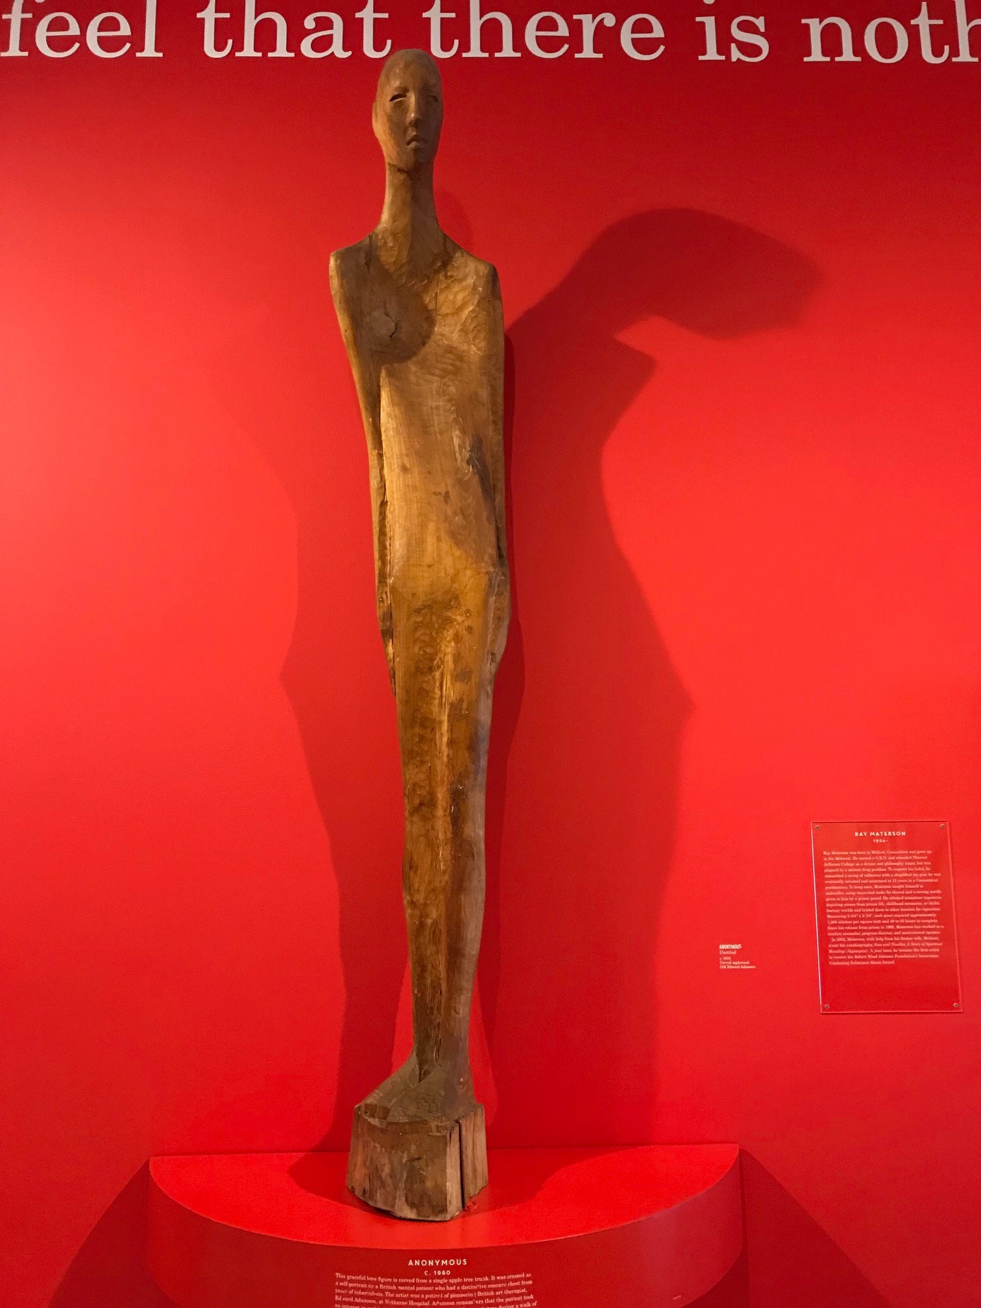
Recovery by Anonymous
The piece is a six foot tall wood carving from a single piece of wood. The wood from which it is carved is sanded smooth. It is a warm orange-brown and mostly uniform in color and texture. The carving is of a tall, slender man with arms pressed against his sides and his head tilted slightly downward. The man’s eyes are squinted closed and his mouth is slightly agape so he looks as if he may be sighing. He has a somewhat large nose and a smooth shaven head and no other distinct facial features. The torso is long and smooth with the back leaning gently forward. The figure’s chest is sunken in so his shoulders point forward. The shoulders are narrow and pointed and the arms disappear into the chest then gradually become more distinct at the lower half of the torso. His legs are narrow and pressed together with the knees locked and he stands on a small pedestal just the length and width of his feet and about six inches high.
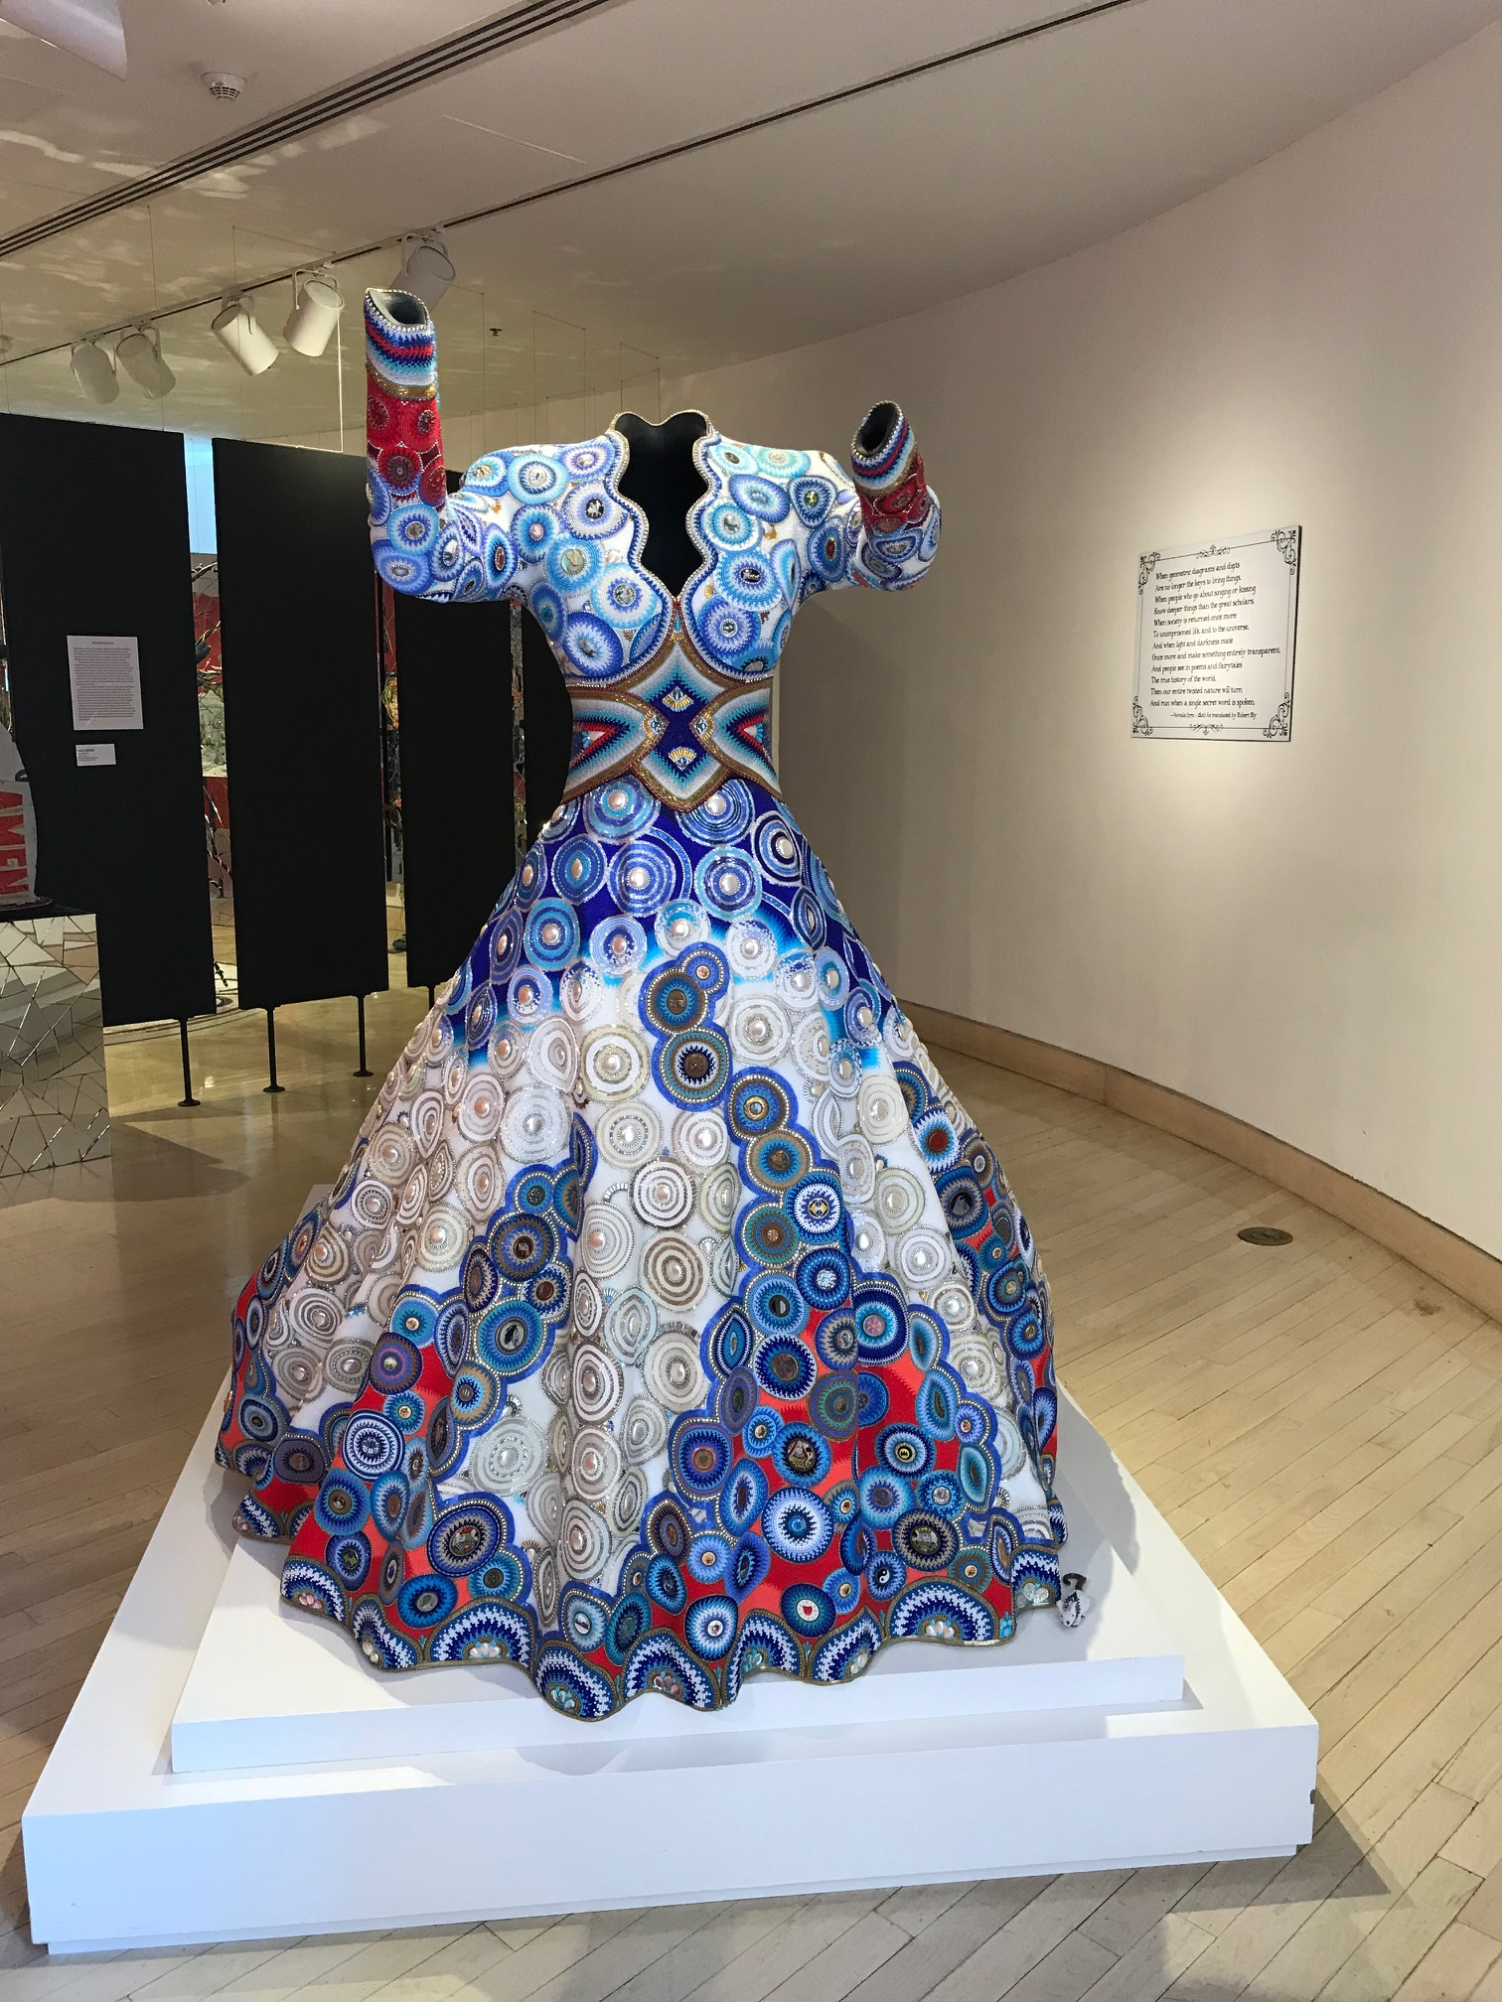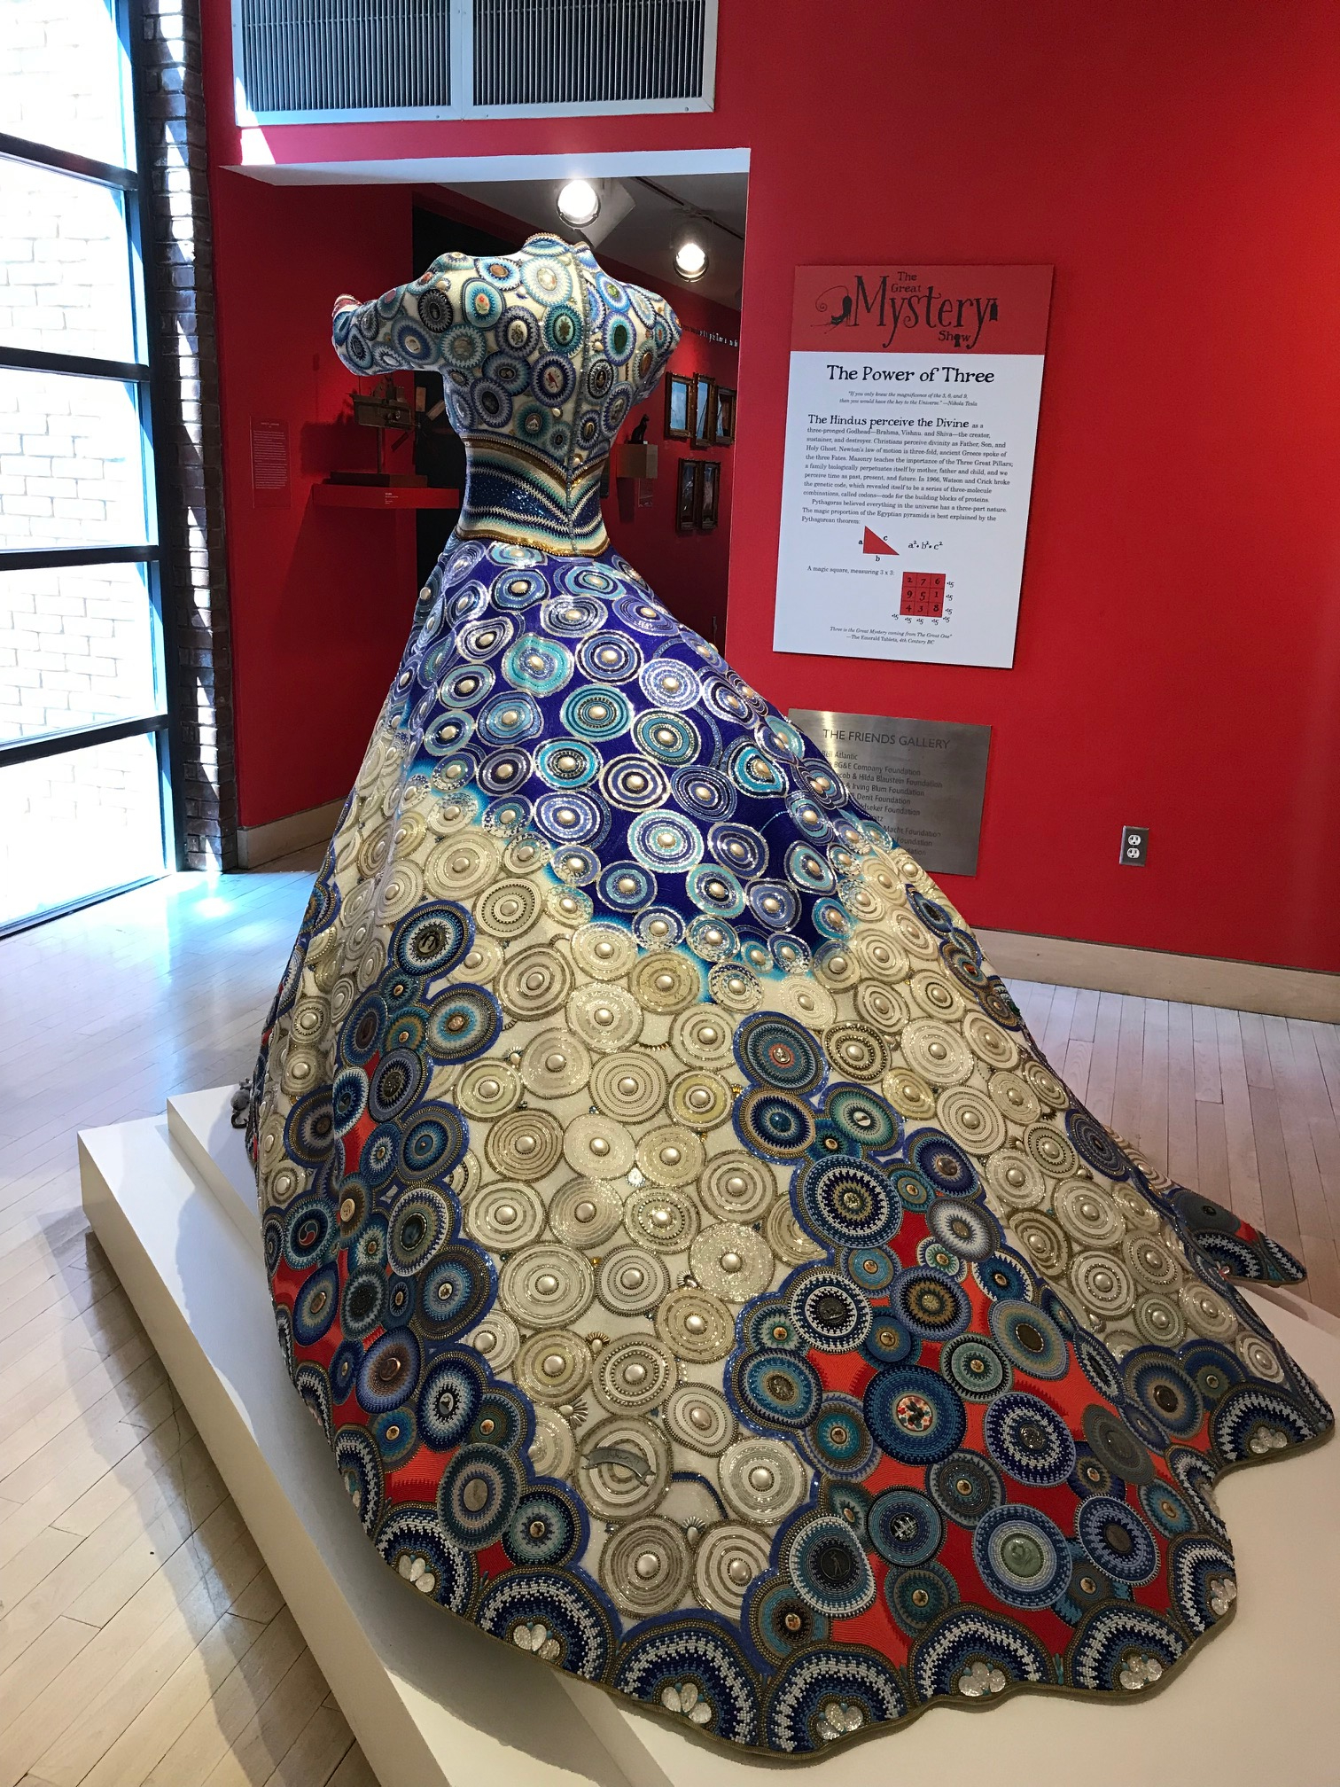
The Gown: Affinity by Jan Huling
The piece is a dress with a fitted bodice and a large skirt with a bustle in the back so it stands upright and trails several feet back. The most striking part of the dress is the fine beading that cover nearly all of it. The skirt and bodice are covered in circles all about 4 inches wide. Each circle is neatly made of layers of tiny glass beads. Some use all beads of the same color and others have a bullseye design with two or three different colors. The beads are mostly white and varying shades of blue with an occasional gold accent. At the center of each circle is a larger, round, smooth stone most of which are white but some of which have designs or small black and white portraits printed on them. On the skirt, the circles combine to form blue tendrils on a white background that reach up from the hem toward the bodice. In some places near the bottom of the skirt, a bright orange fabric peeks out from behind the blue circles.
The waist is narrow and beaded with a diamond shaped geometric design. The waistline creates a clear separation between the skirt and bodice. The bodice is covered in the same beaded circle motif as the skirt. It has a scalloped V-neck edged with a border of blue and white beads. The sleeves are long and continue with the blue and white circles to the forearm where it transitions to solid bright orange beading with dark blue, orange, and white stripes at the end. The dress is displayed on a mannequin with the arms raised and reaching forward.

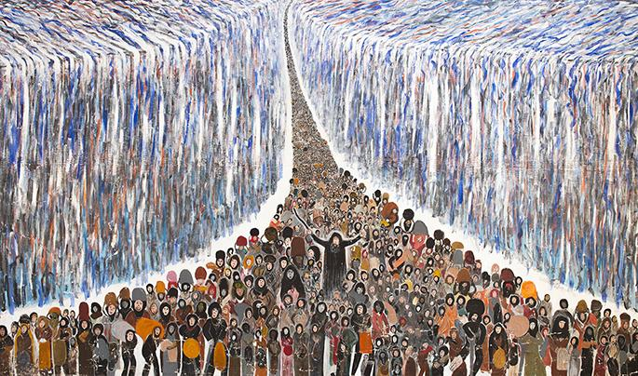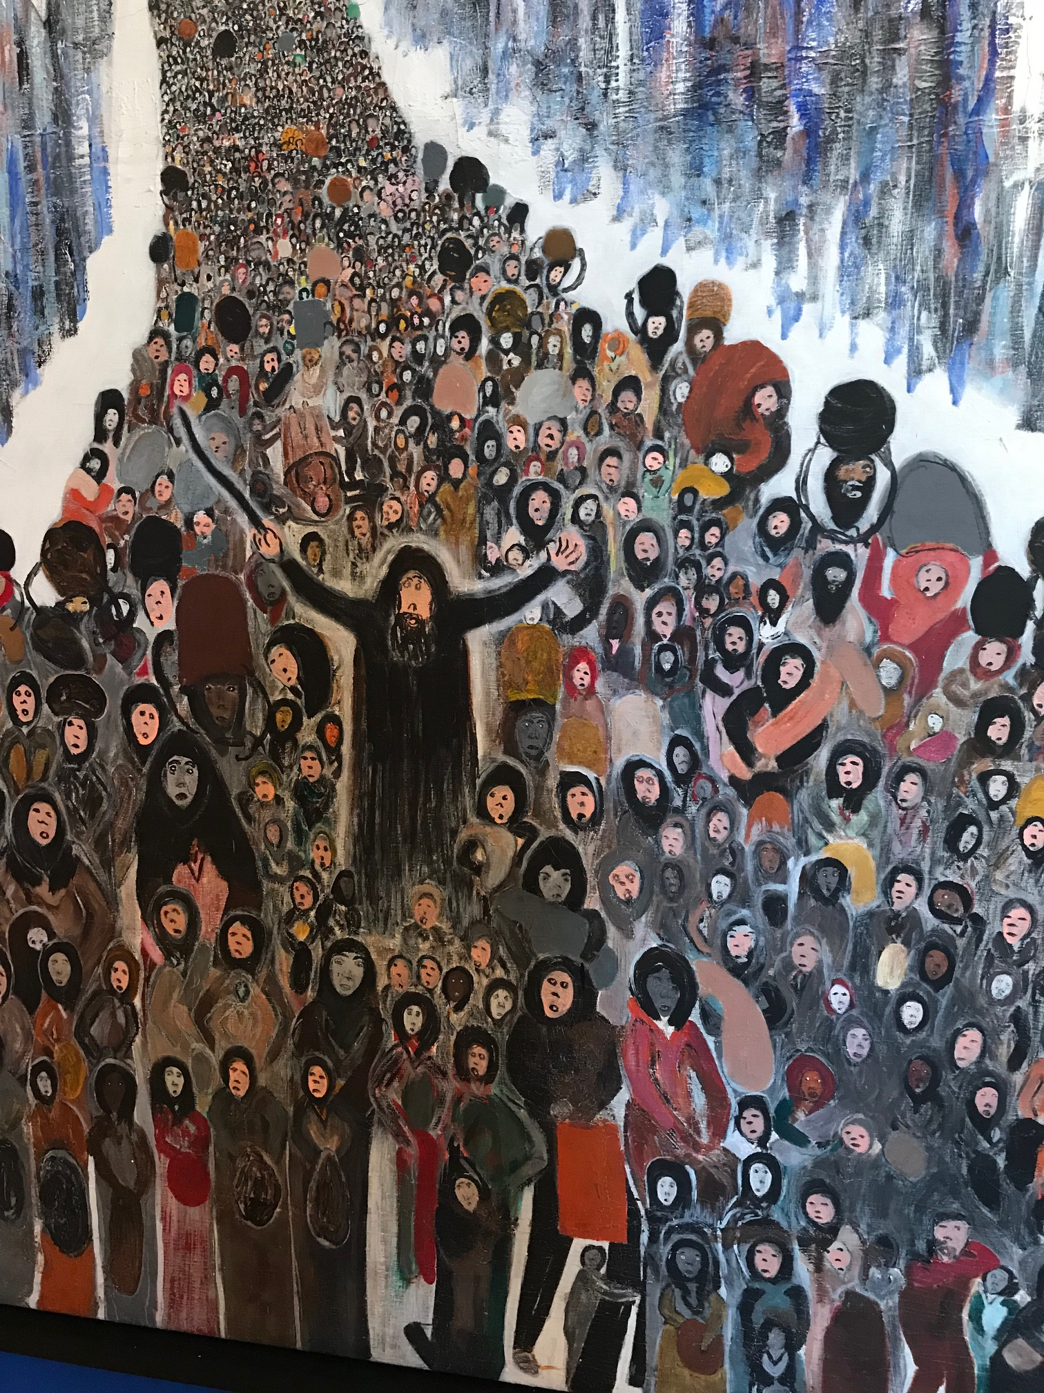
Flee From Egypt—Moses Parting the Red Sea by Rev. Albert Wagner
The piece is a large painting on a canvas about twenty feet wide and six feet high depicting the biblical parting of the Red Sea. In the foreground, a large crowd of people stand facing forward. At the bottom of the painting, the people are large enough to see the details of their faces. Most of the people have concerned or surprised expressions. Many are wearing long dark or earth-tone robes and some are carrying baskets or sacks. At the center of the crowd, one man in particular stands out. He has a long beard and is hunched over slightly with his arms spread wide over his head. The man holds a cane in his left hand and seems to draw the attention of the people near him as well as that of the viewer.
The crowd is flanked on both sides by enormous walls of water. The water is painted with long vertical streaks of mostly white and blues with accents that mirror of the colors of the crowd. As a result, the water seems to be pouring down like a waterfall while staying help back so it forms a smooth, uniform wall of water. The space between the walls of water is completely filled with the crowd which seems to extend back for miles.
Left Image Source:
Wagner, Albert Lee. “Flee from Egypt-Moses Parting the Red Sea.” AVAM.org, American Visionary Art Museum, Baltimore, MD.

Sensory Experience Guiding Questions
Not sure how to look at art? One way to think about it is by thinking about all of your senses. These are some questions you can think about when you look at a piece of art.
- Think about how this piece would feel if you could touch it. Is it rough or bumpy or smooth? Would it feel warm or cool? Would it be heavy or light if you picked it up?
- What sounds does this piece make you think of? Does it remind you of a song? Can you imagine someone’s voice? What do you think the artist might have been listening to when they made this art?
- Does this piece make you think of a memory you have? How did you feel then? What do you remember about the things you smelled or heard or felt or saw?
- Try to describe the piece to a friend. Think about the colors and shapes and where they are. What is it made out of? Describe what it would feel like if you could touch it. Are there any little details you didn’t notice at first glance?

Reflection on AVAM Accessibility “Sampler”
The American Visionary Art Museum (AVAM) generally does a good job of considering accessibility. The entire museum is wheelchair accessible with ramps, a conveniently located elevator, and comfortably wide hallways. Some of the art, like the wooden climbing structure in the sculpture garden, could present accessibility problems for visitors with limited mobility. However, most of the art is primarily visual. In addition to mobility aids, the museum offers video transcripts and closed captioning for visitors with hearing impairments since some of the exhibits have audio-visual elements.
Though the museum does well with access for visitors with mobility and hearing impairments, there is room for improvement in accessibility for people with visual impairments and autism. To fill this need, I created a visitor’s guide with social story elements to point out accessibility measures in place, audio descriptions for a few different types of pieces, and guiding questions for any art in the museum.
Visitor’s Guide
The goal of a social story is to provide a resource for people with autism, especially children, to help understand and navigate difficult situations. Social stories provide factual information in simple sentences and tend to use first person or third person narratives. They avoid opinions since everyone’s opinions differ, and often use positive and encouraging language. The visitor’s guide that I wrote includes elements of a social story but does not strictly follow the same format. The guide seeks to provide useful information about access in the museum and what to expect when visiting. Like a social story, it uses positive or neutral language and simple sentences. It also tends to avoid “you” statements which can be too accusatory or directive. The guide uses factual, descriptive statements rather than opinions and contains only necessary information.
In addition to the social story elements, the visitor’s guide has information directed toward people with a variety of disabilities. It is written in a large, easy-to-read font and includes relevant pictures to supplement the text. The guide includes sections about quiet cool-down spaces and the sensory experience of the museum which have information that is particularly important for people with autism and those with other disabilities that deal with the senses. In addition to the sensory and social descriptions, there is information geared toward people with physical disabilities and limited mobility. The visitor’s guide is presented as a general resource for all visitors of the museum so it was necessary to make it useful to as many people as possible.
Audio Descriptions
In creating the audio descriptions, I wanted to include a combination of visual details, like color and light, as well as descriptors that could be experienced tactilely or spatially, like shape and texture. I felt that the strictly visual elements were important because the art itself is intended to be experienced visually. However, the tactile and spatial descriptors were also particularly important because the target audience for audio descriptions do not rely primarily on vision. Since some people with visual impairments have never experienced color or light and dark, there needed to be enough non-visual descriptors that everyone could understand for each piece.
Audio descriptions are an effective way of making art more accessible to more people, especially when they appeal to senses other than the visual. Though they are undoubtedly valuable, it is a lot to ask of a museum with a collection as enormous as AVAM’s to provide descriptions of every piece, especially considering a large part of the collection is temporary. To supplement the audio descriptions, the museum could encourage visitors to come up with their own verbal descriptions following similar principles. This is one of the goals of the guiding questions which I will discuss in more depth.
Guiding Questions
Much of the art in AVAM is bold and very different from the type of art one expects to find in a “traditional” museum like the Philadelphia Museum of Art or the Louvre. The unconventional art makes it more fun for children so, even though it is not a children’s museum, AVAM does make an effort to be family friendly. The gift shop in particular is full of toys and has almost as much for a child to explore as the rest of the museum. However, art museums can often be difficult for children, and even adults, to appreciate and understand. The museum provides a list of questions specific to The Great Mystery Show made for elementary school tours. These questions turn the exhibit into a scavenger hunt of sorts to keep children engaged.
I wanted to draw attention to the art itself instead of the exhibition or the artists represented there. Rather than creating a scavenger hunt, I wrote a list of more general guiding questions that could help keep visitors engaged in the art. The questions focus on creating a multisensory experience around each piece. In addition to keeping children engaged, my hope is that these questions could also be helpful for supplementing a sensory experience for visitors with sensory impairments. For instance, a blind visitor may not get as much out of a verbal description that includes color and light if they have been blind their entire life. However, they may visit with a companion and could discuss pieces with a guiding questions about sound or texture. The purpose of the guiding questions is to supplement the visitor’s experience if that is something they need. They demonstrate the principle of universal design in that the same questions that may help a blind visitor understand a piece can also be used to engage a bored child or to supplement the experience of a curious adult.

Works Referenced
Gray, Carol. “The Social Story Quiz: Answers.” Carol Gray Social Stories, 2015, carolgraysocialstories.com/wp-content/uploads/2015/09/Answers-to-The-Social-Story-Quiz-.pdf.
Gray, Carol. “What Is a Social Story?” Carol Gray Social Stories, carolgraysocialstories.com/social-stories/what-is-it/.
Redvers-Row, Mandy. “Audio Description: An Art Form In Its Own Right.” Disability Arts Online, Arts Council England, 11 Nov. 2017, disabilityarts.online/magazine/opinion/audio-description-art-form-right/.
“Stuff Everyone Asks.” AVAM.org, American Visionary Art Museum, www.avam.org/stuff-everyone-asks/hours-and-directions.shtml.

For audio descriptions and Visitor’s Guide, most images were taken by myself. Those taken from elsewhere are cited below the image.

