American visionary art Museum 800 Key Highway, Baltimore, MD
Know before you go: Visitor’s guide to Avam

GETTING THERE
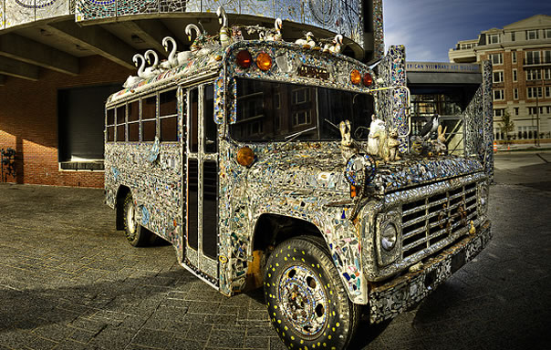
There are several accessible parking spaces near the building. When you arrive, you can enter through the door near the art bus (in the picture above). The museum has several buildings but the one near the art bus is the main one. Tickets are sold inside. There are also available at the front desk. Service animals are welcome, and both buildings have ramps and elevators on every floor.
Image source: Hoffberger, Jack. Gallery-A-Go-Go Bus. Baltimore, MD.
SENSORY EXPERIENCE
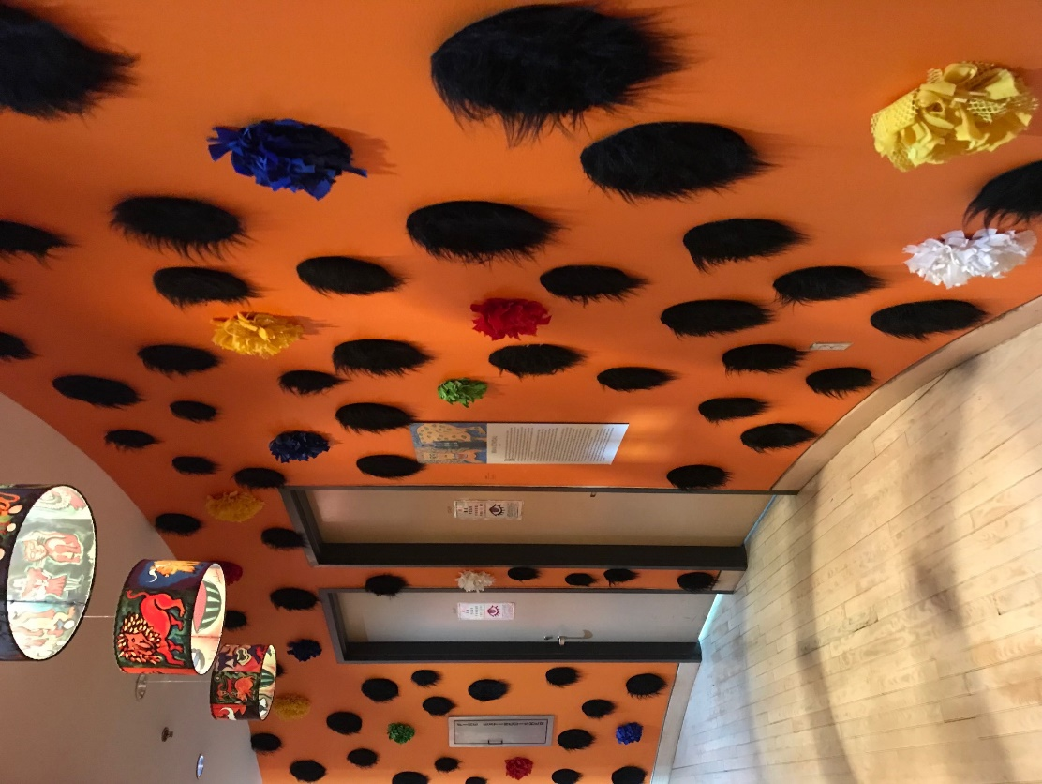
Most of the art is visual and made only to be looked at. There are a combination of paintings, drawings, and sculptures on display. In some of the exhibits, there are videos with sound. There captions or transcripts available for the videos. Some but not all the art can be touched. There are security guards on every floor that can tell you if it is okay to touch something.
QUIET SPACES
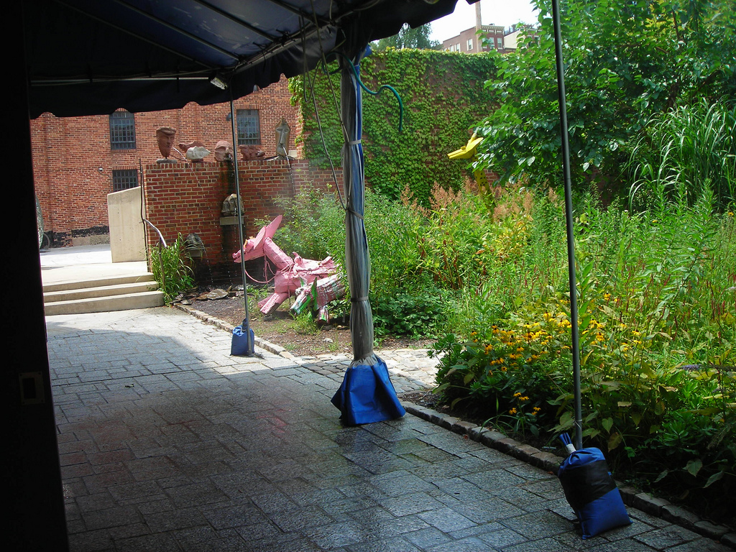
There is a lot of art to see and sometimes there will be a lot of visitors. Taking a break is a good idea and there are some quiet spaces throughout the museum. There are couches on most floors near the elevators and bottom floor is also quiet. Outside, there is a sculpture garden with some benches and a park nearby. Everyone can still get back into the museum after taking a break outside.
Image source: Joyce326. AVAM Sculpture Garden.
INTERACTIVES
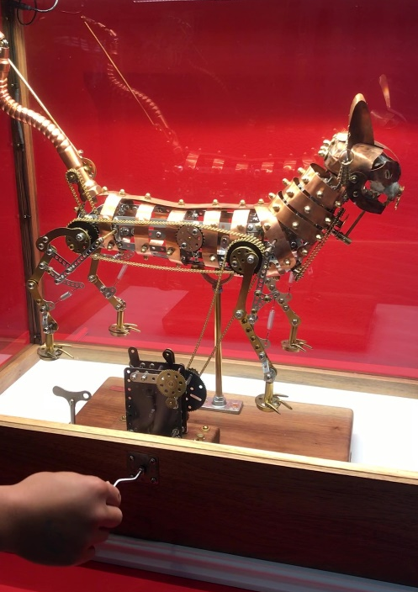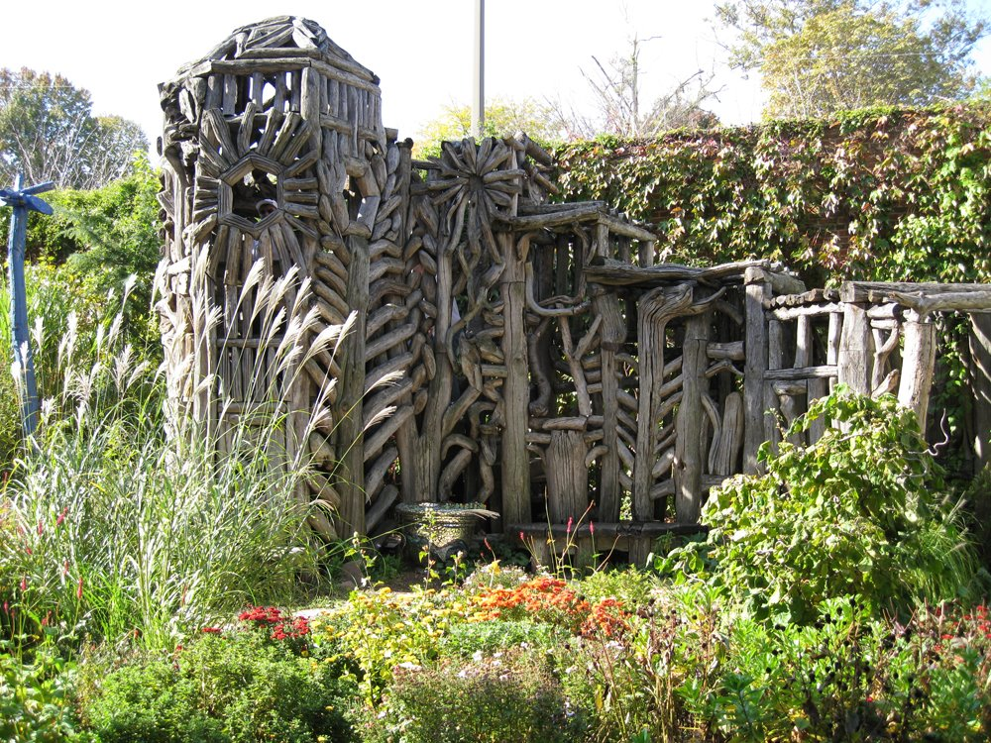
Inside the museum you will find some things that you can move by pushing a button, turning a crank, or moving a lever. There is also an exhibit with 3D glasses to look at some of the paintings. Outside, there is a sculpture garden with a large wooden sculpture (shown above) to climb inside of. The wooden structure is narrow and has steps, so it may not be accessible for visitors with limited mobility.
Image source (right): Becky Goldsmith, Becky. AVAM Wooden Sculpture. 3 Nov. 2008.
FOR MORE INFORMATION
AVAM Website: avam.org
Current Special Exhibitions:
- The Great Mystery Show
- Reverend Albert Lee Wagner: Miracle at Midnight
For Audio Descriptions of Some Art See Serendip
For Guiding Questions See Serendip
More Information Available at Front Desk

