Teacher Notes for “Using Models to Understand Photosynthesis”

In this analysis and discussion activity, students develop their understanding of photosynthesis by answering questions about three different models of photosynthesis. These models are a chemical equation, a flowchart that shows changes in energy and matter, and a diagram that shows the main processes in a chloroplast. Students use a drawing of a plant to create another model of photosynthesis. Finally, students evaluate the advantages of each type of model for understanding photosynthesis; this helps them to appreciate the role of scientific models.

This activity is intended to follow an activity that introduces ATP and cellular respiration, e.g., “How do organisms use energy?” (https://serendipstudio.org/exchange/bioactivities/energy).

Learning Goals
In accord with the Next Generation Science Standards:
- Students prepare for the Performance Expectation:
- HS-LS1-5. "Use a model to illustrate how photosynthesis transforms light energy into stored chemical energy."
- Students learn the following Disciplinary Core Idea:
- LS1.C: "The process of photosynthesis converts light energy to stored chemical energy by converting carbon dioxide plus water into sugars plus released oxygen.”
- Students engage in recommended Scientific Practices, especially:
- Using Models, “Develop and/or use multiple types of models to provide mechanistic accounts and/or predict phenomena, and move flexibly between model types based on merits and limitations.”
- This activity can be used to illustrate two Crosscutting Concepts:
- Systems and system models, including
  - “Models can be used to represent systems and their interactions – such as inputs, processes and outputs – and energy, matter, and information flows within systems.”
- Energy and matter: Flows, cycles and conservation, including
  - “Matter is conserved because atoms are conserved in physical and chemical processes.”
  - “Energy may take different forms (e.g. energy in fields, thermal energy, energy of motion).”
  - “Energy cannot be created or destroyed – only moves between one place and another place, between objects and/or fields, or between systems.”

Instructional Suggestions and Background Information
To maximize student learning, I recommend that you have your students work in pairs to complete groups of related questions. Student learning is increased when students discuss scientific concepts to develop answers to challenging questions. After students have worked together to answer each group of related questions, I recommend that you lead a class discussion that probes student thinking and helps students to develop a sound understanding of the concepts and information covered.

If your students are learning online, we recommend that they use the Google Doc version of the Student Handout available at https://serendipstudio.org/exchange/bioactivities/modelphoto. To answer questions 1-2 and 5-7, students can either print the relevant pages, draw on those and send you pictures, or they will need to know how to modify a drawing online. They can double-click on the relevant drawing in the Google Doc, which will open a drawing window. Then, they can use the editing tools to add lines, shapes, and text boxes.

You can prepare a revised version of the Student Handout, using the Word document. If you use the Word document, please check the format by viewing the PDF.

A key for the Student Handout is available upon request to Ingrid Waldron (iwaldron@upenn.edu). The following paragraphs provide additional instructional suggestions and background information – some for inclusion in your class discussions and some to provide you with relevant background that may be useful for your understanding and/or for responding to student questions.

Question 1 is designed to get students thinking about what they already know about photosynthesis. Class discussion of student answers to this question will alert you to any misconceptions your students may have. If your students begin with a weak understanding of photosynthesis, you may want to show your students the NOVA ~1-minute video introduction to photosynthesis (https://whyy.pbslearningmedia.org/resource/2bdaf922-572b-4f5c-a801-1eb2fb31b101/photosynthesis-unctv-science/) or you may want to precede this activity with a sequence of introductory photosynthesis activities (https://carbontime.create4stem.msu.edu/plants).

A model is a simplified representation of reality that highlights certain key aspects of a phenomenon and thus helps us to better understand and visualize the phenomenon. Many students tend to think of a model as a physical object and may not understand how a chemical equation or diagram can be a useful model. It may be helpful to introduce the idea of a conceptual model. As noted in A Framework for K-12 Science Education, “Conceptual models allow scientists… to better visualize and understand a phenomenon under investigation… Although they do not correspond exactly to the more complicated entity being modeled, they do bring certain features into focus while minimizing or obscuring others.” If your students are not familiar with conceptual models, you may want to give examples of conceptual models that students may have used, e.g. a map, a diagram of a football play, sheet music, or an outline of a chapter or a paper the student is writing.

The Student Handout focuses on understanding the basic process of photosynthesis and includes multiple simplifications. For example, the equation for photosynthesis follows the common convention that photosynthesis produces glucose. The Calvin cycle of photosynthesis actually produces three-carbon molecules which are converted to glucose and fructose, which can be combined to produce sucrose (which is transported throughout the plant). Also, the Student Handout only mentions photosynthesis in plants and omits mention of photosynthesis in cyanobacteria and in purple and green sulfur bacteria.

Another simplification is that the equations and flowchart in the Student Handout do not include the observation that much of the light that shines on a plant is not converted to chemical energy. Some of the light is not absorbed, some is converted to thermal energy, and there are additional inefficiencies. As a result, the net efficiency of leaves’ conversion of light energy to chemical energy is only ~5% (https://en.wikipedia.org/wiki/Photosynthetic_efficiency). The conservation of energy applies to the equivalence between the absorbed light energy (input) and the increase in stored chemical energy + thermal energy (outputs).

If your students are having trouble answering the energy input or output part of question 5, you may want to provide the following hint.

Hint: Read the conservation of energy paragraph carefully.

After question 6, you may want to insert this question.

7. A typical leaf is flat and thin, so each leaf cell is relatively near the surface of the leaf. How does this leaf shape help to maximize the rate of photosynthesis in leaves? | Cross-section of a leaf  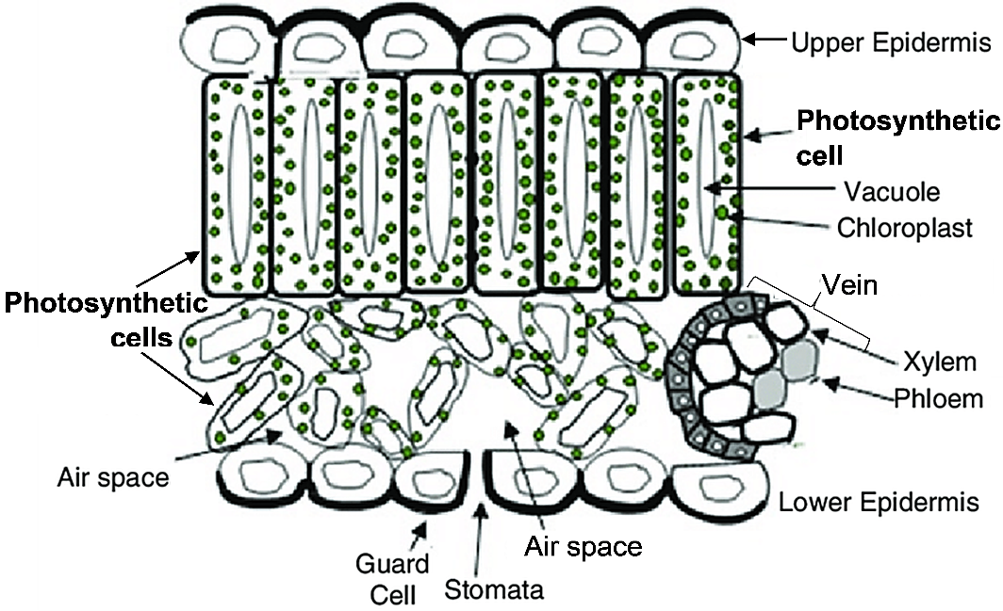

In order for chloroplasts to carry out photosynthesis, both CO₂ from the air and light must reach the chloroplasts. A thin, flat leaf makes it easier to meet both of these requirements for all of the chloroplasts. In addition, xylem brings water with dissolved minerals from the roots, and phloem carries sugars dissolved in water to the roots and other parts of the plant that do not photosynthesize.

The chloroplast diagram on page 3 of the Student Handout introduces some additional information about how photosynthesis occurs. Although the chloroplast diagram is a more detailed model of photosynthesis than the chemical equation or energy and matter flowchart, nevertheless, the chloroplast diagram (like all models) is still a simplification of a more complex reality. More of the complexities of photosynthesis are explained at http://www.bozemanscience.com/photosynthesis/.

To help your students understand the chloroplast diagram in the Student Handout, you may want to ask them to identify which arrows represent:
- movement of molecules into and out of the chloroplast;
- incoming light;
- ATP and NADPH transferring chemical energy and H atoms from the light-dependent reactions to the Calvin cycle;
- chemical reactions that use CO₂ molecules, H atoms and chemical energy to make sugar molecules.
Students who habitually recognize what different arrows represent will be better able to understand many types of diagrams and figures.

A typical leaf cell has about 40 chloroplasts, and a square millimeter of leaf typically has about 500,000 chloroplasts.

You may want to mention that the chlorophyll molecules in chloroplasts give leaves their green color. Or you may want to ask the questions, “Why are leaves green? Why aren’t roots green?”

The figures and explanations below provide more detail about where and how photosynthesis occurs. The first figure below shows the relationship of the microscopic chloroplasts to the macroscopic leaf. The second figure below provides additional information about how the internal structure of a chloroplast contributes to its function.
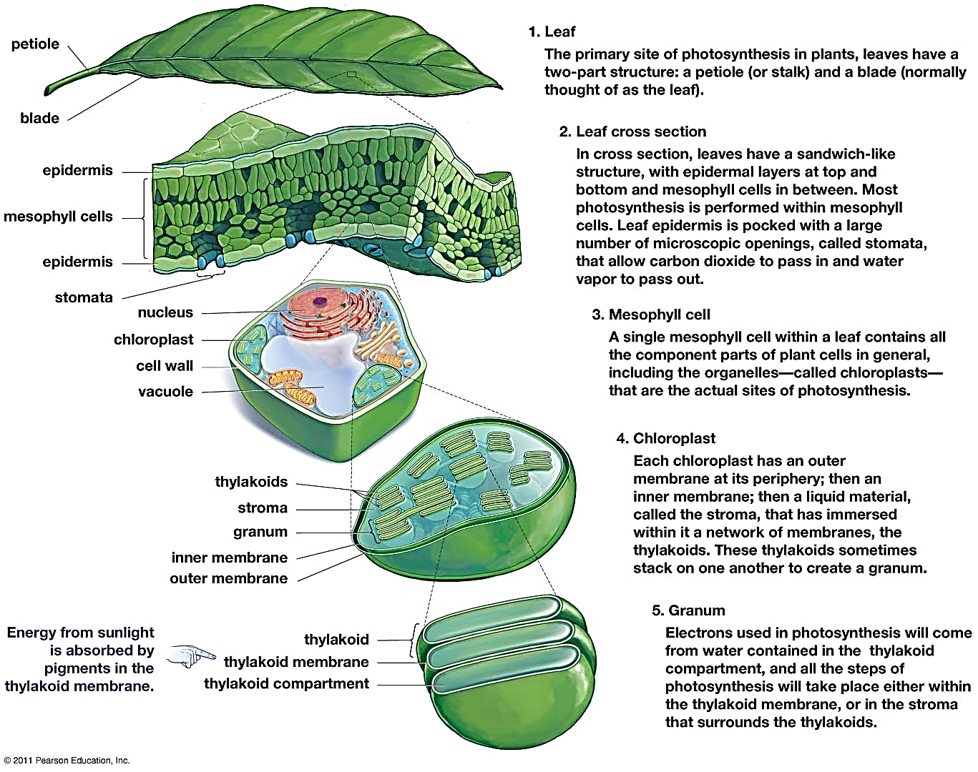
(from Krogh, 2011, Biology – A Guide to the Natural World)

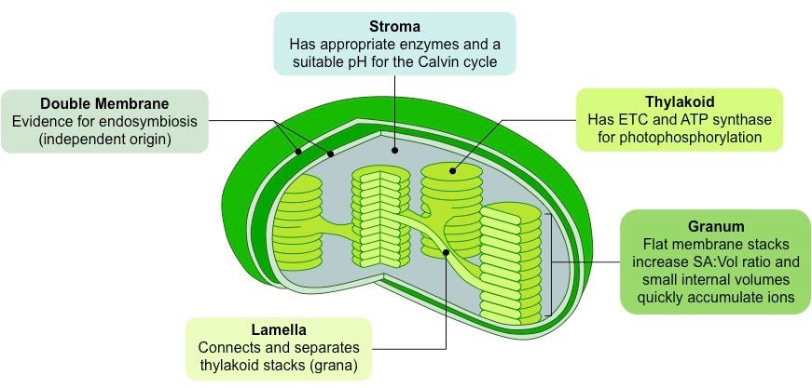
(https://ib.bioninja.com.au/higher-level/topic-8-metabolism-cell/untitled-2/chloroplast.html)

The thylakoid membrane in the chloroplasts plays several important roles in photosynthesis. Chlorophyll and proteins embedded in the thylakoid membrane absorb light and split water to produce O₂ plus H⁺ and electrons. The electron transport chain proteins in the thylakoid membrane produce NADPH and a proton gradient between the thylakoid compartment and the stroma. This proton gradient powers the enzyme, ATP synthase, which is also embedded in the thylakoid membrane. Thus, the thylakoid membrane is crucial for the production of NADPH and ATP which play key roles in the Calvin cycle which produces sugars. (https://en.wikipedia.org/wiki/Thylakoid; https://bio.libretexts.org/Bookshelves/Microbiology/Book%3A_Microbiology_(Boundless)/5%3A_Microbial_Metabolism/5.12%3A_Biosynthesis/5.12C%3A_The_Calvin_Cycle)

The figure below provides a simplified diagram of the Calvin cycle. This diagram shows one of the enzymes mentioned in question 8 – rubisco, which stands for ribulose bisphosphate carboxylase. One additional enzyme is required for the reduction phase of the Calvin cycle, and nine additional enzymes are required for the regeneration phase (https://bio.libretexts.org/Bookshelves/Microbiology/Microbiology_(Boundless)/05%3A_Microbial_Metabolism/5.12%3A_Biosynthesis/5.12E%3A_Regulation_of_the_Calvin_Cycle#:~:text=The%20enzymes%20involved%20in%20this,%2C%20phosphopentose%20epimerase%2C%20and%20phosphoribulokinase).

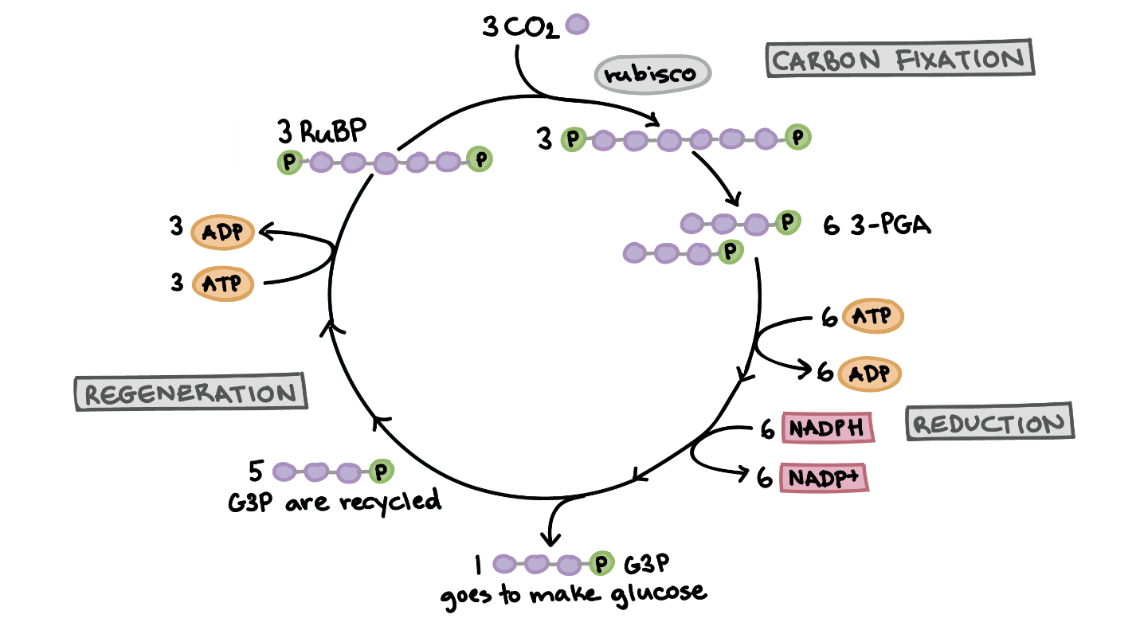
(Each purple ball represents one carbon atom in a molecule;
https://www.khanacademy.org/science/ap-biology/cellular-energetics/photosynthesis/a/calvin-cycle)

Discussion of student answers to question 9 should help your students to understand both the usefulness and the limitations of conceptual models. Question 9b highlights how the three different models of photosynthesis clarify different aspects of a complex biological phenomenon, so different models can be useful for different purposes. You may want to add to question 9 the model that the students created in response to question 6.

Possible Follow-up Activities (all support NGSS)
Photosynthesis and Cellular Respiration – Understanding the Basics of Bioenergetics and Biosynthesis
In this minds-on activity, students analyze how photosynthesis, cellular respiration, and the hydrolysis of ATP provide energy for biological processes. Students learn that sugar molecules produced by photosynthesis are used for cellular respiration and for the synthesis of other organic molecules. Thus, photosynthesis contributes to plant energy metabolism and plant growth. The optional final section challenges students to explain observed changes in biomass for plants growing in the light vs. dark. The Student Handout and Teacher Preparation Notes are available at https://serendipstudio.org/exchange/bioactivities/photocellrespir.
or

Photosynthesis, Cellular Respiration and Plant Growth
This minds-on, hands-on activity begins with the driving question of how a tiny seed grows into a giant sequoia tree. To address this question, students first consider what types of molecules and atoms are in plants. Next, they analyze data from an experiment on changes in plant biomass in the light vs. dark. Then, they conduct an experiment to evaluate changes in CO₂ concentration in the air around plants in the light vs. dark. Students interpret these data to develop an increasingly accurate and evidence-based model of the contributions of photosynthesis and cellular respiration to changes in plant biomass. This activity counteracts several common misconceptions about plant growth, photosynthesis, and cellular respiration. The Student Handout and Teacher Preparation Notes are available at https://serendipstudio.org/sci_edu/waldron/#photobiomass

Where does a tree's mass come from?
Students analyze evidence to evaluate four hypotheses about where a tree’s mass comes from. For example, students analyze Helmont’s classic experiment and evaluate whether his interpretation was supported by his evidence. Thus, students engage in scientific practices as they learn that trees consist mainly of water and organic molecules and most of the mass of the organic molecules consists of carbon and oxygen atoms that came from carbon dioxide molecules in the air. The Student Handout and Teacher Notes are available at https://serendipstudio.org/exchange/bioactivities/plantmass

Why do some plants grow in odd shapes?
In this analysis and discussion activity, students investigate several examples of plants that have grown in odd shapes. As students analyze these anchoring phenomena, they learn (1) how the zones of cell division and elongation contribute to the growth of stems and roots; (2) how the effects of a plant hormone on cell elongation contribute to plant responses to light and gravity; and (3) how differentiated cells (xylem cells, phloem cells and photosynthetic cells) cooperate to supply all parts of the plant with needed molecules and ions. In this activity, students interpret data from scientific studies, develop and refine scientific models, and answer additional analysis and discussion questions. The Student Handout and Teacher Notes are available at https://serendipstudio.org/exchange/bioactivities/plant.

Additional activities for learning about photosynthesis and cellular respiration are available in "Cellular Respiration and Photosynthesis – Important Concepts, Common Misconceptions, and Learning Activities" (https://serendipstudio.org/exchange/bioactivities/cellrespiration).

Source for Figures in Student Handout
- Figure on top of page 1 and bottom of page 2 modified from https://i.pinimg.com/originals/f8/e1/10/f8e11021445a4c54417401d7f653279c.jpg
- Figure on page 3 modified from http://www.mhhe.com/biosci/esp/2001_gbio/folder_structure/ce/m6/s4/assets/images/cem6s4_1.jpg
The chemical equations figure on page 1 was constructed by the author.

By Dr. Ingrid Waldron, Dept. Biology, University of Pennsylvania, © 2023. These Teacher Notes and the Student Handout for this activity are available at https://serendipstudio.org/exchange/bioactivities/modelphoto
You may also want to have your students complete "Using Models to Understand Cellular Respiration" (https://serendipstudio.org/exchange/bioactivities/modelCR).
Quotes from Next Generation Science Standards, available at https://www.nextgenscience.org/ and https://www.nextgenscience.org/sites/default/files/HS%20LS%20topics%20combined%206.13.13.pdf
To draw a shape - At the top of the page, find and click Shape. - Choose the shape you want to use. - Click and drag on the canvas to draw your shape. To insert text - At the top of the page, click Insert. - To place text inside a box or confined area, click Text Box and drag it to where you want it. - Type your text. - You can select, resize and format the word art or text box, or apply styles like bold or italics to the text. When you are done, click Save and Close.
Quotation from A Framework for K-12 Science Education: Practices, Crosscutting Concepts, and Core Ideas (available at http://www.nap.edu/catalog.php?record_id=13165).
The figure in this question is modified from https://classnotes123.com/wp-content/uploads/2022/06/Cross-Section-of-Leaf-Class-10-.png.
Although photosynthesis in plants occurs in chloroplasts, prokaryotes (e.g. cyanobacteria) carry out photosynthesis without chloroplasts.
Obviously, leaves are not always green. Other pigments in leaves can assist chlorophyll by absorbing light at different wavelengths and passing the energy to chlorophyll. In some types of plant, the large quantity of these other pigments masks the green of the chlorophyll, but, even in these leaves, chlorophyll is needed for the light reactions that begin photosynthesis. In deciduous trees in the fall, leaves lose their chlorophyll so the colors of the other pigments are seen in fall foliage. Some plants lack chlorophyll and do not photosynthesize; instead, they are parasitic on other plants.

