Using Models to Understand Photosynthesis

1a. Add to this drawing to show what you already know about:  - the inputs needed for photosynthesis  - the outputs produced by photosynthesis.  1b. What do you already know about why plants need to carry out photosynthesis? | 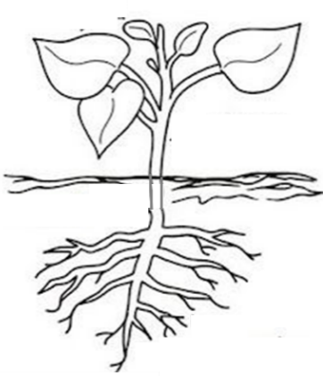

To learn more about photosynthesis, you will analyze three different scientific models of photosynthesis. A scientific model is a simplified representation of reality that highlights some key features of a process such as photosynthesis.

One model of photosynthesis is a chemical equation that summarizes the inputs and outputs of photosynthesis. This figure shows three different versions of the chemical equation that summarizes photosynthesis.
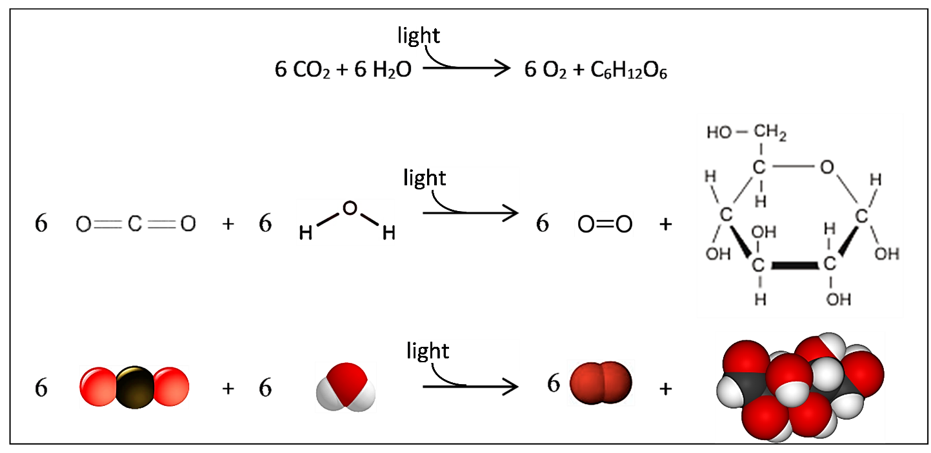
2a. Circle each of the three different representations of the sugar glucose.

2b. Why is photosynthesis a good name for this process?

3. Plant cells use the sugar molecules produced by photosynthesis for two purposes. Some of the sugar molecules are used to synthesize other organic molecules like amino acids and cellulose so the plant can grow. Other sugar molecules and oxygen are used for

__________________________ to make ______ which provides the energy for many biological processes.

Several general principles apply to photosynthesis and all other biological processes.

- Conservation of matter means that atoms are neither created nor destroyed. However, a chemical reaction can reorganize the atoms in input molecules into different output molecules.

- Conservation of energy means that energy is neither created nor destroyed. However, one type of energy can be converted to another type of energy. For example, photosynthesis converts light energy to chemical energy.

- Energy is not converted to matter and matter is not converted to energy.

4. Explain how the chemical equation for photosynthesis illustrates the conservation of matter.
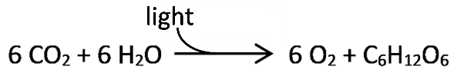

5. General principle C is illustrated in another type of model of photosynthesis – an energy and matter flowchart. Complete this energy and matter flowchart to show how energy and matter change during photosynthesis.
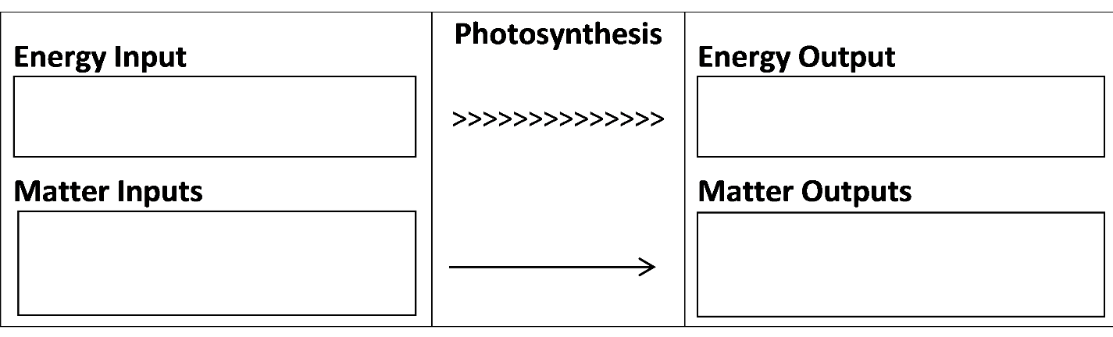

6. Label this figure to summarize what you now know about photosynthesis. If you can, show where each input enters the plant and where one of the outputs exits the plant. (A good answer will provide another model of photosynthesis.)
Photosynthesis takes place in chloroplasts inside leaf cells. This simplified diagram of a chloroplast is another model of photosynthesis.  Photosynthesis includes many steps. The two main groups of steps in photosynthesis are:  - the light-dependent reactions, which convert light energy to chemical energy  - the Calvin cycle, which uses chemical energy, CO₂ molecules, and H atoms to synthesize sugar molecules.  7a. Inside the chloroplast, chlorophyll molecules absorb light and help to convert light energy to |  | 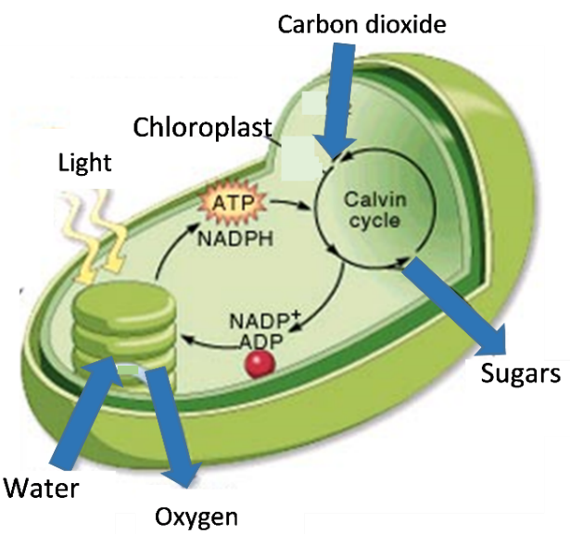
chemical energy. Put an * in the chloroplast diagram to show where chlorophyll molecules should be located to accomplish their function.

7b. Circle the molecules that carry chemical energy and hydrogen atoms from the light-dependent reactions to the Calvin cycle.

8. Suppose that a chloroplast lacked the enzymes needed for the chemical reactions in the Calvin cycle. Could this chloroplast produce sugars when it receives the inputs for photosynthesis (light, water and carbon dioxide)? yes ___ no ___ Explain why or why not.

9a. What are some basic features of photosynthesis that are shown in all three models presented in this activity – the chemical equation on page 1, the energy and matter flowchart on page 2, and the chloroplast diagram on this page?

9b. Different types of models have different advantages for understanding photosynthesis. In the table below, describe the advantages of each type of model. How does this type of model contribute to your understanding of photosynthesis?

Advantages of the
chemical equation

Advantages of the
energy and matter flowchart

Advantages of the
chloroplast diagram

By Dr. Ingrid Waldron, Dept Biology, Univ Pennsylvania, © 2023. This Student Handout (can be copied for classroom use) and Teacher Notes (with background information and instructional suggestions) are available at https://serendipstudio.org/exchange/bioactivities/modelphoto.

