Teacher Notes for
“What types of mutations cause more vs. less severe muscular dystrophy?”

This analysis and discussion activity begins with a brief video about a teenager who has Duchenne muscular dystrophy. Then, students investigate the types of deletion mutation that cause the more severe Duchenne muscular dystrophy vs. the milder Becker muscular dystrophy. During this analysis, students review transcription and translation, learn how to use a codon wheel, and analyze the molecular effects of different types of deletion and point mutations. Finally, students investigate X-linked recessive mutations to understand why almost all Duchenne muscular dystrophy patients are male.

Before students begin this activity, they should understand the processes of transcription and translation. For this purpose, I recommend either of these activities:
- “How Genes Can Cause Disease – Introduction to Transcription and Translation" (a hands-on simulation activity available at https://serendipstudio.org/sci_edu/waldron/#trans) or
- “How Genes Can Cause Disease – Understanding Transcription and Translation” (an analysis and discussion activity, available at https://serendipstudio.org/exchange/bioactivities/trans).

Learning Goals
In accord with the Next Generation Science Standards and A Framework for K-12 Science Education:
- Students will gain understanding of the Disciplinary Core Ideas:
- LS1.A: Structure and Function – “Genes are regions in the DNA that contain the instructions that code for the formation of proteins, which carry out most of the work of cells.”
- LS3.B: Variation of Traits – "Although DNA replication is tightly regulated and remarkably accurate, errors do occur and result in mutations, which are also a source of genetic variation."
- Students will engage in the Scientific Practices:
- Constructing Explanations – “Apply scientific ideas, principles and/or evidence to provide an explanation of phenomena…”
- Using Models – “… use a model to predict and/or describe phenomena.”
- This activity provides the opportunity to discuss the Crosscutting Concept:
- Cause and effect: Mechanism and explanation – Students “propose causal relationships by examining what is known about smaller scale mechanisms within the system.”
- This activity helps to prepare students for the Performance Expectations:
- HS-LS3-1 – “Ask questions to clarify relationships about the role of DNA and chromosomes in coding the instructions for characteristic traits passed from parents to offspring.”
- HS-LS3-2 – "Make and defend a claim based on evidence that inheritable genetic variations may result from mutations…"
Additional Content Learning Goals
- Different versions of a gene result in different versions of a protein which can result in different characteristics. For example, a mutation in the DMD gene can result in no functional dystrophin protein in skeletal and heart muscles; this results in the muscle breakdown which causes Duchenne muscular dystrophy.
- A gene provides the instructions for making a protein via the processes of transcription and translation.
- A codon wheel summarizes which mRNA codons specify which amino acids during translation. The codon wheel also specifies the start and stop codons.
- If a deletion mutation causes the deletion from the mRNA molecule of any number of nucleotides that is not a multiple of 3, this causes a frameshift during translation of the mRNA. After this frameshift, every codon is changed, which results in the production of a nonfunctional protein. In contrast, a deletion mutation that causes the deletion of three nucleotides or a multiple of three nucleotides from the mRNA molecule will generally have less severe consequences since there is no frameshift and the codons after the deletion will remain the same.
- The majority of cases of the more severe Duchenne muscular dystrophy result from frameshift deletion mutations, while deletion mutations that do not cause a frameshift generally result in the milder Becker muscular dystrophy.
- Another cause of Duchenne muscular dystrophy can be a point mutation that results in an early stop codon in the DMD mRNA.
- Because the DMD gene is located on the X chromosome and disease-causing mutations are recessive, muscular dystrophy is very rare in females, and almost all muscular dystrophy patients are males.

Suggestions for Implementation and Background Biology
To maximize student learning, I recommend that you have your students work in pairs to complete groups of related questions. Student learning is increased when students discuss scientific concepts to develop answers to challenging questions. After students have worked together to answer each group of related questions, I recommend having a class discussion that probes student thinking and helps students to develop a sound understanding of the concepts and information covered.

If your students are learning online, I recommend that they use the Google Doc version of the Student Handout available at https://serendipstudio.org/exchange/bioactivities/melanoma. To answer questions 3, 6-11, students can either print the relevant pages, draw on them and send pictures to you, or they will need to know how to modify a drawing online. To answer online, they can double-click on the relevant drawing in the Google Doc to open a drawing window. Then, they can use the editing tools to answer the question.

You may want to revise the Word document or Google Doc to prepare a version of the Student Handout that will be more suitable for your students. If you use the Word document, please check the format by viewing the PDF.

A key is available upon request to Ingrid Waldron (iwaldron@upenn.edu). The following paragraphs provide additional instructional suggestions and background information – some for inclusion in your class discussions and some to provide you with relevant background that may be useful for your understanding and/or for responding to student questions.

This activity begins with a 5-minute video (https://www.youtube.com/watch?v=CkbaEjpxQ3g) that introduces a teenager who is living a full life despite his Duchenne muscular dystrophy, together with an expert who briefly describes the biology of Duchenne muscular dystrophy.
These figures show the role of dystrophin in muscle cells. Each skeletal muscle is made up of many muscle fibers (top figure). Each muscle fiber is a muscle cell. Unlike most cells, each muscle fiber has multiple nuclei.  The internal cytoskeleton of a muscle fiber is connected to membrane proteins, which are connected to the proteins in the basal lamina (middle figure). These connections protect the fragile cell membrane against damage caused by the mechanical stresses of repeated muscle contraction and relaxation. The dystrophin protein plays a crucial role, because it connects the cytoskeleton to membrane proteins and acts as a shock absorber (bottom figure).  In Duchenne muscular dystrophy, defective dystrophin doesn’t connect to membrane proteins. Therefore, the mechanical stresses of repeated muscle contractions cause instability and leakiness of the muscle cell | 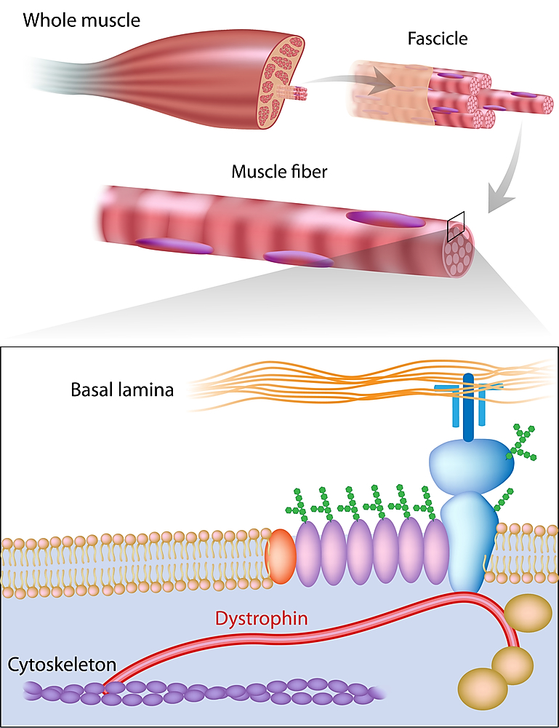

membrane (sarcolemma). Leaky muscle cell membranes cause multiple problems, including influx of excessive calcium and leakage of cell contents, which results in inflammation. As a result, more and more muscle cells die, so the muscle becomes weaker and weaker. | 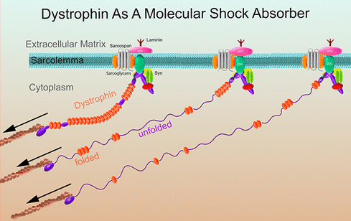  (https://pubs.acs.org/doi/10.1021/acsnano.8b05721 )

As you know from the Student Handout, the DMD gene gives the instructions for making dystrophin. You may want to point out that the DMD gene was discovered by scientists who were investigating the cause of Duchenne muscular dystrophy, which accounts for the name of the gene.

A mutation is a permanent change in the DNA. More than 7000 different mutations in the DMD gene have been identified in patients with Duchenne muscular dystrophy (https://www.frontiersin.org/articles/10.3389/fphys.2023.1183101/full).

Page 1 of the Student Handout introduces the distinction between the more severe Duchenne muscular dystrophy and the milder Becker muscular dystrophy. Question 2 should get your students thinking about the driving question for this activity, “What types of mutations cause more vs. less severe muscular dystrophy?” Students may hypothesize that the size of the mutation correlates with the severity of the disease. This reasonable hypothesis is not correct, but please do not reveal that until after your students have answered question 15. (See page 6 of these Teacher Notes.)

Questions 3-9 review the basic molecular biology of transcription and translation. Questions 8-9 will reinforce student understanding of how translation produces the correspondence between codons in mRNA and amino acids in the polypeptide which is being synthesized by the ribosome. For each codon in the mRNA, a tRNA with an anti-codon that matches the codon by the base-pairing rules brings the correct amino acid into the ribosome, and the ribosome adds the amino acid to the growing polypeptide. There are multiple different types of tRNA molecules, each with an anticodon that matches a codon in the mRNA by the base-pairing rules. Before a tRNA molecule enters the ribosome, a specific enzyme for each type of tRNA attaches the correct amino acid for that tRNA’s anticodon.

Questions 10-12 will help students to understand how the codon wheel is used to predict the outcome of translation. If you prefer a genetic code table, you can substitute the one shown below. An explanation of the advantages of the codon wheel is provided at http://www.millerandlevine.com/circular.html.

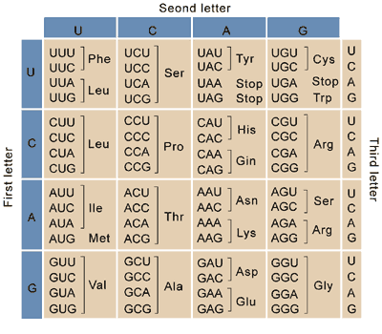
(https://upload.wikimedia.org/wikipedia/commons/2/21/06_chart_pu3.png)

The DNA nucleotide sequences shown in the table in question 13 should be assumed to be the beginning of the template strand (i.e. the DNA strand that RNA polymerase uses to make mRNA). Students may find it easier to complete the second column of the table in question 13a if they first mark every three nucleotides in each version of the DNA.

Question 14 introduces the contrast between mutations that delete 3 nucleotides vs. mutations that delete 1 or 2 nucleotides and thus cause a frameshift. Deletion mutations 1 and 2 in question 13 result in a shift in the reading frame in the ribosome (called a frameshift mutation). Deletion mutation 2 results in an early stop codon (called a nonsense mutation). To help students understand the difference in effects of deletion mutations that shift the reading frame vs. mutations that do not shift the reading frame, you may want to use the example shown below.

Normal sentence

The big cat ate the fat rat.

Deletion mutation 1 sentence (frameshift sentence)
g deleted

The bic ata tet hef atr at.

Deletion mutation 3 sentence (no frameshift)
big deleted

The cat ate the fat rat.

The severity of the effects of the deletion mutations in the DNA depends in large part on the number of nucleotides missing from the mRNA (https://europepmc.org/article/med/2491009). If the number of nucleotides missing from the mRNA is not a multiple of three, this causes a frameshift which generally results in no functional dystrophin protein; no functional dystrophin protein results in more rapid breakdown of muscle cells and the more severe Duchenne muscular dystrophy. If the number of nucleotides missing from the mRNA is a multiple of three, the mutation does not cause a frameshift, which typically results in a less defective version of the dystrophin protein, less rapid breakdown of muscle cells, and the milder Becker muscular dystrophy.

Notice that the crucial factor is whether or not the mutation is a frameshift mutation, not the overall length of the deletion which can be quite long for some cases of Becker muscular dystrophy and quite short for some cases of Duchenne muscular dystrophy. As you discuss student answers to question 15, you will probably want to revisit their answers to question 2. You can also discuss the Crosscutting Concept, Cause and effect: Mechanism and explanation – Students “propose causal relationships by examining what is known about smaller scale mechanisms within the system.”

Approximately 60% of cases of Duchenne muscular dystrophy are due to deletion mutations, and another 10% are due to duplication mutations. If you want your students to learn how unequal crossing-over during meiosis results in deletion (and duplication) mutations, you can end this activity with the Optional Additional Student Handout Page shown on the last page of these Teacher Notes.

The DMD gene is an extremely long gene, which contributes to its relatively high mutation rate. Approximately 30% of cases of muscular dystrophy are due to new mutations during gamete formation in the mother or maternal grandparents (often called de novo mutations) (https://www.ncbi.nlm.nih.gov/pmc/articles/PMC3970902/). In the absence of new mutations, the prevalence of Duchenne muscular dystrophy would gradually decrease because it is disabling before reproductive age.

In addition to mutations caused by deletion of one or more nucleotides, one important type of mutation is a change in one or more nucleotides. As discussed in question 16, a change in a single nucleotide can cause Duchenne muscular dystrophy if it results in an early stop codon. For a more complete and consequently more accurate description of the mutations involved in Duchenne and Becker muscular dystrophy, see https://www.parentprojectmd.org/about-duchenne/what-is-duchenne/types-of-mutations/.

As preparation for question 17, students should be familiar with the basics of inheritance; for this purpose, I recommend “Introduction to Genetics – Similarities and Differences between Family Members” (https://serendipstudio.org/exchange/bioactivities/geneticsFR) or “Genetics” (https://serendipstudio.org/sci_edu/waldron/#genetics). Both Duchenne muscular dystrophy and Becker muscular dystrophy result from mutations in the DMD gene on the X chromosome. The drawings of the unaffected carrier mother and daughter could be misinterpreted to suggest that half of each carrier has muscular dystrophy and half doesn't. Instead, each cell has both X chromosomes, and one of the X chromosomes is randomly inactivated in each cell.

Approximately 10-20% of female carriers have some muscle weakness, mainly due to non-random inactivation of the X chromosome which has the normal allele. Because the dystrophin gene is on the X chromosome and the alleles for defective dystrophin are recessive, both Duchenne and Becker muscular dystrophy are observed almost exclusively in boys. The alleles for defective dystrophin are recessive because a single normal allele in female carriers usually results in sufficient normal dystrophin to keep muscle cells healthy.

Duchenne muscular dystrophy is currently incurable, but various treatments can reduce the symptoms and postpone the worst outcomes. The FDA has approved two types of gene therapy for Duchenne muscular dystrophy patients with specific mutations (https://www.chop.edu/gene-therapy-duchenne-muscular-dystrophy). Researchers are developing additional types of gene therapy that they hope will provide effective treatments for more muscular dystrophy patients (https://www.frontiersin.org/articles/10.3389/fphys.2023.1183101/full). Techniques for genetic testing of carrier mothers and for prenatal diagnosis can provide the basis for avoiding births of affected sons or carrier daughters (https://www.parentprojectmd.org/about-duchenne/is-it-duchenne/genetic-testing/; https://www.nhs.uk/conditions/muscular-dystrophy/genetic-tests/).

For more information on muscular dystrophy see:
- “About Duchenne Muscular Dystrophy” (https://www.genome.gov/Genetic-Disorders/Duchenne-Muscular-Dystrophy)
- “What is Duchenne Muscular Dystrophy” (https://www.mda.org/sites/default/files/2020/10/MDA_DMD_Fact_Sheet_Oct_2020.pdf)
- “Duchenne muscular dystrophy” (https://kidshealth.org/en/parents/duchenne-md.html; also available in Spanish)
- “Becker muscular dystrophy” (https://kidshealth.org/en/parents/becker-md.html; also available in Spanish)
- “Duchenne muscular dystrophy and dystrophin” (https://www.youtube.com/watch?v=Ebu8W8Osuxk) This 8-minute video explains the biology of Duchenne muscular dystrophy and describes gene therapies to treat this disease.

Additional Activities
Additional molecular biology learning activities are suggested in "Molecular Biology: Major Concepts and Learning Activities" (https://serendipstudio.org/exchange/bioactivities/MolBio).

“Cut it out! Editing DNA with CRISPR-Cas9” (https://www.nsta.org/ncss-case-study/cut-it-out) is an analysis and discussion activity that develops student understanding of current research on gene editing to treat muscular dystrophy in mice. For a high school class, you may want to use only the first two pages of this case study with their links to two resources that should be appropriate for students who have a high school background in molecular biology. You may want to omit the last two pages of the case study since they depend on reading and understanding a technical review of the molecular biology of gene editing.

Sources for Figures in Student Handout
- Deletion mutation modified from https://d20khd7ddkh5ls.cloudfront.net/deletion.png
- Overview of transcription and translation + translation in ribosome, both modified from Krogh, Biology – A Guide to the Natural World
- tRNA modified from https://www.geeksforgeeks.org/transfer-rna/
- Codon wheel from http://biobook.kuensting.org/bb/genetics/dna/1000px-Aminoacids_table.png
- Inheritance of X-linked DMD gene from https://almostadoctor.co.uk/wp-content/uploads/2017/06/X-linked_recessive-inheritance.png
Optional Additional Page for Student Handout

For about one third of boys with muscular dystrophy, the mutation that causes the boy’s muscular dystrophy occurred during gamete formation in his mother or in one of his mother’s parents. To understand how a new deletion mutation in the DMD gene can occur, we will begin by reviewing meiosis, the type of cell division that produces haploid gametes.
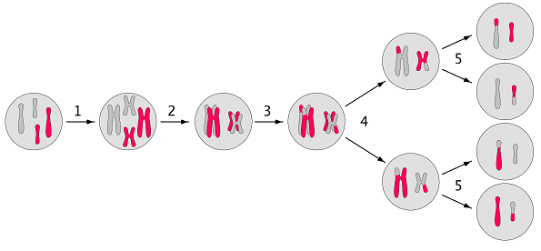
18. Which numbered arrow corresponds to each of the following?
- crossing-over ___
- DNA replication ___
- first cell division ___
- homologous chromosomes line up ___
- second cell division, which produces gametes ___

19. The DMD gene is a very large gene, which is represented in this figure by the parts of the chromosome labeled B, C and D. Explain how unequal crossing-over can produce a chromosome with a deletion mutation. | 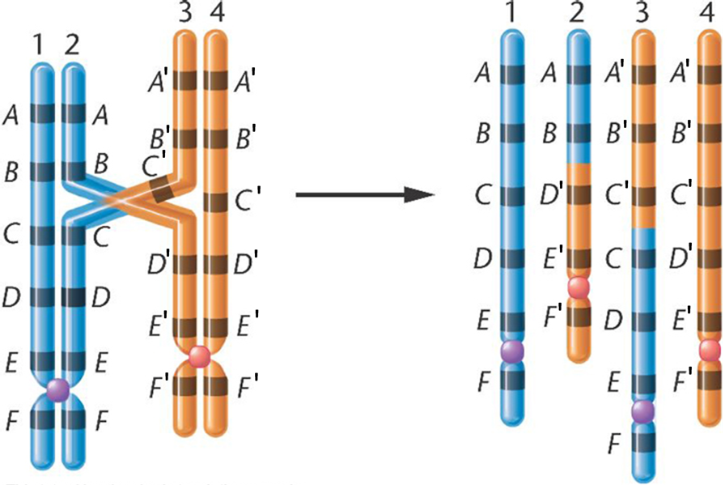

20. Suppose that a gamete with a deletion mutation in the DMD gene is fertilized to produce a zygote. Explain how this zygote would develop into a person who has this mutated DMD gene in every muscle cell.

By Dr. Ingrid Waldron, Department of Biology, University of Pennsylvania, 2024. These Teacher Notes and the Student Handout for this activity are available at https://serendipstudio.org/exchange/bioactivities/mutation.
Next Generation Science Standards (https://www.nextgenscience.org/get-to-know)
A Framework for K-12 Science Education: Practices, Crosscutting Concepts, and Core Ideas (https://www.nap.edu/catalog/13165/a-framework-for-k-12-science-education-practices-crosscutting-concepts).
The figure (https://musculardystrophynews.com/wp-content/uploads/2015/09/shutterstock_115987327.jpg) shows the structure of a skeletal muscle. The anatomy of cardiac muscle is similar, but with some structural and functional differences. For example, each cardiac muscle fiber has a single nucleus, and there are end-to-end junctions between cardiac muscle fibers.
For additional information, see https://www.frontiersin.org/articles/10.3389/fphys.2023.1183101/full.
The term allele is generally used for different versions of a gene that result in different characteristics. However, different versions of a gene that result in a disease are often called mutations and the version of the gene that does not cause disease is called normal.
⁶ After students develop their individual answers to question 7, you may want to have each small group of students develop a consensus answer on a whiteboard. A class discussion of each group’s whiteboard will provide the opportunity to reinforce student understanding of basic molecular biology and clarify any misunderstandings. For this purpose, you will want one whiteboard per student group in your largest class. For information about how to make inexpensive whiteboards and use them in your teaching, see "The $2 interactive whiteboard" and "Resources for whiteboarding" in https://fnoschese.wordpress.com/2010/08/06/the-2-interactive-whiteboard/. To obtain whiteboards, you can go to Home Depot or Lowe's and ask them to cut a 8' x 4' whiteboard (e.g. EUCATILE Hardboard Thrifty White Tile Board) into six pieces with the dimension 32" x 24". They should have a power saw rig that allows their employees to cut the pieces very easily. They should not charge to cut them and the product cost is reasonable. Some important tips for using whiteboards: – Coat the white boards with Endust (or similar product) before using. Every once in a while, wipe them clean and reapply Endust. – Black markers are easiest to erase. To prevent stains, erase right away, especially red or green markers. Do not use markers that are old or almost empty, since the ink from these is more difficult to erase. Recommended brands are Expo markers and Pilot BeGreen markers. To clean up stains you can use Windex or Expo Whiteboard Cleaner. – Teacher and/or students can take a picture of the information on the board if they want to save it.
To avoid overloading students with technical terms, the word "frameshift" is not included in the Student Handout. Of course, you are welcome to include this term if you think it will be helpful for your students.
The type of muscular dystrophy can be influenced by additional factors such as whether the mutation results in an early stop codon and the specific location of the mutation in the dystrophin gene.
Duchenne and Becker muscular dystrophies affect roughly 1 in every 5,000 boys.

