Teacher Notes for Diffusion and Cell Size and Shape
Ingrid Waldron, Department of Biology, University of Pennsylvania

Teaching Points:
- Diffusion plays a very important role in moving substances into and out of cells and moving substances around inside of cells.
- Diffusion is relatively rapid over very short distances, but extremely slow over longer distances.
- The rate of diffusion across the plasma membrane of the cell is proportional to the surface area of the plasma membrane, but the rate of using substances is proportional to cell volume. Therefore, diffusion can only supply adequate amounts of O₂, nutrients, etc. if the surface-area-to-volume ratio is large enough.
- Cells or parts of cells that are very slender can be very long and still have a sufficient surface-area-to-volume-ratio and a short enough distance from the surface to the center for sufficiently rapid rates of diffusion.

Biological Background and Suggestions for Discussing the Questions
1.
Hypothetical Cells | Surface area | Volume | Surface-area-  to-volume ratio | Distance from  center of cell  to nearest cell  surface
10 µm | 6 x 100 µm² | 10³ µm³ | .6/µm | 5 µm
100 µm | 6 x 10⁴ µm² | 10⁶ µm³ | .06/µm | 50 µm
10 µm  10,000 µm 10 µm | [2 x 100] + 4 x 10⁵ µm² | 10⁶ µm³ | ~.4/µm | 5 µm

2. The disadvantages for the larger cube-shaped cell include:
-- distance from surface to center longer so much slower diffusion to the center of the cell (e.g., it takes only 15 milliseconds for O₂ to diffuse to the center of a sphere with a diameter of 20 µm, but it would take 265 days for O₂ to diffuse to the center of a sphere the size of a basketball; diffusion is very slow over long distances due to collisions which repeatedly change the direction of molecular motion)
-- surface-area-to-volume ratio much lower, so ratio of supply to demand much lower for substances like O₂ that diffuse across the cell surface (algebraically, if r = the radius of a sphere or the length of the side of a cube, the surface-area-to-volume ratio is proportional to r²/r³ = 1/r, which demonstrates that for these shapes surface-area-to-volume ratio decreases as cell size increases).
In accord with these limitations of diffusion, most cells are tiny (e.g. prokaryotic cells typically 1-10 µm in diameter and most eukaryotic cells 10 -100 µm.

3. As shown by the calculations, the long, slender axon of a neuron has a relatively short distance from the surface to the center of the axon and has a relatively large surface-area-to-volume ratio.

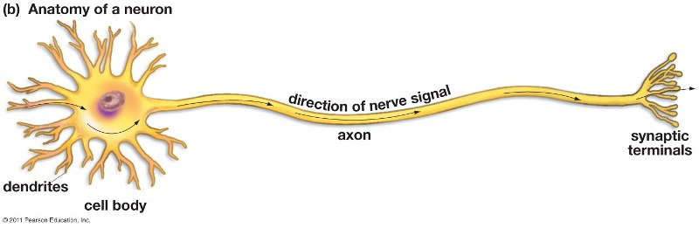

Although diffusion can supply substances like O₂ for the long slender axon, another process is required to move proteins, etc. from the cell body down the long axon. This process is called axoplasmic transport (or axoplasmic flow); this is an active process in which motor proteins move vesicles and organelles along microtubules. This is just one example of the multiple ways that cells supplement diffusion with active processes. Additional examples and links for animations and videos of energy-requiring processes such as molecular pumps, motor proteins moving transport vesicles, and cytoplasmic streaming are provided in "Cell Structure and Function -- Major Concepts and Learning Activities", available at http://serendipstudio.org/exchange/bioactivities/cellstructfunct

These teacher notes, the student handout, and multiple activities for teaching biology are available at http://serendipstudio.org/exchange/bioactivities.

