Vitamins and Health – Why Experts Disagree

Nutritional advice from different sources is often contradictory. Even sources that seem reliable can give opposite advice. In this activity, we will analyze the evidence behind the contradictory advice in one specific case – whether or not to take vitamin E supplements.

- "Recommended Supplement: Vitamin E, about 200 IU"* a day
- "Three very large studies found 40% heart disease risk reduction with supplements."
- "Antioxidant; protects blood fats … Prevents blood sticking, clots and artery damage." (http://www.health-heart.org/vitamins.htm)
vs.
- "Vitamin E: Just say no"
- "… vitamin E supplements haven't been found to offer any conclusive protection against disease in large clinical trials, and they might even be risky."
- "Two analyses have linked doses of vitamin E as low as 400 IU a day – and possibly even lower – to a small but statistically significant increase in mortality." (http://www.consumerreports.org/cro/2012/04/top-selling-vitamin-supplements/index.htm)

*IU = International Unit = 0.67 mg of the natural form of vitamin E or 0.45 mg of the synthetic form

Both websites give accurate descriptions of research evidence, but they argue for opposite advice about whether to take vitamin E supplements. How can the evidence support two opposite conclusions?

To answer this question we'll begin by looking at the evidence behind the opposing claims of "40% heart disease risk reduction" versus a "small but statistically significant increase in mortality". Since heart disease is responsible for one-quarter of deaths in the US, a 40% reduction in heart disease should result in a 10% reduction in mortality, not an increase. To understand these seemingly contradictory research results, we need to look at the different types of research studies that produced these results.

The evidence for a lower risk of heart disease comes from observational studies. In an observational study, researchers observe people or nature as they are without any intervention by the researcher. For example, in one type of observational study, researchers ask people whether they take vitamin E supplements, check which of these people develop heart disease during a follow-up period, and then evaluate whether the risk of developing heart disease differs between people who take vitamin E supplements and those who do not. Results from this type of observational study have shown a correlation or association between taking vitamin E supplements and lower risk of heart disease. However, these results do not establish that vitamin E causes better health, because observational studies cannot eliminate the effects of confounding factors. For example, people who take vitamin supplements tend to have more education and income and a generally healthy lifestyle and these characteristics could be the cause of their better health (see flowchart). Due to the effects of confounding factors, vitamin E supplements may be correlated with better health, even if they do not cause better health.

more income and education and healthy lifestyle
|
\/
less likely to smoke + more physically active + better diet + more likely to take vitamin pills
| | | |
\/ \/ \/ \/
better health, including less heart disease more likely to take
vitamin E supplements

To evaluate causal effects, researchers use experimental studies. In an experiment, researchers control the conditions for two or more groups of subjects. Ideally, all variables are the same for these groups except for one experimental variable which differs between the groups. In this way, the experimenter can test the causal effect of the experimental variable.

In animal experiments, researchers can test the effect of a vitamin supplement by having two groups of genetically identical animals that live under identical conditions, except that one group receives the vitamin supplement and one does not. Obviously, researchers cannot do this with people. Instead, they use a kind of experiment called a clinical trial.

Clinical trials are a type of experiment in which participants are randomly assigned to two groups, one of which receives the treatment (e.g. a vitamin supplement), while the other group receives a placebo (a pill that does not contain the vitamin, but tastes, smells and looks like the vitamin supplement, so the participants in both groups have an equal expectation of benefit). Since the participants are assigned at random to either the treatment group or the placebo group, none of the characteristics of the participants can influence who gets the vitamin supplement and who gets the placebo; therefore, all of the participants' characteristics are the same for the vitamin and placebo groups. Thus, the design of a clinical trial eliminates the effects of confounding factors, so any differences in health outcome can be interpreted as a causal effect of the vitamin supplement.

1. To provide persuasive evidence that a vitamin supplement has a causal effect on health, a study should meet the following criterion:
There should be two groups which have identical characteristics except that one group consumes the vitamin supplement and the other does not.
This criterion is not fulfilled by an observational study that compares people who choose to take vitamin supplements with people who do not. Explain why not.

2. Suppose that a kind-hearted researcher who believes in the benefits of vitamin E decides to help the low income participants in his clinical trial by putting all of them in the vitamin E group. He plans to put all of the high income participants in the placebo group. Explain why this clinical trial would not be a true experiment that could accurately evaluate the causal effects of vitamin E on health.

Why is it crucial for participants to be randomly assigned to the vitamin E and placebo groups in a clinical trial?
3. Observational studies have found that people who take vitamin E supplements have a substantially lower risk of heart disease than those who do not. In contrast, clinical trials have not found consistent benefits of vitamin E supplements. What is a likely explanation for this difference between the findings from observational studies and clinical trials?

Conflicting results are observed even when different studies of the same type are compared. The figure below shows the findings from different randomized, placebo-controlled clinical trials that have evaluated the effects of vitamin E supplements on mortality. Each circle represents one clinical trial, and larger clinical trials with more participants are represented by larger circles. The Y axis represents the difference in the risk of dying for participants who received vitamin E versus participants who received placebo; the dashed line indicates no difference in mortality risk between the vitamin E and placebo groups.

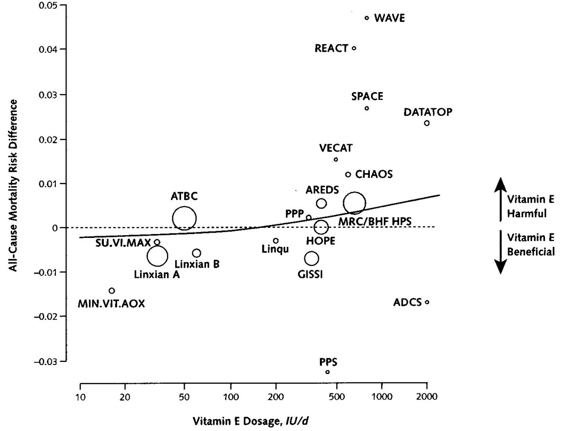
(From Miller et al., Annals of Internal Medicine 2005; 142:37)

4. The results of the smaller clinical trials show a great deal of random variation, as illustrated by the extreme opposite results of the PPS and WAVE clinical trials (see figure). Fill in the blanks to describe the opposite results of these two clinical trials. In the ______ clinical trial, the vitamin E group had lower mortality than the placebo group, as expected. In contrast, the ______ clinical trial found the opposite result, with higher mortality for the vitamin E group

The only large clinical trial to show a significant beneficial effect of vitamin E (Linxian A) was carried out in an area of China where blood levels of vitamin E tend to be lower than in economically developed countries (e.g. the US and European countries where most of the clinical trials were carried out). This result is compatible with the general finding that vitamin supplements are more likely to be beneficial for people with low vitamin intake in their diets.
5. Suppose that an expert argues that people in the US should take vitamin E supplements because two clinical trials (PPS and Linxian A) have found that vitamin E supplements significantly reduced mortality. Would you find this argument persuasive? ___ Yes ___ No

Explain why or why not.

When different clinical trials yield different results, researchers can use a statistical technique called meta-analysis to combine the results from the different clinical trials and calculate a best estimate of the true effect based on all the available data. A recent meta-analysis of clinical trial results estimated that the participants who took vitamin E supplements had 3% higher mortality risk than the participants who took placebo. This result provides the best estimate we have of the effect of vitamin E supplements on mortality in economically developed countries like the US. If vitamin E supplements do cause a 3% increase in mortality risk, this could be considered a relatively small increase in risk for any individual, but it could add up to a lot of deaths if lots of people are taking vitamin E supplements.

In summary, the results from the clinical trials suggest that vitamin E supplements may increase mortality in countries like the US, but may decrease mortality in regions with less adequate diets. To understand how vitamin E could have opposite effects in different circumstances, we need to look at the results from laboratory experiments where researchers tested the effects of vitamin E on molecules or cells in a test tube or petri dish. Laboratory experiments have shown a wide variety of beneficial and harmful effects of vitamin E, including the following.
- Laboratory experiments have shown that vitamin E can have antioxidant effects which protect molecules and cells from damage. However, under other experimental conditions, vitamin E can have pro-oxidant effects which can harm molecules and cells.
- Laboratory experiments have also shown that vitamin E can decrease blood clotting. Decreased blood clotting can reduce the risk of some diseases (e.g. heart disease and a type of stroke caused by blood clots which block needed blood flow), but increase the risk of other diseases (e.g. a different type of stroke caused by bleeding in the brain).
Thus, vitamin E has multiple effects on the molecules and cells in our bodies, and the balance between beneficial and harmful effects of vitamin E supplements may vary depending on factors such as how much vitamin E people are getting from their diet. Because vitamin E has both beneficial and harmful effects, the results of laboratory studies cannot tell us whether the overall health effect of vitamin E supplements will be beneficial or harmful.

6. An advertisement urges you to take an antioxidant supplement that contains several types of antioxidant molecules that laboratory experiments have shown can prevent damage to other molecules and cells. Before you decide whether to take the antioxidant supplement, what else would you want to know?

7. Both websites quoted in the box on page 1 give accurate statements concerning the research evidence, but these two websites argue for opposite conclusions. Explain how these two opposite conclusions can both be supported by factually accurate evidence.

8. Based on all the evidence presented in this activity, which of the following statements best summarizes your conclusion about the health effects of vitamin E supplements for a typical person in the US?
- Vitamin E is an antioxidant and has other beneficial health effects, so everyone should be encouraged to take vitamin E supplements.
- The best evidence suggests that vitamin E supplements may have a small harmful effect on health for people in countries like the US. Therefore, experts should discourage people from taking vitamin E supplements, unless a doctor identifies a specific medical reason for taking these supplements.
- The research results are so contradictory and confusing that scientists don't know whether vitamin E has beneficial or harmful effects on health, so people should just ignore the scientific findings and decide for themselves whether to take vitamin E supplements.

Explain your reasoning and the evidence that supports your conclusion.

9. Suppose that you read a newspaper headline, "New Study Shows that Vitamin D Improves Health". State two reasons why you should be skeptical about this headline and find out more before you start taking vitamin D supplements.

By Dr. Ingrid Waldron, Department of Biology, University of Pennsylvania, copyright 2012. This Student Handout, as well as Teacher Notes and additional activities are available at http://serendipstudio.org/exchange/bioactivities/vitamins .

