UNICORN GENETICS – Understanding Inheritance

How does a baby seem to be a little like one parent and a little like the other? We’ll explore this question using unicorns in just a bit, but first we’ll talk about how genes work.

In most human cells, there are 46 chromosomes, arranged as 23 pairs. The pairs are called homologous chromosomes. Homologous comes from two Greek words: homos, meaning same, and logos, meaning word. So homologous chromosomes have the “same words” – they have information about the same things. But they can still be slightly different! Let’s look at an example found in cats: long or short hair.

Each of a cat’s chromosomes (cats have 38 chromosomes, or 19 pairs, by the way) has many, many types of information on it, but one particular part on each chromosome in one pair is the gene for hair length. And each of these two chromosomes has an allele for that gene: either the short-hair allele (we’ll call that L) or the long-hair allele (we’ll call that l). Since there’s a pair of chromosomes with alleles for this gene, the cat can have two short-hair alleles (LL), two long-hair alleles (ll) or one of each (Ll).

In this case, the short-hair allele is dominant and the long-hair allele is recessive. If an allele is dominant, then if it is there, it “wins” – that’s what the organism is actually like. (We call that the phenotype – the thing you can see when you observe the organism. The actual pair of alleles is called the genotype.) For the recessive allele to show up, the organism must have both alleles recessive.

So what does each cat have – long hair or short hair?

Cat #1 has genotype LL. This cat has hair.  Cat #2 has genotype ll. This cat has hair.  Cat #3 has genotype Ll. This cat has hair. | 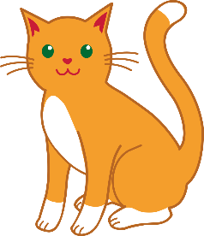

Sometimes an allele can have incomplete dominance. In roses, the red allele (R) has incomplete dominance, while the white allele (r) is recessive. A rose with genotype RR is red. A rose with genotype rr is white. What color do you think a rose with genotype Rr is? The dominance of the red allele is incomplete, so it’s a little red and a little white – pink!

It’s important to note that for most things in a human body, this is a bit oversimplified; most of the things about the way we look are determined by more than one gene, or affected by our environment as well as our genes (for example, spending more time in the sun can result in a person having more freckles).

Okay, so, we can see how a plant or animal’s genes determine how it looks…but what about the whole inheritance thing, with babies looking like their parents?

Well, remember how we said that most human cells have 46 chromosomes, arranged in 23 pairs? There are two types of cells that only have 23 chromosomes – one from each pair. These are the egg cells in a woman’s body and the sperm cells in a man’s body. A baby is made when an egg and a sperm join together.

Let’s go back to the cats for a moment. Imagine that Fluffy is a female cat with genotype Ll.
What kind of hair does Fluffy have?
When Fluffy’s body makes egg cells, each egg cell contains ONE of the alleles for hair length. Since her cells have both alleles to choose from, some of her eggs will have the L allele and some will have the l allele. | 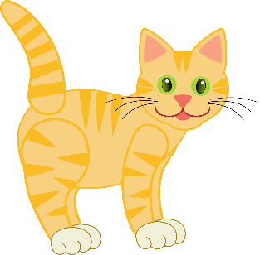

Now imagine that Toby is a male cat with genotype ll.
What kind of hair does Toby have?
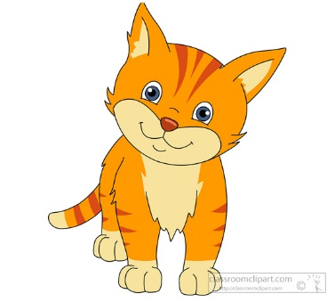 | When Toby’s body makes sperm cells, each sperm cell contains ONE of the alleles for hair length. Since both of his alleles are l, all his sperm cells will have the l allele.

So when Fluffy and Toby have a baby, the baby will get one allele from Fluffy’s egg cell and one allele from Toby’s sperm cell. What kind of hair will the kitten have?

The kitten could have an L allele from Fluffy and an l allele from Toby. That would make
the kitten’s genotype , and the kitten would have hair.

OR

The kitten could have an l allele from Fluffy and an l allele from Toby. That would make
the kitten’s genotype , and the kitten would have hair.

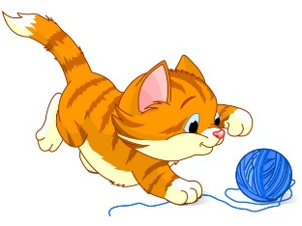

But what about the unicorns?!

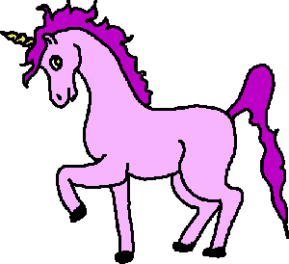

Yes, yes, unicorns! We have some craft sticks representing unicorn chromosome pairs.

Um…what?

We have some craft sticks representing unicorn chromosome pairs. Let me explain.

First, there’s a sex chromosome pair – either XX (yellow craft stick) or XY (blue craft stick). Each side of the craft stick represents one chromosome in the pair. (You’ll also note that the X chromosome has a variety of genes, such as the rainbow/no rainbow gene.)

Then there are two other chromosome pairs.
- The purple craft stick represents the chromosome pair that contains genes for wings, horn & tail length, fur pigment, and coat color.
- The green craft stick represents the chromosome pair that contains genes for horn sparkliness, tail & mane color, and spots on the coat.
And once again, each side of a craft stick represents one chromosome in the pair, and the letters on it show you which allele that chromosome has for each gene on the chromosome.

The chart on the next page shows what the different alleles mean. Use that chart and the craft stick chromosomes for the male and female unicorns to fill out the following information about the male unicorn and the female unicorn.

 |  | MALE |  |  | FEMALE
 |  | Genotype | Phenotype |  | Genotype | Phenotype
Wings
Horn/tail length
Fur pigment
Coat color
Horn sparkliness
Tail/mane color
Spots on coat
Rainbow on back
Beard

Now draw pictures of each of these unicorns!
UNICORN GENOME – DECODING OF THE GENES

Chromosome Dominant alleles Recessive alleles

Purple chromosomes W has wings w no wings
L long horn & tail l short horn & tail
A normal fur pigment a no fur pigment –
completely white,
including no spots
C dark pink coat* c light pink coat*

Green chromosomes S horn can sparkle s horn cannot sparkle
T and t [see below]
F and f [see below]

X chromosome R has rainbow on back r no rainbow on back
Y chromosome M male sex (results in beard)

Incompletely dominant alleles
TT purple tail & mane Tt yellow/purple striped tt yellow tail & mane
tail & mane

FF lots of spots on coat* Ff some spots on coat* ff no spots on coat
(draw 10) (draw 5)

* If unicorn is aa and therefore unable to make fur pigment, it will have a white coat and it will not have any spots (no matter what alleles it has for the coat color and spots genes).

Time for a baby unicorn!

Take the craft sticks for the male unicorn and drop them onto the floor. Which alleles are showing up on each chromosome? Write down the letters that are face-up. (Make sure it’s clear whether each letter is lowercase or uppercase!) This represents the alleles in the chromosomes in one sperm cell.

Purple:

Green:

Blue:

Now take the craft sticks for the female unicorn and drop them onto the floor. Which alleles are showing up on each chromosome? Write down the letters that are face-up. (Make sure it’s clear whether each letter is lowercase or uppercase!) This represents the alleles in the chromosomes in one egg cell.

Purple:

Green:

Yellow:

If the sperm cell and the egg cell you’ve described above join to make a baby unicorn, what will that baby be like? Complete the chart below!

BABY  Genotype Phenotype  Wings  Horn/tail length  Fur pigment  Coat color  Horn sparkliness  Tail/mane color  Spots on coat  Rainbow on back  Beard | 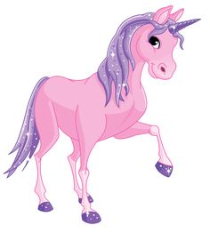

Draw a picture of your baby unicorn!

QUESTIONS

- What is one phenotypic trait that is the same in Mom, Dad, and baby unicorn? (In other words, one thing that looks the same for all three.)

- How did that happen?

- If the same Mom and Dad unicorn had another baby, would that baby necessarily have this same trait? Explain why or why not.

- What is one way that you look similar to one or both of your parents? What is one way that you look different from one or both of your parents? Can you make any guesses about the genes that may have influenced the way you look?

ADDITIONAL NOTES FOR INSTRUCTOR

Preparation: You’ll need two purple craft sticks, two green, one yellow, and one blue. Label the craft sticks as follows. Be sure it’s clear which letters are uppercase and which are lowercase.

For the mother:
- Purple craft stick: write W l A c on one side and write w l a c on the other side.
- Green craft stick: write s T F on one side and write s t f on the other side.
- Yellow craft stick: write R on one side and write r on the other side.

For the father:
- Purple craft stick: write W l a C on one side and write w l a c on the other side.
- Green craft stick: write S T F on one side and write S t f on the other side.
- Blue craft stick: write R on one side and write M on the other side.

You may want to explain to the students that only X chromosomes have the gene for rainbow/no rainbow, and only Y chromosomes have the gene for beard. This may help students understand more clearly that their baby unicorns have either two X chromosomes (female) or one X and one Y (male), even though X and Y do not appear on the craft sticks (since they are not genes).

Keep the mother’s craft sticks separate from the father’s; you may wish to put dots on one parent’s craft sticks for clarity in case they get mixed up.

This is an adapted and simplified version of Dragon Genetics – Understanding Inheritance, which is a plan for high school students and can be found at http://serendipstudio.org/exchange/waldron/dragongenetics2. This version is intended for younger students and uses unicorns instead of dragons.

