Teacher Notes for
“How Genes Can Cause Disease – Understanding Transcription and Translation"

In the first section of this analysis and discussion activity, students learn that different versions of a gene give the instructions for making different versions of a clotting protein, which result in normal blood clotting or hemophilia. Next, students learn how genes provide the instructions for making a protein via the processes of transcription and translation. They develop an understanding of the roles of RNA polymerase, the base-pairing rules, mRNA, tRNA and ribosomes. Finally, students use their learning about transcription and translation to understand how a change in a single nucleotide in the hemoglobin gene can result in sickle cell anemia. Throughout this activity, students use the information in brief explanations, figures and videos to answer analysis and discussion questions.

This activity can be used to introduce students to transcription and translation or to reinforce and enhance student understanding. We estimate that this activity will take 2-3 50-minute periods.

If you prefer a hands-on activity that uses simple paper models to simulate the molecular processes of transcription and translation, see “How Genes Can Cause Disease – Introduction to Transcription and Translation” (https://serendipstudio.org/sci_edu/waldron/#trans).

This activity is intended for students who have been introduced to:
- the structure and function of proteins and DNA (For this purpose we recommend "Introduction to the Functions of Proteins and DNA" (https://serendipstudio.org/exchange/bioactivities/proteins).)
- DNA replication and the base-pairing rules (For this purpose we recommend the analysis and discussion activity, "DNA Structure, Function and Replication" (https://serendipstudio.org/exchange/bioactivities/DNA) or the hands-on activity, "DNA" (https://serendipstudio.org/sci_edu/waldron/#dna).)

Table of Contents
- Learning Goals (pages 1-3)
- Recommendations for Implementation and Background Biology
  - General (page 3)
  - How can genes cause health problems? (pages 3-5)
  - How does a gene give the instructions for making a protein? (page 5)
  - How does transcription make mRNA? (pages 5-6)
  - Synthesis Questions and General Comments on Transcription and Translation Sections (pages 6-8)
  - Translation – How does mRNA give the instructions for making a protein? (pages 8-9)
  - How a Version of the Hemoglobin Gene can Cause Sickle Cell Anemia (pages 10-12)
- Sources for Figures in Student Handout and Related Learning Activities (pages 12-13)

Learning Goals
In accord with the Next Generation Science Standards:
- Students will gain understanding of the following Disciplinary Core Ideas
- LS1.A, Structure and Function, including "Genes are regions in the DNA that contain the instructions that code for the formation of proteins, which carry out most of the work of cells."
- LS3.A, Inheritance of Traits, including "DNA carries instructions for forming species characteristics."
- Students will engage in Science Practices, including:
- “Constructing Explanations… Apply scientific ideas, principles and/or evidence to provide an explanation of phenomena…”
- “Developing and Using Models… use multiple types of models to provide mechanistic accounts and/or predict phenomena, and move flexibly between model types…"
- This activity provides the opportunity to discuss the Crosscutting Concepts:
- Structure and function, including “Students model complex and microscopic structures and systems and visualize how their function depends on the shapes, composition, and relationships among its parts."
- Cause and effect: Mechanism and explanation, including understanding “causal relationships by examining what is known about smaller scale mechanisms within the system.”
- This activity helps to prepare students to meet Performance Expectations
- HS-LS1-1, "Construct an explanation based on evidence for how the structure of DNA determines the structure of proteins which carry out the essential functions of life through systems of specialized cells."
- HS-LS3-1, "Ask questions to clarify relationships about the role of DNA and chromosomes in coding the instructions for characteristic traits passed from parents to offspring."

Additional Content Learning Goals
Genes influence our phenotype by the following sequence of steps:

nucleotide sequence in the DNA of a gene

nucleotide sequence in messenger RNA (mRNA)
transcription

amino acid sequence in a protein
translation

structure and function of the protein
(e.g. normal hemoglobin vs. sickle cell hemoglobin)

person's characteristics or traits
(e.g. normal health vs. sickle cell anemia)

Transcription is the process that copies the message in a gene into a messenger RNA (mRNA) molecule that will provide the instructions for making a protein. The sequence of nucleotides in a gene in the DNA determines the sequence of nucleotides in the mRNA molecule. Each DNA nucleotide is matched with a complementary mRNA nucleotide in accord with the base-pairing rules: C pairs with G and A pairs with U (in RNA) or T (in DNA). To make the mRNA molecule, the enzyme RNA polymerase adds the complementary nucleotides one-at-a-time to the growing mRNA molecule.

A comparison between transcription and DNA replication shows:

Similarities | Differences
- Both processes use a DNA strand and the base-pairing rules to determine which nucleotide is added next.  - Both processes produce a polymer of nucleotides (a nucleic acid).  - Both transcription and replication are carried out by a polymerase enzyme which adds nucleotides one-at-a-time.  - Both DNA and RNA contain the nucleotides, C (cytosine), G (guanine) and A (adenine). | - A single gene is transcribed into an mRNA molecule, whereas the whole chromosome is replicated.  - Transcription produces a single-stranded mRNA molecule, whereas replication produces a double-stranded DNA molecule.  - The enzyme for transcription is RNA polymerase, whereas the enzyme for DNA replication is DNA polymerase.  - T (thymine) in DNA is replaced by U (uracil) in RNA.

Translation is the process that makes proteins. mRNA carries the genetic message from the nucleus to the ribosomes where proteins are synthesized. The sequence of nucleotides in an mRNA molecule specifies the sequence of amino acids in a protein. The sequence of amino acids determines the structure and function of the protein.

Each triplet codon in the mRNA codes for a specific amino acid in the protein. For each type of codon, there is a type of tRNA with a complementary triplet anticodon. For each type of tRNA, there is a specific enzyme that attaches the correct amino acid for the anticodon in that tRNA and the complementary codon in the mRNA. Inside the ribosome, each codon in the mRNA is matched with the complementary anticodon in a tRNA, and the ribosome forms covalent bonds between the amino acids as they are added one-at-a-time to the growing protein.

Recommendations for Implementation and Background Biology
General
To maximize student learning and participation, we recommend that you have your students work in pairs to answer each group of related questions. Student learning is increased when students discuss scientific concepts to develop answers to challenging questions. After your students have answered each group of related questions, we recommend that you have a class discussion to probe student thinking and help students develop a sound understanding of the concepts and information covered. You may want to offer students the opportunity to prepare revised versions of their answers to key questions in order to consolidate accurate understanding.

The PDF of the Student Handout shows the correct format; please check this if you use the Word document to make revisions.

A key is available upon request to Ingrid Waldron (iwaldron@upenn.edu). The following paragraphs provide additional instructional suggestions and background information – some for inclusion in your class discussions and some to provide you with relevant background that may be useful for your understanding and/or for responding to student questions.

How can genes cause health problems?
The Student Handout includes multiple simplifications. For example, the Student Handout discusses two disorders that result from mutations of a single gene, but most human diseases and characteristics are influenced by multiple genetic and environmental factors. Also, a gene is defined as “a segment of DNA that gives the instructions for making a protein” (on page 1 of the Student Handout). A more sophisticated contemporary definition of a gene is “part of a DNA molecule that codes for an RNA molecule, which may be messenger RNA that codes for the sequence of amino acids in one or more proteins, ribosomal RNA, transfer RNA or regulatory RNA”. There is no single universally agreed-upon definition of a gene at this time. For additional information about the challenges and complexities of defining a gene, see http://www.biologyreference.com/Fo-Gr/Gene.html.

Hemophilia is a bleeding disorder due to defective blood clot formation. The video recommended on page 1 of the Student Handout provides a good two-minute introduction. A more comprehensive, highly readable and informative introduction is available at https://learn.genetics.utah.edu/content/genetics/hemophilia/.

In most people, an injury to a blood vessel triggers the activation of a series of clotting proteins which results in the formation of a clot. Mutated versions of the gene for one of these clotting proteins can result in a protein that does not function properly. If the mutation results in an early stop codon in the gene, then no clotting protein may be produced. When one of the blood-clotting proteins is defective or absent, it takes an abnormally long time for a blood clot to form (https://courses.lumenlearning.com/ap2/chapter/hemostasis/).

Different alleles of the gene for a clotting factor cause different degrees of loss of function for the clotting protein, and this results in different degrees of severity of hemophilia. In mild cases, a person may bleed longer than normal after serious injury or surgery. In severe cases, a person may experience spontaneous internal bleeding (e.g. in the joints), frequent large bruises, and nosebleeds that are hard to stop. Severe cases of hemophilia are treated with infusions of normal clotting factor, as often as two or three times per week. Researchers are developing gene therapies which could provide more long-term relief of symptoms (https://www.nature.com/articles/d41586-022-04327-7;
https://www.ema.europa.eu/en/news/first-gene-therapy-treat-severe-haemophilia).

The most common causes of hemophilia are alleles of one of two clotting factor genes on the X chromosome. Since a male has only one X chromosome in each cell, if his X chromosome has an allele that codes for defective clotting protein, he will not be able to make blood clots properly and he will have hemophilia. In contrast, a female has two X chromosomes; since the alleles for defective clotting protein are recessive, a woman generally only has hemophilia if both of her X chromosomes have a recessive allele for defective clotting protein. Thus, almost all people with hemophilia are male, and females may be heterozygous carriers. The chart on page 1 of the Student Handout does not include the fact that the alleles for hemophilia are sex-linked recessive. If your students are already familiar with the concepts of recessive alleles and homozygous vs. heterozygous individuals, you may want to include this information in your discussion. Otherwise, we recommend that you postpone discussion of these issues to our Genetics activity (https://serendipstudio.org/sci_edu/waldron/#genetics).

How does a gene give the instructions for making a protein?
This section introduces transcription and translation as the processes by which a gene gives the instructions for making for making a protein. This introductory section provides a helpful context for learning more about transcription and translation in subsequent sections. Students are reminded that DNA and RNA are polymers of nucleotides, whereas proteins are polymers of amino acids. To reinforce the analogies between transcription and copying a sentence and between biological translation and linguistic translation, you may want to include the following challenge question.
5c. Why is translation a good name for the process that makes a protein, but not a good name for the process that makes mRNA?

If your students are not familiar with the structure of mRNA, you may want to point out that mRNA is single-stranded, in contrast to the double-stranded DNA. The recommended 5-minute video, “What is DNA and how does it work?” (http://statedclearly.com/videos/what-is-dna/), will reinforce student understanding of the concepts in this section of the Student Handout.

How does transcription make mRNA?
This section introduces the basic process of transcription. Many specific aspects of transcription are omitted to ensure that students develop a sound understanding of the basic process. This section provides an opportunity to discuss the Structure and Function Crosscutting Concept, including “Students model complex and microscopic structures and systems and visualize how their function depends on the shapes, composition, and relationships among its parts."

You can use this figure if your students need a refresher about DNA structure or why the rules that describe which nucleotides are complementary are called the base-pairing rules. | 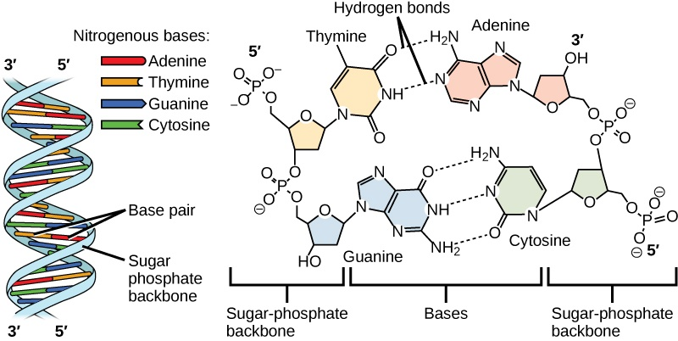  (http://archive.cnx.org/resources/2fd36fdbcc8ece5366feb9b7513b8eaa151e3e08/Figure_09_01_03ab.jpg)

The top of page 5 of the Student Handout recommends a two-minute animation that reviews the process of transcription (https://www.biointeractive.org/classroom-resources/dna-transcription-basic-detail). This animation shows the dynamic nature of transcription, which adds 50 nucleotides per second to a growing RNA molecule. Your students may ask about the transcription factors shown at the beginning of this animation. Because the Student Handout provides a basic introduction to transcription and translation, it does not mention transcription factors. Transcription factors initiate and regulate the transcription of a gene by regulating the activity of RNA polymerase (which is shown in blue in the animation) (https://www.khanacademy.org/science/biology/gene-regulation/gene-regulation-in-eukaryotes/a/eukaryotic-transcription-factors).

Suggestions concerning question 12 are provided in the next section of these Teacher Notes. In questions 13-14, students compare transcription to DNA replication. You can use either of the figures below to remind your students about the process of DNA replication.

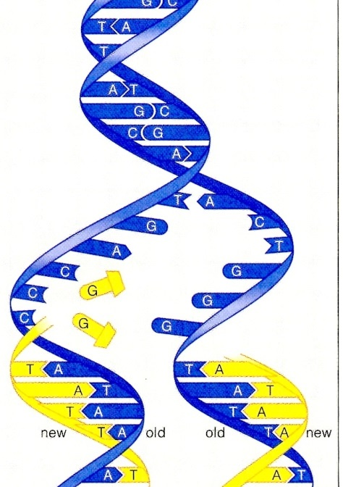  DNA Replication  (not showing the enzymes involved) | 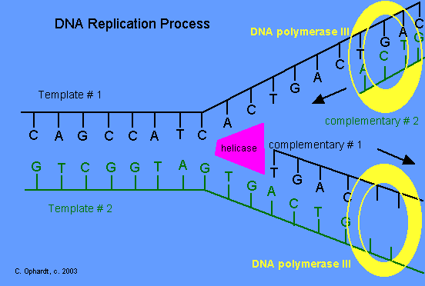

Synthesis Questions and General Comments on Transcription and Translation Sections
To encourage students to actively synthesize their own basic understanding of transcription and translation, we strongly recommend having your students complete questions 12 and 20 (on pages 5 and 7 of the Student Handout), perhaps as a homework assignment if you do not have enough class time. If you feel that these questions will be very challenging for your students, we have several suggestions to help your students succeed.
- If your students have trouble learning vocabulary, you may want to precede questions 12 and 20 with questions that ask for definitions of the terms listed (or perhaps a matching question in which you provide your preferred definitions for these terms).
- You may want to suggest that students review page 4 of the Student Handout as they plan their answers for question 12. Similarly, you may want to suggest that students review page 6 of the Student Handout as they plan their answers for question 20.
● As an introduction to these questions, you may want to provide a concept map or graphic
organizer for your students to review or complete (e.g.
http://lsaportfolio.weebly.com/uploads/5/8/7/4/58741929/8859660_orig.png or
https://o.quizlet.com/atJ6mLwUywPTs2a-U8.vwg_b.png).
- You could provide the beginning of a first sentence to help your students get started.
- We recommend that students work in pairs to develop an answer.

After class discussions of question 12 and 20, we recommend that you have each student revise his/her answers to the question so he/she can consolidate an accurate understanding of transcription and translation.

To help your students understand why RNA polymerase adds nucleotides one at a time, you may want to point out that a typical protein has hundreds of amino acids so a typical mRNA has hundreds or thousands of nucleotides. Have your students think about the problems that would arise if natural selection or a molecular biologist tried to design an enzyme that could simultaneously arrange and join together the whole sequence of hundreds or thousands of nucleotides in an mRNA molecule. Similarly, to help your students understand why ribosomes add amino acids one at a time, you may want to have your students think about the problems of trying to design a ribosome that could simultaneously arrange and bond together the whole sequence of amino acids in a protein, especially considering that there are many thousands of different types of proteins in a cell.

This activity includes several different types of models of transcription and translation. A model is a simplified representation of a real-world phenomenon. Like all models, the models in this activity involve simplifications which help to clarify important points, but also limit the accuracy of the models as representations of the actual complex biological processes. Different types of models serve different purposes for learning about and understanding the processes of transcription and translation. The figures on page 2 of the Student Handout provide a basic framework that provides a context for understanding the complexities that follow. The figures on pages 4 and 6 show more specifics of how transcription and translation are accomplished in the cell. The recommended videos illustrate the dynamic nature of these processes.

To ensure that students develop a good understanding of the basic processes of transcription and translation, this activity omits many complexities. For example, the Student Handout does not mention:
- the initiation and termination phases of transcription and translation (some information on the initiation phase of transcription is given on the previous page)
- introns, exons and splicing (https://bio.libretexts.org/Bookshelves/Biochemistry/Book%3A_Biochemistry_Free_and_Easy_(Ahern_and_Rajagopal)/05%3A_Flow_of_Genetic_Information/5.05%3A_RNA_Processing)
- how polypeptides fold and may combine with other polypeptides to form proteins (https://chem.libretexts.org/Bookshelves/Biological_Chemistry/Supplemental_Modules_(Biological_Chemistry)/Proteins/Protein_Structure/Protein_Folding)
- transcription produces multiple copies of mRNA from a gene; multiple ribosomes move along an mRNA molecule, producing multiple copies of the polypeptide
- differences in which genes are transcribed in different types of cells, which correspond to the differences in the types of proteins in different types of cells (e.g., hemoglobin abundant in red blood cells vs. contractile proteins abundant in muscle cells) (https://www.khanacademy.org/science/biology/gene-regulation/gene-regulation-in-eukaryotes/a/overview-of-eukaryotic-gene-regulation)
- a standard genetic code chart or codon wheel. (Our preference is to use the abbreviated codon chart on page 9 of the Student Handout, so students can concentrate on understanding the basic process of translation, and then, if desired, practice using the codon wheel in a separate activity. For example, in the analysis and discussion activity, "Mutations and Muscular Dystrophy" (https://serendipstudio.org/exchange/bioactivities/mutation), students review transcription and translation, use a codon wheel to analyze different types of mutations, and evaluate which types of mutation result in the more severe Duchenne muscular dystrophy vs. the milder Becker muscular dystrophy.)
If your students already have a good grasp of the basics of transcription and translation, you may want to include some of these additional complexities.

Translation – How does mRNA give the instructions for making a protein?
We suggest that you introduce this section by asking your students which would be more challenging – copying a sentence or translating it and writing down the translated sentence? Just as translating a sentence is more complex than copying it, molecular translation is more complex than transcription. In transcription, the shape and chemical structure of each mRNA nucleotide matches the shape and chemical structure of the complementary DNA nucleotide. In contrast, in translation, the shape and chemical structure of each amino acid does not match the shape and chemical structure of the corresponding mRNA codon. In this section, students will learn how translation is accomplished inside a cell.

As you discuss codons, it may be helpful to make an analogy between using different combinations of the 4 nucleotides to code for each of the 20 different types of amino acids and using different combinations of 26 letters to make thousands of different words. One big difference is that each codon is exactly 3 nucleotides long, whereas the number of letters in a word is variable. There are 4 x 4 x 4 = 64 codons, compared to only 20 amino acids. As would be expected, there can be multiple codons for a single amino acid. (There is a start codon and there are also three stop codons.)

In humans, there are 48 different types of tRNA, compared to 61 different codons for amino acids in mRNA. Some types of tRNA have anticodons that are able to match with two different codons that have the same first two nucleotides but differ in the third nucleotide (both are codons for the same amino acid). This figure shows how a tRNA molecule folds into an upside down L shape. | 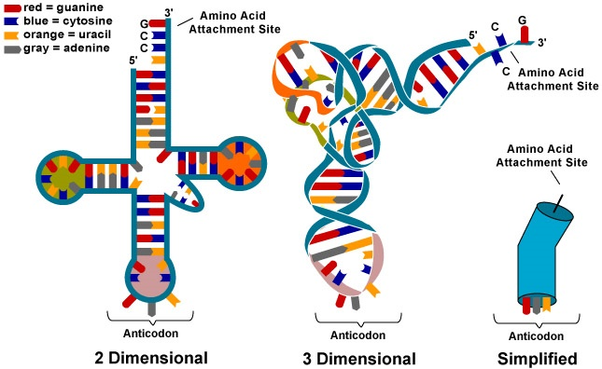  (https://wikispaces.psu.edu/download/attachments/42338219/image-1.jpg )

As discussed on pages 6-7 of the Student Handout, the tRNA molecules play a central role in translating from the nucleotide sequence in mRNA to the amino acid sequence in proteins. For accurate translation, it is crucial that each tRNA be attached to the correct amino acid for its anticodon. This is accomplished by enzymes that attach the correct amino acid for the anticodon in each type of tRNA. The figure below illustrates the action of one of these enzymes.

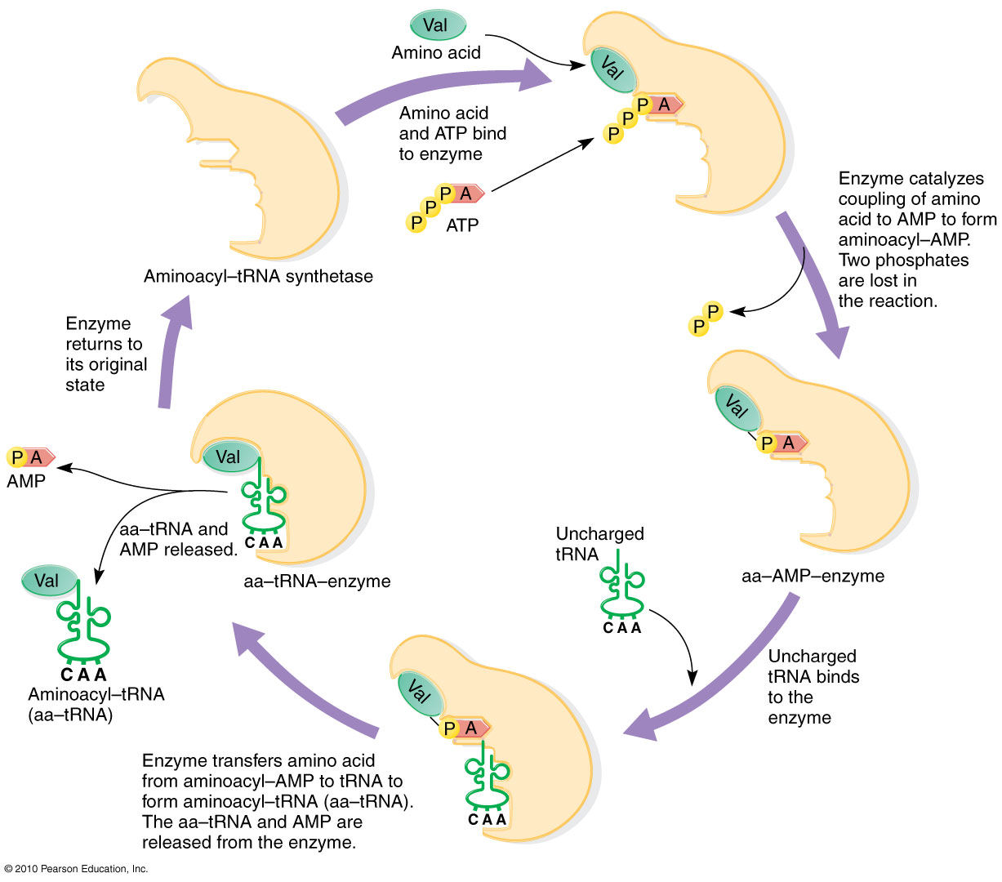
(https://www.mun.ca/biology/scarr/iGen3_06-10_Figure-L.jpg)

Inside the ribosome there is a ribozyme (RNA enzyme) that transfers the amino acid from the tRNA to the growing polypeptide chain. This ribozyme breaks the covalent bond between the tRNA and its amino acid and simultaneously forms a new covalent peptide bond between this amino acid and the next amino acid to be added to the growing polypeptide chain.  When students watch the recommended 2-minute video, “Translation” (https://www.biointeractive.org/classroom-resources/translation-basic-detail), you may want to pause | 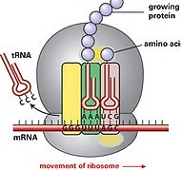
the video at 1 minute and 40 seconds and have them analyze how this animation corresponds to the figure on the bottom of page 6 of the Student Handout. A ribosome adds about 2-20 amino acids per second in eukaryotes and bacteria, respectively.

How a Version of the Hemoglobin Gene Can Cause Sickle Cell Anemia
This section begins with a 4.5-minute recommended video, which provides an overview of sickle cell disease (“How This Disease Changes the Shape of Your Cells” at
https://www.youtube.com/watch?v=hRnrIpUMyZQ).  Page 8 of the Student Handout summarizes the effects of homozygous sickle cell alleles, which result in sickle cell anemia. As discussed, sickled red blood cells can clog the small blood vessels. This clog should be distinguished from the clot that forms when a blood vessel has been injured (see page 4 of these Teacher Notes). The following paragraphs provide additional information.  The figure at right shows one type of sickle, a tool which is probably unfamiliar to many students. | 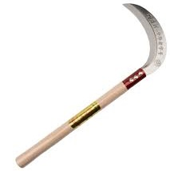  A sickle is a single-handed agricultural tool with a curved blade that is typically used for harvesting grains or hay.

Hemoglobin is made up of four polypeptides, two beta globin and two alpha globin. In this activity, we ignore the gene for the alpha globin polypeptides, since that gene is the same in normal and sickle cell hemoglobin. | 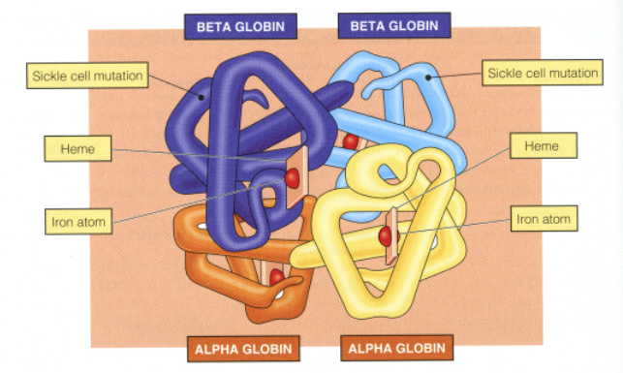

To help your students understand how anemia results from the shorter lifespan of red blood cells with sickle-cell hemoglobin, you may want to explain that the rate of producing new red blood cells can’t keep up with the increased rate of dying of the red blood cells with sickle-cell hemoglobin. (The figure below shows the lifecycle of red blood cells.) Anemia can result in fatigue and shortness of breath.
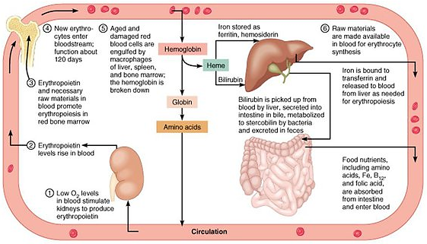
(https://qph.cf2.quoracdn.net/main-qimg-8fc33520d4c363e054b49907ad11ae40-lq)

The severity of sickle cell anemia in different individuals varies from relatively mild sickle cell anemia with few sickling crises and nearly normal health and survival to severe sickle cell anemia with frequent sickling crises, significant organ damage and early death. The majority of people with sickle cell anemia have an intermediate severity. One factor that contributes to variation in the frequency of sickling crises is that some people with sickle cell anemia spontaneously produce relatively high levels of fetal hemoglobin (which contains gamma globin instead of beta globin polypeptides), and fetal hemoglobin inhibits clumping of sickle cell hemoglobin into rods. Hydroxyurea, which increases the production of fetal hemoglobin, is one treatment for sickle cell anemia. A good summary of the medical aspects of sickle cell anemia, including symptoms, diagnosis and treatment is available at https://www.mayoclinic.org/diseases-conditions/sickle-cell-anemia/symptoms-causes/syc-20355876. Recent progress in gene therapy for sickle cell anemia is analyzed in “Gene Editing with CRISPR-Cas – A Potential Cure for Sickle Cell Anemia” (https://serendipstudio.org/exchange/bioactivities/GeneEdit).

Even in a person who has severe sickle cell anemia, most red blood cells are not sickled most of the time. The degree of clumping of sickle cell hemoglobin into rods varies, depending on factors such as differences in dehydration, oxygen levels in the blood, and multiple genetic factors. For example, dehydration increases the concentration of hemoglobin in red blood cells which increases the tendency of sickle cell hemoglobin to clump into rods. The resulting sickled red blood cells can block some of the small blood vessels, which can cause pain and organ damage (called a sickling crisis). An infection that induces vomiting and diarrhea can result in dehydration which can cause a sickling crisis. However, the causes of most sickling crises are unknown.

The top half of page 9 of the Student Handout guides students in analyzing the specific molecular biology of the normal vs. sickle-cell alleles of the hemoglobin gene and the resulting normal vs. sickle-cell hemoglobin proteins. As discussed in the Student Handout, the lower solubility of nonpolar valine in the watery cytosol of the red blood cell (compared to the high solubility of ionic glutamic acid) contributes to the tendency of sickle-cell hemoglobin to clump together in long rods inside the red blood cells. This difference in the solubility of amino acid 6 is crucial because amino acid 6 is in a key location on the outside of the hemoglobin molecule (labeled sickle cell mutation in the figure on the previous page). This provides a good example of how the specific sequence of amino acids plays a crucial role in determining the form and function of a protein.

(http://www.andrew.cmu.edu/course/09-105/GIF97_4/Hb05.GIF)

This section provides a good opportunity to discuss the Crosscutting Concept, Cause and effect: Mechanism and explanation, including that scientists often understand “causal relationships by examining what is known about smaller scale mechanisms within the system.”

The top of page 10 of the Student Handout, including question 25, introduces students to the biology of a person who is heterozygous for the sickle-cell hemoglobin allele. This condition is called sickle cell trait. A person with sickle cell trait rarely has symptoms of sickle cell anemia, because each red blood cell contains both normal and sickle cell hemoglobin, and the normal hemoglobin generally prevents clumping of the sickle cell hemoglobin. Athletic associations recommend testing for sickle cell trait and, for athletes who have sickle cell trait, taking appropriate precautions to prevent extreme exertion and dehydration in order to further reduce the small risk of exercise-related sudden death. Harmful health effects of sickle cell trait are rare, and life expectancy is not detectable reduced. Sickle cell trait has beneficial health effects in areas where malaria is prevalent; individuals with sickle cell trait have less serious malaria infections because the malaria parasite doesn't grow as well in their red blood cells.

In discussing question 26, you may want to point out that our bodies are made up of roughly 100,000 different types of proteins and each protein is made up of hundreds or thousands of amino acids. Thus, there are many many opportunities for variation in proteins and phenotypic characteristics.

Sources for Student Handout Figures
- Figure of boy with bloody nose on page 1 from https://www.nhsdirect.wales.nhs.uk/assets/images/encyclopaedia/Nosebleed.jpg
- Upper figure on page 2, upper figure on page 4, bottom figure on page 6, and figure on page 7 modified from Krogh, Biology – A Guide to the Natural World
- Bottom figure on page 2 and top figure on page 6 modified from
https://owlcation.com/stem/protein-production-a-step-by-step-illustrated-guide
- RNA polymerase on the bottom of page 4 modified from http://www.zo.utexas.edu/faculty/sjasper/images/17.6b.gif
- tRNA on page 6 modified from https://image1.slideserve.com/1916888/structure-of-trna-n.jpg
- Sickle cell anemia figure on the top of page 8 from http://bioinformatics.org/jmol-tutorials/jtat/hemoglobin/images4all/sickle4.png

Related Learning Activities
“Gene Editing with CRISPR-Cas – A Potential Cure for Sickle Cell Anemia” (https://serendipstudio.org/exchange/bioactivities/GeneEdit) is an analysis and discussion activity. This activity introduces Victoria Gray whose severe sickle cell anemia was effectively treated by gene editing with CRISPR-Cas. To begin, students review the molecular biology of sickle cell anemia, transcription and translation. Next, they learn how bacteria use CRISPR-Cas to defend against viral infections. Then, students analyze some of the research findings that scientists used to identify the target for gene editing, and they analyze the CRISPR-Cas gene editing treatment for sickle cell anemia. The Teacher Notes present an optional additional video and question to stimulate students to consider the ethical controversies related to potential uses of CRISPR-Cas.

“The Genetics of Sickle Cell Anemia and Sickle Cell Trait – How One Gene Affects Multiple Characteristics” (https://serendipstudio.org/exchange/bioactivities/geneticsSCA) is an analysis and discussion activity. In this activity, students analyze information about the molecular and cellular basis for sickle cell anemia and sickle cell trait. This provides the basis for understanding how a single gene can affect multiple phenotypic characteristics. Students also create a Punnett square, analyze a pedigree, and evaluate the relative advantages of Punnett squares and pedigrees as models of inheritance. The Teacher Notes include several optional questions which apply student understanding of the biology of sickle cell trait to practical and policy issues.

"Molecular Biology: Major Concepts and Learning Activities" (https://serendipstudio.org/exchange/bioactivities/MolBio) is an overview that reviews key concepts and learning activities. Topics covered include basic understanding of the important roles of proteins and DNA, DNA structure and replication, and the molecular biology of how genes influence traits, including transcription, translation, and the molecular biology of mutations. To help students understand the relevance of these molecular processes, the suggested learning activities link alleles of specific genes to human characteristics such as albinism, sickle cell anemia and muscular dystrophy. Several possible follow-up activities are suggested, including "Mutations and Muscular Dystrophy" (available at https://serendipstudio.org/exchange/bioactivities/mutation).

By Drs. Ingrid Waldron and Jennifer Doherty, Department of Biology, University of Pennsylvania, 2024. These Teacher Preparation Notes and the related Student Handout are available at https://serendipstudio.org/exchange/bioactivities/trans. We are grateful to Dusty Carroll and Carrie Chaitt for helpful suggestions for revision.
https://www.nextgenscience.org/sites/default/files/HS%20LS%20topics%20combined%206.13.13.pdf and https://www.nextgenscience.org/
In most heterozygous women, approximately half of her liver cells have the X chromosome with the normal allele active (due to random inactivation of one X chromosome in each cell), and these cells are able to make enough blood clotting protein to prevent hemophilia. However, in ~30% of heterozygous females, random inactivation of one X chromosome in each cell has resulted in less than half the cells in her liver having the X chromosome with the allele for the normal clotting protein active and these women may have mild hemophilia (e.g. with heavy prolonged menstrual bleeding and frequent nosebleeds).
To help students understand how the mRNA separates from the DNA at the end of transcription, you may want to remind your students that the bonds within each DNA or RNA strand are covalent bonds, but base pairing involves weaker hydrogen bonds which are more readily broken. (There are many many hydrogen bonds connecting the two strands of a DNA molecule, which is why the bonds between the two DNA strands are quite stable.)
For an introduction to the interactions between transcription factors and regions of the DNA, see https://www.biointeractive.org/classroom-resources/regulation-eukaryotic-dna-transcription.
In some organisms (including humans) there is a twenty-first amino acid which is incorporated in some proteins (https://en.wikipedia.org/wiki/Selenocysteine).
This figure is from https://sophialearning.s3.amazonaws.com/packet_logos/110859/large/protein-synthesis-ribosome.jpg?1370878929.
As discussed on the previous page, students analyze transcription and translation of the beginning of the gene for the beta globin polypeptides in the hemoglobin tetramer protein.

