How Genes Can Cause Disease – Understanding Transcription and Translation

How can genes cause health problems?

Tony is upset that he has another nosebleed. He wonders why he gets so many nosebleeds and why they last so long. He asks his Uncle Carlos, who used to have the same problem when he was a boy.  Uncle Carlos explains that hemophilia caused his nosebleeds. He shows Tony a video, “What is hemophilia?” (https://www.youtube.com/watch?v=BoXBuJSURTI). Watch the video.  Uncle Carlos adds that his body makes a defective version of the clotting protein, Factor VIII. He gets weekly injections of the normal version of Factor VIII, so he doesn’t get nosebleeds anymore.  1a. Why do people with hemophilia have more severe nosebleeds? | 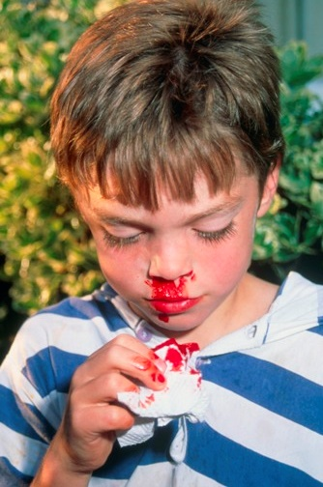

1b. Why don't most of us need injections of Factor VIII to prevent nosebleeds?

Uncle Carlos explains that Tony has probably inherited a gene that causes hemophilia. Tony asks “What is a gene? How can a gene cause hemophilia?”

A gene is a segment of DNA that gives the instructions for making a protein. Different versions of a gene can result in different versions of the protein. Different versions of the protein can result in different characteristics. For example, different versions of the gene for the clotting protein, Factor VIII, can result in normal blood clotting or hemophilia.

Gene in DNA | → | Protein | → | Characteristic
One version of a gene gives instructions for making a normal clotting protein. | → | When a blood vessel is injured, normal clotting proteins result in prompt blood clot formation. | → | After an injury, a blood clot stops the bleeding.
Another version of the gene gives instructions for making a defective clotting protein. | → | Defective clotting protein results in very slow blood clot formation. | → | Excessive bleeding  = hemophilia

2a. Which version of the gene does Uncle Carlos have? (Put UC next to the appropriate box.)

2b. Explain how different versions of a gene determine whether or not a person has hemophilia.

Other genes give the instructions for making other proteins which influence other characteristics. But, how does a gene give the instructions for making a protein?
How does a gene give the instructions for making a protein?

This figure presents an overview of how a gene gives the instructions for making a protein.

3. First, the instructions in the gene in the DNA are copied  to messenger RNA, which is usually abbreviated as mRNA.  This process is called ______________________.  (transcription / translation)  Then, mRNA moves from the _________ to the cytoplasm.  Finally, the instructions in mRNA are used to make a  protein. This process is called ______________________.  (transcription / translation) | 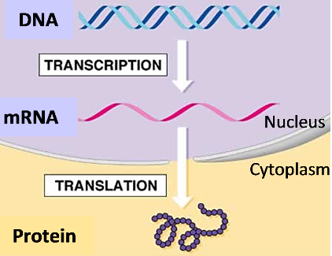

4a. This figure shows more details of short segments of the molecules involved in transcription and translation. Fill in the blanks with the molecules produced by transcription and translation.  4b. DNA and mRNA are polymers of nucleotides. Circle a C nucleotide in DNA and a matching G nucleotide in mRNA.  4c. Proteins are polymers of amino acids. Draw a rectangle around one of the amino acids. | 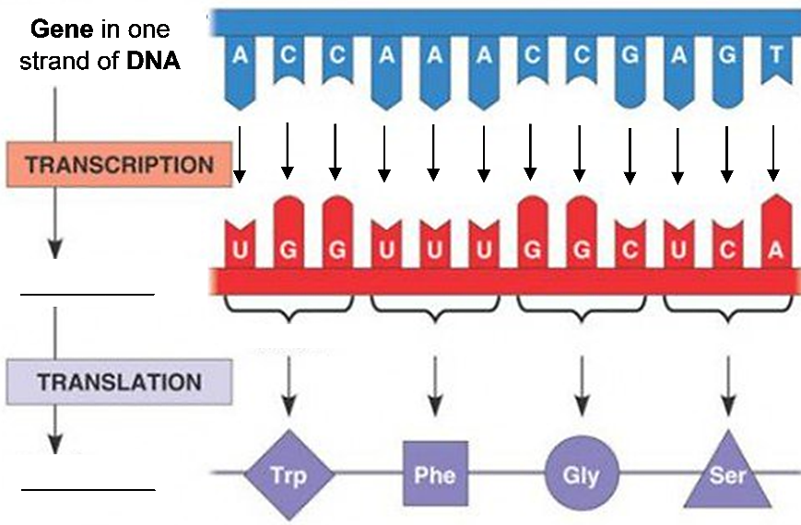

4d. The four types of nucleotides in DNA are ___, ___, ___, and ___.
The four types of nucleotides in mRNA are ___, ___, ___, and ___.
The only difference is that ___ is a nucleotide in DNA and ___ is a nucleotide in mRNA.

5a. During transcription, the sequence of nucleotides in a gene in the DNA determines the

sequence of ___________________ in mRNA.

5b. During translation, the sequence of nucleotides in mRNA determines the sequence of

_________________________ in a protein.

The sequence of amino acids in a protein determines the structure and function of the protein. For example, the sequence of amino acids determines whether a clotting protein is normal or defective.

Notice that:
- Transcription involves copying a message from a sequence of nucleotides in DNA to a matching sequence of nucleotides in mRNA.
- Translation involves translating from a sequence of nucleotides in mRNA to a sequence of amino acids in a protein.

6a. Complete this flowchart to describe an example of how different versions of a gene can result in different characteristics (e.g., normal clotting vs. hemophilia).
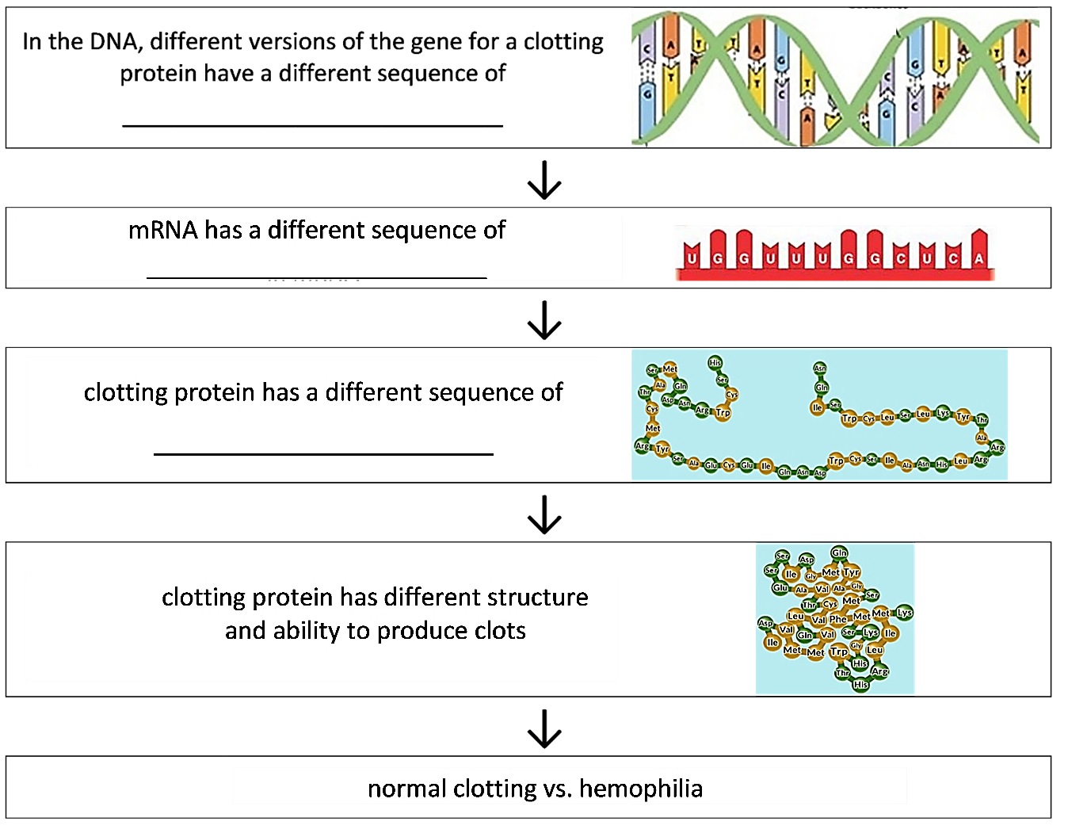

6b. Label the arrow that represents transcription.

6c. Label the arrow that represents translation.

7a. Which process takes place in the nucleus? transcription ___ translation ___

7b. Explain why this process must occur in the nucleus.

Watch the video “What is DNA and how does it work?” at http://statedclearly.com/videos/what-is-dna/. This video will review what you have learned and introduce some new information, which includes a description of the function of ribosomes.

8. In the flowchart in question 6, write ribosome next to the process that occurs in ribosomes.

In the next three sections, you will learn more about transcription, translation, and how one version of the hemoglobin gene can cause sickle cell anemia.
How does transcription make mRNA?

The top figure summarizes how RNA nucleotides are joined together to make mRNA with a sequence of nucleotides that matches the sequence of nucleotides in a gene in the DNA.

In the region of the gene, the two strands of DNA are separated temporarily.

Each DNA nucleotide in the gene is matched with a complementary RNA nucleotide which has a matching shape and charge distribution.

Each RNA nucleotide is joined to the previous RNA nucleotide to make the growing mRNA molecule.

9. Fill in each blank in this figure with DNA or mRNA.

The base-pairing rules summarize which pairs of nucleotides are complementary. The base-
pairing rules for transcription are similar to the base-pairing rules in the DNA double helix.  10. Use the information in the above figure to complete this table. |  | Base-Pairing Rules for Complementary Nucleotides:
 |  | between the two strands  of a DNA double helix | between DNA and mRNA  (during transcription)
 |  | G pairs with C. | G pairs with ____.
 |  | T pairs with A. | T in DNA pairs with ____ in mRNA.  A in DNA pairs with ____ in mRNA.

Transcription is carried out by the enzyme RNA polymerase which:  - separates the two strands of a DNA double helix,  - matches each DNA nucleotide with a complementary RNA nucleotide, and  - joins each RNA nucleotide to the previous nucleotide in the growing mRNA molecule.  11. Why is RNA polymerase a good name for this enzyme? Explain each part of the name: RNA, polymer and ase. | 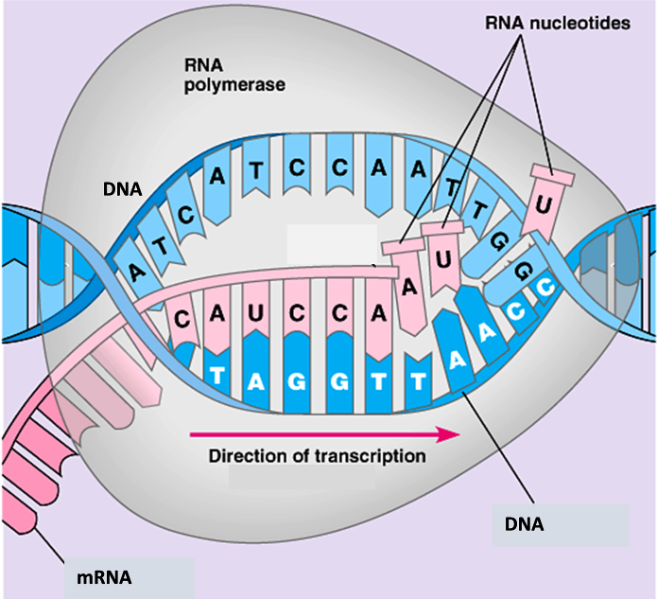

To see the process of transcription in action, view the animation “DNA Transcription” at https://www.biointeractive.org/classroom-resources/dna-transcription-basic-detail.

12. Write a paragraph or draw a diagram to summarize how transcription makes mRNA. A complete answer will include: RNA polymerase, gene, DNA, nucleotides, mRNA,
complementary, base-pairing rules.

The next two questions compare transcription with DNA replication.

13. The first column of this table describes DNA replication. Fill in the blanks in the second column to summarize the differences between DNA replication and transcription.

DNA replication | Transcription
Whole chromosomes are replicated. | A ____________ is transcribed.
Double-stranded DNA is made. | Single-stranded ________ is made.
DNA polymerase is an enzyme that carries out DNA replication. | _____ polymerase is the enzyme that carries out transcription.
T is used in DNA;  A pairs with T in the DNA double helix. | In RNA, T is replaced by ___;  A in DNA pairs with ___ in mRNA.

14. Fill in the blanks in the paragraph below to describe the similarities between transcription and DNA replication.

Both transcription and DNA replication produce nucleic acids, which are polymers of _____________________. Both processes depend on a ____________________ enzyme which adds one ___________________ at a time. To determine which nucleotide is added next, both transcription and DNA replication use the nucleotide sequence in a DNA strand and the ___________________________ rules.

Translation – How does mRNA give the instructions for making a protein?
Translation from a nucleotide sequence in mRNA to an amino acid sequence in a protein requires solutions to several dilemmas. For example, there are 20 types of amino acids in proteins, but only 4 types of nucleotides in mRNA. How do 4 types of nucleotides provide a unique code for each of the 20 types of amino acids in proteins?

This figure shows the answer. (The mRNA is below the
protein to be consistent with the other figures on this page.)
codon.
15a. The mRNA code for each type of amino acid is a sequence of _______ nucleotides, called a
(2 / 3 / 4)
15b. In the figure above, circle the mRNA codon that codes for the amino acid Phe.

During protein synthesis, a transfer RNA (tRNA) molecule brings the right amino acid for each mRNA codon.  16a. This figure shows one type of tRNA with the amino acid Phe attached. The three nucleotides in the anticodon of this tRNA molecule are complementary to the three nucleotides in the mRNA codon for ____.  16b. There are multiple types of tRNA. Each type of tRNA carries a specific amino acid and has an anticodon with three nucleotides that are complementary to the three nucleotides in the mRNA ___________ for that amino acid. For each type of tRNA, there is a specific enzyme that | 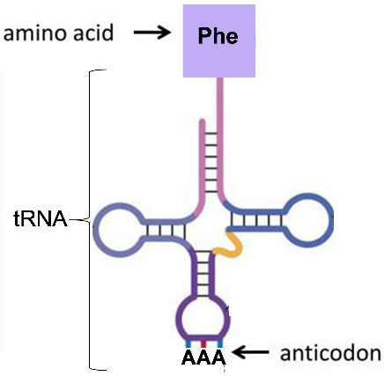
attaches the correct amino acid for the anticodon in that tRNA. These enzymes are needed for
step ______ in the figure below.
(1/2/3/4)
17a. Inside a ribosome, a codon in an mRNA molecule is matched by the base-pairing rules with an ______________ in a tRNA (step 3 in this figure). This tRNA brings the next amino acid to be added to the growing protein molecule.  17b. Each amino acid is joined to the previous ______________ in the growing protein molecule (step ___). Then, the ribosome moves along the mRNA to the next codon (step ___).  17c. In the ribosome, circle a codon in the | 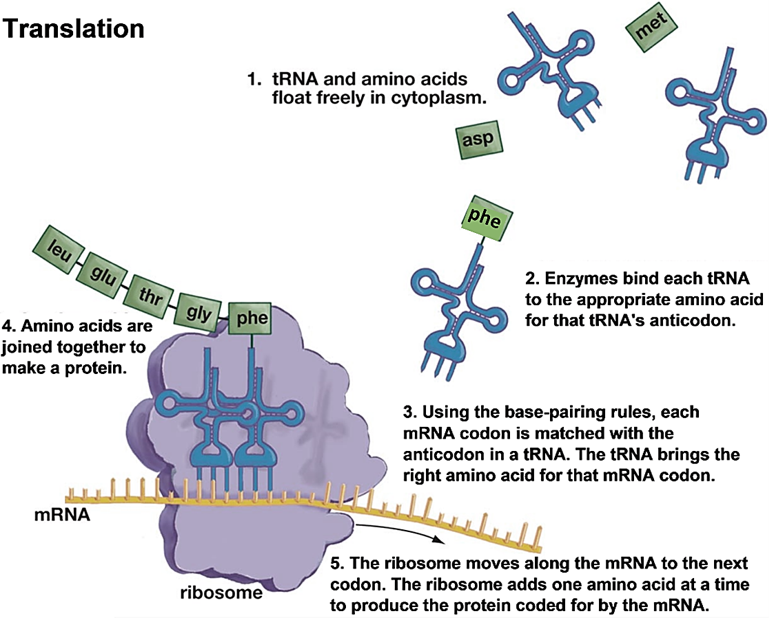
mRNA together with the complementary anticodon in a tRNA molecule.

18. What part of translation depends on the base-pairing rules?

19. tRNA stands for transfer RNA, since a tRNA molecule transfers an amino acid to the growing protein molecule. You could also think of tRNA as translation RNA. Explain how tRNA molecules help the ribosome to translate the sequence of nucleotides in mRNA to a sequence of amino acids in a protein.

To see the process of translation in action, watch “Translation” at https://www.biointeractive.org/classroom-resources/translation-basic-detail.

20a. Fill in the blanks to label each type of molecule in this figure.  20b. Explain each step in the process shown in the figure. A complete answer will include each of the molecules shown and these words:  nucleotides, anticodon, codon,  base-pairing rules, ribosome. | 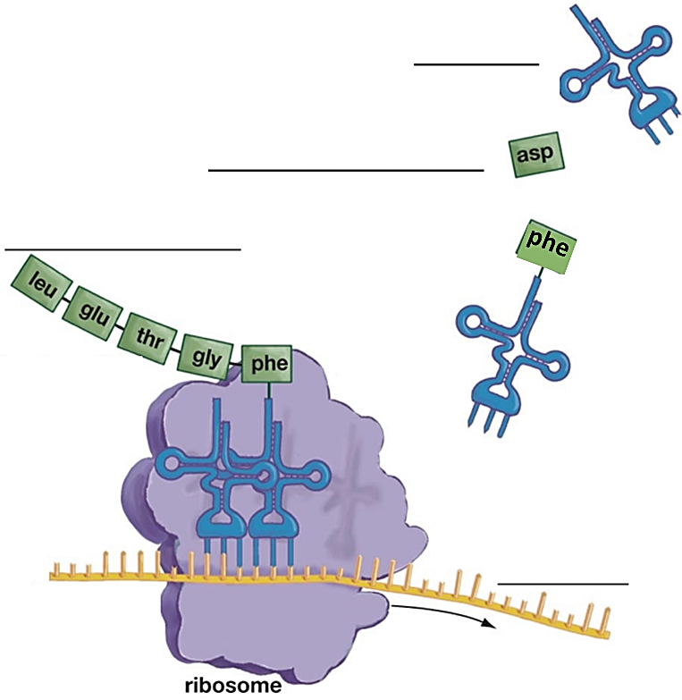

21. Why does a cell need to carry out transcription before translation?

How a Version of the Hemoglobin Gene Can Cause Sickle Cell Anemia

To understand how sickle-cell hemoglobin can cause sickle cell anemia, watch the video, “How This Disease Changes the Shape of Your Cells” at https://www.youtube.com/watch?v=hRnrIpUMyZQ. This video refers to a genetic mutation, which is a change in a gene. A mutation results in a different version of the gene. Different versions of the same gene are called alleles.

The protein hemoglobin in our red blood cells carries oxygen. One allele of the hemoglobin gene gives the instructions to make normal hemoglobin, which dissolves in the cytosol of red
blood cells. These normal, disc-shaped red blood cells can squeeze through even the smallest blood vessels.  In contrast, another allele of the hemoglobin gene gives the instructions to make sickle-cell hemoglobin. Sickle-cell hemoglobin can clump together to form long rods inside the red blood cells. These rods distort the shape of the cell, so the red blood cell is shaped like a banana or sickle.  The sickle-shaped red blood cells can block small blood vessels. This cuts off the oxygen supply, which causes intense pain and damage to body organs. | 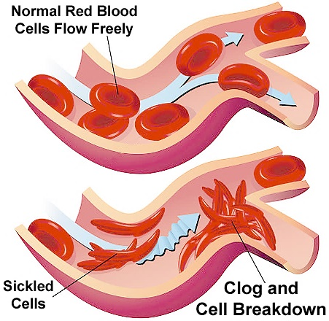

Red blood cells with sickle-cell hemoglobin don’t survive as long as red blood cells with normal hemoglobin. This results in anemia (a low level of red blood cells), which causes fatigue.

22a. Fill in the blanks in this chart to describe how the normal hemoglobin allele results in normal health and the sickle cell hemoglobin allele results in sickle cell anemia.

Gene in DNA | → | Protein |  | → | Characteristics
2 copies of the allele  for  normal hemoglobin | → | Normal hemoglobin dissolves in the cytosol of red blood cells. |  | → | Disc-shaped __________________ can squeeze through small blood vessels → normal health | 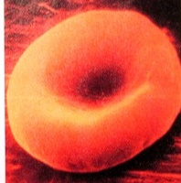
2 copies of the allele  for  sickle cell hemoglobin | → | Sickle-cell  ____________ can clump in long rods inside red blood cells. |  | → | When sickle cell hemoglobin  clumps in long rods,  → sickle-shaped _______________  → block small blood vessels  → not enough oxygen  → pain, damage to body organs.  Also, these red blood cells die faster than they can be replaced  → _________ (low red blood cells).  Person has sickle cell anemia. | 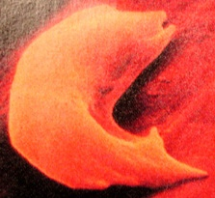

22b. Name the process or processes represented by the first arrow in the chart.

23a. The big table below shows the nucleotide sequence in the beginning of the alleles for normal hemoglobin and sickle-cell hemoglobin. Complete the big table; use the information in the small bottom table for translation.
23b. Circle any difference in the amino acid sequence for the beginning of normal vs. sickle-cell hemoglobin.

Beginning of Allele for Normal Hemoglobin | CACGTAGACTGAGGACTC
Transcription produces: | codon1 | codon 2 | codon 3 | codon 4 | codon 5 | codon 6
Beginning of Normal Hemoglobin mRNA
Translation produces: | amino acid 1 | amino acid 2 | amino acid 3 | amino acid 4 | amino acid 5 | amino acid 6
Beginning of Normal Hemoglobin Protein
Beginning of Allele for Sickle Cell Hemoglobin | CACGTAGACTGAGGACAC
Transcription produces: | codon 1 | codon 2 | codon 3 | codon 4 | codon 5 | codon 6
Beginning of Sickle Cell Hemoglobin mRNA
Translation produces: | amino acid 1 | amino acid 2 | amino acid 3 | amino acid 4 | amino acid 5 | amino acid 6
Beginning of Sickle Cell Hemoglobin Protein

mRNA codon | ACU | CAU | CCU | CUG | GAG | GUG
Amino acid | Thr (Threonine) | His (Histidine) | Pro (Proline) | Leu (Leucine) | Glu  (Glutamic acid) | Val (Valine)

The alleles for sickle-cell hemoglobin and normal hemoglobin differ in a single nucleotide which results in a difference in amino acid 6 out of more than 100 amino acids in the hemoglobin protein. To understand why sickle-cell hemoglobin tends to clump in long rods, whereas normal hemoglobin remains dissolved in the watery cytosol of red blood cells, consider that:
- Valine (Val) is much less water-soluble than glutamic acid (Glu).
- Amino acid 6 is in a crucial location on the outer surface of the hemoglobin protein.

24. Explain how a difference in a single nucleotide in the hemoglobin gene can result in pain and organ damage.

Thus far, we have discussed the biology of a person who has inherited the allele for sickle-cell hemoglobin from both parents and therefore has sickle cell anemia. In contrast, a person who has inherited the allele for sickle-cell hemoglobin from only one parent will have the alleles, proteins and characteristics shown in this table.

Gene in DNA | → | Proteins | → | Characteristics
1 allele for  normal hemoglobin  + 1 allele for sickle-cell hemoglobin | → | Normal and sickle-cell hemoglobin in each red blood cell.  The normal hemoglobin prevents clumping of the sickle-cell hemoglobin. → Both types of hemoglobin dissolve in the cytosol of red blood cells. | → | The disc-shaped red blood cells can squeeze through the small blood vessels → normal health.  Sickle-cell hemoglobin reduces the ability of the malaria parasite to reproduce in red blood cells. → Malaria infections are less severe.

25a. If a person inherits the allele for sickle-cell hemoglobin from only one parent, will he or she have sickle cell anemia? yes ___ no ___

25b. Explain why.

25c. Explain how a person who inherits the allele for sickle-cell hemoglobin from one parent can have a health advantage in some parts of the world.

Each person has more than 20,000 genes that code for the amino acid sequence in different proteins. Proteins have many functions in our bodies, including carrier proteins like hemoglobin, enzymes like RNA polymerase, messenger proteins like growth hormone, and structural proteins like collagen. Our genes act via these proteins to influence our risk of diseases (e.g., sickle cell anemia) and many other characteristics (e.g., height and eye color).

26. Considering that each person is made up of the same 4 nucleotides in our DNA, the same 4 nucleotides in our RNA, and the same 20 amino acids in our proteins, what accounts for the differences between people?

By Drs. Ingrid Waldron and Jennifer Doherty, Dept Biology, Univ Pennsylvania. Copyright, 2023. This Student Handout and Teacher Preparation Notes (with instructional suggestions and background biology) are available at https://serendipstudio.org/exchange/bioactivities/trans.

