Teacher Notes for
Structure and Function of Cells, Organs and Organ Systems

In this activity, students analyze multiple examples of the relationship between structure and function in diverse human cells and in the digestive system. Students learn that cells are dynamic, with constant molecular activity. Students analyze examples that illustrate how organelles work together to accomplish cellular functions and organs and organ systems work together to accomplish functions needed by the organism. Finally, students evaluate the claim that structure is related to function in cells, organs and organ systems.

Before students begin this activity, they should have a basic understanding of the functions of the organelles in eukaryotic cells. For this purpose, I recommend “Introduction to Cells” (https://serendipstudio.org/exchange/bioactivities/CellIntro). If your students need additional review, they may enjoy exploring the animation of cell organelles in animal and plant cells at https://www.cellsalive.com/cells/cell_model_js.htm.

Table of Contents
Learning Goals – pages 1-2
Instructional Suggestions and Background Information
General – page 2
Cell Structure and Function – pages 2-6
Structure and Function of Organs and Organ Systems – pages 6-10
Sources for Figures in Student Handout – page 10
Related Activities – page 10

Learning Goals
In accord with the Next Generation Science Standards:
- This activity helps students to prepare for the Performance Expectations:
- MS-LS1-2. "Develop and use a model to describe the function of a cell as a whole and ways parts of cells contribute to the function."
- MS-LS1-3. "Use argument supported by evidence for how the body is a system of interacting subsystems composed of groups of cells."
- HS-LS1-2. "Develop and use a model to illustrate the hierarchical organization of interacting systems that provide specific functions within multicellular organisms."
- Students learn the following Disciplinary Core Ideas (LS1.A):
- "Within cells, special structures are responsible for particular functions…"
- "Multicellular organisms have a hierarchical structural organization, in which any one system is made up of numerous parts and is itself a component of the next level."
- Students engage in recommended Scientific Practices, including:
- "Constructing Explanations. Apply scientific ideas, principles, and/or evidence to provide an explanation of phenomena…".
- “Engaging in an Argument from Evidence. Construct… and present… a written argument… based on data and evidence.”
- This activity focuses on the Crosscutting Concept: Structure and function. "The functions and properties of natural and designed objects and systems can be inferred from their overall structure, the way their components are shaped and used, and the molecular substructures of its various materials."

Additional Content Learning Goals
- In the human body, different types of cells have different shapes and different amounts of specific molecules and organelles; these differences in structure correspond to the different functions of the various types of cells.
- Cells are dynamic and active.
- The cells in human bodies are organized in tissues, organs and organ systems. The small intestine and the digestive system illustrate how structure is related to function at the organ and organ system levels.
- The digestive system and circulatory system cooperate to bring nutrients to every cell in the body.

Instructional Suggestions and Background Information
To maximize student participation and learning, I suggest that you have your students work individually or in pairs to complete groups of related questions and then have a class discussion after each group of related questions. In each discussion, you can probe student thinking and help them develop a sound understanding of the concepts and information covered before moving on to the next group of related questions.

A key is available upon request to Ingrid Waldron (iwaldron@upenn.edu). The following paragraphs provide additional instructional suggestions, links for recommended videos, and biological information – some for inclusion in your class discussions and some to provide you with relevant background that may be useful for your understanding and/or for responding to student questions.

This learning activity presents general principles, using examples of various cells, tissues, organs and organ systems in humans.

Cell Structure and Function
The Inner Life of the Cell video (https://www.youtube.com/watch?v=FzcTgrxMzZk) recommended on page 1 of the Student Handout provides an excellent animation that will reinforce student understanding of the dynamic activity inside human cells. To avoid excessive detail, I suggest showing only part of this animation, beginning with microtubules and transport vesicles, followed by mRNA exiting the nucleus through pores in the nuclear membrane, and continuing through exocytosis of secreted proteins. This recommended section begins at about 3 minutes and 30 seconds and ends at about 6 minutes and 30 seconds. You will probably want to listen to the narration for your own information, but I recommend that you turn off the narration for classroom viewing because it is probably too technical for your students. I suggest that you give a student-friendly narration, which you can develop, based on the video narration and the relevant section from http://sparkleberrysprings.com/innerlifeofcell.html.

The figure below provides information relevant to question 1. Many secreted proteins have carbohydrates attached; the carbohydrate is often bonded to the protein in the rough ER and processed by removal, substitution or modification of a sugar monomer in the Golgi apparatus (labeled in this figure as the Golgi complex). A similar process produces the proteins that will be inserted in the cell membrane.
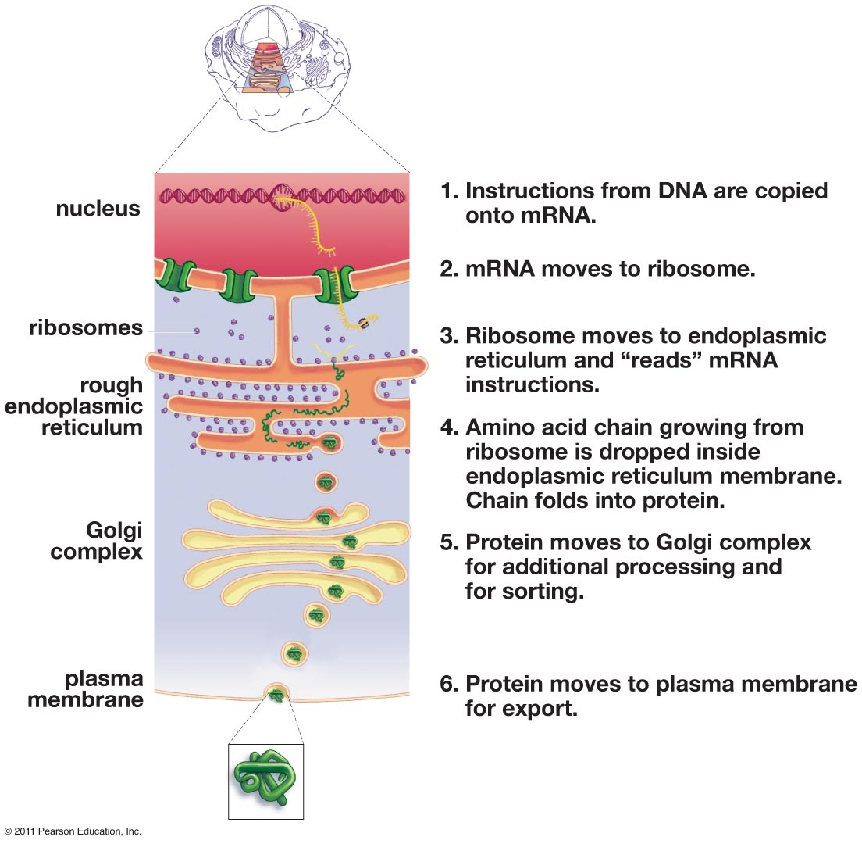
(In this figure the cell membrane is called the plasma membrane. From Krogh, Biology - A Guide to the Natural World, Fifth Edition)

The figure on the top of page 2 of the Student Handout shows the basic process that transports proteins from the rough endoplasmic reticulum to the Golgi apparatus. More detail is available at https://www.ncbi.nlm.nih.gov/books/NBK26941/.

Question 2 revisits protein secretion from a different point of view that includes a broader set of organelles. In your discussion of student answers to this question, you may want to include the point that multiple organelles cooperate to carry out the activities of life in a eukaryotic cell. Be careful to avoid the common error of saying that mitochondria make energy; mitochondria use the energy available from the reactions between glucose and oxygen to make ATP molecules (see “How do organisms use energy?”; https://serendipstudio.org/exchange/bioactivities/energy). Lysosomes contain digestive enzymes that break down damaged organelles and macromolecules into smaller molecules (e.g. amino acids, nucleotides or monosaccharides), which are reused by the cell (see figure below).

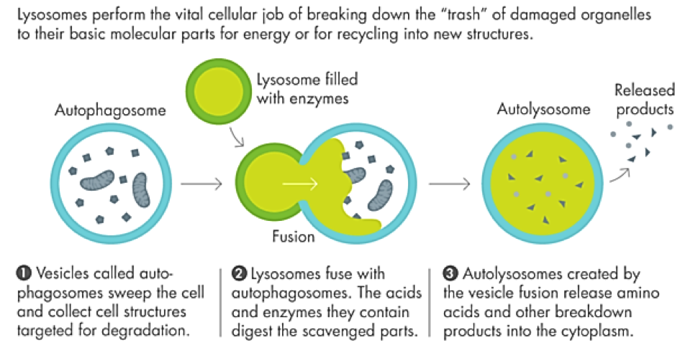
(https://leisureguy.files.wordpress.com/2017/04/creativedestruction-615_double-615x374.png)

When you introduce the concept that structure is related to function, you may want to introduce familiar examples such as the differences between the structure and function of hands and feet, the hard enamel of teeth, and the different shapes of teeth for different functions.

As suggested in question 3a, you may want to show your students a video of sperm swimming (https://sites.tufts.edu/guastolab/movies/ and http://en.wikipedia.org/wiki/Sperm ). Natural selection favors sperm characteristics that contribute to faster swimming, since usually the first
sperm to reach an egg fertilizes the egg, so its genes are passed on to the next generation.  This figure shows how small human sperm are relative to a human egg. Sperm have very little cytoplasm, whereas the egg is a very large cell with a lot of cytoplasm. Once the egg has been fertilized, this large amount of cytoplasm is useful to supply the cytoplasm for the multiple cells that are produced by the cell divisions before the developing embryo implants in the wall of the uterus. | 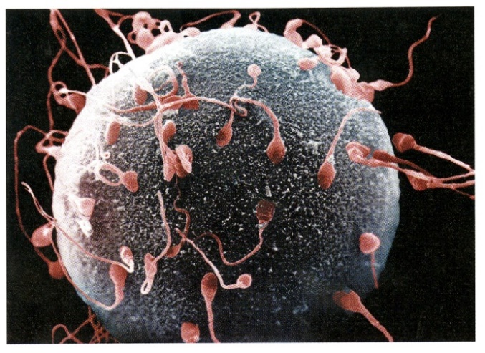  (Figure from Krogh, Biology --  A Guide to the Natural World, Fifth Edition)

The heart pumps blood through the aorta, arteries and arterioles to the capillaries where oxygen and nutrients diffuse out through the capillary wall. Diffusion is reasonably rapid over very short distances, but very slow over any substantial distance. Thus, the single layer of flattened cells in the wall of capillaries maximize diffusion into and out of the blood. The flattened shape of the cells also reflects the fact that the cells in capillary walls have minimal metabolic activity, so there is minimal need for cytoplasm. (The same considerations explain why the alveoli in the lungs are lined by a single layer of flattened cells.)

Mammalian red blood cells are extremely specialized to carry oxygen from the lungs to the tissues all over the body. This figure shows how these specialized cells develop, beginning in the bone marrow and finishing in the blood. The nucleus, mitochondria, and ribosomes are ejected near the end of the development of a red blood cell, resulting in a small cell which is packed with lots of hemoglobin to carry lots of oxygen to the body’s cells. Because of the small size and disk shape of red blood cells, each hemoglobin molecule is near the cell membrane which facilitates efficient uptake and release of O₂ as the red blood cell travels between the lungs and body cells. The absence of mitochondria ensures that the oxygen is not used for cellular respiration in the red blood cells. A disadvantage of this specialized cell structure is that red blood cells have very little capacity for repair; each red blood cell only survives about four months and then has to be replaced.

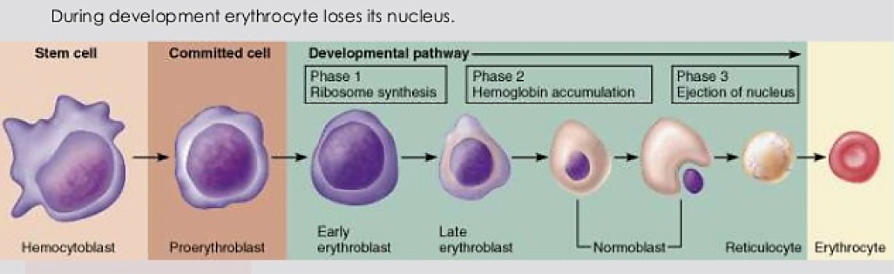
(https://image.slidesharecdn.com/stemcell-140331171428-phpapp02/95/monophyletic-theory-of-hematopoiesis-stem-cells-13-638.jpg?cb=1396286171)

If you haven’t already, you may want to show your students a time lapse video of a phagocytic white blood cell (neutrophil) chasing a bacterium (https://www.youtube.com/watch?v=I_xh-bkiv_c or https://serendipstudio.org/exchange/bioactivities/CellIntro). This video shows the dynamic changes in shape as the phagocytic cell moves.  After a phagocyte has engulfed a microorganism, the phagosome merges with a lysosome which produces nitric oxide and hydrogen peroxide to kill the microorganism and digestive enzymes to break down the microorganism to components the cell can use or | 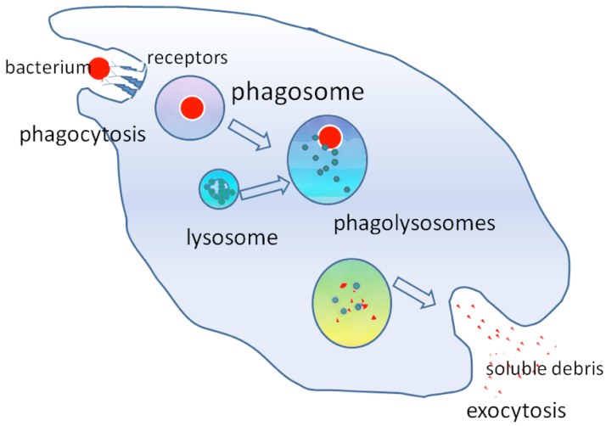  (http://getting-in.com/wp-content/uploads/2012/09/Picture-2212.png)
the body can dispose of. Each phagocyte has hundreds of lysosomes.

For your class discussion of question 8, you may want to include additional information about the dynamism of cells, including:
- A eukaryotic cell can produce hundreds of protein molecules per second; the ribosomes in these cells typically add two amino acids per second to a growing polypeptide.
- A typical cell in a human body uses an average of 10 million ATP molecules per second and produces an equal amount of replacement ATP molecules.
- Mitochondria are replaced approximately every 10 days.
- Many cells in the body are constantly being replaced, e.g. skin cells and the epithelial cells that line that gut.
(Source: Freeman et al., Biological Science, Fifth Edition)

Structure and Function of Organs and Organ Systems
If you want to review levels of organization in biology with your students, I recommend the analysis and discussion activity, “Levels of Organization in Biology” (https://serendipstudio.org/exchange/bioactivities/LevelsOrganization). For a brief review, you may want to use the figure below. An introduction to levels of organization is available at https://www.khanacademy.org/science/high-school-biology/hs-human-body-systems/hs-body-structure-and-homeostasis/a/tissues-organs-organ-systems.

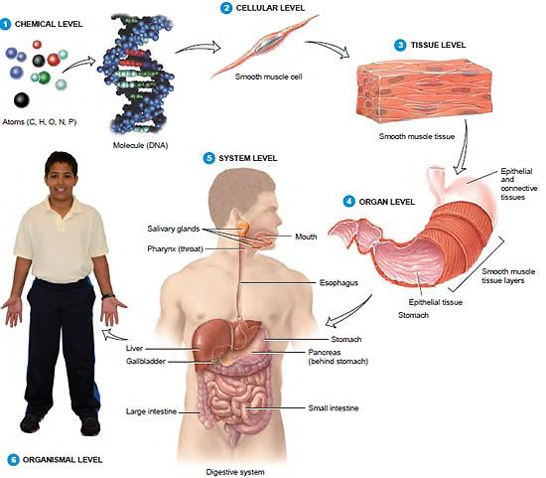
(http://www.protein-structure.net/images/Body-Systems.jpg)

To introduce the digestive system, you may want to show the helpful 5-minute animation available at https://www.youtube.com/watch?v=Og5xAdC8EUI. The two diagrams of the digestive system on page 5 of the Student Handout illustrate how different diagrams of the same structure convey somewhat different information and are useful for different purposes. The first figure clearly shows the sequence of the organs in the digestive system, whereas the second figure more accurately shows the anatomical arrangement of the organs of the digestive system. The first figure shows the cecum, which is a pouch at the beginning of the large intestine, with the appendix at the end of the cecum. Herbivores like rabbits have a large cecum which contains bacteria that assist in the digestion of plant matter.

In your discussion of question 9, you should include the importance of chewing food into smaller particles so digestive enzymes in the small intestine will have better access to the food molecules. Advantages of having food pass through the stomach before the small intestine include having stomach acid kill microorganisms before they enter the small intestine with its large surface area and potential for infection. Also, the storage capacity of the stomach allows a person to eat large meals and gradually releases small amounts of food particles to the small intestine. If too much food enters the small intestine too rapidly, the small intestine malfunctions and cannot digest all the food. People who have reduced stomach volume due to surgery for cancer or weight loss must eat small meals throughout the day.

You may need to explain the upper figure on page 6 of the Student Handout to ensure that your students understand the cutaway view on the left and the magnification of a villus on the right. The figure below shows some additional details of the structure of the lining of the small intestine. The hepatic portal vein carries blood from the small intestine to the liver, which processes some of the food molecules that have been absorbed from the lumen of the small intestine. For example, after a meal, glucose levels are high in the blood that goes from the small intestine to the liver; the liver removes some of the glucose from the blood and converts it to a storage form (glycogen) which will subsequently be available for use between meals. From the liver, the blood flows to the heart which pumps blood containing nutrients to capillaries near every cell in the body.
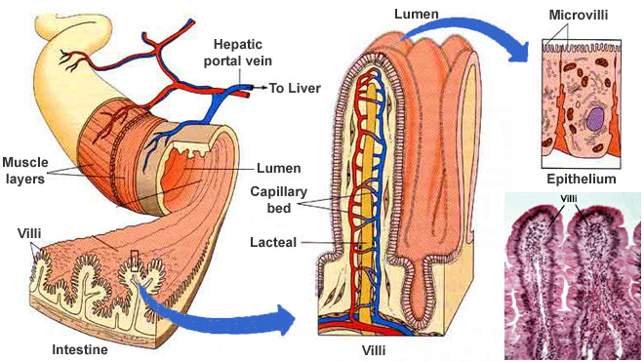
http://www.daviddarling.info/images/small_intestine_cross-section.jpg

The length of the small intestine, the folds in the lining of the small intestine, the villi and the microvilli all increase the surface area for absorption. The surface area of the lining of the small intestine is approximately 300 m², which is roughly the size of a tennis court! The narrow diameter of the small intestine (~2.5 cm) ensures that digested food molecules in the lumen are relatively near to the wall of the small intestine where they can be absorbed. The lacteal inside a villus is a lymph vessel; lacteals play an important role in absorption of fats.

The cells in the epithelium that lines the inner surface of the small intestine synthesize protein enzymes that help to complete the digestion of food molecules. These cells also pump in sugars and amino acids, which increases absorption of these useful molecules from the lumen of the small intestine. To accomplish these functions, these cells need lots of cytoplasm with lots of mitochondria, ribosomes, rough endoplasmic reticulum and Golgi apparatus. (The latter two are needed since digestive enzymes and pump proteins are inserted in the part of the plasma membrane that faces the lumen of the small intestine.) These metabolically active epithelial cells in the lining of the small intestine are tall and have much more cytoplasm per epithelial area than the relatively inactive flattened cells in the capillary wall. (The capillary wall cells do not synthesize enzymes or pump useful molecules; instead the flattened shape provides a minimum barrier to diffusion, as discussed above.) This is another example of how structure is related to function.

Additional information about the digestive system is available at:
- http://www.webmd.com/heartburn-gerd/your-digestive-system
- http://www.biog1445.org/demo/05/humandigestion.html
- http://www.innerbody.com/image/digeov.html.

In discussing the role of the circulatory system (questions 10c and 11), you may want to explain that nutrients diffuse into the blood in the capillaries in the villi of the small intestine and then later diffuse out of the blood in capillaries in other parts of the body (as shown in the top figure on page 3 of the Student Handout).

Question 11 illustrates the important general principle that our bodies consist of multiple body systems that cooperate to accomplish important functions. For example, the digestive and circulatory systems cooperate to provide cells all over the body with digested food molecules that can be used for cellular respiration and as building blocks to synthesize needed molecules.  You may want to include additional examples such as the cooperation between the respiratory system and the circulatory system to provide oxygen to every cell in the body and also to remove the waste product, carbon dioxide. This highly simplified diagram illustrates how the circulatory system is crucial for allowing the specialized digestive, respiratory, and excretory systems to serve needed functions for all the cells in the body. | 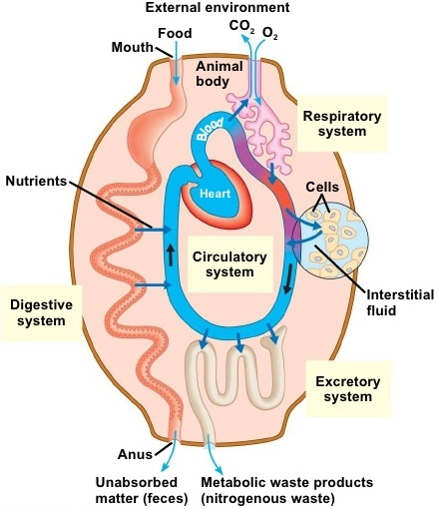

You also may want to point out the role of the nervous system in controlling the activity of the tongue and jaw muscles and regulating other aspects of digestion. A 4-minute rap video that reviews body systems is available at http://mr.powner.org/b/lessons/humans/So%20Many%20Systems%20-%20Human%20Body%20Systems%20Rap.mp4.

Question 12 guides students in developing a scientific argument. You may want to introduce your students to the idea that, in a scientific argument, a claim is evaluated on the basis of the available evidence, with reasoning to explain how the evidence is relevant to the claim. This is also called “Claim, Evidence, Reasoning” or “CER”. In question 12, the claim is stated in the first sentence; the first two columns of the table ask students to give the evidence; and the third column asks for the reasoning. Criteria for evaluating the validity of a scientific argument include:
- how well the claim fits with all the available evidence
- the relevance of the evidence (as explained in the reasoning)
- the quality of the evidence
- whether there is enough evidence.

Students may bring up examples of vestigial structures that have been thought to have no function. However, biologists have recently discovered functions for some structures previously thought to be vestigial and without function. For example, recent research suggests that the human appendix may contribute to immune function and also stores beneficial bacteria that can repopulate the rest of the gut after an illness (e.g. cholera or dysentery) has caused diarrhea that has swept most of the beneficial bacteria out of the gut (https://en.wikipedia.org/wiki/Appendix_(anatomy). Another example is hip bones in whales, which appear to play a role as attachments for muscles that control the penis (https://news.usc.edu/68144/whale-reproduction-its-all-in-the-hips/).

Additional information for teaching about scientific argumentation is available at:
- http://www.scientificargumentation.com/overview-of-scientific-argumentation.html
- The Science Teacher, summer, 2013, pages 30-55, has multiple articles that suggest various ways to develop students’ skills in scientific argumentation.
- http://undsci.berkeley.edu/article/0_0_0/howscienceworks_07 takes a somewhat different approach to the components of a scientific argument.

Sources for Figures in Student Handout
- Eukaryotic animal cell – modified from https://slideplayer.com/slide/6128936/
- Protein synthesis– modified from Krogh, Biology – A Guide to the Natural World, Fifth Edition
- Motor protein walking along microtubule – modified from http://jonlieffmd.com/wp-content/uploads/2012/04/Crop-of-kinesin-.jpg
- Capillary – modified from https://aaimagestore.s3.amazonaws.com/july2017/0017391.003.jpg
- Phagocytosis – modified from https://slideplayer.com/slide/13987131/86/images/24/Inflammatory+Response.jpg
- Tissue, organ and excretory organ system – modified from https://www.khanacademy.org/science/high-school-biology/hs-human-body-systems/hs-body-structure-and-homeostasis/a/tissues-organs-organ-systems
- Digestive system – modified from https://useruploads.socratic.org/LtW1t1ySdKXDGGeeKhpt_cub_human_lesson04_figure4.jpg
- Small intestine – modified from http://www.daviddarling.info/images/small_intestine_cross-section.jpg

Related Activities
Cell Membrane Structure and Function
http://serendipstudio.org/sci_edu/waldron/#diffusion
This activity includes two hands-on experiments and numerous analysis and discussion questions to help students understand how the characteristics and organization of the molecules in the cell membrane result in the selective permeability of the cell membrane. In the hands-on experiments, students first evaluate the selective permeability of a synthetic membrane and then observe how a layer of oil can be a barrier to diffusion of an aqueous solution. Students answer analysis and discussion questions to learn how the phospholipid bilayer and membrane proteins play key roles in the cell membrane function of regulating what gets into and out of the cell. Topics covered include ions, polar and nonpolar molecules; simple diffusion through the phospholipid bilayer; facilitated diffusion through membrane proteins; and active transport by membrane proteins. An optional additional page introduces exocytosis and endocytosis. (This activity supports the Next Generation Science Standards = NGSS.)

Cell Structure and Function – Major Concepts and Learning Activities
http://serendipstudio.org/exchange/bioactivities/cells
This overview presents key concepts that students often do not learn from standard textbook presentations and suggests learning activities to help students understand how the parts of a cell work together to accomplish the multiple functions of a dynamic living cell. Suggested activities also reinforce student understanding of the relationships between molecules, organelles and cells and the importance and limitations of diffusion. This overview provides links to web resources, analysis and discussion activities, and hands-on activities.

By Ingrid Waldron, Department of Biology, University of Pennsylvania, 2021. These Teacher Notes and the Student Handout are available at http://serendipstudio.org/exchange/bioactivities/SFCellOrgan.
Quotations are from http://www.nextgenscience.org/sites/default/files/HS%20LS%20topics%20combined%206.13.13.pdf
If you have previously discussed natural selection, you may want to discuss the role of selection for any improvements in structure that contribute to better function.
Polar substances diffuse through the interstitial fluid between the cells of the capillary wall, whereas lipid soluble substances like oxygen and carbon dioxide diffuse across the cells; the latter drastically increases the area available for diffusion of oxygen and carbon dioxide since the cells of the capillary wall have more than 100 times as much area as the spaces between the cells. The single layer of cells around the capillary lumen is often called a simple squamous epithelium or endothelium.
These criteria are paraphrased from Argument-Driven Inquiry in Biology (by Sampson et al., NSTA Press). This book presents a useful, more extensive format for developing students’ ability to engage in scientific argument.

