Structure and Function of Cells, Organs and Organ Systems

Cell Structure and Function

Review the parts of an animal cell shown in this figure.

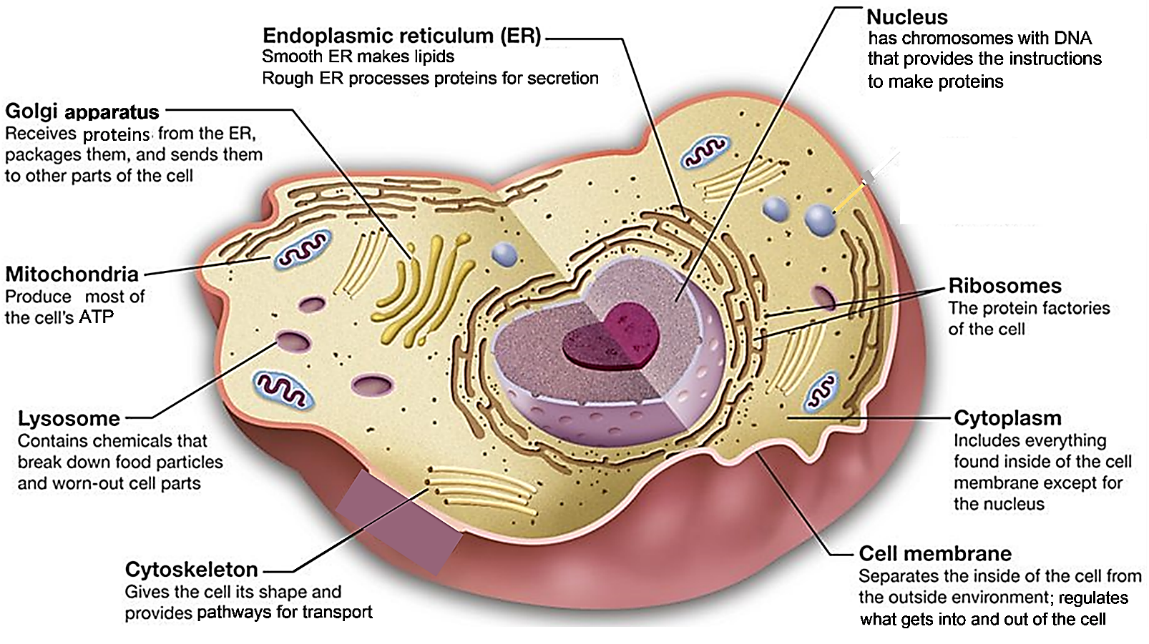

To see some of the continual activity inside a cell, view “Inner Life of the Cell” (https://www.youtube.com/watch?v=FzcTgrxMzZk; begin at about 3 minutes and 30 seconds and end at about 6 minutes and 30 seconds, preferably with a narration by your teacher).

The different parts of a cell work together to accomplish the cell’s functions. For example, this figure shows how cell parts cooperate to secrete proteins such as:
- protein hormones (e.g. insulin)
- protein enzymes that digest your food
- proteins that help your blood to clot.

1. A protein that will be secreted from the cell is:

- made by a __________________ on the rough endoplasmic reticulum,
- then processed in the rough endoplasmic reticulum,

- transported in a vesicle from the ___________________ ______________________to the Golgi apparatus,

- processed some more in the ______________________,
- and transported in a vesicle to the cell membrane where the protein is secreted.

This figure shows how proteins are moved in vesicles, e.g. from the rough endoplasmic reticulum to the Golgi apparatus. A motor protein walks along a microtubule (part of the cytoskeleton) and carries a vesicle containing proteins. | 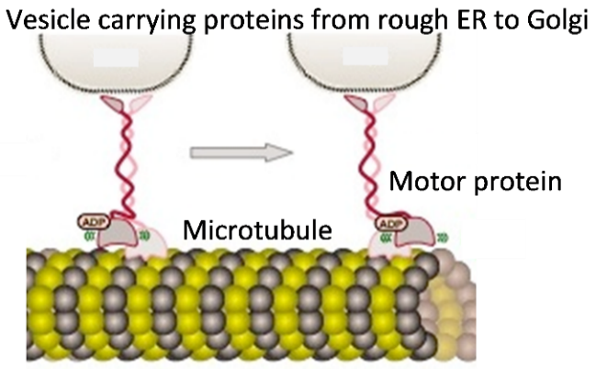

2. If you think of a cell as a factory that makes proteins and ships them out, which parts of the cell accomplish each of the listed functions?
Factory Function | What part or parts of the cell  accomplish this function?
Management – sends out instructions
(DNA –> RNA)

Workbench – makes products (proteins)

Processing – prepares products (proteins)
to leave factory/cell

Transport – moves products (proteins)
around in factory/cell

Security Fence with Gates – controls what
comes into and leaves the factory/cell

Powerhouse – provides energy in a form
the factory/cell can use (ATP)

Cleanup crew – disposes of old and
worn out products and equipment;
prepares them for recycling

Many cells in our bodies do not look like the "typical" animal cell shown on page 1. Different types of cells have different shapes and contents that match their differences in function. For example, the specialized structure of sperm cells helps them to reach and fertilize eggs.

3a. Explain how the flagellum of a sperm cell contributes to sperm function. (Hint: View swimming sperm at https://sites.tufts.edu/guastolab/movies/.)  3b. Why is it an advantage for a sperm cell to have very | 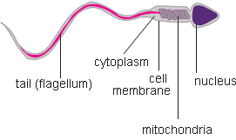
little cytoplasm and lots of mitochondria?

The cells in your body need a constant supply of oxygen and nutrients, and they need to get rid of the carbon dioxide and other waste molecules that they produce. Your blood brings the needed inputs and takes away the cells’ waste products. Near each cell in your body is a tiny blood vessel called a capillary.
- Oxygen and nutrients diffuse from the blood in the capillary to nearby cells.
- Carbon dioxide and other waste molecules diffuse from nearby cells into the blood.

4. Explain why it is useful for the wall of a capillary to consist of a single layer of thin, flattened cells. | 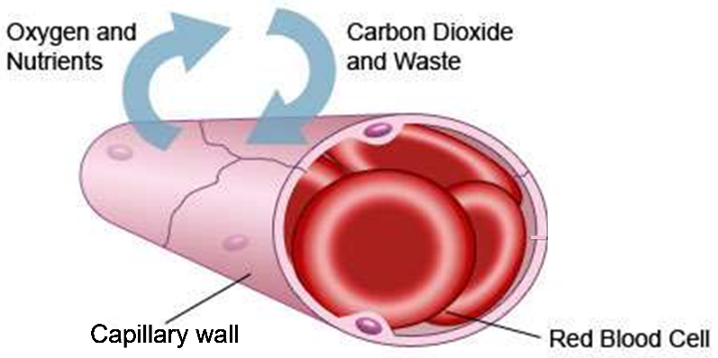

Human red blood cells are specialized to carry lots of oxygen to the body’s cells. Each red blood cell is full of hemoglobin, the protein that carries oxygen.

5a. A human red blood cell has no nucleus, ribosomes or mitochondria. Explain how this helps red blood cells to accomplish their function.

5b. Most cells are constantly replacing damaged molecules and organelles. Explain why a human red blood cell is unable to replace damaged proteins.

Phagocytes are a type of white blood cell that helps to defend the body against bacteria and viruses. Phagocytes squeeze between the cells of the capillary wall to move from the blood to an infected injury. Phagocytes capture the bacteria and viruses. Then, the chemicals and enzymes in the phagocytes’ lysosomes kill and digest the bacteria and viruses.
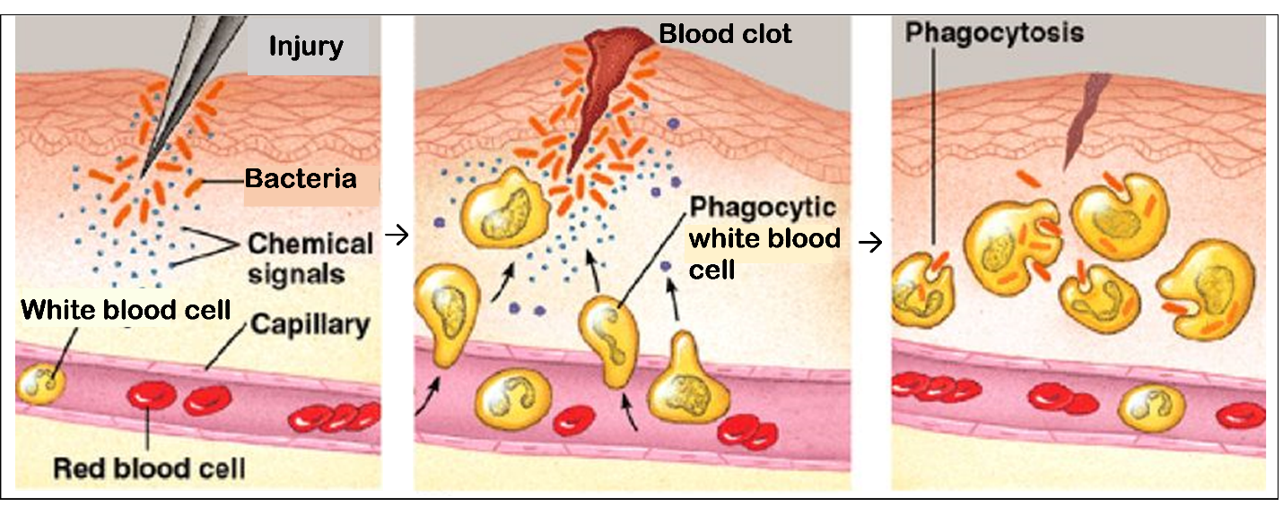

6a. Why do phagocytes need to be able to change shape in order to accomplish their function?

6b. Each phagocyte has many more lysosomes than a typical animal cell. Explain how the many lysosomes help a phagocyte accomplish its function.

7. These examples illustrate the general principle that structure is related to function. Structure includes shape, component parts, and how the parts are organized. Give examples in this table.

Shape matches function.

Parts match function.

8. In a typical diagram of a cell, it looks as though nothing much is happening. In contrast, real cells are highly dynamic, with lots of activity. Briefly describe 3 examples to illustrate the kinds of activity observed in cells.

a.

b.

c.

Structure and Function of Organs and Organ Systems
The cells in your body are organized into tissues, organs and organ systems.
- A tissue is a group of similar cells that serve a common function. Muscle tissue in the bladder is shown in the figure below
- An organ is a body part consisting of two or more tissues that cooperate to carry out a specific function in the body. Familiar body organs include your brain, heart, stomach, kidneys and bladder.
- Multiple organs that have related functions combine to form an organ system that carries out a major body function. For example, the kidneys, bladder, and tubes that carry urine form the excretory system which gets rid of waste molecules and excess water and salt.

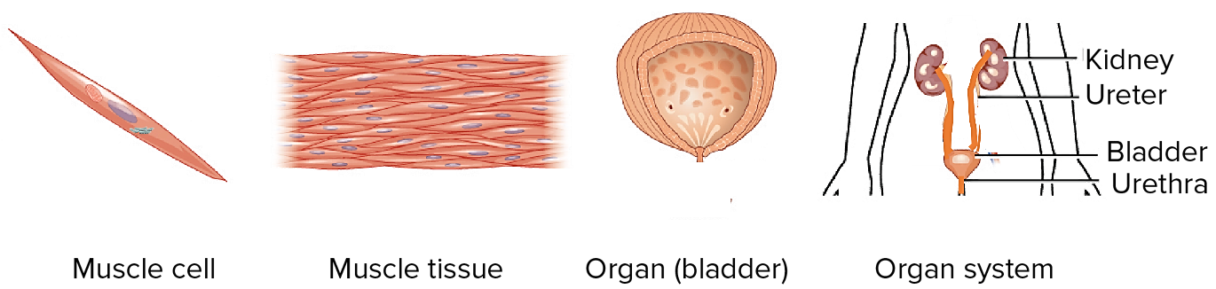

The general principle that "structure is related to function" applies to tissues, organs, and organ systems. We will illustrate the relationship between structure and function with examples from the human digestive system.

The organs in the digestive system cooperate to break down food into small molecules that are absorbed into the blood. These organs include the:
- mouth where teeth, jaw muscles and saliva work together to begin breaking down food into smaller particles;

- esophagus which carries this mixture of food and digestive juices to the stomach where acid helps to kill any germs in the food; the stomach stores a meal and gradually releases small amounts of food for digestion in the small intestine;

- pancreas and liver which supply the small intestine with enzymes and other molecules that aid in the digestion of food molecules;

- small intestine where enzymes break down food molecules into smaller molecules that are absorbed into the blood; most digestion and absorption occur in the small intestine which is much longer than shown here;

- large intestine where water is absorbed and the feces are stored for excretion.

The above figure clearly illustrates the sequence of organs in the digestive system. The figure to the right gives a more realistic picture of the arrangement of these organs in our bodies.  9a. In our digestive system, effective digestion depends on having each organ in the correct order from beginning to end. Why is it useful for food to be processed in the mouth before it enters the small intestine? | 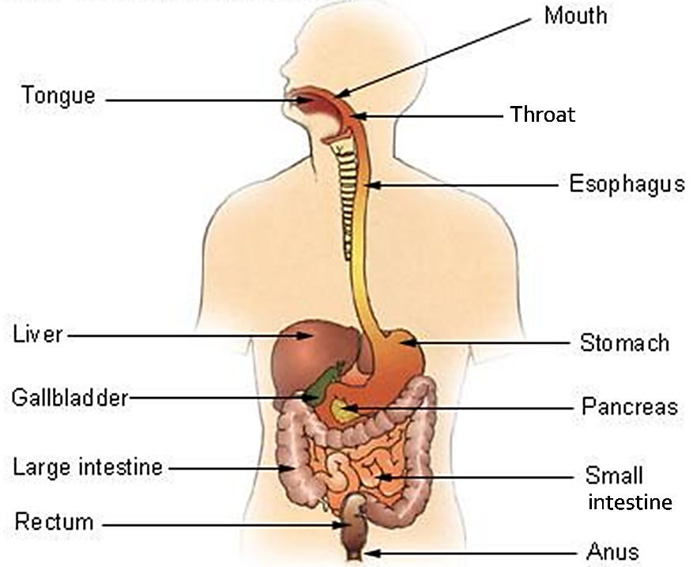

9b. Why is it beneficial to have the stomach before the small intestine?

The small intestine is the organ where most of the enzymatic breakdown of food molecules occurs and most of the absorption of nutrients into the blood occurs. The small intestine is very long tube (6-7 m). The space inside the small intestine is called the lumen. The lumen contains a mixture of digestive enzymes and food molecules which are broken down to small molecules that can be absorbed into the blood. The blood carries nutrients to all the cells of the body.
- The muscles in the wall of the small intestine contract repeatedly to mix the digestive enzymes with the food molecules.  - The many villi on the inner surface of the small intestine contribute to a very large surface area for absorption of digested food molecules from the lumen of the small intestine to the blood.  10a. How do the muscles in the wall of the small intestine contribute to the function of the small intestine? | The left diagram shows that the wall of the small intestine contains blood vessels, layers of muscles, and many villi on the inner surface which faces the lumen. The right diagram shows a greatly magnified view of one of the villi; each of the villi is only about 1 mm long.

10b. How do the many villi on the inner surface of the wall of the small intestine contribute to the function of the small intestine?

10c. How do the capillaries inside the villi contribute to the function of the small intestine?

11. The circulatory system includes the:  - blood, which carries substances like oxygen and glucose  - blood vessels (including the capillaries)  - heart, which pumps blood through the blood vessels to all the parts of your body.  Explain how the digestive system and circulatory system work together to bring nutrients to all the cells in your body. | 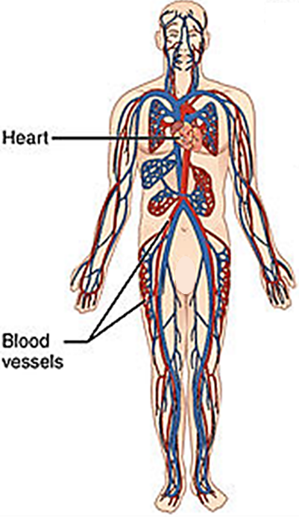

12. Fill in the table to evaluate the claim that “The structure of different types of cells, organs, and organ systems is related to their function.”
- In the first column of the table, give examples of structure. For each example of structure, complete the second and third columns.
- In the bottom two boxes, evaluate the strengths and limitations of your evidence for evaluating this claim.

Examples of Structure  (including shape, component parts, and how the parts are organized) | Function of this Structure | If structure is related to function for this example, explain how the structure contributes to the function. If structure is not related to function, write “not related”.
Cells – Example 1

Example 2

Example 3

Organ (small intestine)

Organ System (digestive system)

Strengths of the Evidence for the Claim

Limitations of the Evidence for the Claim

By Dr. Ingrid Waldron, Dept Biology, Univ. Pennsylvania, © 2021. This Student Handout and Teacher Notes with instructional suggestions and biology background are available at https://serendipstudio.org/exchange/bioactivities/SFCellOrgan.

