What is a species?

1. Coyotes, dogs, cats and lions are each different species. How would you define a species?

One definition of a species is a group of organisms that reproduce with each other and do not successfully reproduce with organisms from other species. Because of reproductive isolation, each species can evolve its own characteristics that are adapted to its environment and niche.

2. The reason why different species can evolve different characteristics is that organisms from different species
- are attracted to each other.
- do not reproduce with each other.
- sometimes mate in zoos or fish tanks.

3. This definition of a species as a group of interbreeding organisms can be used for sexually reproducing organisms that are alive today. However, this definition cannot be used for some other types of organisms. Give examples of types of organisms where scientists could not apply this definition.

There can be problems with the proposed definition of a species, even for sexually reproducing organisms that are alive today. An example is given below.  4. Coyotes, wolves and dogs generally do not interbreed, so they have evolved multiple differences in their characteristics. Describe the differences between the heads of coyotes vs. wolves. (The figures show approximately the relative sizes of their heads.)  When mates of their own species are scarce, coyotes, wolves and dogs sometimes interbreed in nature. For example, when coyotes expanded their range eastward in North America, the coyotes that led this expansion interbred with wolves and dogs. As a result, eastern coyotes have some wolf and dog genes, although most of their genes come from ancestral coyotes.  5. Why are coyotes considered a separate species from wolves and dogs, even though these animals have successfully interbred in the wild? | 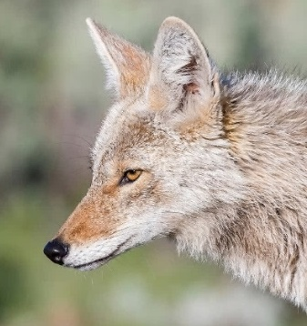  Coyote
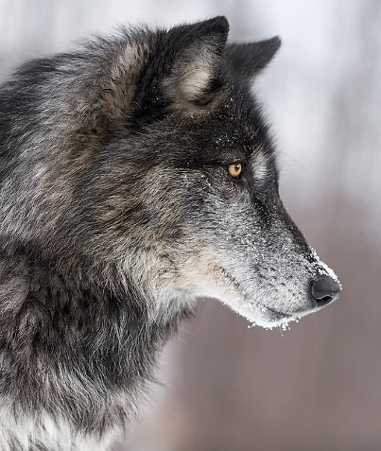
Gray Wolf

The problems with the definition of a species as a group of interbreeding organisms have led scientists to propose other definitions. The goal of these proposed definitions of species is to identify a group of organisms that has evolved separately from other groups of organisms. Scientists have proposed that species should be identified on the basis of differences in genes, anatomy, physiology, behavior, and ecological roles.

For example, you have already learned that coyotes and wolves have different genes and their heads look different. In addition, wolves are bigger and weigh more than coyotes. Wolves hunt in packs that often kill and eat large animals such as moose and elk. In contrast, coyotes often kill and eat small mammals such as mice and rabbits.

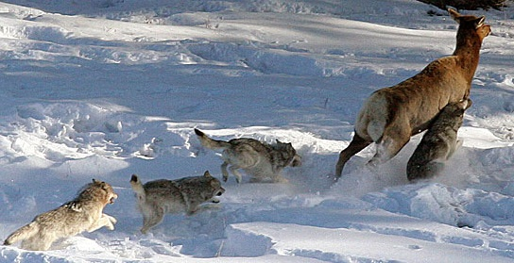 | 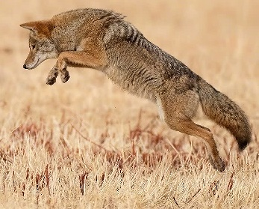  Coyote pouncing on small prey animal  ← Wolves chasing a  deer

6. Because of differences in their typical hunting methods and preferred prey, we would expect natural selection to favor different characteristics in wolves vs. coyotes. Complete this table.

Give a characteristic that would be more of an advantage for: | wolves
 | coyotes

Watch the video, “What Is a Species?” (https://learn.genetics.utah.edu/content/evolution/species/).

7a. Why are grizzly bears and polar bears considered different species?

7b. Although grizzly bears and polar bears are considered different species, some grizzly bears have some polar bear DNA. How did this happen?

8. What are the main take-away messages from this video?

Next, complete the activity “Same or Different Species?” (https://teach.genetics.utah.edu/content/evolution/speciation/same-or-different-species.pdf).

9. What are some reasons why scientists can disagree about whether two organisms belong to the same species or two different species?

By Ingrid Waldron, Dept Biology, Univ Pennsylvania, © 2024. This Student Handout and Teacher Notes with instructional suggestions and background information are available at https://serendipstudio.org/exchange/bioactivities/species.

