Teacher Notes for “Understanding and Predicting Changes in Population Size
– Exponential and Logistic Population Growth Models vs. Complex Reality”

In this analysis and discussion activity, students develop their understanding of the exponential and logistic population growth models by analyzing the recovery of endangered species and growth of bacterial populations. Students learn about the processes that cause exponential or logistic population growth, interpret data from several investigations, and apply their understanding to policy questions.

Next, students analyze examples where the trends in population size do not match the predictions of the exponential or logistic population growth models. They learn that models are based on simplifying assumptions and a model’s predictions are only accurate when the simplifying assumptions are true for the population studied. In the last section, students analyze trends in human population size and some of the factors that affect the earth’s carrying capacity for humans.

One version of the Student Handout also includes mathematical equations. When question numbers or page numbers differ for the two versions of the Student Handout, these Teacher Notes include the relevant number for the version without equations/the version with equations. Explanations related to the mathematical equations are presented in boxes.

Appendices to these Teacher Notes offer optional questions on food poisoning, exponential growth of a rabbit population, additional examples of exceptions to the logistic population growth model, and a research challenge (to develop proposals for sustainable use of two resources that may limit the earth’s carrying capacity for humans).

I estimate that this activity will require 2-5 50-minute periods, depending on your students, which version you use, and whether you include the optional questions in the Appendices.

Table of Contents
Learning Goals – pages 2-3
Instructional Suggestions and Background Information
General Information – page 3
Recovery of Endangered Species – Why does it take so long? – pages 3-4
Bacterial Population Growth – pages 4-5
Limits on Population Growth – pages 5-9
Using the Exponential and Logistic Population Growth Models to Understand Recovery
of Endangered Species – page 9
Exponential and Logistic Population Growth Models vs. Complex Reality – pages 9-12
Human Population Growth – pages 12-14
Additional Resources – page 14
Appendix 1 – Optional Section on Food Poisoning – pages 15-17
Appendix 2 – Optional Section on Rabbit Population Growth – pages 18-19
Appendix 3 – Optional Additional Questions for the top of page 7 in the Student Handout – pages 20-21
Appendix 4 – Optional Research Challenge – pages 22-25

Learning Goals
In accord with the Next Generation Science Standards:
- Students will gain understanding of two Disciplinary Core Ideas;
- LS2.A, Interdependent Relationships in Ecosystems: “Ecosystems have carrying capacities, which are limits to the number of organisms and populations they can support. These limits result from such factors as the availability of living and nonliving resources and from such challenges such as predation, competition, and disease. Organisms would have the capacity to produce populations of great size were it not for the fact that environment and resources are finite. This fundamental tension affects the abundance (number of individuals) of species in any given ecosystem.”
- LS2.C, Ecosystem Dynamics, Functioning and Resilience: “A complex set of interactions within an ecosystem can keep its numbers and types of organisms relatively constant over long periods of time under stable conditions. If a modest biological or physical disturbance to an ecosystem occurs, it may return to its more or less original status (i.e. the ecosystem is resilient), as opposed to becoming a very different ecosystem. Extreme fluctuations in conditions or the size of any population, however, can challenge the functioning of ecosystems in terms of resources and habitat availability. Moreover, anthropogenic changes (induced by human activity) in the environment – including habitat destruction, pollution, introduction of invasive species, overexploitation, and climate change – can disrupt an ecosystem and threaten the survival of some species.”
- Students will engage in several Scientific Practices:
- Using Models. “Evaluate merits and limitations of two different models of the same proposed tool, process, mechanism or system in order to select or revise a model that best fits the evidence or design criteria.”
- Using Mathematics and Computational Thinking. “Use mathematical, computational, and/or algorithmic representations of phenomena or design solutions to describe and/or support claims and/or explanations.” (for the version of the Student Handout that has equations)
- Analyzing and Interpreting Data. “Analyze data using tools, technologies, and/or models (e.g., computational, mathematical) in order to make valid and reliable scientific claims or determine an optimal design solution.”
- Constructing Explanations. “Apply scientific ideas, principles and/or evidence to provide an explanation of phenomena and solve design problems, taking into account possible unanticipated effects.”
- This activity provides the opportunity to discuss these Crosscutting Concepts:
- Systems and System Models: “Models can be used to predict the behavior of a system, but these predictions have limited precision and reliability due to the assumptions and approximations inherent in the models”.
- Stability and change: “Students understand that much of science deals with constructing explanations of how things change and how they remain stable.”
- Scale, Proportion and Quantity: “Patterns observable at one scale may not be observable or exist at other scales.”
- This activity will help students to meet these Performance Expectations:
- HS-LS2-1, “Use mathematical and/or computational representations to support explanations of factors that affect carrying capacity of ecosystems at different scales.”
- HS-LS2-2, “Use mathematical representations to support and revise explanations based on evidence about factors affecting biodiversity and populations in ecosystems of different scales.”
- HS-LS4-5. “Evaluate the evidence supporting claims that changes in environmental conditions may result in: (1) increases in the number of individuals of some species, …”

This activity will also help students meet Common Core State Standards for Mathematics, including “reason abstractly and quantitatively”, “construct viable arguments” and “model with mathematics” and also help students meet Common Core English Language Arts Standards for Science and Technical Subjects, including “write arguments focused on discipline-specific content”.

Instructional Suggestions and Background Information
To maximize student learning and participation, I recommend that you have your students work in pairs to answer each group of related questions. Student learning is increased when students discuss scientific concepts to develop answers to challenging questions. After your students have answered each group of related questions, I recommend that you have a class discussion to probe student thinking and help students develop a sound understanding of the concepts and information covered.

A key (including the answers to the optional questions in the Appendices) is available upon request to Ingrid Waldron (iwaldron@upenn.edu). The following pages provide instructional suggestions and additional background information – some for inclusion in your class discussions and some to provide you with relevant background that may be useful for your understanding and/or for responding to student questions.

After the first paragraph of the Student Handout, you may want to begin with a discussion of:
- what your students already know about changes in population size and/or
- how they interpret the title of this activity.

Recovery of Endangered Species – Why does it take so long?
To engage student interest, I recommend that you begin this section with a 4-minute video, “Whooping Crane: 5 Fascinating Facts” at https://www.youtube.com/watch?v=TVfI2KEkq5A (the first link under the picture of the whooping crane on page 1 of the Student Handout).

There were an estimated 10,000 or more whooping cranes in North America before European settlement; due to hunting and habitat loss, the whooping crane population decreased to an estimated 500-1500 in 1870-1880 (https://en.wikipedia.org/wiki/Whooping_crane). Conservation efforts have allowed the one surviving population of whooping cranes to increase more than tenfold from the low point of ~20 wild whooping cranes in the 1940s (see graph and table on page 1 of the Student Handout). Recovery was slow initially because population growth was slower in the early stages when population size was small and because it took some time to fully develop and implement conservation efforts.

In addition to the surviving population of whooping cranes discussed on page 1 of the Student Handout, a second population of migrating whooping cranes has been established through a captive breeding program and careful training of the young whooping cranes to survive and migrate in the wild. Young whooping cranes bond with the first moving object they see; to ensure that the captive-bred birds will subsequently mate with other whooping cranes, the people who raise them wear crane costumes. Additional information is available in the 4-minute video at https://www.youtube.com/watch?v=Ye4Swf3-yDM. For additional information about whooping cranes, see https://www.savingcranes.org/species-field-guide/whooping-crane/.

Questions about the recovery of endangered species will be discussed further in the fourth section of the Student Handout (pages 4/5-5/6). In the second and third sections (pages 2-3/4), students develop their understanding of exponential and logistic population growth by exploring bacterial population growth (which is easier to analyze than population growth for sexually reproducing, long-lived organisms). The bottom of page 1 of the Student Handout and question 7 will help students understand the transition to analyzing bacterial population growth.

Bacterial Population Growth
To introduce the section on bacterial population growth, you may want to show your students a 15-second video of bacteria dividing by binary fission; the video is available at https://www.youtube.com/watch?v=gEwzDydciWc and https://vimeo.com/14316782. It is important to note that this video has been speeded up by a factor of roughly 2000, compared to a typical doubling time of approximately 30 minutes. You can slow this video down by a factor of four, so your students can more easily follow what is happening; turn off the sound, click on the settings icon in the lower right-hand corner, click on speed and then 0.25, and then play.
Notes for the mathematical equation on page 2 of the mathematical version of the Student Handout

The Student Handout refers to ΔN = N as the equation for exponential population growth. However, two important caveats should be mentioned.
- This is a specific version of ΔN = R N, where R is the per capita rate of change in the size of the population (also known as the geometric rate of increase).
- Strictly speaking, this equation is the discrete-time version of the equation for exponential growth (also called the equation for geometric population growth in a population that has discrete generations, e.g. due to a limited reproductive season each year). The equation for exponential population growth in a continuously reproducing population is dN/dt = rN, where dN/dt is the instantaneous rate of change in the population size and r is the instantaneous rate of increase (also known as the intrinsic growth rate). This is equivalent to N_{t} = N₀e^{rt}, where N_{t} is the number of organisms at time t (https://people.math.sc.edu/vraciu/172handout1.pdf).

I have found that when students are first learning about these equations, they find it much easier to grasp the simpler equations I have included in the Student Handout. However, if you want to introduce your students to the more complex notation and equations, you can make appropriate revisions of the equations on pages 2 and 4 of the mathematical Student Handout.

The bacterial population shows exponential population growth. The rate of increase in population size accelerates over time because the increase in population size in each time period is proportional to the size of the population at the beginning of the time period. As discussed in question 7, the population of whooping cranes (see page 1 of the Student Handout) shows approximately exponential growth.

Students should understand the difference between exponential and linear population growth. (This difference will be revisited in question 12/15 in the third section.) For students who may be less familiar with this difference, you can explain that, in linear population growth, population increases by the same amount during each time interval and/or you can add the following question after question 6.

7a. Suppose that, instead of doubling every 30 minutes, the population added 10 bacteria every 30 minutes. This figure shows the trend in the number of bacteria if this linear population growth continued for 5 hours. When is the difference between linear population growth and exponential population growth bigger?
1 hour ___ 5 hours ___

7b. Explain why.

If you want your students to learn about the relationship between bacterial population growth and food poisoning, see Appendix 1.

Question 8 provides a transition to the next section. To introduce an example of exponential population growth in a sexually reproducing species, you can substitute the questions in the Appendix 2 for question 8 in the Student Handout.

Limits on Population Growth
The exponential population growth model assumes unlimited resources to support exponential increases in population size. In contrast, the logistic population growth model includes the effects of competition for resources (e.g., food, nesting sites, water, or sunlight). Competition for resources is a density-dependent factor that increases as population size increases. It can result in increased mortality and/or decreased reproduction and thus slower population growth rate as population density increases.

You may want to point out to your students that the Y axis for the figure in question 9a has a logarithmic scale. Each data point in the figure represents a different population of bacteria that grew on equal size pieces of tofu for a different length of time. The bacteria in this experiment contribute to food spoilage, not food poisoning. If you want to provide your students with an extension, you can use the following after question 9a in the Student Handout.

This graph shows how populations of these bacteria grew on pieces of tofu at different temperatures. This type of bacteria causes tofu to spoil or go bad. When population size reaches ~10⁶ bacteria per gram of tofu, the tofu has spoiled.  9b. Use these data to explain why tofu that is kept at warmer temperatures will spoil more quickly. | 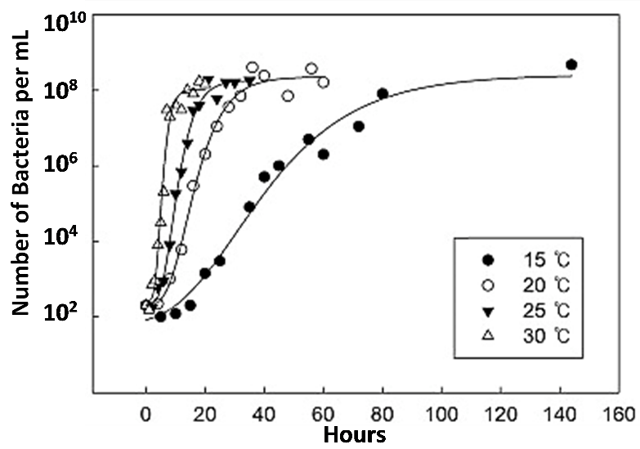

The Student Handout omits several complexities of bacterial population growth in laboratory experiments where the original food supply is not supplemented with additional food. At the beginning, there can be a lag phase during which bacteria are adjusting to new circumstances and producing molecules that contribute to exponential growth in the “log phase”. The “stationary phase” plateau corresponds to the stable population size at carrying capacity. If no new food is provided, eventually the lack of food results in the death or decline phase. | 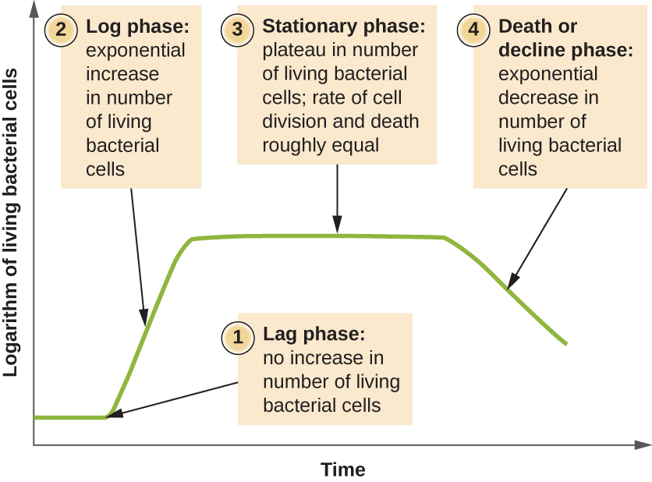  (https://courses.lumenlearning.com/microbiology/chapter/how-microbes-grow/ )

A similar sequence of population growth and decline might be observed in nature for microorganisms growing in a dead plant or animal. In these situations, the definition of carrying capacity as the maximum population size the environment can sustain refers to the stationary phase. In many situations, where organisms are dependent on renewable resources (e.g., herbivores in a prairie), carrying capacity is the maximum population size that the environment can sustain indefinitely. In the last section on human population growth, carrying capacity is used to mean the maximum population size that the environment can sustain indefinitely.

Question 10 can be used for formative assessment. It should be noted that, even for population A in the environment with abundant resources, exponential growth cannot go on forever; eventually, competition for resources will first slow and then stop population growth or an external environmental factor (e.g., putting the bacteria in an autoclave) will stop population growth.

You may want to introduce question 11 with a 5-minute video about bluebirds, available at https://abcbirds.org/bird/eastern-bluebird/. Question 11 challenges students to design an experiment to test whether food or nesting cavities are limiting population growth for bluebirds. Students should remember to include a control, with no increase in food or nesting cavities in
their experimental design.  Eastern bluebird populations decreased during the early twentieth century for multiple reasons, especially competition from more aggressive non-native house sparrows for nesting cavities created by woodpeckers. Populations of eastern bluebirds have increased since about 1980, primarily because many people erected nest boxes which the bluebirds have used for nesting. This history suggests that nest holds have been the primary density-dependent factor limiting | 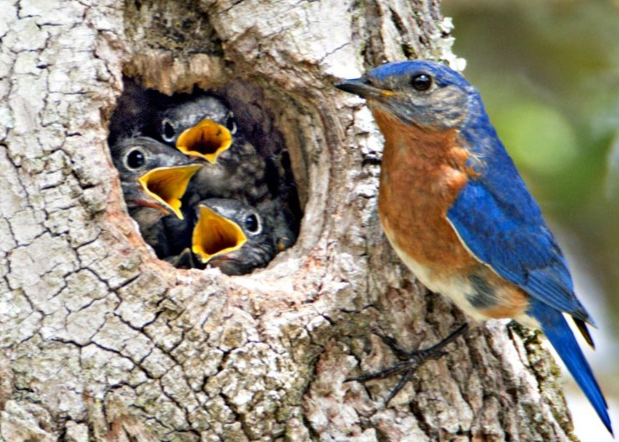  (https://nestwatch.org/wp-content/uploads/2017/08/EastBB-kelly-sandefur-edit-1024x606.jpg)
eastern bluebird population growth.

If you want to introduce an example where food was the limiting factor that determined carrying capacity, you could insert the following (through question 12b) on the bottom of page 3 of the Student Handout.

This graph shows the results of an experiment with paramecia, which are single cell organisms that live in water and eat bacteria. Two populations of paramecia grew in tubes with the same volume of water, but the tube where Population 2 grew had twice as much food as the tube where Population 1 grew. | 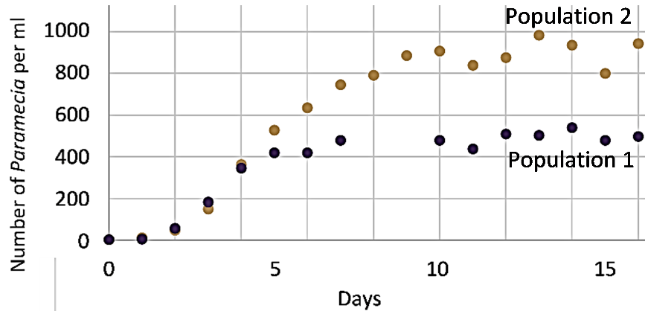

12a. The main limiting factor that determined the carrying capacity for these paramecia was the amount of food ___ space ___.

12b. What evidence supports your answer?

The results shown are for Paramecium aurelia which were grown in centrifuge tubes. Each day the paramecia were centrifuged to the bottom of the tube, so the growth medium could be replaced with fresh medium that had the original concentration of bacteria as food for the paramecia. The concentration of bacteria was twice as great for Population 2 as for Population 1.  Population growth may also be limited by the availability of other resources (e.g., water or sunshine) or the accumulation of waste products. | 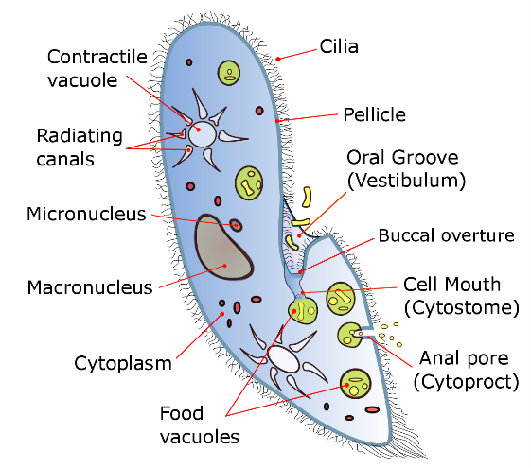

Questions 9-11 in the Student Handout provide a good opportunity to discuss the Crosscutting Concept, Stability and change: “Students understand that much of science deals with constructing explanations of how things change and how they remain stable.”
Notes for mathematical equations on page 4 of the mathematical version of the Student Handout

The only difference between the equations for exponential and logistic population growth is the term (K – N) / K in the logistic population growth equation. This term represents the reduction in growth rate caused by the effects of density-dependent factors. At low population size (N), this term is close to 1, so logistic population growth is quite similar to exponential population growth. As population size increases and approaches the carrying capacity (K) of the environment, this term approaches zero, so population growth rate approaches zero, due to increasing competition for limited resources.

The most rapid increase in population size is observed when N = 0.5 K; population size increases more slowly at lower levels of N (because there are relatively few individuals reproducing) and at higher levels of N (due to the effects of competition for scarce resources, increased risk of infection, etc.). This suggests that, for maximum sustainable harvest, it will often be best to maintain a population at half the carrying capacity.

For questions 14a and 14b, you will probably want to require an answer in decimal format. Question 14c can be used for formative assessment.

Before question 15, you may want to introduce the idea of a conceptual model. Many students think of a model as a physical object and may not understand how a graph or equation can be a model. However, a model is any representation of reality that helps us to better understand and visualize a phenomenon. As noted in A Framework for K-12 Science Education, “Conceptual models allow scientists… to better visualize and understand a phenomenon under investigation… Although they do not correspond exactly to the more complicated entity being modeled, they do bring certain features into focus while minimizing or obscuring others. Because all models contain approximations and assumptions that limit the range of validity of their application and the precision of their predictive power, it is important to recognize their limitations.” To help your students understand conceptual models, you can give examples of conceptual models that students may have used, e.g., a map, a diagram of a football play, sheet music, or an outline for an essay they plan to write.

The mathematical equations and the graphs are two different versions of the exponential and logistic population growth models. The graphs have the advantage of giving a better intuitive feel for the trends in population size. In contrast, the equations have the advantage of helping us to understand the reasons for the different rates of increase at different population sizes. Also, the equations facilitate quantitative predictions concerning changes in population size. Thus, both representations of these population growth models are useful for different purposes.

Using the Exponential and Logistic Population Growth Models to Understand Recovery of Endangered Species
Question 12/16 introduces students to the errors that result when a person uses the wrong model to make predictions. This question also reinforces student understanding of the difference between linear and exponential population growth.

After question 12/16, you may want to ask your students what they already know about endangered species and the recovery of endangered species. As discussed in question 13/17, additional populations in different locations help to reduce the risk of extinction by providing protection against a possible catastrophe in one location (e.g. due to a hurricane or infectious disease epidemic) and by providing additional habitat to support growth of whooping crane populations. See page 4 of these Teacher Notes for information about how one of the additional populations was established. In 2021-22, this second migratory population had 79 whooping cranes. The total number of wild whooping cranes was ~705, including 543 in the original Texas migratory population and 76 and 7 in two non-migratory populations (https://fws.gov/media/annualreportwhoopingcranerecovery2022aransaspdf).

Question 14/18 could lead to a more general discussion of endangered species and the Endangered Species Act. This topic illustrates that evaluations of many public policy issues depend on both good scientific information and people’s values (which cannot be decided by science). For example, science can help us understand how fast endangered species can recover and science can show us how different species have helped us to develop multiple helpful products (e.g., the many medications originally derived from plants, fungi or animals). However, science cannot establish how much value to assign to preserving endangered species like whooping cranes. Two useful general sources on endangered species are https://education.nationalgeographic.org/resource/endangered-species/ and https://www.nytimes.com/2018/03/13/magazine/should-some-species-be-allowed-to-die-out.html.

Exponential and Logistic Population Growth Models vs. Complex Reality
This section of the Student Handout helps students to understand the limitations of the exponential and logistic population growth models. As discussed in this section, all models involve assumptions and simplifications of complex real-world phenomena, so there often are discrepancies between a model’s predictions and phenomena observed in the real world. This whole section can be used to illustrate the Crosscutting Concept, “Models can be used to predict the behavior of a system, but these predictions have limited precision and reliability due to the assumptions and approximations inherent in models.”

Question 15/19 highlights the contrast between the roughly exponential growth for the whooping crane population in recent decades vs. the earlier decline in total number of whooping cranes (which did not follow either the exponential or logistic population growth models). You will probably want to emphasize that neither the exponential nor logistic population growth models include the effects of changes in the external environment, so these models fail to predict trends like the historical decrease in whooping crane population size.

Next, students consider trophic effects in a marine ecosystem. They predict how decreases in predator abundance affected the population size of other species in a food web. Specifically, sea otters were rare in the first half of the twentieth century due to human hunting. As a result, sea urchin populations increased, and kelp populations decreased drastically. In the mid-twentieth century, legal protections for sea otters allowed them to become abundant, which decreased sea urchin populations, which allowed the kelp to flourish (https://ww2.kqed.org/quest/2014/02/25/balancing-act-otters-urchins-and-kelp/). However, in the early 21st century, kelp forests are again in decline due to a combination of factors including a wasting disease that has reduced populations of another sea urchin predator (sunflower sea stars), global warming (which has resulted in marine heat waves), and other factors (https://www.weforum.org/agenda/2022/07/scientists-restore-worlds-kelp-forests/, https://www.nature.org/en-us/newsroom/ca-sunflower-sea-star-kelp-forests/).

The effects of declines in populations of sea urchin predators illustrate top-down regulation of population size. (This term derives from diagrams of food chains and food webs, where predators are shown at the top, herbivores in the middle and plants at the bottom.) Fertilizer runoff into rivers, lakes or the Gulf of Mexico has caused algal blooms; this is an example of bottom-up regulation of population size. In one interesting experiment, an algal bloom was eliminated by reducing the population of fish that ate the zooplankton that ate the algae; this provides another example of top-down regulation of population size. Scientists have concluded that top-down and bottom-up regulation both play important roles in regulating population size, with different relative importance for different populations and at different times.

Question 17/21 focuses student attention on the progression from the exponential population growth model (which includes increases in population size as a result of reproduction) to the logistic population growth model (which adds the effects of competition for limited resources) to a more complete description of the causes of changes in size for real-world populations (which adds the effects of changes in the environment). This leads into a discussion (on the next page of the Student Handout) of the important point that models only make accurate predictions when the simplifying assumptions of the model hold true. For example, the exponential population growth model assumes unlimited resources, so exponential population growth is only observed during the early stages of population growth, e.g. when a species moves into a new environment or is recovering from a catastrophe such as excessive hunting by humans.

The top of page 6/7 of the Student Handout presents two important simplifying assumptions for the logistic population growth model. Because these simplifying assumptions often are not true, growth of natural populations often does not culminate in stable population size at carrying capacity, as predicted by the logistic population growth model.

The reindeer example described on page 6/7 of the Student Handout illustrates how a population crash can result if population size exceeds the carrying capacity sufficiently to degrade the environment and reduce the carrying capacity. The large population of reindeer in the late 1930s (estimated to be approximately three times the carrying capacity of the island) nearly eliminated the lichens which were a critical winter food for the reindeer; the slow-growing lichens had not significantly regenerated when studied ~1950. Question 18/22 reinforces student understanding that the logistic population growth model is only valid if the simplifying assumptions are true (see the top of page 7/8 in the Student Handout).

To illustrate how research methods can influence the conclusions reached, I recommend that you ask your students the following question after question 18/22.

“Suppose that the reindeer researchers had stopped collecting data in 1937. What would they have concluded about growth of this reindeer population? What would they have missed?”

This example illustrates how conclusions can vary, depending on the specific data collected. Thus, reliable conclusions should be based on the results of multiple different studies, and we should be skeptical about conclusions based on a single study. I recommend that you reinforce these general methodological points.

Discussion of the reindeer example may lead to interest in whether human population growth may degrade the environment, reduce the carrying capacity of the earth, and possibly lead to a population crash; the next section of the Student Handout provides some relevant information and questions. It is important to note that for the reindeer example and the human population analysis, I use carrying capacity to mean the maximum population size that the environment can sustain indefinitely.

Appendix 3 provides additional questions which you could use if your students would benefit from additional examples that illustrate that logistic population growth is not observed unless both assumptions are true. For many natural populations, seasonal changes in the environment cause variation in carrying capacity which results in variation in population size. Also, for some populations, population growth rate adjusts slowly as population size approaches carrying capacity. In some cases, population size may repeatedly overshoot and undershoot the carrying capacity, resulting in cyclic changes in population size.

Question 19/23 in the Student Handout can be used for formative assessment. If your students find this question too challenging, you could:
- suggest that your students review the first four sections of this activity to answer question 19a/23a and review the fifth section to answer question 19b/23b
- have them discuss the question first in pairs or small groups and then write their individual answers.
After question 19/23, I recommend that you discuss the Crosscutting Concept, Systems and System Models, which states that models can be used “to predict the behavior of a system, [but] these predictions have limited precision and reliability due to the assumptions and approximations inherent in the models”.

Human Population Growth
This section focuses on total world population, rather than the size of local populations. One reason for this approach is that migration and world trade result in many interconnections between local human populations. Also, total world population is one factor of concern in environmental problems such as global warming and endangered species.

You may want to begin this section with a discussion of students’ prior understanding of world population growth. Also you may want to show your students the animation at https://www.youtube.com/watch?v=PUwmA3Q0_OE (~6.5 minutes long) to help them understand the slow pace of population growth in the early millennia of human existence and the much more rapid pace recently. The last part of this animation has a brief introduction to projections of future population growth, including the importance of decreased birth rates and reasons for uncertainty in the projections. This part of the animation provides the opportunity to ask your students why 2 babies per woman will eventually result in stable population size. (Actually, to take account of mortality before reproductive age, the number should be 2.1 babies per woman on average.) To give your students a feel for the rate of current population growth, you may want to use the “worldometer” at http://www.worldometers.info/world-population/.

Question 20/24 and the preceding graph reinforce student understanding of exponential population growth. Obviously, human population growth is influenced by many factors, including medical advances that decrease mortality and availability of birth control. These factors explain why world population increased faster than exponential growth during much of the twentieth century. In exponential population growth, the percent annual growth rate would be constant; however, this rate increased during the early twentieth century (see figure below). Advances in public health, standard of living and healthcare resulted in decreased mortality and increased population growth. Fertility declines followed with a lag of roughly half a century, so the population growth rate declined in the second half of the twentieth century. Low fertility is contributing to population decreases in countries such as Japan, Greece and Croatia. For additional information about past trends in world population growth, projections for future population growth, and factors that have influenced and will influence these trends, see https://www.prb.org/humanpopulation/, https://www.visualcapitalist.com/ranked-the-20-countries-with-the-fastest-declining-populations/ and https://www.pewresearch.org/fact-tank/2019/06/17/worlds-population-is-projected-to-nearly-stop-growing-by-the-end-of-the-century/.

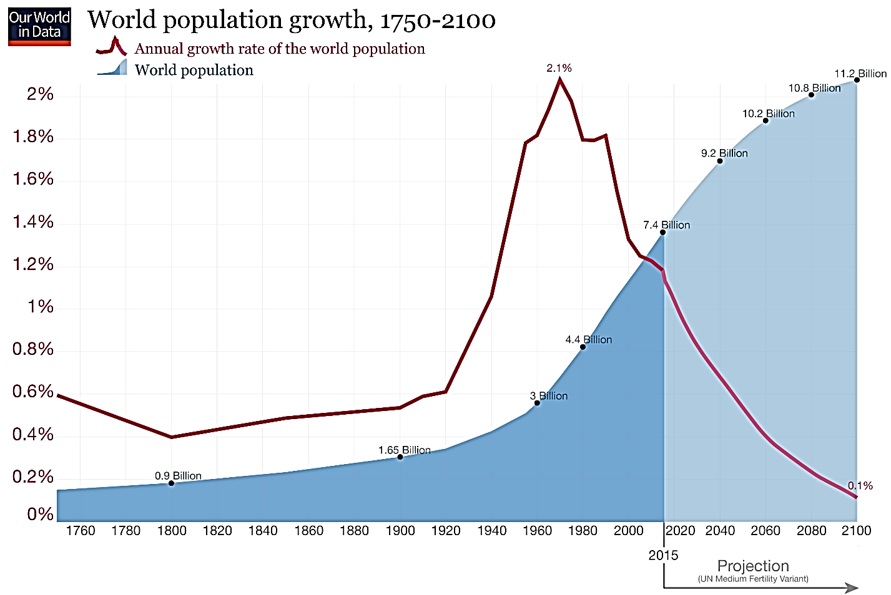
(https://ourworldindata.org/world-population-growth)

Human behavior has had and will continue to have profound effects on the carrying capacity of the Earth for humans. Humans have increased the amount of food that can be produced by developing better breeds of plants and animals, using fertilizers and irrigation, etc.; increased agricultural productivity has increased the number of people that can be fed substantially beyond previous pessimistic predictions by Malthus and Ehrlich (https://www.ncbi.nlm.nih.gov/pmc/articles/PMC1280423/). On the other hand, increasing levels of consumption will reduce the number of people that the earth can sustain. The following sources discuss the wide range of estimates of the Earth’s carrying capacity and the multiple factors that have influenced and will continue to influence the Earth’s carrying capacity:
- https://www.livescience.com/16493-people-planet-earth-support.html (which has a brief video outlining some of the major issues)
- http://agrpartners.com/wp-content/uploads/2013/09/AGR-Thought-Piece-Carrying-Capacity1.pdf
- https://na.unep.net/geas/archive/pdfs/geas_jun_12_carrying_capacity.pdf.

The table below shows the data for the comparisons in question 22/26 between per capita consumption in the US vs. the world average. These data are “food availability” for 2013, which does not take into account food that is wasted or not eaten by consumers. Nevertheless, the
obesity epidemic makes it clear that US food consumption exceeds the optimum level for human health.
 | Average Consumption per Person per Day
 | Calories | Grams of Meat | Grams of Protein
US | ~3700 | ~115 | ~110
World | ~2900 | ~43 | ~80
(Sources: https://ourworldindata.org/food-per-person; https://ourworldindata.org/meat-and-seafood-production-consumption)
For an explanation of why meat has much more environmental impact than plant foods, see “Food and Climate Change – How can we feed a growing world population without increasing global warming?” (https://serendipstudio.org/exchange/bioactivities/FoodClimateChange).

Appendix 4 presents an optional research challenge that introduces students to limited groundwater and phosphorus as two factors that may limit the Earth’s carrying capacity for humans.

Additional Resources
A possible alternative activity (e.g. for middle school students) is “Some Similarities between the Spread of Infectious Disease and Population Growth” (https://serendipstudio.org/sci_edu/waldron/#infectious). This hands-on activity introduces students to some features of exponential and logistic population growth. First, students analyze a hypothetical example of exponential growth in the number of infected individuals. Then, a class simulation of the spread of an infectious disease shows a trend that approximates logistic growth. Next, students analyze examples of exponential and logistic population growth and learn about the biological processes that result in exponential or logistic population growth. Finally, students analyze how changes in the biotic or abiotic environment can affect population size; these examples illustrate the limitations of the exponential and logistic population growth models. This activity supports the Next Generation Science Standards (NGSS).

For additional related activities, see “Ecology Concepts and Learning Activities” (https://serendipstudio.org/exchange/bioactivities/ecology).

Sources for Figures and Data in Table
- Picture of Whooping Crane – http://www.audubon.org/field-guide/bird/whooping-crane
- Graph and Table of Trends in Whooping Crane Population Size – adapted from https://www.sciencedirect.com/science/article/pii/S0006320713000980, Figure 1 and Table 1, plus https://www.fws.gov/uploadedFiles/Region_2/NWRS/Zone_1/Aransas-Matagorda_Island_Complex/Aransas/Sections/What_We_Do/Science/Whooping_Crane_Updates_2013/WHCR_Update_Winter_2016-2017.pdf
- Graph of Logistic Population Growth for Bacteria – adapted from https://ars.els-cdn.com/content/image/1-s2.0-S002364381630768X-gr1.jpg
- Illustration of bluebird pair with nesting box – https://nanpa.org/wp-content/uploads/sites/48/2020/05/Bluebirds-6_S1A4047-1000x915.jpg
- Exponential and Logistic Population Growth – adapted from https://swh-826d.kxcdn.com/wp-content/uploads/2011/12/exponential-vs-logistic-growt.jpg
- Trends in Size of Reindeer Population – http://go.hrw.com/resources/go_sc/bpe/HE0PE332.PDF
- World Population Growth (prepared by Allianz) – adapted from http://populationoverview.weebly.com/uploads/6/0/1/3/60138411/253768413.jpg?726

Appendix 1 – Optional Section on Food Poisoning
(to be inserted before question 7 in the Student Handout)

The rate of population growth depends on environmental conditions. For example, a population of Salmonella bacteria can grow quite rapidly if food is kept at room temperature, but the same population will hardly grow at all if the food is kept in the refrigerator.
If you eat food contaminated with Salmonella, a population of Salmonella can grow in your intestines. If the population of Salmonella in your intestines gets large enough before your immune system has time to mobilize to kill the bacteria, the large population of Salmonella will cause diarrhea, abdominal pain and other symptoms of food poisoning. | 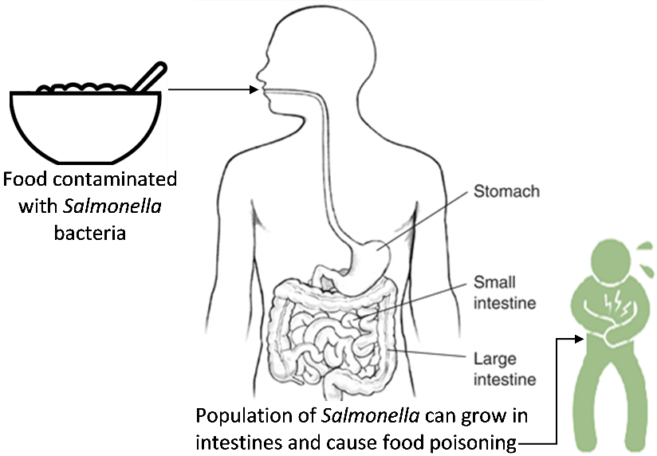
If you eat food with just a few Salmonella, your immune system may kill all the bacteria before the population gets big enough to cause symptoms.

7. Explain why food that has been kept at room temperature for a few hours is more likely to cause food poisoning than food that has been kept in the refrigerator.

Even if a person eats food with enough Salmonella bacteria to cause food poisoning, the person does not get sick immediately. One study found a delay of roughly 1-5 days between when a person ate contaminated food and when he or she experienced the first symptoms of food poisoning. The study found that these delays were longer for people who had consumed fewer Salmonella.

8a. What do you think is happening during the delay between eating a contaminated food and experiencing symptoms of food poisoning?

8b. Explain your reasoning.

Teacher Notes for Appendix 1
this optional section relates bacterial population growth to a phenomenon some students may have experienced personally – food poisoning (also called foodborne illness). You may want to begin this page by asking students, “Why do you think that food poisoning has been included in a section on bacterial population growth?” It will be helpful to distinguish between the invisible bacteria that cause food poisoning and the visible layer of mold on spoiled food. Students should be aware that food that is not obviously spoiled can cause food poisoning; food may be contaminated with types of bacteria that cause illness at doses well below what would be required to produce noticeable changes in appearance and smell that would be identified as spoiled food. You may also want to mention that there are many types of bacteria, most of which do not cause food poisoning and some of which are used in making foods such as yogurt or cheese. Other helpful bacteria live in and on our bodies in what is often called the human microbiome (https://www.hsph.harvard.edu/nutritionsource/microbiome/).

Cooking reduces the risk of food poisoning because cooking can kill bacteria that cause food poisoning; for example, most Salmonella bacteria are killed by heating contaminated food for 1-10 minutes at 60ºC or for less than 1 minute at 70ºC. Refrigeration is protective because Salmonella population growth is very slow at temperatures below 10ºC. Faster population growth of bacteria in contaminated food kept at room temperature increases the risk of food poisoning.

Symptoms of Salmonella food poisoning include diarrhea, vomiting, abdominal pain and fever. Diarrhea and vomiting help to rid the body of Salmonella bacteria. From the point of view of the bacteria, diarrhea and vomiting have the benefit of helping to spread bacteria to new hosts. This optional section does not mention that diarrhea and/or vomiting can be due to causes other than salmonellosis, including other types of food poisoning (due to other types of bacteria or toxins produced by bacteria) or viral gastroenteritis (stomach flu). Stomach flu can be transmitted via contact with someone who is infected, sharing eating utensils, or contaminated food.

The delay between eating food contaminated with bacteria and first experiencing symptoms of food poisoning is due in part to transit time from the mouth to the intestines, but the variation in the delay occurs because it takes different amounts of time for the population of bacteria to multiply to the large population size needed to trigger symptoms. Salmonella bacteria multiply in the lumen and lining of the intestines.

This figure shows the evidence referred to in the second paragraph of this optional section. The delay between exposure and first symptoms is often called the incubation period. As shown in this figure, incubation period (measured in hours) decreases as the number of ingested Salmonella bacteria increases. Each data point represents a well-characterized episode of salmonellosis food poisoning. (Each episode affected between 26 and 967 individuals.) The ingested number of cells was estimated from the concentration of Salmonella in a sample of the contaminated food and the amount of | 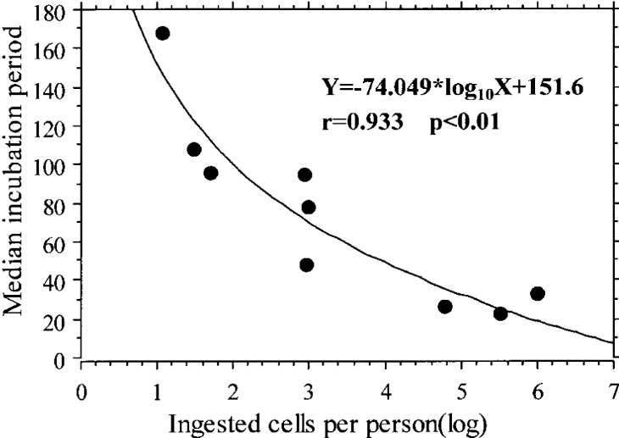  (Abe et al., Journal of Food Protection 67:2735, 2004)
food eaten per person. The number of ingested Salmonella bacteria also influences the proportion of exposed individuals who develop symptoms of food poisoning. The incubation period and susceptibility to food poisoning also depend on the effectiveness of the host’s defenses (e.g. people with AIDS, children under 12, and adults over 65 are more susceptible). General information about salmonellosis is available at https://en.wikipedia.org/wiki/Salmonellosis and
http://www.webmd.com/food-recipes/food-poisoning/tc/salmonellosis-topic-overview#1.

A brief introduction to food poisoning and practical advice to reduce the risk of food poisoning are available at https://www.choice.com.au/food-and-drink/food-warnings-and-safety/food-safety/articles/food-poisoning and https://www.nytimes.com/2018/05/28/well/how-to-minimize-the-risk-of-food-poisoning.html.

Appendix 2 – Optional Section on Rabbit Population Growth
(to be inserted in place of question 8 in the Student Handout)

For cottontail rabbits in the US:
- Each year has a breeding season. Baby rabbits born in one year become breeding adults by the beginning of the next breeding season.
- An adult female rabbit can have 3-4 litters of 4-5 baby rabbits each year.
- A rabbit can live as long as 8 years.

For our analysis of rabbit population growth, we will assume that food is abundant and there is no predation or disease, so:
- Each adult female rabbit produces 20 baby rabbits each year.
- There is no mortality in the first six years.

This figure shows the results of the first year of reproduction by one pair of adult rabbits.

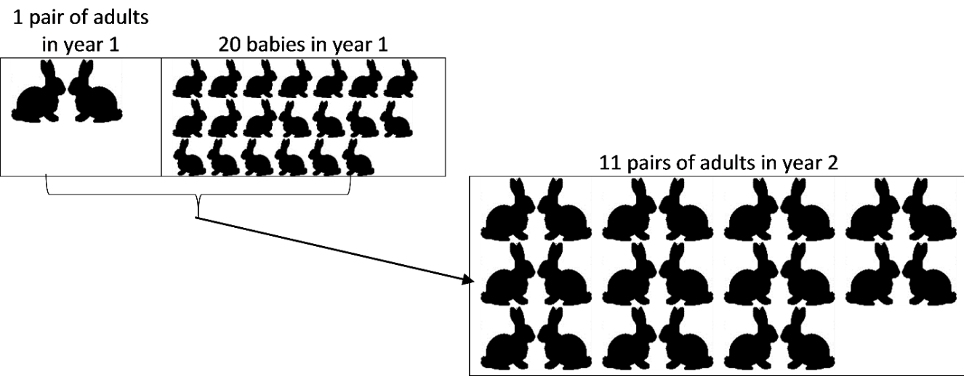

The following table shows population growth for six years.

Year | # Breeding Adults for this year = N | # Baby Rabbits produced during the breeding season = ΔN | Total # Rabbits  at the end of the year = N + ΔN
1 | 2 | 20 | 22
2 | 22 | 220 | 242
3 | 242 | 2420 | 2662
4 | 2662 | 26620 | 29,282
5 | 29,282 | 292,820 | 322,102
6 | 322,102 | 3,221,020 | 3,543,122

8. What evidence supports the conclusion that these results show exponential population growth?

The enormous potential for exponential growth of rabbit populations is illustrated by the Australian experience. European settlers released dozens of rabbits in the early to mid-nineteenth century. By the second half of the nineteenth century, there were millions of rabbits in Australia. By the mid-twentieth century, there were more than half a billion rabbits. These extremely large numbers of rabbits have caused extensive ecological damage.

9. Exponential population growth predicts ever greater yearly increases in the number of rabbits. So, why isn’t the world completely covered in rabbits? (Hint: Think about whether the assumptions for our analysis of rabbit population growth would continue to be true as rabbit population size increased.)

Teacher Notes for Appendix 2
A cottontail rabbit can live up to eight years in captivity and a pair of breeding rabbits can produce 20 babies per year, so in that sense the assumptions for the exponential population growth model for rabbits are reasonable. However, in the Northeast and Midwest of the US (where predators are abundant and winters can be severe), data from natural populations of cottontail rabbits indicate a life expectancy at birth of only about four months. Mortality is high, especially at very young ages and in the winter when food is scarce and rabbits are especially vulnerable to predation. Seasonal changes in rabbit population size are discussed in the supplementary question suggested in Appendix 3. (Sources: http://www.in.gov/dnr/fishwild/3375.htm and http://www.psu.edu/dept/nkbiology/naturetrail/speciespages/cottontail.htm) One factor that is ignored in this Appendix is the potentially harmful effects of inbreeding, which could result in homozygous recessive harmful mutations.

To answer question 8 in this Appendix, students should notice that the total number of rabbits added each year is 10 times the total number of rabbits at the beginning of the year.

The most common rabbit species in the US is the Eastern cottontail (Sylvilagus floridanus). In contrast, the rabbits in Australia are the European rabbit (Orytolagus cuniculus). The European rabbit in Australia has a similar or greater reproductive potential as the Eastern cottontail in the US. The enormous potential for exponential growth of rabbit populations is illustrated by what happened after European settlers released dozens of rabbits in the early to mid-nineteenth century. By the second half of the nineteenth century, there were so many millions of rabbits that, even though Australians killed 2 million or more rabbits annually, the total number of rabbits did not decrease. The very large numbers of rabbits have caused extensive damage to native vegetation, resulting in the decline or extinction of some native marsupials, erosion, and reduced productivity of sheep farming. Australians have used a variety of methods for controlling the rabbit population, including viruses that infect rabbits, poisoning, and the destruction of rabbit warrens. During the 1950s when there were more than half a billion rabbits in Australia, an introduced virus reduced rabbit numbers by more than half, which allowed the number of sheep that farmers could raise to nearly double. However, in subsequent years this method of biocontrol became less effective as the rabbits evolved resistance to the virus and the virus became less virulent (thus allowing infected rabbits to survive long enough for the virus to be transmitted to other rabbits).

Appendix 3 – Optional additional questions on Exceptions to the Logistic Population Growth Model (to be inserted after the first paragraph on page 7 of the Student Handout)

18a/21a. This graph shows seasonal changes in population size for a population of rabbits that lived in Ohio. How did population size change from October to January each year?  18b/21b. What caused the decrease in population size between October and January? Was carrying capacity constant? | 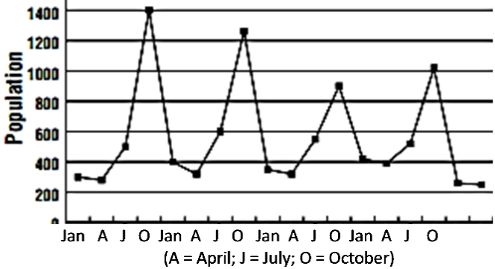

18c/21c. Suppose the researchers had only measured population size once a year at the same time each year. What important effect would the researchers have missed?

The line in this figure shows logistic population growth. The dots show the observed trends in population size for laboratory populations of Daphnia (water fleas), each of which had a constant supply of food.  On days 50-60, food was scarce, but Daphnia continued to reproduce, using their fat stores as a substitute for food. After about day 70, food was so scarce that many Daphnia starved to death and population size was reduced to the carrying capacity. | 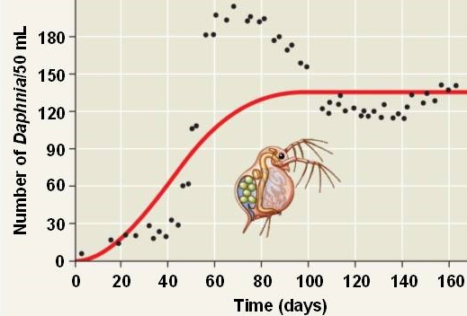

19a/22a. Circle the part of the graph where population size exceeds the carrying capacity.

19b/22b. How did population size increase above the carrying capacity? How did the Daphnia continue to reproduce even though food was scarce?

Teacher Notes for Appendix 3
Optional question 18/21 would help students to understand that both abiotic and biotic factors influence population dynamics. Seasonal changes in weather are density-independent factors that limit the growth of many populations of short-lived plants and animals. During the growing season, population size may increase exponentially and then, during the cold and/or dry season, the carrying capacity of the environment drops dramatically and population size decreases correspondingly. question 18c/21c should alert your students to an important methodological issue.

Question 19/22 will be useful if your students would benefit from another example where population size exceeded carrying capacity because rates of reproduction and mortality did not respond quickly enough as population size approached carrying capacity, you could use the following before the reindeer example. In this experiment, the researchers restored the original density of algae as food for the Daphnia each day and they moved the Daphnia population to fresh water every third day. When population growth rate adjusts slowly to changes in population size, then population size may repeatedly overshoot and undershoot the carrying capacity, resulting in cyclic changes in population size.

Appendix 4 – Optional Research Challenge
(to be inserted after question 25 in the Student Handout)

Some observations suggest that the current world population and consumption levels exceed the Earth’s long-range carrying capacity for humans. For example, many scientists believe that current rates of use of fresh water and phosphorus are too high for long-term sustainability.

Fresh water is an important resource for us to drink and for household use, agriculture and industry. Fresh water in rain, rivers and lakes is in short supply in many farming areas, so water for crop irrigation is pumped from underground fresh water stores. Water is currently pumped out of many underground water stores faster than the underground water is replaced by natural processes. Consequently, there is less and less water in many of the Earth’s large underground fresh water stores. In some regions, this has already resulted in harmful effects, such as wells drying up or salt water seeping into the underground fresh water store. If we continue to use underground water at the current rate, then, in some areas, underground fresh water won’t be available for use by future generations.

Plants need phosphorus to make crucial biological molecules such as DNA, RNA, and the phospholipids in cell membranes. Modern agriculture has high crop yields, in part due to the use of fertilizers that contain phosphate. One problem is that, in many regions, some of the phosphate from fertilizer ends up in rivers and lakes where it contributes to massive growth of algae that can make water undrinkable and cause fish kills. Another problem is that the world has a limited supply of the high phosphate rocks that are the source of most of the phosphate in fertilizer.

Your challenge is to:
- develop proposals to reduce the rate of water use from underground stores
or
- develop proposals to reduce the rate of use of high phosphate rock and reduce the effects of phosphate runoff on rivers and lakes.
Your proposals should allow sufficient food production to provide adequate nutrition for the current world population. Use the following recommended sources.

Recommended Sources – Water
- The Surprising Truth of Water Conservation (I recommend the video and the article; https://wordpressua.uark.edu/sustain/the-surprising-truth-of-water-conservation/)
- The Top 10 Ways Farmers Can Conserve Water (https://www.watercheck.biz/blogs/water-facts-trivia/the-top-10-ways-farmers-can-conserve-water)
Recommended Sources – Phosphate
- Phosphate fertilizer “crisis” threatens world food supply (https://www.theguardian.com/environment/2019/sep/06/phosphate-fertiliser-crisis-threatens-world-food-supply)
- Nutrient Pollution – The Sources and Solutions: Agriculture (how to reduce phosphate water pollution; https://www.epa.gov/nutrientpollution/sources-and-solutions-agriculture)
- The role of diet in phosphorus demand (I recommend the video; https://iopscience.iop.org/article/10.1088/1748-9326/7/4/044043)
Recommended Source – Both
UN launches campaign to cut 1.3 billion tonnes of global food waste (http://www.climatechangenews.com/2013/01/22/un-launches-campaign-to-cut-global-food-waste/)

Teacher Notes for Appendix 4
This optional Research Challenge introduces students to limited fresh water and phosphorus supplies as two factors that may limit the Earth’s carrying capacity for humans. The sources for the second and third paragraphs of this optional Research Challenge include:
- https://www.npr.org/sections/thetwo-way/2015/06/17/415206378/nasa-satellites-show-worlds-thirst-for-groundwater
- https://www.nasa.gov/jpl/grace/study-third-of-big-groundwater-basins-in-distress/
- https://water.usgs.gov/edu/gwdepletion.html.
- https://www.mdpi.com/2071-1050/3/10/2027

The recommended sources for the Research Challenge do not discuss a number of additional important points. For example:
- The proposal to recycle phosphate from human and animal waste does not include a discussion of the challenging problem of removing contaminants before the biosolids are spread on agricultural fields (http://cwmi.css.cornell.edu/case.pdf).
- The recommended sources do not discuss that any increase in production of biofuels will aggravate competition for scarce water and phosphate.
- None of the sources mention the importance of reducing birth rates by making contraceptives available for women who want them and increased education for girls. Reduced population growth could decrease future need for all types of resources.

If your students would benefit from more information about the water cycle and the phosphorus cycle, you may want to show them the following figures.

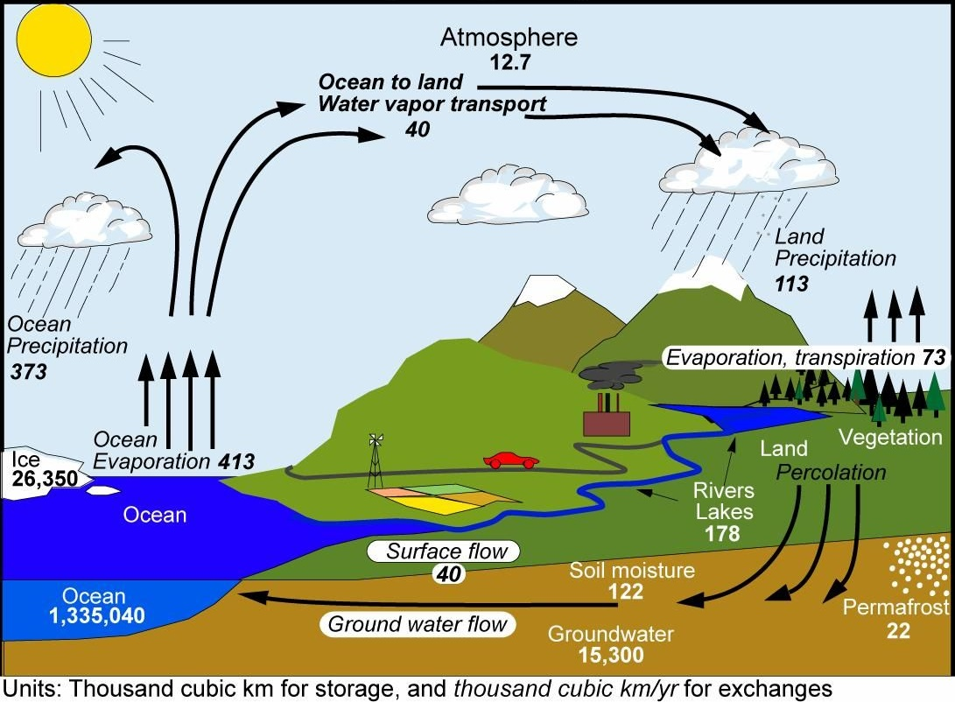
(https://i.pinimg.com/originals/1a/34/c4/1a34c46ceadb7e3764323ec41cc0f6e6.jpg)

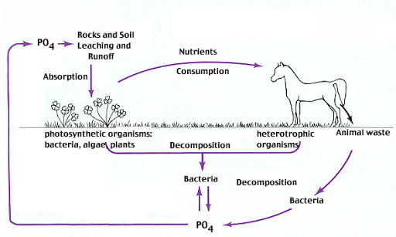
(https://lh3.googleusercontent.com/proxy/RqkbNVNWWAzxJxWNADb-jG2QiP5CYVm9pHuzMaltVeISWoyKlpEjKRW7mvRKAPGFo5zi_t747JRcfAnXGaaBpNY0zurX)

Additional sources for this Research Challenge that you may want to recommend are:
- 10 Ways Farmers Are Saving Water (https://cuesa.org/article/10-ways-farmers-are-saving-water)
- The Hidden Water Resource Use Behind Meat and Dairy (provides information about the large amount of water needed to grow meat; http://waterfootprint.org/media/downloads/Hoekstra-2012-Water-Meat-Dairy_1.pdf)
- Desalination is booming. But what about all that toxic brine? (https://www.wired.com/story/desalination-is-booming-but-what-about-all-that-toxic-brine/)
- Is it safe to use compost made from treated human waste? (https://www.npr.org/sections/thesalt/2013/05/07/182010827/is-it-safe-to-use-compost-made-from-treated-human-waste)
- Case for Caution Revisited: Health and Environmental Impacts of Application of Sewage Sludges to Agricultural Land (http://cwmi.css.cornell.edu/case.pdf)
- Fighting Peak Phosphorus (https://web.mit.edu/12.000/www/m2016/finalwebsite/solutions/phosphorus.html)
- Peak Phosphorus: Clarifying the Key Issues of a Vigorous Debate about Long-Term Phosphorus Security (I recommend pages 2027-2033 and 2039-2044; https://www.mdpi.com/2071-1050/3/10/2027).

I recommend that you have your students read the recommended sources first and then set the sources aside while they draft their proposals. That way, the students will write their proposals entirely in their own words, based on their understanding of the material. After drafting their proposals, students can return to the sources to check and correct specific information in their proposals.

Important issues that you may want to include in your discussion of student reports include:
- The Earth’s carrying capacity for humans will be limited not only by consumption of resources, but also by production of waste products, e.g., phosphate runoff that causes eutrophication.
- Factors that influence the Earth’s carrying capacity for humans include the development of agriculture and increased recycling (increased carrying capacity) and high levels of consumption and rapid use of nonrenewable resources (decreased carrying capacity).
- Different potential limiting factors interact; e.g. phosphate fertilizer runoff can degrade freshwater supplies.
- Human population size can exceed long-term sustainable carrying capacity, but this can lead to substantial problems for future generations. Most scientists believe that it is better to anticipate future problems and begin adjustments now in order to avoid the most serious problems later.

By Dr. Ingrid Waldron, Department of Biology, University of Pennsylvania, 2023. These Teacher Notes and crap related Student Handouts are available at https://serendipstudio.org/exchange/bioactivities/pop.
This version is entitled “Understanding and Predicting Changes in Population Size – Exponential and Logistic Mathematical Models vs. Complex Reality”. If you use this version, you may want to coordinate instruction with your students’ math teacher.
Quotations from http://www.nextgenscience.org/sites/default/files/HS%20LS%20topics%20combined%206.13.13.pdf and https://www.nextgenscience.org/sites/default/files/Appendix%20G%20-%20Crosscutting%20Concepts%20FINAL%20edited%204.10.13.pdf
http://www.corestandards.org/
Since 2015 the US Fish and Wildlife Service has used better methods to estimate the winter population of whooping cranes in Texas, resulting in substantially higher estimates of population size, including the estimate of ~540 in 2021 (https://www.fws.gov/uploadedFiles/WHCR%20Update%20Winter%202017-2018(1).pdf; https://fws.gov/media/annualreportwhoopingcranerecovery2022aransaspdf). The graph and table on page 1 of the Student Handout show data obtained using the old methods, which were consistent over time.
Federal funding for this captive breeding program for whooping cranes was eliminated in 2017 (http://blog.nwf.org/2018/01/a-wild-year-for-the-whooping-crane/).
An example of density-dependent effects on reproduction was observed after deer hunting was permitted in one area of the Adirondacks; the number of deer decreased, the availability of food increased, and the percent of female deer which were pregnant and the number of embryos per female increased dramatically.
House sparrows do use nest boxes designed for bluebirds, but people who have erected these nest boxes have discovered several ways to deter house sparrows (https://bluebirdlandlord.com/how-to-keep-house-sparrows-out-of-bluebird-houses/, https://www.youtube.com/watch?v=q7UIv55O9Fk).
The graph of logistic population growth for paramecia is based on data from “The Struggle for Existence”, by G. F. Gause, 1934. The diagram is from https://upload.wikimedia.org/wikipedia/commons/f/f7/Paramecium_diagram.png.
Quotation from A Framework for K-12 Science Education: Practices, Crosscutting Concepts, and Core Ideas (available at http://www.nap.edu/catalog.php?record_id=13165).
Question numbers in this format give, first, the question number in the version of the Student Handout that does not have mathematical equations and, second, the question number in the version with mathematical equations.
Another example of trophic effects on changes in population size is discussed in our activity “Food Webs, Energy Flow, Carbon Cycle and Trophic Pyramids” (https://serendipstudio.org/exchange/bioactivities/foodweb). Analyses of the effects of reintroducing wolves in an ecosystem in Canada have shown that wolves increased mortality and decreased population size of a dominant herbivore which resulted in increased net growth of willows which in turn provided more nesting sites and cover for songbirds in stream and river valleys (Hebblewhite et al., Ecology 86:2135, 2005). This example illustrates that the availability of nesting sites and places to avoid predation can influence carrying capacity.
Severe winter weather appears to have contributed to the rapid population decline around 1940, but population size continued to decline even when the winter weather ameliorated (Scheffer, The Scientific Monthly 73: 356, 1951). In recent years, there have been roughly 400 reindeer on this island. The lichen have not regrown, but the reindeer have switched to grasses and roots for their winter food. Hunting by humans has kept the reindeer numbers within the new carrying capacity. This recent change in the winter feeding behavior of these reindeer has increased the carrying capacity from the low point ~1950. Reindeer introduced on a nearby island showed much less dramatic increases and decreases in population size; the reasons for the differences between the islands are unknown.
You could also use the examples in this activity to discuss the Crosscutting Concept, Scale, Proportion and Quantity: “Patterns observable at one scale may not be observable or exist at other scales.” For example, the whooping crane and reindeer populations show exponential population growth during one time period, but more complex trends over the long term.
The figure above is based on https://static.shakethatweight.co.uk/uploads/filter-porridge-1.svg, https://i.pinimg.com/originals/d5/7c/f9/d57cf9fa76b9a87c5a9157cbc8c3a6a9.jpg, and https://www.jagranjosh.com/imported/images/E/Articles/Diseases-caused-by-food-poisoning.png.
It should be mentioned that some strains of Salmonella enterica cause typhoid fever, which is much more serious than the type of food poisoning discussed in this activity. If untreated, typhoid fever results in 10-20% mortality; for treated patients, mortality is less than 1%.
Figures in these questions are from https://populationeducation.org/wp-content/uploads/2017/10/pop_ecology_file.pdf and http://www.bio.miami.edu/dana/pix/logisticpopns.gif.
Density-independent factors include freezing weather, tornadoes, floods and fires, each of which can drastically reduce population size, independent of initial population density. Neither the exponential population growth model nor the logistic population growth model takes account of the effects of these density-independent factors on population size.
This source is particularly useful for illustrating scientific analysis of a controversial topic (with a summary of consensus and controversies supported by a clear analysis) and for distinguishing between a hard landing (if resource problems are ignored until they are severe) and a soft landing (if societies anticipate an act to mitigate future problems).

