Teacher Notes for
Where does a tree's mass come from?

Students analyze evidence to evaluate four hypotheses about where a tree’s mass comes from. For example, students analyze Helmont’s classic experiment and evaluate whether his interpretation was supported by his evidence. Thus, students engage in scientific practices as they learn that trees consist mainly of water and organic molecules and most of the mass of the organic molecules consists of carbon and oxygen atoms that came from carbon dioxide molecules in the air.

Before students begin this activity, they should:
- understand basic biological chemistry, including how to interpret chemical formulae;
- understand that matter has mass, energy does not have mass, and energy cannot be converted to matter;
- have a basic understanding of photosynthesis (e.g., by completing "Using Models to Understand Photosynthesis” (https://serendipstudio.org/exchange/bioactivities/modelphoto)).

Learning Goals
In accord with the Next Generation Science Standards:
- Students learn the Disciplinary Core Idea LS1.C: "The process of photosynthesis converts light energy to stored chemical energy by converting carbon dioxide plus water into sugars plus released oxygen. The sugar molecules thus formed contain carbon, hydrogen, and oxygen; their hydrocarbon backbones are used to make amino acids and other carbon-based molecules that can be assembled into larger molecules (such as proteins or DNA), used for example to form new cells."
- Students engage in Scientific Practices, including:
- "Analyzing and Interpreting Data – Evaluate the impact of new data on a working explanation and/or model of the proposed process or system."
- “Constructing Explanations – Apply scientific ideas, principles, and/or evidence to provide an explanation of phenomena….”
- "Engaging in Argument from Evidence – Compare and evaluate competing arguments… in light of currently accepted explanations, new evidence, …."
- This activity helps students to prepare for the Performance Expectation, HS-LS1-6, “Construct and revise an explanation based on evidence for how carbon, hydrogen, and oxygen from sugar molecules may combine with other elements to form amino acids and/or other large carbon-based molecules.”
- This activity helps students to understand the Crosscutting Concept, Cause and Effect: Mechanism and Prediction: “Cause and effect relationships can be suggested and predicted for complex natural… systems by examining what is known about smaller scale mechanisms within the system.”
- This activity helps students to understand the Nature of Science:
- “Most scientific knowledge is quite durable but is, in principle, subject to change based on new evidence and or reinterpretation of existing evidence.”
- “Science knowledge has a history that includes the refinement of, and changes to, theories, ideas, and beliefs over time.”

This learning activity will help to counteract two common misconceptions (Hard-to-Teach Biology Concepts, page 135, by Susan Koba with Ann Tweed).
– Many students think that plants get most of their biomass from the soil. To counteract this misconception, this activity introduces hydroponics.
– Many students don’t understand the importance of photosynthesis and find it hard to believe that the biomass of plants comes largely from a gas (CO₂). In this activity, students analyze why an increase in biomass for plants in the light is correlated with a decrease in CO₂ in the surrounding air.

Instructional Suggestions and Background Information
To maximize student participation and learning, I recommend that you have pairs of students work together to answer each group of related questions. Student learning is increased when students discuss scientific concepts to develop answers to challenging questions; students who actively contribute to the development of conceptual understanding and question answers gain the most. As your students work in pairs to answer the questions, you may want to circulate around the room and ask open-ended, probe questions. After students have worked together to answer a group of related questions, I recommend that you have a whole-class discussion that probes student thinking and helps students to develop a sound understanding of the concepts and information covered.

If your students are learning online, I recommend that they use the Google Doc version of the Student Handout, which is available at https://serendipstudio.org/exchange/bioactivities/plantmass. To answer questions 1, 4 and 6, students can either print the relevant pages, draw on those and send you pictures, or they will need to know how to modify a drawing online. They can double-click on the relevant drawing in the Google Doc, which will open a drawing window. Then, they can use the editing tools to add lines and other shapes. If you want to revise the GoogleDoc or Word document to prepare a version of the Student Handout that will be more suitable for your students, please check the format by viewing the PDF.

A key is available upon request to Ingrid Waldron (iwaldron@upenn.edu). Additional background information and instructional suggestions are included in the paragraphs below.

The hypotheses in the cartoon in question 1 in the Student Handout are intended to get students thinking about the issues that are analyzed in the remainder of the activity. The third hypothesis and the top figure on page 2 of the Student Handout mention “holes in the plant’s leaves”; to help your students understand this, you may want to show your students the stoma (singular of stomata) in this diagram of a cross-section of a leaf.
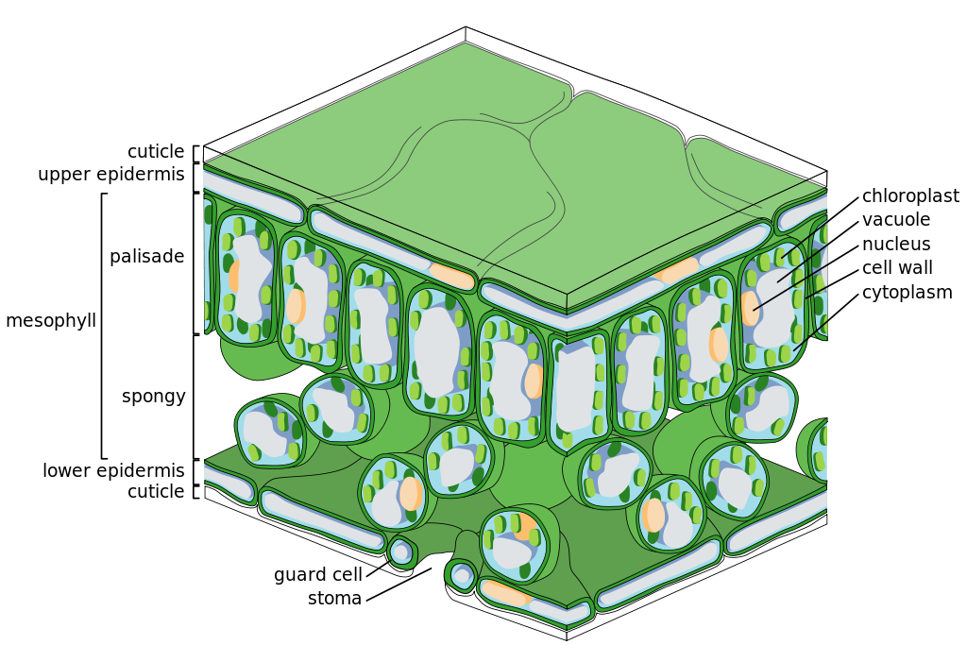
(https://upload.wikimedia.org/wikipedia/commons/thumb/0/06/Leaf_Tissue_Structure.svg/1024px-Leaf_Tissue_Structure.svg.png )

Actively growing tissues such as leaves and root tips are ~75-90% water, and woody parts such as a tree trunk are ~45-60% water. Roughly one-half to two-thirds of a tree’s mass is water (https://web.extension.illinois.edu/askextension/thisQuestion.cfm?ThreadID=19549&catID=192&AskSiteID=87). Almost all of the rest of a plant’s mass consists of organic molecules. Thus, biomass can be estimated by drying a plant and weighing the dried plant.

Each cellulose molecule consists of several thousand glucose molecules linked end-to-end. Cellulose fibers give tensile strength to cell walls. This tensile strength works together with turgor pressure to provide support for a plant (see figure below).  (https://cdn.savemyexams.co.uk/cdn-cgi/image/?f=auto,width=1920/uploads/2020/12/Cellulose_-Structure-linking-to-function-of-cellulose.png) | 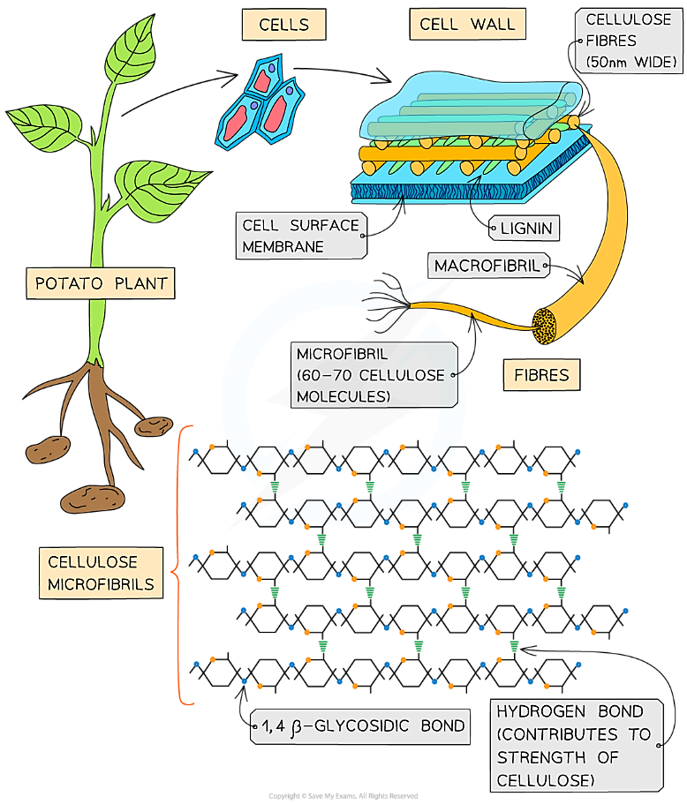
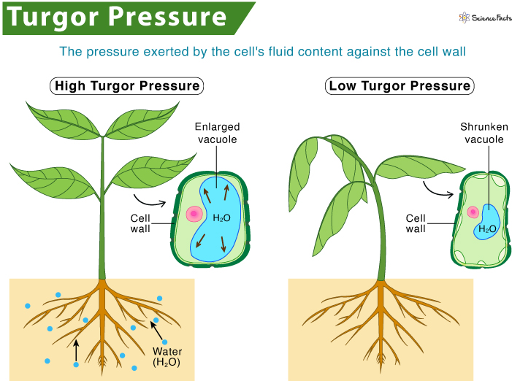
(https://www.sciencefacts.net/wp-content/uploads/2021/01/Turgor-Pressure.jpg)

The chemical formulas shown in question 3 illustrate that amino acids contain nitrogen in addition to the carbon, hydrogen and oxygen contained in carbohydrates. A few amino acids also contain sulfur (https://www.britannica.com/science/amino-acid/Standard-amino-acids). Plants need other minerals for other purposes. (https://www.dpi.nsw.gov.au/agriculture/soils/soil-testing-and-analysis/plant-nutrients). The need for sulfur and other minerals is not discussed in the Student Handout. Question 3 assumes that your students understand that biological processes cannot create atoms or change an atom into a different kind of atom, although the chemical reactions in organisms can rearrange atoms into different molecules.

Question 5 should reinforce student understanding that biological processes do not convert energy to matter (or vice versa).

The lower figure on page 2 of the Student Handout includes an edited version of the figure shown below in a larger size. The detail shown in the figure below is not discussed in this activity. If you want your students to learn more about the multiple reactions involved in photosynthesis, you can use the discussion and analysis activity “Using Models to Understand Photosynthesis” (https://serendipstudio.org/exchange/bioactivities/modelphoto).
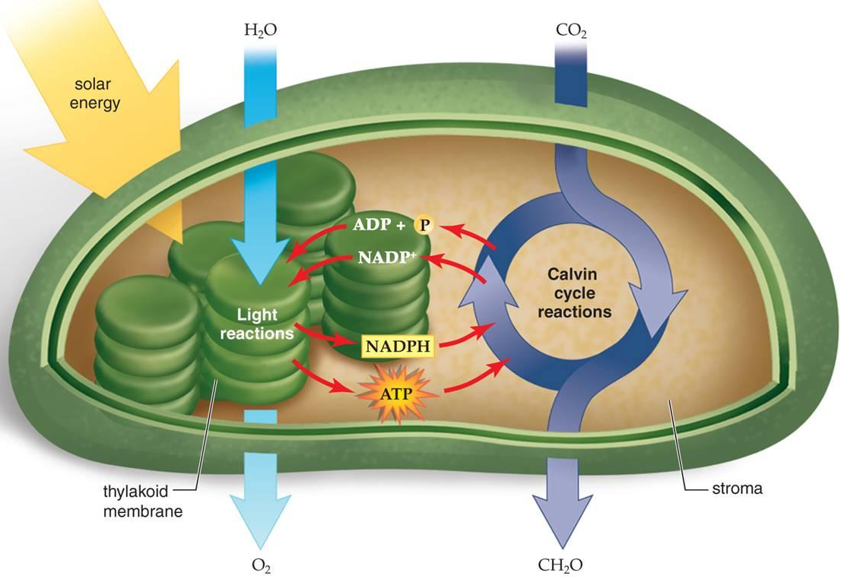
(https://www.accessscience.com/media/EST/media/511700FG0010.jpg)

The following evidence supports the conclusion that atoms from CO₂ are the primary source of the mass of the glucose molecules produced by photosynthesis. Since CO₂ and H₂O are the inputs for photosynthesis, it is obvious that the carbon atoms in glucose must come from CO₂, rather than H₂O. Experiments using isotopes of oxygen have shown that the oxygen atoms in the sugar molecules produced by photosynthesis come from CO₂, while the oxygen atoms in the O₂ produced by photosynthesis come from H₂O (https://www.howplantswork.com/2009/02/16/plants-dont-convert-co2-into-o2/). As discussed in question 6c, carbon and oxygen have much higher atomic weights than hydrogen, so most of the mass of glucose is due to the carbon and oxygen atoms. (See table below.)

Atom | Atomic weight | Percent of molecular weight of glucose
C | 12.0 | 40%
O | 16.0 | 53%
H | 1.0 | 7%

To help students understand that the gas, CO₂, actually has mass, you can use either or both of the following demonstrations.
- Have a student who is wearing a suitable protective glove hold some dry ice. He or she should notice the weight of the dry ice and also how it gives off CO₂ gas. Discuss how the same molecules/atoms are present in both the solid and gas, but are more spread out in the gas.
- Have the students measure the weight of a bottle or cup of carbonated soda immediately after removing the cap, and then several other times over a class period as more and more of the CO₂ bubbles off.

The figure below provides additional information about how glucose molecules are used to synthesize other types of organic molecules.
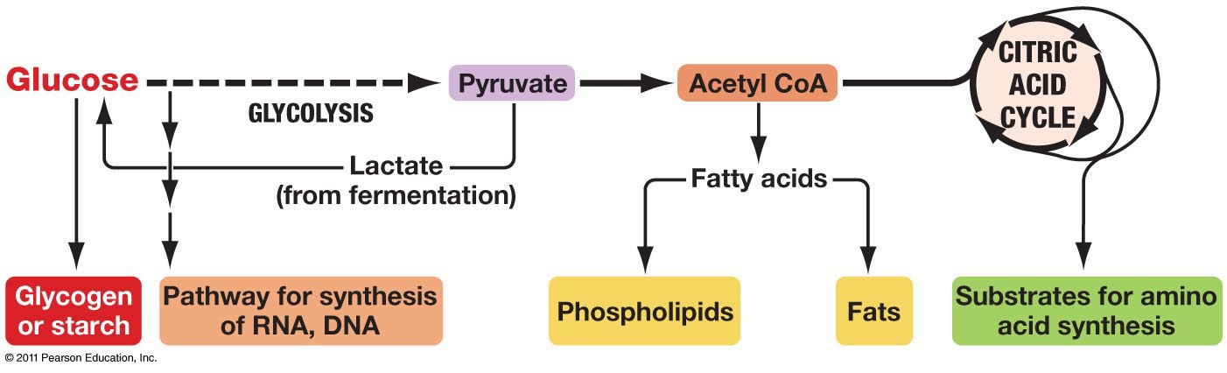
& cellulose
(http://www.uic.edu/classes/bios/bios100/lectures/09_28_anabolic_pathways-L.jpg )

The top of page 3 of the Student Handout introduces hydroponics, which provides a dramatic counterexample to the common misconception that most of a plant’s mass comes from the soil (https://extension.umn.edu/how/small-scale-hydroponics).

The figure on the top of page 2 of the Student Handout shows that CO₂ enters the leaves, but water and minerals (e.g., N) enter the roots. The figure near the top of page 3 of the Student Handout shows that water with dissolved minerals is transported up to the leaves. The figure to the right shows a more complete picture of how substances move in plants; notice that water with dissolved sugars is transported from the leaves down to the roots.

(modified from
https://archive.is/cLD1/4990bf657935ecdd448ffb59502ad68499f04371.gif)

The results of Helmont's experiment are as follows.

 | Weight of Tree | Weight of Dried Soil
1642 | 5 pounds | 200 pounds
1647 | 169 pounds, 3 ounces | 199 pounds, 14 ounces
Change in Weight | + 164 pounds, 3 ounces | -2 ounces

In answering question 10, students should recognize that:
- This experiment established that most of the increase in weight of the tree did not come from the dried soil, but the experiment did not test whether the increase in weight came from water or something in the air.
- This experiment with one tree requires replication before drawing conclusions about plants in general.
If students have trouble answering question 10c, you may want to ask them what alternative interpretation Helmont failed to consider and whether they think the sample size is adequate for the claim.

Although Helmont's experiment is widely cited in biology textbooks, his experiment and interpretation are flawed even by the standards of the seventeenth century (see http://helmont1.tripod.com/hersheypsb49-3.htm). In interpreting his results, Helmont fell prey to the relatively common error of failing to consider alternative interpretations of his results. His results did not eliminate other possible sources of weight (e.g. carbon dioxide which was called sylvestre by Helmont who knew it was produced by burning dried plant matter). (The importance of considering alternative interpretations is reinforced in question 12.) Also, Helmont overgeneralized his results; he concluded "But I have learned by this handicraft-operation that all Vegetables do immediately, and materially proceed out of the Element of water onely.” Finally, Helmont did not replicate his experiment, and he gave an improbably precise measurement of the change in weight of the dry soil. Boyle did a similar experiment with replication in the 1640s and found a decrease in soil weight of 0 pound in one case and 1.5 pounds in the other.

In 1627, Bacon had concluded from his experiments growing terrestrial plants in water instead of soil that "It seemeth by these instances of water, that for nourishment the water is almost all in all, and the earth doth but keep the plant upright, and save it from overheat and over-cold". We now know that, although only a small part of a plant's mass comes from minerals from the soil, plant health requires minerals such as nitrogen and phosphorus in order to make protein and DNA molecules.

Question 11 reintroduces the concept of biomass, defined as the mass of the organic molecules in an organism. For plants, ~96% of the dry mass consists of organic molecules, so biomass is often assessed as the dry mass. The distinction between mass and biomass allows a more sophisticated reformulation of the original hypotheses presented in the cartoon on page 1 of the Student Handout. I recommend that you discuss with your students how this type of more sophisticated reformulation of questions and hypotheses is an important part of scientific progress.

Question 12 introduces two important generalizations about the nature of science. The above information about Helmont’s experiment illustrates the following additional important points. As is often the case, multiple researchers were addressing the same question at about the same time; taken together, their results provided strong evidence that most of the weight of plants does not come from the dry soil. The subsequent change in the interpretation of their experimental results illustrates how conclusions are “subject to change based on new evidence and or reinterpretation of existing evidence”. This example also illustrates that “science knowledge has a history that includes the refinement of, and changes to, theories, ideas, and beliefs over time”.

Discussion during this activity may lead to comments or questions about the role of growing forests in reducing CO₂ concentration in the atmosphere and thus reducing global warming. However, you should be aware that these benefits are counteracted to varying degrees by other effects of trees (e.g. trees’ secretion of volatile organic compounds and the greater absorption of sunlight by leaves compared to more sunlight reflected by snow or light sand) (https://www.nature.com/articles/d41586-019-00122-z). For learning activities and more information about global warming, see “Food, the Carbon Cycle and Global Warming – How can we feed a growing world population without increasing global warming?” (https://serendipstudio.org/exchange/bioactivities/global-warming) and “Resources for Teaching about Climate Change” (https://serendipstudio.org/exchange/bioactivities/ClimateChange).

Additional Resources
This activity is part of an integrated sequence of learning activities described in “Cellular Respiration and Photosynthesis – Important Concepts, Common Misconceptions and Learning Activities” (https://serendipstudio.org/exchange/bioactivities/cellrespiration).

Much of the material in this analysis and discussion activity is included in a hands-on activity “Photosynthesis, Cellular Respiration and Plant Growth” (https://serendipstudio.org/sci_edu/waldron/#photobiomass). This minds-on, hands-on activity begins with the question of how a tiny seed grows into a giant Sequoia tree. To address this question, students first consider what types of molecules and atoms are in plants. They analyze data from an experiment on changes in plant biomass in the light vs. dark and conduct an experiment to evaluate changes in CO₂ concentration in the air around plants in the light vs. dark. Students interpret these data to develop an increasingly accurate and evidence-based model of the contributions of photosynthesis and cellular respiration to changes in plant biomass. This activity counteracts several common misconceptions about plant growth, photosynthesis, and cellular respiration.

Sources for Figures in the Student Handout
– Cartoon on the top of page 1 – from "Hard-to-Teach Biology Concepts" by Susan Koba with Anne Tweed, NSTA Press
– Figures of chemical structures of organic molecules on the bottom of page 1 from http://www.nutrientsreview.com/wp-content/uploads/2014/09/Glucose-formula.jpg; https://classconnection.s3.amazonaws.com/954/flashcards/1172954/jpg/biopic1328807784092.jpg; https://www.britannica.com/science/amino-acid;
– Figure of inputs for photosynthesis on page 2, modified from http://www.gardeninginfozone.com/wp-content/uploads/2011/03/how-plants-grow2.jpg
– Figure of chloroplast and photosynthesis on page 2, modified from https://www.accessscience.com/media/EST/media/511700FG0010.jpg
– Figure of plant absorbing and transporting minerals on page 3, modified from https://www.nagwa.com/en/explainers/963167471528/

By Dr. Ingrid Waldron, Department of Biology, University of Pennsylvania, 2022. These Teacher Notes and the related Student Handout are available at https://serendipstudio.org/exchange/bioactivities/plantmass.
A hands-on activity that includes much of the material in this activity is “Photosynthesis, Cellular Respiration and Plant Growth” (https://serendipstudio.org/sci_edu/waldron/#photobiomass).
Quotations are from Next Generation Science Standards (http://www.nextgenscience.org/sites/default/files/HS%20LS%20topics%20combined%206.13.13.pdf and https://www.nextgenscience.org/sites/default/files/resource/files/Appendix%20H%20-%20The%20Nature%20of%20Science%20in%20the%20Next%20Generation%20Science%20Standards%204.15.13.pdf).
https://www.researchgate.net/profile/Muhsin-Menekse-2/publication/328772747_The_role_of_collaborative_interactions_versus_individual_construction_on_students'_learning_of_engineering_concepts/links/5be9ec54299bf1124fce1aab/The-role-of-collaborative-interactions-versus-individual-construction-on-students-learning-of-engineering-concepts.pdf
To insert text, at the top of the drawing page, click Insert and Text Box and drag it to where you want it. Type your text. When you are done, click Save and Close. To draw a shape, at the top of the drawing page, find and click Shape; choose the shape you want to use; click and drag on the canvas to draw your shape. When you are done, click Save and Close.
An organic molecule (also called an organic compound) is a complex carbon-containing molecule. Organic molecules are normally produced by and found in living organisms. For the purposes of this activity, weight is a good estimate of mass.
Unfortunately, different scientists use different definitions of biomass and mass. Some scientists use biomass to refer to the total weight of an organism, and some scientists use mass to refer to the weight of the organic molecules in a plant; neither of these definitions is used in this activity. Another common measure of biomass is the mass of carbon in an organism; the mass of carbon is approximately half of the dry weight.
See footnote 3 for sources of quotes.

