Where does a tree's mass come from?

1. A tiny seed has grown into a very large tree. Where did the tree’s mass come from? For each hypothesis in this cartoon, write true or false, or revise the sentence to state a hypothesis that you think is true.

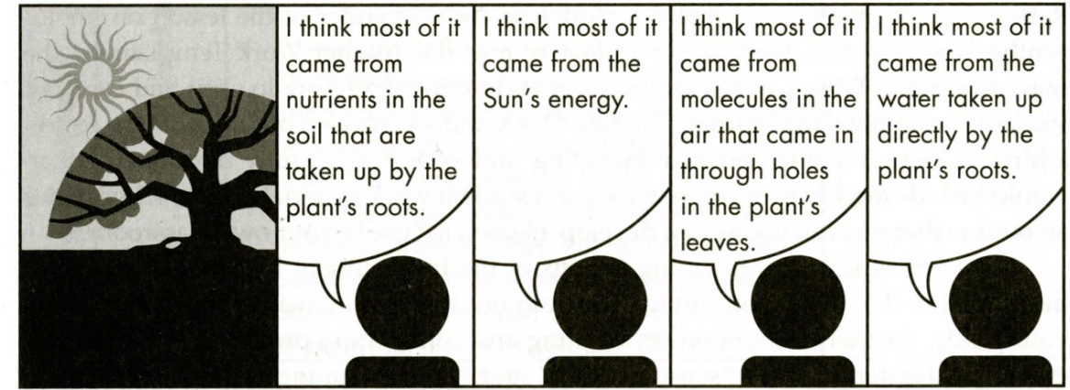

2. Roughly half of the mass of a tree is water, and roughly half consists of organic molecules (e.g., sugars, cellulose, amino acids, and proteins). Where do you think the water and organic molecules come from?

How do you think a tree gets or makes this type of molecule?
Biomass (mass of
organic molecules)
+ Mass of water
molecules
= Total mass of a tree

3. The figure below shows the chemical structure of several organic molecules. Each kind of atom in these organic molecules must be contained in the molecules that plants use to make the organic molecules. List each kind of atom in these organic molecules and suggest a possible source for each kind of atom.

Glucose
Example of an  Amino acid | etc.; folds into Protein

Trees gain mass by the same basic processes as other plants. Therefore, to understand how a tree gains mass, we will consider evidence from all types of plants. This figure describes how a plant gets the inputs for photosynthesis to make sugars. Plants use these sugars to make other organic molecules.
4. For each kind of atom in the organic molecules in question 3, write its symbol next to the description in this figure of how this kind of atom enters the plant.

5. Sunlight is needed for photosynthesis because:
- sunlight becomes sugar molecules.
- sunlight makes CO₂.
- sunlight provides the energy for reactions that transform CO₂ and H₂O to sugars and O₂.
- all of the above.

This figure shows that photosynthesis occurs in chloroplasts, which are tiny organelles inside leaf cells. Photosynthesis produces sugars, and additional reactions convert these sugars to other organic molecules such as cellulose or amino acids.

6a. Draw a rectangle around the part of this figure that shows photosynthesis.

6b. Photosynthesis produces sugar molecules such as glucose. What molecule supplies the carbon and oxygen atoms to make glucose?

6c. The chemical formula for glucose is C₆H₁₂O₆. The atomic weights of carbon and oxygen are
more than ten times higher than the atomic weight of hydrogen. Therefore, the source of most

of the mass of a glucose molecule is ________.
(CO₂ / H₂O / O₂)

7. Many glucose molecules are joined end-to-end to make cellulose, which is the main molecule in plant cell walls. Explain how the carbon and oxygen atoms from CO₂ molecules in the air become part of the cellulose molecules in plant cell walls.

Many plants can be grown with their roots in water instead of soil. However, these plants do not grow well unless the water has some dissolved compounds that contain nitrogen and other
minerals.

8a. Why do plants need nitrogen?

8b. How do the leaves of most plants get nitrogen? (Hint: See figure.)

9a. Carbon and oxygen atoms are responsible for most of the mass of a protein molecule. Where do the carbon and oxygen atoms in plant proteins come from?

9b. Explain your reasoning.

In the seventeenth century, Helmont carried out an experiment to evaluate where a plant’s mass came from. He planted a willow tree in a pot with soil and added only water during the five-year experiment. The tree grew from 5 pounds at the beginning of the experiment to 169 pounds at the end. In contrast, the weight of the dried soil decreased by only 2 ounces. Helmont concluded that almost all the weight of plants comes from water.

10a. What was Helmont’s claim?

10b. What was his evidence?

10c. What was wrong with Helmont’s reasoning? Why is his claim not supported by his evidence?

10d. What would be a more valid claim based on Helmont’s evidence?

10e. Explain the reasoning that links your more valid claim (10d) to Helmont’s evidence (10b).

Conclusions

11. A tree’s mass = the mass of the water in the tree + the biomass (the mass of the organic molecules in the tree). Complete this table to summarize your conclusions about where a tree’s mass or biomass comes from.

For each statement, indicate whether it is true or false. | Describe or diagram the evidence or scientific principle  that supports your conclusion.
A substantial part of a tree’s mass comes from water taken up by the tree’s roots.
___ true
___ false

Most of a tree’s biomass comes from molecules in the air that enter the tree’s leaves.
___ true
___ false

Most of a tree’s biomass comes from nutrients in the soil that are taken up by the tree’s roots.
___ true
___ false

The sun’s energy becomes most of a tree’s biomass.
___ true
___ false

12. Complete this table to describe how the information presented in this activity illustrates two points about the nature of science.

Nature of Science | Example to Illustrate this Point
Scientific understanding is improved if there is a clear distinction between closely related terms such as mass and biomass.
In order to avoid false conclusions, it is important to consider alternative interpretations of the results of an experiment.

By Dr. Ingrid Waldron, Dept Biology, Univ Pennsylvania, © 2022. This Student Handout (can be copied for classroom use) and Teacher Notes (with background information and instructional suggestions) are available at https://serendipstudio.org/exchange/bioactivities/plantmass.

