Teacher Notes for
How have mutations and natural selection affected fur color in mice?

In this analysis and discussion activity, students figure out how mutations and natural selection can result in matches between the fur color of various populations of rock pocket mice and the color of their environments. Next, students view a video that presents relevant research findings, and students answer the embedded multiple-choice questions. Finally, students answer multiple questions and analyze several scenarios to enhance their understanding of mutations and natural selection.

If you plan to photocopy the Student Handout for your students, please make a test copy first to make sure the black mice in the figures for questions 6 and 10 don’t totally disappear in the photocopies. You may want to use a lighter setting for photocopying or insert the modified version of the relevant pages of the Student Handout, which are provided at the end of these Teacher Notes.

Learning Goals
In accord with the Next Generation Science Standards:
      - Students will gain understanding of two Disciplinary Core Ideas:
      - LS4.B Natural Selection. "Natural selection occurs only if there is both (1) variation in the genetic information between organisms in the population and (2) variation in the expression of that genetic information – that is, trait variation – that leads to differences in performance among individuals. The traits that positively affect survival are more likely to be reproduced, and thus are more common in the population."
      - LS4.C Adaptation. “Evolution is a consequence of the interaction of four factors: (1) the potential for a species to increase in number, (2) the genetic variation of individuals in a species due to mutation and sexual reproduction, (3) competition…, and (4) the ensuing proliferation of those organisms that are better able to survive and reproduce in that environment.”
"Natural selection leads to adaptation, that is, to a population dominated by organisms that are anatomically, behaviorally, and physiologically well suited to survive and reproduce in a specific environment. That is, the differential survival and reproduction of organisms in a population that have an advantageous heritable trait leads to an increase in the proportion of individuals in future generations that have the trait and to a decrease in the proportion of individuals that do not. Adaptation also means that the distribution of traits in a population can change when conditions change."
- Students will engage in the Scientific Practice:
- Constructing Explanations. “Apply scientific ideas, principles, and/or evidence to provide an explanation of phenomena… Apply scientific reasoning, theory, and/or models to link evidence to the claims to assess the extent to which the reasoning and data support the explanation or conclusion.”
- This activity provides the opportunity to discuss the Crosscutting Concepts:
- "Cause and effect: Mechanism and explanation": Students “suggest cause and effect relationships to explain and predict behaviors in complex natural and designed systems. They also propose causal relationships by examining what is known about smaller scale mechanisms within the system.”
- "Stability and change": “Students understand much of science deals with constructing explanations of how things change and how they remain stable.”
- This activity helps to prepare students for the Performance Expectations:
- HS-LS4-2, "Construct an explanation based on evidence that the process of evolution primarily results from four factors: (1) the potential for a species to increase in number, (2) the heritable genetic variation of individuals in a species due to mutation … and (4) the proliferation of those organisms that are better able to survive and reproduce in the environment."
- HS-LS4-4, "Construct an explanation based on evidence for how natural selection leads to adaptation of populations."

Suggestions for Implementation and Background Biology
To maximize student participation and learning, I suggest that you have your students work in pairs to complete each group of related questions and then have a class discussion after each group of questions. In each discussion, you can probe student thinking and help them develop a sound understanding of the concepts and information covered before moving on to the next group of related questions.

If your students are learning online, I recommend that they use the Google Doc version of the Student Handout available at https://serendipstudio.org/exchange/bioactivities/NaturalSelectionMice. You may want to revise the Word document or Google Doc to prepare a version of the Student Handout that will be more suitable for your students. If you use the Word document, please check the format by viewing the PDF.

A key is available upon request to Ingrid Waldron (iwaldron@upenn.edu). The following paragraphs provide additional instructional suggestions and background information – some for inclusion in your class discussions and some to provide you with relevant background that may be useful for your understanding and/or for responding to student questions.

The first page of the Student Handout sets the stage for understanding natural selection, and the second page introduces the logic of natural selection. However, the term “natural selection” is not introduced until the video which students watch at the beginning of page 3 of the Student Handout. Obviously, you may want to use the term “natural selection” if your students are already familiar with this concept.

Question 4 asks students to synthesize the information on page 1 of the Student Handout to describe what happened after a volcanic eruption. This question is designed to get students thinking about the issues that will be explained in subsequent parts of the activity, so your discussion of student answers to question 4 should focus on the concepts that students bring up and not try to lay out a definitive answer.

In the figures on page 2, the light-colored mice probably appear darker on the light background and lighter on the dark background, even though they are the exact same shade of gray. This illustrates a common visual illusion where objects appear darker when contrasted with a lighter background. Obviously, these figures show only a small subset of the thousands of mice in a population of rock pocket mice.

In these figures, the population of mice with light fur on the light-colored rocks is assumed to be at carrying capacity. Since the light-colored rocks provide a stable environment, the number of mice on the light-colored rocks also remains stable. The top two figures on page 2, together with figure A, illustrate the potential for population growth when a new environment opened up as the lava cooled. Figures A-B illustrate mutation which provided the genetic variation needed for the natural selection illustrated in figures B-D.

After your class discussion of student answers to question 6, I recommend that you revisit question 4. I also recommend that you discuss the Crosscutting Concept of Stability and change. You may want to begin by asking students to compare and contrast the change or lack of change for the populations of rock pocket mice on the stable light-colored rock vs. the changing dark rock that results when a lava flow cools. Students should notice that, on the stable light-colored rock, the population of mice has stable fur color and stable population size. In contrast, there was considerable change in the population size and fur color of the mice on the dark rock that resulted, as cooling lava became a newly available habitat.

Question 7 introduces the random nature of mutation and the nonrandom nature of natural selection.

Next, students view the video, “The Making of the Fittest: Natural Selection and Adaptation” (available at https://www.biointeractive.org/classroom-resources/interactive-questions-natural-selection-and-adaptation). This video is available in Spanish for English language learners, and transcripts are available in both English and Spanish for hearing-impaired students (https://www.biointeractive.org/sites/default/files/NatSelectionAdaptation-Transcript-Film.pdf and https://www.biointeractive.org/sites/default/files/NatSelectionAdaptation-transcript-Spanish-film.pdf).

I recommend that you have your students vote on the answer to each embedded multiple-choice question at the appropriate places in the video. One effective way to encourage each student to choose his/her answer independently is to have each student hold up a piece of paper to vote on each possible answer. The last page of these Teacher Notes provides a template which you can reproduce to provide your students with pieces with:
- Correct or Incorrect to vote on the first four multiple-choice questions (which have only one correct answer)
- True or False to vote on the last two questions (since these questions have more than one correct answer).

For each question, after the students have voted, if many students voted for the incorrect answer to a particular question, you can have students discuss the question with each other. They should analyze why each of the answer options is correct or incorrect and try to figure out the right answer together. Then, have the class re-vote and discuss their reasoning.

At ~5 minutes the narrator refers to changes in four chemical letters. It may be helpful to know that the four nucleotides that are changed in the mutated Mc1r gene are separated by many nucleotides and result in changes in four different amino acids at crucial locations in the melanocortin-1-receptor protein. This melanic allele is dominant.

The first batch of three multiple-choice questions in the video (just after 5 minutes) is as follows:

Why did dark-colored rock pocket mice first appear in a population of light-colored rock pocket mice?
- They have a genetic mutation that affects their fur color.
- There is dark lava rock in the area where they live.
- Individuals change color to blend in with the environment.
- Predators eat light-colored rock pocket mice.

Why do dark-colored rock pocket mice on dark lava flows have white bellies?
- There is no selection for dark bellies by visual predators.
- Mutations causing dark bellies do not occur.
- There is a reproductive advantage to having a dark belly.
- White bellies are an important part of camouflage.

Mutations are always
- good.
- bad.
- neutral.
- a change in an organism’s DNA.

The fourth multiple-choice question (shortly after ~7 minutes in the video) is:

When dark-colored fur gives mice a 1% competitive advantage and 1% of the population begins with dark fur, in about 1000 years 95% of the population will have dark fur. Which of the following statements is true?
- The dark-colored pocket mice, in this population, have fewer offspring than light-colored rock pocket mice.
- If dark-colored rock pocket mice had a competitive advantage of 0.1% it would take more than 1000 years for 95% of the population to have dark fur.
- If dark-colored mice had a competitive advantage of 5%, it would take more than 1000 years for 95% of the population to have black fur.
- If dark-colored mice had a competitive advantage of 10%, it would take more than 1000 years for 95% of the population to have black fur.
This question can be quite challenging so, before you have your students vote, you may want to provide an explanation something like the following.
- Competitive advantage measures how big the difference in survival and reproduction is, comparing mice with dark fur vs. mice with light fur. You might want to ask your students why the mice with dark fur would have a competitive advantage.
- The second answer means that if the competitive advantage for dark fur were smaller, then it would take longer before most of the mice in the population would have dark fur.
- The last two answers mean that if the competitive advantage for dark fur were larger, then it would take longer before most of the mice in the population would have dark fur.

You might want to show your students the “Pocket Mouse and Predation” animation available at https://www.biointeractive.org/classroom-resources/rock-pocket-mice-and-predation. This animation illustrates how, on dark rocks, light mice are more subject to predation than dark mice. This gives the dark mice a competitive advantage, and the size of this competitive advantage determines how fast natural selection increases the proportion of mice with dark fur (for a population of mice on dark rock). The figure below illustrates how the size of a competitive advantage is associated with the rate of change in the percent of mice that have a new allele (e.g. an allele for dark fur).

Competitive
Advantage

~10-25%

~2-4%

~1-2%

~0.5-1.0%

~0.2-0.4%
(http://content.csbs.utah.edu/~rogers/ant5221/lecture/selection.pdf)

You may also want to mention that evolution by natural selection can occur relatively rapidly in rock pocket mice populations because rock pocket mice have a short lifecycle and high reproductive rates.

The last two multiple-choice questions (~9 minutes and 45 seconds in the video) have more than one correct answer.

What does Dr. Carroll mean when he says “while mutation is random, natural selection is not”?
- Mutations are caused by changes in the environment.
- Natural selection can favor some mutations and not others.
- Selection can change depending on the environment.
- Mutations for advantageous traits are more likely to be passed on to the next generation.

In the lab, Nachman examined dark-colored mice from two different populations living hundreds of miles apart. The mice looked nearly identical. Their dark color was caused by two different genes. What does this tell you?
- Dark fur color evolved only once in rock pocket mice.
- There are at least two genes involved in creating dark-colored mouse fur.
- Dark fur color evolved independently on each of these lava flows.
- Different mutations in two different genes cannot generate the same phenotype.
- Under similar conditions, natural selection can favor similar adaptations.

After the video, questions 8-15 will reinforce and deepen student understanding of mutations and natural selection.

Question 9 ask students to apply a definition of natural selection to fur color in rock pocket mice. Although no direct evidence is available for natural selection in rock pocket mice, the following bullet points provide indirect evidence that natural selection is the reason why most rock pocket mice have fur color that matches their environment.
- Genetic evidence and field observations indicate that rock pocket mice move freely between light and dark habitats, especially at the borders between dark and light rocks. The mice do not show a preference for rocks that match their fur color, so the differential distribution of fur color on different color rocks is not due to the behavior of the mice.
- The video presents evidence that genes control fur color. Mice cannot vary their fur color to blend in with their environment (as an octopus does).
- Experimental evidence for a different type of mouse living on a dark substrate showed that dark coloration decreased the risk of predation by owls.
The first two observations eliminate alternative possible explanations for the observation that the fur color of most of the mice matches their environment; they thus provide indirect evidence for natural selection.

Question 11 refers to a finding that, on the dark rock of one lava flow in northern Arizona, the mice have light-colored fur. To explain this finding, your students need to know that mutations are rare events. The researchers suggest that the light-colored fur of the mice on this lava flow “likely reflects the fact that [this] lava flow is an extension of the relatively young Sunset Crater (<800 years old); consequently, there may have been insufficient time for melanic mice to evolve in this population. In addition, there are no populations of melanic mice nearby from which melanic migrants may invade.” This illustrates that natural selection can only operate when one or more alleles for an adaptive trait are present in the population. This is one reason why evolution is a slow process, and the slow pace of evolution is one reason why not all characteristics observed in living organisms are adaptive. This example provides the opportunity to discuss the Crosscutting Concept, Cause and effect: Mechanism and prediction. Students should notice how understanding the mechanisms of mutation and natural selection helps us to understand a seeming exception to the predictions of the theory of evolution. This question also provides the opportunity to reinforce student understanding of mutation as a major source of the heritable variation that must be present for natural selection to occur.

As discussed in question 12a, mice moved freely between the light-colored rocks and dark rocks. This is one reason why not all of the mice have fur color that matches their environment, particularly near the boundary between light and dark rocks. Another reason for mismatches between the fur color of mice and their environment is that populations of mice with light fur can survive on dark rocks in locations where they are not competing with mice with dark fur (e.g. because a mutation for dark fur has not occurred yet). (See question 11.) Although natural selection is more obvious when a new environment opens up or when the environment is changing, natural selection also plays an important role in maintaining adaptations in stable environments. This point is highlighted in question 12b.

Questions 11 and 12a show the limits of natural selection. Both questions illustrate that natural selection can only act on heritable variation in a population. For example, if there is no mutation that reduces the movement of rock pocket mice to rocks that do not match their fur color, then the mice will not evolve this desirable trait.

Discussion of student answers to question 13 will illustrate how natural selection operates at different levels of biological organization. Individual mice with fur color that does not match the color of their environment are more likely to be killed by predators. For the populations that lived on the dark rocks, the proportion of mice with an allele for dark fur has increased. Question 13b provides another opportunity to contrast the effects of natural selection in a changing or changed environment with the effects of natural selection in a stable environment.

In your discussion of student answers to question 14, you can refer back to questions 7 and 11 which illustrate the random nature of mutation. You can also refer to questions 9-10 and 12 which illustrate the non-random nature of natural selection.

Additional Recommended Activities are described in “Resources for Teaching and Learning about Evolution” (https://serendipstudio.org/exchange/bioactivities/evolrec).

Sources for Figures in the Student Handout
On page 1, figure of rock pocket mice from http://images.slideplayer.com/14/4440398/slides/slide_19.jpg. and figure of great horned owl from https://i.natgeofe.com/k/50fe4ce2-3d74-4da8-984d-887b7fb75005/GreatHornedOwl1_2x3.jpg.
All other figures were constructed by the author.

Possible Substitute Version of Pages 2-3 of the Student Handout
The next two pages of these Teacher Notes provide a version of pages 2-3 of the Student Handout with modified figures. Although the camouflage for the dark mice isn’t as good as the Student Handout figures when viewed online or when printed initially, these figures may be better for photocopying to ensure that the dark mice don’t disappear into their background.

This figure shows the mice that were living on a little part of a much larger area of light-colored rock. This figure also shows a little part of a new lava flow that was too hot for mice to live on.

This figure shows the mice in the same area a year later, after the volcanic rock had darkened as it cooled enough for mice to live there.

5. What changes occurred between the first and second figures? What caused these changes? A complete answer will include: births, deaths, migrated, and total number of mice.

Figures A-D show what the population of mice looked like at different times over the next 1000 years.  Figure A shows the result of the continuing increase in the number of mice. Light-colored mice were more likely to be killed by predators on the dark rock. However, the mice had so many babies that there was a large population of light-colored mice on the dark rock.  6a. What do you think happened between figures A and B?  6b. What do you think happened after figure B to cause the changes observed in figures C and D? | 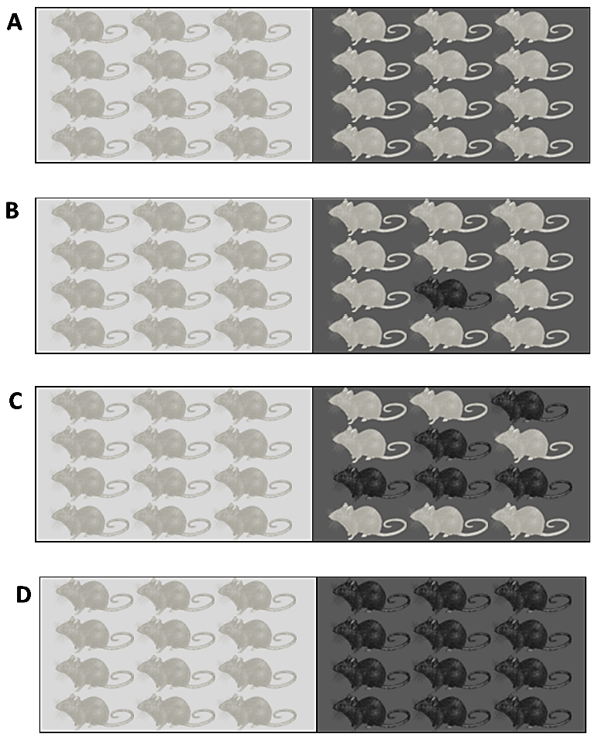

7a. Suppose that a mother mouse that lived on the light-colored rock had a baby mouse with a mutation that resulted in dark fur. Do you think that dark mice would become increasingly common on the light-colored rock? yes ___ no ___

7b. Explain why or why not.

Watch the video “The Making of the Fittest: Natural Selection and Adaptation” (https://www.biointeractive.org/classroom-resources/interactive-questions-natural-selection-and-adaptation). Answer the questions in this video.

8a. What does “fittest” mean in the title, “The Making of the Fittest: Natural Selection and Adaptation”?
- can run the fastest and farthest
- can win fights with other mice
- most able to survive and have offspring

8b. What is the adaptation that increases fitness?

In the process of natural selection, a heritable trait that increases fitness becomes common in a population because:
• Individuals that have this trait are more likely to survive and reproduce.
• Offspring tend to have the same trait as their parents.

9. Explain how the evolution of fur color in rock pocket mice on dark rocks illustrates the above definition of natural selection. For example, what is the heritable trait and how does it influence fitness?

10. As shown in the video, the desert has many miles of light-colored rocks, with scattered areas of dark rock from past volcanic eruptions. Researchers have found that:
- Most of the rock pocket mice that live on these different areas of dark rock have a similar phenotype (dark fur).
- However, different mutations are responsible for the dark fur in two populations of mice that live on two different areas of dark rock.

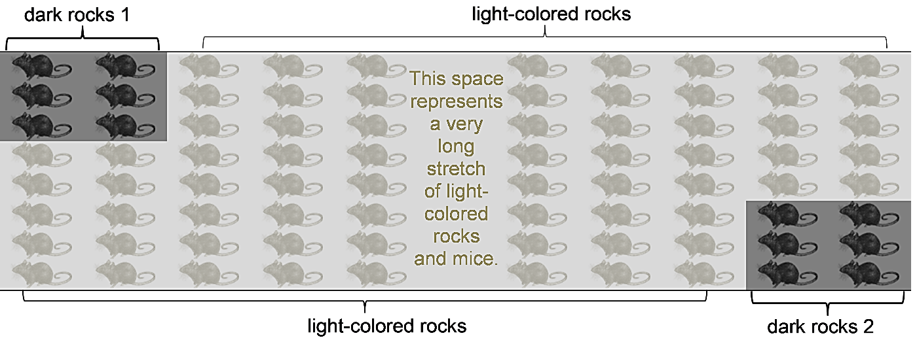
Explain why the mice on two different areas of dark rock have similar phenotypes but different genotypes.

Correct | Incorrect
True | False
Correct | Incorrect
True | False

Pieces for two students to vote on the multiple-choice questions in the video

By Ingrid Waldron, Department of Biology, University of Pennsylvania, © 2023, with helpful input from Ray Howanski, Ridley School District. These Teacher Notes and the Student Handout are available at https://serendipstudio.org/exchange/bioactivities/NaturalSelectionMice.
Next Generation Science Standards quotations from https://www.nextgenscience.org/ and https://www.nextgenscience.org/sites/default/files/HS%20LS%20topics%20combined%206.13.13.pdf
If you want to introduce your students to natural selection before this activity, you may want to use “What is natural selection?” (https://serendipstudio.org/exchange/bioactivities/NaturalSelectionIntro) or "Evolution by Natural Selection" (http://serendipstudio.org/sci_edu/waldron/#evolution).
The population size on light-colored rock has been stable only if you ignore the mice that were killed by the lava flow when the volcanos erupted.
Although the video shows daytime scenes, rock pocket mice are nocturnal; even at night, visual camouflage is important for protection against owls, the primary predator of rock pocket mice. Rock pocket mice live on rocks and do not live on the nearby sandy areas, although they do sometimes migrate across them. A version of the video without questions is available at https://www.biointeractive.org/classroom-resources/making-fittest-natural-selection-and-adaptation.
Mutation is a random process in the sense that, as far as scientists have been able to determine, there is no tendency for genes to mutate to a useful allele in a particular environment. This is probably all that your students need to know, but you may want to know that mutations are not entirely random; for example, rates of mutation differ in different parts of the genome in ways that appear to be adaptive.
Source = personal communication, Michael Nachman, November 2016. See also question 12a and the comment at about three minutes in the video, “Field studies show that mice move freely between light and dark rocks.” These field observations are supported by analyses of mitochondrial genes, which indicates substantial migration between regions with light rocks and regions with dark rocks (Evolution (2004) 58:1329-1341).
Heredity (2006) 94:217-228. These researchers estimate that “the overall mutation rate to dark color is about 10⁻⁶ per genome per generation”.
For rock pocket mice, no evidence is available to assess changes in population characteristics over time. However, research on natural selection in some other populations of organisms in changing environments has shown the predicted increases in the frequency of adaptive characteristics (e.g., see "Natural Selection and the Peppered Moth" (https://serendipstudio.org/exchange/bioactivities/NaturalSelectionMoth) and "The Origin of Species: The Beak of the Finch" (https://www.biointeractive.org/classroom-resources/origin-species-beak-finch)).

